 | INTERNATIONAL TELECOMMUNICATION UNION  TELECOMMUNICATION  STANDARDIZATION SECTOR  STUDY PERIOD 2022-2024 |  | SG17-Cn
 |  |  | STUDY GROUP 17
 |  |  | Original: English
Question(s): |  | 1/17 | Goyang-Si, 29 August – 8 September 2023
CONTRIBUTION
Source: |  | Ministry of Communications (India)
Title: |  | Proposed new work item on “Cyber Security Reference Architecture” (CS-RA)
Contact: |  | N. KISHOR NARANG  Ministry of Communications  India |  | Tel: +91 98101 63990  E-mail: kishor@narnix.com

Abstract: | The Contribution proposes to develop a new work item proposal on Cyber Security Reference Architecture (CS-RA) that shall provide a unified, systemic and granular approach for architecting and deploying Digital Systems, Solutions and Infrastructures in a comprehensively cyber secure and resilient manner in diverse use cases and application domains leading to significant improvement in their respective Security, Resilience and Immunity along with reducing the vulnerable surface attack areas in the Digital Systems.
Background:
Those of us who have worked in cybersecurity for many years often start to think we’ve “seen it all”. We haven’t. Recent years have ushered in a host of new adversaries, new attack methods and new challenges for those of us in the cybersecurity industry.
International law defines Four Global Commons (natural assets outside national jurisdiction) which are the earth’s natural resources i.e. the High Seas, the Atmosphere, Antarctica, and Outer Space. Cyberspace is the 5th Global Common. It is also considered as the 5th Dimension beyond the 3 dimensions of Space & 4th dimension being the Time. Challenges that all economies are facing today in safeguarding the security and privacy of its ecosystem including citizen are - Transnational Nature of Cyber Crime, ‘Cultural’ Vulnerabilities, Internet Resilience and Threat Landscape.
Cyber risk threat vectors have evolved rapidly, and attacks have become increasingly sophisticated, deliberate, and unrelenting in nature. In the digital era, trust is a complex issue fraught with myriad existential threats to the enterprise. And while disruptive technologies are often viewed as vehicles for exponential growth, tech alone can’t build long-term trust. Every aspect of an organization disrupted by technology represents an opportunity to gain or lose stakeholders' trust.
The new paradigm of Smart Grid, Smart Building, Smart Home, Smart City, Smart Manufacturing already complicated by the ‘Internet of Things’ & Internet of ‘Everything’ made further complex by the Artificial Intelligence, Machine Learning Blockchain & Quantum Computing, make it truly complex to develop & embed comprehensive Security, Privacy and Trustworthiness attributes in the products, systems and solutions for any use case or application - be it consumer, commercial, industrial, automotive or strategic domains like Civic/critical infrastructure, defense and aerospace.
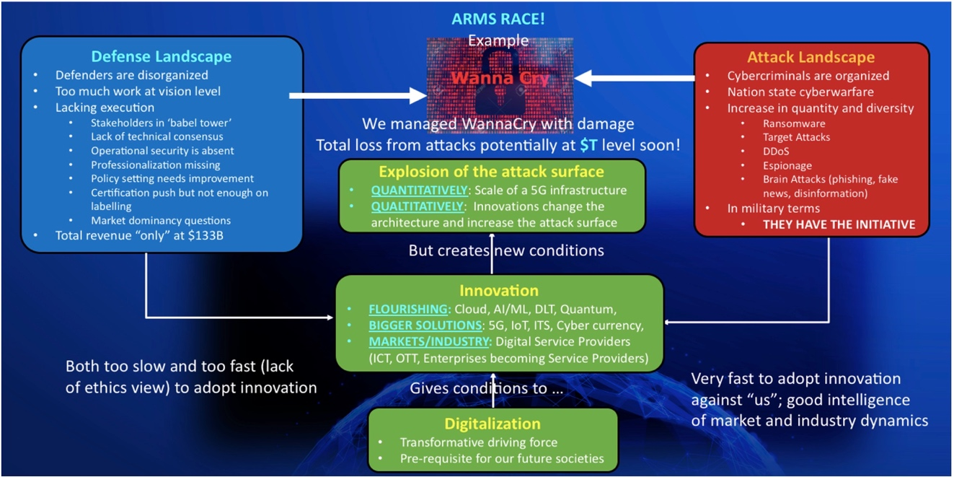
Figure 1. Cyber Security Landscape (courtesy Arnaud Taddei)
The recent evolution of disruptive technologies and digitalization compounded by the Covid 19, changing geopolitical situations and increasing cyber-attacks from not-so-friendly nations; bring a whole new set of challenges for the Security and Security Evaluation Methodologies for complex nature & architectures of diverse Digital (Information and Communication Technology) Systems including but NOT limited to Civic & Critical Infrastructures of the nations, leveraging the IT & Communication Networks evolving to meet these rising needs of the Government, Industry, Businesses and Society at large.
On one hand, we have the highly protected Networks for the ‘Critical Information Infrastructures’; on the other hand, these very ‘highly protected networks’ need to give access to the consumers for Consumer Engagement and Participation in these Smart (Digital) Infrastructures to meet the true drivers of setting them up.
The imperatives of building a sustainable and secure planet have given rise to new paradigms like the green movement, DC power, renewables, microgrids, sustainable transportation, networking devices, network & cyber security, smart homes, smart buildings, smart grids and smart cities… All these shifting and rising paradigms are ultimately converging into the new & much larger paradigm of ‘Sustainable and Trustworthy’ Digital Infrastructure.
These large Smart Networks are actually highly complex ‘Systems of Systems’ and “Networks of Networks’, and thus create fresh challenges in the Security Paradigm and development of Protection Profiles or Compliance Testing Schema and Frameworks.
Strong security controls and practices are foundational elements for building and maintaining stakeholder trust. Recognizing the impact of security breaches on customer trust, enterprises go beyond the expected table stakes by completely redesigning their security models to protect enterprise systems and data. Security experts no longer assume that walling off the network would provide the security required to maintain system integrity and customer trust. They are embracing the zero-trust concept, an innovative security model that eliminates network- based trust.
It is evident that Cyber Security is a very complex paradigm, and with evolving new technologies, requirements, and ever-increasing Attack Surface the vulnerabilities are rising many folds with time. In such a dynamic scenario, how do we develop a Cyber Security Strategy to make our Digital Systems & Infrastructures comprehensively Safe, Secure, Resilient and Trustworthy?
DIGITAL TRANSFORMATION
New technologies and paradigms like IoT, Big Data, Artificial Intelligence, Virtualization, Cloud Computing, 5G (& now 6G in the very near future), Blockchain, Quantum Computing and other disruptive technologies like AR/VR, Web 3.0 & Metaverse are promising to disrupt the way we design products, systems, and solutions. Today, we need to develop new strategies (and standards) that can help us navigate seamlessly through a much wider and complex canvas of technologies, ecosystem & stakeholders.
In the wake of technological advancements, especially in the field of ICT all the ecosystems be it Smart Cities, Smart Grid, smart Buildings, Smart Factories or all the Enterprises now find themselves making three classes of transformations –
- Improvement of Infrastructure – to make it resilient & sustainable.
- Addition of the Digital Layer - which is the essence of the smart paradigm; and
- Business Process Transformation - necessary to capitalize on the investments in smart technologies.
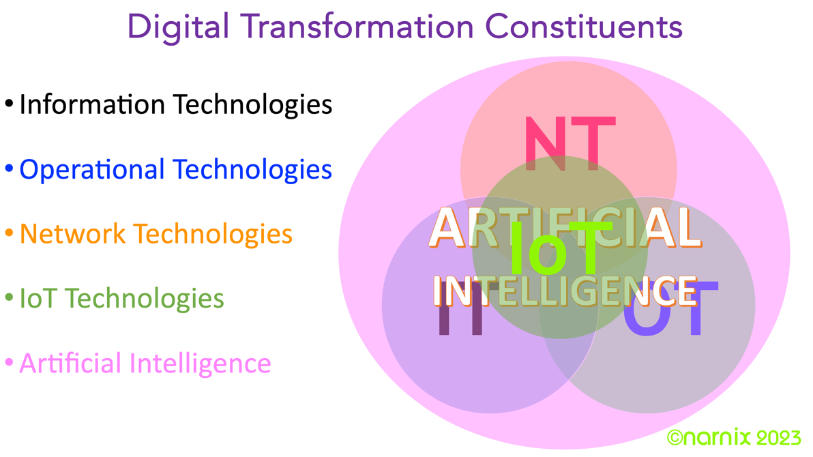
Figure 2. Digital Transformation
The genesis of Digital Transformation is not only about the integration of IT (Information Technologies) and OT (Operational Technologies), as the Network Technologies have evolved to a level of complexity and advancements (5G & Software defined Networks) that play a crucial role in the digital transformation. Last but not the least, the new kids on the block – IoT & AI have become so pervasive and ubiquitous that they enhance the value proposition of Digital Transformation comprehensively in any ecosystem. Digital Transformation is NOT a technology, it’s a complex paradigm with domain-specific implications as we are living in an ephemeral world, and Artificial Intelligence (AI) & Machine Learning (ML) and other disruptive technologies are powering the digital transformations happening in every domain around the world bringing new level of complexities for Cyber Security of Digital Systems.
While Artificial Intelligence (AI) (and Machine Learning (ML) is one of the technologies being deployed to mitigate cybersecurity risks due to its speed that human operators may not be able to match, not to forget that it is also being heavily leveraged for the cyber offensive endeavours to out manoeuvre the cyber defences of various digital systems/infrastructures. Hence it would be imperative to develop some comprehensive strategies to leverage AI & ML…
CYBER IMMUNITY
The pandemic-induced digital transformation has increased exposure to cyber threats as we cross the digital fault line due to remote working and escalated online presence. To counter this, an intuitive and adaptive cyber posture defined by zero latency networks and quantum leaps will be needed across industries. These developments, while great for humanity, will challenge privilege, privacy, and defend every citizen.
Cyber Immunity will create IT networks that are inherently secure and self-learning. AI-induced digital intuition is one of the pillars that will allow intelligent adaption. The ability of AI systems to out-innovate malicious attacks by mimicking various aspects of human immunity will be the line of defense to attain cyber resilience based on both supervised and unsupervised machine learning. These systems will be designed to make the right decisions with the context-based data, pre-empt attacks on the basis of initial indicators of compromise or attack, and take intuitive remediated measures, allowing enterprises to be more resilient.
IMPERATIVES
To develop a truly comprehensive & granular set of collaterals to demystify this complex and nuanced paradigm and help the stakeholders embed the cyber security, resilience & immunity in digital systems, solutions, and infrastructures.
To develop such collaterals, it is imperative to delve into the diverse security aspects and implications of the new paradigm of Digital Systems & Infrastructure needing a new rigorous and vigorous effort in developing a “Comprehensive Cyber Security Reference Architecture”.
The comprehensive Cyber Security Reference Architecture must be developed after detailed and granular study & analysis of the complex domain, encompassing all the critical domains and Stakeholders classifications and their respective imperatives (concerns, requirements, and expectations) from Cyber Security, Privacy, Resilience & Trustworthiness Perspective. In addition to Standards and certification, long-term cyber resilience requires ongoing risk management, constant assessment, and training. Simply applying standards alone will not result in an “achieved cyber-secure state”.
SYSTEMS APPROACH:
The multiplicity of technologies and their convergence in many new and emerging markets, however, particularly those involving large-scale infrastructure demand a top-down approach to standardization starting at the system or system-architecture rather than at the product level. Therefore, the systemic approach in standardization work can define and strengthen the systems approach throughout the technical community to ensure that highly complex market sectors can be properly addressed and supported. It promotes an increased co-operation with many other standards-developing organizations and relevant non-standards bodies needed on an international level. Further, standardization needs to be inclusive, top down and bottom up; a new hybrid model with a comprehensive approach is needed.
Systems Approach is a holistic, iterative, discovery process that helps first defining the right problem in complex situations and then in finding elegant, well-designed, and working solutions. It incorporates not only engineering, but also logical human and social aspects.
We need to undertake this task of global importance, which shall make a significant contribution in building a “Robust Foundation for Digital Systems & Infrastructures” along with paving ways to make our community “sustainable, secure and resilient”.
After detailed and granular study & analysis of the complex domain, it is critical to develop a Granular Cyber Security Reference Architecture with multiple views and interdependence matrix of stakeholders, their respective concerns and technologies, standards (also Policies & Regulatory
With this as the background, this contribution proposes a New Work Item on “Cyber Security Reference Architecture” to be developed and produce an ITU-T Recommendation. This New Work Item, if approved by SG17, is proposed to be put it under Question 1/20 to enable the SG 17 experts to consider as a top-down strategy project rather than a regular project.
References:
- ITU-T X.arch-design
- ITU-T X.800
- ITU-T Z.150
- ISO/IEC/IEEE 42010
- ISO/IEC/IEEE 42020
- ISO/IEC/IEEE 42030
- IEC SRD 63188
- ISO 15704
- ISO/IEC/IEEE 15288
- ISO/IEC/IEEE 12207
- ISO/IEC 31000 Family
- ISO/IEC 27000

Annexure - I
Rationale, Approach and Value – Cyber Security Reference Architecture
RATIONALE
Security is essentially an attribute of a System, and without understanding the Architecture and other critical design aspects of the system, attempting to make any system comprehensively secure would be futile and sub optimal, to say the least. Along with architecture and core design aspects, what is crucial, is to also collect the diverse Security Concerns from the different stakeholders’ perspectives and from different components of the systems (from design perspective).
Security Architecture is a set of physical and logical security-relevant representations (i.e., views) of system architecture that conveys information about how the system is partitioned into security domains and makes use of security-relevant elements to enforce security policies within and between security domains based on how data and information must be protected.
Note: The security architecture reflects security domains, the placement of security-relevant elements within the security domains, the interconnections and trust relationships between the security-relevant elements, and the behavior and interaction between the security-relevant elements. The security architecture, similar to the system architecture, may be expressed at different levels of abstraction and with different scopes.
Reference Architecture is a source of information comprising descriptions of generalized architecture concepts, requirements, and recommendations which is used to conceptualize architectures and capture architecture descriptions. Reference architectures can be expressed as a set of models, views, model views, processes, elements, their relationships, and rules, etc.
A Reference Architecture provides a template for solution architectures which realizes a predefined set of requirements of a particular domain. Reference architectures are standardized architectures that provide a frame of reference for a vertical domain or sector. A Reference Architecture uses its subject field Reference Model (as the next higher level of abstraction) and provides a common (architectural) vision, a modularization and the logic behind the architectural decisions taken.
Reference Architectures can be instantiated for a particular domain or for specific projects. Reference architectures can be defined at different levels of abstraction. They are used as a constraint for more concrete architectures. Typically, a Reference Architecture includes common architecture principles, patterns, building blocks and standards. Reference Architectures provide guidance on how to apply specific patterns and/or practices to solve specific classes of problems. Reference Architecture can also be considered as a description of how to build a class of artifacts. These artifacts can be embodied in many forms including design patterns, methodologies, standards, metadata, and documents of all sorts.
The purpose of Reference Architectures is:
- To illustrate to any stakeholder, how future implementations (which are based on the Reference Architecture) can address his/her concerns and change his/her personal, professional, and social life for the better, explicitly linking the needs (or high-level requirements) with the principles of reference architecture.
- To provide a common methodology for architecting cyber-physical systems in the specific system domain (different people in similar situations find similar solutions or propose innovations).
To help stakeholders, programmes, and projects to collaborate and coordinate their efforts – common agreements (i.e. standards) on various system elements (e.g. services, interfaces, data, etc.), common vision, etc.
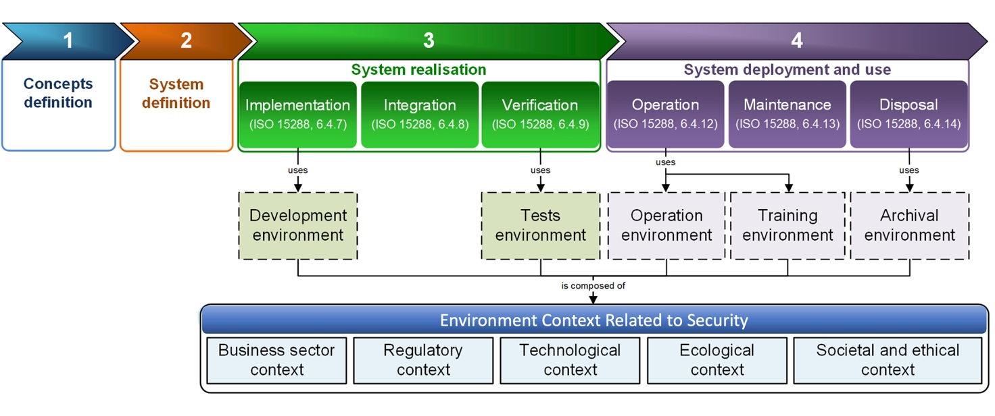
Figure 3. Security Architecture Design Considerations
The Cyber Security Reference architecture (CS-RA) shall provide a set of high-level artefacts and strategic guidance to help them address their cyber security concerns in a systemic and structured manner leveraging the Architecture principals laid out in ISO/IEC/IEEE 42010.
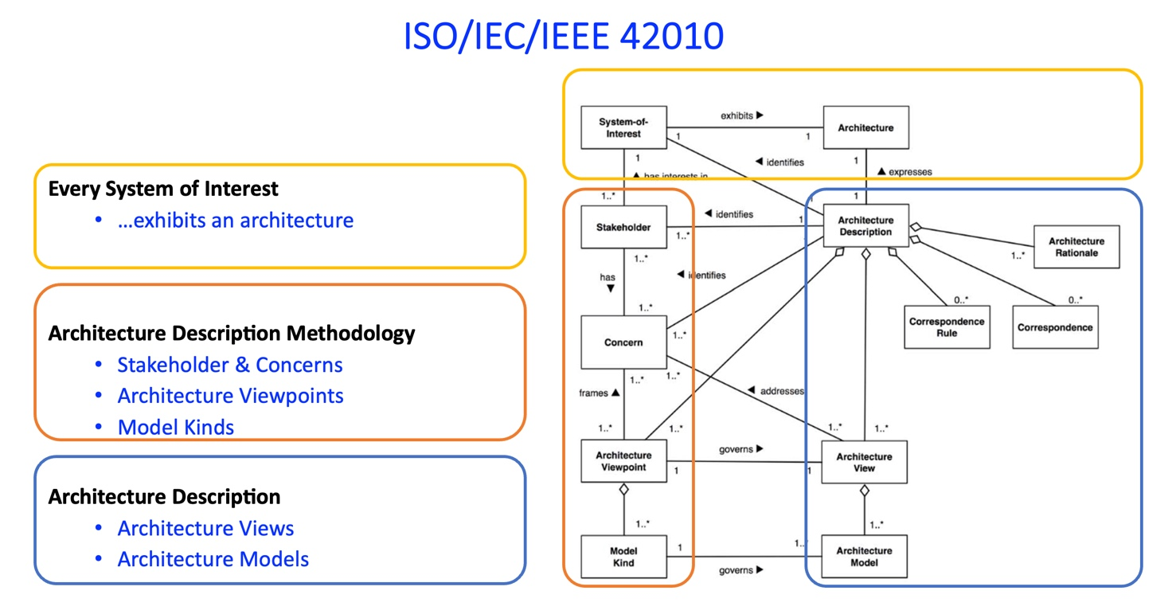
Figure 4. ISO/IEC/IEEE 420xx as a foundational instrument for the architect

Beyond leveraging the ISO/IEC/IEEE 42010 as the foundation, it shall also embed the guidance and best practices recommended in the Standards compendium illustrated in the graphics below for development of relevant artefacts of the reference architecture.
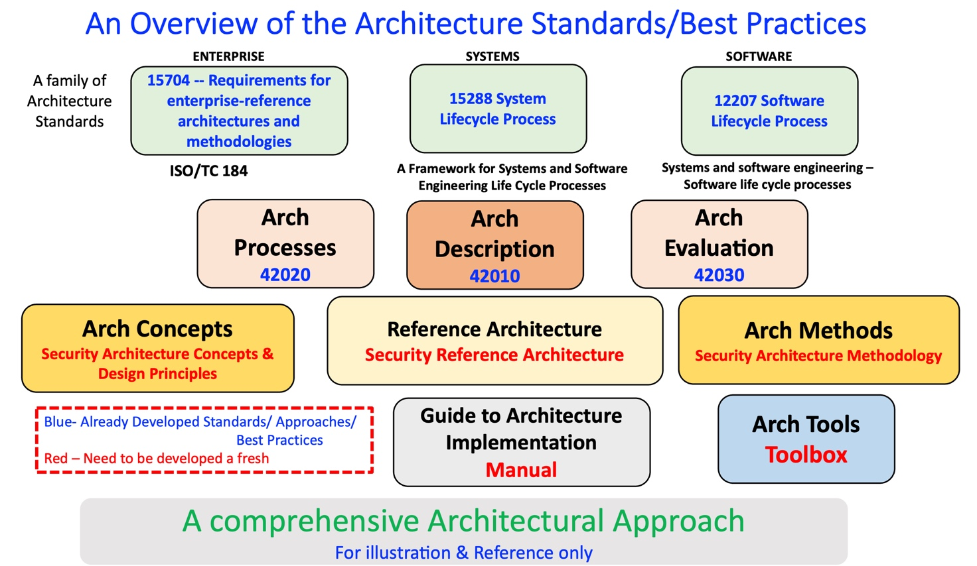
Figure 5. Architecture Standards and Best Practices
It may be noted that only the standards depicted in the blocks in upper two layers are only available, and NO comprehensive work has been done yet on the Security specific Architecture Concepts & Design Principles, Security Architecture Methodology and Security reference architecture. Even there is NO ToolBox to address these requirements.
FOUR LEVELS OF ARCHITECTING
If the future solutions are rather complex, then it is recommended to use the following four levels of architecting:
Reference Model is an abstract framework for understanding concepts and relationships between them in a particular problem space (actually, this is terminology).
Reference Architecture is a template for potential solution architectures, which realizes a predefined set of requirements.
Note: Reference Architecture uses its Reference Model (as the next higher level of abstraction) and provides a common (architectural) vision, a modularization and the logic behind the architectural decisions taken.
Solution Architecture is architecture of the future system.
Note: A Solution Architecture (also known as a blueprint) can be a tailored version of a particular Reference Architecture (which is the next higher level of abstraction).
Implementation is a realization of the future system.
The dependencies between these 4 levels are shown in illustration below:
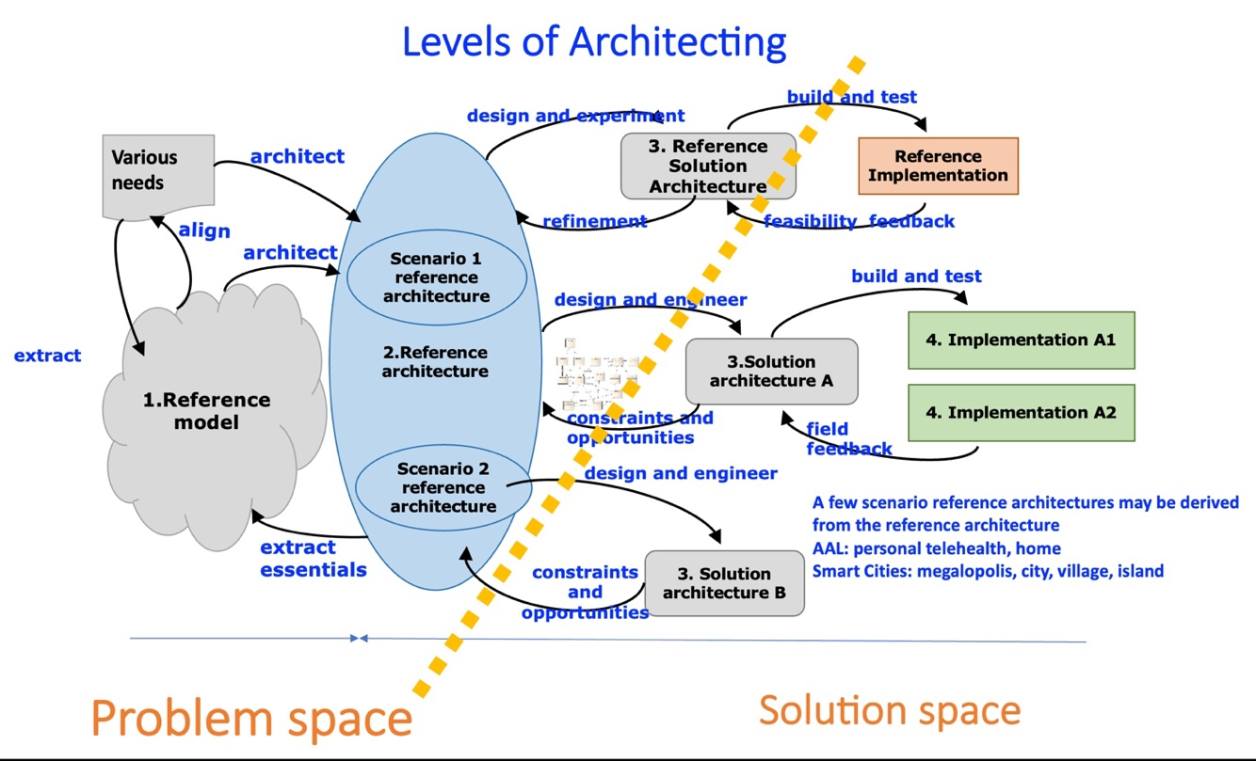
Figure 6. Levels of Architecting
The presence of some “loops” of this illustration confirms the complexity of architecting. For example, there is no guarantee that the original high-level requirements have a high-quality content, e.g. based on a prefect terminology; thus collecting of important concepts in the reference model may necessitate some modifications in the high-level requirements to align their terminology.
THE VALUE & STRUCTURE
The CS-RA will bring methodological and practical guidance on how to achieve the essential security and resilience in any Digital systems, Solution and/or Infrastructure.
It will provide a common methodology for architecting systems of systems thus enabling different system designers/architects in similar situations to find similar solutions or propose innovations that can benefit the global ecosystem.
It will provide a template for security architectures of various Digital Systems, Solutions, and Infrastructures.
It will provide a unified approach for architecting and implementing comprehensively secure and resilient digital systems as an eco-system to allow common solutions in similar contexts, aiming at improving efficiency and at increasing opportunities for business and innovations.
The positioning of the CS-RA, as an ITU-T recommendation will address the following market, industry, and standardization needs:
- The CS-RA will help digital systems’ architects, designers, stakeholders, and projects to collaborate and coordinate their efforts via common agreements (i.e. standards) on various system elements (e.g. services, interfaces, data, etc.), guiding principles and sharing vision.
- The CS-RA will be a unique enabler for aligning various stakeholders’ concerns, ontologies, existing models, and viewpoints, thus facilitating coordination and cooperation in developing a commonly agreed understanding of the Cyber Security problems and potential solutions.
- The CS-RA will define cyber security capabilities in a way that will allow standardization of interfaces and functionality for digital systems building blocks that could be provided by various industry sectors.
- The CS-RA will be a key enabler for effective and efficient collaboration of all SDOs in the Cyber Security domain for diverse Digital systems, solutions, and infrastructures.
The Cyber Security Reference Architecture needs to be developed in methodologically sound, explicit, reproducible, and transparent way to allow the usage of this Reference Architecture by any digital system in its transformation into to cyber secure, resilient, and immune digital system.
Considering any cyber security as a complex & nuanced attribute of uber-complex digital system of systems, its reference architecture is defined (in accordance with ISO/IEC/IEEE 42010) via a coherent set of viewpoints and model kinds.
IEC 63188:2022, the Smart Cities Reference Architecture Methodology (SCRAM) defines this set, the relations between various viewpoints and types of Models, and some techniques to create some models from other models. It is therefore a systematic way to describe how the CS-RA can be structured and put together. The SCRAM explicitly links various stakeholders’ needs (or high-level requirements) with the principles of Reference Architecture to provide end-to-end traceability.
THE NEXT STEPS
It is of utmost importance to explore the diverse aspects and nuances of the Granular Cyber Security Reference Architecture with multiple views and interdependence matrix of stakeholders, their respective concerns and technologies, standards (also Policies & Regulatory interventions) required to address them in a wholistic manner with the following systemic follow up actions:
- Mapping the already developed Standards on various aspects of the developed Reference Architecture.
- Identifying the GAPS in Standards and developing new Systems Standards and Products/Domain specific Standards.
- Developing a comprehensive Compliance Testing Framework and Ecosystem of Test Labs, supporting, and enabling services.
Organizations, SDOs and in specific, ITU Study groups would benefit by using a common harmonized and standardized approach to describe and integrate Cyber Security in their Digital Systems Architecture Definition (e.g. characteristics, contexts, risks, stakeholders, requirements, guidance, etc.) for both, a new or an existing system, or in ITU Study Groups’ projects that want to address Digital System(s) Cyber Security Resilience and Immunity for their specific purpose.
The SDOs & Stakeholders’ needs:
- Common definitions for key terms and a common concept system.
- Large numbers of use cases to help identify the detailed requirements of each stakeholder in the Trustworthiness domain and of each attribute & nuance to help identify what standards are needed.
- A Cyber Security Reference Architecture to show how this paradigm contributes as a whole and how all the different subsystems relate to different aspects of Cyber Security, Resilience, and Immunity.
- A comprehensive inventory and map of standards related to Cyber Security paradigm from all SDOs to enable a gap analysis.
This will be done:
- by promoting collaboration and systems thinking between all the Member States, Sector Members, SDOs & other agencies in relation to Cyber Security Strategies, Approaches, Processes, Compliances etc.
- by undertaking systems analysis to understand the needs for standards and assess new work item proposals related to Cyber Security & it’s all different nuances.
- by identifying & developing systems standards where needed and by providing recommendations to relevant ITU Study Groups and other SDOs.
Global standardization landscape of Cyber Security Paradigm is very fragmented ITU, IEC, ISO, IEEE, many consortia, groups, and companies are working in the Cyber Security domain. However, their works are fragmented and incompatible.
Thus, none of them can individually address the complete domain comprehensively. Therefore, there is a need for orchestrating close collaboration, co-ordination, and harmonization amongst the various on-going efforts.
________________________________

After detailed and granular study & analysis of the complex domain, it is critical to develop a Granular Security Reference Architecture with multiple views and interdependence matrix of stakeholders, their respective concerns and technologies, standards (also Policies & Regulatory interventions) and governance required to address them in a wholistic manner.
This comprehensive and granular work could be split into smaller Work Packages and developed in structured phases like:
- Step 1: A Technical Report undertaking the required groundwork of collecting detailed information on different aspects of the Security paradigm including but not limited to the domains, context, nuances, attributes, stakeholders, applications and use cases etc. etc.
- Step 2: Analyzing the collected information to extract the requirements, relationships, interdependence, views, models etc. amongst various aspects that can help develop a comprehensive Reference Architecture of Security.
- Step 3: Developing the Reference Architecture of Security with already identified Views, Models, relationships, interdependence and other aspects.
- Step 4: Develop a User Guide and/or Implementation Guide for leveraging the Reference Architecture in any given Domain, Application or Use Case.
- Step 5: Creating an Inventory of the Standards in and around the Security paradigm.
- Step 6: Mapping the identified relevant standards with the different Blocks and/or Layers of the Security Reference Architecture. Another approach for mapping the Standards could be around classification based on Security Concerns, domains, use cases, applications etc… However, an exhaustive Standards Inventory without any structured mapping shall not be helpful to the ecosystem stakeholders for identifying the appropriate standards for their respective needs.
- Step 7: Identifying the GAPS in Standards available and required.
  - Classifying them into System Standards and/or Products/Domain, applications, services specific Standards.
  - Identifying the most appropriate SDOs for developing them by themselves or jointly with ITU-T SG 17.
- Step 8: Developing a comprehensive Compliance Testing Framework & Schemas for setting up TRUST Centers.

A solid foundation needs a comprehensive understanding of the load it has to bear and the ingradients that shall withstand the load under extreme stress conditions as well. This needs a rigourous design efforts itself supported by structured approach carefully curated to meet the needs the ultra-complex paradigm with ever increasing adversity & challenges in wake of dark forces.

________________________________

