 | INTERNATIONAL TELECOMMUNICATION UNION  TELECOMMUNICATION  STANDARDIZATION SECTOR  STUDY PERIOD 2025-2028 |  | SG5-Cn
 |  |  | STUDY GROUP 5
 |  |  | Original: English
Question(s): |  | 7/5 |  | Geneva, 3-12 June 2025
CONTRIBUTION
Source: |  | Ministry of Communications, Department of Telecommunications, India
Title: |  | Proposal for creation of New Work Item on ITU-T L.EW_INT_ACT.” E-Waste Lifecycle Integrity and Accountability"”
Contact: |  | Vineet Malik  TEC,DoT  Ministry of Communications, India |  |  | Tel: 9999184213  Fax:  E-mail: vineet.malik@gov.in
Contact: |  | Kanika Gambhir  DoT  Ministry of Communications, India |  |  | Tel: 9891056945  Fax:  E-mail: kanika.gambhir@gov.in

Abstract:
This contributions proposes to create a new Work item on L.EW_INT_ACT “E-Waste Lifecycle Integrity and Accountability. This proposal introduces a structured approach to strengthen integrity and accountability in e-waste management. It outlines guidance structure to introduce accountability and integrity of data across the various stages of the E-waste lifecycle.

1. Background
The rapid growth of waste generation, especially electronic waste (E-waste), has become a critical challenge for global sustainability. With the integration of digital technologies such as Artificial Intelligence (AI), Internet of Things (IoT), and Blockchain in waste management, there is a need to address the need to ensure transparency, traceability, and responsible handling throughout the e-waste lifecycle. This proposal introduces a structured approach to strengthen integrity and accountability in e-waste management. It outlines strategies to introduce accountability and integrity of data across the various stages of the E-waste lifecycle—collection, transportation, dismantling, recycling, and disposal. Many devices may still carry residual data, proprietary components, or hazardous materials. A lifecycle-wide perspective is necessary to manage these risks effectively while supporting sustainable practices
E-Waste Lifecycle Integrity & Accountability measures are essential at every stage of the e-waste management process, including:
- Collection and storage, where devices may still contain sensitive data.
- Transportation and logistics, where tracking systems and IoT devices must be protected from tampering or interception.
- Dismantling and recycling, where data-bearing components must be securely handled or destroyed.
- Final disposal, to ensure no recoverable data is left on discarded hardware.

2. Rationale
E-waste management is not only an environmental issue but also a governance issue. The absence of clearly defined integrity controls and accountability mechanisms across the waste lifecycle increases the risk of improper disposal, data leakage, and non-compliance with environmental regulations.
This proposal focuses on:
- Promoting transparent and responsible e-waste handling across all lifecycle stages.
- Ensuring traceability of materials and devices.
- Embedding accountability in operations, roles, and reporting mechanisms.

3. Gap Analysis
While there have been general recommendations on bringing trust in ICT systems, there is no specific structured document focusing on integrating Accountability measures into e-waste management systems. Current documents often overlook the potential integrity and accountability controls within e-waste management systems, especially regarding IoT devices and data storage platforms used in E-waste management.

Area | Existing ITU-T Recommendations | Gap Identified for E-Waste Domain
ICT Cybersecurity Frameworks | ITU-T X.1205 | Focuses on cybersecurity; does not address e-waste-specific operational integrity
E-Waste Guidelines | ITU-T L.1031( L.1031 : Guideline for the development of an e-waste management system and achieving the e-waste targets of the Connect 2030 Agenda ) | Addresses targets and logistics, not operational accountability
E-Waste and Circular Economy | ITU-T L.ICT4RD | Limited to recycling principles; lacks lifecycle integrity and traceability

4. Proposal
This document proposes the creation of a new work item, known as ITU-T L.EW_INT_ACT, designed specifically for the management of E-waste lifecycle. The guidance document will address the integrity and accountability challenges within the various stages of the e-waste management process.

The AI justification is placed as Annexure-I and baseline text Is Annexure-II

Annex I

A.1 justification for new ITU T L.EW_INT_ACT
Question: | 7/5 | Proposed new ITU-T Recommendation | Geneva, Switzerland, 3-12 June 2025
Reference and title: | ITU-T, L.EW_INT_ACT - “E-Waste Lifecycle Integrity and Accountability"”
Base text: | TDxxxx |  | Timing: | 04,2026
Editor(s): | Vineet Malik, Ministry of Communications, India, vineet.malik@gov.in  Kanika Gambhir , Ministry of Communications, India, kanika.gambhir@gov.in |  | Approval process: | AAP
Scope (defines the intent or object of the Recommendation and the aspects covered, thereby indicating the limits of its applicability):

To develop a guidance document that supports governments, waste handlers, and ICT product stakeholders in establishing integrity-driven, environmentally sound, and accountable e-waste management, This Recommendation will cover integrity and accountability practices across all stages of the e-waste lifecycle and focus on environmental risk mitigation, chain-of-custody transparency, and role-based responsibility.

Summary
This proposed ITU-T Recommendation, titled "E-Waste Lifecycle Integrity and Accountability," introduces a structured approach to strengthen transparency, traceability, and responsible handling across the entire e-waste lifecycle—from collection to final disposal. With the increasing use of digital technologies in waste management, the proposal emphasizes the importance of operational integrity, data handling responsibility, and role-based accountability. It aims to fill existing gaps by guiding stakeholders on best practices for environmentally sound, secure, and accountable e-waste management systems that support long-term sustainability and compliance.
Relations to ITU-T Recommendations or to other standards (approved or under development):
ITU-T L.ICT4RD
Liaisons with other study groups or with other standards bodies:
SG17,SG20
Supporting members that are committing to contributing actively to the work item:
India

Annexure-II

Baseline text for Draft New Work Item “ ITU-T L.EW_INT_ACT.” E-Waste Lifecycle Integrity and Accountability"”
Summary

This proposed ITU-T Recommendation, titled "E-Waste Lifecycle Integrity and Accountability," introduces a structured approach to strengthen transparency, traceability, and responsible handling across the entire e-waste lifecycle—from collection to final disposal. With the increasing use of digital technologies in waste management, the proposal emphasizes the importance of operational integrity, data handling responsibility, and role-based accountability. It aims to fill existing gaps by guiding stakeholders on best practices for environmentally sound, secure, and accountable e-waste management systems that support long-term sustainability and compliance.

Scope

To develop a guidance document that supports governments, waste handlers, and ICT product stakeholders in establishing integrity-driven, environmentally sound, and accountable e-waste management, This Recommendation will cover integrity and accountability structure across all stages of the e-waste lifecycle and focus on environmental risk mitigation, chain-of-custody transparency, and role-based responsibility

2. References
ITU-T L.ICT4RD

3. Definitions

3.1 Terms defined elsewhere
This Recommendation uses the following terms defined elsewhere:
[TBD]

3.2 Terms defined in this recommendation
[TBD]
4.

Abbreviations and acronyms
This Recommendation uses the following abbreviations and acronyms:
AI - Artificial Intelligence
ICT - Information and Communications Technology
IoT - Internet of Things
E-waste - Electronic Waste
RAT - Risk Assessment and Treatment

5. Conventions
None

6. Guidance Document Overview
This template structure for guidance that can span across the entire lifecycle of waste management, with specific recommendations for each stage:
1. Collection: Ensuring the safety/privacy of data collected about E-waste.
2. Logistic: Protecting the logistics of waste transportation and tracking systems.
3. Dismantling: Securing systems that handle data and operations for dismantling E-waste.
4. Recycling: Ensuring the integrity and accountability in recycling systems and preventing unauthorized access.
5. Disposal: Ensuring safe data disposal methods and protecting against environmental threats.

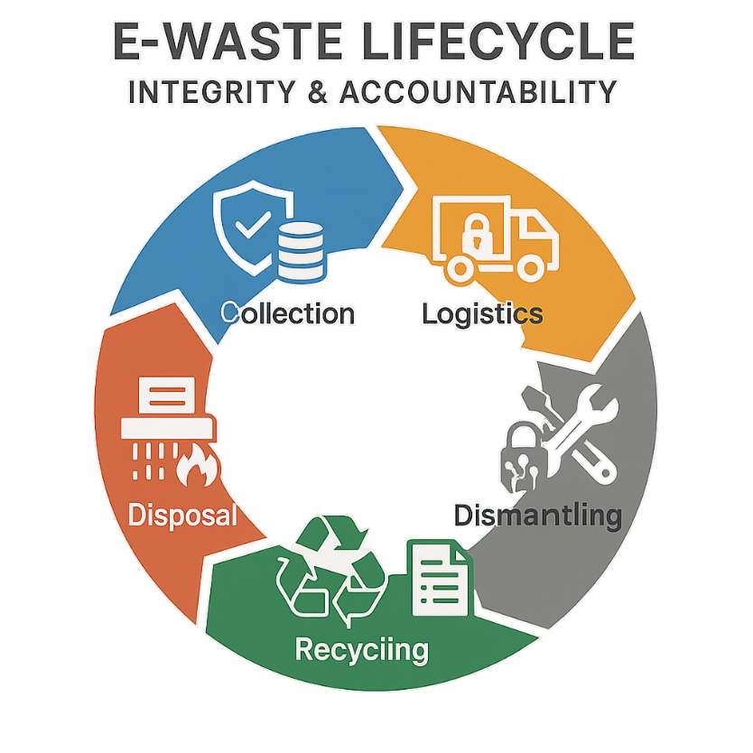

7. Operation Principles
7.1 Integrity: means all e-waste handling activities comply fully with environmental protection goals and ethical data handling practices..
7.2 Accountability: means clearly assigned roles and traceable actions ensuring that all parties can be held responsible for compliance
7.3 Transparency: means Enabling visibility across the e-waste value chain for regulators and the public.
8. Structured Approach for E-Waste Lifecycle Integrity and accountability
The proposed guidance document for E-waste management encompasses the entire lifecycle of electronic waste handling and is supported by essential operational capacities. These capacities include the deployment of appropriate hardware and software solutions, alongside skilled human resources to ensure comprehensive protection from emerging digital threats across all phases of the E-waste value chain.
Assuring integrity and accountability throughout the E-waste lifecycle ensures not only the protection of sensitive data and systems but also builds a more resilient and accountable e-waste management ecosystem.
The following paragraphs detail integrity and accountability focus areas and required capacities for each stage of the lifecycle:
During the collection stage, the primary focus is on maintaining traceability, preventing unauthorized access, and ensuring the secure handling of data-bearing devices. Key measures include RFID or barcode tagging of devices for inventory tracking, tamper-evident seals to detect unauthorized access attempts, and maintaining chain-of-custody documentation to ensure accountability throughout transit. To support these controls, recyclers can deploy secure mobile collection units, GPS-tracked transport, and restricted-access storage containers. Personnel responsible for collection must also be trained to handle E-waste securely and avoid any data leaks or unauthorized access.
In the logistics and transportation stage, the emphasis shifts to protecting the integrity and confidentiality of information as E-waste is moved between locations. Measures such as GPS tracking, encrypted communication between logistics partners, and intrusion detection systems are vital. These efforts are backed by operational capacities like encrypted telematics hardware, secure logistics management platforms, and staff trained in secure practices related to transportation.
At the dismantling and sorting stage, ensuring both integrity and accountability is vital, as this phase often involves exposure to residual data stored on ICT components. Integrity demands that data is handled securely and ethically—enforced through strong access controls, certified data erasure, and real-time monitoring to prevent tampering or unauthorized access. Accountability complements this by ensuring that every action is traceable and that individuals or entities are held responsible for lapses. This includes maintaining audit logs, assigning clear roles and responsibilities, and enforcing compliance with data protection protocols. Tools such as biometric access systems, documented SOPs, and regular third-party audits ensure that dismantling staff are both empowered and answerable for maintaining the integrity of the process. Together, integrity and accountability protect not only data but also public trust in e-waste handling practices.
In the recycling stage, where materials are reprocessed or repurposed, the focus is on maintaining secure operations within potentially automated or connected environments. The actions include isolating recycling systems within segmented networks, maintaining secure logs, and deploying AI-driven tools to detect abnormal activities. Operationally, this requires robust network infrastructure, centralized logging systems, and analysts who can interpret threats and maintain system integrity.
Lastly, the disposal stage must ensure that any remaining sensitive information is irreversibly destroyed, and that systems used in disposal are protected from external manipulation. Key actions involve verified data destruction, and securing disposal systems from remote tampering. The operational requirements for this stage include using tamper-proof disposal hardware, disposal audit software, and well-trained teams who follow secure disposal protocols and compliance guidelines.
<KPIs, Best Practices, and Regulations to be developed for consistent monitoring, effective implementation, and adherence to standards throughout all stages.>
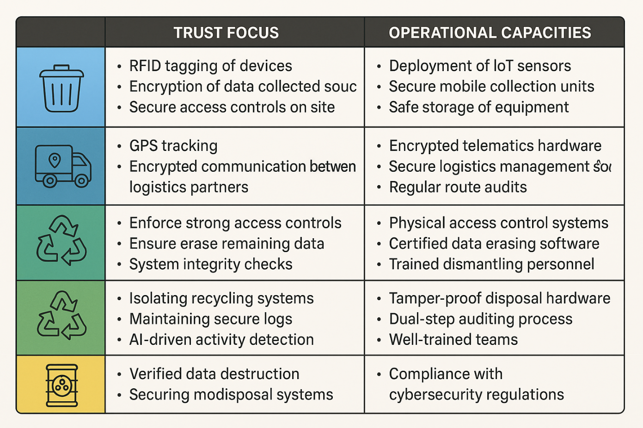

Fig: E-Waste Lifecycle Integrity and Accountability

9. Conclusion
The proposed text for E-Waste Management fills a critical gap in current ICT and waste management guidelines by introducing sector-specific controls. As digital technologies increasingly penetrate the waste sector, ensuring integrity, accountability and system resilience becomes non-negotiable. This document when developed would not only protects sensitive operational data but also enhances the reliability and sustainability of digital waste management infrastructures. By embedding these measures throughout the E-waste lifecycle, the document supports secure, efficient, and globally compliant waste processing systems, ultimately contributing to safer and smarter environmental practices.

