 | INTERNATIONAL TELECOMMUNICATION UNION  TELECOMMUNICATION  STANDARDIZATION SECTOR  STUDY PERIOD 2025-2028 |  |  |  | SG5-CXXX
 |  |  |  |  | STUDY GROUP 5
 |  |  |  |  | Original: English
Question(s): |  |  | 3/5 |  | Geneve, 03-12 June 2025
Contribution
Source: |  |  | Discussions in Adhoc group
Title: |  |  | Proposed modifications to baseline text in Draft new Recommendation ITU-T K.devices “RF-EMF exposure assessment of devices operating close to the human body”
Contact: |  | Neha Upadhyay  TEC, DoT  Ministry of Communications, India |  | Tel: +91 11 23323221  Fax:  E-mail: neha.upadhyay86@gov.in
Contact: |  | Jafar Keshvari  IEEE  Institute of Electrical and Electronics Engineers |  | Tel:  Fax:  E-mail: jafar.keshvari@ieee.org
Contact: |  | Leonardo Marques Campos  ANATEL  Brazil |  | Tel: +55 61 2312 1945  E-mail: leonardoc@anatel.gov.br
Contact: |  | José Antônio de França Junior  ANATEL  Brazil |  | Tel: +55 61 2312 2472  E-mail: josefranca@anatel.gov.br

Abstract: | This contribution proposes modifications to the baseline text in the draft new Recommendation ITU-T K.devices: “RF-EMF exposure assessment of devices operating close to the human body”. Combined version of the contributions from India, Brazil and experts from IEEE-IEC JWG.

Discussion and Proposal:
Based on the discussions and contributions received during the ad hoc meetings of Study Group-5 held since the previous session from 17-21 June, 2024, further modifications have been incorporated into the draft new Recommendation K.devices: “RF-EMF exposure assessment of devices operating close to the human body” and the updated document was prepared (TD1229).
This contribution proposes further modifications to the text of this draft new recommendation and the same is presented below.

Draft Recommendation ITU-T K.devices
RF-EMF exposure assessment of [wireless communication] devices operating close to the human body
Summary
With the proliferation of International Mobile Telecommunications-2020 (IMT-2020), Internet of Things (IoT) and millimeter wave (mmWave) wireless communication networks, the world is witnessing the emergence of next generation personal communication devices, such as hand-held devices including mobile phones, laptops, tablets, wearable devices, and sensors etc., which can operate at high frequencies, including 6 GHz and mmWave frequencies. Technologies like Machine to Machine (M2M) communication, IoT have given rise to the densification of wireless communication networks and have triggered a digital revolution in our daily lives in the form of smart homes, smart cities, smart factories, smart vehicles, etc. On one hand, this digital revolution has enabled ubiquitous connectivity not only for ‘everyone’ but also for ‘everything’, and on the other, it has brought wireless networks and devices closer and closer to human life, leading to a quantum jump in the number, types and variety of wireless communication devices that operate in close proximity to the human body.
Recommendation ITU-T K.devices focuses on the assessment and monitoring of human exposure to radio frequency (RF) electromagnetic fields (EMFs) from portable wireless communication devices operating in close proximity to the human body. This includes procedures for evaluating exposure and compliance with safe exposure limits for specific absorption rate (SAR) and absorbed power density (S_{ab}) and reference levels for incident power density (S_{inc}) using existing international standards as a reference. This new Recommendation will give dedicated and clear guidance for the EMF exposure compliance assessment of portable wireless communication devices operating close to the human body.
Keywords
RF EMF compliance assessment, absorbed power density, SAR, incident power density, wireless communication

Table of Contents
Page
1. Scope …………………………………………………………………......................... 4
2. References…………………………………………………………………………...... 4
3. Definitions ………………...…………………………………………………………. 5
3.1. Terms defined elsewhere………………………………………………..................... 5
3.2. Terms defined in this Recommendation…………………………………………….. 6
4. Abbreviations and acronyms………………………………………………………….. 6
5. General guidance……………….……………………………………………………... 6
6. General characteristics of typical wireless communication devices operated in proximity of human body .…………………………………………………………………………….. 7
7. Physical quantities for demonstrating compliance to safe exposure limits………...….. 7
8. Compliance assessment and Exclusion criteria ……………….………………………. 7
8.1. Types of RF Exposure ……………….……………………….................................... 8
8.2. Measurement methodologies ………………………………………….……...……... 8
8.3. Compliance limits for SAR and Power Density..……………………………………. 11
8.4. Standards for different measurement methodologies ..……….……………………... 11
8.5. Factors for consideration in compliance assessment ………………………………. 12
8.6. Specific criteria to optimize measurement in compliance assessment……………… 13
8.7. Computational methods for EMF exposure assessment……..……………………… 13
8.8. Exclusion criterions in Conformance Assessment .………………………………… 14
9. Proximity sensors …………………………………………………………………….. 14
10. Time-averaged SAR …………………………………………………………………. 15
11. Impact on the overall exposure level ………...……………………………………… 16
12 Guidance on applicability of SAR assessment on different category of devices...….. 17
Appendix I - Example for determining SAR Test Exclusion Threshold condition……... 19
Appendix II - Guideline for typical usage patterns for each device category…………... 23
Appendix III - Optimization Procedure for Evaluating SAR in Portable Terminal Stations with Non-Simultaneous Transmitting Antennas…………………………………………………… 24
Appendix IV - Optimization Procedure for Assessing psSAR of a Portable Terminal Station Operating in Close Proximity to the Head……………………………………………… 27

Introduction
NA

Draft Recommendation ITU-T K.devices
RF-EMF exposure assessment of wireless communication devices operating close to the human body

1 Scope
This Recommendation gives guidance on the means to assess and monitor human exposure to RF-EMF from wireless communication devices operating in proximity to human body.

2 References
[ITU-T K.91] Recommendation ITU-T K.91 (2022), Guidance for assessment, evaluation and monitoring of human exposure to radio frequency electromagnetic fields.
[ITU-T K.52] Recommendation ITU-T K.52 (2022), Guidance for assessment, evaluation and monitoring of human exposure to radio frequency electromagnetic fields.
[ICNIRP-2020] ICNIRP PUBLICATION:2020, ICNIRP GUIDELINES for Limiting Exposure to Electromagnetic Fields (100kHz to 300GHz).
[IEC/IEEE 62209-1528] IEC/IEEE 62209-1528:2020, Measurement procedure for the assessment of specific absorption rate of human exposure to radio frequency fields from hand-held and body-worn wireless communication devices − Part 1528: Human models, instrumentation and procedures (Frequency range of 4 MHz to 10 GHz).
[IEC 62209-3] IEC 62209-3:2019, Measurement procedure for the assessment of specific absorption rate of human exposure to radio frequency fields from hand-held and body-mounted wireless communication devices - Part 3: Vector measurement-based systems (Frequency range of 600 MHz to 6 GHz).
[IEEE C95.1] IEEE C95.1 (2019), IEEE Standard for Safety Levels with Respect to Human Exposure to Electric, Magnetic, and Electromagnetic Fields, 0 Hz to 300 GHz.
[IEC/IEEE 63195-1] IEC/IEEE 63195-1:2022, Assessment of power density of human exposure to radio frequency fields from wireless devices in close proximity to the head and body (frequency range of 6 GHz to 300 GHz) - Part 1: Measurement procedure.
[IEC/IEEE 63195-2] IEEE/IEC 63195-2-2022, Assessment of power density of human exposure to radio frequency fields from wireless devices in close proximity to the head and body (frequency range of 6 GHz to 300 GHz) - Part 2: Computational procedure.
[IEC/IEEE 62704-1] IEC/IEEE 62704-1:2017, Determining the peak spatial-average specific absorption rate (SAR) in the human body from wireless communications devices, 30 MHz to 6 GHz – Part 1: General requirements for using the finite difference time-domain (FDTD) method for SAR calculations.
[IEC/IEEE 62704-4] IEC/IEEE 62704-4:2020, Determining the peak spatial-average specific absorption rate (SAR) in the human body from wireless communication devices, 30 MHz to 6 GHz - Part 4: General requirements for using the finite element method for SAR calculations.
[IEC 62479] IEC 62479:2010, Assessment of the compliance of low-power electronic and electrical equipment with the basic restrictions related to human exposure to electromagnetic fields (10 MHz to 300 GHz).
IEEE Std 1528.7 IEEE Std 1528.7-2020, IEEE Guide for EMF Exposure Assessment of Internet of Things (IoT) Technologies and Devices.
[IEC PAS 63446] IEC PAS 63446:2022, Conversion method of specific absorption rate to absorbed power density for the assessment of human exposure to radio frequency electromagnetic fields from wireless devices in close proximity to the head and body – Frequency range of 6 GHz to 10 GHz.

3 Definitions

3.1 Terms defined elsewhere
This Recommendation uses the following terms defined elsewhere:
3.1.1 Absorbed Power Density (APD) [IEC PAS 63446]: power per skin surface unit area that is absorbed in the bodyICNIRP-2020 refers to the APD as S_{ab}.
3.1.2 Average time interval [ICNIRP-2020]: is the standard period of 6 (six) minutes for portable devices radiated energy measures.
3.1.3 Incident Power Density (IPD) [IEC PAS 63446]: power per unit area that impinges on the body surface. ICNIRP-2020 refers to the IPD as S_{inc}.
3.1.4 Low-power equipment [IEC 62479]: equipment where the available antenna power and/or the average total radiated power is less than or equal to the low-power exclusion level.
3.1.5 Low-power exclusion level [IEC 62479]: specified condition on device output power, which may also depend on other variables such as frequency and distance of radiating source from persons, such that the exposure level produced by the source will not exceed a specific basic restriction. If the device output power is less than P_{max}, then the device is deemed to comply with the basic restrictions.
3.1.6 (Incident) Power Density [ITU-T K.52]: power per unit area normal to the propagation direction of the electromagnetic field, expressed in watts per square meter (W m⁻²).
3.1.7 Specific Absorption Rate (SAR) [IEC/IEEE 62209-1528:2020]: measure of the rate at which energy is absorbed by the human body when exposed to a radio frequency electromagnetic field.
The time derivative of the incremental energy (dW) absorbed by (dissipated in) an incremental mass (dm) contained in a volume element (dV) of a given mass density (ρ_{m}).
$$SAR = \frac{d}{dt}\frac{dW}{dm}=\frac{d}{dt}\left(\frac{1}{ρm} \frac{dW}{dV}\right)$$
SAR is expressed in units of watts per kilogram (W/kg).
SAR can be calculated by:
$$SAR=\frac{σE^{2}}{ρm}$$
$$SAR=c\frac{dT}{dt}$$
$$SAR=\frac{J^{2}}{ρm σ}$$
where:
E is the r.m.s. value of the electric field strength in body tissue in V/m
σ is the conductivity of body tissue in S/m
ρ_{m} is the density of body tissue in kg/m3
c is the heat capacity of body tissue in J/kg ºC
dT/dt is the initial time derivative of temperature (at t = 0) in body tissue in °C/s;
J is the value of the induced current density in the body tissue in A/m2.
NOTE – Based on the definition in [ITU-T K.52]

3.2 Terms defined in this recommendation
This Recommendation defines the following terms:
3.2.1 Wireless communication devices operating close to the human body: device in which any emitting structures, when in normal operation, may located up to 200 mm away from the user's body.

4 Abbreviations and acronyms
This Recommendation uses the following abbreviations and acronyms:
EIRP Equivalent Isotropically Radiated Power
ERP Effective Radiated Power
DUT Device Under Test
PD Power Density
P_{max} Low-power exclusion level
IPD, S_{inc} Incident Power Density
APD, S_{ab} Absorbed Power Density
SAR Specific Absorption Rate

5 General guidance
5.1 The evaluation of specific absorption rate (SAR), absorbed power density (APD, S_{ab}) and incident power density (IPD, S_{inc}) must be carried out in a laboratory that meets all requirements on temperature, humidity and pressure parameters, involving the direct measurement on a phantom that simulates the human head or body and exhibits the same absorption characteristics as human tissue.
5.2 The DUT must be evaluated according to all the conditions allowed in the reference [IEC/IEEE 62209-1528], [IEC PAS 63446] and [IEC/IEEE 63195-1] standards, except for additional and specific conditions recommended in this Recommendation, for the evaluation of portable wireless communication devices operating in the radio frequency bands between 4 MHz – 10 GHz and 6 GHz – 300 GHz, respectively.
5.3 The sample submitted for the conformity assessment must be representative of the model in production, in the configurations and software and hardware versions of the product that will be distributed on the market, include complementary accessories and compatible auxiliary devices for carrying out all tests complementary to the assessment of DUT compliance.
5.4 The values of the basic restrictions for limiting human exposure to RF-EMF by the peak spatial average SAR or peak spatial average APD, or the reference levels of the peak spatial average IPD, on the entire human body and those located for the head, trunk and limbs are established in the normative ICNIRP-2020 guideline or in the normative guideline that may supersede it.
5.5 Suppliers of wireless communication devices subject to exposure assessment should inform, with emphasis, in the operation manual or on the product packaging, compliance with the limits and the maximum measured value of the SAR and APD or IPD, referring to exposure located on the head and trunk, when applicable.

6 General characteristics of typical wireless communication devices operated in proximity of human body
6.1 Measurements under conditions where the manufacturer recommends using the product at a specific distance away from the body should be taken up to a maximum distance from any part of the human body established by the compliance program responsible administration, up to the maximum limit defined in the reference [IEC/IEEE 62209-1528], [IEC PAS 63446] and [IEC/IEEE 63195-1] standards for the SAR, APD and IPD assessment purposes.
6.2 For portable wireless communications devices where the assessment is carried out at a distance from any part of the human body, based on manufacturer recommendations about the product usage, it is recommended that SAR measurements for devices operating close to the body should be measured with a distance not larger than 15 mm from the phantom, considering that this type of product is typically used next to the user and the level of emission is substantially affected by this coupling between the phantom and the device and may not represent the real overall exposure.
6.3 Nevertheless the definition of the RF band from 4 MHz to 10 GHz by the [IEC/IEEE 62209-1528] standard, the test procedures for evaluating SAR must be performed in the range from 4 MHz to 6 GHz and evaluated by the limits of APD at bands at 6 GHz to 10 GHz as it is the appropriate metric for assessing the compliance of exposures associated with RF-EMF. At frequency bands between 10 GHz and 300 GHz, either evaluation by the limits of the reference level IPD or the basic restriction of APD must be performed.

7 Physical quantities for demonstrating compliance to safe exposure limits
7.1 Wireless communication devices, such as hand-held devices (mobile phones, two-way radios, tablets), laptops, desktop computers and body-mounted wireless devices, are characterized by either SAR, IPD, or APD evaluation.
7.2 As per the ICNIRP 2020 guidelines for limiting exposure to electromagnetic fields for frequencies of operation below about 6 GHz, where the EMF penetrates deep into tissue, local EMF exposure is described in terms of the basic restriction peak spatial average SAR (W kg⁻¹). The peak spatial average SAR is assessed with the help of dosimetric phantoms that reproduce both the penetration of the EMF into body tissue and the dielectric loading of the DUT by the presence of the body of the user.
7.3 For frequencies of operation above 6 GHz, where EMFs are absorbed more superficially, ICNIRP 2020 defines exposure limits in terms of basic restrictions on the local APD (W m⁻²) and reference levels for the local IPD (W m⁻²)., the IPD is assessed in free space without the presence of a phantom. Hence, the dielectric loading of the DUT by the user’s body, is neglected for the free-space metric IPD. This may lead to higher uncertainties when assessing user exposure by IPD measurements in the reactive near-field of the DUT.
7.4 SAR evaluation of personal wireless communication devices can be performed with experimentally in accordance with [IEC/IEEE 62209-1528] or [IEC 62209-3] or computationally in accordance with [IEC/IEEE 62704-1] and [IEC/IEEE 62704-4].
7.5 IPD evaluation can be performed experimentally for portable wireless devices in accordance with [IEC/IEEE 63195-1] or numerically in accordance with [IEC/IEEE 63195-2]. [IEC/IEEE 63195-2] also specifies complementary techniques for [IEC/IEEE 63195-1] Refer to 8.7 for details.
7.6 APD evaluation of personal wireless devices operating in the 6 – 10 GHz frequency range can be performed in accordance with [IEC PAS 63446] using the experimental equipment specified for the assessment of the peak spatial average SAR. For frequencies above 10 GHz, experimental and computational APD evaluation standards are currently under development within IEC/IEEE.

8 Compliance assessment and exclusion criteria
The assessment of EMF exposure compliance for devices used in close proximity to the human body is primarily carried out through measurement of SAR, APD and IPD to comply with the defined limits.
8.1 Types of RF Exposure
- General Public Exposure
General Public SAR exposure limits apply when the general public may be exposed to RF sources in close proximity to their body, or when persons who are exposed as a consequence of their employment may not be fully aware of the potential for exposure or do not exert control over
their exposure.
- Occupational Exposure
Occupational/Controlled limits for SAR exposure apply when persons are exposed, as a consequence of their employment, provided these persons are fully aware of and exert control over their exposure. Such devices include but are not limited to certain MRTS (mobile radio trunked service), HF (High Frequency), VHF (Very high Frequency) and UHF (Ultra high Frequency) radio handsets etc. To create a sense of safety from exposure, it is necessary to make the personnel aware by specific training programmer and by use of visual advisories such as labelling, embossing, or on an equivalent electronic display.
8.2 Measurement methodologies
- Specific Absorption Rate (SAR)
The measurement is carried out to assess the SAR value of RF devices used in close proximity to the human body. SAR measurement system has components which include standardized models of the human head, body, limbs, liquids that simulate the RF absorption characteristics of different human tissues, calibration apparatus, base station simulator equipment, robotic probes and control system, supporting software. This system is used to carry out measurement by placing the RF device in various common positions next to the head and body, and the robotic probe takes a series of measurements of the electric field at specific pinpoint locations in a very precise, grid-like pattern. The worst-case scenario for RF exposure is expected to be simulated during the SAR measurement. The highest SAR value observed for the various positions or modes of operation of the device is reported as the SAR value for the device.
- SAR measurement System
The SAR measurement System consists mainly of the following components:
- Robot Arm Controller for E-field probe
- Specific Anthropomorphic Mannequin (SAM) Phantom
- Head/Body Tissue Simulating Liquids
- DUT Holder
- Probes & Dipole Kit
- Data Acquisition Electronics
- Measurement Server
- Computer & Software
Figure 1 - Components of the SAR measurement system
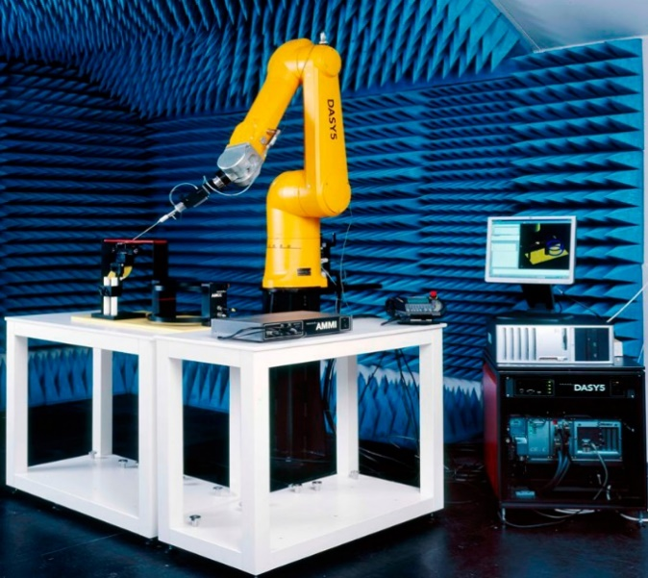  SAR Robot System | 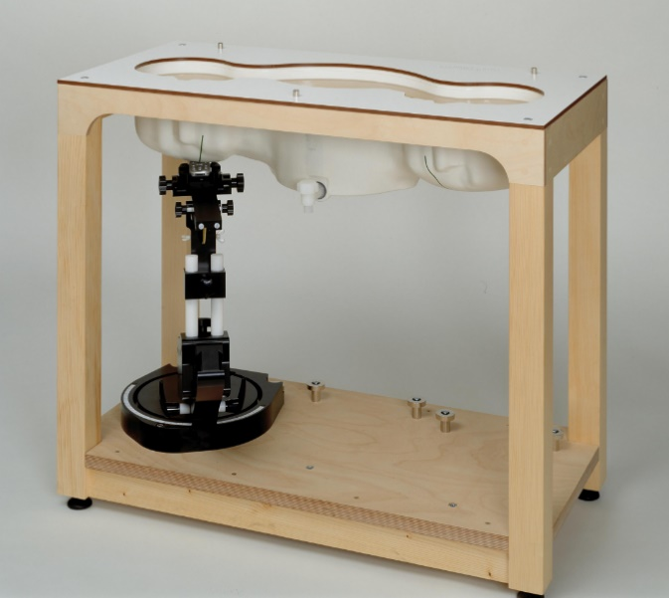  SAM Phantom
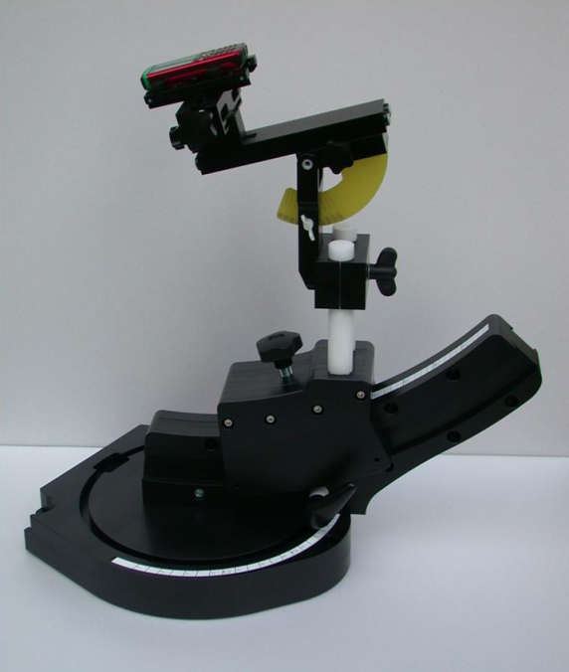  EUT holder | 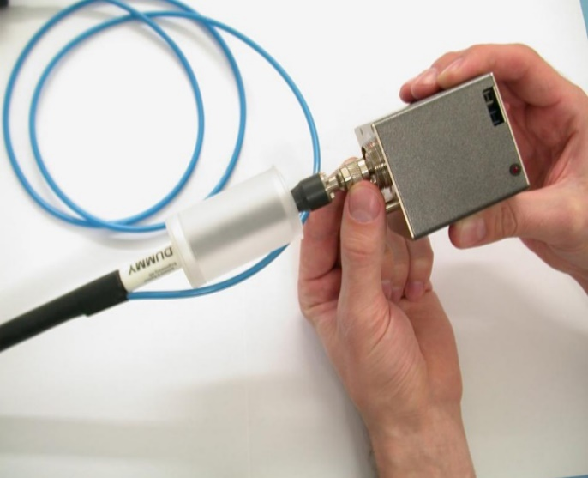  E-field probe
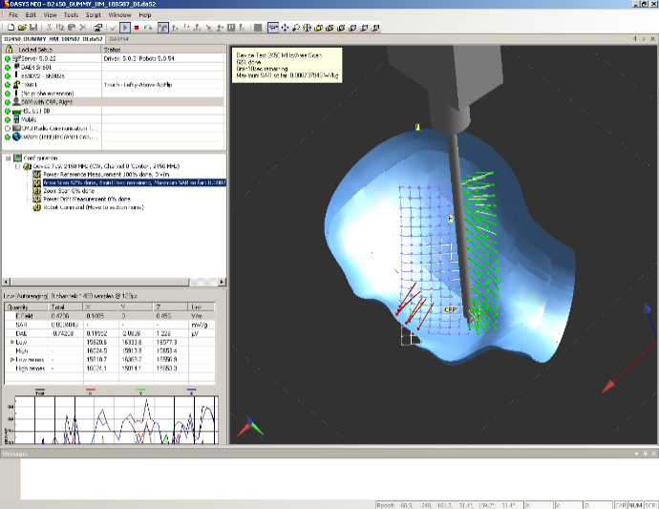  Software for SAR measurement (Representation of measurement points side- view) | 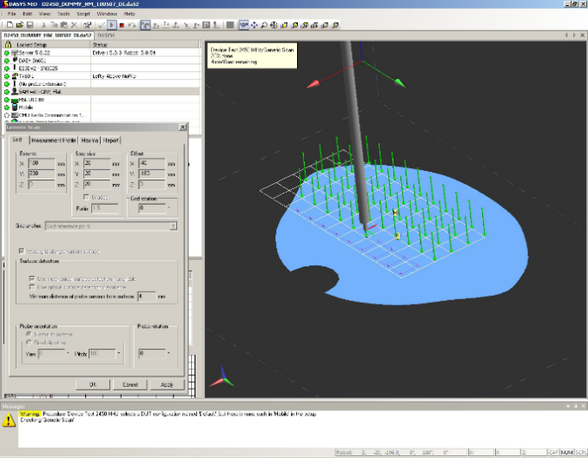  Software for SAR measurement (Representation of measurement points top view)
- Measurement Methodology & Steps
Figure 2 - Methodology and steps for SAR measurement based on IEC/IEEE 62209-1528*
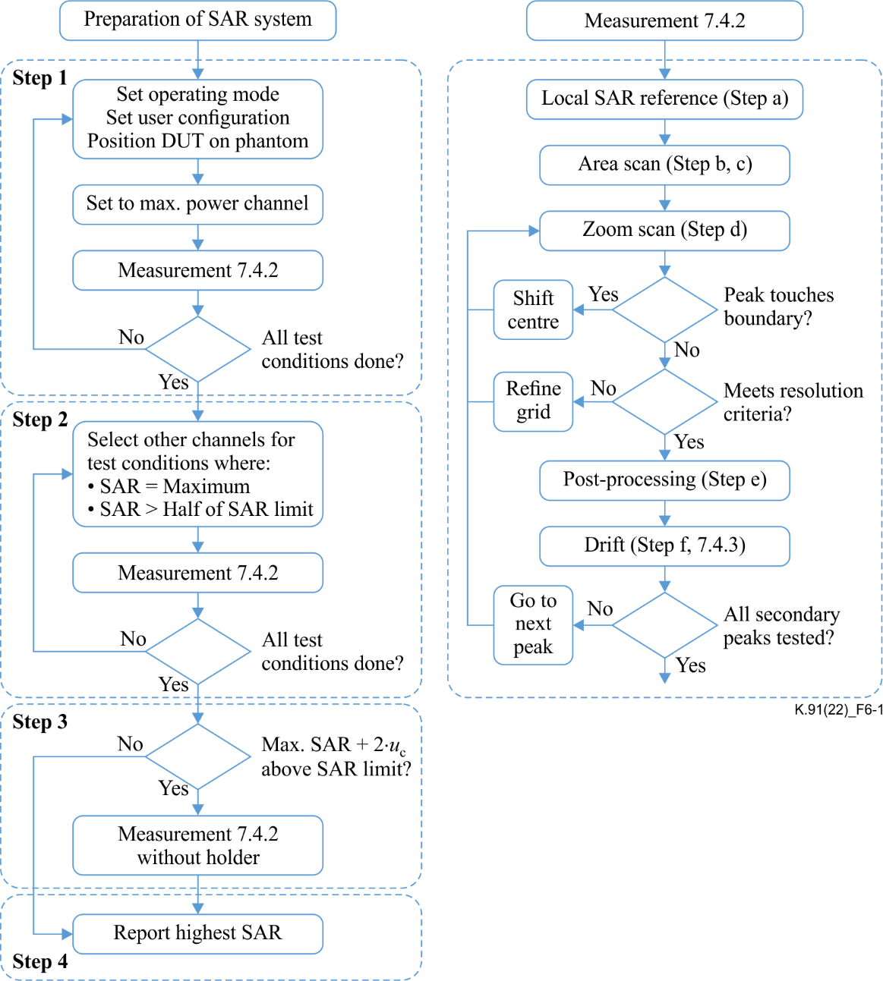
*Reproduced with permission from IEC/IEEE 62209-1528 ed 1.0 "Copyright © 2020 IEC Geneva, Switzerland. www.iec.ch in ITU-T K.91

- Incident Power Density (IPD)
This technique is used in case of mmWave frequency (6-300 GHz) of operation in the RF devices. Unlike the lower frequency fields, mmWave fields do not penetrate far into the human body. In fact, mmWave radiation penetrates only a few mm of the skin surface and does not reach the inner regions of the body. Hence, especially in case of 5G (IMT-2020) devices operating at higher FR2 frequency bands, for assessing compliance to RF EMF exposure, the measurement of the incident power density must be employed. It should be noted that in the reactive near-field, coupling and dielectric loading of the EUT by the user is neglected due to free-space assessment of IPD, leading to possibly higher uncertainties compared to APD assessment.

Figure 3 - Typical measurement setup for power density measurement for EMF exposure assessment from devices operating in bands above 6 GHz
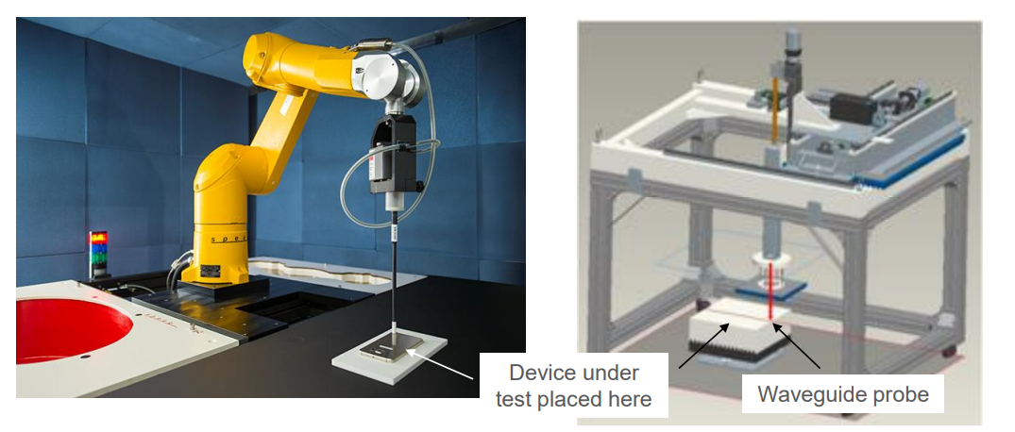
- Absorbed Power Density (APD)
In the 6 GHz to 10 GHz band the SAR of the exposure can be measured and then be converted to absorbed power density value according to [IEC PAS 63446], to assess compliance with the absorbed power density limit. In the frequency band 6 GHz to 300 GHz, the measurement and computational methods for direct APD assessment are under development and IEC/IEEE is working on standardization of these assessment methods and procedures.

8.3 Compliance Limits for SAR, APD, and IPD
ICNIRP defines the basic restrictions for SAR and APD, and the reference levels for IPD to ensure safe exposure to EMF from devices. Countries adopt these limits, however there are some countries who prescribe their own limits for these quantities.

8.4 Standards for different measurement methodologies
- Standards for SAR measurement
- [IEC/IEEE 62209-1528] provides measurement techniques for peak spatial average SAR (psSAR) of RF transmitting devices. The standard can cover devices of frequency range from 4 MHz to 10 GHz. These devices include single or multiple transmitters or antennas at distances up to 200 mm from a human head or body.
The device categories covered include, but are not limited to, mobile phones and radio transmitters in personal, desktop and laptop computers including push-to-talk devices, wireless power transfer devices operating under the specified frequency range of the Standard.
- [IEC/IEEE 62209-3]- provides measurement techniques for psSAR of RF transmitting devices using vector measurement-based systems. The standard can cover devices of frequency range from 600 MHz to 6 GHz.
The wireless communication device categories covered include but are not limited to mobile phones, radio transmitters in personal computers, desktop and laptop devices, push-to-talk devices, etc.
- Standards for IPD measurement
- [IEC/IEEE 63195-1] provides measurement techniques for peak spatial-average incident power density (IPD) from RF electromagnetic field (EMF) transmitting communication devices used close to the human body. The standard covers devices of frequency range from 6 GHz to 300 GHz.
- Standards for APD measurement
- [IEC PAS 63446:2022] provides conversion factors for SAR to absorbed power density (APD) from RF electromagnetic field (EMF) transmitting communication devices used close to the human body. The specification covers devices of frequency range from 6 GHz to 10 GHz.
The RF transmitting communication device categories covered in this document include but are not limited to mobile phones, radio transmitters in personal computers, desktop and laptop devices, and multi-band and multi-antenna devices.
- Standards for Exposure Assessment for Internet of Things (IoT) Devices
- IEEE Std 1528.7-2020: IEEE Guide for EMF Exposure Assessment of IoT Technologies and Devices.
This guide provides references to the appropriate methodology for classifying IoT devices based on RF exposure characteristics. This document further mentions that, aside from the applications that require body-worn usage, IoT devices are usually placed at 1 m distance or more away from persons. It also mentions about, “How many devices need to be present and how close to a person, to potentially expose a human above the safety limits” if multiple IoT devices are grouped to form a population of devices.

8.5 Factors for consideration in compliance assessment
Compliance assessment to safe exposure to EMF from devices is dependent of several factors. These factors govern which limits of SAR, IPD or APD apply, which standard of measurement to use, which number of measurements that need to be carried out for a particular device etc. These factors that affect the compliance assessment of devices are as below:
- Category of device (occupational use/general use);
- Usage position of the device (near head, on the body, on the limbs, in close proximity to the body etc.);
- Frequency of operation of the device (SAR measurement for < 6 GHz range, APD conversion for 6-10 GHz range, IPD measurement for 6-300 GHz range);
- Operating power of the device;
- Different communication modes of the device (cellular, Wi-Fi, Bluetooth, NFC etc.); and
- Distance of measurement from device.

8.5.1 Considerations for Distance of DUT from surface during SAR measurement
The measurement distance of the DUT from the surface of measurement for carrying out SAR measurement should d generally be as per the actual usage of the device. For different categories of devices and as per their usage, different distance of measurement may be prescribed. A guidance based on the prevalent practices in some of the countries has been provided in Appendix II.

[Editor´s Note: Proposal received on this ongoing work item to make it Recommendation ITU-T K.devices. As there were updates in the term used, further contributions are invited and will be discussed in the next meeting.
Term review needs to be done at next meeting]

8.6 Specific criteria to optimize SAR measurement procedures in compliance assessment.

8.6.1 Identifying the configuration that produces the maximum psSAR for a personal wireless communication device capable of transmitting across multiple frequency bands and featuring various usage configurations often involves conducting numerous SAR tests. To address cost concerns and streamline the overall measurement time for a DUT, without compromising the guarantee of compliance with the limits for exposure to EMFs set by the ICNIRP, three distinct approaches can be employed:

a) Fast SAR testing: Aiming to reduce measurement time for each device configuration as specified in section 7.9.2 of the IEC/IEEE 62209-1528 standard.

b) SAR test reduction techniques: Allowing for a decrease in the number of required tests in accordance with section 7.9.3 of the IEC/IEEE 62209-1528 standard.

c) Optimization procedures outlined in Appendices III and IV of this Recommendation.

8.6.2 Administrations have the flexibility to adopt these approaches to optimize SAR testing procedures. However, these approaches shall not be used simultaneously.
8.7 Computational methods for EMF exposure assessment
8.7.1 Computational methods for the assessment of the exposure to EMF in terms of the peak spatial average SAR and the peak spatial average IPD are standardized for the finite-difference time-domain method [IEC/IEEE 62704-1, IEC/IEEE 63195-2] and for the finite element method [IEC/IEEE 62704-4, IEC/IEEE 63195-2]. These standards specify the requirements on the implementation and verification of the computational algorithm for the calculation of the electromagnetic fields and the post-processing for the calculation of the peak spatial-average SAR and the peak spatial-average IPD. They give guidance on the validation of the numerical model of the DUT and on the assessment of the computational uncertainty of the results. As 5G devices operating in the millimetre wave frequency range often use array antennas with beamforming capabilities, creating a number of possible exposure conditions which may be too large for experimental evaluation, IEC/IEEE 63195-2 specifies computational techniques that complement the experimental methods of IEC/IEEE 63195-1. These methods employ different strategies to find the exposure condition having maximum IPD.
- [ [IEC/IEEE 62704-1] Determining the peak spatial-average specific absorption rate (SAR) in the human body from wireless communications devices, 30 MHz to 6 GHz - Part 1: General requirements for using the finite difference time-domain (FDTD) method for SAR calculations.]
[Editor´s Note: Proposal received on this ongoing work item to make it Recommendation ITU-T K.devices. As there was no consensus, further contributions are invited and will be discussed in the next meeting.
Line by Line review need to be done at next meeting]
- [IEC/IEEE 62704-4] Determining the peak spatial-average specific absorption rate (SAR) in the human body from wireless communication devices, 30 MHz to 6 GHz - Part 4: General requirements for using the finite element method for SAR calculations.
- [IEC/IEEE 63195-2]: Assessment of power density of human exposure to radio frequency fields from wireless devices in close proximity to the head and body (frequency range of 6 GHz to 300 GHz) - Part 2: Computational procedure.

8.8 Exclusion criteria in SAR conformance assessment
For certain RF devices or under a certain mode of operation of a RF device, the maximum operating power is below a certain threshold and hence, the assessment for compliance through measurement of SAR, IPD or APD in such cases may be excluded. These threshold power levels are prescribed in standards, e.g. [IEC 62479], as well as defined by certain countries under their regulatory frameworks.
IEC 62479:2010: Assessment of the compliance of low-power electronic and electrical equipment with the basic restrictions related to human exposure to electromagnetic fields (10 MHz to 300 GHz) provides the requirements of power thresholds and other related conditions for low power devices as well as low power operating modes of devices. These requirements specify the criteria satisfying which the SAR, IPD or APD compliance assessment through measurement for low power devices and low power operation modes may not be required.
Note: In IEC 62479:2010 the term power density is used, but the same approach can be adapted for incident power density and absorbed power density limits.
Further, information on threshold limits for exclusion criteria for SAR conformance assessment based on best practices in some countries is provided under Appendix I which provides guidance on how exclusion criteria under different measurement conditions and for different frequency bands can be determined.

9 Proximity Sensors
Proximity sensors are designed to detect nearby objects typically parts of the body of users such as the head, hand, or torso, without physical contact. In mobile devices, they are commonly used to turn off the screen when held to the ear or to sense when the device is close to the skin or another surface.
In addition to these functions, proximity sensors can be used to dynamically control the output power of mobile devices based on its distance from the user or surrounding objects. When the device is within the triggering range of the sensor, the output power is automatically reduced to ensure compliance with SAR limits. When the device is farther away, beyond the activation threshold, the sensor is deactivated, allowing the device to resume full power.

To ensure proper sensing coverage in all relevant exposure scenarios, devices may incorporate one or more proximity sensors, depending on the size and placement of the antenna. [While performing an assessment for SAR, The triggering distance and coverage area of proximity sensors must be evaluated in accordance with Subclause 7.7 of the [IEC/IEEE 62209-1528] standard.]

[The proximity sensor SAR test procedure and evaluation of triggering distance and coverage area of proximity sensors must be evaluated in accordance with Subclause 7.7 of the [IEC/IEEE 62209-1528] standard.]
[Editor´s Note: Proposal received on this ongoing work item to make it Recommendation ITU-T K.devices. As there was no consensus, further contributions are invited and will be discussed in the next meeting.]

10 Time-averaged SAR
Time-averaged SAR (TAS) refers to the average amount of radiofrequency (RF) energy absorbed by body tissue over the specified averaging period. For this reason, Dynamic Power Control and Exposure Time-Averaging (DPC-ETA) has recently been introduced to help wireless devices maintain real-time SAR compliance. DPC-ETA addresses this issue by determining SAR compliance based on the actual power usage recorded by the RF modem, averaged over a defined time window. The device adjusts its output power in real-time using the known linear relationship between SAR and power for a given operating mode and exposure condition. As long as the time-averaged power remains within the SAR limits, the device is allowed to transmit at higher power levels for short periods, enabling better performance without exceeding compliance thresholds.
- Standard for TAS algorithm validation

- Subclause 7.6 of the [IEC/IEEE 62209-1528] standard.
- [IEC TR 63424-1:2024] Validation of dynamic power control and exposure time-averaging algorithms - Part 1: Cellular network implementations for SAR at frequencies up to 6 GHz.

11 Overall exposure level assessment of RF device

The overall exposure assessment from RF device is done by performing measurements under different RF modes of operation of the device covering different technologies such as IMT, Wi-Fi, Bluetooth etc. and different frequency bands. The exclusion criteria is also applied based on the threshold conditions for the different frequency bands of operation and transmit power in those operating modes. The Head/Body/Limbs SAR is measured as applicable and the worst SAR value is determined and reported.

For a device having frequency bands of simultaneous operation in sub-6GHz as well as above 6 GHz bands (typically a 5G handset), the total exposure ratio (TER) of simultaneous and co-located exposure (see subclause 7.5 of IEC/IEEE 63195-1) may be determined as below:
$$\sum_{i>100kHz}^{6GHz}{\frac{SAR_{i}}{SAR_{lim}}}+\sum_{i>6GHz}^{10GHz}{\frac{S_{ab_{i}}}{S_{ab_{lim}}}}+\sum_{i>10GHz}^{300GHz}{\frac{S_{inc_{i}}}{S_{inc_{lim}}}}≤1$$
Where:
- SAR_{i} is the SAR exposure caused by frequency i.
- SAR_{lim} is the SAR limit.
- $S_{ab_{i}}$ is the APD exposure caused by frequency i.
- $S_{ab_{lim}}$ is the APD limit.
- $S_{inc_{i}}$ is the IPD exposure caused by frequency i.
- $S_{inc_{lim}}$ is the IPD limit.

12 Guidance on applicability of SAR assessment on different category of devices

SAR is assessed on the different parts of the body based on the usage of the RF devices on the body. Different SAR limits are also specified for different body parts where the device has the highest possibility/duration of usage SAR is generally assessed around the head and ear, body and limbs. The Table below provides a broad guidance on the applicable SAR assessment for a particular category of device.
Category of device | Applicable SAR assessment
 | Localized SAR  (Head) | Localized SAR  (Body) | Localized SAR (Limbs  and Extremities)
Hand-held devices like Cellular/ Mobile/Satellite phones etc. which will be used close to the head. | Applicable | Applicable | Applicable
Hand-held devices like tablets, phablets etc. which will be used in close proximity of 20 cm or less to the body | May not be Applicable | Applicable | Applicable
RF devices like Wi-Fi dongles, Mobile data cards which are expected to be used in close proximity of 20 cm or less to the body | May not be Applicable | Applicable | May not be Applicable
IoT/RF devices expected to be worn on the body | May not be Applicable | Applicable | May not be Applicable  (See Note #2)
IoT/RF devices expected to be worn on the body near the head. | Applicable | Applicable | May not be Applicable
IoT/RF devices expected to be used in close proximity of 20 cm or less to the body | May not be Applicable | Applicable | May not be Applicable

Note #1: There may be cases where one or more of the SAR assessments as specified in the table above may not be required or in some cases may additionally be required.
Note #2: This case is only applicable when the RF/IoT device is worn on the limbs or extremities. For e.g. tracking devices, smart watches etc.

Appendix- I
(This appendix does not form an integral part of this Recommendation.)

Example for determining SAR Test Exclusion Threshold condition
[Below is a methodology followed by some of the countries for determining SAR test exclusion threshold conditions for 1 g Head and Body SAR and 10 g Limbs SAR.]
[Editor´s Note: Proposal received on this ongoing work item to make it Recommendation ITU-T K.devices. As there was no consensus, further contributions are invited and will be discussed in the next meeting.
Line by Line review need to be done at next meeting]
- Determination of SAR Test Exclusion Threshold condition
For certain low power RF devices standalone or for a low power mode of an RF device, the evaluation of SAR by measurement or numerical simulation is not required when the corresponding SAR Test Exclusion Threshold condition(s), listed below, is (are) satisfied:

- For 100 MHz to 6 GHz and test separation distances ≤ 50 mm, the 1-g and 10-g SAR test exclusion thresholds are determined by the following:
$\frac{\left(max. power of channel \left(Pmax\right), including tune-up tolerance, mW\right)}{\left(min. test separation distance, mm\right)}×\sqrt{f\left(GHz\right)}≤3.0$(for 1-g SAR)

$\frac{\left(max. power of channel \left(Pmax\right), including tune-up tolerance, mW\right)}{\left(min. test separation distance, mm\right)}×\sqrt{f\left(GHz\right)}≤7.5$(for 10-g extremity SAR)

where
- f(GHz) is the RF channel transmit frequency in GHz
- Power and distance are rounded to the nearest mW and mm before calculation
- The result is rounded to one decimal place for comparison
- The values 3.0 and 7.5 are referred to as numeric thresholds in step b) below
The test exclusions are applicable only when the minimum test separation distance is ≤ 50 mm, and for transmission frequencies between 100 MHz and 6 GHz. When the minimum test separation distance is < 5 mm, a distance of 5 mm is applied to determine SAR test exclusion.
Some approximate exclusion threshold numerical values at selected frequencies and distances are at Section 2 below.

- For 100 MHz to 6 GHz and test separation distances > 50 mm, the 1-g and 10-g SAR test exclusion thresholds are determined by the following:
1) For 100 MHz to 1500 MHz
$$\left[\left(Power allowed at numeric threshold for 50 mm in step a\right)+ [(test separation distance – 50 mm)\right] × (f(MHz)/150) mW$$

2) For > 1500 MHz and ≤ 6 GHz
$$\left[\left(Power allowed at numeric threshold for 50 mm in step a\right)+ [(test separation distance – 50 mm)\right] × 10 mW$$

Some approximate exclusion threshold numerical values at selected frequencies and distances are at Section 3 below.
- For frequencies below 100 MHz, the following may be considered for SAR test exclusion:
1) For test separation distances > 50 mm and < 200 mm, the power threshold at the corresponding test separation distance at 100 MHz in step b) is multiplied by [1 + log(100/f(MHz))]
2) For test separation distances ≤ 50 mm, the power threshold determined by the equation in c) 1) for 50 mm and 100 MHz is multiplied by ½
Some approximate exclusion threshold numerical values at selected frequencies and distances are at Section 4 below.

- SAR Test Exclusion Thresholds for 100 MHz – 6 GHz and ≤ 50 mm Approximate
SAR Test Exclusion Power Thresholds at Selected Frequencies and Test Separation Distances are illustrated in the following Tables.
Table 1
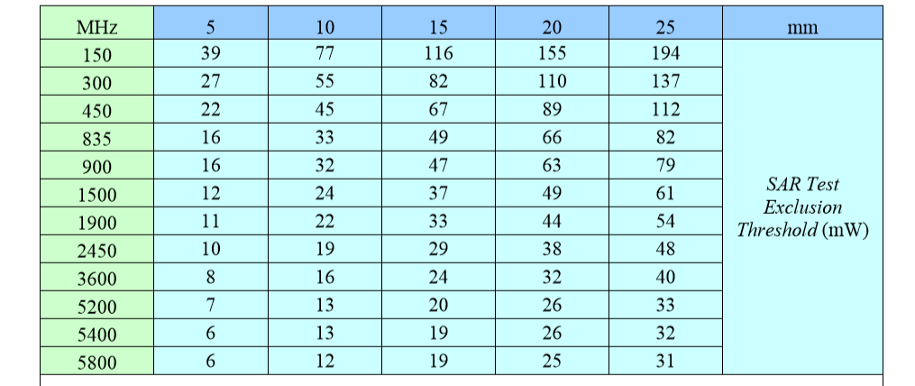

Table 2
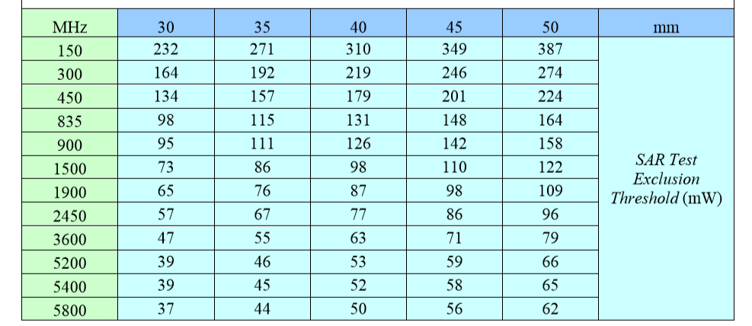
Note: 10-g Extremity SAR Test Exclusion Power Thresholds are generally 2.5 times higher than the 1-g SAR Test Exclusion Thresholds indicated above. These thresholds do not apply, by extrapolation or other means, to occupational exposure limits.

- SAR Test Exclusion Thresholds for 100 MHz – 6 GHz and > 50 mm
Approximate SAR test exclusion power thresholds at selected frequencies and test separation distances are illustrated in the following table.
Table 3
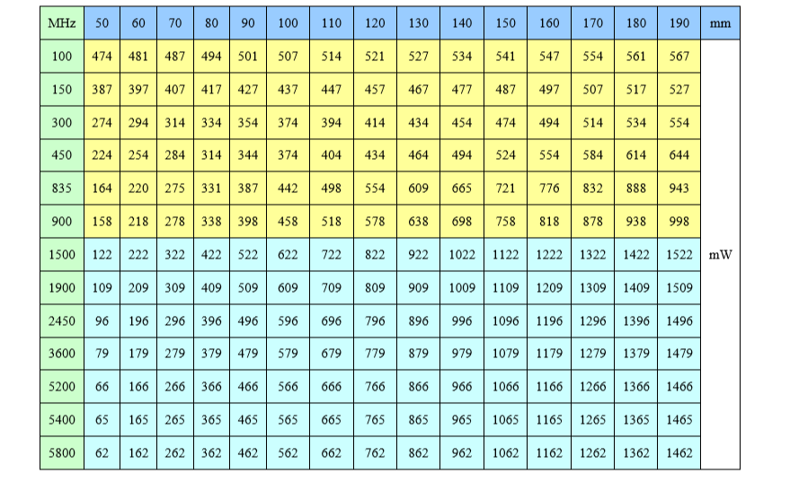

- SAR Test Exclusion Thresholds for < 100 MHz and < 200 mm
Approximate SAR test exclusion power thresholds at selected frequencies and test separation distances are illustrated in the following table.
Table 4
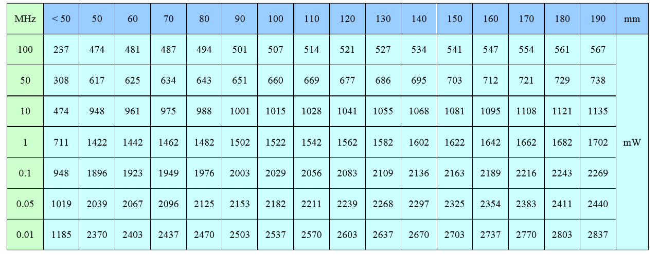

Appendix II
(This appendix does not form an integral part of this Recommendation.)
The information presented in the table serves as a guideline for typical usage patterns for each device category. However, if the manufacturer's specifications differ from those listed and more accurately represent the typical usage condition, those specifications should take precedence to ensure the most critical scenario is considered when assessing human exposure in close proximity to the body.

The table below provides guidance on the typical measurement distances for the different category of devices based on practices in some of the countries:

Category of device | Distance of EUT from surface for SAR measurement
 | Localized SAR  (Head) | Localized SAR  (Body) | Localized SAR (Limbs  and Extremities)
Hand-held devices like Cellular/ Mobile/Satellite phones etc. which will be used close to the head. | 0 mm | 5 mm or less | 0 mm
Hand-held devices like tablets, phablets etc. which will be used in close proximity of 20 cm or less to the body | May not be Applicable | 25 mm or less | 0 mm
RF devices like Wi-Fi dongles, Mobile data cards which are expected to be used in close proximity of 20 cm or less to the body | May not be Applicable | 5 mm or less | May not be Applicable
IoT/RF devices expected to be worn on the body | May not be Applicable | 5 mm or less | 0 mm  (See Note #2)
IoT/RF devices expected to be worn on the body near the head. | 0 mm | 5 mm or less | May not be Applicable
IoT/RF devices expected to be used in close proximity of 20 cm or less to the body | May not be Applicable | 25 mm or less | May not be Applicable
Note #1: The above specified distances of EUT from surface for SAR measurement are based on broad categorization and may vary depending on the equipment usage.
Note #2: This case is only applicable when the RF/IoT device is worn on the limbs or extremities. For e.g. tracking devices, smart watches etc

Appendix- III
(This appendix does not form an integral part of this Recommendation.)

Optimization Procedure for Evaluating SAR in Portable Terminal Stations with Non-Simultaneous Transmitting Antennas

<Neha Upadhyay, India: Can we also mention here that this optimization procedure is based on practices followed in some of the countries ?>

[Editor´s Note: Proposal received on this ongoing work item to make it Recommendation ITU-T K.devices. As there was no consensus, further contributions are invited and will be discussed in the next meeting.
Line by Line review need to be done at next meeting]

- In contemporary personal wireless communication devices, which are capable of autonomously selecting each non-simultaneous transmitting antenna that work across a wide range of RF bands, determining the configuration that yields the highest psSAR may demand conducting numerous SAR tests. Hence, this Appendix presents an alternative approach, drawing from the expertise of Brazilian testing laboratories, aimed at optimizing the number of SAR tests.
- To apply the test reduction procedure, the following requirements must be satisfied:
- The DUT must autonomously select each non-simultaneous transmitting antenna.
- No MIMO (multiple-input and multiple-output) techniques shall be applied.
- The same SAR measurement system (including probe, phantom, tissue-equivalent medium, and electronics) must be used for each frequency band and phantom combination.
- This method involves identifying the non-simultaneous transmitting antenna that generates the highest psSAR value among a group of non-simultaneous transmitting antennas operating on the same RF band, forming an RF group. This is achieved by selecting the wireless technology with the highest time-averaged transmitting power level from the priority order outlined below and conducting a full SAR test for all non-simultaneous transmitting antennas of the same RF group. Subsequently, the remaining wireless technologies that operate in the same RF group need to be tested only for the antenna which produced the highest psSAR value.
- If the DUT features the autonomous selection of each non-simultaneous transmitting antenna, along with multiple antennas and multiple transmitters capable of transmitting simultaneously, the assessment of the simultaneous transmission capability must be conducted separately in accordance with the relevant sections of the IEC/IEEE 62209-1528 standard.
- The testing laboratory must be provided with the following information regarding the DUT: the number of non-simultaneous transmitting antennas autonomously selected by the DUT, the RF bands in which each of these antennas operate, the wireless technologies utilized within each RF band, and the power classes associated with each wireless technology.
- The DUT must be made available with a test mode that allows the operation of the non-simultaneous transmitting antennas to be enabled and disabled, considering that the tests are carried out individually, according to the procedures described below.
- The following procedure outlines how this can be accomplished:
  - Identify all non-simultaneous transmitting antennas that can be autonomously selected by the DUT.
  - Group these non-simultaneous transmitting antennas according to their commonly used RF bands, forming an RF group.
  - For each non-simultaneous transmitting antenna of an RF group choose the wireless technology with the highest time-averaged transmission power level.
  - To identify the wireless technology with the highest time-averaged transmission power level, adhere to the following priority order:
    - 2G technologies, in the sequence: 1) GSM, 2) GPRS, 3) EDGE;
    - 3G technologies, in the sequence: 1) WCDMA, 2) HSPA, 3) HSPA +;
[Editor´s Note: Proposal received on this ongoing work item to make it Recommendation ITU-T K.devices. As there was no consensus, further contributions are invited and will be discussed in the next meeting.
Line by Line review need to be done at next meeting]
    - 4G technology (LTE);
    - 5G NR technology.
  - If a specific non-simultaneously transmitting antenna of an RF group does not utilize the wireless technology identified as having the highest time-averaged transmission power level, the SAR test for this antenna must be conducted for the next wireless technology in accordance with the established priority order.
  - A full SAR test procedure must be conducted on all non-simultaneous transmitting antennas of each RF group, employing the respective wireless technology with the highest time-averaged transmission power level.
[Editor´s Note: Proposal received on this ongoing work item to make it Recommendation ITU-T K.devices. As there was no consensus, further contributions are invited and will be discussed in the next meeting.
Line by Line review need to be done at next meeting]

  - Once the SAR test procedures on all non-simultaneous transmitting antennas of an RF group are completed, identify the non-simultaneous transmitting antenna which produced the highest psSAR level.
  - Further SAR test procedures for the remaining wireless technologies according to the aforementioned priority order must only be conducted on the non-simultaneous transmitting antenna that produced the highest psSAR value.
  - If any psSAR value for the remaining wireless technologies is within 3 dB from the normative SAR limit, the SAR measurement for the respective wireless technology must be carried out in all non-simultaneous transmitting antennas of the RF group.
  - If an RF band is used exclusively by a single non-simultaneous transmitting antenna, conduct a full SAR test in accordance with section 7.4.2 of the IEC/IEEE 62209-1528 standard for that specific RF band.
[Editor´s Note: Proposal received on this ongoing work item to make it Recommendation ITU-T K.devices. As there was no consensus, further contributions are invited and will be discussed in the next meeting.
Line by Line review need to be done at next meeting]

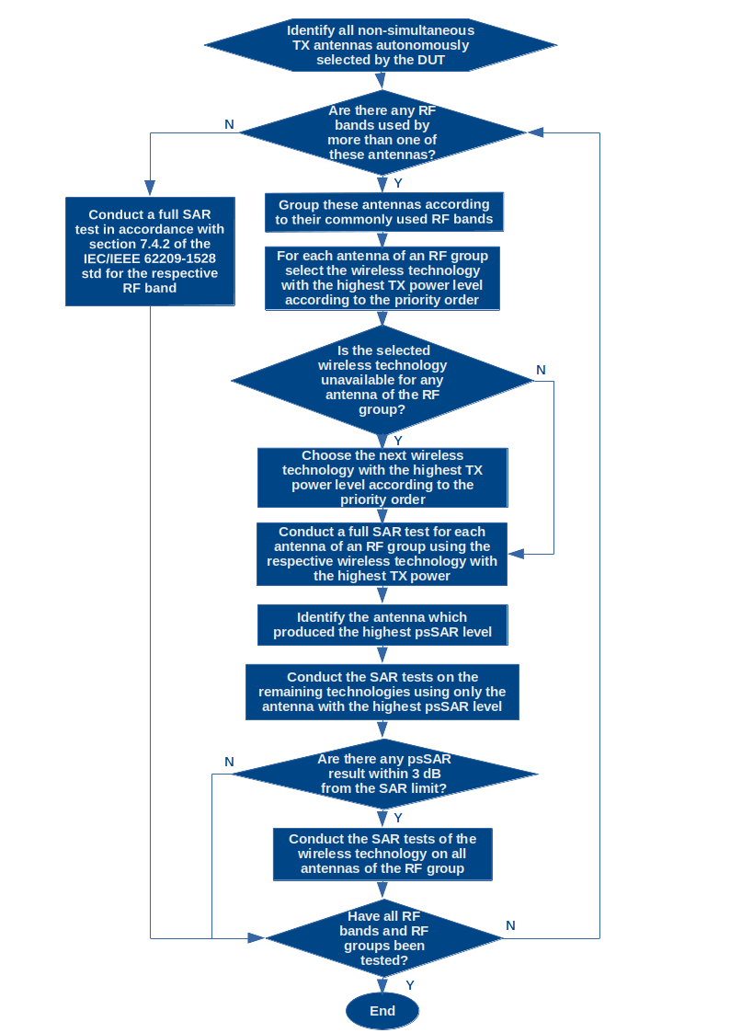
Figure 4 - Flow chart of the optimization procedure for evaluating SAR in portable terminal stations with non-simultaneous transmitting antennas

Appendix- IV
(This appendix does not form an integral part of this Recommendation.)

Optimization Procedure for Assessing psSAR of a Portable Terminal Station Operating in Close Proximity to the Head

<Neha Upadhyay, India: Can we also mention here that this optimization procedure is based on practices followed in some of the countries ?>

[Editor´s Note: Proposal received on this ongoing work item to make it Recommendation ITU-T K.devices. As there was no consensus, further contributions are invited and will be discussed in the next meeting.
Line by Line review need to be done at next meeting]

- This Appendix introduces an alternative method aimed at minimizing the number of necessary SAR tests for determining the highest psSAR of a portable terminal station operating in close proximity to the head. This method combines information provided in Annexes B.2 and B.3 of the IEC/IEEE 62209-1528 standard, leveraging insights from Brazilian testing laboratories' expertise.
- To apply the test reduction procedure, the following requirements must be satisfied:
- The RF bands to be tested must fall within the frequency range of 800 MHz to 2 GHz
[Editor´s Note: Proposal received on this ongoing work item to make it Recommendation ITU-T K.devices. As there was no consensus, further contributions are invited and will be discussed in the next meeting.
Line by Line review need to be done at next meeting]

- No MIMO (multiple-input and multiple-output) techniques shall be applied.
- The same SAR measurement system, including the probe, phantom, tissue-equivalent medium, and electronics, must be used for each frequency band.
- The testing laboratory must be provided with the following information regarding the DUT: the number of antennas, the RF bands in which each of these antennas operate, the wireless technologies utilized within each RF band, and the power classes associated with each wireless technology.
- The DUT must be made available with a test mode that allows the operation of the antennas to be enabled and disabled, considering that the tests are carried out individually, according to the procedures described below.
- The following procedure outlines how this can be accomplished:
  - For each RF band in the range of 800 MHz to 2 GHz of the DUT, conduct a full SAR test procedure, covering all specified test configurations, cheek and tilt positions outlined in section 7.4.2 of the IEC/IEEE 62209-1528 standard, using the wireless technology with the highest time-averaged power level according on the priority order outlined below.
  - Choose the wireless technology with the highest time-averaged transmission power level according to the following priority order:
    - 2G technologies, in the sequence: 1) GSM, 2) GPRS, 3) EDGE;
    - 3G technologies, in the sequence: 1) WCDMA, 2) HSPA, 3) HSPA+;
    - 4G technology (LTE);
    - 5G NR technology.
  - Identify whether the highest psSAR value, obtained from the aforementioned procedure, occurred on the left or right side of the phantom.
  - If the antenna is internally located within the DUT and positioned within a 2.5 cm distance from the lower end of the DUT, then the test procedure for the remaining wireless technologies, identified according to the priority order outlined earlier, should only be conducted at the cheek position for the side of the phantom where the highest psSAR value was recorded in the preceding step.
[Editor´s Note: Proposal received on this ongoing work item to make it Recommendation ITU-T K.devices. As there was no consensus, further contributions are invited and will be discussed in the next meeting.
Line by Line review need to be done at next meeting]

  - Conversely, if the antenna placement differs from above, the evaluation of the remaining wireless technologies must occur at cheek and tilt positions, specifically on the side where the highest psSAR value was identified before.
  - Regardless of the antenna placement, if any SAR results obtained in the test procedures for the remaining wireless technology exceeds a SAR value greater than --3 dB of the applicable SAR limit, it is crucial to conduct all test configurations and positions specified in section 7.4.2 of the IEC/IEEE 62209-1528 standard for the respective wireless technology.
[Editor´s Note: Proposal received on this ongoing work item to make it Recommendation ITU-T K.devices. As there was no consensus, further contributions are invited and will be discussed in the next meeting.
Line by Line review need to be done at next meeting]

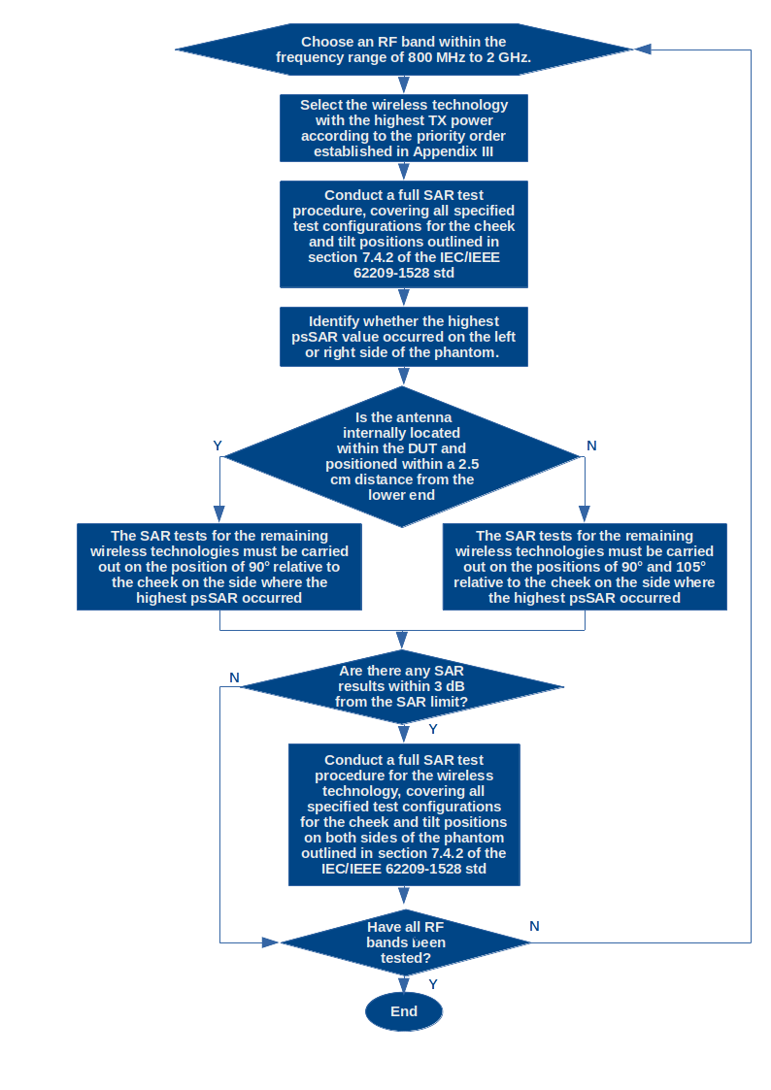
Figure 5 - Flow chart of the optimization procedure for assessing psSAR of a portable terminal station operating in close proximity to the head

______________

Bibliography

[a. ICNIRP 2020] ICNIRP guidelines for limiting exposure to electromagnetic fields (100 khz to 300 ghz)

[b. KDB 447498 D01] General RF Exposure Guidance v06provides guidance pertaining to RF exposure requirements for mobile and portable device equipment authorizations
[Editor´s Note: Proposal received on this ongoing work item to make it Recommendation ITU-T K.devices. As there was no consensus, further contributions are invited and will be discussed in the next meeting.
Line by Line review need to be done at next meeting]

