 | INTERNATIONAL TELECOMMUNICATION UNION  TELECOMMUNICATION  STANDARDIZATION SECTOR  STUDY PERIOD 2022-2024 |  | SG13-TD045/WP3
 |  |  | STUDY GROUP 13
 |  |  | Original: English
Question(s): |  | 16/13 |  | Geneva, 4-15 July 2022
TD
Source: |  | Editors
Title: |  | Draft new Recommendation ITU-T Y.Trust-Registry: “Trust Registry for Devices and Applications: requirements, architectural framework”
Contact: |  | Abhay Shanker Verma  TEC, DOT  India |  |  | Tel: +91 11 2332 9333  Fax: +91 11 23329367  E-mail: as.verma@gov.in
Contact: |  | Ranjana Sivaram  TEC, DOT  India |  |  | Tel: +91 98681 36990  E-mail: ranjana.sivaram@gov.in
Contact: |  | Sharad Arora  Independent Expert  India |  |  | Tel: +91 93542 67306  E-mail: sharadsan@gmail.com

Abstract: | Draft output of proposed new work item on Y.Trust-Registry: “Trust Registry for Devices and Applications: requirements, architectural framework”

Summary:
This output document is based on the discussion results of the following contributions in the Q16/13 plenary meeting (Geneva, 4-15 July 2022).
Number | Source | Title
C-0165R3 | Telecommunication Engineering Centre (TEC), Ministry of Communications, India. | Proposal for initiating a new work item on “Trust Registry for Devices and Applications: requirements, architectural framework”

Meeting Results:
The meeting has agreed to initiate the new work item with target completion by Q2, 2024 as per AAP.

Attachments:
Annexure-I - A.1 Justification
Annexure-II - proposed initial text of draft Recommendation ITU-T Y.Trust-Registry: “Trust Registry for Devices and Applications: requirements, architectural framework”

Annexure-I
A.1 Justification for proposed draft new Recommendation Y.Trust-Registry

Question: | 16/13 | Proposed new ITU-T Recommendation | Geneva, 04 July – 15 July 2022
Reference and title: | ITU-T Y.Trust-Registry "Trust Registry for Devices and Applications: requirements, architectural framework"
Base text: | C-0165R3 |  | Timing: | Q2, 2024
Editor(s): | Abhay Shanker Verma, TEC (India), +91 99995 54900, as.verma@gov.in;  Ranjana Sivaram, TEC (India), +91 98681 36990, ranjana.sivaram@gov.in  Sharad Arora, Independent Expert (India), +91 93542 67306, sharadsan@gmail.com |  | Approval process: | AAP
Scope (defines the intent or object of the Recommendation and the aspects covered, thereby indicating the limits of its applicability):
This document provides:
- Overview of trust registry and hierarchy
- Requirements for Registration, Interrogation and Notification pertaining to the trustworthiness of the connected devices and applications throughout the lifecycle;
- Requirements for root(s) of trust to enable the mechanisms and functions of the registry;
- An architectural framework for the hierarchical setup of trust registries belonging to various domains, sectors and/ or geographical areas;
- Functional architecture, reference points and flows for the registration, interrogation and notification of the trustworthiness of devices and applications.
Summary (provides a brief overview of the purpose and contents of the Recommendation, thus permitting readers to judge its usefulness for their work):
The world is witnessing a massive proliferation of connected devices and services that affect every walk of life. The security threats from this vast, distributed and often unregulated emerging ecosystem of providers of devices and applications are also clear to the world. This recommendation defines the requirements that must be fulfilled by a trust registry that, when supported by the various stakeholders, is likely to create an environment for sustainable and orderly proliferation of trusted devices and applications.
This Recommendation describes requirements, an architectural framework for a hierarchy of registries, functional architecture and flows for the registration, interrogation and notification throughout the lifecycle of devices and applications, with the objective that the trustworthiness of a device or an application can be established at any point in time.
The approach in this recommendation is generic in nature, independent of the operator and network technology providing a framework to create a trust registry.
Relations to ITU-T Recommendations or to other standards (approved or under development):
ITU-T Y.3056, Y.3052, Y.3053, X.1250, X. 5G sec-t
Liaisons with other study groups or with other standards bodies:
ITU-T SG 17, oneM2M
Supporting members that are committing to contributing actively to the work item:
India (Republic of)

Annexure- II

Draft Recommendation ITU-T Y.Trust-Registry

Trust Registry for Devices and Applications: requirements, architectural framework

Summary
The world is witnessing a massive proliferation of connected devices and services that affect every walk of life. The security threats from this vast, distributed and often unregulated emerging ecosystem of providers of devices and applications are also clear to the world. This recommendation defines the requirements that must be fulfilled by a trust registry that, when supported by the various stakeholders, is likely to create an environment for sustainable and orderly proliferation of secure devices and applications.
Requirements, an architectural framework for a hierarchy of registries, functional architecture and flows for the registration, interrogation and notification throughout the lifecycle of devices and applications is proposed, with the objective that the trustworthiness of a device or an application can be established at any point in time.
Keywords
<Mandatory>

Table of Contents
1 Scope 5
2 References 5
3 Definitions 5
3.1 Terms defined elsewhere 5
3.2 Terms defined in this Recommendation 5
4 Abbreviations and acronyms 6
5 Conventions 6
6 Overview of trust registry and hierarchy 6
7 Requirements 7
8 Architectural framework 7
9 Functional Architecture 8
10 Reference points 8
11 Flows 8

Draft Recommendation ITU-T Y.Trust-Registry

Trust Registry for Devices and Applications: requirements, architectural framework

1 Scope
The recommendation includes:
- Overview of trust registry and hierarchy;
- Requirements for Registration, Interrogation and Notification pertaining to the trustworthiness of the connected devices and applications throughout the lifecycle;
- Requirements for root(s) of trust to enable the mechanisms and functions of the registry;
- An architectural framework for the hierarchical setup of trust registries belonging to various domains, sectors and/ or geographical areas; and
- Functional architecture, reference points and flows for the registration, interrogation and notification of the trustworthiness of devices and applications.

2 References
The following ITU-T Recommendations and other references contain provisions, which, through reference in this text, constitute provisions of this Recommendation. At the time of publication, the editions indicated were valid. All Recommendations and other references are subject to revision; users of this Recommendation are therefore encouraged to investigate the possibility of applying the most recent edition of the Recommendations and other references listed below. A list of the currently valid ITU-T Recommendations is regularly published. The reference to a document within this Recommendation does not give it, as a stand-alone document, the status of a Recommendation.
[ITU-T X.yyy] Recommendation ITU-T X.yyy (date), Title.

3 Definitions
<Check in the ITU-T terms and definitions database at www.itu.int/go/terminology-database whether the term has already been defined in another Recommendation. It would be more consistent to refer to such a definition rather than to redefine the term>

3.1 Terms defined elsewhere
<Normally, terms defined elsewhere will simply refer to the defining document. In certain cases, it may be desirable to quote the definition to allow for a stand-alone document>
This Recommendation uses the following terms defined elsewhere:
3.1.1 <Term 1> [Reference]: <optional quoted definition>.
3.1.2 <Term 2> [Reference]: <optional quoted definition>.

3.2 Terms defined in this Recommendation
This Recommendation defines the following terms:
3.2.1 <Term 3>: <definition>.

4 Abbreviations and acronyms
This Recommendation uses the following abbreviations and acronyms:
<abbr> <expansion>
<Include all abbreviations and acronyms used in this Recommendation>

5 Conventions
In this Recommendation, requirements are classified as follows:
• The keywords "is required to" or “are required to” indicate a requirement/ requirements, which must be strictly followed and from which no deviation is permitted if conformance to this document is to be claimed;
• The keywords "is recommended" indicate a requirement, which is recommended but which is not absolutely required. Thus, such requirements need not be present to claim conformance; and
• The keywords "optionally" or "may" indicate an optional requirement which is permissible, without implying any sense of being recommended. These terms are not intended to imply that the vendor's implementation must provide the option; it means the vendor may optionally provide the feature and still claim conformance with the specification.

6 Overview of trust registry and hierarchy
<TBD>
The concept of a hierarchical Trust Registry architecture may as below:

Note: This is an indicative diagram to propose the concept. There can be several models in which the registrars may interact bilaterally.

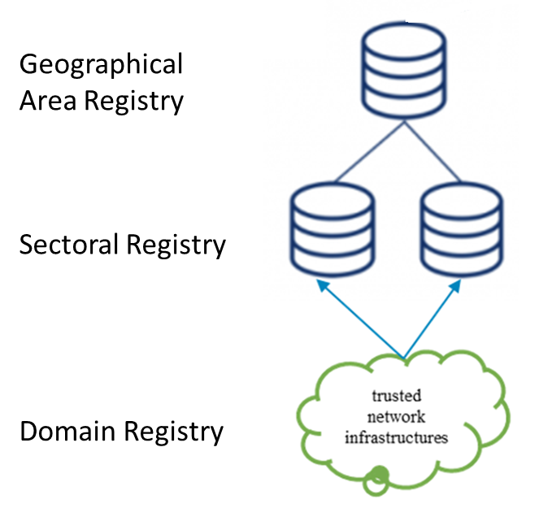

Figure 1: Concept of a Hierarchical Trust Registry Architecture

7 Requirements
<TBD>
7.1 Requirements for registration

<TBD>
7.2 Requirements for interrogation
<TBD>
  - Requirements for notification
<TBD>
  - Requirements for root(s) of trust
<TBD>
  - Requirements for reference points and flows
<TBD>

8 Architectural framework
<TBD>

9 Functional Architecture
<TBD>

10 Reference points
<TBD>

11 Flows
<TBD>

Annex A
<Annex Title>
(This annex forms an integral part of this Recommendation.)
<Body of annex A>

Bibliography
[b-ITU-T X.yyy] Recommendation ITU-T X.yyy (date), Title.

Appendix I
(This appendix does not form an integral part of this Recommendation.)
Identity and security is a critical requirement for all types of Devices and Apps

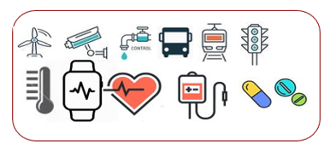

Device Security Classes
Use Case Classification and Compliance
Registration & Certification

Applications

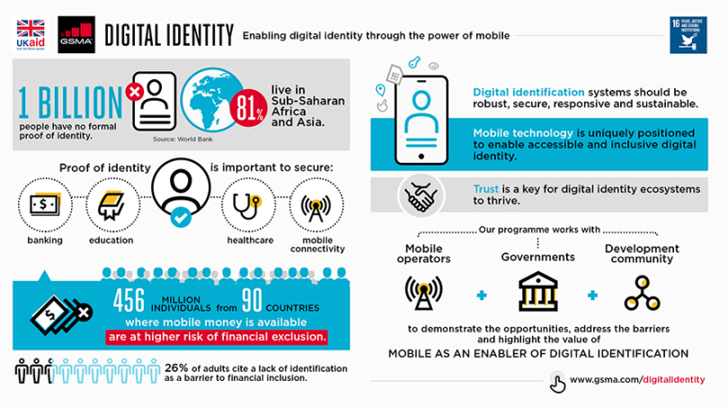
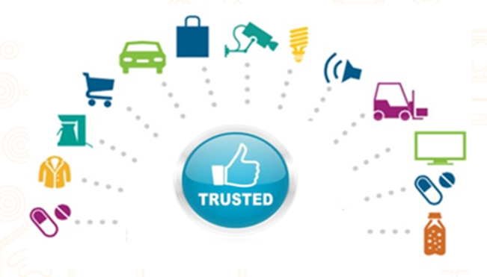

Smart Devices
Mobile Devices

Appendix II
(This appendix does not form an integral part of this Recommendation.)

New Age devices and applications need added security

Registration & Certification
Use Case Classification and Compliance
Device Security Classes

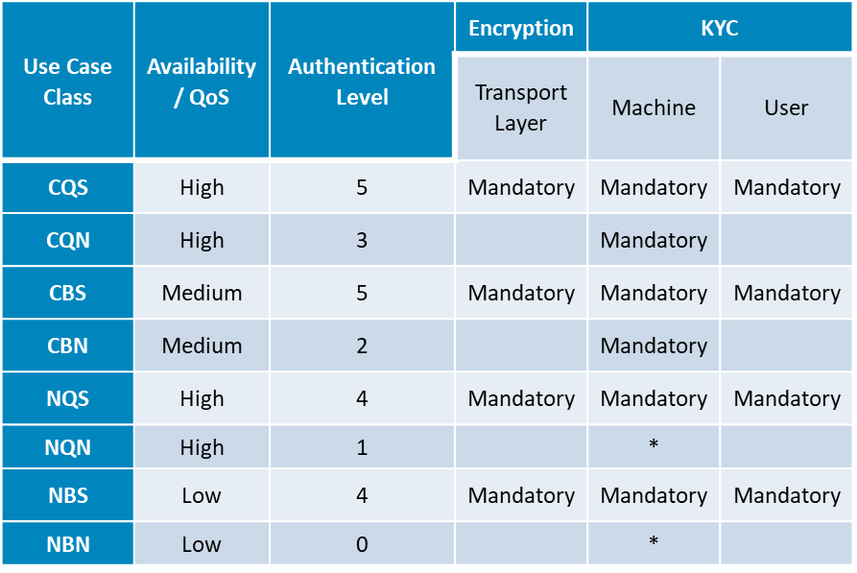
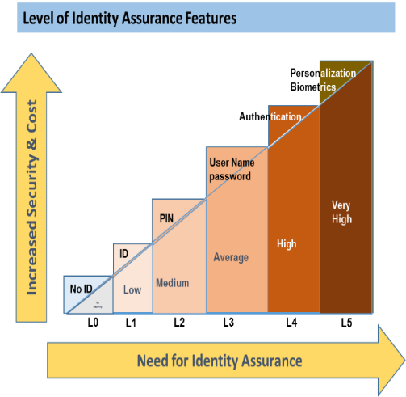
Trust Framework
- Keys and Certificates
- Trusted Service Provider
- Authenticated Devices
- Certified Applications

Root of trust
Security by Design: Unique global tamper resistant identity as root of trust, certification, digital trust, registration and compliance
Authentication

Requirements for Security by design and End to End Security are stated by national and international bodies

_________________

