Radiocommunication Study Groups | 
Received: Date 20xx  Source: Annex 4.4 to Document 5D/1668-E | Document XX/-E
 | Date 20xx
 | Original: English
India (Republic of)
AMENDMENT ON WORKING DOCUMENT TOWARDS A PRELIMINARY DRAFT NEW REPORT ITU-R M.[IMT.AAS]
Introduction
India (Republic of) submitted document ANNEX 2.10: [SOURCE DOC. 5D/320] and ANNEX 2.11: [SOURCE DOC. 5D/320] at 36th meeting of WP5D held in Oct 2020 to incorporate graphical representation of mathematical form of Advance Antenna System(AAS) given in Recommendation ITU-R M.2101.
In the document, 2D/3D plots after simulation has shown side/grating lobe as a result of various elevation angle of main beam at various $\frac{d_{V}}{λ}$ factor, after certain point beyond 0.5 $\frac{d_{V}}{λ}$ factor. Simulation in the document has shown the limitations of technical parameters, which can be consider to use Recommendation ITU-R M.2101within that limits for sharing studies.

Proposal
This proposal intent to bring more clarity in general way by making editorial changes and updating document indicated in turquoise colour.

Annex 4.4 to Working Party 5D Chairman’ Report
…

[Editor’s note: The Annex below has not been fully reviewed nor agreed to be included in the current Working Document.]
[ANNEX 2.10: [Source Doc. 5D/320 (IND)]
Mathematical form of composite antenna pattern given in Recommendation ITU-R M.2101 has been represented in graphical form in this proposal. Recommendation ITU-R M.2101 equations was simplified in [ANNEX 2.11] to study. Simplified equation has been simulated to see the effect of main beam when steered in vertical plane. Main beam was steered from $0^{°}$ to ${60}^{°}$ in vertical plane at $\frac{d_{V}}{λ}$ factor varying from 0 to 1. 2D/3D plots after simulation gives an idea on in-band and adjacent band side/grating lobe at various elevation of main beam by co-relating in-band and adjacent band with $\frac{d_{V}}{λ}$ factor.

The mathematical form of radiation pattern from array of elements given in Recommendation ITU-R M.2101 are as per below.

1 Element radiation pattern (Table 3 of Rec. ITU-R M.2101-0)

Vertical radiation pattern
$A_{E,V}\left(θ\right)=-min\left[12{\left(\frac{θ-90}{θ_{3dB}}\right)}^{2}, SLA\right]$
where:
θ: elevation angle in degrees;
SLA_{V}: front-to-back ratio;
$θ_{3dB}$: vertical 3 dB beamwidth.

Horizontal radiation pattern
$A_{E,H}\left(φ\right)= -\min\left[12{\left(\frac{φ}{φ_{3dB}}\right)}^{2}{,A}_{m}\right]dB$
where:
$φ$: azimuth angle in degrees;
$A_{m}$: front-to-back ratio;
$φ_{3dB}$: horizontal 3 dB beamwidth.
$A_{E}\left(φ,θ\right)=G_{E,max}-min\left\{-\left[A_{E,H}\left(φ\right)+A_{E,V}\left(θ\right)\right]{,A}_{m}\right\}$
where:
G_{E,max}: Element gain (dBi).

2 Composite radiation pattern (Table 4 of Rec. ITU-R M.2101-0)
$A_{A,Beami}\left(θ,φ\right)=A_{E}\left(θ,φ\right)+{10log}_{10}\left({\left|\sum_{m=1}^{N_{H}}{\sum_{n=1}^{N_{V}}{w_{i, n, m}.ν_{n, m}}}\right|}^{2}\right)$
where:
$ν_{n, m}=e^{i.2π.\left(n-1\right). \frac{d_{V}}{λ} .\cos\left(θ\right)}.e^{i.2π.\left(m-1\right). \frac{d_{H}}{λ} .sin⁡(θ).sin⁡(φ)}$
$w_{i, n, m}=\frac{1}{\sqrt{N_{H}.N_{V}}}e^{i.2π.\left(n-1\right). \frac{d_{V}}{λ} .sin⁡(θ_{i,etilt})}.e^{-i.2π.\left(m-1\right). \frac{d_{H}}{λ}. cos{(θ}_{i,etilt}).sin{(φ}_{i,escan})}$
N_{H}: number of horizontal elements;
N_{V}: number of vertical elements;
d_{H}: horizontal element spacing;
d_{V}: vertical element spacing;
λ: frequency wavelength;
$θ_{i,etilt}$: vertical electrical steering;
$φ_{i,escan}$: horizontal electrical steering.

3 Simplification of complex mathematical form of composite radiation pattern
Mathematical form of composite radiation pattern given in Recommendation ITU-R M.2101 is complex. This complex form was simplified to visualize the graphs to study the radiation pattern to study the effect of elevation angle of main beams against $\frac{d_{V}}{λ}$ factor The mathematical form after simplification can be written as follow:
$A_{A,Beami}\left(θ,φ\right)=A_{E}\left(θ,φ\right)+{10log}_{10}\left({\left|\frac{1}{\sqrt{N_{V}.N_{H}}}\right|}^{2}.{\left|\frac{\sin\left(\frac{Ψ_{1}.N}{2}\right)}{\sin\left(\frac{Ψ_{1}}{2}\right)}\right|}^{2}.{\left|\frac{\sin\left(\frac{Ψ_{2}.M}{2}\right)}{\sin\left(\frac{Ψ_{2}}{2}\right)}\right|}^{2}\right)$
where:
$Ψ_{1}=2π.\frac{d_{V}}{λ}.\left(\cos\left(θ\right)+\sin\left(θ_{i,etilt}\right)\right)$
$Ψ_{2}=2π.\frac{d_{H}}{λ}.\left(\sin\left(θ\right).\sin\left(φ\right)-cos{(θ}_{i,etilt}).sin{(φ}_{i,escan})\right)$
$φ_{i,escan}≠0 (i.e it can be 0.000000001)$
N_{H}: number of horizontal elements;
N_{V}: number of vertical elements;
d_{H}: horizontal element spacing;
d_{V}: vertical element spacing;
λ: frequency wavelength;
$θ_{i,etilt}$: vertical electrical steering;
$φ_{i,escan}$: horizontal electrical steering.
Details of simplification in [Annex 2.11].

4 Technical parameter
Frequency 26 GHz has been used to determine element spacing. At 0.5 $\frac{d_{V}}{λ}$ factor, elements spacing is 5.8 mm. Fixed parameters taken for plot are given in Table 1.

Table 1
Technical parameter | Value
Gain of single element | 5 dBi
No. of elements ($N_{H}X N_{V}$ ) | (8 × 8) and (16 × 16)
Front-to-back ratio ($A_{m}$) | 30 dB
Front-to-back ratio (SLA_{V}) | 30 dB
Vertical 3 dB beamwidth ($θ_{3dB}$) | 65°
Horizontal 3 dB beamwidth ($φ_{3dB}$) | 65°
Element spacing (at 26 GHz and $\frac{d_{V}}{λ}$ factor = 0.5) | 5.8 mm

5 3D Graph showing composite radiation pattern from array of elements (8 × 8 and 16 × 16) at 0°, 30° and 60° elevation angle of main beam from horizon
MATLAB (R2008b) and MS Excel has been used for plotting the graphs. 3D Graph has been plotted at an elevation angle of main beam at 0°, 30° and 60°. In the graph Y-axis is $\frac{d_{V}}{λ}$ factor, X-axis is elevation angle, and Z-axis is radiation from array of elements. Z-axis is shown perpendicular to screen which can be read as per colour bar. Y-axis ($\frac{d_{V}}{λ}$factor) has scaling from 0 to 1, and X-axis has scaling from 0 to 180 degree. Steering of azimuth angle of main beam ${(φ}_{i,escan})$has been kept close to zero.

Figure 1
Array of elements (8 × 8) | Array of elements (16 × 16)
Main beam elevation angle, $θ_{i,etilt}$ = ${ 0}^{°}$
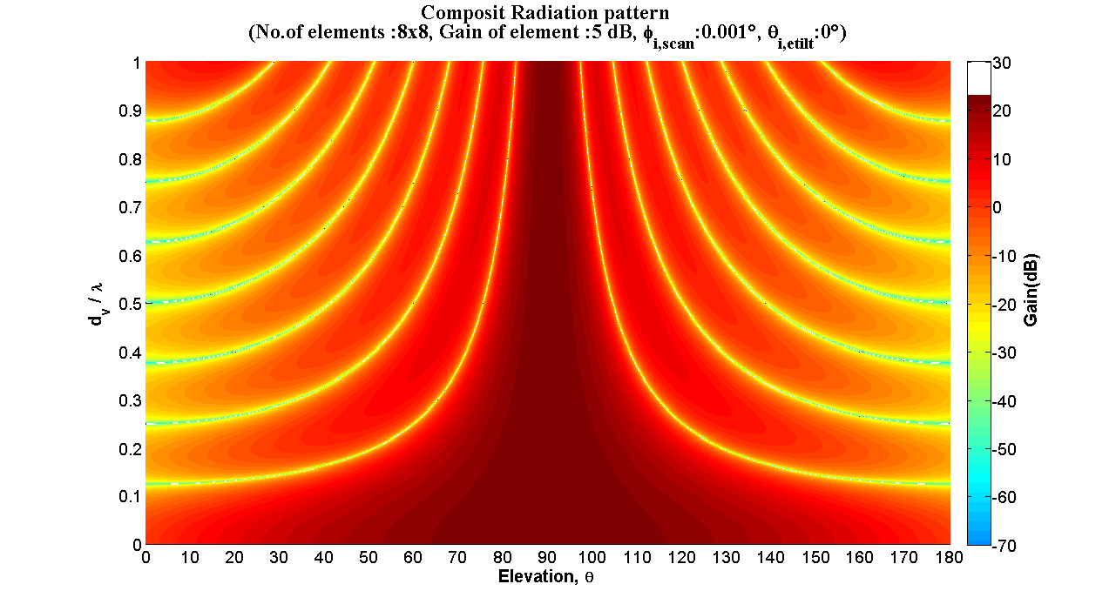 | 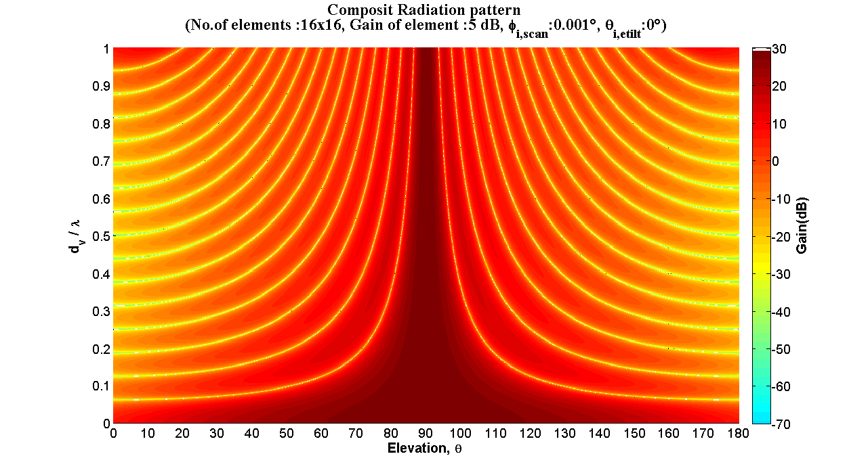
Main beam elevation angle, $θ_{i,etilt}$ = ${ 30}^{°}$
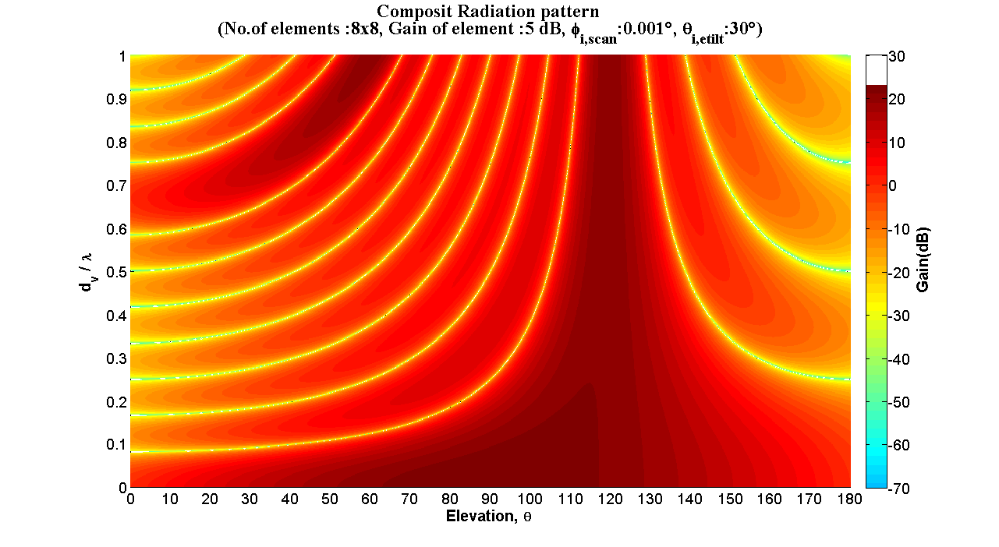 | 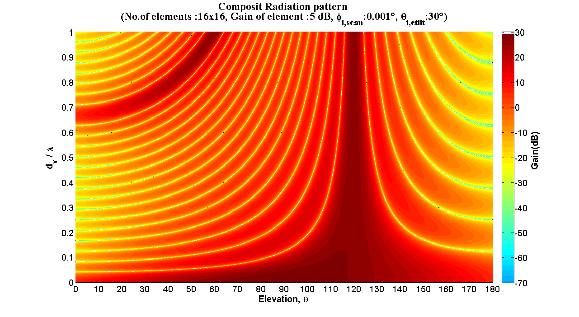
Main beam elevation angle, $θ_{i,etilt}$ = ${ 60}^{°}$
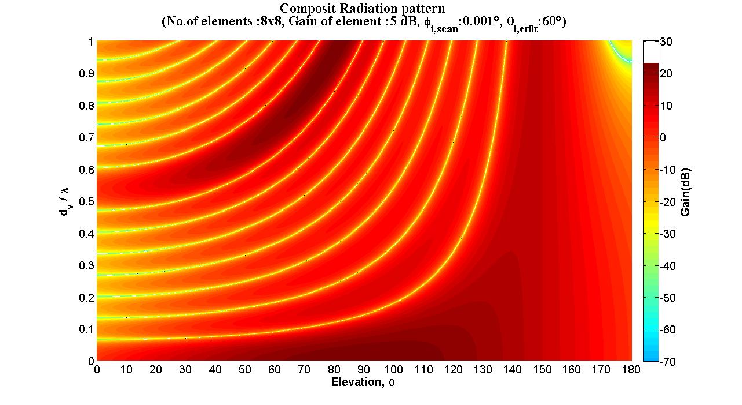 | 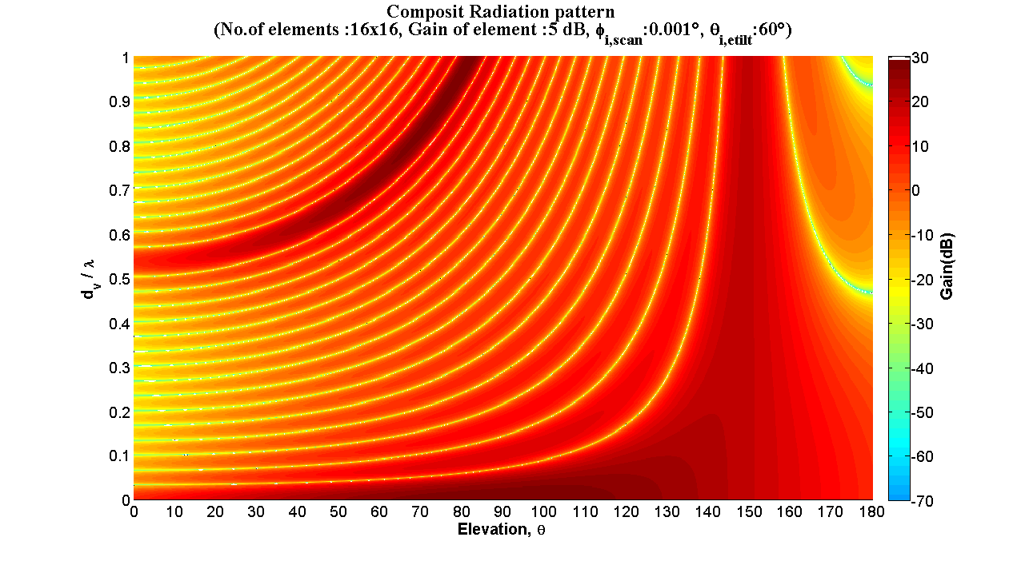

6 2D Graph showing composite radiation pattern from array of elements (8 × 8 and 16 × 16) at 0°, 30° and 60° elevation angle of main beam from horizon at various $\frac{d_{V}}{λ}$ factor
26 GHz has been taken as design frequency to study the side lobes/grating lobes on other frequencies on different elevation of main beam below horizon. In the graph Y-axis is the gain of radiation pattern (as per colour bar in Figure 1), and X-axis is elevation angle.

6.1 Radiation pattern at 24.25 GHz, 26 GHz and 27.5 GHz (corresponding $\frac{d_{V}}{λ}$ factor 0.46, 0.5, and 0.52)
Figure 2
Array of elements (8 × 8) | Array of elements (16 × 16)
As per Figure 2, radiation at elevation from $0^{°}$ to ${180}^{°}$ on frequency 24.25 GHz, 26 GHz and 27.5 GHz, does not show major side lobes and grating lobes when the main beam was steered up to $60^{°}$ elevation angle. Main beam is sharper and has more gain in case of 16 × 16 array elements in comparison to 8 × 8.

6.2 Radiation pattern at 0.65 and 0.8 $\frac{d_{V}}{λ}$ factor
Figure 3
Array of elements (8 × 8) | Array of elements (16 × 16)
Figure 4
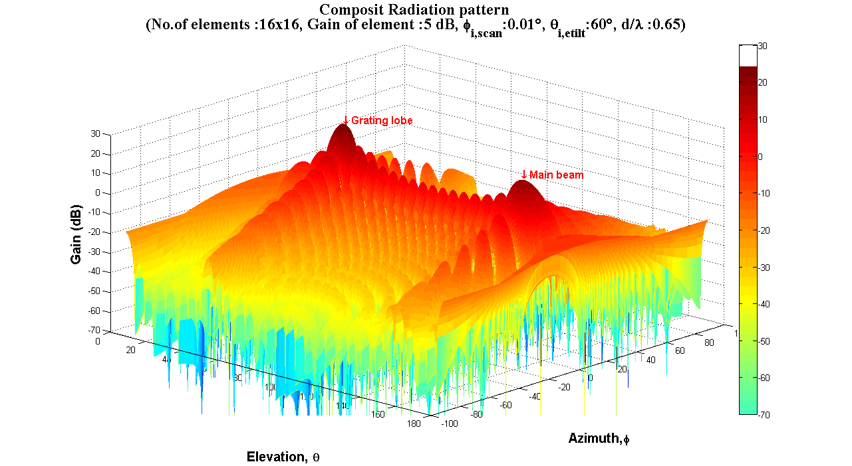
Figure 3 and Figure 4 show grating lobe when the main beam elevation angle is steered below the horizon. At 0.65 $\frac{d_{V}}{λ}$ factor and ${60}^{°}$ elevation angle of main beam, grating lobe was noted which has more gain than the main beam.
After giving inputs of $\frac{d_{V}}{λ}$ factor and vertical plane elevation ( $θ_{i,etilt}$), some results of main beam gain and grating lobe with its elevation angle are mentioned in below table based on simulation.

Input |  | Result
$$\frac{d_{V}}{λ}$$ | $$θ_{i,etilt}$$ | Main beam Gain (dBi) |  | Grating lobe Gain (dBi)/elevation angle
 |  | 8x8 | 16x16 | 8x8 |  | 16x16
0.5 | $$0^{°}$$ | 23.0 | 29.0
0.5 | $${30}^{°}$$ | 20.6 | 26.5
0.5 | $${60}^{°}$$ | 14.0 | 19.2
0.65 | $$0^{°}$$ | 23.0 | 29.0
0.65 | $${30}^{°}$$ | 20.5 | 26.5 | 5.2 | $${18}^{°}$$ | 6.1 | $$8^{°}$$
0.65 | $${60}^{°}$$ | 13.6 | 19.0 | 18.1 | $${50}^{°}$$ | 24.0 | $${48}^{°}$$
0.8 | $$0^{°}$$ | 23.0 | 29.0
0.8 | $${30}^{°}$$ | 20.5 | 26.5 | 16.5 | $${44}^{°}$$ | 22.4 | $${42}^{°}$$
0.8 | $${60}^{°}$$ | 13.3 | 18.8 | 21.6 | $${68}^{°}$$ | 27.5 | $${68}^{°}$$

Following are the observations;
- After certain point beyond 0.5 $\frac{d_{V}}{λ}$ factor, at certain fixed elevation angle of main beam, grating lobe gain and its elevation angle increases on increasing $\frac{d_{V}}{λ}$ factor.
- At higher elevation angle of main beam after certain point beyond 0.5 $\frac{d_{V}}{λ}$ factor, grating lobe gain is more prominent than lower elevation angle of main beam.
- Gain of main beam reduces on increasing elevation of main beam.
- Number of side lobes increases with increase in number of elements.

7 $\frac{d_{V}}{λ}$ factor and corresponding operating frequency range
Spacing between elements at 26 GHz and 0.5 $\frac{d_{V}}{λ}$ factor is 5.8 mm. The spacing of element remains fixed irrespective of operating frequency. This give rise to various values of $\frac{d_{V}}{λ}$ factor. Table 2 shows operating frequency range and corresponding $\frac{d_{V}}{λ}$ factor with reference to 26 GHz as design frequency. The frequency bands shown are below 50 GHz, identified for IMT during WRC-19.
Table 2
Element spacing 5.8 mm at frequency 26 GHz and 0.5 $\frac{d_{V}}{λ}$
S. No | Operating frequency range  (GHz) | Operating $\frac{d_{V}}{λ}$ range
1 | 24.25 to 27.5 | 0.466 to 0.528
2 | 37 to 43.5 | 0.711 to 0.836
3 | 45.5 to 47 | 0.875 to 0.903
4 | 47.2 to 48.2 | 0.907 to 0.926

Figure 5

8 Conclusion
The study demonstrated that due to grating lobe the flexibility of steering of main beam in vertical plane reduces as $\frac{d_{V}}{λ}$ factor increases, after certain point beyond 0.5 $\frac{d_{V}}{λ}$ factor. So, in general it is appropriate to use the Recommendation ITU-R M.2101 for sharing studies in certain limits as resulted in simulation.

[Editor’s note: The Annex below has not been fully reviewed nor agreed to be included in the current Working Document.]

[ANNEX 2.11: [Source Doc. 5D/320 (IND)]
Simplification of antenna factor given in Table 4 of
Recommendation ITU-R M.2101

1 Element pattern for antenna array model (Table 3 of Rec. ITU-R M.2101-0)
$A_{E,V}\left(θ\right)=-min\left[12{\left(\frac{θ-90}{θ_{3dB}}\right)}^{2}, SLA\right]$
$A_{E,H}\left(φ\right)= -\min\left[12{\left(\frac{φ}{φ_{3dB}}\right)}^{2}{,A}_{m}\right]dB$
$A_{E}\left(φ,θ\right)=G_{E,max}-min\left\{-\left[A_{E,H}\left(φ\right)+A_{E,V}\left(θ\right)\right]{,A}_{m}\right\}$ (i)

2 Composite antenna pattern (Table 4 of Rec. ITU-R M.2101-0)
$A_{A,Beami}\left(θ,φ\right)=A_{E}\left(θ,φ\right)+{10log}_{10}\left({\left|\sum_{m=1}^{N_{H}}{\sum_{n=1}^{N_{V}}{w_{i, n, m}.ν_{n, m}}}\right|}^{2}\right)$ (ii)
where:
$ν_{n, m}=e^{i.2π.\left(n-1\right). \frac{d_{V}}{λ} .\cos\left(θ\right)}.e^{i.2π.\left(m-1\right). \frac{d_{H}}{λ} .sin⁡(θ).sin⁡(φ)}$
$w_{i, n, m}=\frac{1}{\sqrt{N_{H}.N_{V}}}e^{i.2π.\left(n-1\right). \frac{d_{V}}{λ} .sin⁡(θ_{i,etilt})}.e^{-i.2π.\left(m-1\right). \frac{d_{H}}{λ}. cos{(θ}_{i,etilt}).sin{(φ}_{i,escan})}$

3 Antenna factor simplification
The product of super position vector ($ν_{n, m}$) and weighting ($w_{i, n, m}$) is given by
$$w_{i, n, m}.ν_{n, m}=\frac{1}{\sqrt{N_{H}.N_{V}}}\left(e^{i.2π.\left(n-1\right). \frac{d_{V}}{λ} .\sin\left(θ_{i,etilt}\right)}.e^{-i.2π.\left(m-1\right). \frac{d_{H}}{λ}. cos{(θ}_{i,etilt}).sin{(φ}_{i,escan})}.e^{i.2π.\left(n-1\right). \frac{d_{V}}{λ} .\cos\left(θ\right)}.e^{i.2π.\left(m-1\right). \frac{d_{H}}{λ} .sin⁡(θ).sin⁡(φ)}\right)$$
$$w_{i, n, m}.ν_{n, m}=\frac{1}{\sqrt{N_{H}.N_{V}}}\left(e^{i.2π.\left(n-1\right). \frac{d_{V}}{λ} .\cos\left(θ\right)}.e^{i.2π.\left(n-1\right). \frac{d_{V}}{λ} .\sin\left(θ_{i,etilt}\right)}.e^{i.2π.\left(m-1\right). \frac{d_{H}}{λ} .sin⁡(θ).sin⁡(φ)}.e^{-i.2π.\left(m-1\right). \frac{d_{H}}{λ}. cos{(θ}_{i,etilt}).sin{(φ}_{i,escan})}\right)$$
$$w_{i, n, m}.ν_{n, m}=\frac{1}{\sqrt{N_{H}.N_{V}}}\left(e^{i.\left(n-1\right).2π. \frac{d_{V}}{λ} .( \cos\left(θ\right)+.\sin\left(θ_{i,etilt}\right))}.e^{i.\left(m-1\right).2π. \frac{d_{H}}{λ} .((sin⁡(θ).sin⁡(φ) -. cos{(θ}_{i,etilt}).sin{(φ}_{i,escan}))}\right)$$
$w_{i, n, m}.ν_{n, m}=\frac{1}{\sqrt{N_{H}.N_{V}}}\left(e^{i.\left(n-1\right).Ψ_{1}}.e^{i.\left(m-1\right).{ Ψ}_{2}}\right)$ (iii)
where:
$Ψ_{1}=2π.\frac{d_{V}}{λ}.\left(\cos\left(θ\right)+\sin\left(θ_{i,etilt}\right)\right);$
$Ψ_{2}=2π.\frac{d_{H}}{λ}.\left(\sin\left(θ\right).\sin\left(φ\right)-cos{(θ}_{i,etilt}).sin{(φ}_{i,escan})\right)$
Summation of elements and putting eq.(iii) in 2nd part of (ii)
$\sum_{n=1}^{N}{\sum_{m=1}^{M}{w_{i, n, m}.ν_{n, m}}}=\sum_{n=1}^{N}{\sum_{m=1}^{M}{\frac{1}{\sqrt{N_{H}.N_{V}}}\left(e^{i.\left(n-1\right).Ψ_{1}}.e^{i.\left(m-1\right).{ Ψ}_{2}}\right)}}$
$\sum_{n=1}^{N}{\sum_{m=1}^{M}{w_{i, n, m}.ν_{n, m}}}=\frac{1}{\sqrt{N_{V}.N_{H}}}\sum_{n=1}^{N}{e^{i.\left(n-1\right).Ψ_{1}}.\sum_{m=1}^{M}{e^{i.\left(m-1\right).Ψ_{2}}}}$
$\sum_{n=1}^{N}{\sum_{m=1}^{M}{w_{i, n, m}.ν_{n, m}}}=\frac{1}{\sqrt{N_{V}.N_{H}}}{AF}_{N} . {AF}_{M}$
where:
${AF}_{N}=\sum_{n=1}^{N}{e^{i.\left(n-1\right).Ψ_{1}}}; {AF}_{M}=\sum_{m=1}^{M}{e^{i.\left(m-1\right).Ψ_{2}}}$
Factor ${AF}_{N}$ and ${AF}_{M}$ are simplified:
${AF}_{N}=\sum_{n=1}^{N}{e^{i.\left(n-1\right).Ψ_{1}}}$ (iv)
Expansion of equation (iv):
${AF}_{N}=e^{0}+e^{i.Ψ_{1}}+e^{i.{2Ψ}_{1}}+ . . . + e^{i.Ψ_{1}.\left(N-1\right)}$
${AF}_{N}=1+e^{i.Ψ_{1}}+e^{i.{2Ψ}_{1}}+ . . . + e^{i.Ψ_{1}.\left(N-1\right)}$
${AF}_{N}-1=e^{i.Ψ_{1}}+e^{i.{2Ψ}_{1}}+ . . . + e^{i.Ψ_{1}.\left(N-1\right)}$ (v)
Equation (iv) can also be written in this form:
${AF}_{N}.e^{i.Ψ_{1}}=\sum_{n=1}^{N}{e^{i.n.Ψ_{1}}}$
Expansion of above equation:
${AF}_{N}.e^{i.Ψ_{1}}=e^{i.Ψ_{1}}+e^{i.{2Ψ}_{1}}+ . . . + e^{i.Ψ_{1}.\left(N-1\right)}+e^{i.Ψ_{1}.N}$ (vi)
Put equation (v) in (vi):
${AF}_{N}.e^{i.Ψ_{1}}={AF}_{N}-1+e^{i.Ψ_{1}.N}$
${AF}_{N}.e^{i.Ψ_{1}}-{AF}_{N}=-1+e^{i.Ψ_{1}.N}$
${AF}_{N}.\left(e^{i.Ψ_{1}}-1\right)=e^{i.Ψ_{1}.N}-1$
${AF}_{N}=\frac{e^{i.Ψ_{1}.N}-1}{e^{i.Ψ_{1}}-1}$
${AF}_{N}=\left(\frac{e^{\frac{i.Ψ_{1}.N}{2}}.e^{\frac{i.Ψ_{1}.N}{2}}-e^{\frac{i.Ψ_{1}.N}{2}}.e^{\frac{-i.Ψ_{1}.N}{2}}}{e^{\frac{i.Ψ_{1}}{2}}.e^{\frac{i.Ψ_{1}}{2}}-e^{\frac{i.Ψ_{1}}{2}}.e^{\frac{-i.Ψ_{1}}{2}}}\right).\frac{2i}{2i}$
${AF}_{N}=\frac{e^{\frac{i.Ψ_{1}.N}{2}}}{e^{\frac{i.Ψ_{1}}{2}}}\left(\frac{{e^{\frac{i.Ψ_{1}.N}{2}}-e^{\frac{-i.Ψ_{1}.N}{2}}}/{2i}}{{e^{\frac{i.Ψ_{1}}{2}}-e^{\frac{-i.Ψ_{1}}{2}}}/{2i}}\right)$
${AF}_{N}=e^{\frac{i.Ψ_{1}.(N-1)}{2}}.\left(\frac{\sin\left(\frac{Ψ_{1}.N}{2}\right)}{\sin\left(\frac{Ψ_{1}}{2}\right)}\right)$
If the reference point is the physical centre of the array, the factor ${(AF}_{N})$above reduces to:
${A EQ F}_{N}=e^{\frac{i.Ψ_{1}.(N-1)}{2}}.\left(\frac{\sin\left(\frac{Ψ_{1}.N}{2}\right)}{\sin\left(\frac{Ψ_{1}}{2}\right)}\right)$
Similarly,
${A EQ F}_{M}=e^{\frac{i.Ψ_{2}.(M-1)}{2}}.\left(\frac{\sin\left(\frac{Ψ_{2}.M}{2}\right)}{\sin\left(\frac{Ψ_{2}}{2}\right)}\right)$
Now equation (ii) can be written as below:
$A_{A,Beami}\left(θ,φ\right)=A_{E}\left(θ,φ\right)+{10log}_{10}\left({\left|\frac{1}{\sqrt{N_{V}.N_{H}}}.{A EQ F}_{N}.{A EQ F}_{M}\right|}^{2}\right)$
$A_{A,Beami}\left(θ,φ\right)=A_{E}\left(θ,φ\right)+{10log}_{10}\left({\left|\frac{1}{\sqrt{N_{V}.N_{H}}}.\left(\frac{\sin\left(\frac{Ψ_{1}.N}{2}\right)}{\sin\left(\frac{Ψ_{1}}{2}\right)}\right).\left(\frac{\sin\left(\frac{Ψ_{2}.M}{2}\right)}{\sin\left(\frac{Ψ_{2}}{2}\right)}\right)\right|}^{2}\right)$
$A_{A,Beami}\left(θ,φ\right)=A_{E}\left(θ,φ\right)+{10log}_{10}\left({\left|\frac{1}{\sqrt{N_{V}.N_{H}}}\right|}^{2}.{\left|\frac{\sin\left(\frac{Ψ_{1}.N}{2}\right)}{\sin\left(\frac{Ψ_{1}}{2}\right)}\right|}^{2}.{\left|\frac{\sin\left(\frac{Ψ_{2}.M}{2}\right)}{\sin\left(\frac{Ψ_{2}}{2}\right)}\right|}^{2}\right)$
where:
$Ψ_{1}=2π.\frac{d_{V}}{λ}.\left(\cos\left(θ\right)+\sin\left(θ_{i,etilt}\right)\right)$
$Ψ_{2}=2π.\frac{d_{H}}{λ}.\left(\sin\left(θ\right).\sin\left(φ\right)-cos{(θ}_{i,etilt}).sin{(φ}_{i,escan})\right)$

…

Constantine A. Balanis, Antenna theory analysis and design, Third edition, Chapter 6 (6-10a)

