Radiocommunication Study Groups | 
Received: 17 April 2023  Source: Annex 3.7 to Document 5D/1668 and  CG outcome-clean (final) | Document 5D/xxxx
 | 17 April 2023
English only

GENERAL ASPECTS
India (Republic of)
Proposal for further update TO [PRELIMINARY draft new recommendation or THE working document towards A preliminary draft new recommendation] ITU-R M.[ IMT.FRAMEWORK FOR 2030 AND BEYOND ]

1 Introduction
ITU-R Working Party (WP) 5D has been developing a draft new Recommendation ITU-R M.[IMT.FRAMEWORK FOR 2030 AND BEYOND] (Annex 3.7 to Doc. 5D/1668). At the 43nd meeting of the Working Party 5D (WP 5D), the draft version of a working document towards preliminary draft new Recommendation ITU-R M.[IMT.VISION 2030 AND BEYOND] was further developed and was renamed as ITU-R M.[ IMT.FRAMEWORK FOR 2030 AND BEYOND]. 5D decided to have a CG meeting for further update of the outcome from 43rd meeting of WP 5D with focus on sections 2.2, 3 and 4. The output of the same was circulated by CG chair as CG outcome (Section 2.2+3+4)- Clean (final).docx by the CG Chair on 11-05-2023. Chair has invited all members to provide input for sections 2.2, 3 and 4 to the 44th meeting of WP 5D in June over this document.
India has recently published a 6G Vision document and can be accessible from link. India’s Vision for 6G emphasizes design, development and deployment of network technologies that provide ubiquitous, intelligent and secure connectivity for high-quality living experiences for the world.

2 Discussion
WP5D at its meeting #43 continued discussions on the document and CG was formed to specifically discuss Section 2.2, 3 and 4. The Indian administration in its contribution 5D/1614 and CG-10 document recommended that:

- Inclusion of Ubiquitous connectivity/Ubiquitous Communication, which has Coverage and Mobility as key capabilities as a standalone Usage Scenario to specifically focus on the developing countries’ requirement.
- Provided the definition of Coverage as a quantifiable metric
- Inclusion of new metrics namely Waveform Efficiency, Interface Interoperability, and Composability
- Continue to have Energy efficiency as a metric in IMT2030 as a separate capability or as a sub-section of sustainability capability.

This document removes many of the square bracket in Section 3 and 4 and further simplifies/expands the text for better clarity.
Additional inputs are provided in Section 1, 2, 5.

3 Proposal
It is proposed that ITU-R WP5D Meeting 44 considers the inputs provided in this contribution.
India proposes to adopt Ubiquitous communication as a standalone Usage Scenario along with the associated Capabilities as an essential element of IMT 2030 Framework, which is an open issue pending for resolution in Meeting #44.
Attachment: 1
APPENDIX -1

<<Note: These changes are made in Section 1 over (Annex 3.7 to Doc. 5D/1668)

1 Introduction
With the evolution of information and communications technologies, Ubiquitous intelligent networks would enable human being use augmented intelligence. An enriched user experience will be facilitated through seamless unification of the physical and digital worlds, built on an ecosystem of networks and device technologies. An enhanced cyber-physical world will give an immersive user experience, enable new forms of human collaboration, bring benefits to industries, and open new business opportunities.
Future IMT systems will s[Editorial1] upport additional capabilities in terms of enhancements to capacity, data rates, latency, security, privacy and resilience, and also new capabilities for ubiquitous intelligence and sensing, while providing economic and efficient coverage. In addition to and along with the increasing ambitions with various use cases and enhanced performance, IMT-2030 systems will support a sustainable world through significantly improved cost, energy, and resource efficiency.
The objective of this Recommendation is to provide guidelines on the framework and overall objectives of the future development of IMT-2030, so as to allow the design, development and deployment of technologies that provide ubiquitous intelligence and secure connectivity for high quality living experience of humankind.
This Recommendation is organized as follows. Motivations and societal considerations are presented followed by trends of IMT-2030 in § 2. Usage scenarios and capabilities of IMT-2030 are derived in § 3 and 4, respectively. Finally, considerations of ongoing development are described in § 5.
>>

<< Note: These changes are made in Section 2.1 over (Annex 3.7 to Doc. 5D/1668)

2.1 Motivation and societal considerations
The motivation for the development of IMT-2030 is to continue to build an integrating and inclusive information society[1] and to expand its goals towards societal considerations including UN’s sustainable development goals (SDGs). To this end, IMT-2030 is expected to be an important enabler for achieving the following characteristics, among others:
– Inclusivity: Bridging digital divides by ensuring access to meaningful connectivity to enable the active participation of all.
– Sustainability: Sustainability refers to the principle of ensuring that our actions today do not limit the range of economic, social, and environmental options open to future generations. IMT-2030 is envisaged to be built on energy efficient technologies and expected to contribute towards the achievement of the UN’s SDGs, e.g., to improve healthcare and learning, combat climate change, and eliminate digital divide.
– Dependability: It is expected to provide dependable communication, thereby contributing to a society in which people and industries can grow, deliver value, and thrive safely.
– Innovation: Fostering innovation with technologies supporting connectivity, facilitating productivity, efficiency and management of resources.
– Security, privacy and enhanced resilience: The future IMT system is expected to be built to be secure and privacy preserving by design. This is fundamental to achieving broader societal and economic goals. Further enhancements to resilience are envisaged to be a key consideration in the design, deployment and operation of IMT systems.
– Ubiquitous Connectivity: To connect the unconnected and bridge the digital divide in previously unserved areas, IMT-2030 is expected to include affordable connectivity and, at minimum, basic broadband services with extended coverage, including sparsely populated areas through interworking and interconnecting among various access technologies.
– Standardization and interoperability: To achieve wide industry support for IMT-2030, future IMT systems are expected to be designed from the start to use standardized and interoperable interfaces, ensuring that different parts of the network, whether from the same or different vendors, work together as a fully functional system.
These technological advances will impact not just user experience but also transform economies and lives everywhere. It will very likely include intelligent network management and control, and integrated wireless sensing and communication while balancing the potential consequent carbon footprint with reduced energy consumption and a myriad of sustainable and eco-friendly initiatives.
>>
<<Note : This changes are made in Section 2.2 in CG outcome (Section 2.2+3+4)- Clean (final).docx by the CG Chair on 11-05-2023

2.2 User and application trends
Applications and services enabled by future wireless communication technology are expected to connect humans, machines and various other devices together. With the advances in human-machine interfaces, interactive and high-resolution video systems such as extended reality (XR) displays, haptic sensors and actuators, and/or multi-sensory (auditory, visual, haptic or gesture) interfaces, IMT-2030 system may offer humans immersive experiences that are virtually generated or happening remotely. On the other hand, machines are envisaged to be intelligent, autonomous, responsive, and precise in accuracy through advances in machine perception, robotics, and artificial intelligence (AI). In a physical world, humans and machines will continuously interact with each other, working with a digital world that extends the real world by using a great number of advanced sensors and AI. Such a digital world not only replicates but also affects the real world by providing virtual experiences to humans, and computation and control to machines. Hyper-connectivity and advanced user experience delivered by IMT-2030 systems will improve and enable access to required information, resources (both virtual and physical), and social services without constraints of time and physical location.
IMT-2030 is expected to integrate sensing, compute and AI capabilities into communication and serve as a fundamental infrastructure to enable new user and application trends. From these trends, it is expected that IMT-2030 provides a wide range of use cases while continuing to provide native support for essential communications such as voice calling. Furthermore, IMT-2030 technology is expected to drive the next wave of digital economic growth, as well as drive far-reaching shifts in sustainability, digital equality and universal connectivity, etc.

2.2.1 Ubiquitous intelligence
With the steady progress and fast spread of technologies such as AI and particularly machine learning (ML), it is expected that intelligence would be present every part of the communication ecosystem to support the building of smart cities and communities. Future connected devices may become fully context-aware for more intuitive and efficient interactions among humans, machines, and the environment. Possible autonomous management of networks by AI/ML may also be capable of performing self-monitoring, self-organizing, self-optimizing and self-healing without human intervention. It is expected that a particular or a series of protocols/functions of air-interface may be replaced by AI/ML models for better performance in an effective way.
IMT-2030 could serve as an AI infrastructure capable of providing services for intelligent applications. AI-based air interface design and air interface enablement for distributed computing and intelligence will allow for end-to-end native AI and thereby leading to the convergence of communication and computing. These systems may support inferences, model training, model deployment, as well as computing distributed across networks and devices, and are expected to operate meeting high expectations on security, privacy, resilience and transparency.

2.2.2 Ubiquitous computing
In addition to ubiquitous intelligence, it is expected that ubiquitous use of data computing resources would also expand throughout the IMT system. Emerging trends in this regard include expansion of data processing from the network towards devices closer to the origination of the user information and support for proliferation of ubiquitous intelligence throughout the IMT system. This trend also introduces improvements for applications requiring real-time responses and more economical data transport. Ubiquitous computing across IMT-2030 systems enables efficient utilization of resources and optimal placement of workloads, as well as scales and manages the infrastructure to run the applications.

2.2.3 Immersive multimedia and multi-sensory interactions
The future of multimedia and human-centric communication enabled by IMT-2030 is expected to give an immersive experience through multi-sensory interactions and in-depth integration between physical and digital worlds. This will provide a richer and real time interactive video experience. Extended reality (XR) with multi-sensory capabilities is expected to be personalized and developed into a truly immersive experiences for users via appropriate interactions between physical space, cyber space, and users. In addition to these trends, holographic telepresence along with near-realistic 3D rendering of virtual participants in meetings may become common for work, social interactions, entertainment, tele-education, remote live performances, etc.
New human-machine interfaces, remote operations of machines/ robots, and devices leveraging edge cloud computing resources and AI to deliver tactile internet, ambience awareness and realistic 3D experience are also foreseen to enable immersive and intelligent interactions for such applications as remote tele-surgery, where surgical control is maintained remotely by the surgeon, tele-consultation, remote operation of machinery in industry and transportation.

2.2.4 Digital twin and virtual world
IMT-2030 is expected to be used to replicate the physical world into a digital virtual world as precise real-time representations or digital twins. Digital twins have the potential to provide ubiquitous tools and knowledge platforms for the modelling, monitoring, managing, analysing and simulating of physical assets, resources, environments and situations.
Using advanced technologies such as integration of communication with AI, sensing, and computing, digital twins will also synchronize the digital world to the physical world and provide connections between the digital replica components. Digital twin is expected not only replicate but also affect the physical world by providing digital maps for virtual experiences to humans and computed control to machines. Digital twins are envisaged to become a powerful tool in the evolution of multiple industries including health care, agriculture, construction, etc.

2.2.5 Evolved industrial applications
Through the leveraging of real-time intelligence and its ability to facilitate interactions between robots and humans, IMT-2030 systems are expected to scale the performance of smart industrial applications. Future IMT-2030 systems for these applications would be centred around collaborative robots (cobots), with the capability to exchange real-time intelligence and cooperate to enable efficient use of resources and energy, optimizations of manufacturing, automated product delivery, etc. Industry applications will further require connectivity to every intelligent device with extremely reliable and low-latency connections, as well as highly accurate environment awareness e.g., positioning to enable ubiquitous and real-time information collection, sharing, and intelligent control and feedback.
Sensing supported 3D measurement and modelling is important for robotic movement in the industrial environment.

2.2.6 Digital health and well-being
Digital Health delivery was used effectively during COVID pandemic by many countries. IMT-2030 is expected to further contribute to improving digital-health and well-being delivery services. Through the leveraging of, ubiquitous connectivity, multi-sensory communication, positioning and sensing related capabilities, IMT-2030 system is expected to facilitate the digital health services including interactive and immersive remote monitoring, data-based treatment decisions, tele-diagnosis, remote tele-medical assistance, tele-rehabilitation, digital clinical trials and telemedicine. The increased number of connection of wearable devices, and body sensors may also make this technology pervasive. And in some scenarios, these pervasive IoT devices function may function without battery as well.

2.2.7 Ubiquitous connectivity
Ubiquitous connectivity is critical for delivering a wide range of services such as access to education, health, transport, logistics, and business opportunities. IMT-2030 is expected to contribute to achieving the UN SDGs, bridging the digital divide, by connecting the unconnected and under-connected areas in an efficient manner, by addressing the challenges of connectivity, coverage, capacity, data rate and the mobility of terminals.
IMT-2030 is therefore expected to support the development of ubiquitous mobile services to society that would deliver on digital inclusion for all by meaningfully connecting the rural and remote communities, further extending into sparsely populated areas, and maintaining the consistency of user experience between different locations including deep indoor coverage. [Interconnection of various IMT access technologies such as terrestrial and non-terrestrial networks, fixed wireless access, etc. is expected to support ubiquitous connectivity.]
[CG convener’s note: The text above between square brackets may be considered to be moved to Section 5.]

2.2.8 Integration of sensing and communication
In IMT-2030, the integration of sensing and communication is expected to become a key enabler for a wide range of use cases. Moreover, measuring the physical surroundings through sensing combined with AI will further enable a full context awareness.
Sensing information is envisaged to be shared in certain environments and across network systems in a distributed manner to facilitate specialized services. Sensing would support various value-added innovative applications such as ultra-high precision positioning and localization of devices and passive objects, high resolution and real-time 3D-mapping for automated and safe driving/transport, and industrial automation. Other opportunities include gesture and activity recognition, environment sensing and material inspection.

2.2.9 Sustainability
Sustainability is a foundational aspiration of future IMT systems. IMT-2030 systems are expected to help address the need for increased environmental, social, and economic sustainability. Future IMT systems are expected to reduce their own environmental impact by minimizing power consumption, using energy efficiently and reducing greenhouse gas emissions. IMT-2030 system implementations are also expected to be designed to achieve the least possible environmental impact and to use resources efficiently. Leveraging circularity principles helps retain and recover value from resources and extend lifetime through such important considerations as reusing, repairing, repurposing or recycling. Moreover, IMT-2030 systems may allow for efficient deployment and operations, thereby improving both environmental sustainability and the affordability necessary to support social sustainability. Beyond its own environmental impact, IMT-2030 systems are expected to need to contribute towards empowering other industries to reduce their environmental impacts.
>>

<<Note: These changes are made in Section 2.5 over (Annex 3.7 to Doc. 5D/1668)

2.5 Spectrum implications (yet to be developed)
[Editor’s note: Elements of potential spectrum implications.]
[The development of IMT-2030 is expected to enable new use cases and applications, and address rapid traffic growth, for which contiguous and broader channel bandwidths than are currently available for IMT systems will be desirable.
No single frequency range satisfies all the criteria required to deploy IMT systems. There are differences in the demands, deployments and timings of mobile data growth in different countries. Multiple frequency ranges will be needed to meet the capacity and coverage requirements of IMT systems and to serve the emerging services and applications. It is envisaged that IMT-2030, similar to other IMT technologies, will be used in a variety of deployments such as wide area, hot spots, campuses, indoor, etc. with different frequency ranges typically used to enable various deployments. Demand for spectrum is anticipated to continue to increase for a variety of uses and research and development into enhanced coexistence and spectrum sharing approaches with other users in the same band (including technical aspects) will continue and be an important consideration. [This could enable more efficient use of existing IMT spectrum as well as potentially facilitating opportunities to access and share some new spectrum / This could potentially facilitate opportunities to access and share some new spectrum.]

>>
<<Note : This changes are made in Section 3 and 4 in CG outcome (Section 2.2+3+4)- Clean (final).docx by the CG Chair on 11-05-2023

3 Usage scenarios of IMT-2030
[Editor’s note: The introductory text needs to be reviewed at the next WP 5D #44 meeting].
IMT-2030 is expected to expand and support various user, application and technology trends as described in § 2, while providing prospects towards digital transformation.
IMT-2030 is envisaged to encompass both communication-based and beyond communication usage scenarios, which are use cases enabled by a common set of capabilities.
IMT-2030 is expected to be built on overarching aspects which act as design principles commonly applicable to all usage scenarios. These distinguishing design principles of the IMT-2030 system are including, but are not limited to, sustainability, security/privacy/resilience, connecting the unconnected/Global connectivity for providing universal and affordable access to all human beings independent of the location, and ubiquitous intelligence for improving overall system performance.

[3.1 Communication-based usage scenarios]
Usage scenarios of IMT-2030 are envisaged to encompass usage scenarios which expand on those of IMT-2020 (i.e., eMBB, URLLC, and mMTC) into broader use requiring evolved and new capabilities. In addition to expanded IMT-2020 usage scenarios , IMT-2030 is envisaged to enable new use cases arising from capabilities, such as artificial intelligence and sensing, which previous generations of IMT systems were not designed to natively support.
The usage scenarios of IMT-2030 are:

[Immersive Communication]
This usage scenario extends the enhanced Mobile Broadband (eMBB) of IMT-2020 and covers use cases which provide a rich and interactive video (immersive) experience to users, including the interactions with machine interfaces.
This usage scenario covers a range of environments, including hotspots, urban and rural, which come with additional and new requirements compared with those of eMBB from IMT-2020.
Typical use cases include communication for immersive extended reality (XR), remote multi-sensory telepresence, and holographic communications, etc. Supporting mixed traffic of video, audio, and other environment data in a time-synchronized manner is an integral part of immersive communications, including also stand-alone support of voice.
[Editor’s note: The capabilities related to usage scenario “Immersive Communication” need to be reviewed together with section 4 on “Capabilities”].
Capabilities that aim for enhanced spectrum efficiency and consistent service experiences along with leveraging the balance between higher data rates and increased mobility in various environments, are essential. Certain immersive communication use cases may also require support of high reliability and low latency for responsive and accurate interaction with real and virtual objects, as well as larger system capacity for simultaneous connecting numerous devices.
Extremely Reliable and Low-Latency Communication
This usage scenario extends the Ultra-Reliable and Low-Latency Communication (URLLC) of IMT-2020 and covers specialized use cases that are expected to have more stringent requirements on reliability and latency. This is typically for time-synchronized operations, where failure to meet these requirements could lead to severe consequences for the applications.
Typical use cases include communications in a factory among machines for full automation, control and operation. These types of communications can help in realizing various applications such as robotics interaction including tactile feedback and monitoring, drone operation, remote medical assistance, energy transmission and distribution, etc.
[Editor’s note: The capabilities related to Usage Scenario B need to be reviewed together with section 4 on “Capabilities”. Also consider removing repetitions/duplication].
This usage scenario would require support of enhanced reliability and low latency, and depending on the use case, precise positioning, and connection density.
Massive Communication
This usage scenario extends massive Machine Type Communication (mMTC) of IMT-2020, and involves connection of massive number of devices or sensors for a wide range of use cases and applications.
Expected applications of this usage scenario include to the connecting of sensing the environment, monitor, tracking, measuring, controlling, and allowing the development of insights from a massive number of real-world objects.
Typical use cases include expanded and new applications in smart cities, transportation, logistics, health, energy, environmental monitoring, agriculture, infrastructure, and many other areas including those requiring a variety of IoT devices such as intelligent IoT devices, low complexity IoT devices of extremely small size, without battery or batteries with a longer life.
This usage scenario would require support of high connection density, and depending on use cases, a wide range of data rates, low power consumption, [long battery life], mobility, [extended coverage], and high security and reliability.
Ubiquitous Communication
This usage scenario is intended for connecting the unconnected. This usage scenario provides user experienced data rates with minimum guaranteed cell-edge throughput in all prevailing test environments (indoor, rural areas) and possible new environments that can be created. This includes aspects of connectivity with extended coverage (including remote and sparsely populated areas, indoor, 2D and 3D coverage, etc.) and offering a minimum quality of service (e.g., user experienced data rate, latency) to a wide range of mobility conditions. Under this scenario, IMT-2030 system will also support public safety including rescue and recovery efforts of communication in the event of natural disasters as disaster-resilient infrastructures.
Typical use cases could range from IoT and low data-rate services , basic broadband services in those remote and sparsely populated areas to bridge the digital divide.
Coverage and mobility are the key capabilities to be considered in this usage scenario while, at minimum, moderate user experienced data rate, latency and high mobility requirements should also be supported within the targeted cell coverage area.
[IMT-2030 is expected support the interconnectivity between the terrestrial networks and non-terrestrial networks, combining satellite with terrestrial mobile networks in order to offer service continuity through mobility procedures and/or increased reliability or resilience through multi connectivity procedures.]

[3.2 Beyond Communication usage scenarios]

Integrated Artificial Intelligence and Communication
This usage scenario would support distributed compute and AI-powered applications. It enables unprecedented and specialized use cases by leveraging data collection, local or distributed compute offload, and the distributed training and inference of AI models across various intelligent nodes, such as TRxPs and devices in the IMT systems.
Typical use cases include IMT system assisted automated driving, autonomous collaboration between devices for medical assistance applications, offloading of heavy computation operations across devices and the networks, the creation of and prediction with digital twins, and IMT system assisted collaborative robots, as known as cobots, for the handling of complex tasks.
This usage scenario would require support of high area capacity and user experienced data rates, as well as low latency and high reliability, depending on the specific use case. Besides communication aspects, this usage scenario would demand a set of new capabilities related to the integration of artificial intelligence and compute functionalities into IMT systems, including data acquisition and fusion, distributed AI model training, model sharing and distributed inference across IMT systems, and computing resource orchestration and chaining.
Integrated Sensing and Communication
This usage scenario facilitates new applications and services that require sensing capabilities. It makes use of the IMT system to offer wide area multi-dimensional sensing that provides spatial information about unconnected objects as well as connected devices and their movements and surroundings.
Typical use cases include IMT system assisted navigation (automotive and aerial), posture/gesture recognition, localization, movement tracking, offering sensing data for AI and XR applications, gathering information for digital twin/representation of the physical world/surroundings and information about environment such as rain detection.
[Editor’s note: Capabilities for Usage scenario F will be revised once section 4 is stable, and the text below will be aligned accordingly.]
Along with the provided communication capabilities, this usage scenario requires support of high-precision positioning and sensing-related capabilities, including range/velocity/angle estimation, object and presence detection, localization, imaging and mapping.
Figure A illustrates some examples of envisioned usage scenarios for IMT-2030.
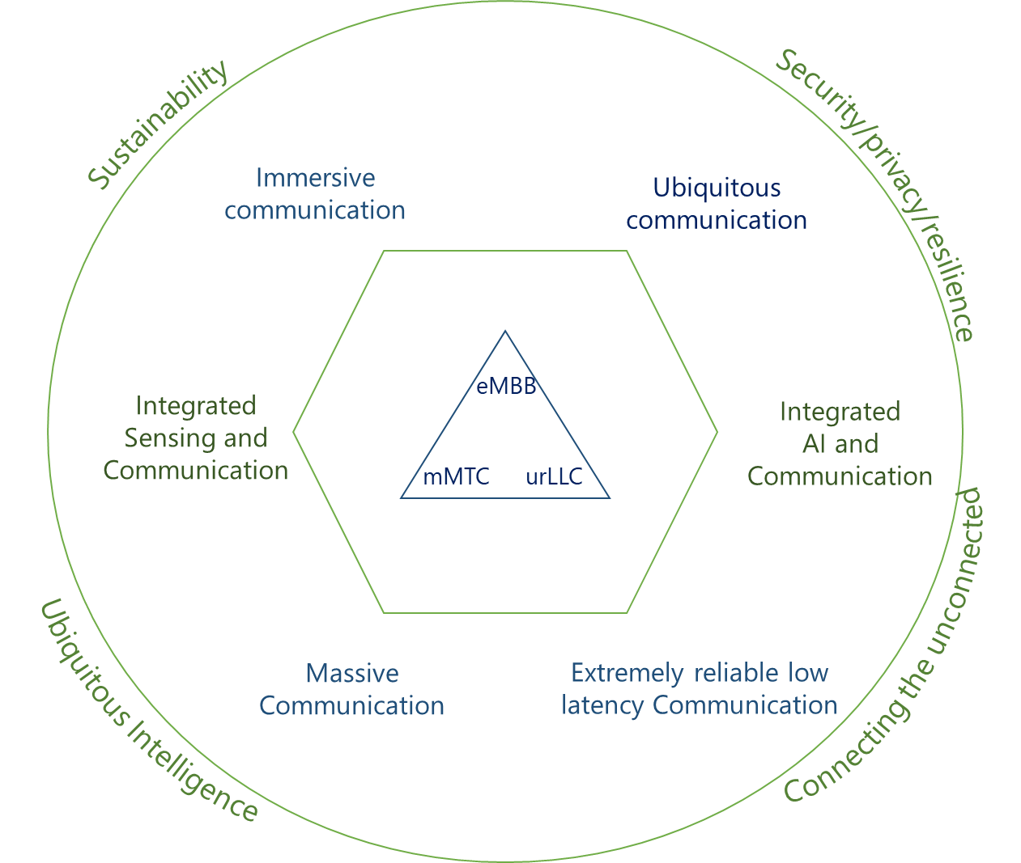
[Editor’s note: Where to place this text below needs to be discussed in WP 5D #44 meeting.]
Use cases which are not foreseen are expected to emerge, and some of the use cases might be enabled by different set of capabilities inherited from multiple usage scenarios. For future IMT, flexibility will be necessary to adapt new use cases that come with a wide range of requirements.
Future IMT systems would encompass a large number of different features. Depending on the circumstances and the different needs in different countries, future IMT systems should be designed in a highly modular manner so that not all features have to be implemented in all networks.

4 Capabilities of IMT-2030
IMT-2030 is expected to provide enhanced capabilities than those described in Recommendation ITU-R M.2083, as well as new capabilities to support the expanded usage scenarios of IMT-2030. In addition, each capability will have different relevance and applicability in the different usage scenarios.
The [range of/target] values given for capabilities are the estimated targets for research and investigation for IMT-2030. All target values within the range have equal priority may be further developed in other ITU-R Recommendations/Reports and may be revised in the light of future studies. Exact targets may further depend on certain parameters and assumptions including, but not limited to the frequency band of operation, the available bandwidth, deployment scenario, and other parameters, and the values stated are for the most favourable such assumptions.
The capabilities of IMT-2030 include:
[CG Convener’s note: Whether to separate the value range of each item into a separate table will be further discussed at the 44th meeting.]
1) Peak data rate
Maximum achievable data rate under ideal conditions per device (in Gbit/s).
The [research] target of peak data rate could be [100 – 200 Gbit/s].
2) User experienced data rate
Achievable data rate that is available ubiquitously across the coverage area to a mobile device (in Gbit/s).
The [research] target of user experienced data rate could be [500 – 1 000 Mbit/s],.
3) Spectrum efficiency
Spectrum efficiency refers to average[/peak/5th percentile] data throughput per unit of spectrum resource and per cell (bit/s/Hz).
The [research] target of spectrum efficiency could be [1.5 – 3 times of IMT-2020].
4) Area traffic capacity
Total traffic throughput served per geographic area in Mbit/s/m².
The [research] target of area traffic capacity could be [50 – 500 Mbit/s/m²], subject to deployment scenario.
5) Connection Density
Total number of connected and/or accessible devices per unit area (per km²).
The [research] target of connection density could be [10⁶ – 10⁸] devices/km².
6) Mobility
Maximum speed, at which a defined QoS and seamless transfer between radio nodes which may belong to different layers and/or radio access technologies (multi-layer/-RAT) can be achieved (in km/h).
The [research] target of mobility could be [500 – 1 000] km/h.
7) Latency over the air interface
Latency over the air interface refers to the contribution by the radio network to the time from when the source sends a packet of a certain size to when the destination receives it (in ms).
The [research] target of latency (over the air interface) could be [1 – 0.1] ms.
8) Reliability
Reliability over the air interface relates to the capability of transmitting a given amount of traffic within a predetermined time duration with a given success probability.
The [research] target reliability (over the air interface) could be [(1-10⁻⁵) – (1-10⁻⁷)].
9) Coverage
Coverage refers to the delivery of services with the required quality metrics to end-users over a desired geographical area of service, so that users can benefit from the expected services in both uplink and downlink directions.
Coverage can be quantified and depends on a variety of parameters such as the availability [and characteristics] of the spectrum used to deliver the applications and services, the characteristics of the networks and devices used, the radio access interface and other physical layer elements determining the maximum acceptable coupling loss or as a specific minimum throughput at cell edge distance.

The target value for maximum coupling loss is [140-160] dB or minimum throughput is [0.1-5] Gbps at cell edge distance
10) Positioning
Positioning is the ability to calculate the approximate position of connected devices. Positioning accuracy is defined as the difference between the calculated horizontal/vertical position and the actual horizontal/vertical position of a device.
Target positioning accuracy could be [1 – 10] cm .
11) Sensing-related capabilities
Sensing-related capabilities refer to the ability to provide certain functionalities in the radio interface including range/velocity/angle estimation, object detection, localization, imaging, mapping, etc. These capabilities could be measured in terms of accuracy, resolution, detection rate, false alarm rate, etc.
[CG Convener’s note: Option 1 is for qualitative case. Option 2 is for quantitative case. This should be discussed further at WP 5D #44.]
Option 1: [Target [localization] accuracy of range resolution could be [cm order (and sub-cm)].]
Option 2: [Target [localization] accuracy of range resolution could be [cm order (and sub-cm)] in 3D and velocity could be [10] kmph.
12) AI-related capabilities
AI-related capabilities refer to the ability to provide certain functionalities throughout the IMT systems to support AI/ML enabled applications for users [and to further enhance the communication associated capabilities]. These capabilities include data collection, distributed AI model training and inference, computing, etc.
13) Security, privacy and resilience
Security is defined as preservation of confidentiality, integrity, and availability of information, such as user data and signalling.
Privacy refers to an individual's [right/ability] to determine for themselves when, how, and for what purpose their personal information in particular personally identifiable information is processed by others, while end user privacy includes preventing unauthorized user tracking.
Resilience is the ability of the networks and systems to continue operating correctly during and after a natural or man-made disturbance.
14) Sustainability
Sustainability, or more specifically environmental sustainability, refers to the ability of both the network and devices to minimize greenhouse gas emissions and other environmental impacts throughout their life cycle. As important factors, this includes improving energy efficiency, minimizing energy consumption and minimizing the use of materials and other resources/ improving architecture designing and manufacturing procedures, for example by optimizing for longevity, repair, reuse and recycling.

14.1) Energy efficiency
Energy efficiency is a quantifiable metric of sustainability and has two aspects:
– on the network side (radio access network (RAN) and core network (CN)), energy efficiency refers to the quantity of information bits transmitted to/ received from users, per unit of energy consumption of the RAN (in bit/Joule).
– on the device side, energy efficiency refers to quantity of information bits per unit of energy consumption of the communication module (in bit/Joule).
The target metrics are [TBD] for both RAN and device; depending upon the spectrum bands that are identified for IMT 2030.

15) Waveform Efficiency
This is defined as operating point of the transmit waveform as a percentage of the saturation power of the power amplifier (PA).
The potential value can be [TBD]% for either DL or UL or both waveforms depending on deployment scenario.
[Editor’s note: This should be moved to the quantifiable section while renumbering]
16) Interface Interoperability
Interface interoperability refers to the openness of the interfaces defined between nodes in a radio network (system) and as can be validated in an inter-system plug and play deployment scenario. Interface interoperability is defined as the % of inter-vendor interfaces which are interoperable against the total number of inter-vendor interface.
The target value is100%
[Editor’s note: This should be moved to the quantifiable section while renumbering]
17) Compossibility
Compossibility refers to the degree of freedom provided by the Radio network architecture to scale in terms of Usage Scenario. The objective is to achieve “Service Separation” during deployment of one or multiple of Usage Scenarios at a given location.

[Editor’s note: It was agreed during WP 5D #43 the illustration figure for capabilities could consider the following elements:
1) Stand-along description of capabilities or description with evolution of capabilities from IMT-2020.
2) Do not include use cases.
3) May include explicit value/range.
4) May make comparison with IMT-2020 value in Recommendation ITU-R M.2083.
5) Aiming to include all agreed capabilities (both qualitative & quantitative) in the figure.
6) adding the description for ‘range of values’ to the figure

[CG Convener’s note: Following two texts as a description for ‘range of values’ to the diagram were proposed to the CG. It will be discussed at WP 5D #44.]
[Option 1, CG-5 GSA]
The range of values given for capabilities are the estimated targets for research and investigation for IMT-2030. All values within the range have equal priority, and they may be further developed/reconsidered in other ITU-R Recommendations/Reports.
[Option 2, CG-8 KOR]
The range of values are only targets for research and investigation.
]
The capabilities of IMT-2030 are shown in Figure B.

[CG Convener’s note: According to the outcome of the CG, the following two options will be discussed further at WP 5D #44.]
[Option 1: Stand-alone type]
[Editor’s note: Missing capabilities of Coverage, Waveform Efficiency, Energy Efficiency, Interface interoperability and Compossibility needs to be added in the image below.]

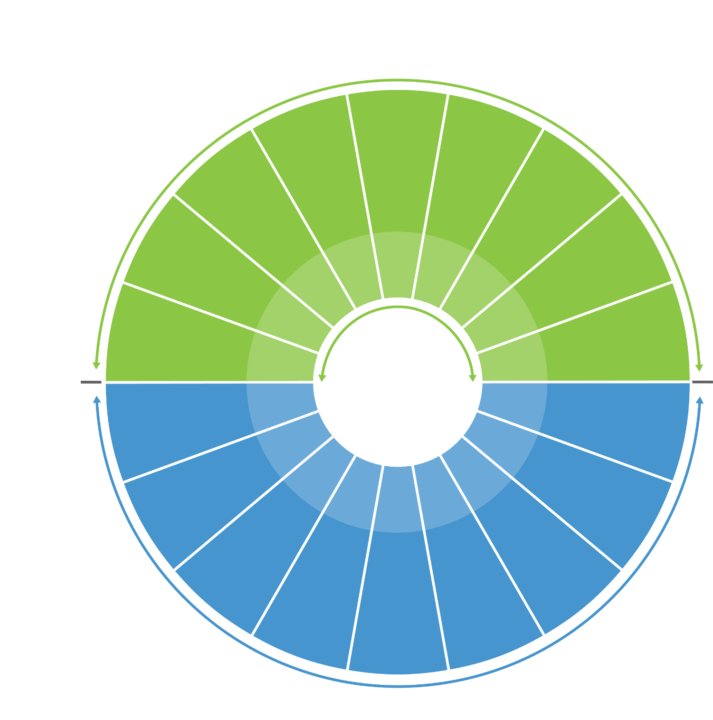
Peak data rate (100-200 Gbit/s)
User experienced data rate (500-1,000 Mbit/s)
Spectrum efficiency
(1.5-3x of IMT-2020)
Area traffic capacity (50-500
Mbit/s/m²)
Connection density
(10⁶ – 10⁸
devices/km²)
Mobility
(500-1,000 km/h)
Latency
(0.1-1ms)
Reliability
(1-10⁻⁵-1-10⁻⁷)
Security, privacy, and resilience
20
100
3x of IMT-A
10
10⁶
500
1
1-10⁻⁵
Coverage
[140-160dB]
Positioning
(1-10 cm)
Sensing-related capabilities
AI-related capabilities
Sustainability
Energy efficiency
Waveform Efficiency
Interface Interoperability
Compossibility
Enhanced capabilities from IMT-2020
Capabilities of
IMT-2030
New
capabilities of IMT-2030
Note: The range of values are only targets for research & investigation.
100%
Capabilities of
IMT-2020

<< Note: These changes are made in Section 2.5 over (Annex 3.7 to Doc. 5D/1668)

5 Considerations of ongoing development

The objective of the development of IMT-2030 is to address the anticipated needs of users of mobile services in the years 2030 and beyond. This system is to be developed to deliver fiber broadband to every home and integrated dense wireless and optical network, with wireless communications primarily serving mobile users. This section provides relationships between IMT-2030 and existing IMT, other access systems, timelines and focus areas for further study.

5.1 Relationships

5.1.1 Relationship between IMT-2030 and existing IMT
In order to support emerging usage scenarios and applications for 2030 and beyond, it is foreseen that development of IMT-2030 would be required to offer enhanced capabilities as described in § 4. The values of these capabilities go beyond those described in Recommendation ITU-R M.2083. The minimum technical requirements (and corresponding evaluation criteria) are to be defined by ITU-R based on these capabilities for IMT-2030. They could potentially be met by adding enhancements to existing IMT, incorporating new technology components and functionalities, and/or the development of new radio interface technologies.
Furthermore, IMT-2030 is envisaged to interwork with existing IMT.
>>

As addressed in Recommendation ITU-R Y.4600, a digital twin is a digital representation of an object of interest and may require different capabilities according to the specific domain of application, such as synchronization between a physical thing and its digital representation, and real-time support.
As addressed in “Global strategy on digital health 2020-2025” of WHO, “Digital health: The field of knowledge and practice associated with the development and use of digital technologies to improve health. Digital health expands the concept of eHealth to include digital consumers, with a wider range of smart-devices and connected equipment. It also encompasses other uses of digital technologies for health such as the Internet of things, artificial intelligence, big data and robotics.”
The term “ubiquitous” is related to the considered target cell coverage area and is not intended to relate to an entire region or country.
The term “ubiquitous” is related to the considered target coverage area and is not intended to relate to an entire region or country.
The radio coverage area over which a mobile terminal can maintain a connection with one or more units of radio equipment located within that area. For an individual base station, this is the radio coverage area of the base station or of a subsystem (e.g., sector antenna).

