 | INTERNATIONAL TELECOMMUNICATION UNION  TELECOMMUNICATION  STANDARDIZATION SECTOR  STUDY PERIOD 2022-2024 |  | SG11-TD474/GEN
 |  |  | STUDY GROUP 11
 |  |  | Original: English
Question(s): |  | 12/11 |  | Geneva, 10-19 May 2023
TD
Source: |  | Editor
Title: |  | Output – baseline text of draft Recommendation Q.TSRT_IoT “Test specifications for remote testing of Internet of Things using the probes” (Geneva, 10-19 May 2023)
Contact: |  | Anshul Kumar Gupta  TEC, DoT  Ministry of Communication, India |  |  | Tel: +91 9785951159  E-mail: anshulkr.gupta@gov.in

Abstract: | This TD contains the output document of draft Recommendation Q.TSRT_IoT “Test specifications for remote testing of Internet of Things using the probes”. It incorporates changes proposed in C108-R1 and according to discussion which took place at Q12/11 meeting in May 2023.

Draft new Recommendation ITU-T Q.TSRT_IoT
Test specifications for remote testing of Internet of Things using the probes
Summary
Internet of Things, defined in Recommendation ITU-T Y.2060, nowadays plays an important role for telecommunication and information technologies.The Internet of things (IoT) is one of the global infrastructures for the information society, delivering advanced services by interconnecting things based on, existing and evolving, interoperable information and communication technologies.
Currently, methods of remote testing of network equipment are actively used. During testing, special attention is paid to the quality of service parameters (delays, losses, jitter, bandwidth and etc.), however, in relation to the specifics of the IoT devices, it is most appropriate to control the parameters of the functioning for end devices. IoT devices, as a rule, have battery power and monitoring of their operation parameters will allow timely adjustments to the algorithms of their functioning in order to extend the battery life.
The use of probes will allow to address the IoT device and conduct remote testing of various parameters of the Internet of Things devices, such as: power consumption, memory and processor operation, open interfaces, etc. The description of the test specifications for testing will allow us to develop a unified approach for conducting appropriate tests IoT devices.
Keywords: Internet of things, Test specification, Remote testing, Probe

Draft new Recommendation ITU-T Q.TSRT_IoT
Test specifications for remote testing of Internet of Things using the probes

1 Scope
This recommendation describes test specifications for remote testing of Internet of Things devices using the probes.

2 References
The following ITU-T Recommendations and other references contain provisions which, through reference in this text, constitute provisions of this Recommendation. At the time of publication, the editions indicated were valid. All Recommendations and other references are subject to revision; users of this Recommendation are therefore encouraged to investigate the possibility of applying the most recent edition of the Recommendations and other references listed below. A list of the currently valid ITU-T Recommendations is regularly published. The reference to a document within this Recommendation does not give it, as a stand-alone document, the status of a Recommendation.

[ITU-T Q.3056] Recommendation ITU-T Q.3056,Signaling procedures of the probes to be used for remote testing of network parameters
[ITU-T Q.3952] Recommendation ITU-T Q.3952, The architecture and facilities of a model network for Internet of things testing.
[ITU-T Q.4062] Recommendation ITU-T Q.4062, Framework for IoT testing
[ITU-T Q.4063] Recommendation ITU-T Q.4063, Framework for testing identification systems used in Internet of things
[ITU-T Y.2060] Recommendation ITU-T Y.2060, Overview of Internet of Things.
[ITU-T Y.2066] Recommendation ITU-T Y.2066, Common requirements of the Internet of Things.
[ITU-T Y.2067] Recommendation ITU-T Y.2067, Common requirements and capabilities of the gateway for Internet of Things applications.
[ITU-T Y.2069] Recommendation ITU-T Y.2069, Terms and definitions for the Internet of Things.
[ITU-T Y.4500.15] Recommendation ITU-T Y.4500.15/Q.3955, oneM2M – Testing framework.
TBD

3 Definitions

3.1 Terms defined elsewhere
This Recommendation uses the following terms defined elsewhere:
3.1.1 device[ITU-TY.2060]: With regard to the Internet of things, this is a piece of equipment with the mandatory capabilities of communication and the optional capabilities of sensing, actuation, data capture, data storage and data processing.
3.1.2 Internet of things (IoT) [ITU-T Y.2060]: A global infrastructure for the information society, enabling advanced services by interconnecting (physical and virtual) things based on existing and evolving interoperable information and communication technologies.

4 Abbreviations and acronyms
This Recommendation uses the following abbreviations and acronyms:
CoAP Constrained Application Protocol
DUT Device Under Test
HTTP Hypertext Transfer Protocol
GW Gateway
IANA Internet Assigned Numbers Authority
MQTT Message Queue Telemetry Transport
TCP Transmission Control Protocol
UDP User Datagram Protocol
OS Operating System
TBD

5 Endorsement
None.

6. Architecture of system for remote testing of IoT-devices using probes:
IOT devices under test (Without OS)

Wi-fi, BLE, Lora,Sigfox, LTE, 6Low PAN, ZWave, ZigBee
IOT device under test
IoT Gateway

IoT Gateway

Wi-fi, BLE, Lora, Sigfox,
LTE,6Low PAN, ZWave , ZigBee

MQTT, COAP, HTTP,AMQP
IOT devices under test (with OS)

Wi-fi, BLE, Lora,Sigfox, LTE, 6Low PAN, ZWave, ZigBee
IOT device under test

Internet
Probe
IoT Test Server

Web interface

Web interface
Probe
IoT Cloud server

User


User

Figure 1– Architecture of a system for remote testing of IoT-devices using probes
Depending on the particular features of the network construction and the tasks, all the elements and subsystems indicated in this clause may be used jointly or separately in different combinations, including in a single hardware system.
A system for remote testing of IoT-devices has user client- cloud server architecture and comprises the following elements:
Probe – A test tool which uses probing packets to collect measurements of various parameters of the IoT device under test. It can either be a hardware and/or software.

6.1IoT Test Server
The block diagram of the service core is shown in Figure 2 and includes a cloud server and a database management system.
Information transmitted via MQTT, CoAP, XMPP, DDS, AMQP, HTTP data transfer protocols can be in any format (platform independent). As a client of the software platform, it is assumed to use a PC or a smartphone with a browser (Chrome, Internet Explorer, Firefox).
The key functions of the software platform service core are:
- Registration, modification and removal of user devices in the system.
- Ensuring interaction with user devices through data transfer protocols MQTT, CoAP, XMPP, DDS, AMQP, HTTP.
- Automated collection and processing of data coming from user devices with various protocols and interfaces.
- Providing system users with a template for generating recommended signatures for data transfer protocols MQTT, CoAP, XMPP, DDS, AMQP, HTTP.
- Creation, storage and modification of user signatures and use cases.
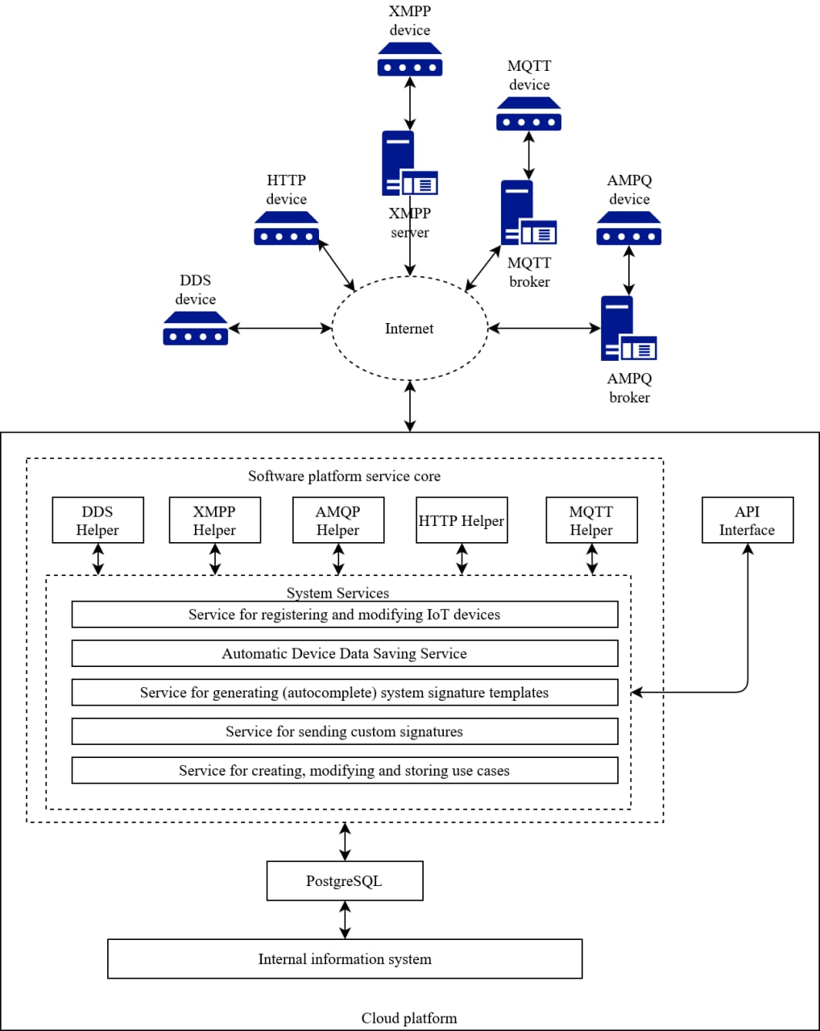
Figure 2 - Structural diagram of IoT Test Server

The block diagram reflects the architecture of the service core of the software platform, consisting of:
- IoT Test Server
- Database management systems - a cluster of an object-relational database management system to improve the fault tolerance of the platform.
- Software platform service cores:
• DDS Helper - implements the publisher-subscriber pattern of the DDS machine-to-machine communication protocol, the helper can simultaneously act as a subscriber and publisher. Also provides customization of user-selected QoS policy.
• XMPP Helper - Authorizes in a third-party XMPP server selected by the user, creates and/or joins private chats and group rooms, sends invitations to initiate chats to other users and IoT devices.
• AMQP Helper - Performs queuing and dequeuing, message sending and receiving, and connection and authorization, through standard authentication or X.509 certificate peer verification, in a third-party or custom AMQP broker.
• HTTP Helper - Listens on the standard HTTP (80) and HTTPS (443) application layer protocol ports. Implements the identification of users' Internet of Things devices through tokens and Basic authorization. If there are no authentication fields, it is required to transfer data by device identifier number (if this method is specified as allowed)
• MQTT Helper - Performs connection and authorization in a third party or custom MQTT broker. Implements a mechanism for creating modifications and deleting subscriptions. It also allows the software platform and the user to act as a publisher.
• System Services – is a layer that provides interaction between the external interfaces of the software platform and the DBMS cluster.
TBD

7.Remote testing of IoT device using probes

7.1 Probes for IoT device detection and classification
IoT device detection is one of the most important preliminary stages. Scanning open network ports might be used for detection of IoT devices.
For the purpose of detection and classification of IoT devices, the probes may be generally categorized as:
7.1.1 Port scanning probe: It finds active IoT devices in the network by scanning ports on specified IP addresses. The port scanning probes scan common ports using TCP connect scan and detects open network ports on device which respond to port scan query. The probe results different combination of open ports for each device.
7.1.2 Classifier probe: After the port scanning probe, the classifier probe may be initiated. It classify the IoT device based on open network ports number and the application data transfer protocol used on this network port. A hierarchical approach with optimal probing may be used by which device may be classified correctly.
Most of the IoT devices are manufactured for specific (and limited) tasks, they expose different sets of protocols operating on port numbers specific to the device. For example Constrained Application Protocol (CoAP), Message Queue Telemetry Transport (MQTT), Hypertext Transfer Protocol (HTTP) etc. The non-profit organization "Internet Assigned Numbers Authority" (hereinafter "IANA") determines the fixed port numbers which are used for certain purposes and establishes a correspondence between them, and the application-layer protocols applied. By comparing the list of detected network ports on the scanned device and the IANA database, the application data transfer protocol used on this network port can be determined.
Other ports not listed in the IANA database that use TCP protocol for data transfer typically send a response to any request. The response received from the device allows determining of which application-layer protocol the port is using.

7.1.3 Identification Probe: Depending on the classification of IoT device, the identification probe may be initiated. It determines the type of IoT devices by analysing the information contained in the data field of the received packets. The identification probe will also gather additional information about the device, like the applications running it, and additional attributes, such as memory, network cards, and drivers.

7.2 Methodology for polling IoT devices using probes
7.2.1 IoT devices with OS
After the previous stage IoT device detection and classification, the list of IoT devices and their parameters is fixed in the system: information about the device and a set of protocols used.
Based on the set of protocols used, a request queue is formed to periodically poll the probe of IoT device. An association is formed between the request and the value received.
Values are passed as a byte string. The use of byte strings is due to a decrease in the load on both the IoT device and the communication network.

Table 7-1Example describes the server request from probe:
Table 7-1 Example of structure for the server request from probe
Start sequence | Length | Device ID
4 bytes | 2 bytes | 8 bytes
Message ID | Timestamp | Message type
1 bytes | 8 bytes т | 1 byte
Payload |  | End sequence
[***] |  | 4 bytes

Start and end sequence - a fixed set of bytes indicating the beginning and end of the message.
Length - the number of bytes occupied by all fields, except for the payload length, start and end sequence fields.
Device ID - a unique value assigned by the information collection platform for this device
Message ID- message number. Changes cyclically from 0 to 255, to avoid re-counting messages and skipping replies.
Timestamp - the time of relevance of the transmitted data.
Message type is a value associated in the system with event types to understand the level of importance of the message.
Payload - directly data transmitted from the device.

Probes are polled from the server at certain time intervals. If there is no response from the probe, a record is generated and a new attempt to establish a connection is placed in the request queue.
The system has a single query execution queue between the server and the probe to prevent simultaneous polling of all probes and creating a heavy load on the communication network.
Reference parameters for comparison are a set of primary data obtained from the probe or values set for a specific type of IoT device.
After collection, the data is recorded in a single event format, which records the type of event, source, time and transmitted data.
Depending on the type of message, it either immediately generates an alert for the administrator, or waits in line to write to the database.
Thus, all parameters of IoT devices in the communication network are constantly monitored. However, each IoT device with a probe can report a sudden state change.
The division of all records into events allows you to analyze both changes in a specific IoT device and changes in the entire communication network both in time and in any other parameters.
For example, if processor utilization increases or open software ports appear.

To monitor the status of IoT devices using a microprocessor, it is possible to implement two types: by polling or automatic sending, as well as a combined option, when the IoT device sends the basic set of parameters on its own, and the extended set is issued only upon request.

7.2.2 IoT devices without OS (only firmware)

- IoT devices working with server directly:-

To track the status of IoT devices using a microprocessor, it is possible to implement either the ability to respond to requests with the transfer of the necessary parameters, or to send data independently at a certain time. The choice of implementation depends on the functions of the IoT device (either it is constantly connected to the network, or it is in sleep mode and wakes up only during the measurement and data transfer.
It is assumed that only devices using the operating system for microcontrollers (for example, RTOS) will be able to use the tracking functionality, in other cases, the implementation of support falls entirely on the shoulders of hardware software developers.

- IoT devices working with server via broker:-

IoT devices using protocol like MQTT, AMQP communicate to network through broker server which is based on Publish/Subscribe messaging method. Broker is responsible for receiving network connections from the client IoT devices and handling the client’s requests of Subscribe/Unsubscribe and Publish to the topic, as well as forwarding the messages published by the publisher client Iot device on a topic to other subscribers IoT devices of that topic.
To track status of IoT devices, a parent topic i.e. Test probe may be created to broker from remote test/user client by publishing to topic and other IoT devices connected, can subscribe tothe parent topic.The parent topic may contain the message for subscriber IoT devices to transfer the necessary parameters for subscriber IoT devices. The subscriber Iot device of the parent topic may also publish another topic i.e. Testprobe/IoT-1 to which test/user client may subscribe.
For getting parameters from IoT devices, a test/user client sends message/command for publish the topic i.e Testprobe to broker through network which sends message/command to subscriber IoT devices. In response, IoT devices will be publishing to parameter data to broker for topic i.e. Testprobe/IoT-1 and broker send the parameter data to test/user client. The data may be recorded in server for analysis.For IoT devices with resource constraints (Low power, low CPU/memory), only critical data may be requested by remote test/user clients via the broker. As such devices may also operate in a Wake-on-request mode; this critical data may be piggybacked with the response message to the Wake-on-request message. In case the IoT device loses its connection with the broker, the "last seen" status of the IoT device, as recorded by the Broker may be sent to the remote test/user client upon request. "

7.2.3 Proprietary IoT devices

To track the state of IoT devices, the hardware software of which cannot be changed, a support module is created in the core of the software platform. Such modules for interacting with the IoT device implement API calls available for the IoT device, provided by the manufacturer, or it is possible to parse the configuration WEB page, and format the data in the required format to write to the service database.

8. Collected data analysis module

8.1 Static characteristics and dynamic characteristics
All data transmitted from devices can be divided into 2 categories: static characteristics and dynamic characteristics.
For ESP8266 and ESP32 devices, the following categories can be obtained.
The staticcharacteristics include:
● MAC address of the device
● Device IP address
● Software version
● Device name
Dynamic characteristics include:
● Used RAM
● Temperature

In the case of devices with Linux operating system (for example, devices of the Raspberry Pi family), a greater number of device characteristics, both static and dynamic, can be obtained.
The static characteristic include:
● MAC address of the device
● Device IP address
● Software version
● Device name
● Number of processor cores
● The amount of disk space for each logical partition. In connection with the virtual fragmentation of the disk into parts, which are called partitions
● Network interfaces, etc.

Dynamic characteristics include:
● Used RAM
● Graphics card temperature
● The number of transmitted network packets;
● Number of network packets received;
● The amount of disk space for each logical partition. In connection with the virtual fragmentation of the disk into parts, which are called partitions;
● The amount of used disk space for each logical partition;
● Load per processor core, etc.
Static data processing does not require additional software implementation. Working with such data involves tracking changes in their state and transferring information about changes in static characteristics to an administrator or user. These changes can be an important indicator in case of emergency situations with the device, up to access to the device by third parties and detection of the fact of an attack on the device.
Processing dynamic data requires additional software implementation. Working with such data involves tracking changes in these indicators over time. As a result of the analysis, tables with processed data are formed. Based on this data, graphs are subsequently dynamically drawn, which clearly demonstrate changes in parameters over time. In addition, some parameters are subjected to additional mathematical processing in order to calculate the resulting value of the parameter. For example, the percentage of successfully sent and received network packets. Thus, the data analysis module allows you to sort and process the data received in the monitoring module into special tables, each of which is responsible for a specific characteristic (parameter).
Also, the collected data analysis module allows you to assess the state of Internet of Things devices by analyzing the frequency of changes in transmitted information. If the response from the device was not received within the expected period of time, actions are taken similar to those in case of a change in the static characteristics of devices.

8.2 Set of parameters for monitoring Internet of things devices collected by probes
The set of parameters for monitoring Internet of things devices can be different and depends on the characteristics of the Internet of things device itself. IoT devices can be classified with and without an operating system, with a microprocessor and a microcontroller, etc.
To systematize, the set of parameters for monitoring of Internet of things devices is present at Recommendation ITU-T Q.3913 «Set of parameters for monitoring Internet of things devices» (08/2014).
Below are the main set of parameters for monitoring Internet of things devices collected by probes.

- Traffic parameters. Traffic measurement can be applied in usage-based accounting, traffic profiling, traffic engineering, attack/intrusion detection and QoS monitoring. For example, flow-based traffic measurement can be used to help determine device performance or behaviour through the analysis of the measurement parameter values.
- General
- Flow-based IP traffic measurements

- Anomalous behaviour and events parameters.Monitoring anomalous behaviour or events is an important aspect of security threat detection. A baseline of normal behaviour must be identified over a period of time. Once certain parameters have been defined as normal, any departure from one or more of these parameters is flagged as anomalous. Many anomaly detection algorithms have been proposed that differ in the information used for analysis and in the techniques that are employed to detect deviations from normal behaviour. Examples of anomaly detection methods include statistical methods, rule based methods, profiling methods and model-based approaches.
- Abnormal service activity
- Mismatch between IMEI/MEID and IMSI
- Loss of connectivity
- Change of location
- Unusual logon activities

- Performance parameters
- Delay
- Packet loss rate
- Throughput
- Link utilization
- Availability

- Battery parameters. A device may use a battery as a power supply when the device is mobile, in open country or when the mains power supply is out of service. Some battery parameters should be monitored to indicate the battery state, longevity and capacity so that the operator is informed of the current or future sate of the device.
- Temperature
- Voltage
- Discharge current
- Charging current
- Remaining capacity of the battery

TBD

Appendix I
Testbed for remote testing of Internet of Things using the probes
(This appendix does not form an integral part of this Recommendation.)
TBD

______________________

