 | INTERNATIONAL TELECOMMUNICATION UNION  TELECOMMUNICATION  STANDARDIZATION SECTOR  STUDY PERIOD 2022-2024 |  |  | SG11-TD403/GEN
 |  |  |  | STUDY GROUP 11
 |  |  |  | Original: English
Question(s): |  |  | 14/11 | Geneva, 10-19 May 2023
TD
Source: |  |  | Editors
Title: |  |  | Output – draft baseline text of Recommendation ITU-T Q.N-att-framework “Framework of NFV automated testing” (Geneva, 10-19 May 2023)
Contact: |  | Linze Wu  China Telecom  China |  |  | Tel: + 86 20 38639090  E-mail: wulinz@chinatelecom.cn
Contact: |  | Krishna Kumar Lahoti  Criterion Network Labs  India |  |  | Tel: +91 7207580125  E-mail: krishna@cnlabs.in

Abstract: | This document is the output of draft Recommendation Q.N-att-framework “Framework of NFV automated testing”. This document includes the results of discussion during the Q14/11 meeting, which was held on 10-19 May 2023, Geneva.

The following table shows discussion results for input documents:

DOC No. | Source | Title | Result and action
C207R1 | India | Proposal to advance baseline text of draft ITU-T Recommendation Q.N-att-framework “Framework of NFV automated testing”. | Accepted with modification
C139R1 | China Telecom | Proposal for updating clause 4 and clause 8 in draft ITU-T Q.N-att-framework | Accepted
Major issues of the draft Recommendation are summarized as follows.
- Abbreviations and acronyms are added in clause 4;
- Add NFV test objective based on NFV architecture in clause 6 to give a whole picture of NFV testing;
- More NFV automated testing scenarios are given in clause 7;
- Refine requirement description and add more requirements in clause 8.
It is recommended that future contributions cover following topics:
- Enhance the descriptions in the main body for consent;
- But not limited to.

Draft Recommendation ITU-T Q.N-att-framework
Framework of NFV automated testing
Summary
The purpose of this Recommendation is to provide a framework for NFV automated testing. Firstly, as a high-level demand, design consideration for NFV automated testing is analyzed. Then, framework requirements for NFV automated testing will be derived based on the use case. Besides, reference framework and reference implementation of NFV automated testing will also be introduced.
Keywords
NFV, automated testing, framework

Table of Contents
Page
1. Scope 5
2. Reference 5
3. Definition 5
3.1. Terms defined elsewhere 5
3.2. Terms defined in this Recommendation 5
4. Abbreviations and acronyms 6
5. Conventions 6
6. Overview of NFV architecture and NFV automated testing 6
6.1. NFV architecture 6
6.2. NFV automated testing 7
7. Design consideration of NFV automated testing 8
7.1. Role consideration for NFV automated testing: 8
7.2. Support of single component test and scenario test 8
7.3. Support of reusability and flexibility 8
7.4. Support of test result reliability 8
8. Framework requirements 9
8.1. Test scheme template management function requirements for framework of NFV automated testing 9
8.2. Test case management function requirements for framework of NFV automated testing 9
8.3. Test task management function requirements for framework of NFV automated testing 10
8.4. Test orchestration function requirements for NFV automated testing framework 10
8.5. Test tool management function requirements for NFV automated testing framework 11
8.6. Test report management requirements for NFV automated testing framework 11
8.7. Test object management requirements for NFV automated testing framework 11
9. Reference NFV automated testing framework 11
Appendix I. Use cases of automated testing of NFV 11
I.1 Use case template 11
I.2 Use case of test case template 12
I.2 Use case of test reliability 14

- Scope
This Recommendation provides the framework of NFV automated testing. This Recommendation addresses the following subjects:
- Overview of NFV architecture and NFV automated testing
- Design consideration for NFV automated testing
- Framework requirements
- Reference NFV automated testing framework
- Use cases of NFV automated testing
- Reference
The following ITU-T Recommendations and other references contain provisions which, through reference in this text, constitute provisions of this Recommendation. At the time of publication, the editions indicated were valid. All Recommendations and other references are subject to revision; users of this Recommendation are therefore encouraged to investigate the possibility of applying the most recent edition of the Recommendations and other references listed below. A list of the currently valid ITU-T Recommendations is regularly published. The reference to a document within this Recommendation does not give it, as a stand-alone document, the status of a Recommendation.
[ETSI GS NFV 002] Recommendation ETSI GS NFV 002 (2014), NFV architecture for including references to documents of other organizations in ITU-T Recommendations
[TBD]
- Definition
  - Terms defined elsewhere

[Editor’s NOTE on July 2022]: Definition of NFV in this Recommendation should be addressed. Contributions are invited .
This Recommendation uses the following terms defined elsewhere:
3.1.1 test case [ITU-T Y.4500.15/Q.3955]: Specification of the actions required to achieve a specific test purpose, starting in a stable testing state, ending in a stable testing state and defined in either natural language for manual operation or in a machine-readable language (such as testing and test control notation version 3 (TTCN-3)) for automatic execution.
3.1.2 network functions virtualization (NFV) [b-ETSI GS NFV 003]: Principle of separating network functions from the hardware they run on by using virtual hardware abstraction.
[TBD]
  - Terms defined in this Recommendation
This Recommendation defines the following terms:
3.2.1 test orchestration: A process that sorts the execution order of a set of test cases and interactions with the test tools of carrying out certain test cases in an automated manner.
3.2.2 test scheme template: A test scheme template refers to a combination of test cases and relevant test parameters, which can be used directly or be customized based on different requirements.
3.2.3 test task: A test task is the instantiation of a test template, which is created by the tester based on the test template in the test library.
3.2.4 test entity: A test entity is an object in the test script, which corresponds to the test-related software and hardware.
3.2.5 test case template: A test case template is a structured description of a test case, which organizes the unstructured data of the test case into a standardized data structure to simplify the conversion from test case to test script.
[TBD]
- Abbreviations and acronyms
This Recommendation uses the following abbreviations:
API Application Programming Interface
CLI Command Line Interface
ID IDentification
IT Information Technology
MANO Management And Orchestration

NFV Network Function Virtualization
NFVAT NFV automated testing

NF Network Function
NFVI Network Function Virtualization
NFVO Network Function Virtualization Orchestration
NS Network Service
VIM Virtual Infrastructure Management
VNF Virtualization Network Function
VNFM Virtualization Network Function Management
VOLTE Voice Over LTE
5GC 5G Core

[TBD]
- Conventions
[TBD]
- Overview of NFV architecture and NFV automated testing
  - NFV architecture
NFV is a sort of network virtualization technology, which uses software to install, control and operate the network functions running on general hardware. It integrates cloud and virtualization technology, making the new generation of network services have better scalability and automation ability. The goal of NFV is to replace the private, specialized and closed network function in the telecommunication network, and to realize the unified and universal software open architecture.
The underlying technology logic of NFV technology largely depends on virtualization technology. Virtualization technology can decompose general computing, storage, network and other hardware devices into a variety of virtual resources, realize hardware decoupling, and realize network functions and dynamic flexible deployment according to needs. The bottom design philosophy of NFV architecture relies on cloud computing pattern. Cloud computing can realize the elasticity of application or even the matching of resources and business load, which not only improves the utilization of resources, but also ensures the response speed of the system.
The Figure 6-1 [ETSI GS NFV 002] stands for the NFV high-level architecture, including NFVI, MANO and VNF.
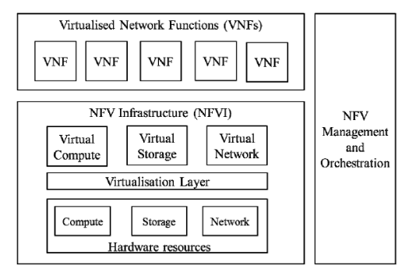
Figure 6-1. High-level NFV architecture [ETSI GS NFV 002]
NFVI includes virtualization layer and hardware resources, which can be deployed across several physical locations. All virtual resources should be in a unified shared resource pool. VNFs run on top of NFVI, which provide some kind of network services deployed in virtual machine, container or bare-metal physical machine by using the infrastructure provided by NFVI. MANO provides the overall management and orchestration of NFV, which is composed of NFVO, VNFM and VIM. They manage, respectively, NS life-cycle, VNF life-cycle and NFVI.
  - NFV automated testing
Three main working layers of NFV are identified: VNF layer, NFVI layer, and NFV MANO layer. Each layer is composed of multi-components, with many participants from different vendors. Each component depends on and calls each other. NFV automated testing should support the following test dimensions for Baseline, Security, NFVI and Assurance so that basic goals of Solution Validation, Interoperability, Verification of SLA/Assurance, and Deployment Readiness can be validated.
Test dimensions for VNF:
- Basic Validation – Verification of core services, verification of LCM operations, onboarding.
- Functionality – verification of basic functionality, after reboot, behaviour with VIM network fault, behaviour when VIM controller is restarted, VIM network restarted, support for IPv6-Only (test by turning off IPv4 on the interfaces),
- Performance – verification based on different resource configurations, max throughput, instance creation/deletion time, forwarding performance benchmarking using different traffic types, packet/frame size, load tests,
- Scale – verification of multiple instances of VNF, max number of VNF, scale-out/in,
- VNFM interactions - Verification of integrity of VNFD/NSD, instantiation, placement, destruction, resilience/recovery, monitoring, backup/restore, updates/roll-back, LCM after rebooting the VNF, VNF config injection/reconfig time,
- NFVO interactions – verification of VNF deployment using available NSDs, Live migration, fault management and logging,
- Service chain,
Test dimensions for NFVI:
- NFVI stack installation
- Fault Management and Log Collection
- MTU changes
- Platform awareness
- NFVI under loaded conditions
- Support for IPv6-Only (test by turning off IPv4 on the interfaces)
- Support for service chain
Test dimensions for MANO (VNFM, NFVO, VIM):
- VNF Types
- Lifecycle Management – VNFD/VNF image onboarding, deployment using supported flavor, instantiation/destruction/resilience/recovery/monitoring/updates/rollbacks.
- Various VIM Infrastructure
- VNF Placement / Scaling
- NFVO Fault Management and Log Collection
- Different types of NFVO (component testing of VNFM)
- End-to-End service orchestration
- Different types of VNFM (component testing of NFVO)
- Different types of VIM (component testing of NFVO)
- Network Service Instantiation
Broad Test Dimensions to cover Interoperability, Compatibility, Assurance, Service Orchestration, Deployment Readiness.
- VNF Onboarding
- VNF Config Upgrades
- Data Plane Performance
- Fault and Healing
- Functionality
- Service Instantiation
- NFV service configuration
- Control Plane Scaling
- Placement constraints
- Use-case specific test cases
Because many realizations of components are private commercial solutions instead of open sourced, the compatibility and interoperability between them are poor, and the system integration complexity is high. In order to promote the application and implementation of NFV architecture, a lot of repetitive testing work needs to be carried out. Compared with traditional IT test, NFV testing has the following features:
- With more components involved, the testing environment is more complicated. Upgrades in each component may lead to changes in the testing environment, requiring re-testing. At the same time, the iteration cycle of NFV network elements is shorter, which requires higher testing frequency.
- Adoption of NFV has cloud-based elastic resource management issues, orchestration issues, operation and maintenance issues, as well as interoperability issues caused by layer decoupling. So, the test content and test scope are larger, including infrastructure testing, VNF functions testing, performance testing, security testing, compatibility testing, interoperability testing, orchestration and management testing of network services, etc.
The testing carried out manually is inefficient and unreliable. There is a need to develop NFV automated testing tools to improve the efficiency and reliability of NFV testing. Test cases in automated testing are usually developed before test execution in the format of scripts which can be executed repeatedly to reduce testing cost. It is also easy to fix the script flaws after they are discovered and modify the script based on different situation. Besides, automated testing takes advantage of a lot of existing testing tools and executes test tasks in parallel.

- Design consideration of NFV automated testing
[Contributor’s note]: This clause describes the design consideration of NFV automated testing, which may include roles consideration, signal component test and scenario test consideration, reusability and flexibility consideration, template-based testing consideration, test result reliability consideration.
  - Role consideration for NFV automated testing:
There are three roles involved in NFV automated testing, test designer, script developer and tester:
- Test designer: test designer is responsible for the design of NFV test plan. Based on the test purpose, the role involves identifying what test cases need to be conducted with which test tools during the test, determining the execution order of test cases, determining what parameters need to be configured. Test designer in NFV automated testing is usually someone with professional NFV background and rich test experience.
- Script Developer: script developer is responsible for the developing of test scripts based on the test cases designed by test designers. Script developer is usually a programmer with a background in computer or software development. There is no need for script developer to have test related experience.
- Tester: tester is responsible for the conduction of test, which involves choosing appropriate test plan, setting up test environment, executing test cases automatically and analyzing testing results. Tester is someone who is familiar with the NFV automated testing tool.

  - Support of single component test and scenario test
Three main working layers are identified in NFV architecture: VNF, NFVI and NFV MANO. Each layer is composed of multiple components. It is necessary for a single component test to make sure it can function correctly. NFV automated testing is required to support single component test.
Applications and implementations of NFV architecture usually include multiple components provided by various vendors from the three working layers. These components work together for different scenario. Examples of NFV scenario are: 5GC, VIMs, VOLTE, Enterprise SD-WAN, E-CORD, Access vCPE, Service Provider vEPC, vCDN, Data Center SDDC and etc. It is essential for a specific scenario test to confirm whether these components are compatible with each other and whether they provide corresponding functions together. NFV automated testing is required to support scenario test.
[TBD]
  - Support of reusability and flexibility
In order to promote the applications and implementations of NFV architecture in different locations, especially for telecommunication provider and manufacturers, many repetitive testing work needs to be carried out. NFV automated testing needs to support test reusability to avoid extra work, which can be achieved by template. Templating includes the templating of test schemes and the templating of test cases, which can be used directly or be customized based on different requirements. They are both the concept of test design time.
Besides, applications and implementations of NFV architecture in different locations may differ from each other because of some special local conditions. NFV automated testing is required to support flexible scalability for testers to adjust test schemes, test cases and relevant test parameters in order to adapt to different conditions.
  - Support of test result reliability
Automated testing requires less manual participation, so there is requirement to ensure the reliability of test results. However, the NFV system is complex, a test task will contain multiple complete test cases, and a complete test case contains multiple steps, each of which performs multiple operations on multiple test objects. The intermediate operating state is difficult to retain. As a result, it is difficult to reproduce the intermediate state after the test, which challenges the reliability of the test results. Through the real-time test log during test execution, the test task stoppage to check the status, and the detailed test report after the test is completed, the reliability of the test results can be guaranteed.
- Framework requirements
[Contributor’s note]: This clause describes the framework requirements of NFV automated testing, which may include test template requirement, test case management function requirement, test orchestration function requirement, test tools management function requirement, test report management function requirement, and test object management.
  - Requirements of NFVAT for test template support
[Editor’s NOTE on July 2022]: These are general descriptions about test templates, research should be done to find if there is any existing Recs which we can refer to.
[Editor’s NOTE on April 2023]: This clause describes the test template requirements of NFV automated testing, which may include test scheme template requirement and test case template requirement.
It is required that NFVAT provides test scheme templates and test case templates for NFV testers.

NOTE 1 – Test scheme template and test case template are the concepts of test design state. Test scheme templates can be divided into component test scheme templates and scenario test scheme templates.
NOTE 2 – A component test scheme template of NFV aims at the testing of a single component which only belong to one working layer in NFV architecture.
NOTE 3 – A scenario test scheme template of NFV aims at the testing of a specific scenario to confirm whether the functional components are compatible with each other and whether they have the ability to provide corresponding capabilities together in the specific scenario. An NFV scenario consists of multiple components from different NFV architecture layers.

It is required that NFVAT provides test scheme template repository and test case template repository to upload, store, update, and delete templates for NFV testers.

It is required that NFVAT generates test case templates according to the test information input by NFV testers.
NOTE 3 – Test case templates includes test case description, inputs, preconditions, test steps, and expected results.
NOTE 4 – Test information input by NFV testers is the description of test steps and expected results.
NOTE 5 – Test case description includes test case ID, test case type, test object, and test case provider.
NOTE 6 – Inputs include the information required for script execution and the serialized byte sequence of the test entity.
NOTE 7 – Preconditions include test cases that this test case depends on, conditions that the test environment needs to meet, and scripts required to verify the conditions.
NOTE 8 – A test step includes step description, preconditions, step identifiers, and step details; the preconditions are used to identify whether the step can be executed; the step details are used to define the specific actions of each step.
NOTE 9 – Step details, define the interaction type, entities involved in the test, interaction content, and output information; the type is CLI or API; the output information includes the log generated by the test step, the entity generated by the test step, and the result of the test step.
NOTE 10 – Expected results describe the final results that the test should obtain.

It is required that NFVAT generates test scripts based on the test case template.
[TBD]
  - Requirements of NFVAT for test task execution
A test task is the instantiation of a test template, a concept of test execution state, which is created by the tester based on the test template in the test template repository. A test task is initialized by just filling test parameters in test cases templates, or by adjusting the test cases contained in the test template and filling test parameters. Test tasks can be divided into scenario test tasks and component test tasks.
It is required that NFVAT provides the management of test parameters, which contains the parameters of test cases, and the parameters of test component/scenario.
NOTE 1 – Example of test case parameters are the type of test case to indicate whether it is a functional test case or a performance test case, test tool which will carry out the test case, and test category parameter closed/semi-closed to identify whether this test case will pass data to other test cases.
NOTE 2 – Examples of test component/scenario parameters are the test object/objects of the test component/scenario, the execution order and number of all test cases, input and output data of all test cases.
It is required that NFVAT manages the life cycle of test tasks, including the creation, start, update, pause and deletion of test tasks.
It is recommended that NFVAT supports the viewing of the intermediate status of the test task execution.
It is recommended that NFVAT provides test detection points and supports troubleshooting during test task execution.
NOTE 3 – The test case script writer sets test detection points and develops test cases according to test requirements during the development of test case scripts.
NOTE 4 – Before testing, NFV tester selects several expected pause positions from the test detection point.
NOTE 5 – During the execution of the test task, when it is executed to the detection point of the test case script, check whether the position of the detection point matches the expected pause position; If it matches, generate a test pause instruction and pause the test task. The tester shall inspect the intermediate state of the test; If it doesn't match, generate the test continue instruction and continue to execute the test task.
It is required that NFVAT monitoring the test task execution metrics to reflect test status.
NOTE 6 – The metrics of NFV automated testing task are used by both NFV tester and operator to know whether a test task works properly. It usually includes resource-level metrics and test-level metrics.
NOTE 7 – Resource-level metrics are metrics of resources used during NFVAT, including compute/network/storage hardware metrics, virtualization layer metrics, virtual compute/network/storage resource metrics, VNF metrics and etc. Each resource-level metrics can be divided into resource utilization rate, resource operation status, resource quantity, and etc
NOTE 8 – Test-level metrics are usually defined by NFVAT designer, and vary from test task to test task. For a 5GC network function testing task, metrics include session number, traffic throughput and etc.
It is required that NFVAT stores the history of test task failure during task execution.
It is required that NFVAT provides user interface for users to create test task, search test task status and view test task results.
[TBD]
  - Requirements of NFVAT for test task orchestration
This function provides process to sort the execution order of a set of test cases and interactions with the test tools of carrying out certain test cases in an automated manner. It interacts between test cases and test tools to help test execution.
It is required that NFVAT provides analysis of test cases to form a process file recording the execution order of each test case in the test template.
It is required that NFVAT carries out test cases in the test template according to the execution order in the process file.
It is required that NFVAT generates independent log files for Main Script Log, VIM log, NFVO log, VNFM log, VNF log for each test case, as applicable.

[TBD]

  - Requirements of NFVAT for test report generation
It is required that NFVAT generates test report of each test task automatically for the NFV tester to download.
It is required that NFVAT provides information about the test task in the report.
NOTE - Information includes stakeholders involved in the test, information about the test environment, all parameters set during the task, records of the execution process, problems found and etc.
It is required NFVAT provides test result to indicate whether the test is passed, partially passed or failed.
It is recommended NFVAT scores the test based on test results.
It is recommended that NFVAT provides setting on the storage time length of the test report, beyond which test reports would be automatically deleted.

[TBD]
  - Requirements of NFVAT for test tool management
It is recommended that NFVAT supports registry of test tool in the test tool catalogue.
It is required that NFVAT provides instantiation ability of test tool according to corresponding test cases and call of test tools to execute test cases.
It is recommended that NFVAT provides version control for test tools.
It is recommended that NFVAT supports pushing test tools from repository to remote NFV test bed.

  - Requirements of NFVAT for test object management
It is required that NFVAT supports registry of test object in the test object catalogue.
It is recommended that NFVAT verifies the network connectivity of test objects.
  - Requirements of NFVAT from system level
It is required that NFVAT can be customizable to accommodate different types of MANO platforms and include at least one open-source MANO platforms.
NOTE 1 – Example of open-source MANO platforms are OSM, ONAP, Tacker, XOS and etc.
It is recommended NFVAT include pre-built dynamically configurable NFVI templates
It is required that NFVAT can be deployed in container and VM infrastructure based on open-source infrastructure platforms.
NOTE 2 – Example of open-source infrastructure platforms are OpenStack and Kubernetes.
It is required that NFVAT provides extensible interface for external hardware traffic generators and network devices.
It is required that NFVAT provides functional and use case focused test suites.
It is required that NFVAT supports customizable for product vendor and end user needs.
- NFV automated testing framework
[Contributor’s note]: This clause will give the reference framework of NFV automated testing.
  - Resource data model
The core elements of resource data models in NFV automated testing include test scheme template, test case template, test task, test case, test tool, test parameter, test object and test report. The relationship among the elements is shown in Figure 9-1.
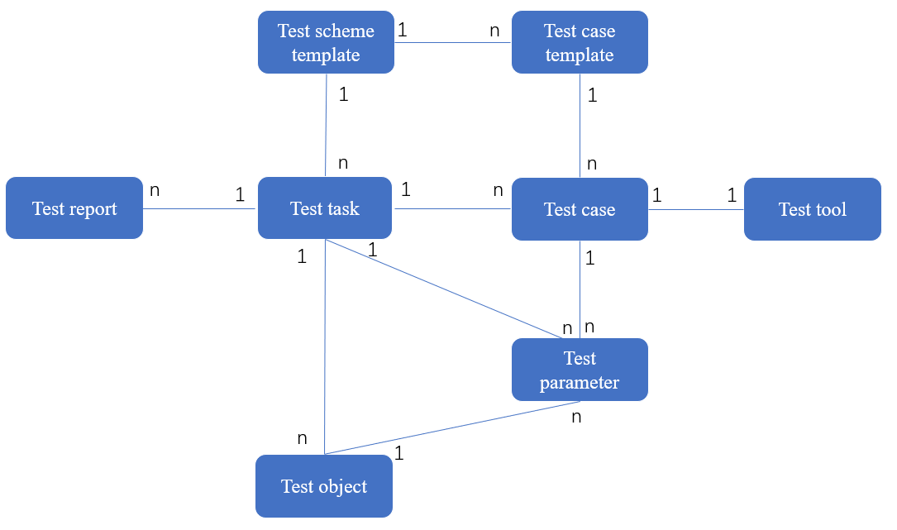
Figure 9-1 resource data model in the NFV automated testing
A test scheme template refers to a combination of test cases templates and relevant test parameters, which can be used directly or be customized based on different requirements. A test case template is a structured description of a test case, which organizes the unstructured data of the test case into a standardized data structure to simplify the conversion from test case to test script. A test task is the instantiation of a test scheme template while a test case is the instantiation of a test case template, both by filling in the parameters. A test object is a managed object which has attributes, operations and notifications to the test task. A test tool is the hardware or software used to carry out or assist in carrying out the test case required. A test report is a document produced at the end of the test giving an overall summary of the test carried out.
  - NFV automated testing stages
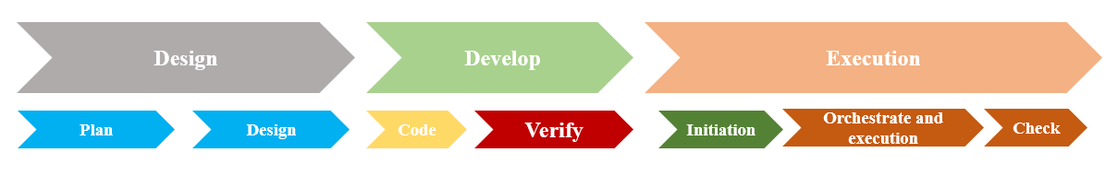
Figure 9-1 NFV automated testing stages
The lifecycle of NFV automated testing includes 8 stages, where each stage is iterative. Each stage defined in Figure 9-1 is described as follows.
- Plan
At this stage, the test designer defines test plan based on the test requirements provided by NFV tester. The test plane can be presented by test task description documents and test case description documents.
- Design
At this stage, the test designer designs what test cases need to be executed to complete the test scheme, what input should be set for each test case template, and the execution order of the test cases based on test plan. Templates are generated after the design is completed, and these templates follow the design consideration in clause 7.
- Code
At this stage, the test developer develops the test script according to the test case template designed by the test designer and the test parameters required by the test case.
- Verify
At this stage, the test developer tests the usability of the test script and resolves bugs found.
- Initiation
At this stage, the tester selects the required test scheme template and instantiates the test task to perform automated testing on the test objects.
- Orchestration and execution
At this stage, the execution order of test cases is generated for the tester to adjust according to specific needs. Then the test tools will carry out those test cases in an automated manner.
- check
At this stage, the tester will get a test report produced by the system. The tester measures and analyzes the report and then conduct acceptance of the test objects. If the acceptance conclusion is failed, new demands will be provided to the product development team.

Appendix I. Use cases of automated testing of NFV
(This appendix does not form an integral part of this Recommendation.)
[Contributor’s note]: This clause will give the use case for exporting clause8.

[TBD]

I.1 Use case template
The use cases developed in Appendix I should adopt the following unified format for consistent readability and convenient material organization.
Table I.1 Use case template
Title | Title of the use case
Description | Scenario description of the use case
Roles | Roles involved in the use case
Figure (optional) | Figure to explain the use case, but is not mandatory
Pre-conditions (optional) | The necessary pre-conditions that should be achieved before starting the use case.
Post-conditions (optional) | The post-condition that will be carried out after the termination of current use case.
Derived requirements | Requirements derived from the use cases, whose detailed descriptions are presented in the dedicated clauses.

I.2 Use case of test case template
Title | Use case of test case template
Description | In the process of NFV testing, NFV tester often need to create a virtual machine for test tools to call. As a basic operation, a test case template can be created for it, which is convenient for repeated use in the future.  This test case template should contain the following information:  - test case id;  - test case type: this test case is a functional test case;  - precondition: the jump host where the test tool is located needs to communicate with the network where the virtual machine will be created, which can be verified by the ping command;  - input information: the name of the virtual machine, the flavour of the virtual machine, the network of the virtual machine, etc;  - test steps: call the API of the virtual infrastructure management platform, request to create a virtual machine;  - expected results: virtual machine1 is successfully created, the operating system of virtual machine1 is working well, and virtual machine1 is in flavour1.  The test case template can be structured as below.  ------------------------------------------------------------------------------------  ID: 002  Test_case_type: functional  Object: OpenStack  Inputs:  - name: flavor_1  type: openstack_flavor  - name: network_1  type: openstack_network  pre_conditions:  dependency: 001 #None  condition: jump host connects to network_1  pre_steps:  - step_id: server_ping_server  description: jump host connects to network_1  step_detail:  entity: $jump host$network_1  type: CLI  content: ping $network_1.gateway  // the gateway of network_1  output:  log: $log1  result: $status1  steps:  - step_id: create_server  description: call openstack create virtual machine API  pre_condition: $status1  step_detail:  entity: $openstack  type: API  content: #API request body  output:  log: $log2  result: $status2  entity: $virtual machine1  Expected results:  - virtual machine1 is successfully created  - the operating system of virtual machine1 is working well  - virtual machine1 is in flavour1  ------------------------------------------------------------------------------------  Based on the test case template, the test case can be easily transformed into test scripts.
Roles | NFV tester
Figure (optional) | 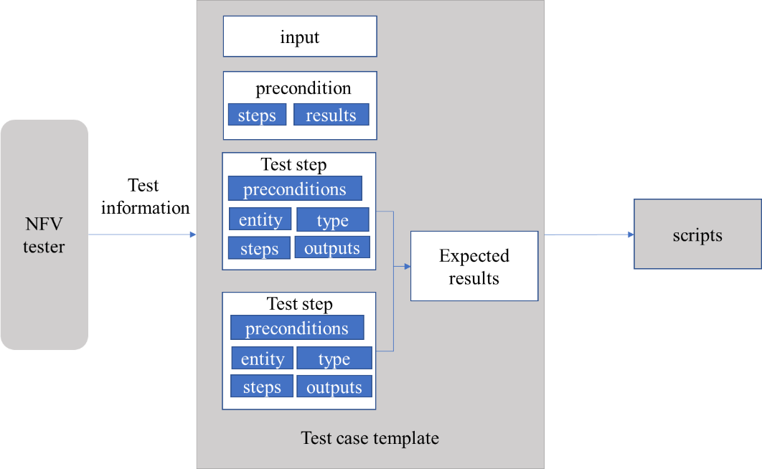
Pre-conditions (optional)
Post-conditions (optional)
Derived requirements | It is required that test case management function generates test case templates according to the test information input by NFV testers. The test case template includes test case description, inputs, preconditions, test steps, and expected results；  NOTE 1 – Test case description information includes test case ID, test case type, test object, and test case provider.  NOTE 2 – Inputs include the information required for script execution and the serialized byte sequence of the test entity.  NOTE 3 – Preconditions include test cases that this test case depends on, conditions that the test environment needs to meet, and steps required to verify the conditions.  NOTE 4 – A test step includes step description, preconditions, step identifiers, and step details; the preconditions are used to identify whether the step can be executed; the step details are used to define the specific interaction of the step.  NOTE 5 – Step details, defines the interaction type, entities involved in the test, interaction content, and output information; the type is CLI or API; the output information includes the log generated by the test step, the entity generated by the test step, and the result of the test step.  NOTE 6 – Expected results describe the final results that the test should obtain.  It is recommended that test case management function provides test case template repository for testers to select the required templates, or add new template to the repository.  It is required that the test case management function generate test scripts based on the test case template.

I.3 Use case of test reliability
Title | Use case of test reliability
Description | Automated testing requires less manual participation. The state of the system usually returns to the initial state after the test is completed. If the automatic testing is executed in the black box, it is difficult to reproduce and check the intermediate state of the test after the test is completed. This reduces the credibility of the final test results. At the same time, if the test is terminated due to problems encountered during the test, these problems may be the problem of VNF service, the problem of network configuration, the problem of environment setting, the problem of resource quota, etc. It is difficult to locate faults. If a test pause point is provided during the test process for testers to pause the execution of the test during NFV automatic testing and check the intermediate state of the test, such as checking the network connection of virtual machine and verifying the configuration of VNF, the reliability of test results can be improved. At the same time, it can provide a guarantee for the troubleshooting of environmental problems, the recurrence of faults and the confirmation of the state of test objects.  The interaction between NFV testers and NFV automatic testing system is as follows:  1. Script developers develop test case scripts, set check points at key positions of test cases, and write relevant codes.  2. NFV testers create test task, select test cases in NFV automatic testing platform according to test requirements. For each test case, NFV tester select the pause points that meet the test requirements from the check points in the test case script. A list of test task pause points is formed.  3. The NFV automatic testing platform selects the corresponding test tool, and gradually performs the test on the test object according to the step information of the test case.  4. When the test case script executes to the check point, query whether the current check point is in the test task pause point list. If the check point is in the test task pause point list, the automatic test platform sends the test pause instruction to the test tool to pause the current test task.  5. After the test task is suspended, the tester logs in the management module or GUI of the test object and the test environment to check the intermediate state, such as the network connection of the virtual machine and the port group setting of the virtualization platform, and analyses whether the current state is consistent with expectation. If the situation is inconsistent with the expectation, troubleshoot the problem. If the current state is consistent with the expectation, requests to continue the test.  6. The automated test platform receives the request to continue the test and continues to execute the test case until the test task is completed.  The test execution workflow is as follow.
Roles | NFV tester, Script developers
Figure (optional) | 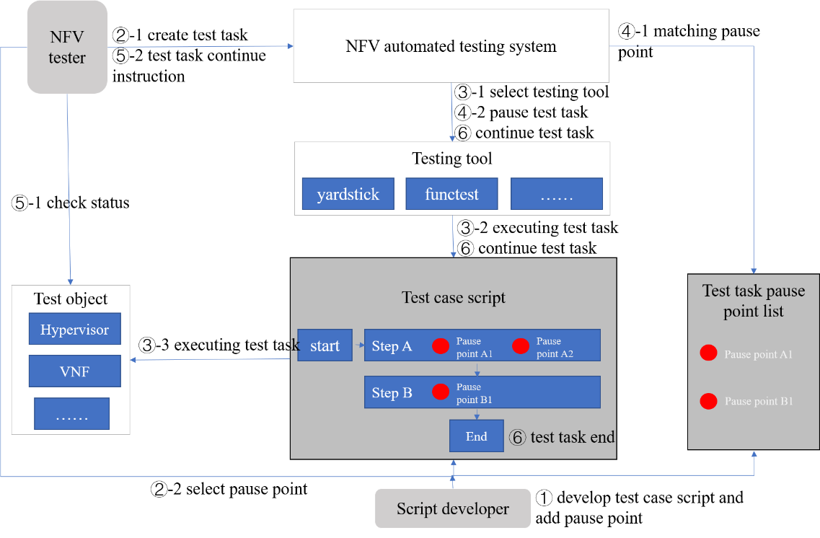
Pre-conditions (optional)
Post-conditions (optional)
Derived requirements | It is required that test task management function manages the life cycle of test tasks, including the creation, start, pause and deletion of test tasks.  It is recommended that test task management function supports the viewing of the intermediate status of the test task execution.  It is recommended that test task management function supports troubleshooting during test task execution.  NOTE 1 – The test case script writer sets test detection points and develops test cases according to test requirements during the development of test case scripts.  NOTE 2 – Before testing, NFV tester selects several expected pause positions from the test detection point.  NOTE 3 – During the execution of the test task, when it is executed to the detection point of the test case script, check whether the position of the detection point matches the expected pause position;  If it matches, generate a test pause instruction and pause the test task. The tester shall inspect the intermediate state of the test;  If it doesn't match, generate the test continue instruction and continue to execute the test task.  It is required that test task management function monitoring the test task execution status.  It is required that test task management function stores the history of test task failure during task execution.

I.4 Use case of NFV automated testing in cloud service continues integration / continues delivery
Title | Use case of NFV automated testing in cloud service continues integration / continues delivery
Description | VNF can be provided based on cloud computing, and the continuous integration and delivery of cloud services can be used to accelerate the online process of network functions. The continuous integration and delivery process of cloud computing-based VNF can be summarized as follows:  CSN: Network service developers analyse CSC's network requirements and define specific tasks.  Based on this, the CSN: network service developers provide a development plan. The plan and corresponding tasks are created on the development platform.  Then, a series of CI based development practices are used to ensure that VNF code or functional entities can be integrated, tested and deployed.  VNF has passed strict automated tests to verify whether the requirements of VNF are met. Only the code or functional entity that has passed the automated test can be deployed to the real environment through the deployment pipeline defined in the CD.  After the code is delivered to the production environment, CSP automatically monitors its status to receive quality assurance feedback. According to the service level agreement (SLA) between CSP and CSC, CSP is responsible for the continuity of network functions in the cloud.  Finally, CSP provides VNF services to CSC.  VNF automated testing is an important part of continuous integration and continuous delivery, which determines whether the service can meet user needs before deployment.
Roles | CSN: Network service developers  CSC  CSP
Figure (optional) | 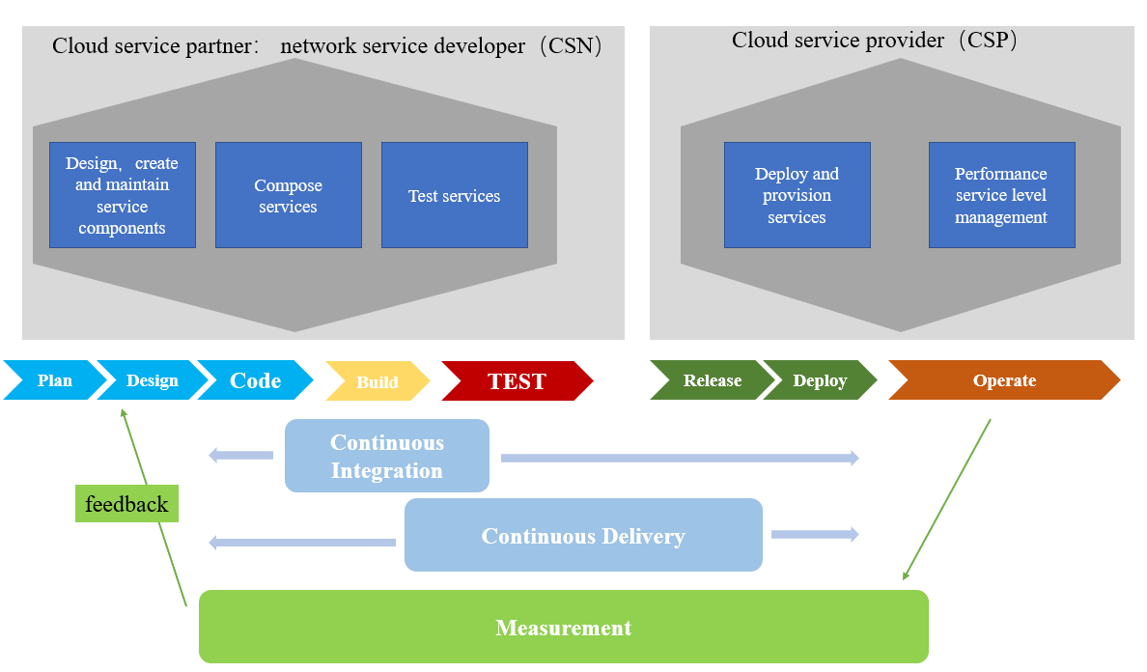
Pre-conditions (optional)
Post-conditions (optional)
Derived requirements

I.5 Use case of NFV automated testing report
Title | Use case of NFV automated testing report
Description | The test report of NFV automated testing is the documents which can present the process and results of the test, present the problems and defects found during the test, provide a basis for correcting the problems in the NFV system, and lay a foundation for NFV acceptance and delivery.  Test report should contain the following information:  - Information of the tester;  - Test object information, including product name, version and product provider;  - Test environment information, including deployment location, surrounding systems and equipment, and equipment connection, etc;  - Test task information, including task name, test template used;  - Test case information, including the total amount of test cases, the detailed information of each test case, the start time and end time of each test case, the test conclusion of each test case (including pass, fail, partial pass), etc;  - The execution process of the test, including the resources used, the parameters configured, the intermediate execution status, the execution results obtained, the verification of the results, etc;  - test score and test result.  An example of the test report is shown below.  ------------------------------------------------------------------------------------  Tester: Davide  Test object: hypervisor  Product type: computing virtualization  Product version: v0.05  Provider: Hua Wei  Environment name: Washington Data Center  Environment description: None  Test case amount: 3  Amount of test cases that do not pass: 0  Amount of test cases that pass: 3  Test score: 100  Test result: PASS  ------------------------------------------------------------------------------------
Roles
Figure (optional)
Pre-conditions (optional)
Post-conditions (optional)
Derived requirements | It is required that the test report management function generates test report of each test task automatically.  It is required that the test report management function provides information about the test task in the report.  NOTE - Information includes stakeholders involved in the test, information about the test environment, all parameters set during the task, records of the execution process, problems found and etc  It is required that the test report management function provides test result to indicate whether the test is passed, partially passed or failed.  It is recommended that the test report management function scores test results.  It is required that test object management function supports registry of test object in the test object catalogue.  It is recommended that test object management function can verify the connectivity of test objects.

I.6 Use case of NFV automated testing orchestration
Title | Use case of NFV automated testing orchestration
Description | The purpose of NFV test orchestration is to create multiple automated test jobs and execute them one by one as planned. It is the most critical step in NFV automated testing. Figure I-5 shows an implementation example of test orchestration. It usually includes the following modules:  Workflow manager: receives requests from the web side, generates workflow description files, deploys specific workflows to the workflow engine, instantiates workflows, etc;  Workflow engine: receives the workflow issued by the workflow manager, and generates the job to be processed according to the parameters input by the NFV tester;  Worker: provides the job workers of various types of jobs to process jobs. The workflow engine can actively call the job workers to execute jobs or put the jobs in the queue for the job workers to obtain;  Query manager: NFV tester queries the execution status and results of workflow instances by query manager.
Roles | NFV tester
Figure (optional) | 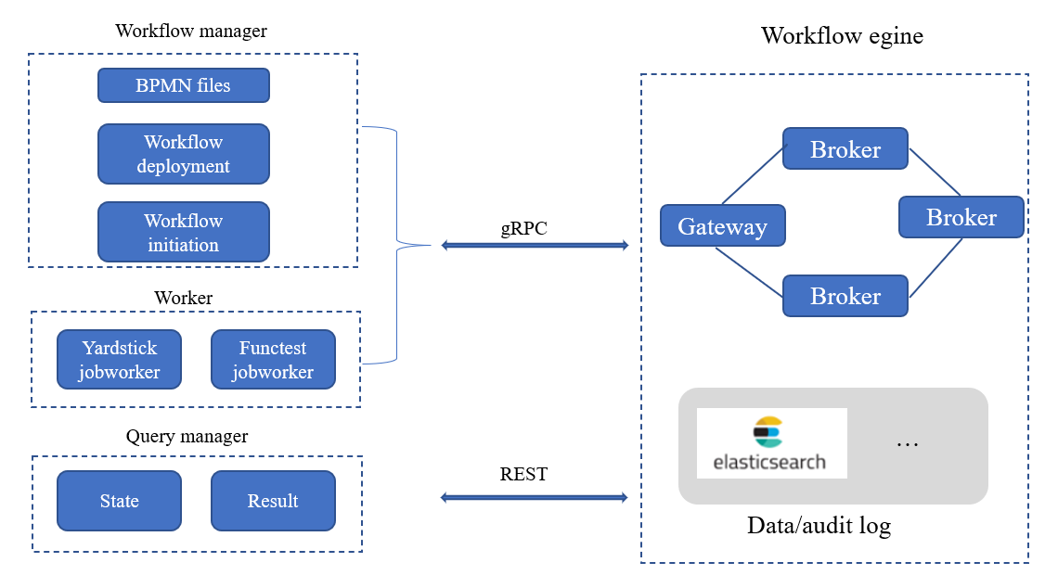
Pre-conditions (optional)
Post-conditions (optional)
Derived requirements

