 | INTERNATIONAL TELECOMMUNICATION UNION  TELECOMMUNICATION  STANDARDIZATION SECTOR  STUDY PERIOD 2025-2028 |  |  | SG11-TD262/GEN
 |  |  |  | STUDY GROUP 11
 |  |  |  | Original: English
Question(s): |  | 15/11 |  | Geneva, 19-28 February 2025
TD
Source: |  | Editors
Title: |  | Determination – draft Recommendation ITU-T Q.5056 (ex. Q.FC-MCM) “Framework for combating online Multimedia Content Misappropriation” (Geneva, 19-28 February 2025).
Contact: |  | Rafael Araujo  Brazil | Tel: +55-61-2312-2000  E-mail: rafael.araujo@anatel.gov.br
Contact: |  | Marcelo Alves da Silva  Brazil | Tel: +55-61-2312-2000  E-mail: marcelo.alves@anatel.gov.br
Contact: |  | João Zanon  Brazil | E-mail: zanon@anatel.gov.br
Contact: |  | Biren Karmakar  C-DOT, Ministry of Communications  India | Tel: +91-11-26598474  E-mail: biren@cdot.in
Contact: |  | Rajendra Kumar  C-DOT, Ministry of Communication  India | Tel: +91-11-26598466  Email: rajk@cdot.in

Abstract: | This document contains the updated text of the draft Recommendation ITU-T Q.5056 (ex. Q.FC-MCM) “Framework for combating Multimedia Content Misappropriation”, based on the TD933/GEN (Geneva, 1-10 May 2024) and discussions held in Q15/11 sessions (Geneva, 19-28 February 2025). It is proposed for determination.

This document contains updates to the text of the draft Recommendation ITU-T Q.5056 (ex. Q.FC-MCM) “Framework for combating Multimedia Content Misappropriation”, based on the TD933/GEN (Geneva, May of 2024), consolidates Contributions SG11-C72 and SG11-C86 and results of the discussions held during Q15/11 meetings (Geneva, 19-28 February 2025).
The output document is proposed for determination.
Draft new Recommendation ITU-T Q.5056 (ex. Q.FC-MCM)
Framework for combating online Multimedia Content Misappropriation
Summary
With the expansion of connectivity and large availability of Over-the-top (OTTs) solutions for content delivery, the world has been facing cases of multimedia content misappropriation due to the use of tampered or malicious software or counterfeit or malicious receivers, among other possibilities.
This behavior has negative impacts for all the involved stakeholders. It generates less revenue for the content creator and distributors, less taxes to the administrations, larger infrastructure and security impacts to the network operators, wider attack surface to internet services, and higher risks to the consumers that may have their personal data stolen or compromised, all caused by tampered or malicious software or counterfeit or malicious receivers.
Additionally, it is common to have content stolen in one country distributed around the globe and, therefore, international collaboration between all stakeholders is required to mitigate this international digital piracy problem.
Even though industry has taken extensive measures to prevent this to happen, recognizing the ongoing growth of digital piracy, violation of Intellectual Property and its negative impacts, administrations have been trying to address this issue by adapting their regulations and procedures designed to mitigate the misappropriate distribution and use of multimedia content.
Considering this complex scenario, there is no single solution, and a group of actions need to be taken, in a collaborative way, by all the involved stakeholders.
Therefore, this Recommendation aims to present a reference framework with requirements and actions that should be considered when deploying solutions to combat multimedia content misappropriation.
Keywords
Counterfeit receivers, malicious receivers, tampered software, malicious software, multimedia content misappropriation, Intellectual Property.
Table of Contents
1 Scope 5
2 References 5
3 Definitions 5
3.1 Terms defined elsewhere 5
3.2 Terms defined in this Recommendation 5
4 Abbreviations and acronyms 5
5 Conventions 5
6 General Aspects 6
6.1 Examples of forms of Multimedia Content Misappropriation 6
7 Combating online Multimedia Content Misappropriation stakeholders 7
7.1 Complainants 7
7.2 Coordinating Entity 7
7.3 Overseeing Body 7
7.4 Service Providers 7
8 High level requirements and key considerations 7
8.1 Readily detect and remove misappropriated content from the network. 7
8.2 Control of irregular devices that facilitate multimedia content misappropriation. 7
8.3 Raise consumer awareness on the negative impacts of multimedia content misappropriation. 8
9 Framework requirements 8
9.1 Support of applicable national legal and regulatory frameworks 8
9.2 Clear procedures and responsibilities when removing misappropriated content 8
9.3 Actions to raise awareness and support of users 9
9.4 Generate statistics and monitor the multimedia content misappropriation on the network. 9
9.5 Multimedia content misappropriation scenarios to be addressed. 9
10 Reference Framework 9
10.1 Reference Framework to combat online multimedia content misappropriation 10
11 Indicative approaches and Desirable procedures when implementing the Framework 12
11.1 Stakeholders’ collaboration approach 12
11.2 Communications approach - fast communication channels with service providers 13
11.3 Continuous improvement approach 13
11.4 Technology integration approach 13
11.5 Risk assessment and management of impacting legitimate services 13
11.6 Distribution, receival and implementation of Traffic Redirection Order 14
12 Security Considerations 14
Bibliography 15

Draft new Recommendation ITU-T Q.5056 (ex. Q.FC-MCM)
Framework for combating online Multimedia Content Misappropriation

Scope
This Recommendation contains a reference framework with requirements and actions that should be considered when deploying solutions to combat multimedia content misappropriation.

References
The following ITU-T and other references contain provisions which, through reference in this text, constitute provisions of this Recommendation. At the time of publication, the editions indicated were valid. All Recommendations and other references are subject to revision; users of this Recommendation are therefore encouraged to investigate the possibility of applying the most recent edition of the Recommendations and other references listed below. A list of the currently valid ITU-T Recommendations is regularly published. The reference to a document within this Recommendation does not give it, as a stand-alone document, the status of a Recommendation.

Definitions

Terms defined elsewhere
None.

Terms defined in this Recommendation
This Recommendation defines the following terms:
3.2.1 Multimedia content misappropriation: The action to distribute, exhibit, or obtain copyrighted or licensed multimedia content in violation of licensing conditions.

Abbreviations and acronyms
This Recommendation uses the following abbreviations and acronyms:
MCM Multimedia content misappropriation

Conventions
This Recommendation applies the following verbal forms for the expression of provisions:
- The keyword "is required to" indicate a requirement which must be strictly followed and from which no deviation is permitted if conformance to this Recommendation is to be claimed.
- The keywords "should" and “is recommended” indicate requirements which are recommended but which are not absolutely required. Thus, this requirement need not be present to claim conformance.
- The keyword "may" indicate an optional requirement which is permissible, without implying any sense of being recommended. This term is not intended to imply that the vendor's implementation must provide the option, and the feature can be optionally enabled by the network operator/service provider. Rather, it means the vendor may optionally provide the feature and still claim conformance with this Recommendation.

General Aspects
With the expansion of connectivity and large availability of Over-the-top (OTTs) solutions for content delivery, the world has been facing cases of multimedia content misappropriation due to the use of tampered or malicious software or counterfeit or malicious receivers, for instance.
This behavior has negative impacts for all the involved stakeholders, generating less revenue for the content creator and distributors, less taxes to the administrations, larger security impacts to the network operators, and wider attack surface to internet services, all caused by tampered or malicious software or counterfeit or malicious receivers and to the consumers that may have their personal data stolen or compromised.
Additionally, it is common to have multimedia content stolen in a country distributed around the globe and, therefore, international collaboration between all stakeholders is required to mitigate this international piracy problem.
Even though industry has taken extensive measures to prevent this to happen, recognizing the ongoing growth of digital piracy, violation of Intellectual Property and its negative impacts, administrations have been trying to address this issue by adapting their regulations and procedures designed to mitigate the misappropriate distribution and use of multimedia content.
Considering this complex scenario, there is no single solution, and a group of actions need to be taken, in a collaborative way, by all the involved stakeholders.

Examples of forms of Multimedia Content Misappropriation
Multimedia content misappropriation can occur in several forms such as but not limited to:
- Audio Content Misappropriation
1. Music piracy: Unauthorized use or distribution of copyrighted music.
2. Audio sampling without authorization: Using parts of another's audio work without authorization.
- Image and Video Content Misappropriation
1. Image theft: Using someone else's images without authorization or proper attribution.
2. Video piracy: Unauthorized use or distribution of copyrighted videos.
- Text-Based Content Misappropriation
1. Article spinning: Rewriting and republishing someone else's article without authorization.
2. E-book piracy: Unauthorized use or distribution of copyrighted e-books.
- Copyright Infringement Unauthorized Reproduction: Copying and distributing multimedia content (images, videos, music) without authorization from the rights holder.
- Public Performance or Display: Using copyrighted content in public settings (e.g broadcasts, public events) without proper authorization.
- Plagiarism: Presenting someone else’s work (such as audio, image, video, or text) as one’s own without proper authorization.
- Fair Use Violations Exceeding Fair Use: Using copyrighted material in ways that do not qualify as "fair use," such as using substantial portions of a work without authorization for commercial purposes.

Combating online Multimedia Content Misappropriation stakeholders

Complainants
Complainants are entities that can investigate on their own and later present the occurrence of misappropriation of multimedia content. Typically, they are Pay TV operators, Multimedia Content Creators, Distributors or Associations, or other multimedia content industry representatives.

Coordinating Entity
This is a central entity that is responsible to independently investigate multimedia content misappropriation occurrences, with or without input from complainants, as well as to propose operations to disrupt the misappropriation of content while ensuring such operations will have no or minimal impact on regular services. The central entity is also responsible for monitoring the operations and to report their results to the overseeing body.

Overseeing Body
The overseeing body is a superior instance that has a legal mandate to approve or reject the operations proposed by the coordinating entity and later appreciates its report.

Service Providers
Service providers, such as, Internet Service Providers (Access), Tier-1 Interconnexion Providers, International Cable Providers, and Domain Name Service Providers execute the network operations determined by the coordinating entity, effectively cutting the access from to the misappropriated content servers.

High level requirements and key considerations
There are several challenges to be faced by stakeholders when deploying solutions to combat multimedia content misappropriation. Therefore, when deploying solutions, the following high-level requirements should be considered:

Readily detect and remove misappropriated content from the network.
Stakeholders should establish misappropriate content investigation facilities where digital rights or legal services enforcement agencies can investigate the legitimacy of the content being distributed by applications, devices, OTT offers and media distribution sites.
Stakeholders should implement a network function – e.g., packet inspection, content watermarking – to parametrically detect protocols and traffic related to the activity of misappropriating and distribution of misappropriated content, such as Paid TV control word sharing, Paid TV card sharing, IPTV contents, P2P flows and any other irregular traffic. This network function should provide information on a level compatible with the specific Administration legal framework.
Stakeholders may implement fast and reliable means to share parameters sufficient to take down the misappropriation and the distribution of misappropriated content.
Stakeholders may implement a network function to take down the misappropriation and the distribution of misappropriated content.

Control of irregular devices that facilitate multimedia content misappropriation.
Administrations may establish cybersecurity requirements for telecommunications and content access equipment.
Administrations may have implemented a certification or accreditation program for telecommunications and content access equipment that comprises tests of technical conditions and parameters of the end-user operation of these equipments.
Administrations may set requirements to manufacturers or providers of telecommunications or content access equipment comprising: (i) a product support/update policy; (ii) a channel to report identified security vulnerabilities; and (iii) a Coordinated Vulnerability Disclosure (CVD) processes implemented.
Administration may set requirements to certify or approve equipment for (i) safe password practices (e.eg., equipment must not use default common passwords for all produced equipment, passwords that are derived from MAC addresses, blank, hardcoded or weak passwords), (ii) resilience to brute-force attacks, (iii) safe use, storage and transmission of cryptographic keys, (iv) reduction of cyberattack attack surface (e.g., disable unused ports and functionalities not essential to operation of the equipment).
Administrations may certify or approve equipment that does not endanger the physical and digital safety of users or the integrity of telecommunications networks.
Administrations may have a Market Surveillance Program in which the commercially available products are checked (i) against the technical conditions and parameters they were certified or approved and (ii) against new discovered vulnerabilities. If the certification conditions have not been maintained or new vulnerabilities are discovered, the product may have its approval suspended until the problem is solved. It is important to remember that the suspension of approval prevents the product from being distributed on the national market.

Raise consumer awareness on the negative impacts of multimedia content misappropriation.
Stakeholders (i.e., Regulators, ISP, telecommunications service providers and content providers) are invited to elaborate communication plans regarding the negative impacts of multimedia content misappropriation to the consumers.
The communication content may address the negative effects on the content industry, the risk of using tampered software or non-certified equipment that facilitate multimedia content misappropriation but can also pose risks of personal data theft and to the integrity of the network.

Framework requirements
The framework to combat multimedia content misappropriation should consider the following requirements:

Support of applicable national legal and regulatory frameworks
Administrations should have legislation for the protection of the intellectual and property rights of multimedia content and its supporting distribution mechanisms, either by OTT offers or by offers whose traffic is based on regulated telecommunication networks. Such legislation may contain provisions for fast take-down of misappropriated content, either via jurisdictional or administrative orders.

Clear procedures and responsibilities when removing misappropriated content
Administrations may have legislation that clearly establishes an entity or a set of entities as responsible to coordinate the combat against multimedia misappropriated content.
It is recommended that such entity or entities have sufficient capabilities to (i) determine if a multimedia content has been misappropriated and is being commercialized or distributed in breach of its licensing, (ii) determine the methods to reduce or eliminate the usage of misappropriated content, and (iii) establish enforcement means to apply and verify the application of such methods.
Close Collaboration with Law Enforcement Agencies and other Domestic agencies. Entities in charge of coordinating the combat against multimedia misappropriated content may seek close collaboration with Law Enforcement Agencies, Tax Revenue Agencies, Customs Agencies, Digital Rights Management associations, and Telecommunication Agencies to establish join efforts such as:
- prevent the import of devices that facilitate multimedia content misappropriation;
- investigate the organizations responsible for distributing misappropriated content;
- seize equipments that facilitate multimedia content misappropriation;
- detect the physical or digital distribution of misappropriated content;
- prevent the physical or digital distribution of misappropriated content.

Actions to raise awareness and support of users
Stakeholders may elaborate communication plans regarding the negative impacts of multimedia content misappropriation, the physical and user data risks associated with the use of non-certified equipment and with software/applications that do not have a traceable chain of development and responsibility.

Generate statistics and monitor the multimedia content misappropriation on the network.
Stakeholders may enable statistics and monitoring of multimedia content misappropriation as well as efficiency of counter-misappropriation measures.

Multimedia content misappropriation scenarios to be addressed.
The online multimedia content misappropriation is the scenario addressed in this framework.

Reference Framework
Based on the requirements outlined in section 8, a reference framework to combat multimedia content misappropriation is depicted in the following figures.
It is important to note that each depicted element should be implemented according to each administration's needs and legal framework.

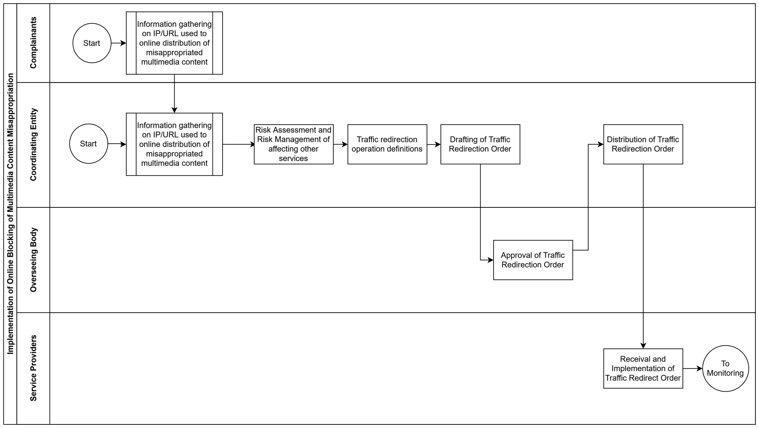
Reference Framework to combat online multimedia content misappropriation
Figure 1 – Implementation of Online Blocking of Multimedia Content Misappropriation
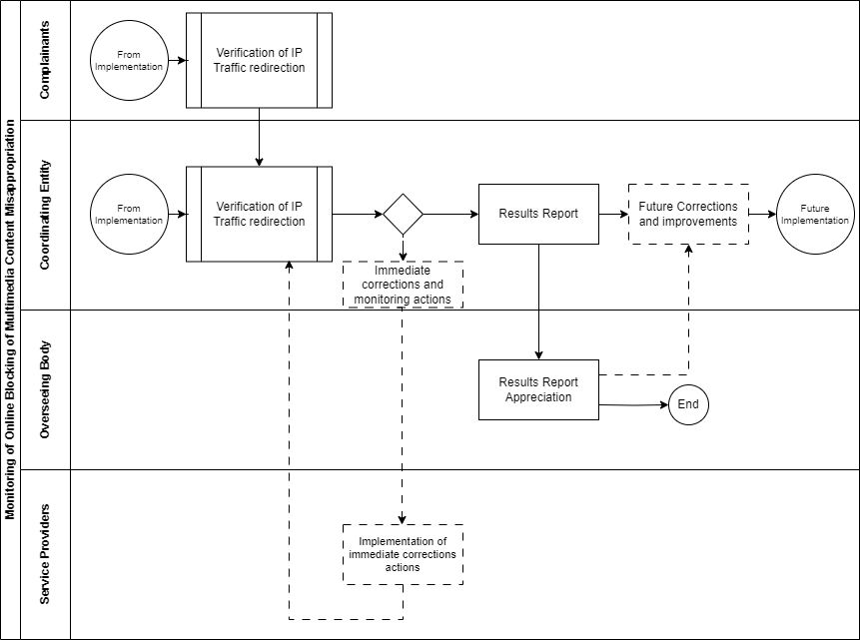
10.1.1 Swimlane blocks description for Figure 1 – Implementation of Online Blocking of Multimedia Content Misappropriation
Figure 2 – Monitoring of Online Blocking of Multimedia Content Misappropriation
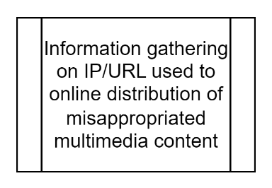
The initial block at the framework is “Information gathering on IP/URL used to online distribution of misappropriated multimedia content”. This represents the initial findings of the complainants, or the findings and investigations led by the Coordinating Entity. The output should be the resources (Unified Resources Locators, numerical IP addresses, other) that are used to enable the misappropriated content.
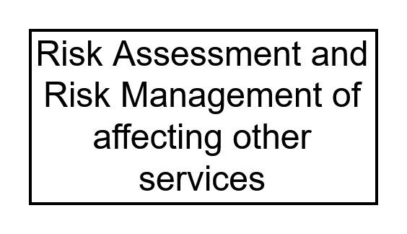
An operation that aims to interrupt the misappropriation of content must assesss and manage the risk of affecting other services. The Coordinating Entity must verify if it is safe to interrupt the use of the resources previously identified.

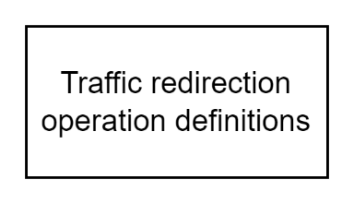
After identifing the resources whose access can be safely addressed, the Coordinating Entity should define how, when, and for how long the traffic to these resources will be redirected or blocked.

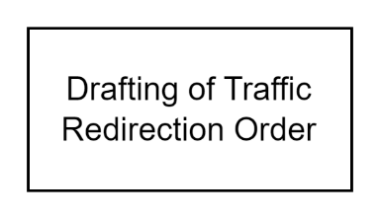
The definitions previously defined should be drafted into a Traffic Redirection Order to submission to the Overseeing Body.

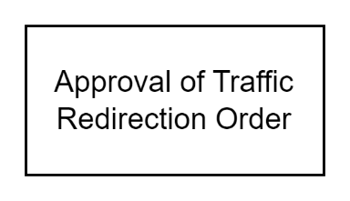
In this block, the Overseeing Body analyses, approves or rejects the Traffic Redirection Order. If rejected, there are no further action, but the information can be used in future orders.

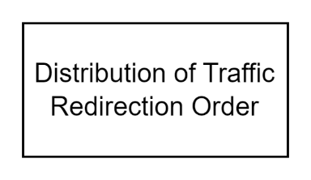
After approval from the Overseeing Body, the Traffic Redirection Order is distributed to the Service Providers by the Coordinating Entity. This constitutes an “Operation”.

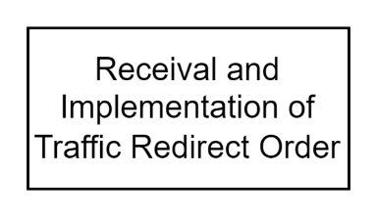
The Services Providers should receive and, at the designated timeframe, implement the Traffic Redirection Order. It can be desired to have confirmations sent to the Coordinating Entity.
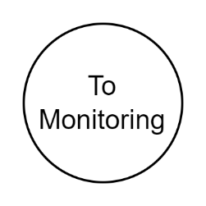

After the Traffic Redirection Order Implementation, the Operation shall be monitored as in Figure 2.

10.1.2 Swimlane blocks description Figure 2 – Monitoring of Online Blocking of Multimedia Content Misappropriation

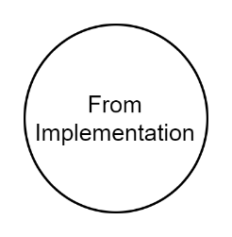
Start from the Implementation of Online Blocking of Multimedia Content Misappropriation (Figure 1).

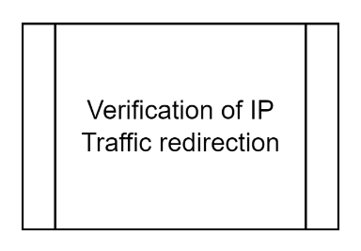
The Coordinating Entity must verify if the traffic is being redirected as instructed, in a sample or in the total number of Services Providers that have received the Traffic Redirect Order. This can be achieved by different kinds of probes such as test applications on devices connected to the network provided by the Service Providers (crowd testing), trace route operations from designated servers or routing inspection (e.g., Looking Glass servers)

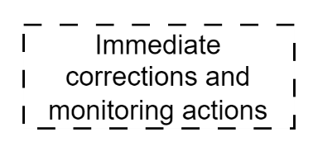
If the traffic redirection has not been implemented or has undesirable results (such as unpredictably affecting services not related to its purpose), immediate correction should be taken by the Coordinating Entity. The correction consists of issuing subsequent traffic redirection orders as in the implementation phase and monitoring its effects.

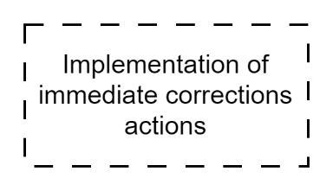
After receiving subsequent correction instructions, Service Providers should implement them immediately. The output of this block loops back to the Verification of IP Traffic redirection block.

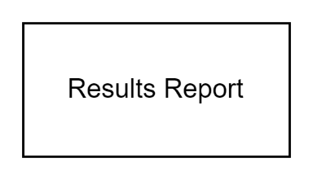
The Coordinating Entity should elaborate a Results Report periodically or at the end of an Operation. This report should be submitted to the appreciation of the Overseeing Body.

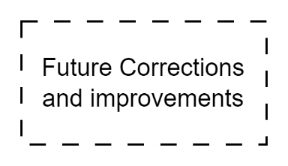
The corrections and experiences described in the Results Report should be considered for correcting and improving the definition of future Operations.

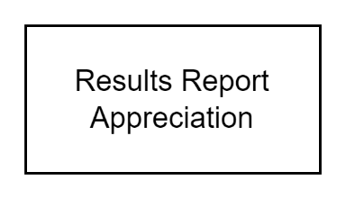
The Overseeing Body should appreciate the Results Report and consider its findings on the approval of future Traffic Order Redirection, i.e., future Operations.

Indicative approaches and Desirable procedures when implementing the Framework
When deploying a solution to combat online multimedia content misappropriation, countries should consider the following approaches and desirable procedures:

Stakeholders’ collaboration approach
Collaboration among stakeholders – complainants, coordinating entity, overseeing body and services providers – together with law enforcement agencies is key to address multimedia misappropriation and in developing this framework.
Complainants as content creators, distributors and other licensing-holders have an important role in combatting multimedia misappropriation, but their collaboration may be narrowed by interest on protecting only the content to which they have economic value on. It is suggested that other stakeholders should seek a more balanced approach, since they may have a broader interest in combatting multimedia content misappropriation.
Collaboration with law enforcement agencies to identify misappropriated multimedia content can be a valuable source of information to this framework. Similarly, information collected by the complainants can be useful for law enforcement.
Transparency and accountability of shareholders may benefit the collaboration among them and is subject to data protection.

Communications approach - fast communication channels with service providers
The coordinating entity should consider opening and maintaining a communication channel with the service providers during the implementation of the traffic redirection orders.
This open communication channel approach can be instrumental in quickly confirming the receipt of the traffic redirection orders, the specific time of implementation of the order per service provider, as well as dealing with immediate corrections as needed, and general questions and answers.

Continuous improvement approach
The application of this framework and its procedures within an administration may be reviewed to improve its effectiveness and to address new challenges and emerging technologies, as well as emerging security concerns. Stakeholder feedback may be encouraged to identify areas for improvement.

Technology integration approach
[b-ITU-T QSTR-MCM-UC] contains reports on the practical application of parts of this framework (Annex I, item I.1). It can be noted that providers of misappropriated content may react to traffic redirection orders, and so additional traffic redirection orders may be issued (as in the “Future implementations” block in Figure 2) to address their reactions.
The multimedia combat misappropriation framework can be leveraged to quickly respond to these reactions by an approach to integrate automation and technologies such as (i) AI and digital watermarking to continuously monitoring for new misappropriated content, (ii) AI to assist risk assessment and management, as well as to define the traffic order redirection and (iii) routing protocols and automatic distribution to distribute, receive and implement traffic redirection orders.

Risk assessment and management of impacting legitimate services
In order to ensure that an operation does not unduly affect legitimate services, administrations should carry out a risk assessment of the IP/URL whose traffic is planned to be redirected. Risk assessment should include an analysis of whether legitimate services are served from the same IP address or URL in proxy server arrangements and may consider the traffic interest of the legitimate service geographically or during the period of the redirection operation. Risk management planning may suggest a narrower and preferably shorter timeframe for the duration of the operation if there are risks of affecting legitimate service, for instance. The results of risk assessment and the risk management plan should be clearly communicated to the overseeing body prior to the approval of traffic redirection order.

Distribution, receival and implementation of Traffic Redirection Order
Administrations may consider using the fastest means to distribute and implement the content of the traffic redirection order. This largely depends on the administrative requirements of the country, but will generally consist of notification, email notification with digital signatures, or the secure distribution of the traffic redirection order via network routing protocols (e.g. Border Gateway Protocol) or configuration files.

Security Considerations
Cyberattacks against stakeholders – This framework may be implemented with varying levels of reliance on online interactions among stakeholders. It should be noted that stakeholders might suffer cyberattacks aimed at diminishing the effectiveness of such interactions. Consequently, it is advisable for stakeholders to implement robust security measures to protect their interactions and underlying infrastructure. For instance, a Denial of Service (DoS) attack may be directed toward the "Distribution of Traffic Redirection Order" action block, potentially causing delays or interruptions in the "Receival and Implementation of Traffic Redirect Orders" phase. Additionally, an online penetration attack may seek to compromise data associated with Traffic Redirection Orders or the interfaces of Service Providers.
Incorrect identification of content misappropriation – While the identification of the specific contents that have been misappropriated is beyond the scope of this recommendation, special considerations should be taken to avoid the occurrence of false positive identification, wherein multimedia content utilized in accordance to its licensing is erroneously flagged as misappropriated, and false negative identification, wherein misappropriated multimedia content is inaccurately recognized as compliant to its licensing terms. It is worth nothing that tampering multimedia may be employed as a strategy to circumvent misappropriation detection, which can result in false negatives; for instance, when video content undergoes resizing, tilting, or skewing to evade automatic detection of content misappropriation.
The incorrect identification of content misappropriation can undermine the intended objectives of this framework. In particular, false positives can be considered as a security issue, as they can impede the authorized distribution of content.
User Data Security Considerations – The “Information gathering on IP/URL used to online distribution of misappropriated multimedia content” block of this framework can be carried out by various investigation techniques, including (IP) traffic inspection. This framework only requires the collection of the IP/URL of the server or service responsible for the distribution of misappropriated multimedia content, which can be efficiently done in traffic inspection at a controlled environment (one or more laboratories). Therefore, this framework does not require the collection of end-user data which could potentially have an impact on security and user protection .
Nevertheless, administrations should take precautions regarding security, user protection, user profiling and the monitoring of user-generated content in accordance with their respective applicable laws and regulations.

Bibliography
[b-QSTR-MCM-UC] ITU-T Technical Report QSTR-MCM-UC] (10/2023) – Use cases on the combat of multimedia content.
_____________________

