 | INTERNATIONAL TELECOMMUNICATION UNION  TELECOMMUNICATION  STANDARDIZATION SECTOR  STUDY PERIOD 2025-2028 |  | SG11-TD231
 |  |  | STUDY GROUP 11
 |  |  | Original: English
Question(s): |  | 3/11 |  | Geneva, 19-28 February 2025
TD
Source: |  | Editors
Title: |  | Output – draft revised Recommendation ITU-T Q.IEM_arch_req “Reference architecture and signalling requirements for interactive emergency messaging through mobile network” (Geneva, 19-28 February 2025)
Contact: |  | Ashish Vyas  Ministry of Communications  India |  |  | Tel: 91-7428301942  E-mail: ashish.vyas@gov.in
Contact: |  | Arjun Singh  Ministry of Communications,  India |  |  | Tel: +91-9990883192  E-mail: arjun.singh93@gov.in
Contact: |  | Saurabh Basu  Centre for Development of Telematics  India |  |  | Tel: +91-8506846661  E-mail: sbasu@cdot.in
Contact: |  | Smriti Sachdev  Centre for Development of Telematics  India |  |  | Tel: +91-9891508000  E-mail: smriti@cdot.in
Contact: |  | Sandeep Sharma  Centre for Development of Telematics  India |  |  | Tel: +91-9034589567  E-mail: sandeeps@cdot.in
Contact: |  | Jinlan Ma  China Telecom  P.R.China |  |  | Tel: +8620 38639726  E-mail: majl6@chinatelecom.cn
Abstract: |  | This document is the revised output of draft Recommendation ITU-T Q.IEM_arch_req “Reference architecture and signalling requirements for interactive emergency messaging through mobile network”, resulting from discussion of Q3/11 meeting during 19-28 February 2025.
This document is the revised output of draft Recommendation ITU-T Q.IEM_arch_req “Reference interface architecture and signalling requirements for interactive emergency messaging through mobile network”, resulting from discussion of Q3/11 meeting during 19-28 February 2025.
This document is based on this meeting's discussion and results on the following contribution:

No. | Title | Source | Discussion
SG11-C55 | ITU-T Q.IEM_arch_req - Propose to update requirements for interactive emergency messaging | China Telecommunications Corporation | Accepted with modifications.
SG11-C62 | Proposal for advancement in the baseline text of draft Recommendation ITU-T Q.IEM_arch_req “Reference architecture and signalling requirements for interactive emergency messaging through mobile network”. | Ministry of Communications, India | Accepted with modifications.

Table of Contents
1 Scope 4
2 References 4
3 Definitions 5
3.1 Terms defined elsewhere 5
3.2 Terms defined in this Recommendation 5
This Recommendation defines the following terms: 5
4 Abbreviations and acronyms 5
5 Conventions 5
6. Overview 5
7. Requirements for interactive emergency messaging 7
8. Reference architecture for interactive emergency messaging 7
9. Signalling protocol requirements for interactive emergency messaging 7
9.1 Signalling protocol requirements for network originated emergency messaging 7
9.2 Signalling protocol requirements for mobile originated emergency messaging 8
10. Message format for interactive emergency messaging 8
11. Security consideration 8

Recommendation ITU-T Q.IEM_arch_req
Reference architecture and signalling requirements for interactive emergency messaging through mobile network

1 Scope
This Recommendation specifies reference architecture and signalling requirements required for interactive emergency messaging through mobile network by addressing many aspects that are crucial in nature but have still not been evolved in the signalling protocols. The scope of this recommendation is as follows:
1） Reference architecture for interactive emergency messaging through mobile network;
2) Signalling requirements for interactive emergency messaging;
3) Interactive emergency message delivery format;
4) Security consideration.

2 References
The following ITU-T Recommendations and other references contain provisions which, through reference in this text, constitute provisions of this Recommendation. At the time of publication, the editions indicated were valid. All Recommendations and other references are subject to revision; users of this Recommendation are therefore encouraged to investigate the possibility of applying the most recent edition of the Recommendations and other references listed below. A list of the currently valid ITU-T Recommendations is regularly published. The reference to a document within this Recommendation does not give it, as a stand-alone document, the status of a Recommendation.
[ITU-T E.100] Recommendation ITU-T E.100 Supplement 1 (2019), Framework of disaster management for disaster relief systems.
[ITU-T E.108] Recommendation ITU-T E.108 (2016), Requirement for a disaster relief mobile message service.
[ITU-T E.119] Recommendation ITU-T E.119 (2017), Requirement for safety confirmation and broadcast message service for disaster relief.
[3GPP TS 23.041] Technical Specification 3GPP TS 23.041 V13.3.0 (2016), 3rd Generation Partnership Project: Technical Specification Group Core Network and Terminals; Technical realization of Cell Broadcast Service (CBS) (Release 13).
[ETSI TS 103 625] Technical Specification ETSI TS 103 625 V1.2.1 (2012) Emergency Communications (EMTEL): Transporting Handset Location to PSAPs for Emergency Calls - Advanced Mobile Location
[ETSI TS 102 900] Technical Specification ETSITS 102 900 V1.2.1 (2012) Emergency Communications (EMTEL): European Public Warning System (EU-ALERT) using the Cell Broadcast Service
[ETSI TS 102 182] ETSI TS 102 182: Emergency Communications (EMTEL); Requirements for communications from authorities/organizations to individuals, groups or the general public during emergencies.

3 Definitions

3.1 Terms defined elsewhere
This Recommendation uses the following terms defined elsewhere:
TBD

3.2 Terms defined in this Recommendation

This Recommendation defines the following terms:
3.2.1 Interactive emergency messaging – Providing two-way messaging among targeted group of stakeholders for any emergency or in an ongoing crisis situation.

4 Abbreviations and acronyms
This Recommendation uses the following abbreviations and acronyms:
CB Cell Broadcast
SMS Short Message Service

5 Conventions
In this Recommendation:
The keywords "is required to" indicate a requirement which must be strictly followed and from which no deviation is permitted, if conformance to this Recommendation is to be claimed.
The keywords "is recommended" indicate a requirement which is recommended but which is not absolutely required. Thus, this requirement need not be present to claim conformance.
The keywords "can optionally" indicate an optional requirement which is permissible, without implying any sense of being recommended. This term is not intended to imply that the vendor's implementation must provide the option, and the feature can be optionally enabled by the network operator/service provider. Rather, it means the vendor may optionally provide the feature and still claim conformance with this Recommendation.

6. Overview
Today in the era of rapid technology development, it is essential that technology is to be utilized effectively for the betterment of people and facilitate them to take informed decision. In past few decades, the telecom has played a crucial role for providing emergency information, mobile terminal being the key receiver because people always carry it with them and the penetration ratio of telecom is higher than that of any other communication medium.
The speed and accuracy of conveying information is crucial for the protection of people to give them sufficient time for preparation in emergency or an ongoing crisis situation. Currently, SMS based or CB based telecom technologies are in use for dissemination of information especially in emergency situation. CB based technology is widely used technology as it is a network congestion independent broadcast messaging service that holds an upper hand in low latency dissemination which enables it to reach a large number of people in near real-time and thereby saving lives and livelihoods. Figure 6.1 shows the block diagram of CB technology.

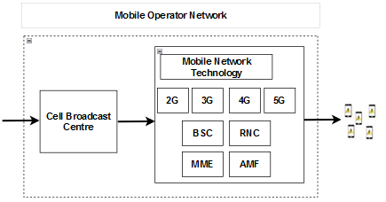
Figure 6.1

However, there is no provision in CB for collecting information on the acknowledgement of message delivery to mobile handsets and it is not supportive for image and video transmission to provide effective alerting, especially for disabled or illiterate population. Further, there does not exist any provision to have a closed group communication.
Apart from CB technology, there are some other emergency technologies used for their distinct purposes such as emergency call facility (Dial 112), SMS based disaster message dissemination, Public safety network but all these have their own limitations.
Figure 6.2 shows the exiting emergency telecommunications technologies available and their limitations and overall challenges.
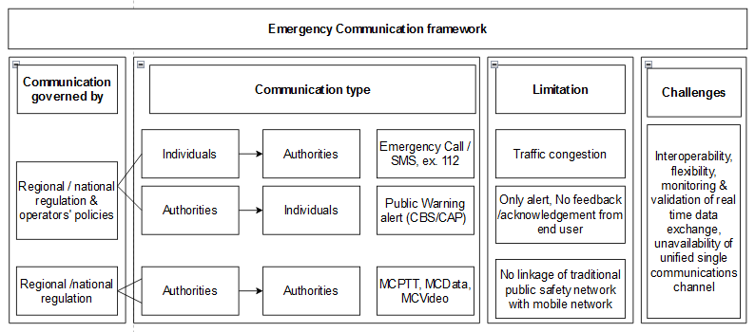
Figure 6.2
The most of components of existing emergency messaging framework is in silos and have issue of interoperability among them due to which many crucial aspects of emergency messaging are missing in the signalling protocols.

Hence, there is a need to converge and define reference interface architecture and signalling requirements required for interactive emergency messaging through mobile network which addresses crucial aspects of emergency messaging at signaling level.

7. Requirements for interactive emergency messaging
- It is required that emergency message system shall have interoperable interfaces with existing protocols.
- It is recommended that interactive emergency messaging can be provided either through specific code or emergency number.
- It is required that it should have the support of emergency messaging including but not limited to Emergency alert, Alert acknowledgement, Alert Coverage Feedback, Request for assistance from UE, Response to assistance, Fetch UE location, Event basis alert to UE, Close group messaging, Convey the ‘SAFE’ status, Convey on ground situation, etc. with support of Image and video services.
- It is required that the emergency messages must be broadcast with minimal delays (i.e. low latency).
- It is recommended that the emergency messages system should have the support of geo-fencing to ensure only users/devices in affected areas receive alerts.
- It is recommended that the emergency messages system must provide identification of the message originator/sender such as national/regional government authorities involved in disaster management/emergency communications.
- It is required to support interactive emergency message delivery to UE connected to mobile network via radio, satellite or UAV (Unmanned Aerial Vehicle).
- It is required to support interactive message transmission between emergency message center and UE including text, image, audio and video.
- It is required to support interworking with existing SMS system such as IP SMS, NAS SMS or RCS (Rich Communication Services) etc.
- It is required to support emergency message identification and handling with higher priority for network.
- It is recommended to support file transfer via interactive emergency message between emergency message center and UE.

[Editor’s note: the emergency message center should be defined in section 8 in the future meeting. Contributions are welcome.]

8. Reference architecture for interactive emergency messaging
[Editor’s note: see TD167/GEN. Contributions are welcome.]

9. Signalling protocol requirements for interactive emergency messaging

[Editor’s note: this section should be addressed based on the architecture defined in section 8.]

9.1 Signalling protocol requirements for network originated emergency messaging
- It is required that it should support the legacy networks (2G/3G) along with the support of modern networks like 4G/5G.
- It is recommended that it should support the feature of multi-language so that it can send and receive the emergency messages in local/regional languages.
- It is required to handle high volumes of simultaneous messages/alerts and user/UE responses, especially in densely populated areas.
- It is required that emergency warning message should be displayed on the UE screen immediately, even during a voice/video call, and should stay on the display regardless of the user settings, until the emergency message indication is cancelled by the user.

9.2 Signalling protocol requirements for mobile originated emergency messaging
- It is required that UE must provide accurate location, if it supports, to the network during emergency message transmission.
- It is required that the UE should support fallback mechanisms for emergency messaging across multiple network types such as 2G/3G/4G/5G.
- It is recommended that UE must be capable of recognizing and initiating the emergency message/alert even without requiring the SIM card (i.e. over WiFi connection).

10. Message format for interactive emergency messaging
TBD

11. Security consideration
- The emergency messages content of the system and user/UE response must be encrypted to prevent the tampering the of the messages.
- It is required to have the role-based access control (RBAC) and multifactor authentication (MFA) in order to restrict the system access to authorized personnel. It will ensure that only authorized systems can send the emergency messages.

[Note: detailed features will be added and refined.]

____________________

