 |  |  | International telecommunication union  Telecommunication Standardization Bureau
 |  |  |  | Geneva, 20 March 2023
Ref: |  | Addendum 1 to  TSB Collective letter 2/15  SG15/HO |  | - To Administrations of Member States of  the Union;  - To ITU-T Sector Members;  - To ITU-T Associates of Study Group 15;  - To ITU Academia
Tel: |  | +41 22 730 6356
Fax: |  | +41 22 730 5853
E-mail: |  | tsbsg15@itu.int
Web: |  | http://itu.int/go/tsg15
Subject: |  | Meeting of Study Group 15; Geneva, 17 to 28 April 2023
Dear Sir/Madam,
The following Work Item under AAP received comments during the Last Call period of AAP-15, dated 16 October 2022:
− Recommendation ITU-T G.9962 (2018) Amd.2, Unified high-speed wire-line based home networking transceivers - Management Specification: Amendment 2.
This Work Item (i.e., G.9962 Amd.2) was posted as SG15-TD115/PLEN for approval at the meeting of Study Group 15 from 17 to 28 April 2023.
Yours faithfully,  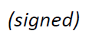  Seizo Onoe  Director of the Telecommunication  Standardization Bureau | 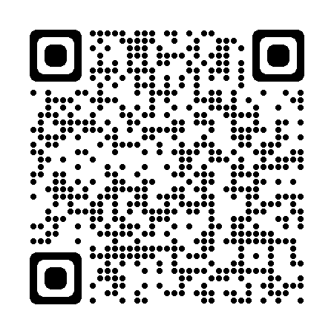 ITU-T SG15
 | Latest meeting information

