 |  | International telecommunication union  Telecommunication Standardization Bureau
 |  |  | Geneva, 29 September 2023
Ref: | Addendum 1 to  TSB Collective letter 6/13  SG13/TK |  | - To Administrations of Member States of the Union;  - To ITU-T Sector Members;  - To ITU-T Associates of Study Group 13;  - To ITU Academia
Tel: | +41 22 730 5126
Fax: | +41 22 730 5853
E-mail: | tsbsg13@itu.int
Web: | http://itu.int/go/tsg13
Subject: | Meeting of ITU-T Study Group 13; Geneva, 23 October – 3 November 2023
Dear Sir/Madam,
I wish to inform you that draft new Recommendation ITU-T Y.3159 “Framework for classifying network slice level in future networks including IMT-2020” received comments during the Last Call period of AAP-19, dated 16 December 2022.
The comments resolution for this draft Recommendation is still in progress and since a planned study group meeting is sufficiently close, the Chairman of Study Group 13, in consultation with TSB, took the decision in accordance with Recommendation ITU-T A.8, § 4.4.2, as reflected in TSB AAP-36, dated 16 September 2023,
to consider this draft new Recommendation for approval at the Study Group 13 meeting taking place from 23 October to 3 November 2023 in Geneva. Corresponding documentation is available in SG13-TDs 495, 496, 497/WP1.
I wish you a productive and enjoyable meeting.
Yours faithfully,  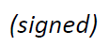  Seizo Onoe  Director of the Telecommunication  Standardization Bureau | 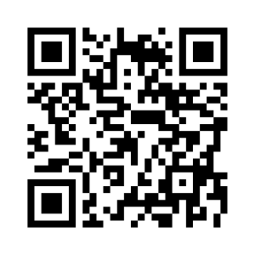 ITU-T SG13
 | Latest meeting information

