**Introduction to Web Development: JavaScript**

**Class 1: Exercises**

1. Review chapters 1 and 2 of this courses video series titled “Modern JavaScript From The Beginning”.

<https://learning.oreilly.com/videos/modern-javascript-from/9781789539509/>

1. Get your development environment up and running.
   1. Visual Studio Code installed on your laptop.

<https://code.visualstudio.com/download>

* 1. Installation of a few extensions into VS Code.
     1. Live Server
     2. JavaScript (ES6) Code Snippets
     3. Bracket Pair Color DLW

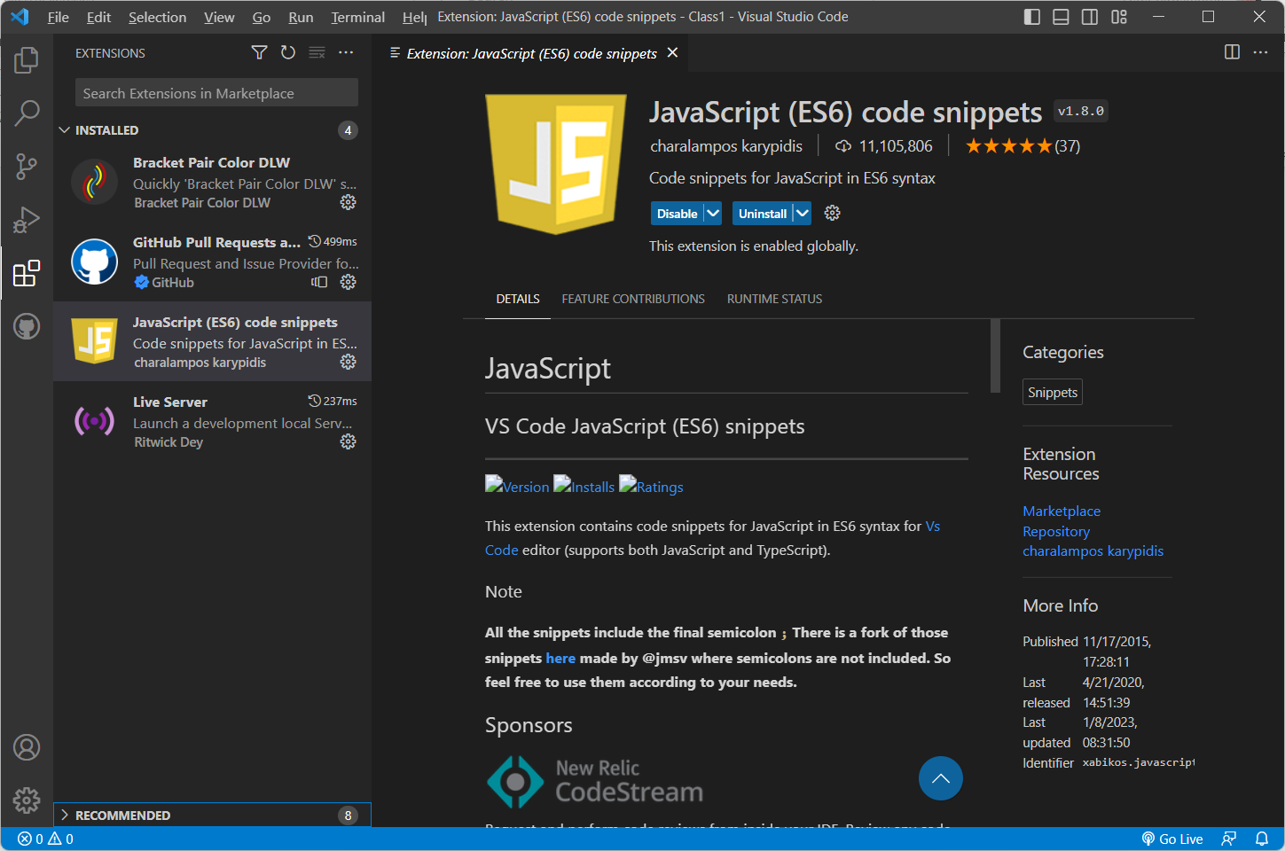

1. Run some JavaScript in your browser
   1. Have a simple HTML page run some embedded JavaScript

<!DOCTYPE html>

<html lang="en">

<head>

<title>Intro to WebDev: JavaScript Sandbox</title>

</head>

<body>

<h1>Intro to WebDev: JavaScript Sandbox</h1>

<script>

alert('Easy Peasy!');

</script>

</body>

</html>

* 1. Have a simple HTML page linked to a JavaScript file

<!DOCTYPE html>

<html lang="en">

<head>

<title>Intro to WebDev: JavaScript Sandbox</title>

</head>

<body>

<h1>Intro to WebDev: JavaScript Sandbox</h1>

<script src="app.js"></script>

</body>

</html>

index.html

// this is a comment

/*

this is also a comment

*/

alert('JavaScript from a js file.');

// in the browser window, right click and inspect

console.log("logging to browser console");

app.js

1. Write JavaScript that outputs to your browser console

<!DOCTYPE html>

<html lang="en">

<head>

<title>Intro to WebDev: JavaScript Sandbox</title>

</head>

<body>

<h1>Intro to WebDev: JavaScript Sandbox</h1>

<script src="console.js"></script>

</body>

</html>

index.html

console.log('Hello World!');

console.log(2345);

console.log(false);

var message = 'In 2022 JavaScript was the most popular programming language!';

console.log(message);

console.log([3,4,5,6]);

console.log({a:1,b:2});

console.table({a:1,b:2});

console.error('this is an error.');

console.warn('this is a warning.');

console.js

1. Become familiar with the var, let, and const JavaScript variables.
   1. Reminder remove the two back-slashes // as comments on the lines of code. Some comments are still just comments.

// var, let, const

// variables can be reassigned

var fullName = 'Jack Nimble';

console.log(fullName);

fullName = 'Jill Spill';

console.log(fullName);

// // variables can be initialized

// var message;

// console.log(message);

// message = 'Welcome to JavaScript!'

// console.log(message);

// // can be created with letters, numbers, $, _

// // cannot start with a number

// var firstName = "Jack"; // Camel case (most common)

// var first_name = "Jack"; // Underscore

// var FirstName = "Jack"; // Pascal case (used as a class in OO programming)

// var firstname;

// console.log(first_name);

// // LET

// let fullName = "Sue Storm";

// console.log(fullName);

// // fullname = "Johnny Storm";

// fullName = "Johnny Storm";

// console.log(fullName);

// // CONST

// const lastName = "Storm";

// console.log(lastName);

// // constants cannot be re-assigned.

// lastName = "Smith";

// // it must have a value

// const message;

// const person = {

// firstName: 'Marcus',

// lastName: 'Aurelius',

// age: 59

// };

// console.log(person);

// person.firstName = 'Annia';

// person.age = 34;

// console.log(person);

// const numbers = [1,2,3,4,5];

// numbers.push(6);

// numbers = [4,5,6,7,8]; // constants cannot be re-assigned.

// console.log(numbers);