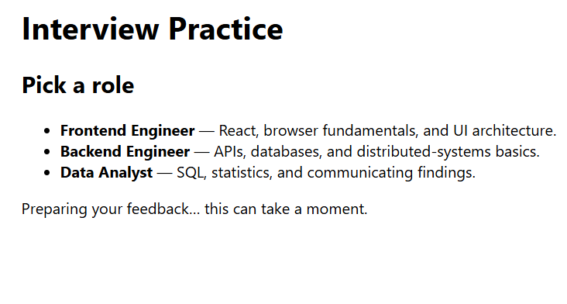
Fig 1 : const FAKE_STATE: FeedbackStatus = "pending"

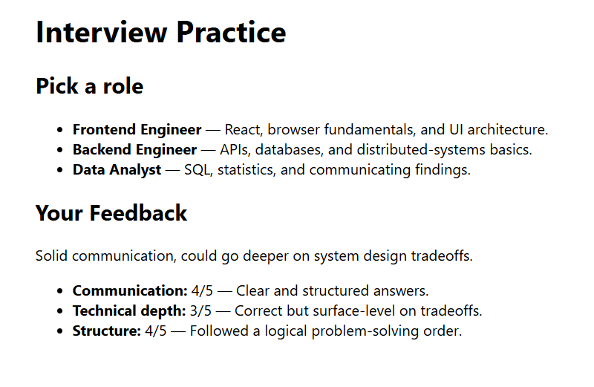

Fig 1 : const FAKE_STATE: FeedbackStatus = "ready"

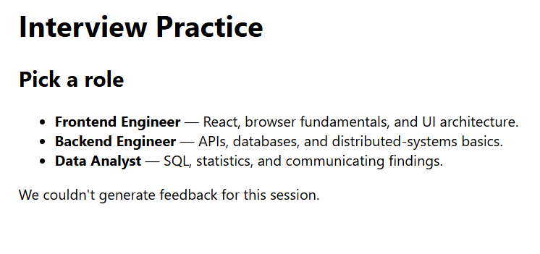

Fig 1 : const FAKE_STATE: FeedbackStatus = "failed"

