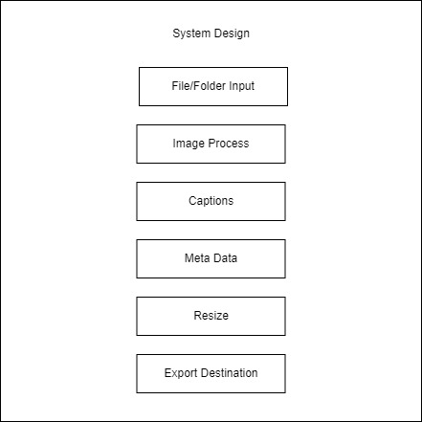

Above picture display’s overall system features on building block where each feature is stacked over each other creating a whole system

**\*note:- The building block (features) are not placed in order**

# Input

The program starts from the input feature, it accepts both file as JPG, PNG, JPEG and Folder containing same file formats.

## UI Design

For Input feature an Entry box or input file

# Image Process

The following feature applies picture adjustments correcting light and shadow. This will be an automation feature.

## UI Design

For each image feature a text input box for each value

# Caption

Caption feature is for adding a banner and caption on the photo

## UI Design

A small size preview box of an image and on the left side an entry box for color of the banner and entry below for the caption of the image. And two button below them apply and clear

# Meta Data

This to add keyword and meta data in picture

* UI Design

A input which accepts file input for the metadata file. Input must be txt

# Export Destination

Same as input function