2/13/2018

Paryag Mehta

MS-BA

Business Data Warehouse

Assignment# 1

**Assumptions/Observations:**

1. In SQL workbench not able to assign Boolean as data type, automatically getting assigned as TINYINT
2. Buyer can write maximum one review for a purchased product (Writing review is not mandatory).
3. Entry in the transaction table will be made only when the payment has already been made for that transaction.
4. Every purchase transaction must have a billing address associated with it.
5. For all the entities created, have named them as entity_ParyagM but when tables get created in SQL, all the table names were changed to lower case and wasn’t able to change those in the editor so kept them as they are.

ER Model:

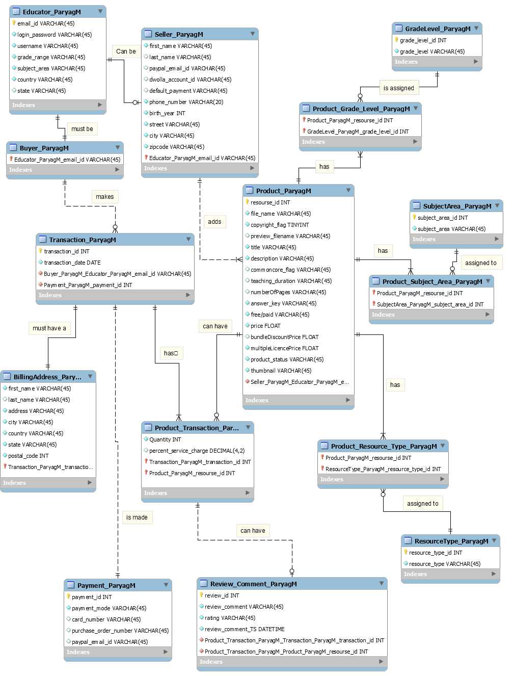

1. **Educator table:**

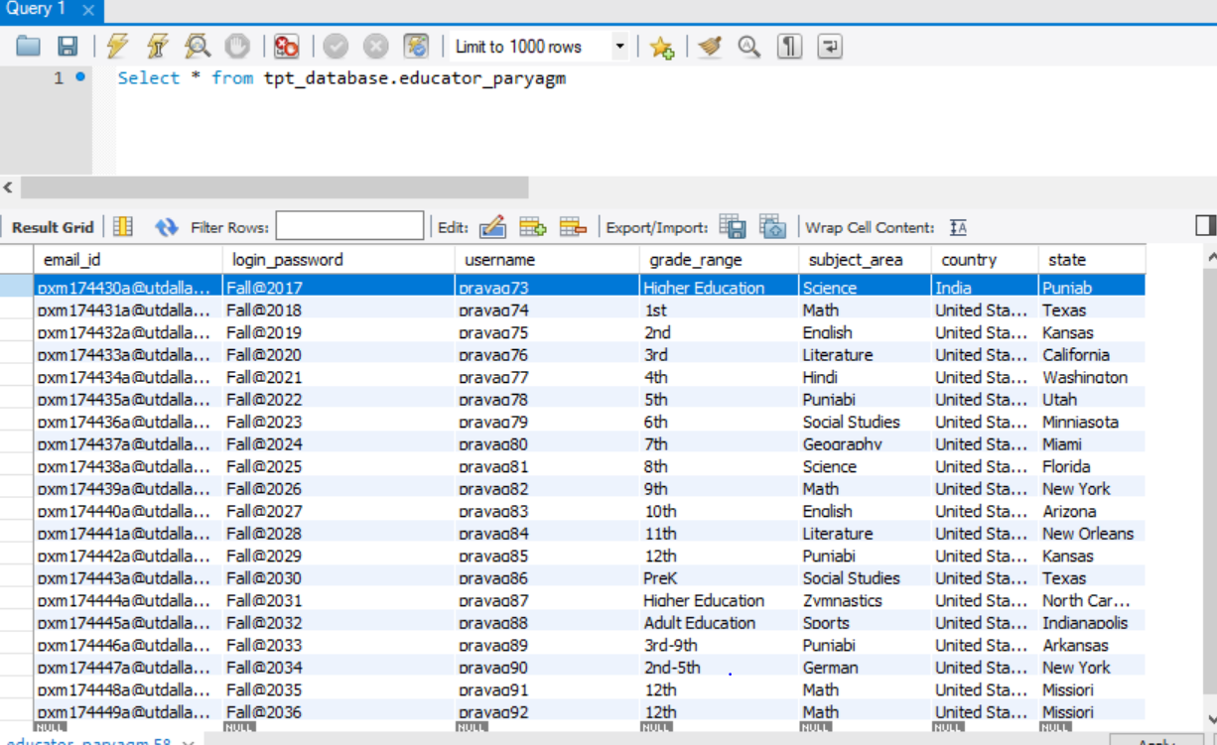

1. **Buyer Table:**

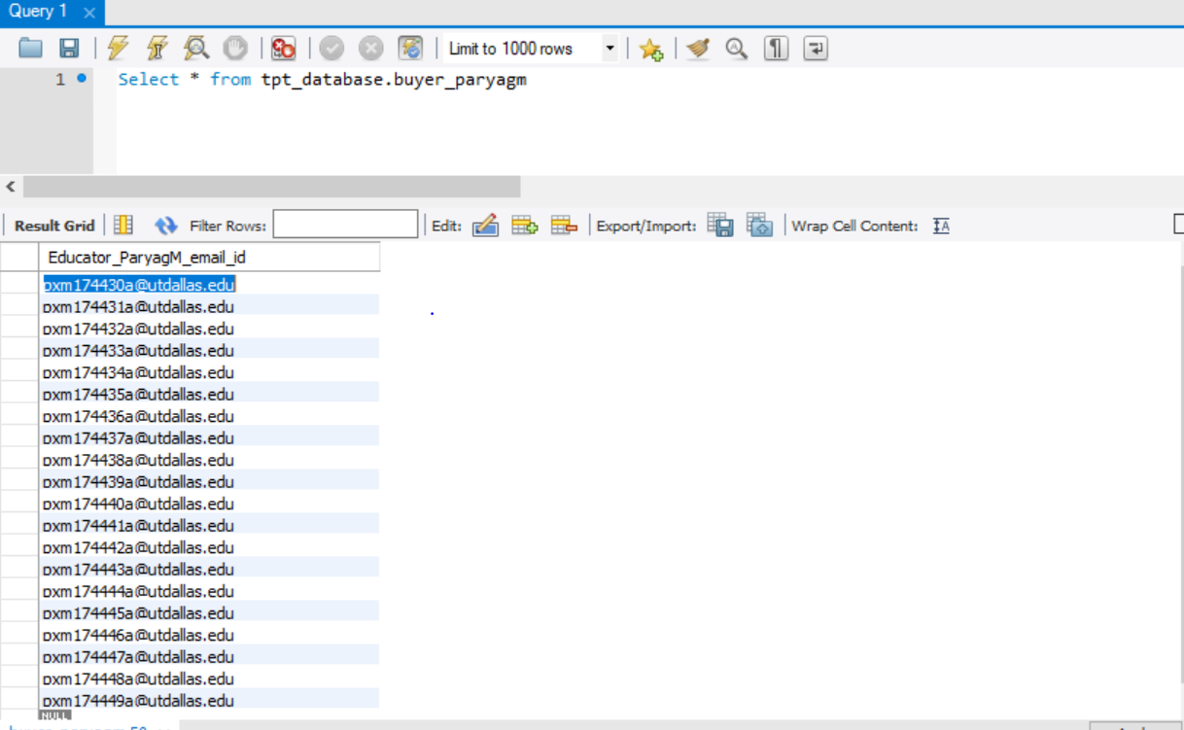

1. **Seller Table:**

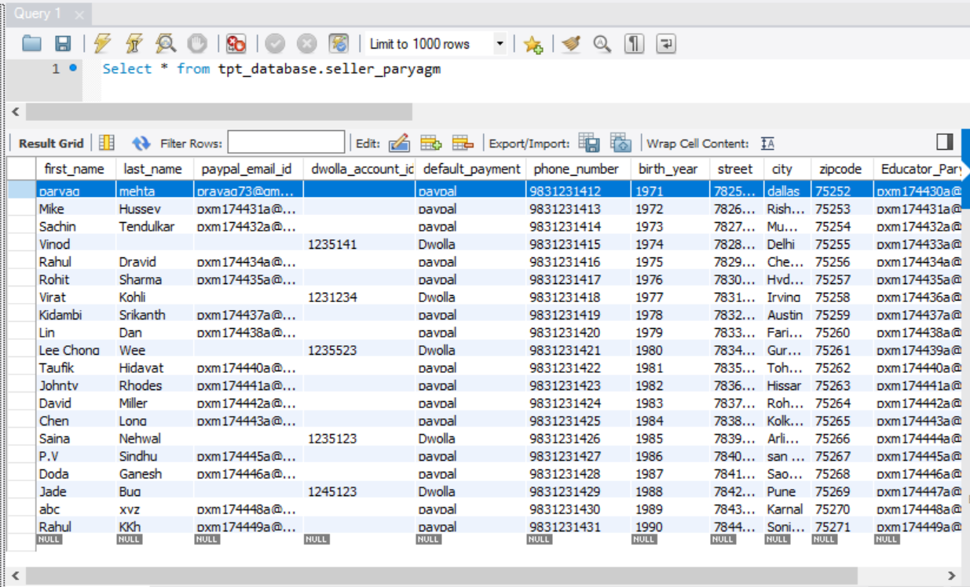

1. **Product Table:**

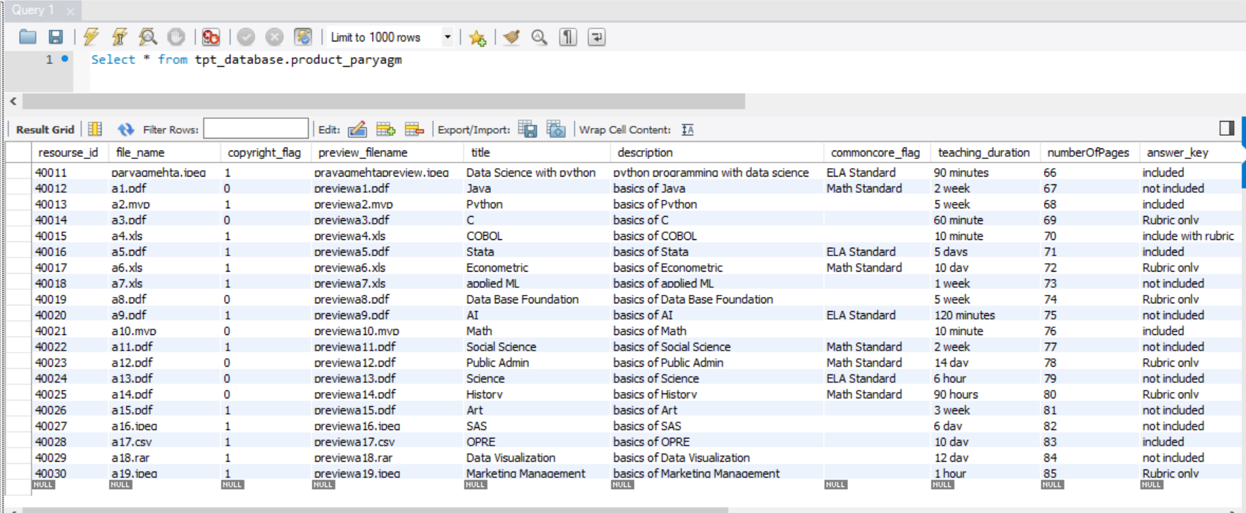

1. **Payment Table:**

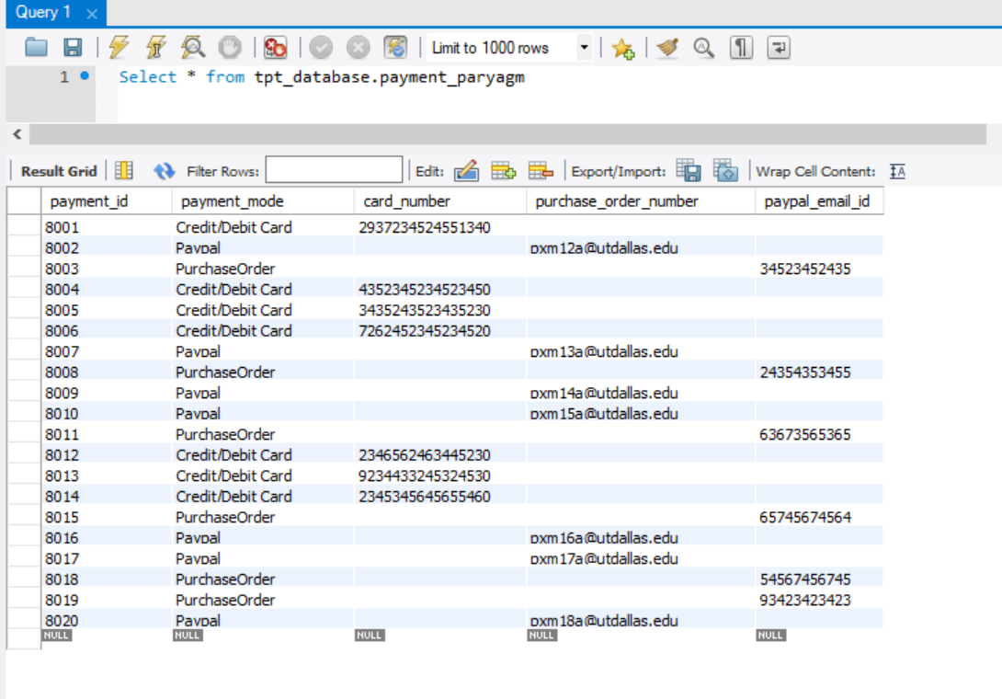

1. **Transaction Table:**

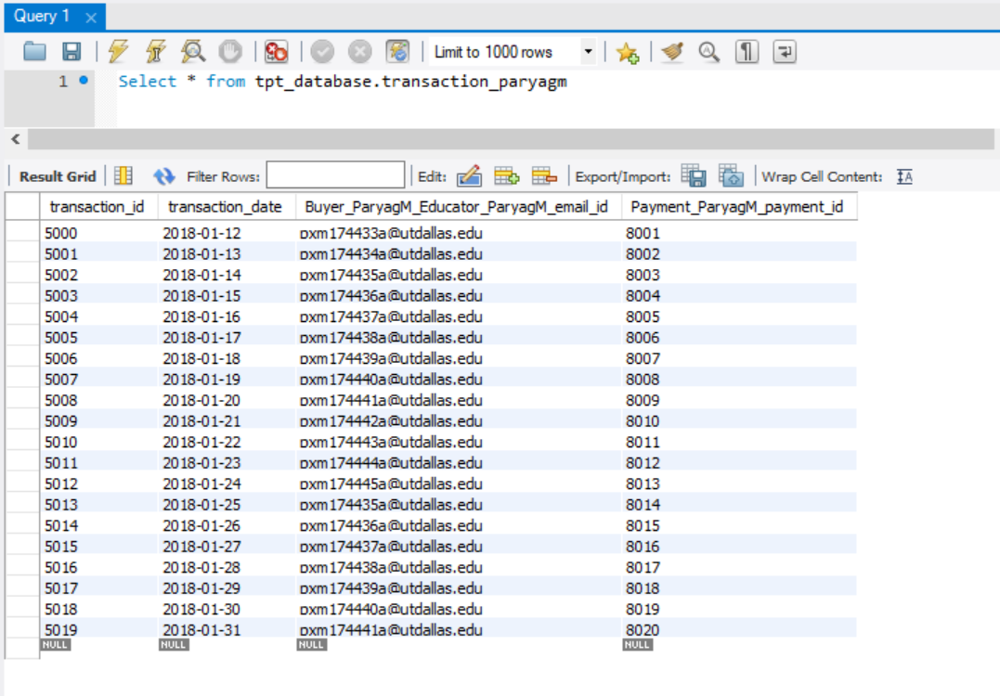

1. **Billing Address Table:**

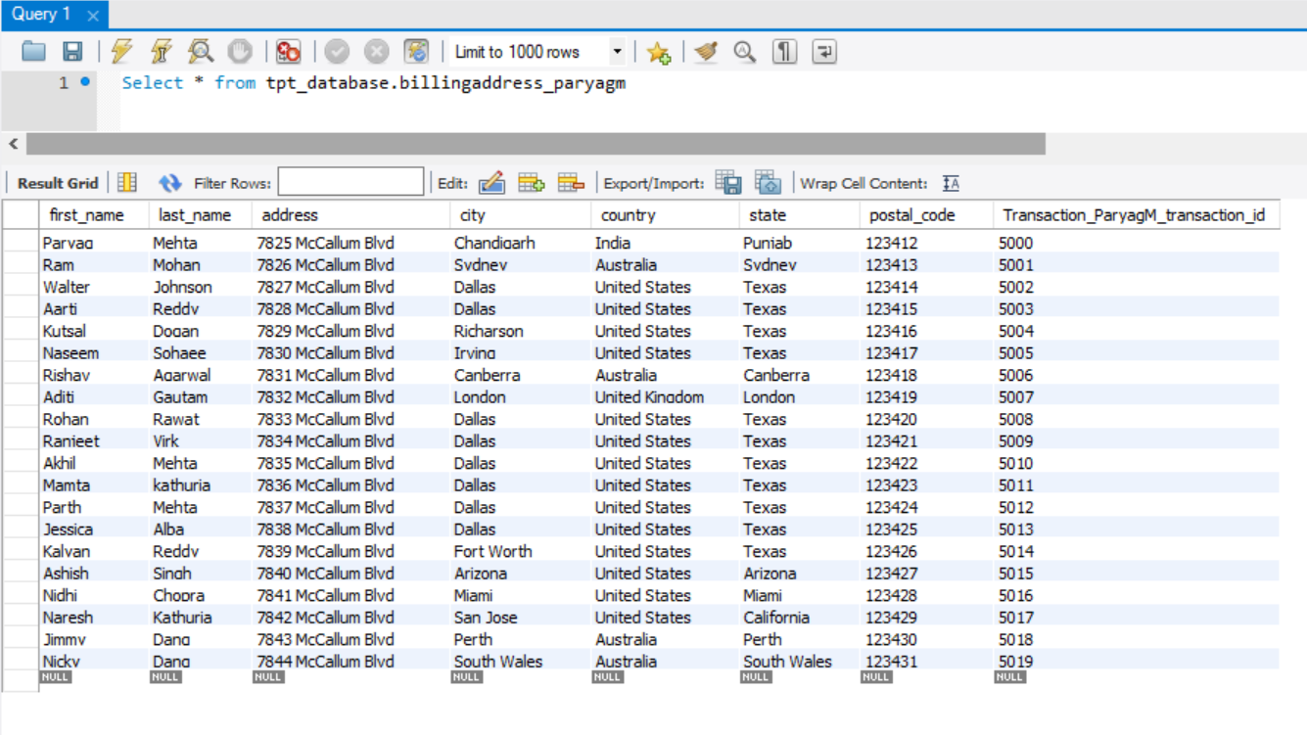

1. **Product Transaction Table:**

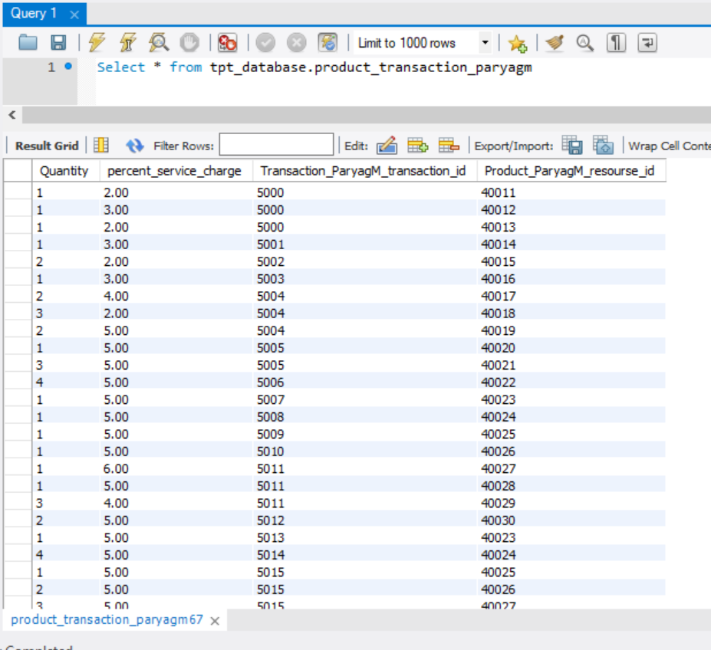

1. **Review Comment Table:**

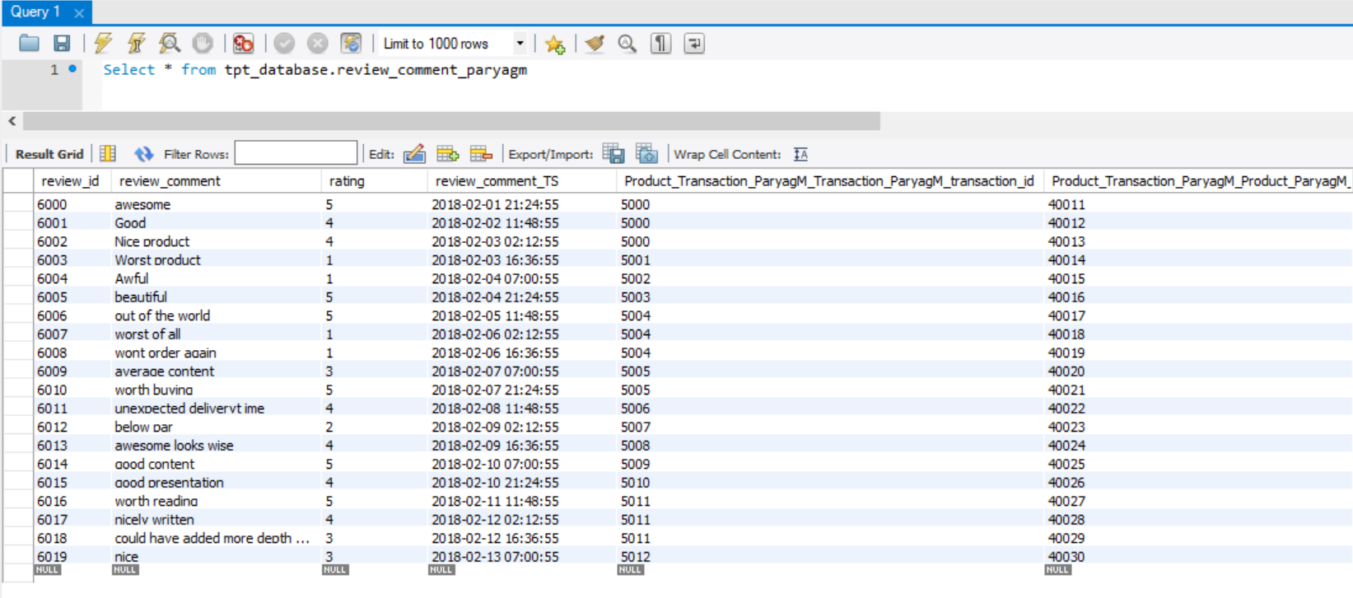

1. **Resource Type Table:**

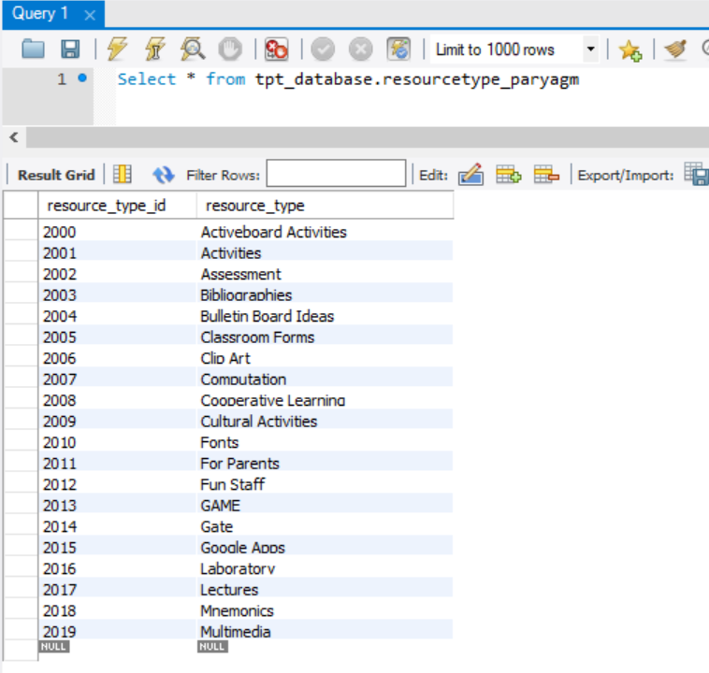

1. **Product Resource Type Table (Intersection Table):**

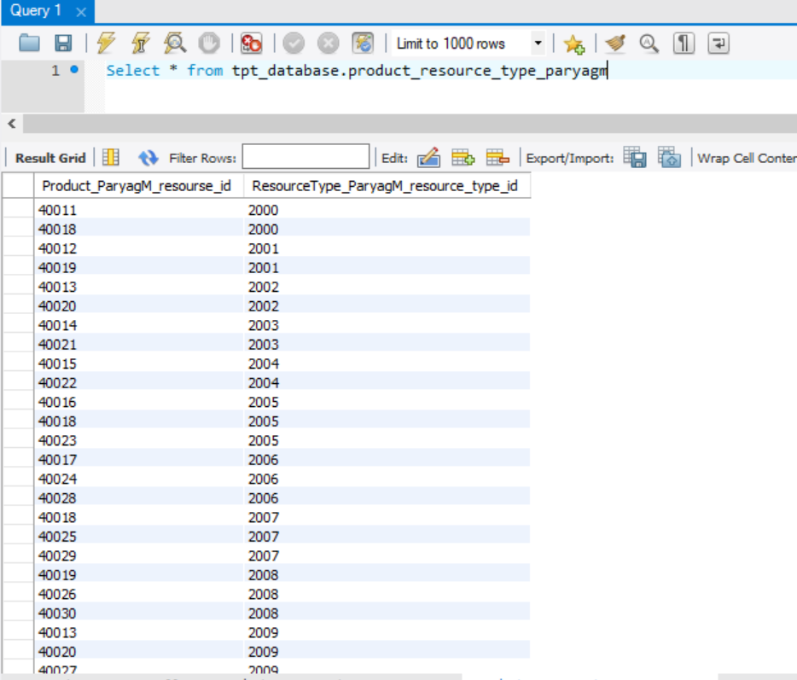

1. **Subject Area Table:**

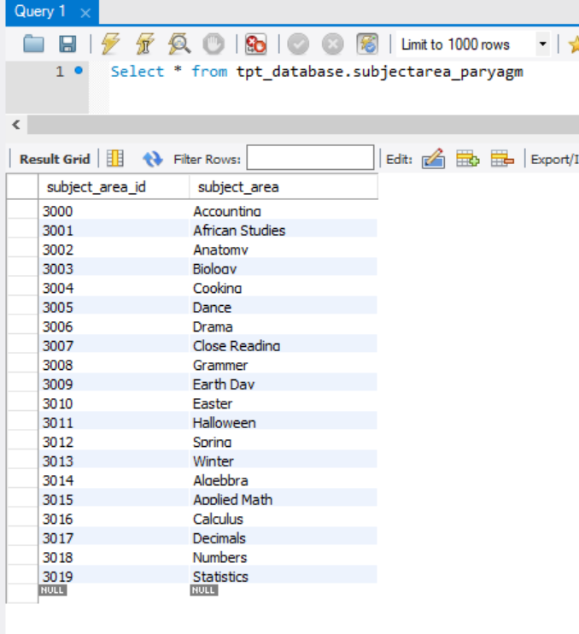

1. **Product Subject Area Table:**

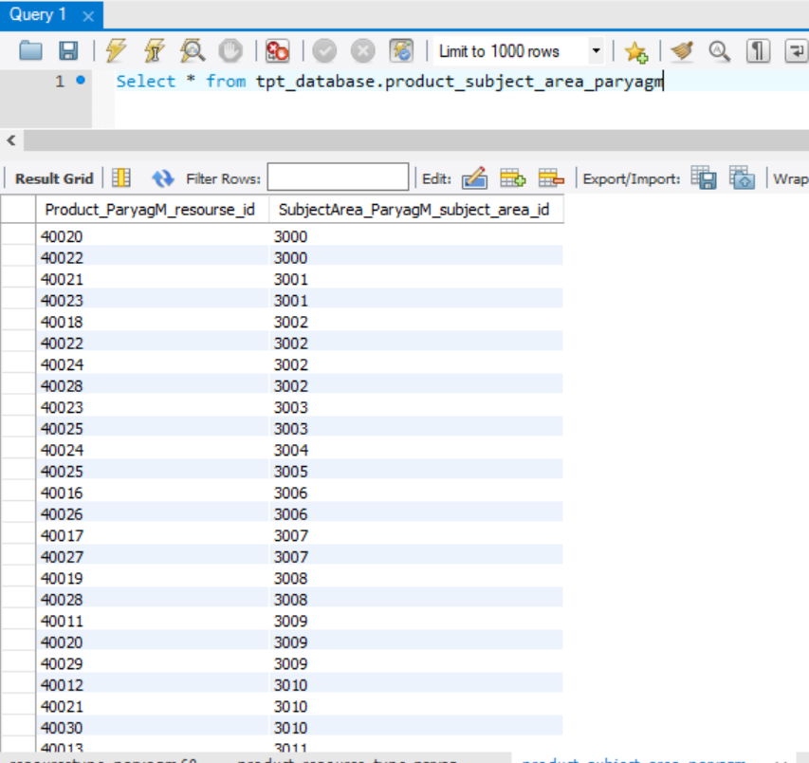

1. **Grade Level Table:**

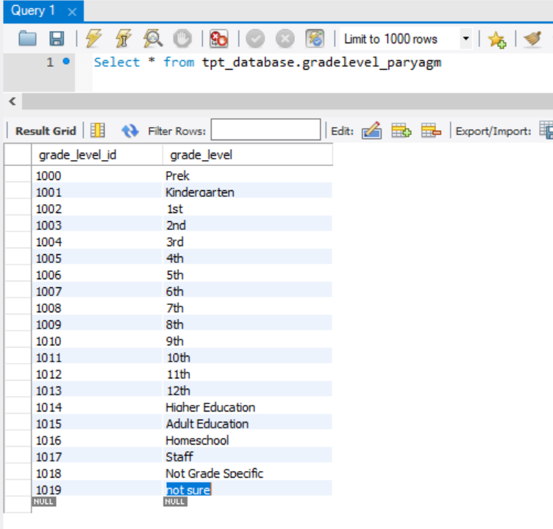

1. **Product Grade Level Table:**

