Business Data Warehouse

Assignment 2

Mehta, Paryag

2018

**Assumptions in the Dimension Model:**

* Once a User sign-up at the TPT website using his email id, he automatically becomes a Buyer.
* There will be only one shipping address per buyer.
* Buyer can update the review comment at the later stage.
* One buyer can give only one review comment on a product; in case he\she purchases the same product and choose to comment again, the previous comment would get updated.
* **Transaction Fact Grain:** one product per buyer per seller in a day.

**Review Fact Grain:** One review per product per buyer in a day

* From the Buyers perspective he can put a rating on a product, however, it is not mandatory. Seller cannot comment on the product; however, he can reply to the comment.
* As per the website, a seller can estimate a fee to sell a product or let TPT decide it.

**Role Playing Dimensions(Alias):**

* Educator Table has been aliased to Seller table and the Buyer table.
* Date dimension has been aliased as Review Date Dimension and Transaction Date Dimension.

**Slowly Changing Dimensions:** Type 2.

* Buyer, Seller and Product as designed as Slowly changing dimensions.

**Conformed Dimensions:**

* Buyer, Seller and Product are also designed as Conformed dimensions as they are connected to Fact_Transaction_Details and Fact_Review table.

**Null Handling:**

To handle Null, a dummy row is inserted in all the dimensions. The key for the null record have been added as ‘1111’

**Pivoting:** Grade Level, Subject Area and Resource Type

All the 3 fields (Grade Level, Subject Area and Resource Type) have be pivoted in the product table with maximum 3 resource type, 3 grade levels and 3 subject area.

**Dimensional Model:**

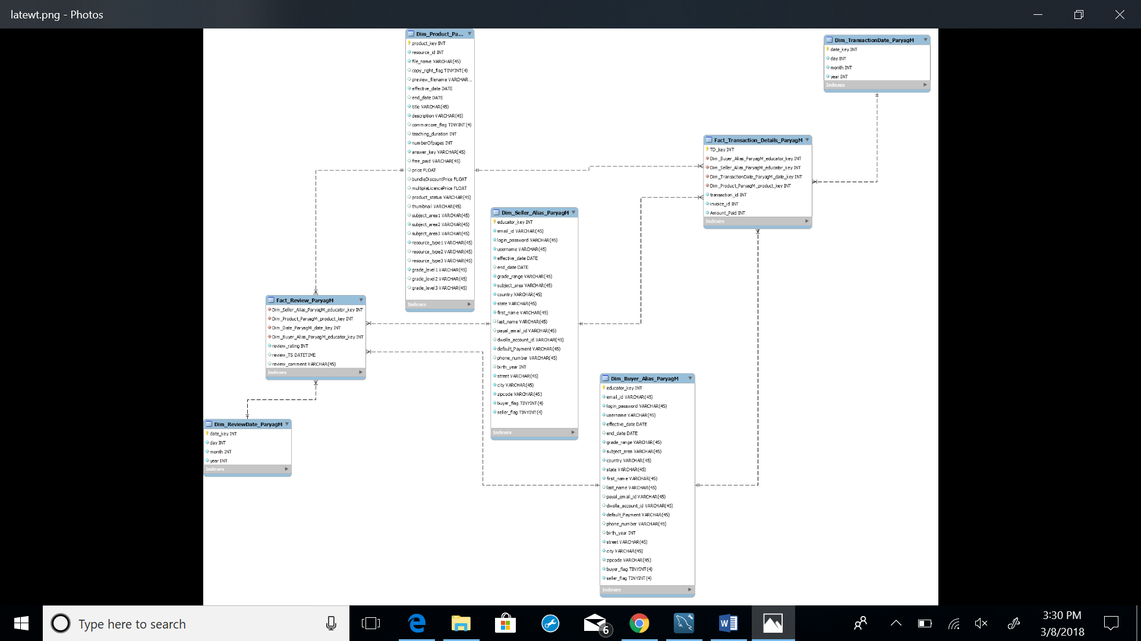

**Review Fact:**

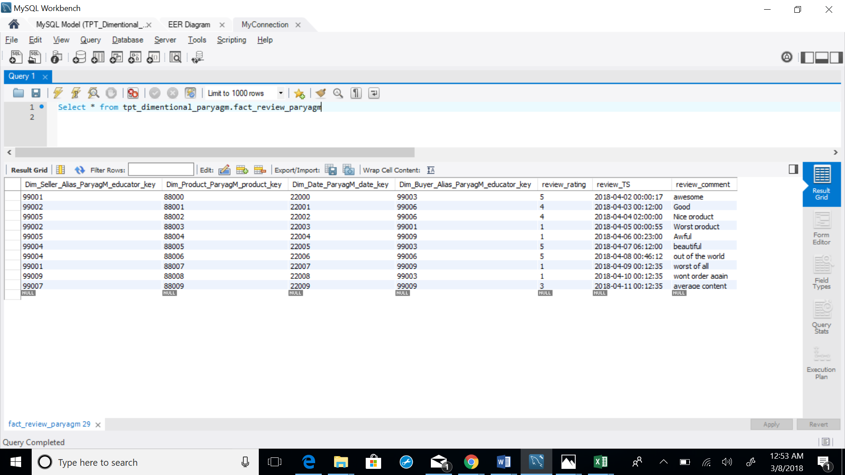

**Transaction(Selling\Buying) Fact:**

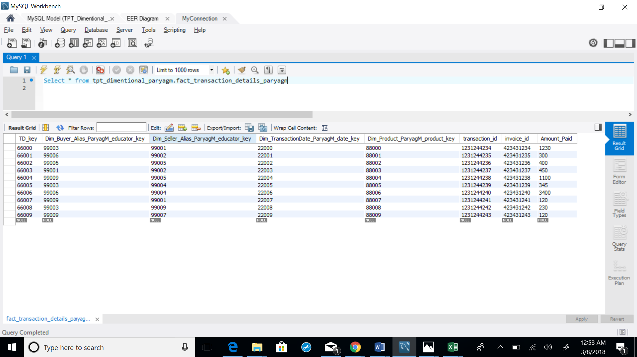

**Product Dimension:**

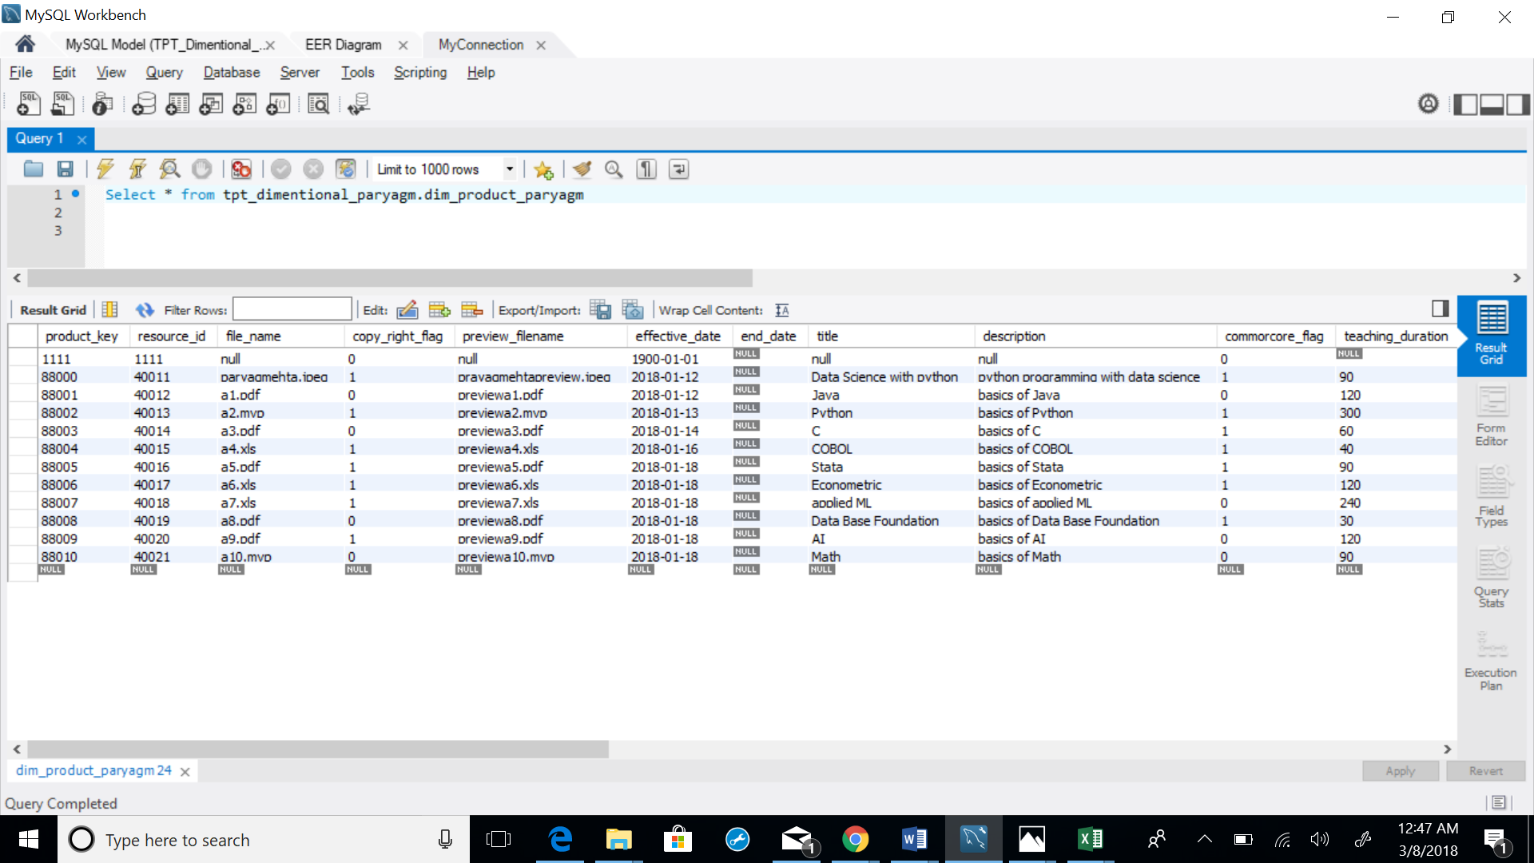

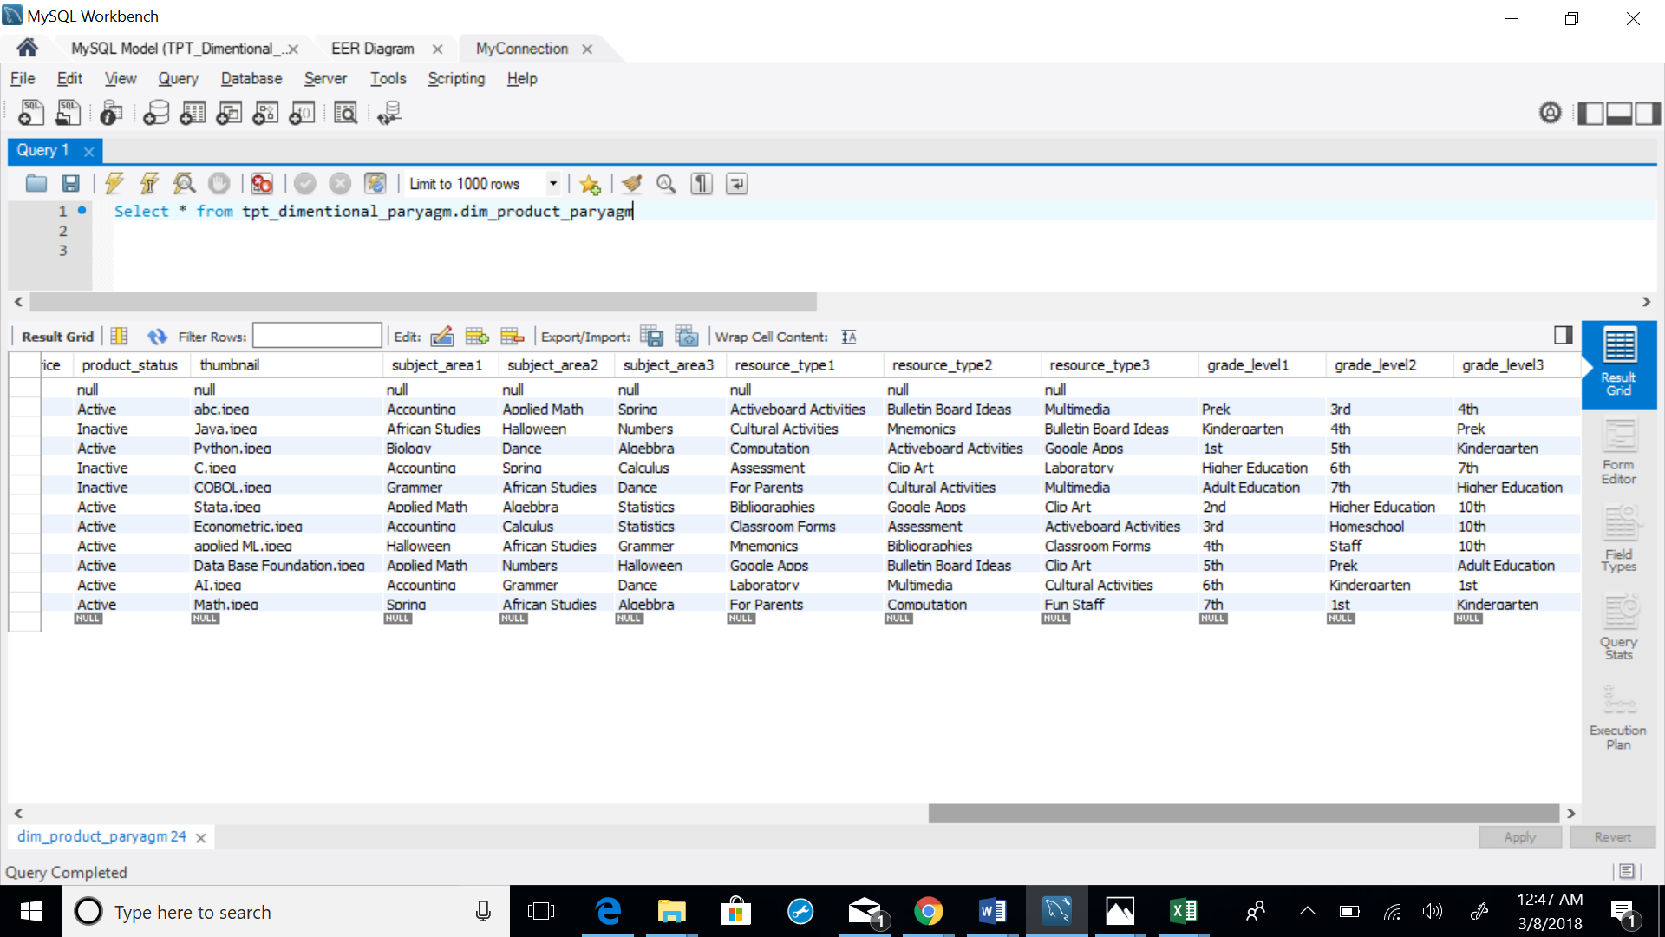

**Seller Dimension (Educator Alias):**

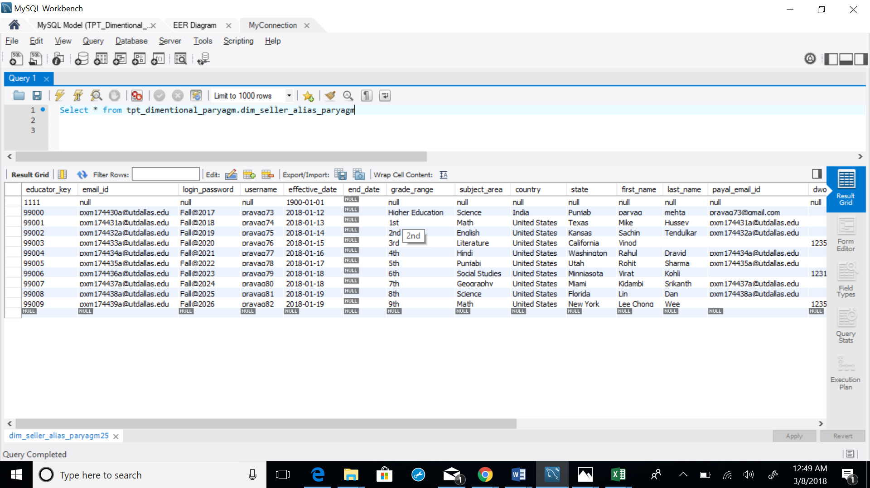

**Buyer Dimension(Educator_Alias):**

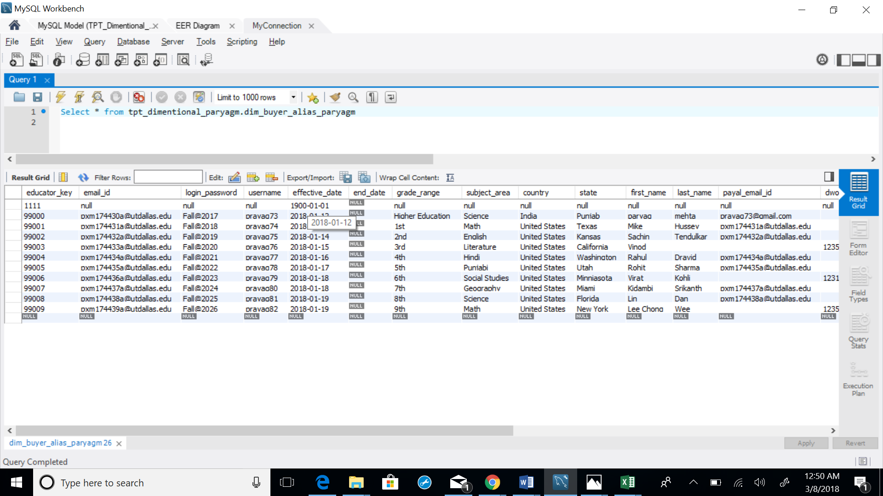

**Review Date Dimension(Date Alias):**

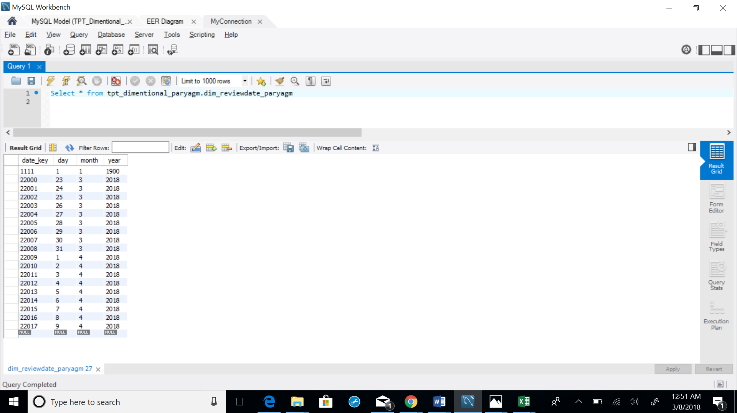

**Transaction Date Dimension (Date Alias):**

