Python Programming Practical Assignment
This document includes code snippets, explanations, and screenshots for each Python program as per the assignment requirements. Replace the screenshot placeholders with your actual output images after executing the programs.

1. Grade Checker
Code:
score = int(input("Enter your score: "))
if score >= 90:
print("Grade: A")
elif score >= 80:
print("Grade: B")
elif score >= 70:
print("Grade: C")
elif score >= 60:
print("Grade: D")
else:
print("Grade: F")
Explanation:
This program takes a numeric score as input and uses if-elif-else conditions to determine the grade.
📸 Screenshot: 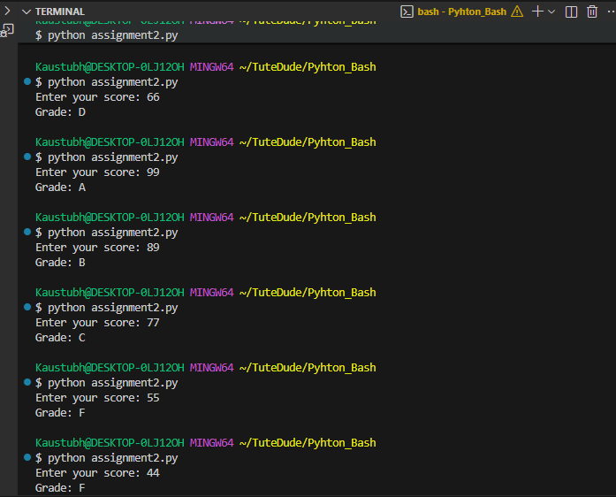

2. Student Grades (Dictionary Operations)
Code:
grades = {}
while True:
print("\nOptions:")
print("1. Add new student")
print("2. Update existing grade")
print("3. Display all grades")
print("4. Exit")
choice = input("Enter choice (1-4): ")
if choice == '1':
name = input("Enter student name: ")
grade = input("Enter student grade: ")
grades[name] = grade
print(f"Added {name} with grade {grade}")
elif choice == '2':
name = input("Enter student name to update: ")
if name in grades:
grade = input("Enter new grade: ")
grades[name] = grade
print(f"Updated {name}'s grade to {grade}")
else:
print("Student not found!")
elif choice == '3':
print("\nAll Student Grades:")
for student, grade in grades.items():
print(f"{student} : {grade}")
elif choice == '4':
print("Exiting program.")
break
else:
print("Invalid choice, try again!")
Explanation:
This program uses a dictionary to store student names and grades. It allows adding, updating, and displaying records using basic if-else logic.
📸 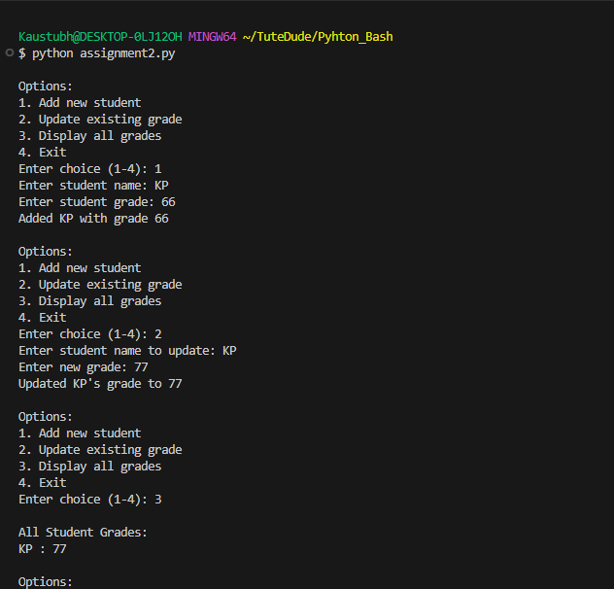

3. Write to a File
Code:
file = open("example.txt", "w")
file.write("This is a simple text file.\n")
file.write("Writing from Python using file handling.\n")
file.close()
print("File 'example.txt' created and written successfully.")
Explanation:
This program opens (or creates) a text file named example.txt and writes text lines into it using the write() function.
📸 Screenshot: 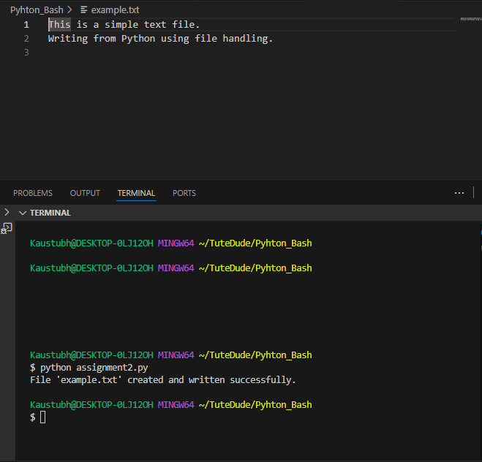

4. Read from a File
Code:
file = open("example.txt", "r")
content = file.read()
file.close()
print("File content:\n")
print(content)
Explanation:
This program reads the contents of example.txt file and displays it on the console using the read() method.
📸 Screenshot: 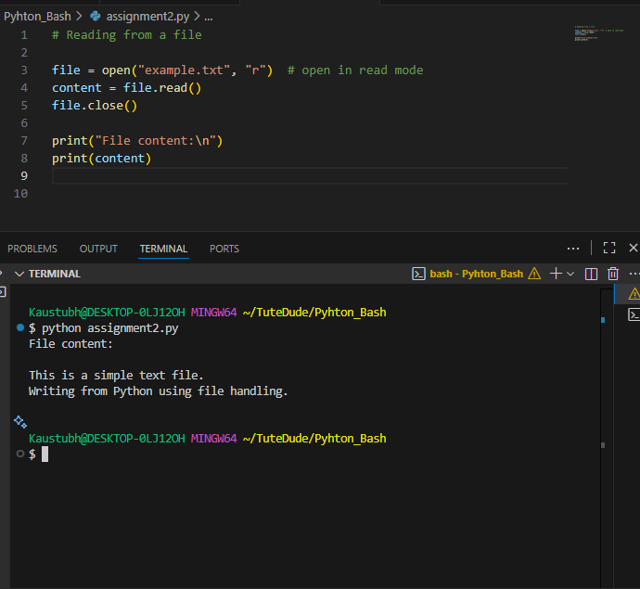

Submission Guidelines
1. Attach this document (.docx) with screenshots and code.
2. OR upload this document and all .py files to your GitHub repository.
3. Add the GitHub repo link below:
GitHub Repo Link: ______________________________

