Linux Command-Line Practical Assignment
This document contains step-by-step commands, explanations, and screenshots for the Linux practical tasks. Replace each placeholder with your screenshot and confirm the output shown in your terminal.

1. Creating and Renaming Files/Directories
Commands:
mkdir test_dir
cd test_dir
touch example.txt
mv example.txt renamed_example.txt
Explanation:
- mkdir creates a directory.
- touch creates an empty file.
- mv renames or moves a file.
📸 Screenshot: 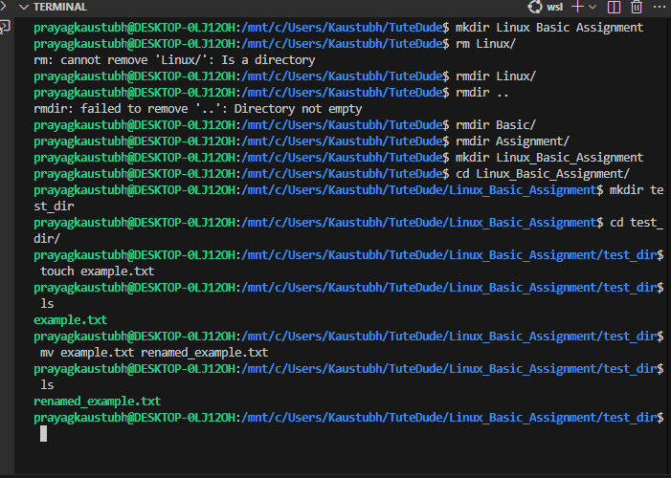

2. Viewing File Contents
Commands:
cat /etc/passwd
head -n 5 /etc/passwd
tail -n 5 /etc/passwd
Explanation:
Displays all, first 5, and last 5 lines of the /etc/passwd file respectively.
📸 Screenshot: 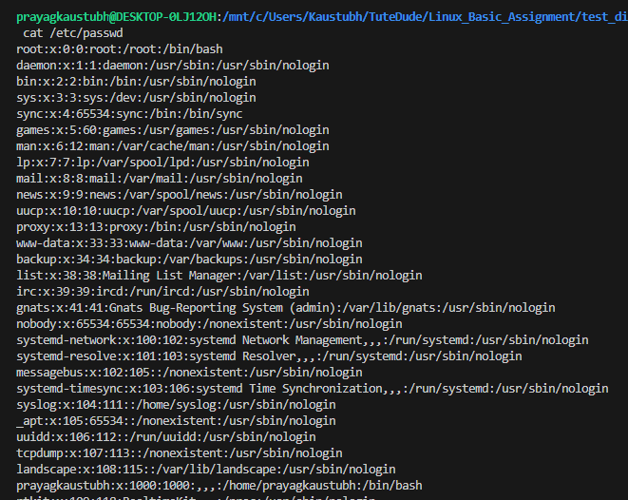

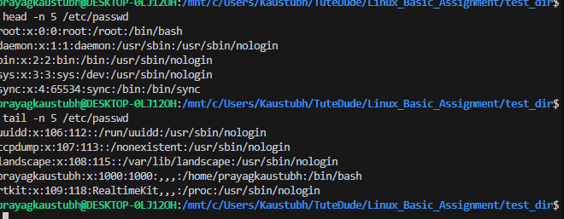

3. Searching for Patterns
Command:
grep 'root' /etc/passwd
Explanation:
Searches and displays lines containing the word 'root'.
📸 Screenshot: 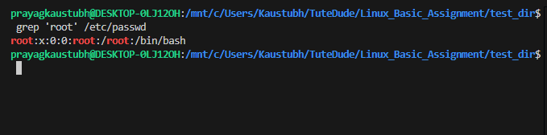

4. Zipping and Unzipping
Commands:
cd ..
zip -r test_dir.zip test_dir
unzip test_dir.zip -d unzipped_dir
Explanation:
- zip compresses files into a zip archive.
- unzip extracts the compressed archive.
📸 Screenshot: 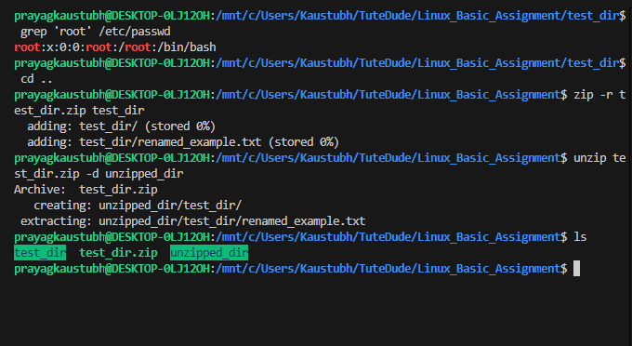

5. Downloading Files
Command:
wget https://example.com/sample.txt
Explanation:
Downloads a file from the internet using wget.
📸 Screenshot: 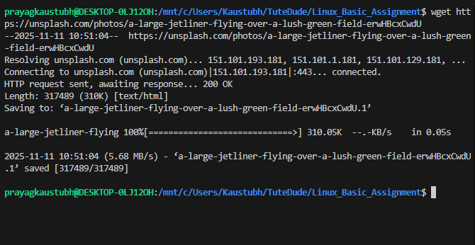
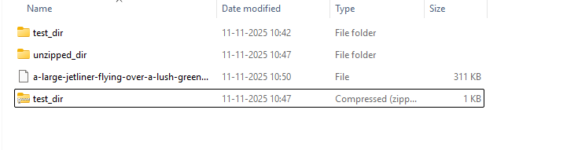

6. Changing Permissions
Commands:
touch secure.txt
chmod 444 secure.txt
ls -l secure.txt
Explanation:
- chmod 444 makes a file read-only for all users.
- ls -l shows permissions in long format.
📸 Screenshot: 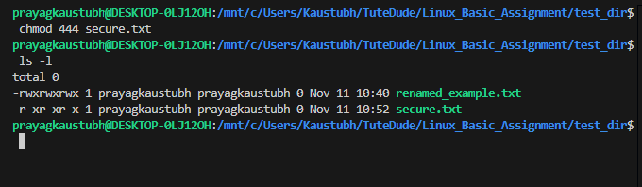

7. Working with Environment Variables
Commands:
export MY_VAR='Hello, Linux!'
echo $MY_VAR
Explanation:
Sets an environment variable and displays its value.
📸 Screenshot: 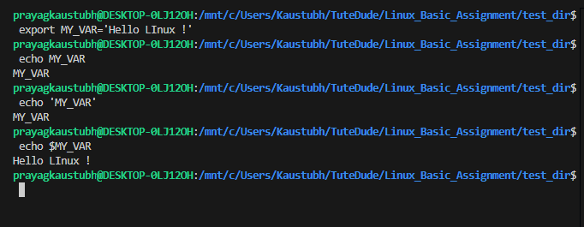

8. GitHub Submission
Steps:
1. Create a new GitHub repository (e.g., linux-commands-practice).
2. Upload this document and related files.
3. Commit and push.
4. Add your GitHub repository link below:
GitHub Repo Link: ___________________________

