# 0. The purpose of system.

Team 6 assumed that the system received from CMU for the studio project as records commuting time through employee face recognition

# 1. Identify the PnG types, goals, motivations, skills

|  |  |  |
| --- | --- | --- |
| PnG 1 | Type | Internal Engineer |
| Goal | Ruin the manager's reputation |
| Motivation | Revenge to the manager |
| Skill | Implement a back door access to the commuting DB |
| Misuse case | Using a back door. And modify the commuting time of the manager. |

|  |  |  |
| --- | --- | --- |
| PnG 2 | Type | Employee |
| Goal | Not going to work, but cheating as if you went to work. |
| Motivation | debt of gambling |
| Skill | Tampering through networking by spoofing |

|  |  |  |
| --- | --- | --- |
| PnG 3 | Type | Spy |
| Goal | Steal all components of the system |
| Motivation | Competitors request |
| Skill | Physical power and ability to use various equipment |

|  |  |  |
| --- | --- | --- |
| PnG 4 | Type | Hacker |
| Goal | Display hacker's name on the screen |
| Motivation | Strives for recognition |
| Skill | Physical power and ability to use various equipment |

|  |  |  |
| --- | --- | --- |
| PnG 5 | Type | stalker |
| Goal | Get the privacy info for specific person |
| Motivation | obsessive |
| Skill | sniffing |

# 2. Comparison with STRIDE

Indicate whether they discovered threats that did not appear with STRIDE or whether it reinforced the STRIDE results

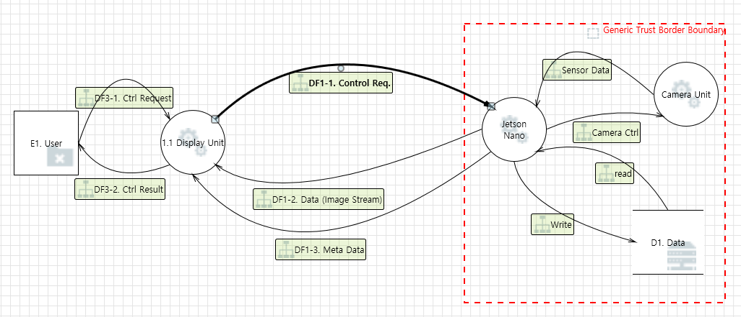

|  |  |  |
| --- | --- | --- |
| **Threat** | | **Comparison PnG** |
| Spoofing | Display Unit > Jetson Nano  Control Req may be spoofed by an attacker and this may lead to unauthorized access to Jetson Nano. | Similar with PnG case 5 |
| Tampering | Data > Jetson Nano  Data read flowing may be tampered with by an attacker. Ensure the integrity of the data flow to the data store. | Similar with PnG case 1, 2 |
| Repudiation | Display Unit > Jetson Nano  Jetson Nano can repudiation Display Unit. Consider using logging or auditing Display Unit. | No PnG cases |
| Information disclosure | Jetson Nano > Display Unit  Data flowing across Meta Data may be sniffed by an attacker. Consider encrypting the data flow. | Similar with PnG case 5 |
| Denial of Service | Camera Unit  Camera crashes, halts, stops or runs slowly; in all cases violating an availability metric. | No PnG cases |
| Elevation of Privilege | Display Unit > Jetson Nano  User may be able to impersonate the Control Req in order to gain additional privilege. | Similar with PnG case 4 |

PnG cases 3 is not appear with STRIDE,.