CMU Project Report (Team6)

Table of Contents

0. Introduction 3

1. Schedule 3

2. System Requirement 3

3. Security Goals 3

4. Security Requirements 3

5. Assets 4

6. Threat Modeling 4

7. Security Risk Assessment 4

8. Mitigation 4

9. Architecture 4

10. Static Analysis 4

11. Fuzz & Penetration Test 5

12. Conclusion 5

# 0. Introduction

TODO: Introduce team member and role and project

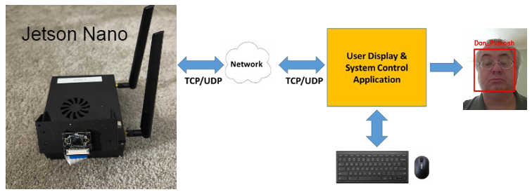

# 1. Schedule

Note: This is our rough schedule that’s set-up in the first week so it will be updated periodically.

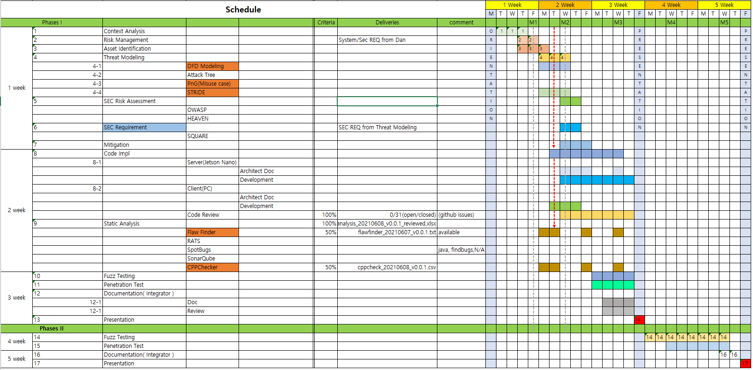

# 2. System Requirement

We’ve analyzed the requirement documents that was given by professor Dan and professor Jeff. The name of the first document is **LG May 2021 Lecture Secure Coding Project Intro V1.1.pptx.pdf** and the second is **LG Security Class Project Description.pdf.**

We’re struggling to find and extract our system requirement from these documents.

Here is our first artifact from the first, Project Description-1,2,3.

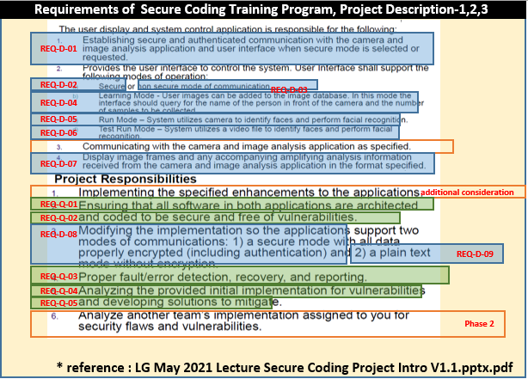

But, we needed to compare another document below because it (the second) was also describing system requirements of Jetson Nano system. The second document says requirements of Tartan Secure Camera Application.

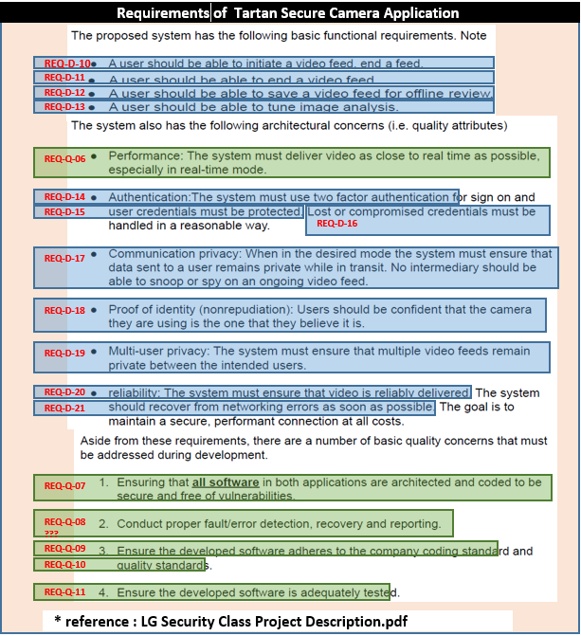

Those made us confused. Therefore, we should clarify and draw the requirement for our system after discussing with Professor DAN.

|  |
| --- |
| Summary of meeting with Professor DAN |
| Mandatory requirements described in the "LG May 2021 Lecture Secure Coding Project Intro V1.1.pptx.pdf" document.  - no vulnerability in the system  - secure architecture  - implement 5 modes (run, test run, learning, secure, non-secure)  - Jetson Nano sends the Camera Image and Face Recognized information. It should be separated.  - Client receives the data above, and displays it after combining it |

We’ve extracted our requirements from the list above and attached the result.

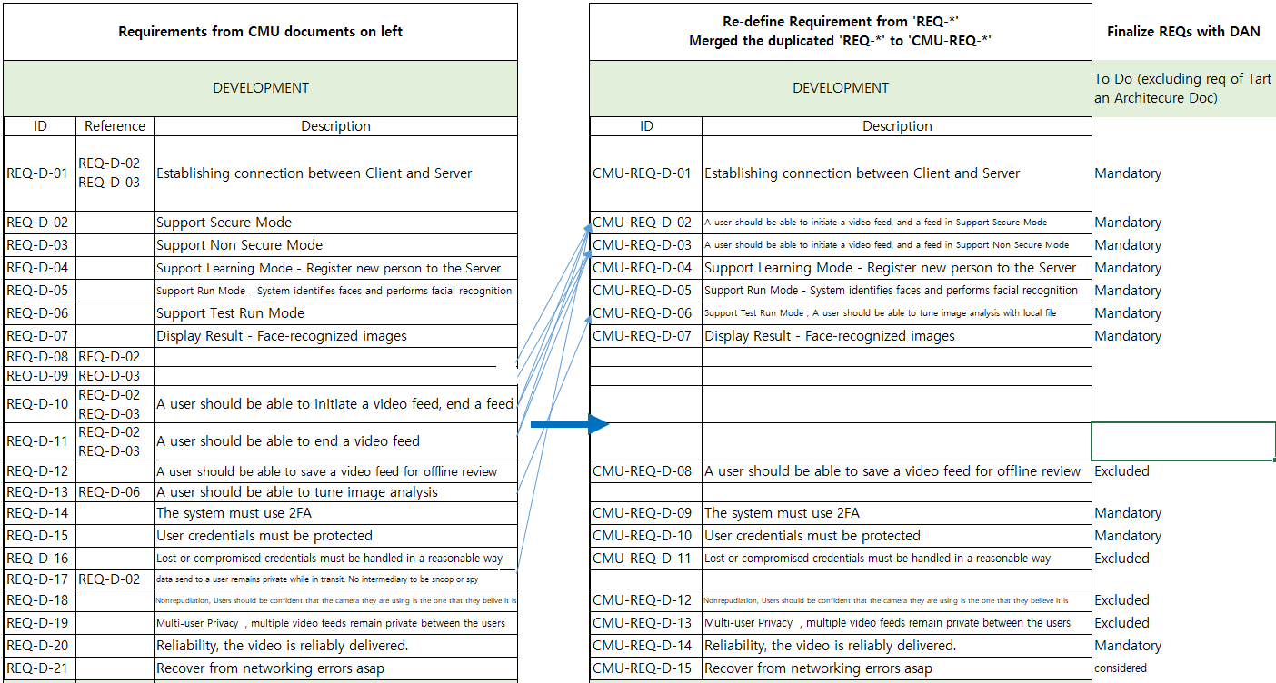

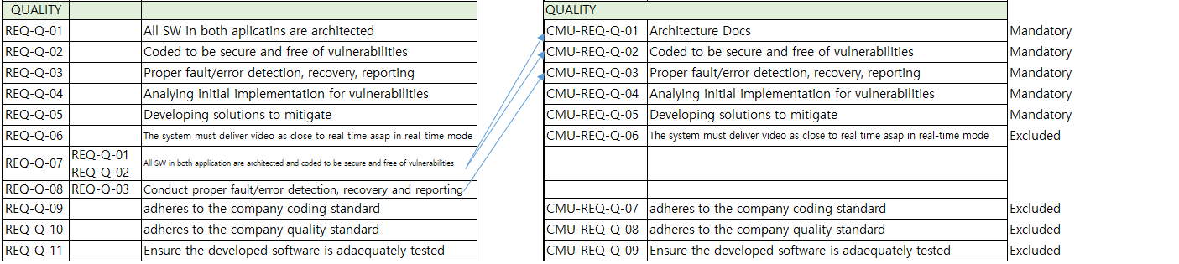

# 3. Security Goals

Protecting the user privacy information in our system.

# 4. Security Requirements

-- iter 1

[ ] Any information related (personal) privacy SHALL be protected securely. (Friend video/Learned PHOTO)

[ ] Any information related (personal) privacy SHALL be accessible to only authorized entities. (Learned PHOTO)

[*] The system SHALL use only approved algorithms for cryptographic operation.

[*] Server and client SHALL communicate over encrypted and authenticated channel.

-- iter 2

[*] Any information related (personal) privacy SHALL be protected securely. (ID/PASS/Friend video/Learned PHOTO)

[*] Any information related (personal) privacy SHALL be accessible to only authorized entities. (ID/PASS/Learned PHOTO)

[*] The system SHALL have a resiliency against key compromise. (TLS Key, Cert)

# 5. Assets

-- iter 1

[ ] Images for transmission over camera cable

[*] Images for transmission over network

[*] The Friend video

[*] Client program itself

[*] Client program hash code on server side

-- iter 2

[*] User info. data (ID, type, password)

# 6. Threat Modeling

# 7. Security Risk Assessment

# 8. Mitigation

# 9. Architecture

## 9.1. Overall Architecture

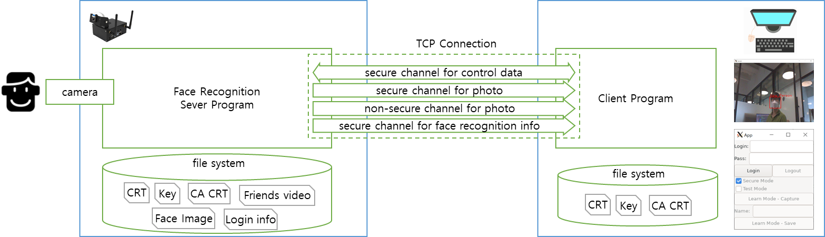

## 9.2. Terminology and Definitions

|  |  |
| --- | --- |
| **Terminology** | **Definitions** |
| CA CRT | Self signed Root Certificate |
| CRT | CA signed Certificate |
| Key | Private Key |
| Login info |  |
| Face Image |  |
| Photo |  |
| Secure Mode |  |
| Non Secure Mode |  |
| Run Mode |  |
| Test Run Mode |  |
| Learn Mode |  |
| Secure channel for control data | TLS TCP connection.  The request and response message is transmitted. |
| Secure channel for photo | TLS TCP connection.  The photo data is transmitted from the server to the client |
| Non-secure channel for photo | TCP connection.  The photo data is transmitted from the server to the client |
| Secure channel for face recognition info | TLS TCP connection.  The coordination of the recognized face on the photo and the recognized name is transmitted from the server to the client |

## 9.3. Source Directory

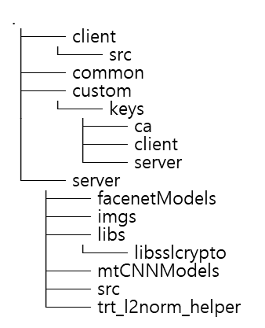

## 9.4. Setup Guide

### 9.4.1. Server

cd source/server/

python3 step01_pb_to_uff.py

rm -rf MTCNN_FaceDetection_TensorRT/

git clone https://github.com/PKUZHOU/MTCNN_FaceDetection_TensorRT

mv MTCNN_FaceDetection_TensorRT/det* ./mtCNNModels

mkdir build; cd build

cmake -DCMAKE_BUILD_TYPE=Release ..

make -j

./LgFaceRecDemoTCP_Jetson_NanoV2 5000 9.2.2. Client

### 9.4.2. Client

apt install cmake libssl-dev libgtkmm-3.0-dev libopencv-dev

cd source/client/ && mkdir build; cd build

cmake ..

make

./client

## 9.5. Scenario

# 10. Static Analysis

# 11. Fuzz & Penetration Test

# 12. Conclusion