Login Window where you need to enter your Administrator Credentials for Office 365.

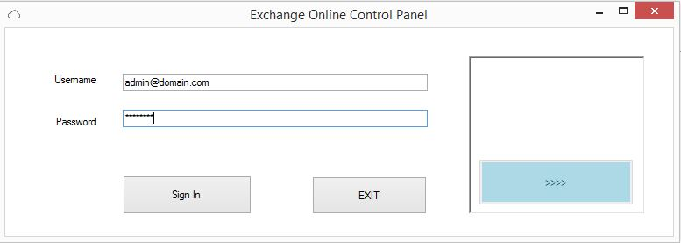

Once you enter your credentials, you need to click on ‘sign in’ button and wait for the session to be established. It will take the same time as PowerShell takes to connect to EXO and also import MSONLINE module to connect MSOLservice

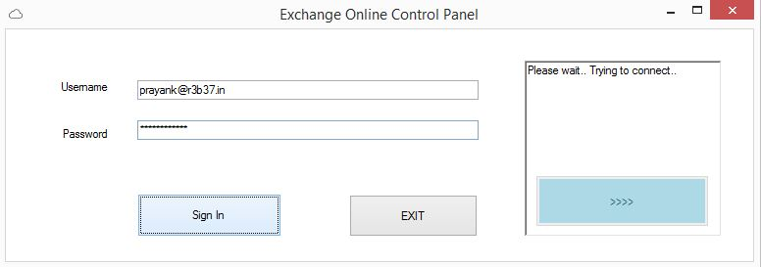

You will see the color changed for the button which will navigate you to EXO panel once the session is established.

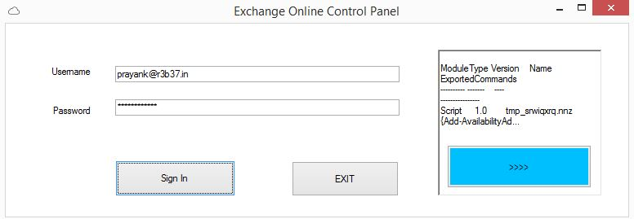

Once you click on the blue button, it will open the mail window from where you can open different tabs.

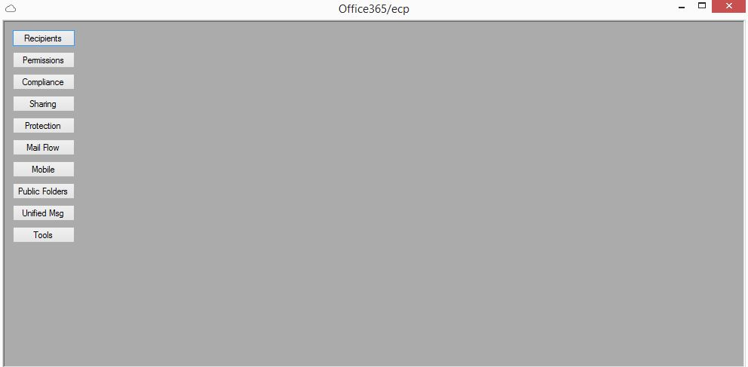

Recipients tab main window:

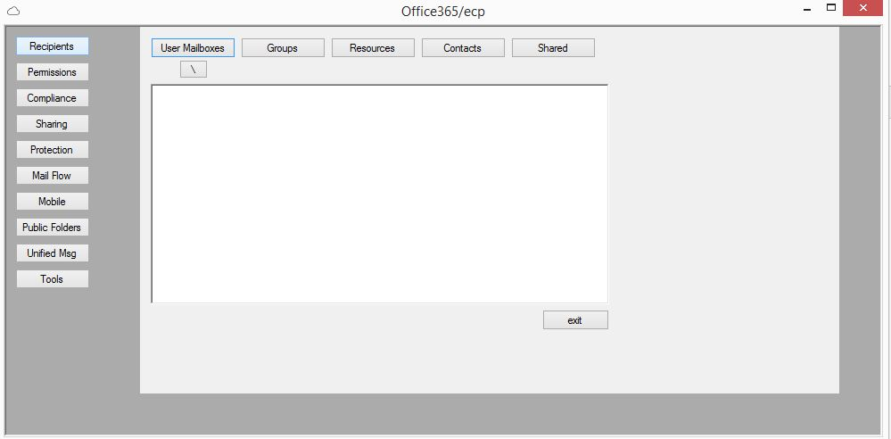

When you click on ‘user mailboxes’ button, it will list all the user mailboxes by running the PowerShell cmdlet:

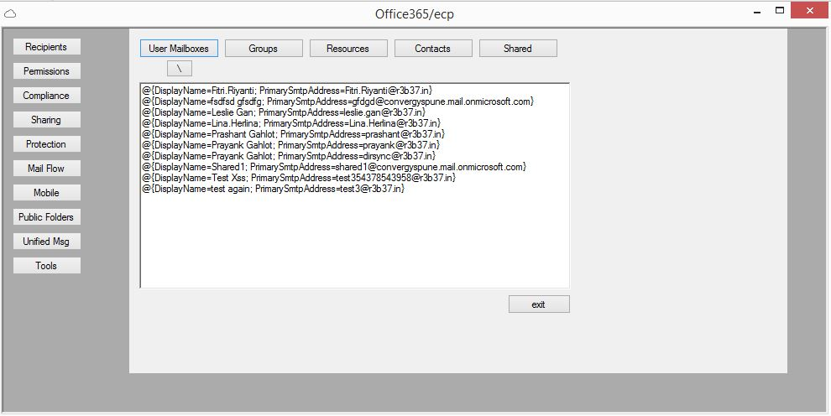

You can click on’\’ button to edit/view mailbox properties.

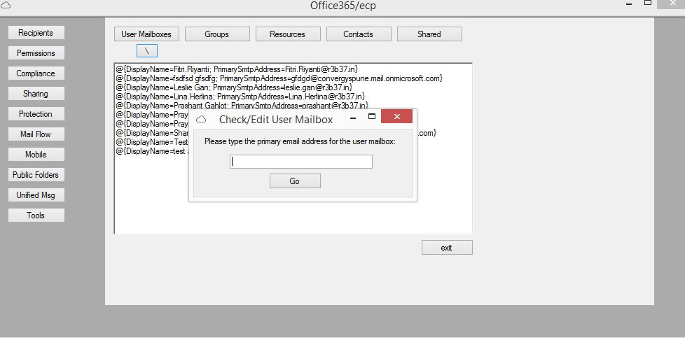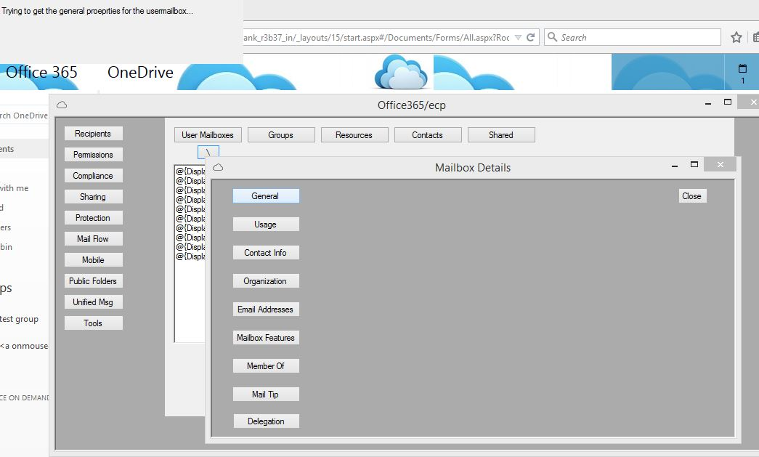

After you click on ‘general’ tab:

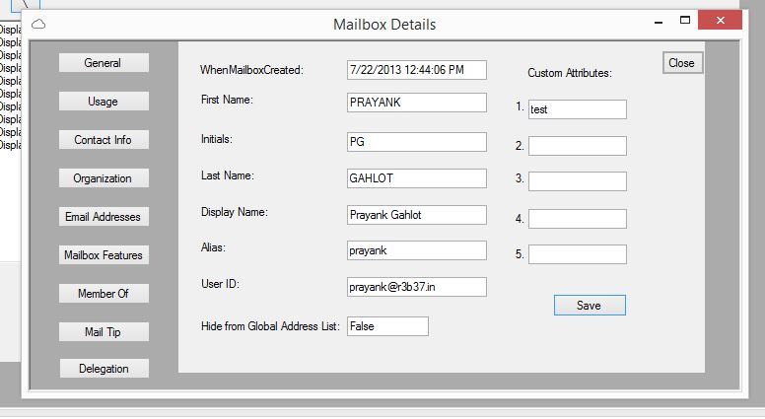

Saving the changes made to Initials:

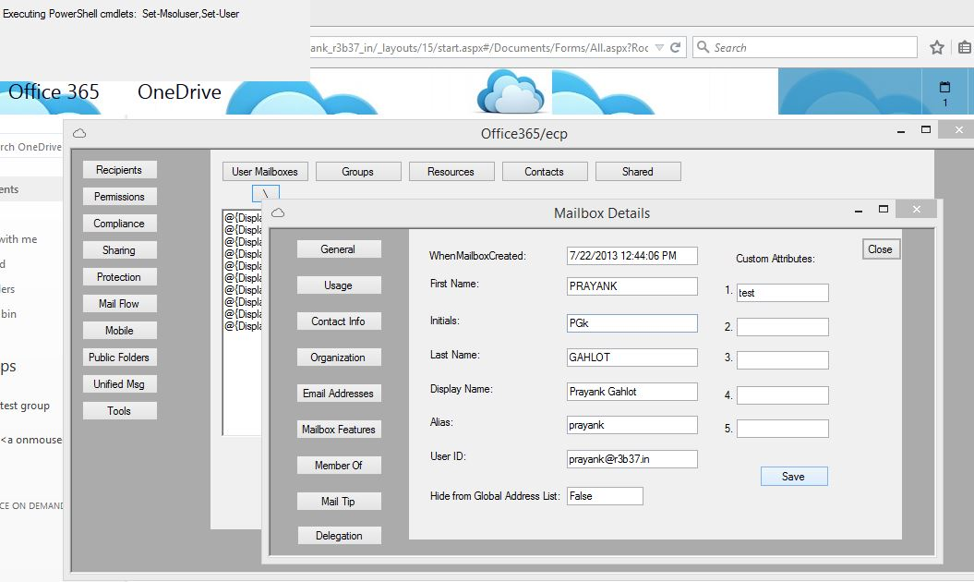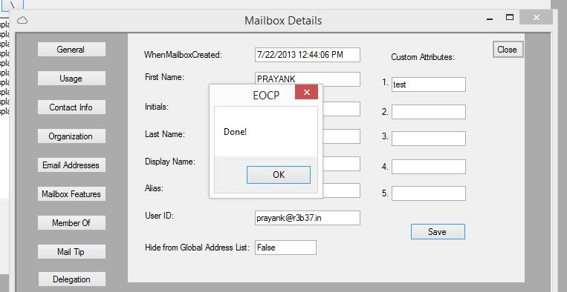

Tools Section:

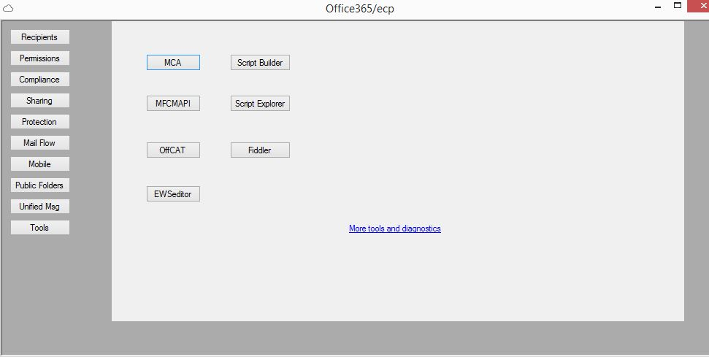

MCA:

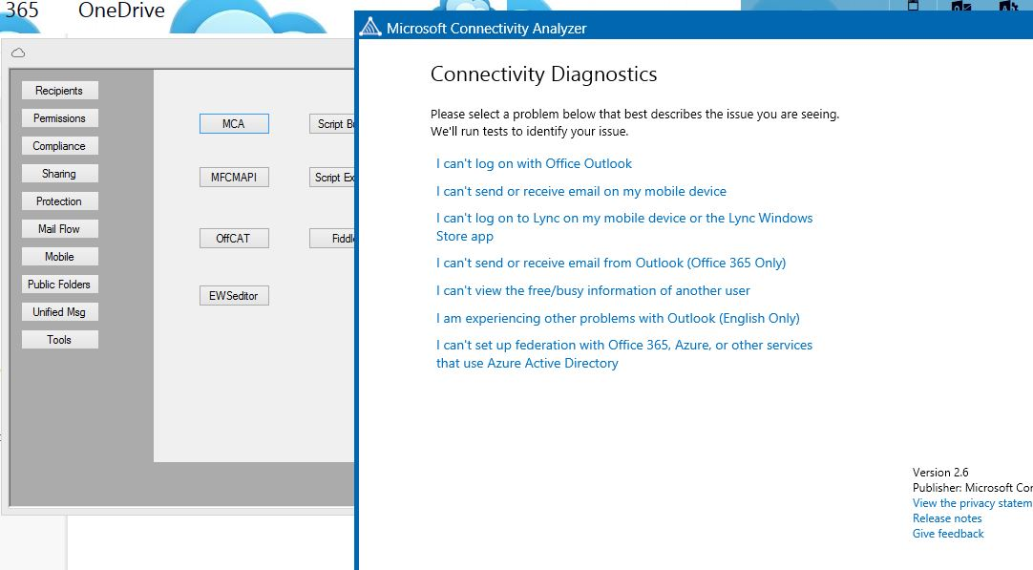

Script Builder:

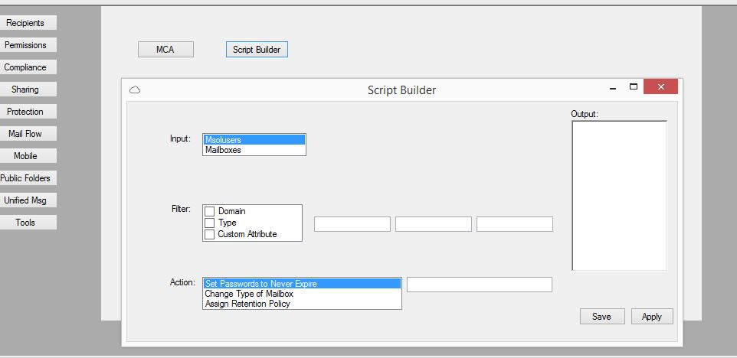

Clicked on ‘apply’:

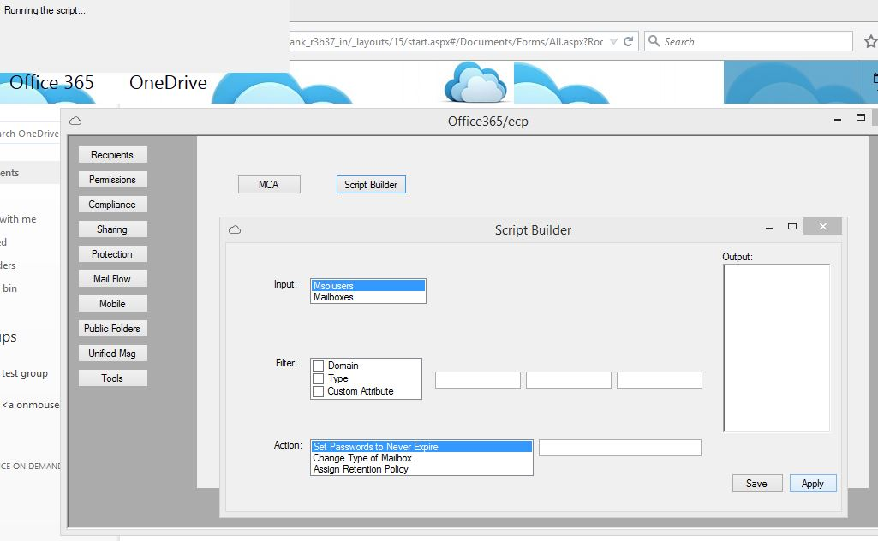

Results for the script we ran:

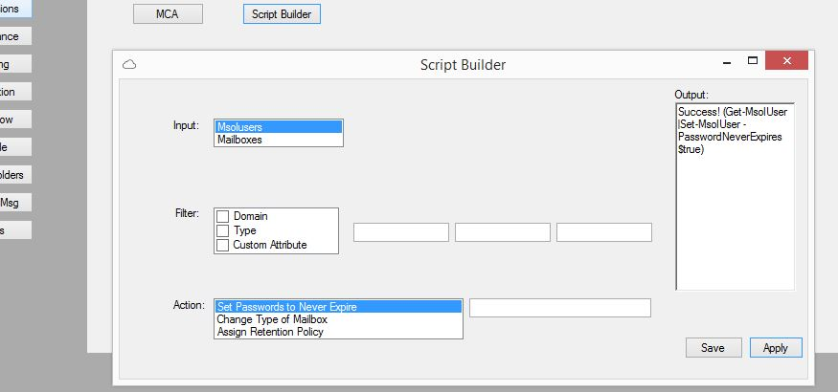

Script Explorer:

