**Scenarios specific to Industry sector**

We have one scenario (STEEL_NSP) specific to the Steel Industry and one calibration run for the bottom-up Industry sector as described below –

**STEEL_NSP Scenario –**

This is a scenario specific to Steel industry which is based on the targets that have been set in the National Steel Policy 2017 (NSP) by the Ministry of Steel. Salient features of the policy are -

* Target of achieving crude steel capacity of 300 MT by 2030 with a capacity utilization factor of 85%. Based on these, the production target for FY31 in this run is 255 MT.
* Share of the Blast furnace - Basic oxygen furnace (BF-BOF) route to be increased to 60-65% of total production. For this run, the BOF share is assumed as 60%.
* Balance production 35- 40% is from the other routes viz. EAF (Electric Arc furnace) & IF (Induction furnace) based.
* The capacity target for 2047 is 500 MT. For NSP run, the target for 2041 is suitably interpolated and it is assumed that BOF share stays around 58-60%.
* Per capita steel consumption to reach 158 kg from current levels of ~ 70 kg.
* Targets for techno-economic performance (including SEC) are as given in table below –

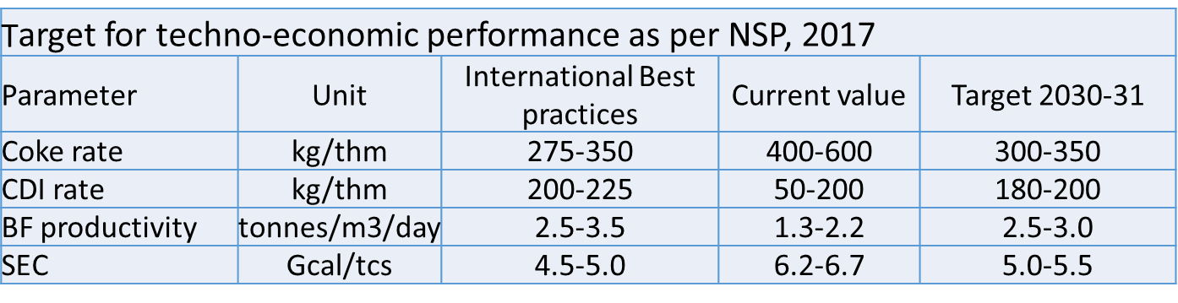

Further, it is assumed that -

* SEC improvement rate is to be faster and SEC achieves current best available technology levels in 2041 (same as Vikasit Bharat scenario)
* Uptake for decarbonising levers like green hydrogen based DRI-EAF route and CCUS are slower and same as Reference scenario.

**BU_IND_Calibration –**

The calibration run is carried out for the three bottom-up industry sectors (Steel, Cement & Aluminium) with model period starting from 2022 to obtain the demand figures for all energy carriers and calibrate them with actual consumption figures for 2022 / 2023 for those carriers whose data is available.