**Name –** Prayas Prakash Sambhare

**Roll no –** 17ME33039

Effective properties:

1. E1 = 117.81 Gpa
2. E2 = 7.98 Gpa
3. Nu12 = 0.273
4. G12 = 3.57 Gpa

**Youngs Modulus(E1) v/s Theta**

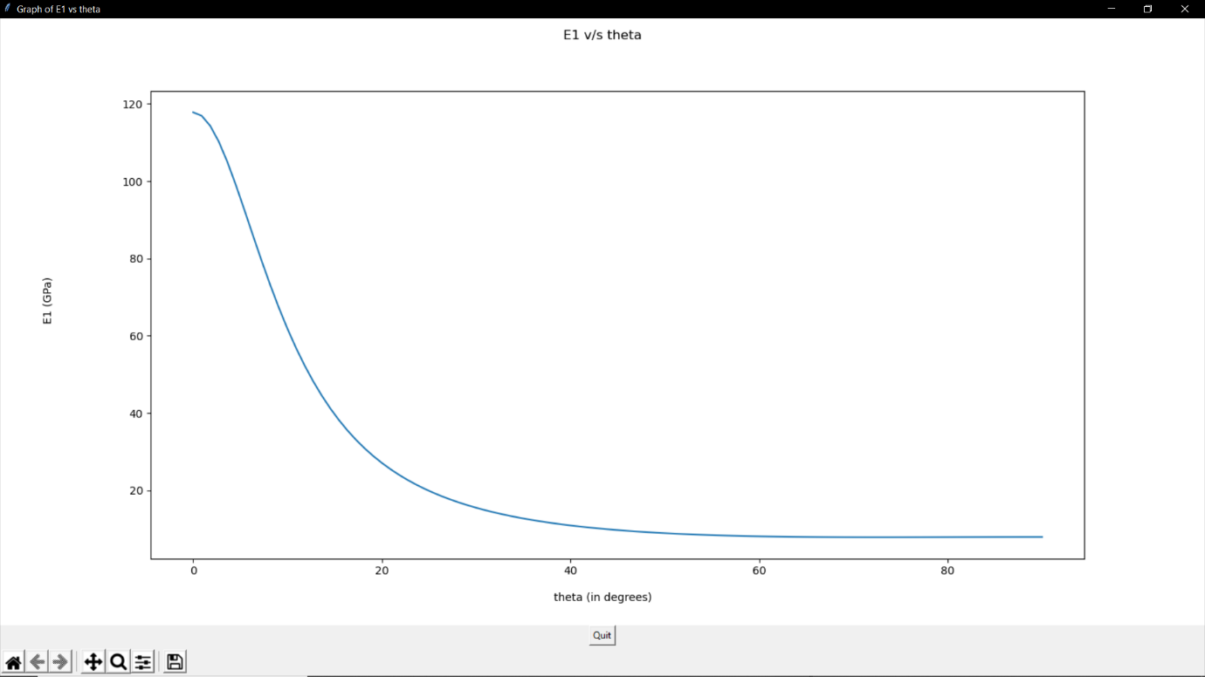

**Youngs Modulus(E2) v/s Theta**

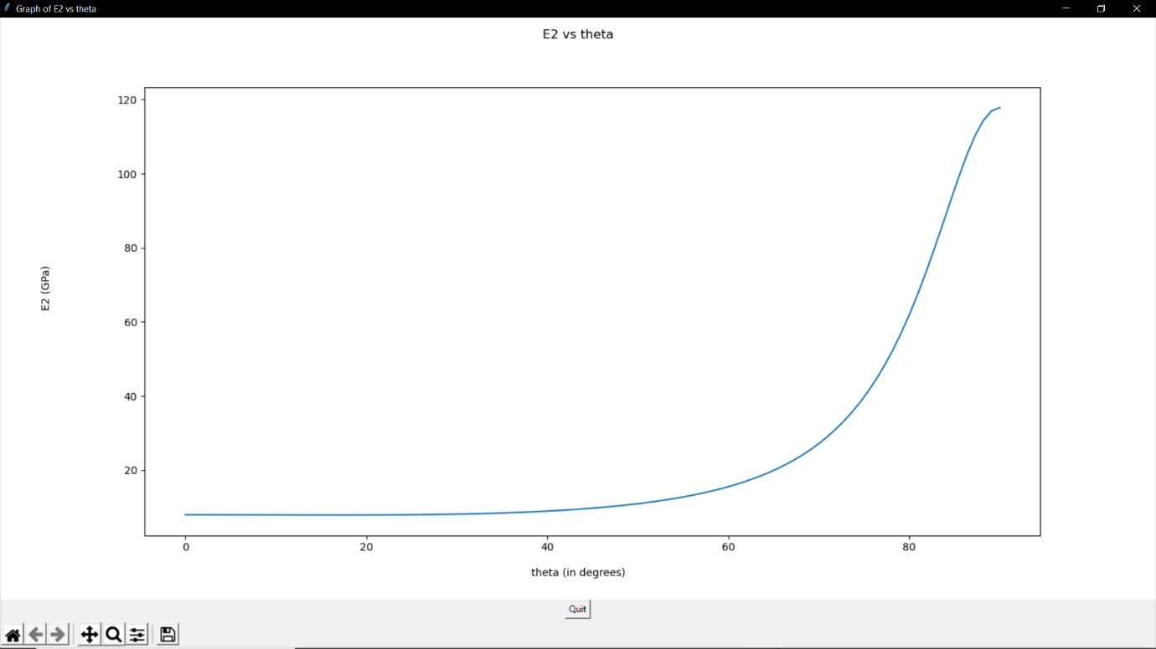

**Shear Modulus(G12) v/s Theta**

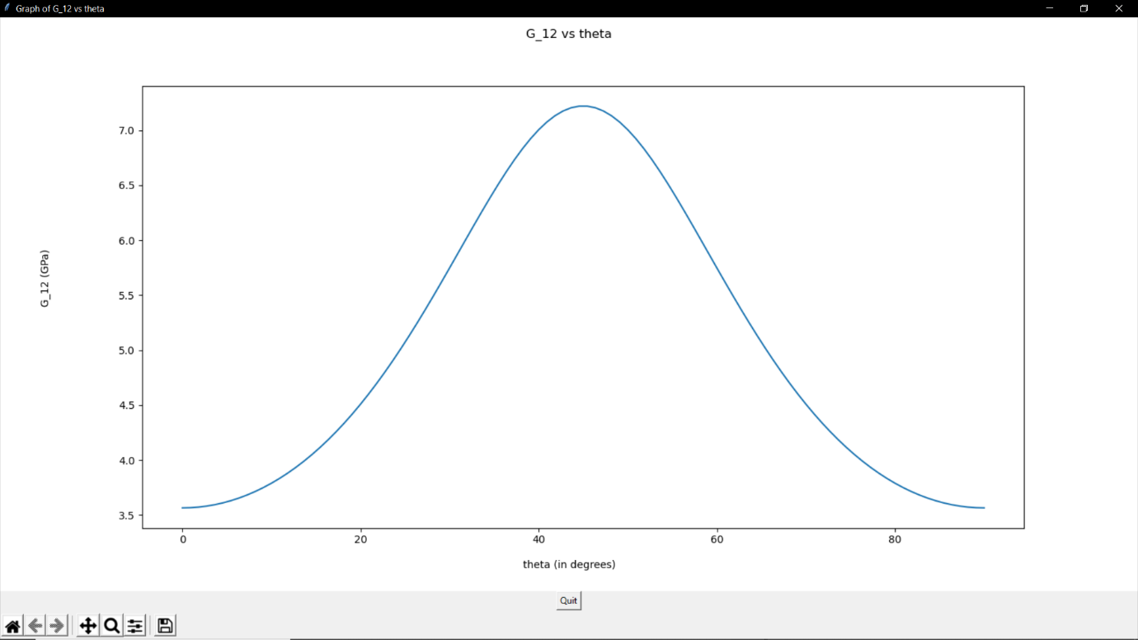

**Q16 v/s Theta**

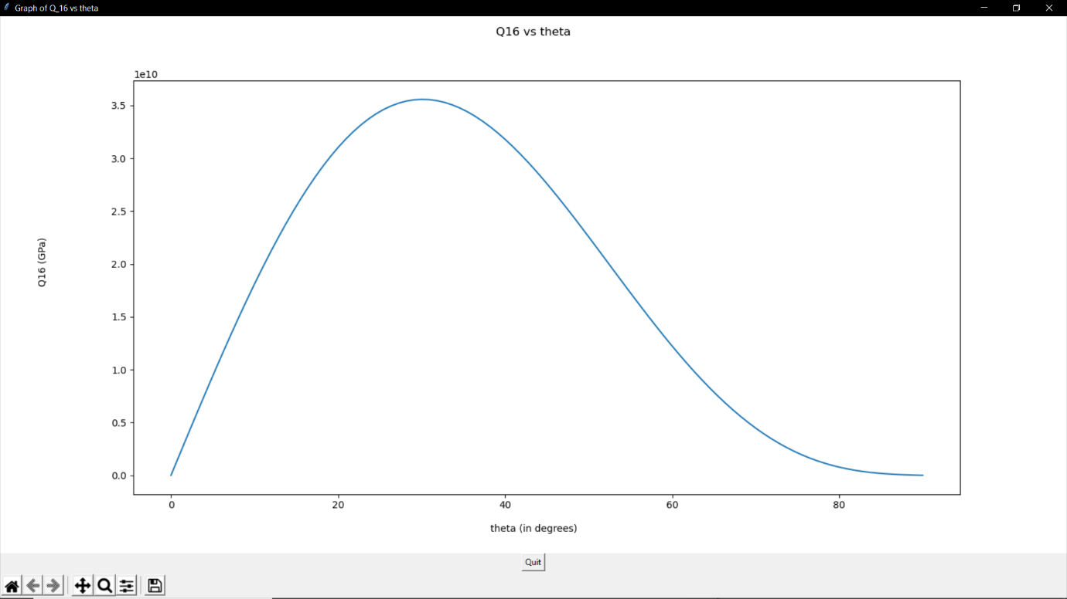

ABD matrix =

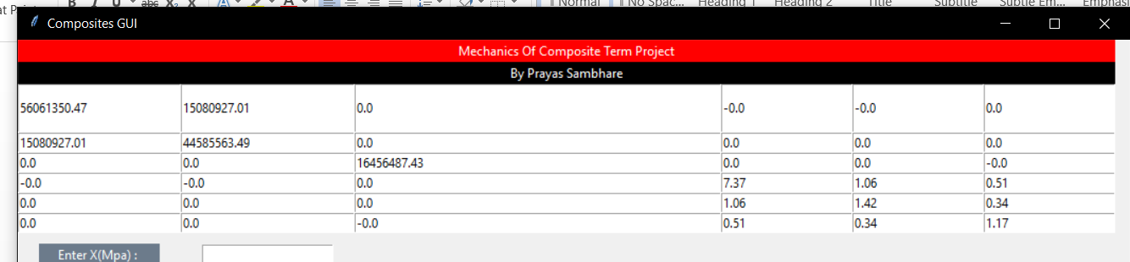

Margin of Safety:

For 0 degree lamina : R = 13.85 (tensile fibre mode)

For 90 degree lamina: R = 20.19 (compressive fibre mode)