GYM MEMBERSHIP MANAGEMENT SYSTEM
DBMS Mini Project
Submitted by: Prayas Singh
Roll No: 202501100100189
College: KIET Group of Institutions
Subject: Database Management System
Academic Year: 2026–27
Introduction
The Gym Membership Management System is a database project developed using MySQL. It is designed to maintain information about gym members, their membership plans and their attendance records. The system uses relational tables, primary keys, foreign keys and SQL queries to organize and retrieve information efficiently.
Objectives
- Store gym member information.
- Maintain membership details.
- Track member attendance.
- Establish relationships between database tables.
- Retrieve information using SQL queries.
- Calculate total membership revenue.
Entity Relationship Diagram
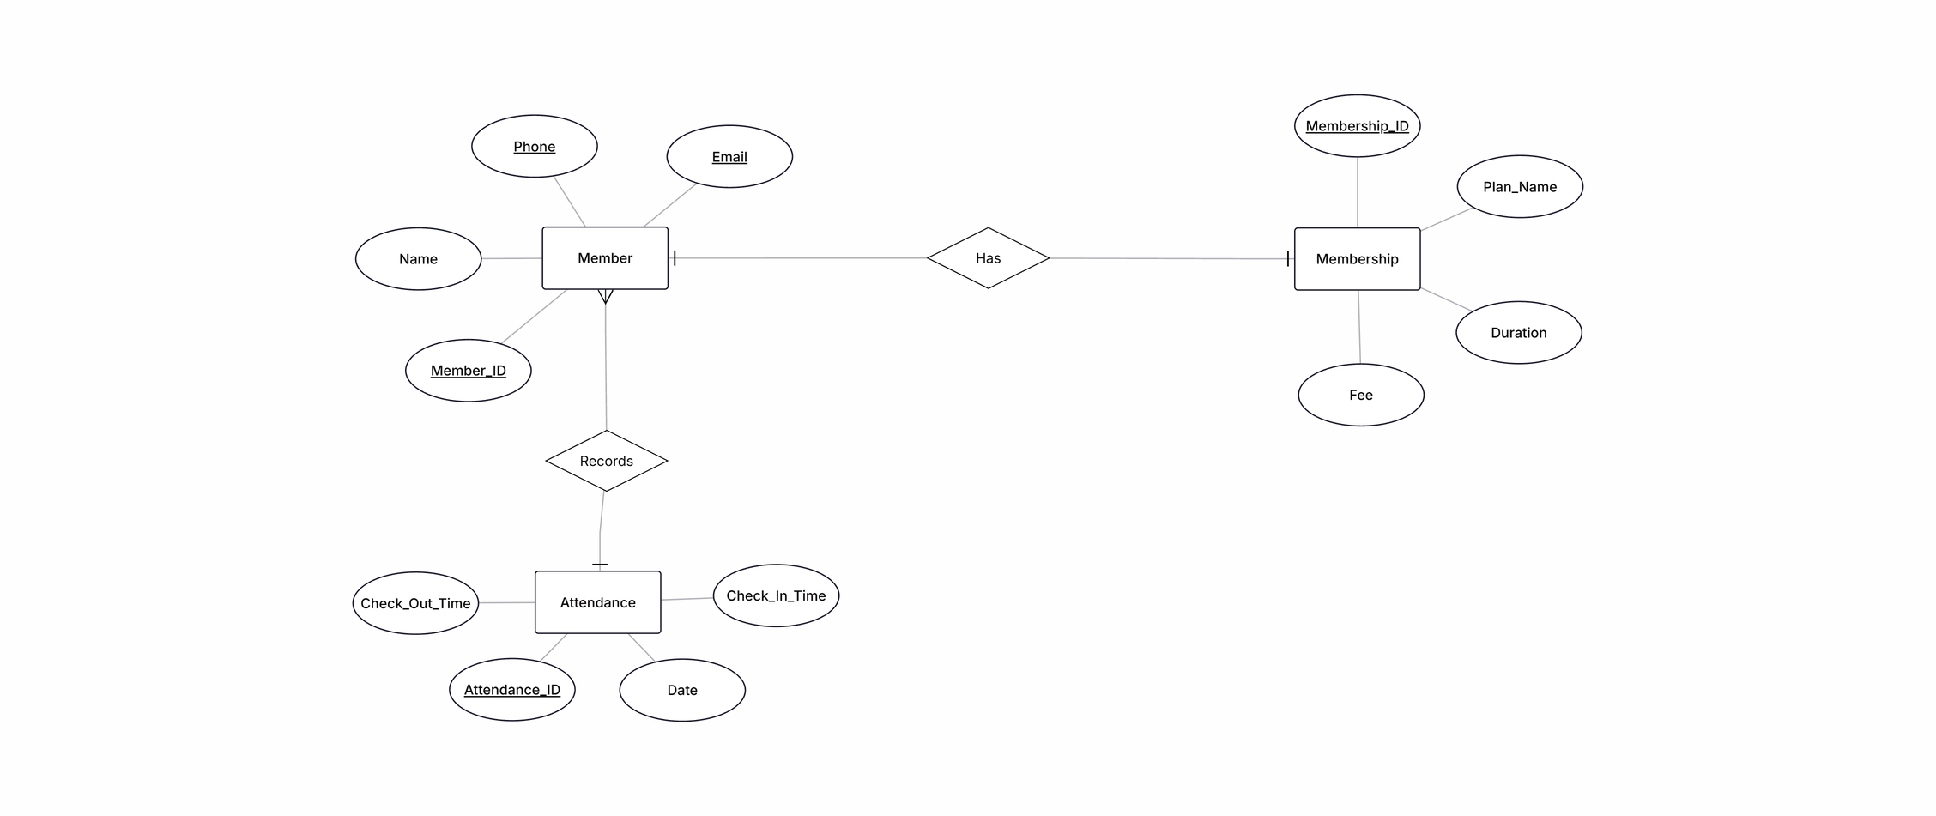
ER Diagram of the Gym Membership Management System
The ER diagram contains three entities: MEMBER, MEMBERSHIP and ATTENDANCE. The MEMBER and MEMBERSHIP entities have a one-to-one relationship, while MEMBER and ATTENDANCE have a one-to-many relationship.
Database Tables
Table | Primary Key | Foreign Key
MEMBER | Member_ID | —
MEMBERSHIP | Membership_ID | Member_ID
ATTENDANCE | Attendance_ID | Member_ID

A primary key uniquely identifies each record in a table, so no two rows can have the same value and it can never be empty. Member_ID, Membership_ID and Attendance_ID are the primary keys of the three tables.
A foreign key is a column that refers to the primary key of another table and creates a relationship between the two tables. Member_ID in MEMBERSHIP and ATTENDANCE refers to Member_ID in MEMBER, so a membership or attendance record can only be added for a member who exists.
SQL Implementation
1. Database creation
CREATE DATABASE IF NOT EXISTS gym_membership_db;
USE gym_membership_db;
2. Table creation
CREATE TABLE MEMBER (
Member_ID INT PRIMARY KEY,
Name VARCHAR(30),
Phone VARCHAR(15),
Email VARCHAR(50)
);

CREATE TABLE MEMBERSHIP (
Membership_ID INT PRIMARY KEY,
Plan_Name VARCHAR(20),
Duration INT,
Fee DECIMAL(10,2),
Member_ID INT UNIQUE NOT NULL,
FOREIGN KEY (Member_ID) REFERENCES MEMBER(Member_ID)
);

CREATE TABLE ATTENDANCE (
Attendance_ID INT PRIMARY KEY,
Attendance_Date DATE,
Check_In_Time TIME,
Check_Out_Time TIME,
Member_ID INT,
FOREIGN KEY (Member_ID) REFERENCES MEMBER(Member_ID)
);
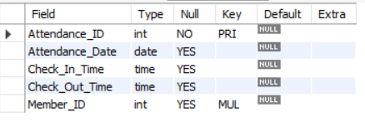
Figure 1: Structure of ATTENDANCE table (DESC ATTENDANCE).
3. Member records
SELECT * FROM MEMBER;
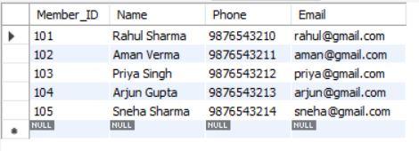
Figure 2: Records of MEMBER table.
4. Membership records
SELECT * FROM MEMBERSHIP;
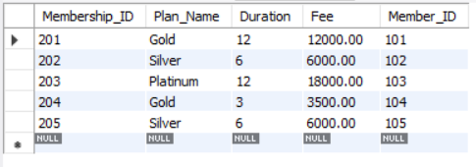
Figure 3: Records of MEMBERSHIP table.
5. Attendance records
SELECT * FROM ATTENDANCE;
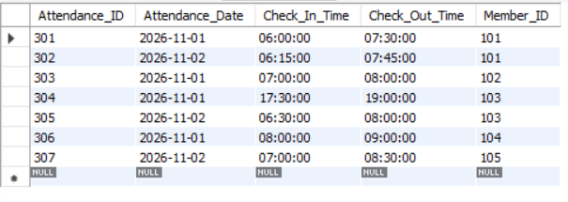
Figure 4: Records of ATTENDANCE table.
SQL Queries and Outputs
1. Gold membership query
Displays all members who have taken the Gold plan.
SELECT *
FROM MEMBERSHIP
WHERE Plan_Name = 'Gold';
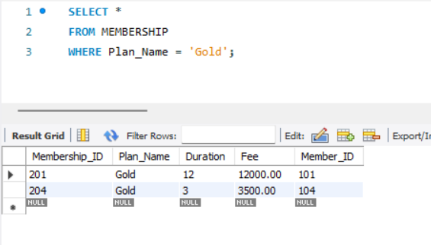
Figure 5: Members with Gold membership.
2. JOIN query
Combines MEMBER, MEMBERSHIP and ATTENDANCE to show each member with their plan and attendance.
SELECT M.Member_ID, M.Name, MS.Plan_Name, MS.Fee,
A.Attendance_Date, A.Check_In_Time, A.Check_Out_Time
FROM MEMBER M
JOIN MEMBERSHIP MS ON M.Member_ID = MS.Member_ID
JOIN ATTENDANCE A ON M.Member_ID = A.Member_ID;
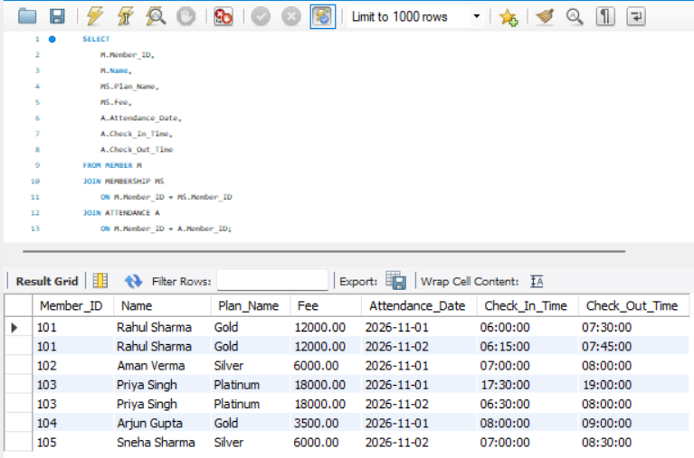
Figure 6: JOIN of MEMBER, MEMBERSHIP and ATTENDANCE tables.
3. Attendance count query
Counts the number of attendance records of each member.
SELECT M.Name, COUNT(A.Attendance_ID) AS Total_Attendance
FROM MEMBER M
LEFT JOIN ATTENDANCE A ON M.Member_ID = A.Member_ID
GROUP BY M.Member_ID, M.Name;
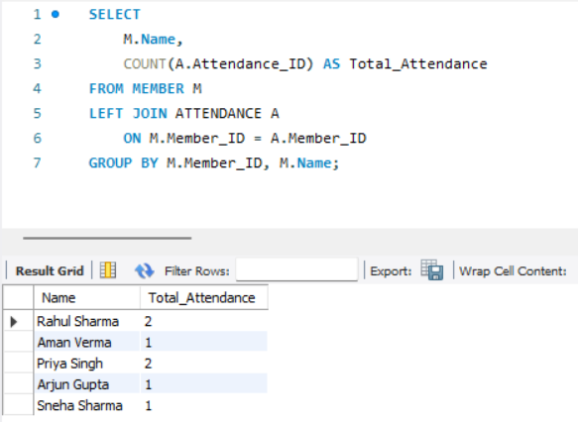
Figure 7: Total attendance of each member.
4. Revenue calculation
Calculates the total fee collected from all memberships.
SELECT SUM(Fee) AS Total_Revenue
FROM MEMBERSHIP;
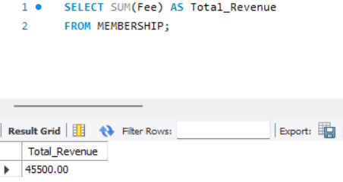
Figure 8: Total membership revenue.
5. Members with more than one visit
Lists members who visited the gym more than once.
SELECT M.Name, COUNT(A.Attendance_ID) AS Visits
FROM MEMBER M
JOIN ATTENDANCE A ON M.Member_ID = A.Member_ID
GROUP BY M.Member_ID, M.Name
HAVING COUNT(A.Attendance_ID) > 1;
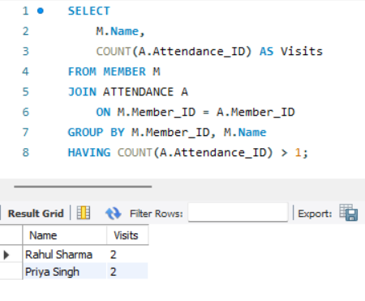
Figure 9: Members with more than one visit.
6. Membership sorting query
Shows all memberships sorted from the highest fee to the lowest.
SELECT *
FROM MEMBERSHIP
ORDER BY Fee DESC;
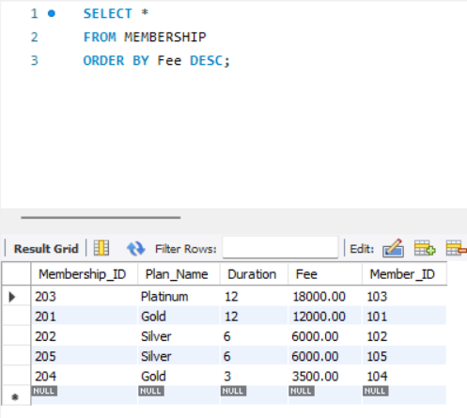
Figure 10: Memberships sorted by fee in descending order.
Results
- Total members: 5
- Total membership records: 5
- Total attendance records: 7
- Total membership revenue: ₹45,500
- Members with more than one attendance: Rahul Sharma and Priya Singh
Conclusion
The Gym Membership Management System was successfully implemented using MySQL. The project demonstrates database creation, table creation, primary and foreign keys, data insertion, joins, aggregate functions and data retrieval. It provides a basic relational database structure for managing gym membership and attendance information.
Project Source Code
The complete source code, SQL script, ER diagram and screenshots of this project are available in the GitHub repository:
https://github.com/prayasPradzzy/Gym-Membership-DBMS

