**Table of contents**

**Chapter I**

**Introduction…………………………….………………6**

**Chapter II Different Types of Technologies in Use**

Chapter 2.1 Halo/Juwa (Plough)

Chapter 2.2 Dhiki/ Jaato / Okhal

Chapter 2.3 Bhakari / Nanglo/ Ghum/ Namlo/ Doko

Chapter 2.4 Theki/Madani

Chapter 2.5 Handi

Chapter 2.6 Gundri (Straw Mat)

Chapter 2.7 Hate Tan (Hand loom)

Chapter 2.8 Pustak dani

Chapter 2.9 Laltin (Lantern)

Chapter 2.10 Scarecrow

Chapter 2.11 Chariot/ Cart

**Chapter III Conclusion**

Introduction

Traditional technology is a type of technology that is based on any tradition or culture that has been passed down from generation to generation until it has been adapted to meet the needs of the present generation. People have been using different technologies for long to make their works easy. In our communities too, people used many traditional technologies which are no longer in practice (may be still in practice). Meet some elderly people in your community and ask them about such technologies. Make a list of such technologies and write a detailed report on them possibly with their pictures.

Border and furrow irrigation, as well as field levelling, are examples of traditional technology. We've put these technologies together because they're extensively used, and village leaders in the majority of villages recall using them long before agricultural reform began in the early 1980s. And some other traditional technologies are Hadi, Dhiki, Bhakari etc which are still in use in some household in Nepal. Indigenous ways of life offer priceless information and support efficient use of the environment. This wisdom is frequently overlooked or forgotten in the present era of technological growth. Little systematic work has been done in Nepal to comprehend the scientific underpinnings of this knowledge. It is advised that the documentation of Indigenous Technical Knowledge (ITK) be covered as a cross-cutting problem in the environmental and sustainable development curricula. Understanding ITK, their benefits and drawbacks, can assist professionals in this industry enhance their present expertise. The paper documents ITK related to the management of water resources, soil fertility, biodiversity, and forest management, as well as ITK related to pest management, biofencing, agricultural equipment and implements, and traditional beliefs. primarily from Kavre, Dhading, Kaski, Baglung and Syanga districts in Nepal.

We were not frequently introduced to new tools and technologies during my childhood. There are still many isolated areas of Nepal where people are unaware of contemporary tools and technologies. People living in rural areas lead quite different lives from those of us who live in urban areas. Many years ago, in a time before modern tools and technologies, Nepalese people created a variety of items that might meet our daily needs. In many areas of Nepal, the latest technology are still not available, and the population is struggling to make ends meet. In some still-remote parts of Nepal, nobody has ever even seen a car or a bus. Although many of us are unaware of several common equipment that were widely utilized just a decade ago, residents in rural areas still tend to employ the conventional methods. I'm here with some of the customary equipment used by the citizens of Nepal. Did you have knowledge of any or all of these?

**Halo (Plough)**

Halo is the traditional tool to plough the field in Nepal.It is entirely made up of wood except the plouging tip is made up of iron.

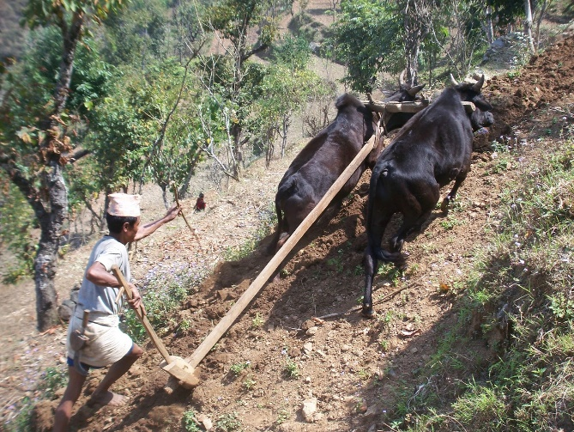Halo is a farm tool for loosening or turning the soil before sowing seed or planting. Ploughs were traditionally drawn by oxen and horses, but in modern farms are drawn by tractors. A plough may have a wooden, iron or steel frame, with a blade attached to cut and loosen the soil. It has been fundamental to farming for most of history. The earliest ploughs had no wheels; such a plough was known to the Nepalese as Halo.

The prime purpose of ploughing is to turn over the uppermost soil, bringing fresh nutrients to the surface while burying weeds and crop remains to decay. Trenches cut by the plough are called furrows. In modern use, a ploughed field is normally left to dry and then harrowed before planting. Ploughing and cultivating soil evens the content of the upper 12 to 25 centimetres (5 to 10 in) layer of soil, where most plant-feeder roots grow.

Ploughs were initially powered by humans, but the use of farm animals was considerably more efficient. The earliest animals worked were oxen. Later, horses and mules were used in many areas.  **Jaato**

Jato is a grinding machine which is made up of from stone and a wood handle at the top to make it easier to roll it, also known as “grinder”. It is used by hand to grind rice, pulses, wheat and other grains by the people in Himalayan region, Terai region, especially in the rural village in a current situation. It consists of two round carved stones, bottom part is placed at the floor and the next stone is placed above the bottom part. The bottom stone has the big wooden nail in the center which supports the top part and the top part has two holes one in the center to insert grains and the other on the side to place a wooden handle (hato) for grinding. The grains are grind using a circular motion with the help of the handle and the person has to be sitting down to do the task.

Jato is a type of rotary hand quern or grinder in the Himalayan region of Nepal, Sikkim, Darjeeling and Bhutan. It is a traditional tool to grind grains. It consists of two round stones (disc) of which the bottom part is attached to the ground or the floor in the house. This attached disc or lower disc is immovable and has a big nail or a piece of wood (mani or bell) in the centre to keep the top stone in place while grinding. The top part however has two holes in it, one in the middle to insert grains and the other on the side to place a wooden handle (hato) for grinding. The grains are ground using a circular motion with the help of the handle and the person has to be sitting down to do the task.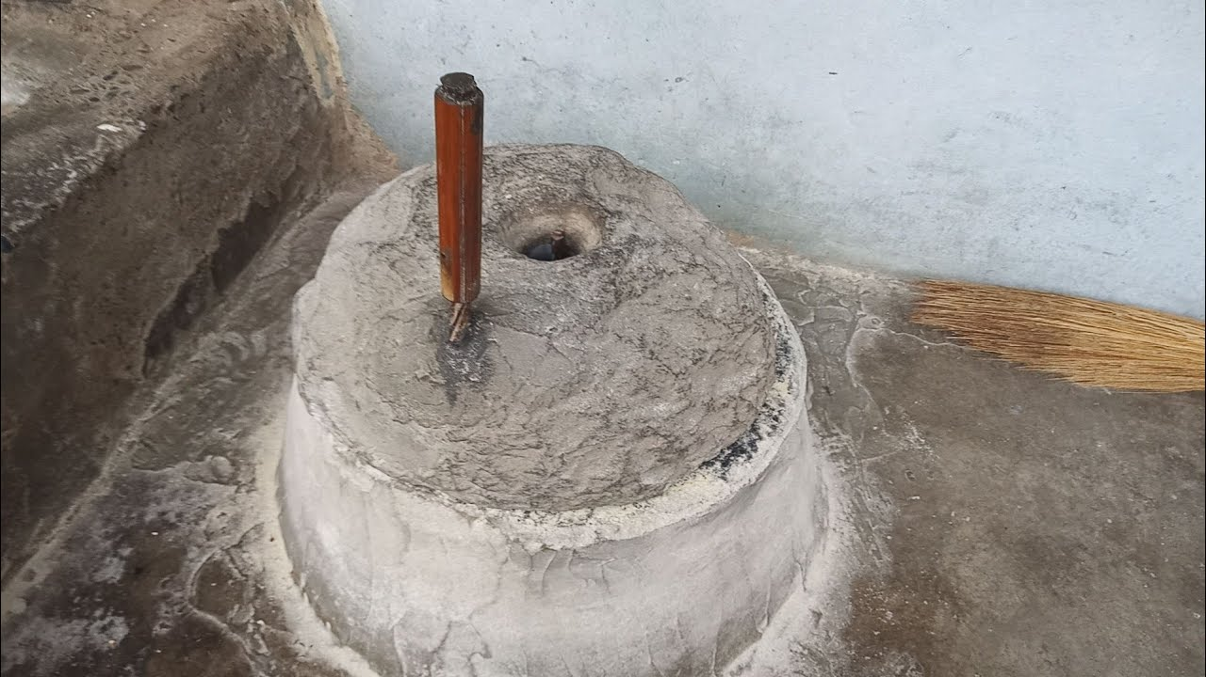

Advantages of Jato:

Easy to use.

Efficient flow of ground grains.

Reduces the force needed to grind

Disadvntages of Jato:

Continuous use of Jato causes pain in the palm, It is immovable and bulky,

**Dhiki**

Dhikki is a Nepalese traditional manual grinder which is used in villages as a rice beater.  It is used to grind paddy, rice, dry chillies and many other and so mostly it is used to make powder goods from dry grains or plants. Different area is separated in a house for Dhikki usually on a backyard. It is a very slow process and requires enormous amount of energy and effort.

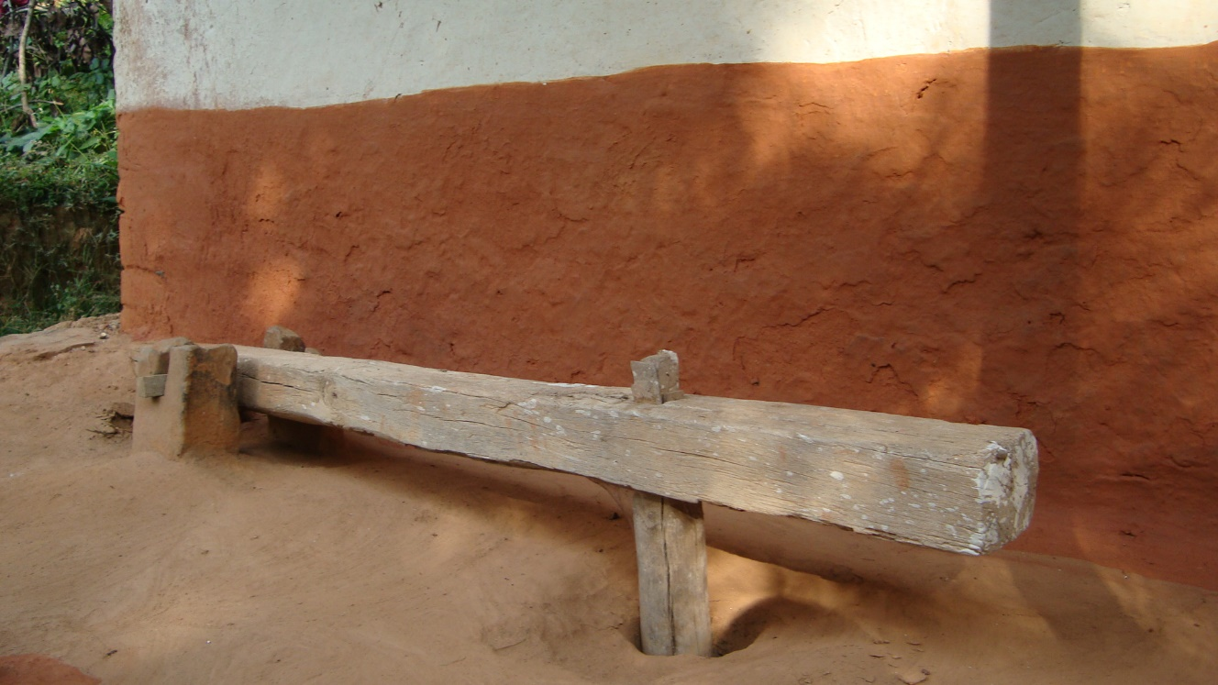

Dhikki is made up of wood and works like a lever and the framework consists of a fulcrum having two pillars on each side, an effort area, a long and thick plank of horizontal wood which has a small vertical extension that goes into a hole made in the ground. It is in this hole that the grains or dry chillies are kept to transform them into powder. It works like the see-saw i.e. when one part’s up the other one’s down and vice versa. The person using this usually places his/her leg on one side and press it hard and then leave it so that the other part hits the rice, millet, etc. and grinds it.

**Okhal**

Okhal is a Nepalese traditional manual grinder which is used in villages as a grinder to grind different types of spices and other eatable items. It has two parts one where the spices are kept and another which grind the spices and making them a fine powder. It is a device used for crushing, pounding or grinding flour, spices, and other ingredients with a pestle.

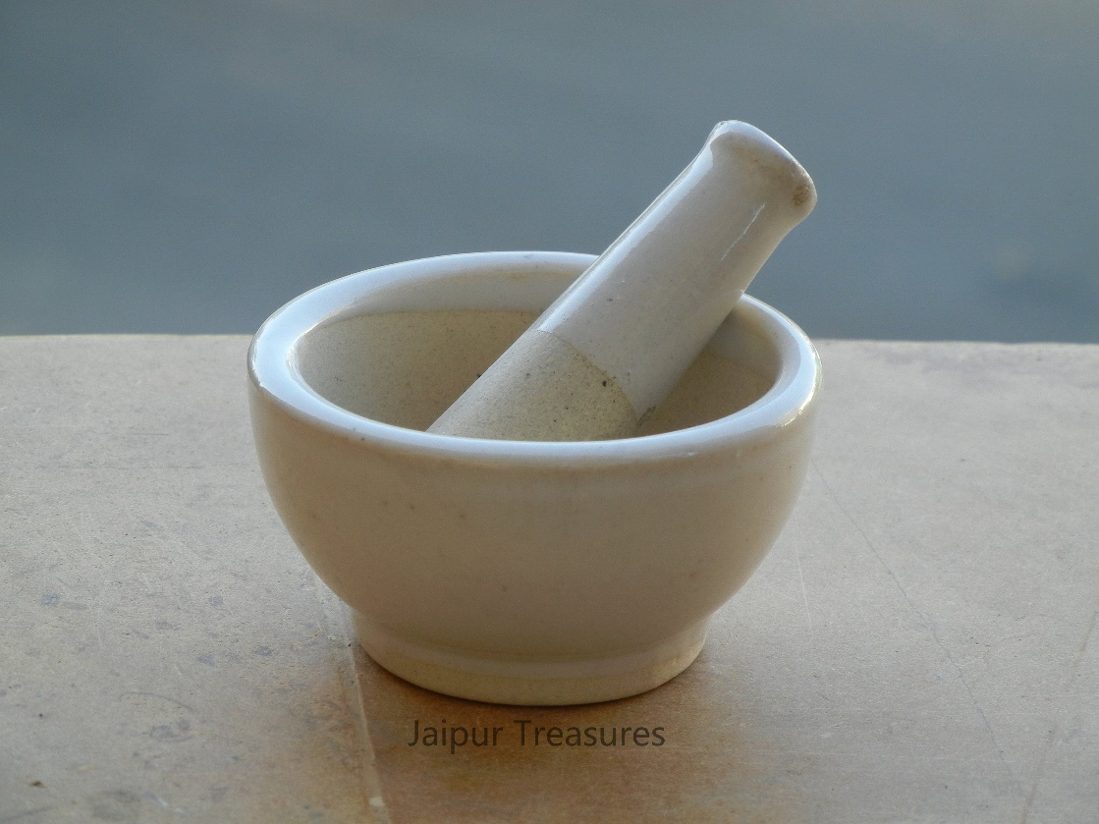

Traditionally made from stone, metal or wood, the okhal is an integral part of Nepali kitchens. The mortar and pestle works faster than a knife to crush nuts, pound garlic into a paste, smash ginger or chiles to infuse flavor, or grind whole spices into powders.

**Nanglo**

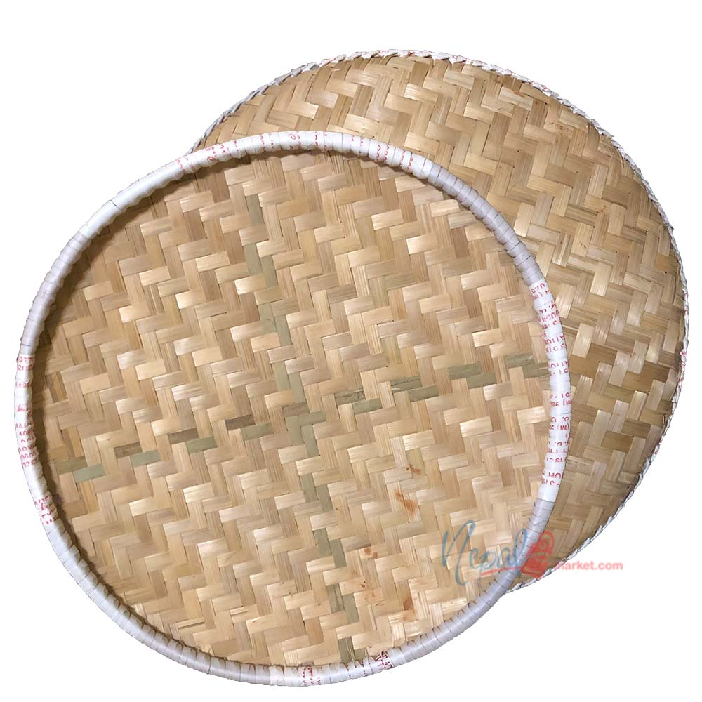

Nanglo is a flat round woven tray made up of bamboo. It is made traditionally out of thin bamboo pieces intermingled into a flat surface-like ancient method of weaving cloth manually by tangling threads. It is used for sifting grain and used to separate dust particles from paddy, rice, dal, beans, and other cereals (winnowing). Nanglo is an indispensable part of every Nepali kitchen. While it is mostly limited to villages, it can be found occasionally on large cities as well.

**Ghum**

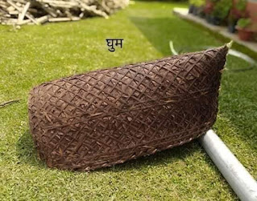

Ghum is an traditional raincoat in Nepal. It is used as an umbrella. We have to place it in our head to get cover from rain. It is hand made by Nepalese people. It is made from thin and long sliced of a bamboo.

The folded mat used by farmers and workers is an ingenuous umbrella that provides complete protection from the rain; unlike the conventional umbrella, it allows both the hands to remain free to continue work.

This unusual and utilitarian farmer’s umbrella is attached to a string that is slung over the forehead as a support. Made in bamboo the waterproofing is done with the leaves of the camel foot climber bhorla (Bauhinia Vahlia), which is sandwiched between the two layers of open weave bamboo sheets.

**Namlo**

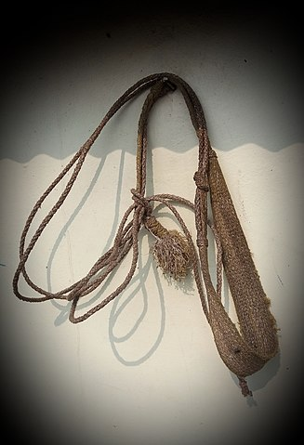

Namlo is a Nepalese traditional tool. It is made from a piece of fiber or a thick cloth and rope. It is use to help people to carry stuff like a carrying heavy stuff like doko, sack of rice, wheat etc. We have to cover the item by the rope and put the fabric in our forehead to use it. It help to carry stuff which are heavy by spreading the weight all over our body.

Namlo is mostly used with doko to carry heavy stuff from one place to another. The word, “Namlo'', is a strap used together with a “DOKO” basket to transport goods. It's meaning is symbolic as the weaving of the basket represents the cultural bonding and support of the Nepalese community worldwide

**Doko**

Doko is (Nepali: डोको) is a Nepali word for a bamboo basket. These kind of baskets are popular all across the country to carry stuff. Doko, here, kind of represents similar basket. The idea here is to have a one-stop portal - or basket - where students can find all the necessary stuff required during their four years of bachelors program. These items include college and university forms, past papers of both college and university exams, information about club-related activities, and profiles of each of the students who have studied or are studying in Deerwalk Institute of Technology.

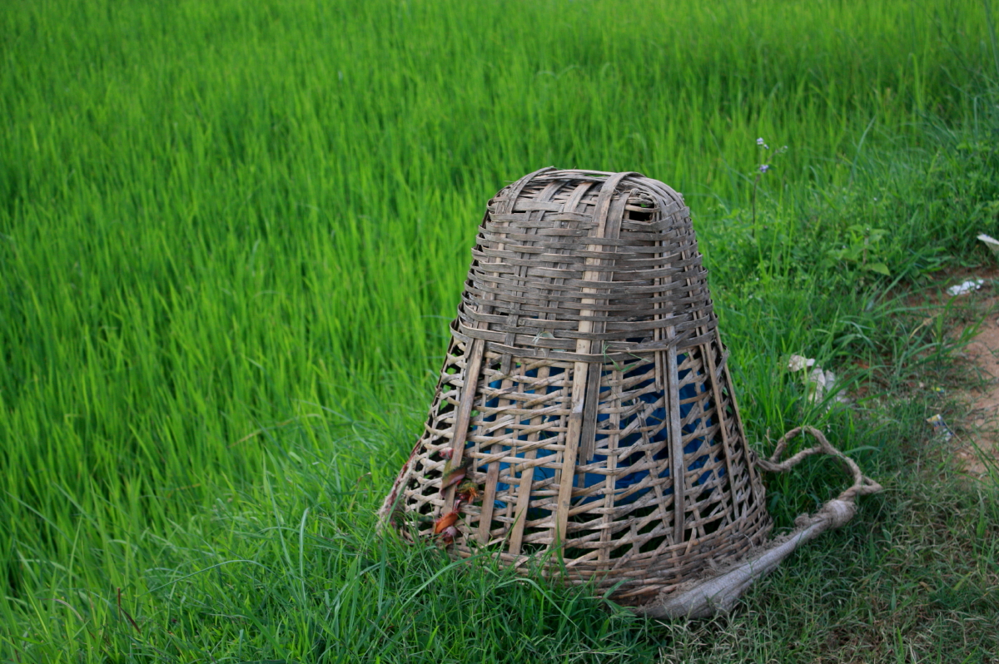

Dokos are typically 0.1 to 0.2 m3 in volume, so an average person can carry 20-50kg. They have shoulder straps, and usually head straps called namlo (Nepali: नाम्लो) that take part of the load off the carrier's shoulders.

Dokos are used to carry goods, vegetables, grains, water pots, etc. They are also used to carry small animals and poultry, as well as serving as temporary cages for animals. Where there are no motor roads, special oversized dokos are used to transport people unable to walk. Doko production has been a good source of income as well. Blind people are trained for doko production to earn their livelihood in Nepal. In almost every rural area of Nepal the doko is utilized as a common tool for carrying heavy loads.

**Theki and Madani**

Theki is the biggest of all devices used in churning butter and is the basic foundational device used. Cylindrical in shape at the body, it has a narrow neck while the mouth is a spreading fan-like structure. It is most commonly made up of darigitho wood. It is usually used to store milk fat and make butter out of it which can later be cooked to make the clarified butter also known as ghee and also make buttered milk. The “Theki” is only a vessel, whereas the “Madani” is like a thick stick with turbines at one end.

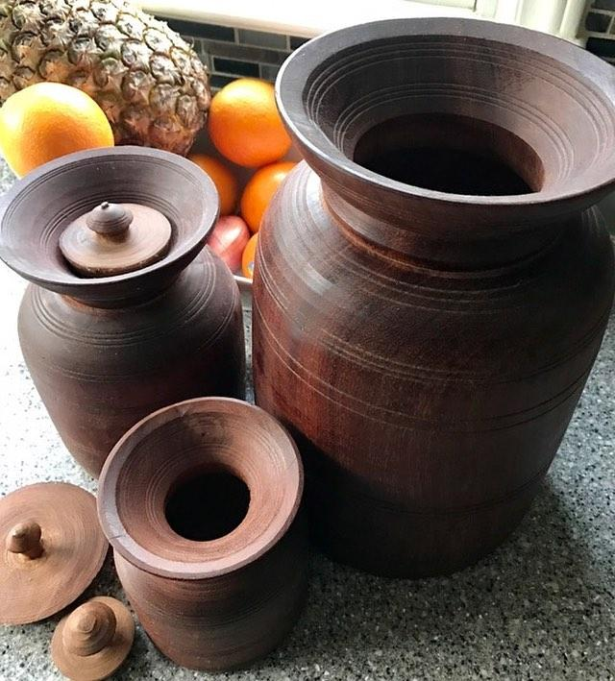

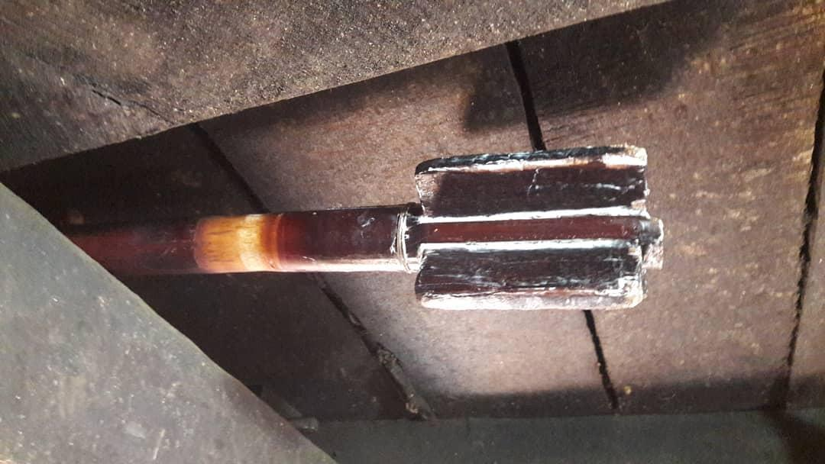The “Madani” is then kept inside the “Theki” with milk fat in it. Slowly the person starts to rotate the “Madani” until the butter separates from the curd. As there are turbines present it works like a mixer grinder and separates the fat and the buttered milk. The addition of hot water in the middle of the process can fasten the process.

To make Ghee, curd, mahi etc we first need to keep the “Theki and Madani” near a pillar so that Madani can be tied very loosely (in fact right parallel to the pillar). The “Madani” is then wrapped around spirally by another rope in such a manner that when you pull one side the other gets smaller (if that makes sense just like a hand exercise). The curd accumulated over a period of few days is brought and collected in the Theki.

**Hadi**

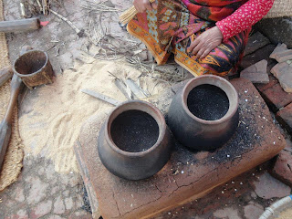HADI is our own popcorn maker and has been in use since centuries. It is an important earthen kitchen utensil which is not only used to make pop corn but also to steam vegetables such as potatoes and sweet potatoes. The amazing thing is that it does not require oil to make corn nor water to steam vegetables(though you need to cover them), hence making it a very essential tool in nepalese kitchen. (no wonder people were so slender back then!!!!).

Whenever people remember popcorn I bet the instant figure coming in their mind will be the HADI. but how many of us remember the collection of bamboo sticks required to stir the corn for even cooking???? how many of us know what it is called?????. Well to make life easy let me tell you, it is called KAPTERO. As mentioned earlier it is made up of bamboo cut into uniform thin, slender and long pieces and bind together.

 HADI is quiet dark at the bottom as it accumulates smoke from beneath the wood fire stove. Many years ago this smoke at the bottom of HADI was mixed with oil to make it a valid stamp presser for providing thumb prints in legal documents. But with the increasing use of automatic popcorn makers, hassle free stamp pads and using metal utensils have decreased the use of this traditional clay pot

**Gundri (Straw mat)**

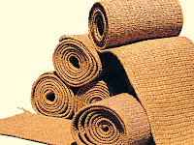Gundri is another type of mat which is popular among the Newar culture in Nepal. It is made up of hay (PARAL) and is long rectangular shape (long enough to seat almost 15 people in a single line). It is usually used in "Bhoj" or "Na-kha-tya" where there is assemble of huge number of people and food is distributed by cooks to all the people. It is generally rolled and stored for reusing next time. Since it is made by hay locally, it is cheap, effective and biodegradable as well.It is also said that walking in "SUKUL" also increases blood circulation to your legs and feet... hence reducing oedema to lower extremities.

"Gundri"(गुन्द्री) is a biodegradable Nepali carpet made out of hay. It is used in villages and are locally made by the women who runs the household. It is massively used all around Nepalese villages but now runs a doubt of continuity with the increasing lifestyles of people and coming of cheap carpets in the markets. Also time and skills required to make "Gundri"(गुन्द्री) is diminishing with every generation and years.

Hate Tan (Hand Loom)

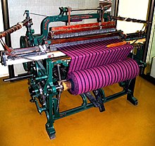Hate Tan is a device used to weave cloth and tapestry. The basic purpose of any loom is to hold the warp threads under tension to facilitate the interweaving of the weft threads. The precise shape of the loom and its mechanics may vary, but the basic function is the same. We can make various cloths from Hate Tan. Most of the women in colder region of Nepal used to make woolen sweater, woolen cap, muffler from Hate Tan.

A handloom is a simple machine used for weaving. In a wooden vertical-shaft loom, the heddles are fixed in place in the shaft. The warp threads pass alternately through a heddle, and through a space between the heddles (the shed), so that raising the shaft raises half the threads (those passing through the heddles), and lowering the shaft lowers the same threads — the threads passing through the spaces between the heddles remain in place. This was invented in the 13th century.[citation needed] It can have a Jacquard machine attached to it. Handloom weavers commonly use three types of looms: pit looms, stand looms, and frame looms.

**Pustak Dani**

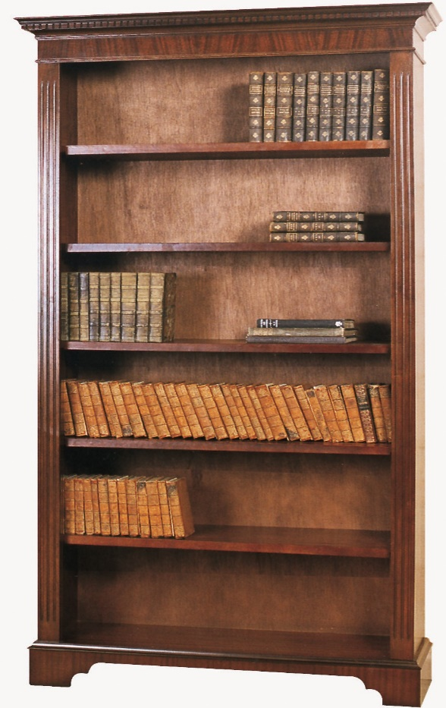Pustak Dani Means Book self or Book Rack. Like its name it is used to store books.

It is used to store books and use books when need. In previous time houses were made up of mud there would be water leakage all over the house and rat were all over the house. So, to preserve the books from animals, kids and water pustak dani was made. It is made from wood or bamboo. Bamboo Pustak Dani is easier to make.

**Laltin (Lantern)**

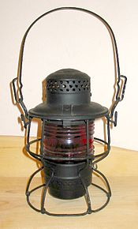A lantern is an often portable source of lighting, typically featuring a protective enclosure for the light source – historically usually a candle or a wick in oil, and often a battery-powered light in modern times – to make it easier to carry and hang up, and make it more reliable outdoors or in drafty interiors. Lanterns may also be used for signaling, as torches, or as general light-sources outdoors.

The lantern enclosure was primarily used to prevent a burning candle or wick being extinguished from wind, rain or other causes. Some antique lanterns have only a metal grid, indicating their function was to protect the candle or wick during transportation and avoid the excess heat from the top to avoid unexpected fires.

**Scare Crow**

A scarecrow is a decoy or mannequin, often in the shape of a human. Humanoid scarecrows are usually dressed in old clothes and placed in open fields to discourage birds from disturbing and feeding on recently cast seed and growing crops. Scarecrows are used around the world by farmers, and are a notable symbol of farms and the countryside in popular culture.

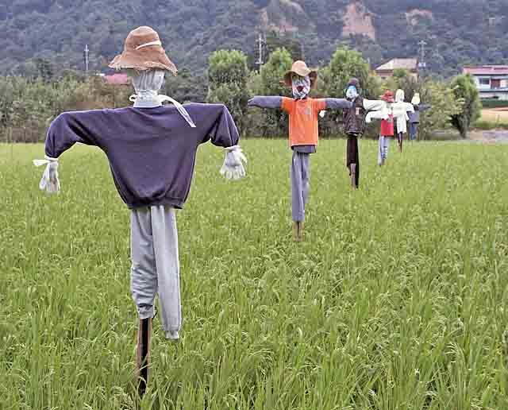

The common form of a scarecrow is a humanoid figure dressed in old clothes and placed in open fields to discourage birds such as crows or sparrows from disturbing and feeding on recently cast seed and growing crops. Machinery such as windmills have been employed as scarecrows, but the effectiveness lessens as animals become familiar with the structures.

Since the invention of the humanoid scarecrow, more effective methods have been developed. On California farmland, highly-reflective aluminized PET film ribbons are tied to the plants to produce shimmers from the sun.

**Chariot/ Cart**

The chariot that evolved from the ancient vehicle of this name (see Chariot) took on two main forms:

A light, four-wheeled, horse-drawn carriage having a coach box and back seats only, popular in the early 19th century.

A vehicle for conveying persons especially in state, such as a triumphal car or a coach of state. This stately but manoeuvrable horse carriage was used for ceremonial occasions or for pleasure.

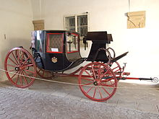

A chariotee was a light, covered, four-wheeled pleasure carriage with two seats.

A post chariot was a carriage for traveling post. The term was used specifically for a kind of light four-wheeled carriage with a driver's seat in front.

A vehicle such as a cart or wagon for transporting goods was also sometimes called a chariot.

**Conclusion**

In conclusion I want to say that Nepal, a famous tourism destination, is home for countless cultures and traditions. Though Nepal is quite lacking in terms of development, we Nepali believe ourselves to be rich when it comes to diverse ways of our people. Times are changing and along with its wave, our ways are getting modernized as well. Since my childhood, we were not so far introduced to new tools and technologies. Even now, there are many remote places in Nepal where people are unknown about modern technologies and tools. The life of those people in remote area and here in city area is totally different. Many years ago in Nepal when there were no modern tools and technologies, Nepalese people had made many equipment’s which can fulfill our daily needs. The new technologies have not reached still in many parts of Nepal and people survive with barely enough incomes.

I think we should preserve our traditional tools and way and skill of creating it because

It preserves our culture, tradition etc

It is cheaper and easily available as they're produced locally, etc

It completely based on Nepalese originality

The pride of ancestor deeds

Environmental friendly and durable

It is base for using modern technology

There are still some remote areas of Nepal where people have not even seen a motor car or a bus. Although the people in rural areas still use the traditional forms, many of us don’t know about some day to day tools that used to be very prominent just a decade ago.

We have to teach new generation about the traditional and local technologies of Nepal which were used by our ancestor we should try to preserve our traditional technologies because it show our tradition how our ancestor used to live