Zomato

🗂️ Project Overview
This project involves the analysis and prediction of Zomato restaurant data, specifically focusing on establishments in Bangalore, India. The dataset includes various features such as online order availability, table booking options, ratings, votes, contact information, location, restaurant type, preferred dishes, cuisines offered, approximate cost for two people, reviews, menu items, and categorization in terms of type and city.

📝 Summary
The primary goal is to perform exploratory data analysis (EDA) and predict restaurant success, providing valuable insights for decision-makers in the food industry. The dataset, sourced from Zomato, comprises a diverse range of information about Bangalore restaurants, allowing for a comprehensive analysis of factors influencing their performance.

📄 Description
Analytical approaches include data visualization to identify relationships between features, exploratory data analysis based on various ratings, and even the creation of a content-based recommender system for restaurant recommendations. The project aims to empower decision-makers with actionable insights derived from the rich Zomato restaurant dataset.

📊 Data Set Information
- url: The dataset includes URLs providing detailed information about each restaurant, facilitating further exploration and analysis.
- address: Restaurants' physical addresses are available, offering insights into their geographical locations.
- name: The names of the restaurants are included, providing a unique identifier for each establishment.
- online_order: The dataset indicates whether a restaurant offers online ordering or not.
- book_table: Information on whether a restaurant allows customers to book tables is included.
- rate: Ratings of restaurants are provided, giving an overview of customer satisfaction.
- votes: The number of votes received by each restaurant is included, reflecting the level of customer engagement.
- phone: Contact phone numbers for the restaurants are available, allowing for direct communication.
- location: The dataset includes the location of each restaurant in Bangalore, enabling spatial analysis.
- rest_type: Categorization of restaurants by type is provided, offering insights into the variety of establishments.
- dish_liked: Preferred dishes at each restaurant are listed, showcasing popular menu items.
- cuisines: Information on the cuisines offered by each restaurant is included, highlighting culinary diversity.
- approx_cost(for two people): The approximate cost for two people is specified, aiding in budget considerations.
- reviews_list: Detailed reviews for each restaurant are available, offering qualitative insights.
- menu_item: The dataset includes information on menu items offered by each restaurant.
- listed_in(type): Restaurants are categorized by type, providing additional classification.
- listed_in(city): Categorization based on city is included, allowing for city-specific analyses.

1. Import Packages
import pandas as pd
import numpy as np
import matplotlib.pyplot as plt
import seaborn as sns
import warnings
warnings.simplefilter('ignore')
%matplotlib Inline

1.1 Read Data
df = pd.read_csv("E:\My Environment\MCA Notes\Assignments\AI & ML Assignments\Assignment(Projects)\zomato.csv")
df.head()
url \
0 https://www.zomato.com/bangalore/jalsa-banasha...
1 https://www.zomato.com/bangalore/spice-elephan...
2 https://www.zomato.com/SanchurroBangalore?cont...
3 https://www.zomato.com/bangalore/addhuri-udupi...
4 https://www.zomato.com/bangalore/grand-village...
address name \
0 942, 21st Main Road, 2nd Stage, Banashankari, ... Jalsa
1 2nd Floor, 80 Feet Road, Near Big Bazaar, 6th ... Spice Elephant
2 1112, Next to KIMS Medical College, 17th Cross... San Churro Cafe
3 1st Floor, Annakuteera, 3rd Stage, Banashankar... Addhuri Udupi Bhojana
4 10, 3rd Floor, Lakshmi Associates, Gandhi Baza... Grand Village
online_order book_table rate votes phone \
0 Yes Yes 4.1/5 775 080 42297555\r\n+91 9743772233
1 Yes No 4.1/5 787 080 41714161
2 Yes No 3.8/5 918 +91 9663487993
3 No No 3.7/5 88 +91 9620009302
4 No No 3.8/5 166 +91 8026612447\r\n+91 9901210005
location rest_type \
0 Banashankari Casual Dining
1 Banashankari Casual Dining
2 Banashankari Cafe, Casual Dining
3 Banashankari Quick Bites
4 Basavanagudi Casual Dining
dish_liked \
0 Pasta, Lunch Buffet, Masala Papad, Paneer Laja...
1 Momos, Lunch Buffet, Chocolate Nirvana, Thai G...
2 Churros, Cannelloni, Minestrone Soup, Hot Choc...
3 Masala Dosa
4 Panipuri, Gol Gappe
cuisines approx_cost(for two people) \
0 North Indian, Mughlai, Chinese 800
1 Chinese, North Indian, Thai 800
2 Cafe, Mexican, Italian 800
3 South Indian, North Indian 300
4 North Indian, Rajasthani 600
reviews_list menu_item \
0 [('Rated 4.0', 'RATED\n A beautiful place to ... []
1 [('Rated 4.0', 'RATED\n Had been here for din... []
2 [('Rated 3.0', "RATED\n Ambience is not that ... []
3 [('Rated 4.0', "RATED\n Great food and proper... []
4 [('Rated 4.0', 'RATED\n Very good restaurant ... []
listed_in(type) listed_in(city)
0 Buffet Banashankari
1 Buffet Banashankari
2 Buffet Banashankari
3 Buffet Banashankari
4 Buffet Banashankari
df.info()
<class 'pandas.core.frame.DataFrame'>
RangeIndex: 51717 entries, 0 to 51716
Data columns (total 17 columns):
# Column Non-Null Count Dtype
--- ------ -------------- -----
0 url 51717 non-null object
1 address 51717 non-null object
2 name 51717 non-null object
3 online_order 51717 non-null object
4 book_table 51717 non-null object
5 rate 43942 non-null object
6 votes 51717 non-null int64
7 phone 50509 non-null object
8 location 51696 non-null object
9 rest_type 51490 non-null object
10 dish_liked 23639 non-null object
11 cuisines 51672 non-null object
12 approx_cost(for two people) 51371 non-null object
13 reviews_list 51717 non-null object
14 menu_item 51717 non-null object
15 listed_in(type) 51717 non-null object
16 listed_in(city) 51717 non-null object
dtypes: int64(1), object(16)
memory usage: 6.7+ MB
df.describe()
votes
count 51717.000000
mean 283.697527
std 803.838853
min 0.000000
25% 7.000000
50% 41.000000
75% 198.000000
max 16832.000000
df.shape
(51717, 17)

2.Distribution of Ratings:
df['rate'].hist(bins=10, edgecolor='black', alpha=0.7)
plt.title('Distribution of Ratings')
plt.xlabel('Rating')
plt.ylabel('Frequency')
plt.show()
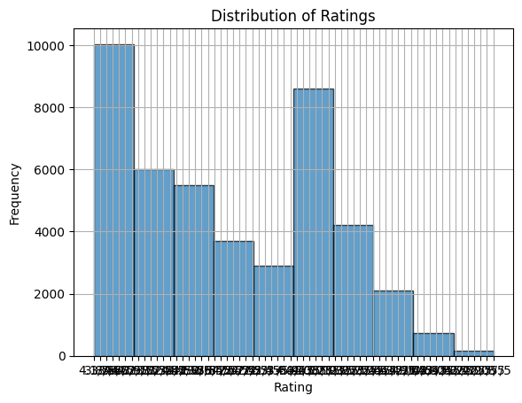

3.Online Order Distribution:
df['online_order'].value_counts().plot(kind='bar', color=['skyblue', 'orange'])
plt.title('Distribution of Online Orders')
plt.xlabel('Online Order Availability')
plt.ylabel('Frequency')
plt.xticks(rotation=0) # Rotate x-axis labels for better readability
plt.show()
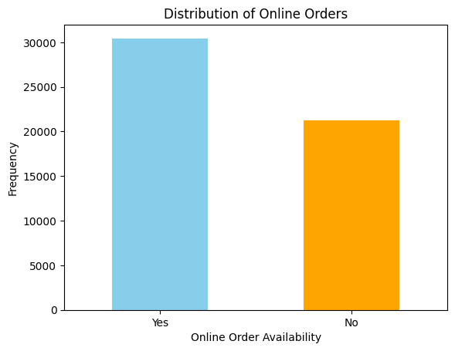

4.Restaurants Delivering Online or Not:
Visualize the distribution of restaurants based on whether they offer online delivery.
plt.figure(figsize=(8, 6))
sns.countplot(x='online_order', data=df, palette='viridis')
plt.xlabel('Online Delivery')
plt.ylabel('Number of Restaurants')
plt.title('Distribution of Restaurants Offering Online Delivery')
plt.show()
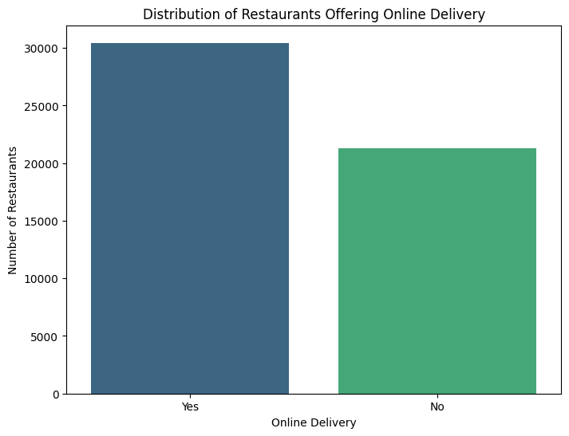

6. Restaurants Allowing Table Booking or Not:
Create a bar chart to show the proportion of restaurants allowing table booking.
booking_proportion = df['book_table'].value_counts(normalize=True) * 100
plt.figure(figsize=(8, 6))
sns.barplot(x=booking_proportion.index, y=booking_proportion.values, palette='pastel')
plt.xlabel('Table Booking Allowed')
plt.ylabel('Proportion (%)')
plt.title('Proportion of Restaurants Allowing Table Booking')
plt.show()
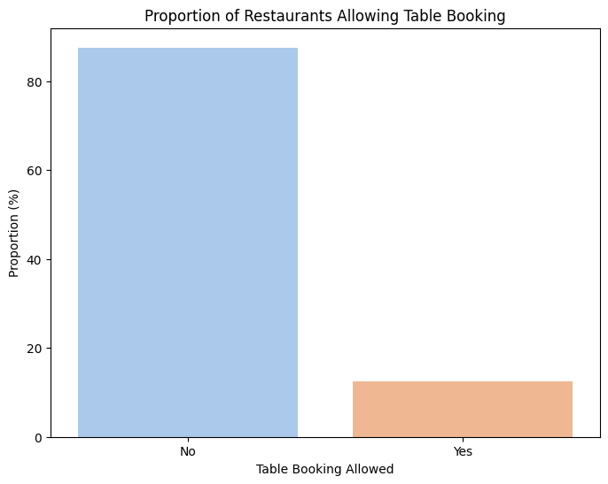

7.Restaurant Type:
Visualize the distribution of restaurant types (e.g., cafes, fine dining) in a pie chart or bar charons.s.

Using Pie chart
# Calculate the distribution of restaurant types
restaurant_type_distribution = df['rest_type'].value_counts()
plt.figure(figsize=(10, 10))
plt.pie(restaurant_type_distribution, labels=restaurant_type_distribution.index, autopct='%1.1f%%', startangle=90)
plt.title('Restaurant Type Distribution')
plt.show()
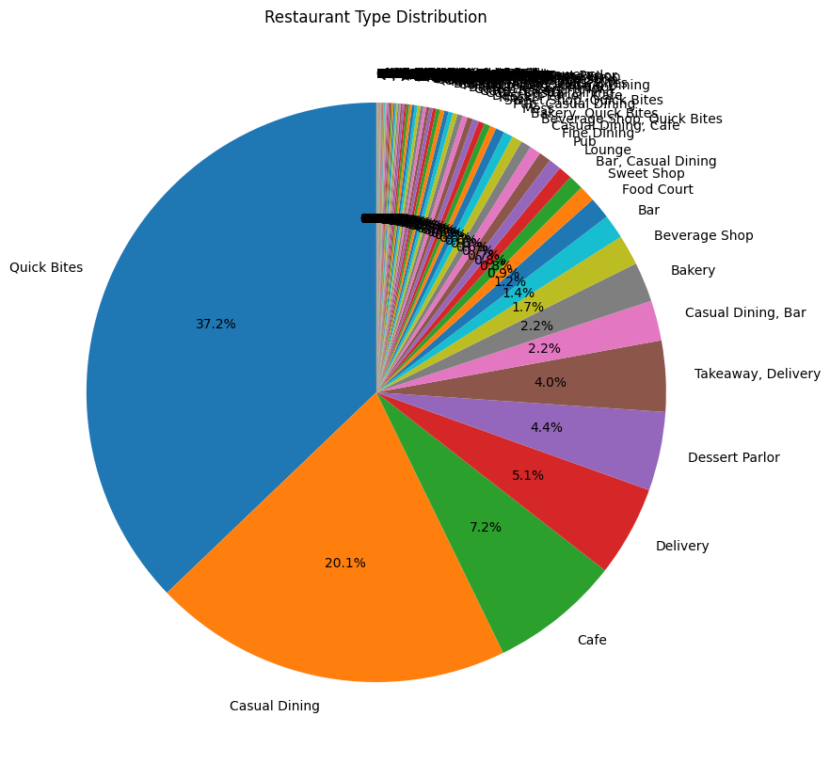

Using bar chart
restaurant_type_distribution = df['rest_type'].value_counts()
plt.figure(figsize=(12, 6))
sns.barplot(x=restaurant_type_distribution.index, y=restaurant_type_distribution.values, palette='viridis')
plt.xlabel('Restaurant Type')
plt.ylabel('Count')
plt.title('Restaurant Type Distribution')
plt.xticks(rotation=90)
plt.show()
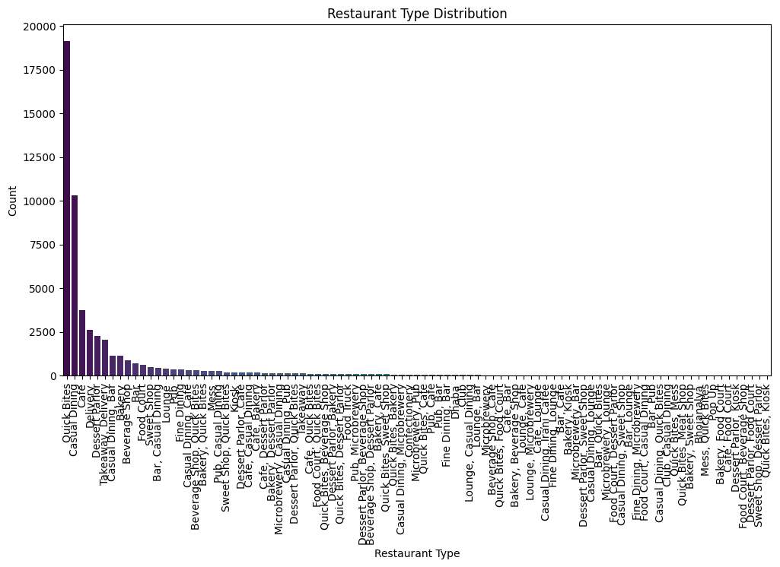

8.Types of Services:
Use a bar chart or pie chart to illustrate the types of services offered by restaurants (online delivery, table booking).

Using Bar Chart
# Count the types of services
service_counts = df[['online_order', 'book_table']].apply(pd.Series.value_counts)
service_counts.plot(kind='bar', rot=0, color=['skyblue', 'lightgreen'])
plt.title('Types of Services Offered by Restaurants')
plt.xlabel('Service Type')
plt.ylabel('Count')
plt.legend(title='Service', labels=['Online Delivery', 'Table Booking'])
plt.show()
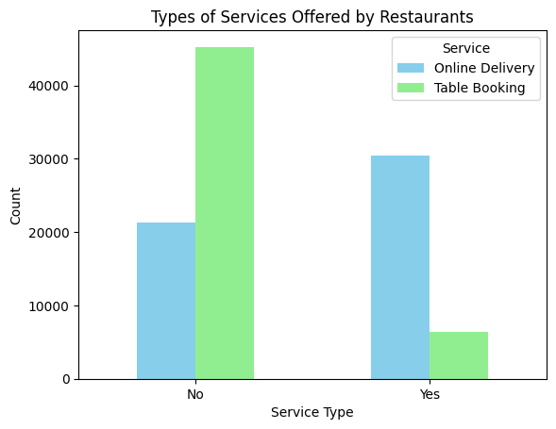

Using Pie Chart
plt.figure(figsize=(8, 8))
plt.pie(service_counts.sum(axis=1), labels=service_counts.index, autopct='%1.1f%%', colors=['skyblue', 'lightgreen'])
plt.title('Distribution of Services Offered by Restaurants')
plt.show()
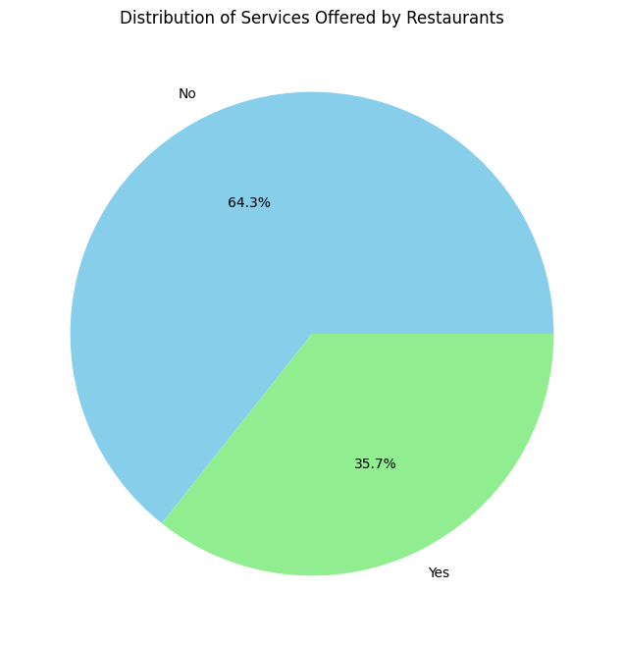

9. Cost of Restaurant:
Visualize the distribution of the approximate cost for two people using a histogram.t.
df['approx_cost(for two people)'] = pd.to_numeric(df['approx_cost(for two people)'].str.replace('[^\d.]', ''), errors='coerce')
# Plot a histogra
plt.figure(figsize=(10, 6))
sns.histplot(df['approx_cost(for two people)'], bins=20, kde=True, color='skyblue')
plt.title('Distribution of Approximate Cost for Two People')
plt.xlabel('Approximate Cost (in Indian Rupees)')
plt.ylabel('Frequency')
plt.show()
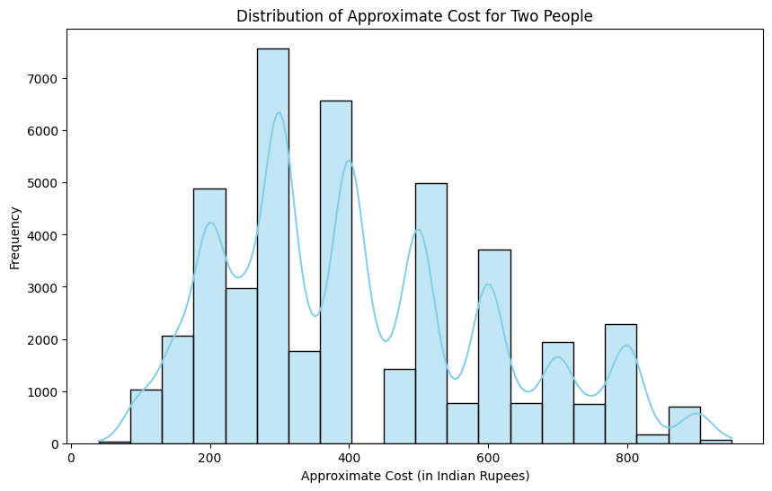

10. Number of Restaurants in a Location:
Create a bar chart or map to display the count of restaurants in each location.
plt.figure(figsize=(15, 8))
sns.countplot(x='location', data=df, order=df['location'].value_counts().index, palette='viridis')
plt.title('Number of Restaurants in Each Location')
plt.xlabel('Location')
plt.ylabel('Count of Restaurants')
plt.xticks(rotation=90) # Rotate x-axis labels for better readability
plt.show()
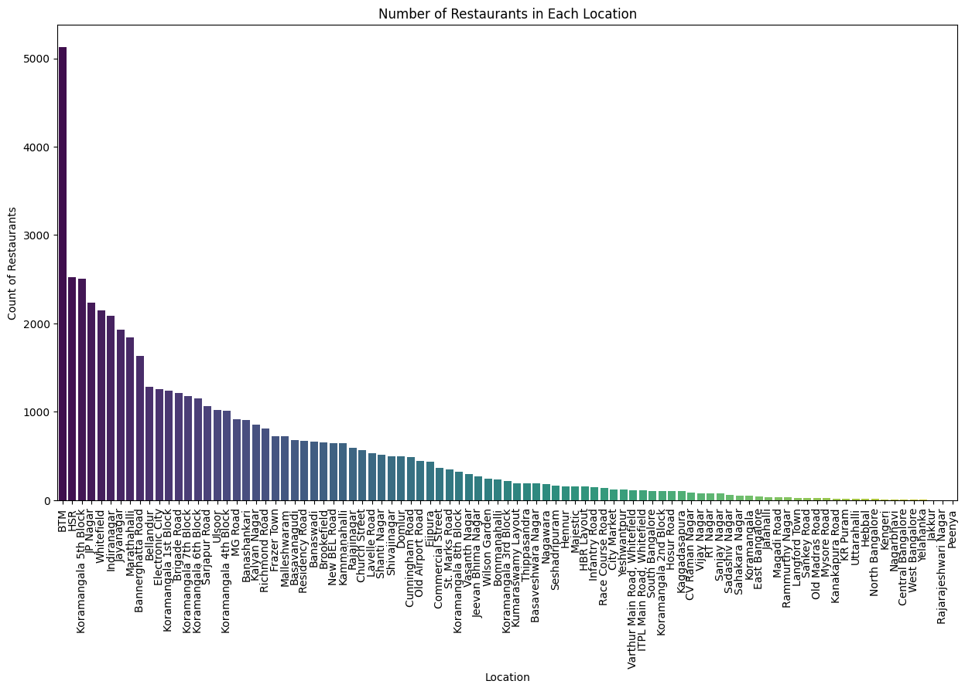
import seaborn as sns
from sklearn.model_selection import train_test_split
from sklearn.linear_model import LinearRegression
from sklearn.tree import DecisionTreeRegressor
from sklearn.ensemble import RandomForestRegressor
from sklearn.metrics import mean_squared_error
import warnings
warnings.filterwarnings('ignore')
%matplotlib inline
df=df.drop(['url','phone'],axis=1)
df.duplicated().sum()
43
df.drop_duplicates(inplace=True)
df.duplicated().sum()
0
df.dropna(how='any',inplace=True)
df = df.rename(columns={'approx_cost(for two people)':'cost','listed_in(type)':'type',
'listed_in(city)':'city'})
df.columns
Index(['address', 'name', 'online_order', 'book_table', 'rate', 'votes',
'location', 'rest_type', 'dish_liked', 'cuisines', 'cost',
'reviews_list', 'menu_item', 'type', 'city'],
dtype='object')
df.head()
address name \
0 942, 21st Main Road, 2nd Stage, Banashankari, ... Jalsa
1 2nd Floor, 80 Feet Road, Near Big Bazaar, 6th ... Spice Elephant
2 1112, Next to KIMS Medical College, 17th Cross... San Churro Cafe
3 1st Floor, Annakuteera, 3rd Stage, Banashankar... Addhuri Udupi Bhojana
4 10, 3rd Floor, Lakshmi Associates, Gandhi Baza... Grand Village
online_order book_table rate votes location rest_type \
0 Yes Yes 4.1/5 775 Banashankari Casual Dining
1 Yes No 4.1/5 787 Banashankari Casual Dining
2 Yes No 3.8/5 918 Banashankari Cafe, Casual Dining
3 No No 3.7/5 88 Banashankari Quick Bites
4 No No 3.8/5 166 Basavanagudi Casual Dining
dish_liked \
0 Pasta, Lunch Buffet, Masala Papad, Paneer Laja...
1 Momos, Lunch Buffet, Chocolate Nirvana, Thai G...
2 Churros, Cannelloni, Minestrone Soup, Hot Choc...
3 Masala Dosa
4 Panipuri, Gol Gappe
cuisines cost \
0 North Indian, Mughlai, Chinese 800.0
1 Chinese, North Indian, Thai 800.0
2 Cafe, Mexican, Italian 800.0
3 South Indian, North Indian 300.0
4 North Indian, Rajasthani 600.0
reviews_list menu_item type \
0 [('Rated 4.0', 'RATED\n A beautiful place to ... [] Buffet
1 [('Rated 4.0', 'RATED\n Had been here for din... [] Buffet
2 [('Rated 3.0', "RATED\n Ambience is not that ... [] Buffet
3 [('Rated 4.0', "RATED\n Great food and proper... [] Buffet
4 [('Rated 4.0', 'RATED\n Very good restaurant ... [] Buffet
city
0 Banashankari
1 Banashankari
2 Banashankari
3 Banashankari
4 Banashankari
df['cost'].unique()
array([800., 300., 600., 700., 550., 500., 450., 650., 400., 750., 200.,
850., 150., 350., 250., 100., 900., 950., 230., 180., 330., 40.,
120.])
print(df['cost'].unique())
print('---'*10)
df.dtypes
[800. 300. 600. 700. 550. 500. 450. 650. 400. 750. 200. 850. 150. 350.
250. 100. 900. 950. 230. 180. 330. 40. 120.]
------------------------------
address object
name object
online_order object
book_table object
rate object
votes int64
location object
rest_type object
dish_liked object
cuisines object
cost float64
reviews_list object
menu_item object
type object
city object
dtype: object
df['rate'].unique()
array(['4.1/5', '3.8/5', '3.7/5', '4.6/5', '4.0/5', '4.2/5', '3.9/5',
'3.0/5', '3.6/5', '2.8/5', '4.4/5', '3.1/5', '4.3/5', '2.6/5',
'3.3/5', '3.5/5', '3.8 /5', '3.2/5', '4.5/5', '2.5/5', '2.9/5',
'3.4/5', '2.7/5', '4.7/5', 'NEW', '2.4/5', '2.2/5', '2.3/5',
'4.8/5', '3.9 /5', '4.2 /5', '4.0 /5', '4.1 /5', '2.9 /5',
'2.7 /5', '2.5 /5', '2.6 /5', '4.5 /5', '4.3 /5', '3.7 /5',
'4.4 /5', '2.1/5', '4.9/5', '3.4 /5', '3.6 /5', '3.3 /5', '4.6 /5',
'4.9 /5', '3.2 /5', '3.0 /5', '2.8 /5', '3.5 /5', '3.1 /5',
'2.3 /5', '2.4 /5', '4.7 /5', '4.8 /5', '2.1 /5', '2.0 /5',
'2.2 /5'], dtype=object)
df = df.loc[df.rate !='NEW']
df['rate'].unique()
array(['4.1/5', '3.8/5', '3.7/5', '4.6/5', '4.0/5', '4.2/5', '3.9/5',
'3.0/5', '3.6/5', '2.8/5', '4.4/5', '3.1/5', '4.3/5', '2.6/5',
'3.3/5', '3.5/5', '3.8 /5', '3.2/5', '4.5/5', '2.5/5', '2.9/5',
'3.4/5', '2.7/5', '4.7/5', '2.4/5', '2.2/5', '2.3/5', '4.8/5',
'3.9 /5', '4.2 /5', '4.0 /5', '4.1 /5', '2.9 /5', '2.7 /5',
'2.5 /5', '2.6 /5', '4.5 /5', '4.3 /5', '3.7 /5', '4.4 /5',
'2.1/5', '4.9/5', '3.4 /5', '3.6 /5', '3.3 /5', '4.6 /5', '4.9 /5',
'3.2 /5', '3.0 /5', '2.8 /5', '3.5 /5', '3.1 /5', '2.3 /5',
'2.4 /5', '4.7 /5', '4.8 /5', '2.1 /5', '2.0 /5', '2.2 /5'],
dtype=object)
df['rate'] = df['rate'].apply(lambda x: x.replace('/5',''))
plt.figure(figsize=(17,10))
chains=df['name'].value_counts()[:20]
sns.histplot(x=chains,y=chains.index,palette='hls')
plt.title("Most famous restaurants chains in Bangaluru")
plt.xlabel("Number of outlets")
plt.show()
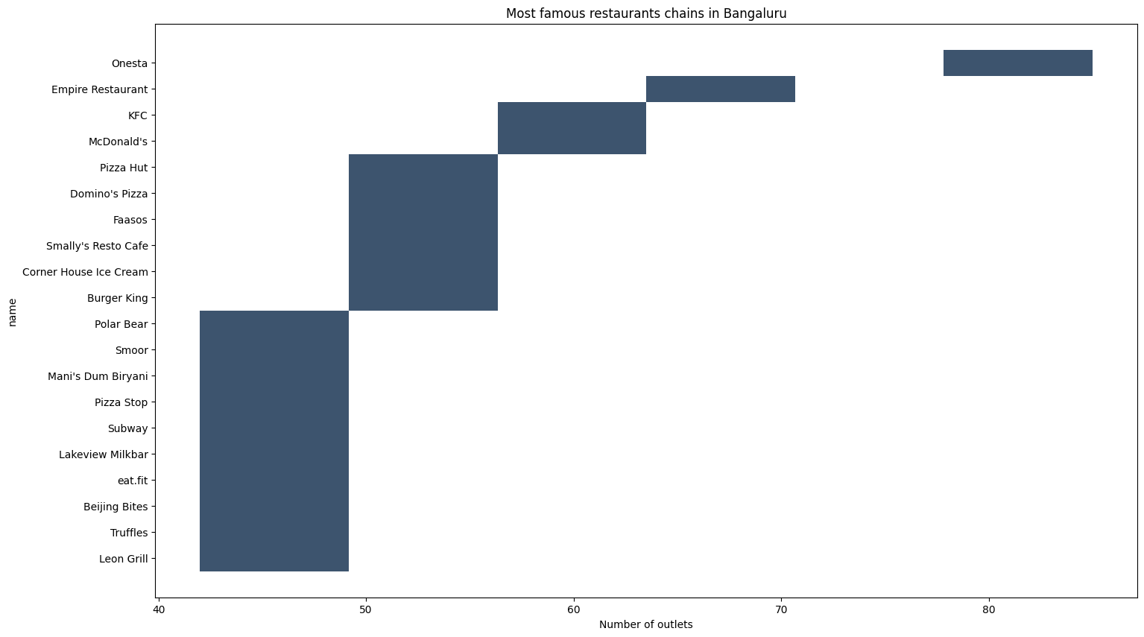
plt.figure(figsize=(9,7))
sns.histplot(df['rate'],bins=20)
plt.show()
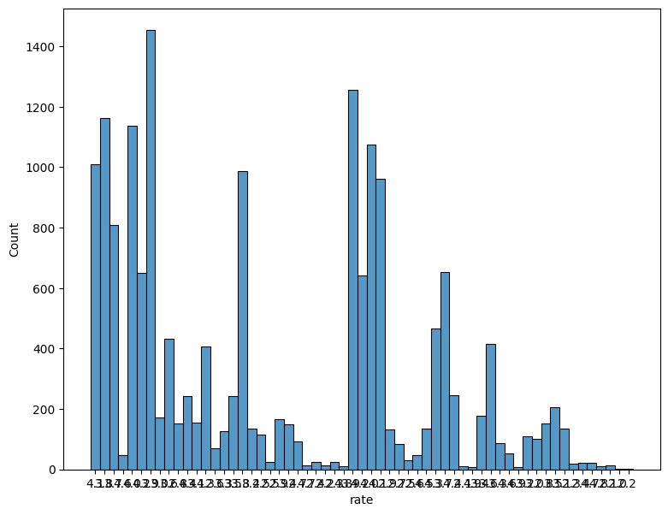
# #Distribution of the cost Vs ratings in parallel with online order
plt.figure(figsize=(15,7))
sns.scatterplot(x="rate",y='cost',hue='online_order',data=df)
plt.xticks(rotation = 90)
plt.show()
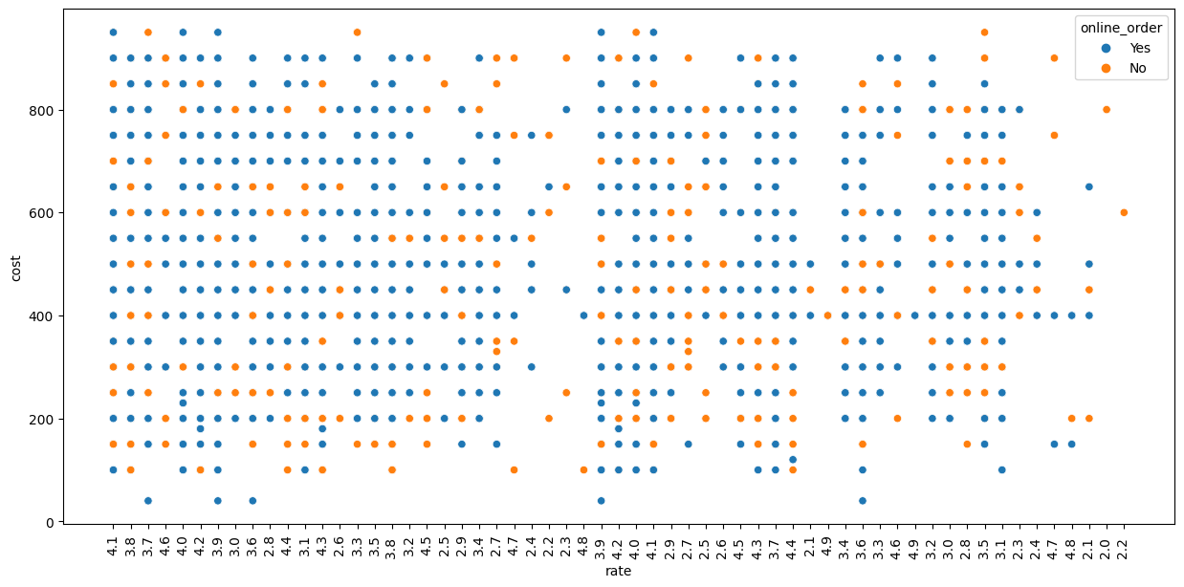
df['rate'].unique()
array(['4.1', '3.8', '3.7', '4.6', '4.0', '4.2', '3.9', '3.0', '3.6',
'2.8', '4.4', '3.1', '4.3', '2.6', '3.3', '3.5', '3.8 ', '3.2',
'4.5', '2.5', '2.9', '3.4', '2.7', '4.7', '2.4', '2.2', '2.3',
'4.8', '3.9 ', '4.2 ', '4.0 ', '4.1 ', '2.9 ', '2.7 ', '2.5 ',
'2.6 ', '4.5 ', '4.3 ', '3.7 ', '4.4 ', '2.1', '4.9', '3.4 ',
'3.6 ', '3.3 ', '4.6 ', '4.9 ', '3.2 ', '3.0 ', '2.8 ', '3.5 ',
'3.1 ', '2.3 ', '2.4 ', '4.7 ', '4.8 ', '2.1 ', '2.0 ', '2.2 '],
dtype=object)
df['rate'].min()
'2.0 '
df['rate'].max()
'4.9 '
df['rate']=df['rate'].astype(float)
((df['rate']>=1) & (df['rate']<2)).sum()
0
((df['rate']>=2) & (df['rate']<3)).sum()
1085
((df['rate']>=3) & (df['rate']<4)).sum()
8957
(df['rate']>=4).sum()
7260
slices=[((df['rate']>=1) & (df['rate']<2)).sum(),
((df['rate']>=2) & (df['rate']<3)).sum(),
((df['rate']>=3) & (df['rate']<4)).sum(),
(df['rate']>=4).sum()
]
labels=['1','2','3','>4']
colors = ['red','green','black', 'pink']
plt.pie(slices,colors=colors, labels=labels, autopct='%1.0f%%', pctdistance=.5, labeldistance=1.2,shadow=True)
fig = plt.gcf()
plt.title("Percentage of Restaurants according to their ratings")
fig.set_size_inches(10,10)
plt.show()
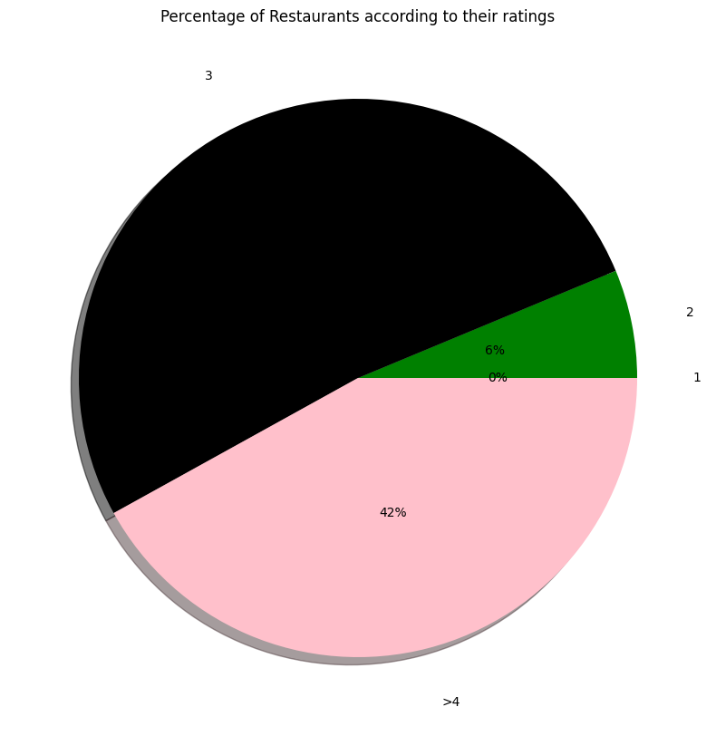
plt.figure(figsize=(15, 7))
sns.countplot(data=df, x='type')
plt.xticks(rotation=90, ha='right')
plt.show()
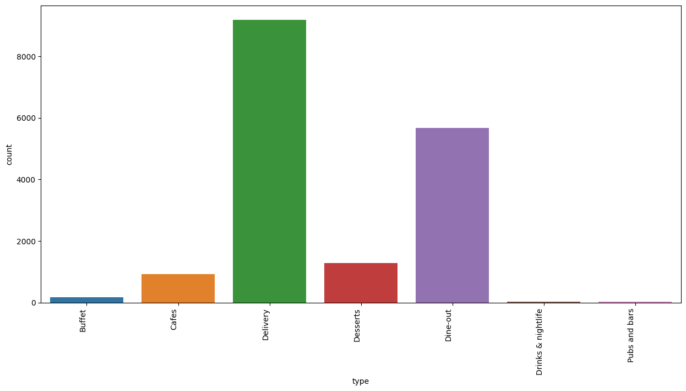
plt.figure(figsize=(8,8))
sns.histplot(df['cost'])
plt.show()
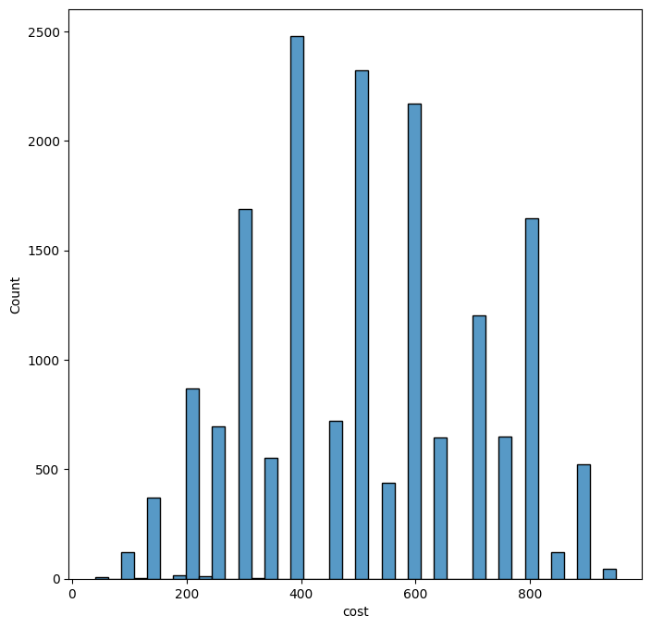
#re=regular expression (use for splitting words)
import re
df.index=range(df.shape[0])
likes=[]
for i in range(df.shape[0]):
array_split=re.split(',',df['dish_liked'][i])
for item in array_split:
likes.append(item)
df.index=range(df.shape[0])
df.index
RangeIndex(start=0, stop=17302, step=1)
print("Count of Most liked dishes in Bangalore")
favourite_food = pd.Series(likes).value_counts()
favourite_food.head(30)
Count of Most liked dishes in Bangalore
Pasta 1710
Burgers 1142
Burgers 1068
Sandwiches 1057
Coffee 1050
Paratha 947
Biryani 807
Chicken Biryani 768
Pizza 755
Coffee 728
Tea 717
Mutton Biryani 716
Thali 712
Fries 703
Sandwich 699
Hot Chocolate 649
Biryani 638
Butter Chicken 602
Roti 596
Noodles 575
Brownie 549
Nachos 538
Chicken Curry 531
Rolls 501
Chaat 492
Tandoori Chicken 490
Pizza 482
Fish 463
Waffles 459
Rolls 435
Name: count, dtype: int64
ax = favourite_food.nlargest(n=20, keep='first').plot(kind='bar',figsize=(18,10),title = 'Top 30 Favourite Food counts ')
for i in ax.patches:
ax.annotate(str(i.get_height()), (i.get_x() * 1.005, i.get_height() * 1.005))
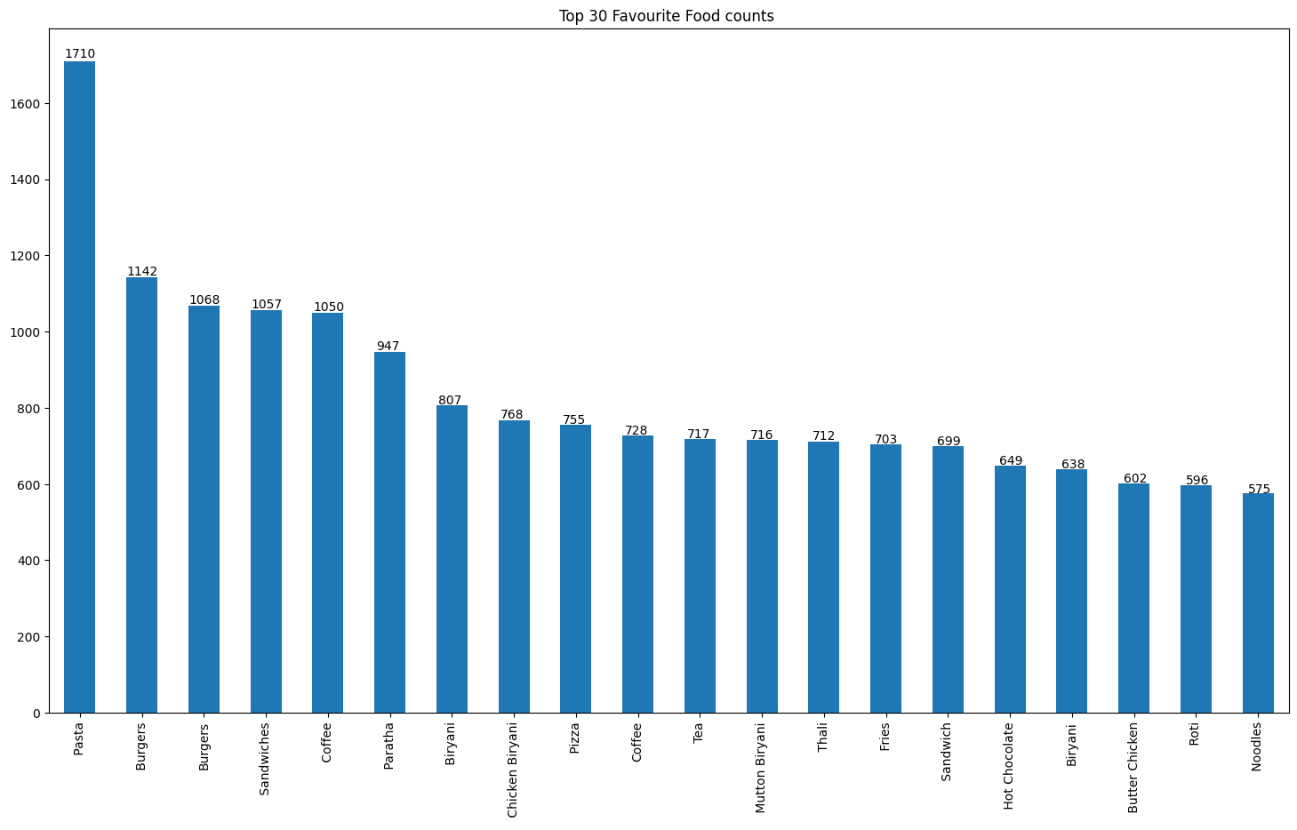
plt.figure(figsize=(15,7))
chains=df['name'].value_counts()[:20]
sns.histplot(x=chains,y=chains.index,palette='Set1')
plt.title("Most famous restaurant chains in Bangaluru",size=20,pad=20)
plt.xlabel("Number of outlets",size=15)
plt.show()
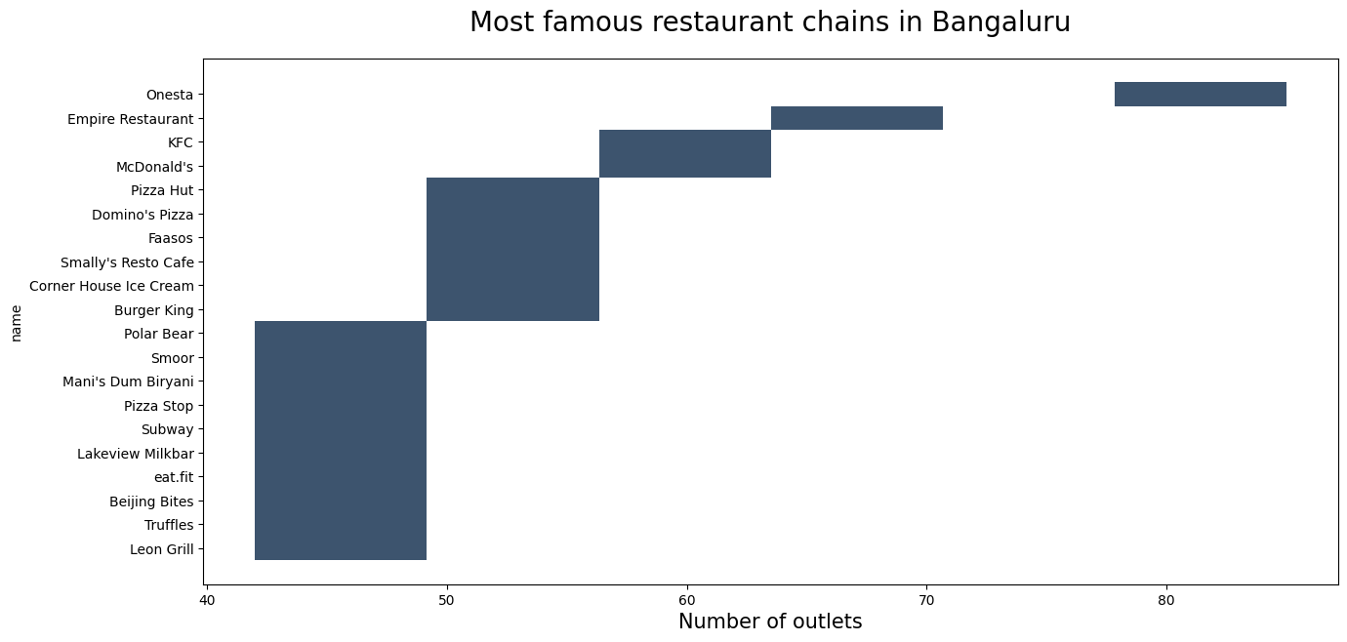
df.online_order[df.online_order == 'Yes'] = 1
df.online_order[df.online_order == 'No'] = 0
df.online_order.value_counts()
online_order
1 13513
0 3789
Name: count, dtype: int64
df.online_order = pd.to_numeric(df.online_order)
df.book_table[df.book_table == 'Yes'] = 1
df.book_table[df.book_table == 'No'] = 0
df.book_table = pd.to_numeric(df.book_table)
df.book_table.value_counts()
book_table
0 15595
1 1707
Name: count, dtype: int64
from sklearn.preprocessing import LabelEncoder
le = LabelEncoder()
df.location = le.fit_transform(df.location)
df.rest_type = le.fit_transform(df.rest_type)
df.cuisines = le.fit_transform(df.cuisines)
df.menu_item = le.fit_transform(df.menu_item)
df.head()
address name \
0 942, 21st Main Road, 2nd Stage, Banashankari, ... Jalsa
1 2nd Floor, 80 Feet Road, Near Big Bazaar, 6th ... Spice Elephant
2 1112, Next to KIMS Medical College, 17th Cross... San Churro Cafe
3 1st Floor, Annakuteera, 3rd Stage, Banashankar... Addhuri Udupi Bhojana
4 10, 3rd Floor, Lakshmi Associates, Gandhi Baza... Grand Village
online_order book_table rate votes location rest_type \
0 1 1 4.1 775 1 16
1 1 0 4.1 787 1 16
2 1 0 3.8 918 1 13
3 0 0 3.7 88 1 36
4 0 0 3.8 166 4 16
dish_liked cuisines cost \
0 Pasta, Lunch Buffet, Masala Papad, Paneer Laja... 990 800.0
1 Momos, Lunch Buffet, Chocolate Nirvana, Thai G... 479 800.0
2 Churros, Cannelloni, Minestrone Soup, Hot Choc... 389 800.0
3 Masala Dosa 1141 300.0
4 Panipuri, Gol Gappe 1000 600.0
reviews_list menu_item type \
0 [('Rated 4.0', 'RATED\n A beautiful place to ... 4403 Buffet
1 [('Rated 4.0', 'RATED\n Had been here for din... 4403 Buffet
2 [('Rated 3.0', "RATED\n Ambience is not that ... 4403 Buffet
3 [('Rated 4.0', "RATED\n Great food and proper... 4403 Buffet
4 [('Rated 4.0', 'RATED\n Very good restaurant ... 4403 Buffet
city
0 Banashankari
1 Banashankari
2 Banashankari
3 Banashankari
4 Banashankari
my_data=df.iloc[:,[2,3,4,5,6,7,9,10,12]]
my_data.to_csv('Zomato_df.csv')
x = df.iloc[:,[2,3,5,6,7,9,10,12]]
x.head()
online_order book_table votes location rest_type cuisines cost \
0 1 1 775 1 16 990 800.0
1 1 0 787 1 16 479 800.0
2 1 0 918 1 13 389 800.0
3 0 0 88 1 36 1141 300.0
4 0 0 166 4 16 1000 600.0
menu_item
0 4403
1 4403
2 4403
3 4403
4 4403
y = df['rate']
y
0 4.1
1 4.1
2 3.8
3 3.7
4 3.8
...
17297 3.8
17298 3.4
17299 3.6
17300 2.5
17301 2.5
Name: rate, Length: 17302, dtype: float64
x_train,x_test,y_train,y_test=train_test_split(x,y,test_size=.3,random_state=10)
lr_model=LinearRegression()
lr_model.fit(x_train,y_train)
LinearRegression()
from sklearn.metrics import r2_score
y_pred=lr_model.predict(x_test)
r2_score(y_test,y_pred)
0.12060896703420043
#Preparing Extra Tree Regression
from sklearn.ensemble import ExtraTreesRegressor
ET_Model=ExtraTreesRegressor(n_estimators = 120)
ET_Model.fit(x_train,y_train)
y_predict=ET_Model.predict(x_test)
from sklearn.metrics import r2_score
r2_score(y_test,y_predict)
0.9105627427728819

📝 Conclusion
- url: The URL of the restaurant, likely pointing to its Zomato page, providing additional information and reviews about the restaurant. This can be used for external references or linking to specific restaurants in analyses.
- address: The physical address of the restaurant in Bangalore. Useful for geographical analysis, understanding restaurant distribution, and locating specific venues.
- name: The name of the restaurant, a crucial identifier in the dataset. Used for restaurant-specific analysis, identifying popular establishments, and general categorization.
- online_order: Indicates whether the restaurant accepts online orders. Valuable for assessing the digital presence of restaurants and understanding consumer preferences.
- book_table: Specifies whether the restaurant allows customers to book tables in advance. Useful for analyzing dining trends, preferences, and the overall restaurant experience.
- rate: Represents the overall rating of the restaurant. Essential for ranking and comparing restaurants based on customer feedback.
- votes: The number of votes contributing to the restaurant's rating. Helpful in understanding the reliability of the rating and the popularity of the restaurant.
- phone: Contact number for the restaurant, enabling communication and possibly further analysis regarding customer interactions or preferences.
- location: Indicates the neighborhood or area in Bangalore where the restaurant is situated. Important for location-based analyses and understanding regional dining preferences.
- rest_type: Describes the type or category of the restaurant, providing insights into the diversity of dining options in Bangalore.
- dish_liked: Specifies dishes that are particularly liked at the restaurant. Valuable for menu analysis and understanding customer preferences.
- cuisines: Lists the cuisines offered by the restaurant. Useful for identifying popular cuisines in Bangalore and analyzing the culinary diversity.
- approx_cost(for two people): Indicates the approximate cost for two people. Essential for budget analysis and understanding the pricing structure of restaurants.
- reviews_list: Contains reviews for the restaurant. Valuable for sentiment analysis and understanding specific aspects of customer feedback.
- menu_item: Lists specific items on the restaurant's menu. Useful for menu analysis and understanding the variety of offerings.
- listed_in(type): Specifies the type of listing on Zomato, providing additional categorization for analysis.
- listed_in(city): Indicates the city listing on Zomato, allowing for filtering and analysis based on different cities.

