Task 1
Frequency-Selective Residual Decay
  - Advanced Deep Learning project report
MAE on ImageNet-100, with a SiT extension
9 November 2026

Summary
This project changes the identity shortcut inside a transformer block. The original residual-decay method scales the whole shortcut. Our version also keeps part of a local average, so nearby visible patches can retain shared information while the remaining detail still receives the original decay.
We trained five MAE variants for 200 epochs each, starting from scratch. All used the same ImageNet-100 release, model, seed, effective batch size and learning-rate schedule. Final classification evaluation used the complete training split to fit the linear classifier and all 5,000 validation images to measure accuracy.
Study item | Setting
Main model | Custom MAE ViT-B/16 from the supplied repository
Comparisons | Standard shortcuts, fixed decay, uniform beta=0.5, uniform beta=1, Gaussian beta=0.5
Data | 126,689 training images and 5,000 validation images in 100 classes
Hardware | H200 GPU with a 7 GiB PyTorch allocator limit
Additional study | Three SiT-B/4 variants, also trained for 200 epochs

The Gaussian-like 5x5 filter with beta=0.5 gave the best MAE result: 75.66% linear-probe accuracy and 65.98% KNN accuracy. Fixed decay reached 72.02% and 59.90%. The uniform filter at beta=0.5 also helped, but beta=1 reduced accuracy to 65.28%.
The feature measurements support a tradeoff rather than a simple rule. Beta=1 produced the lowest high-frequency share and rank entropy, yet it did not give the best classifier. Moderate preservation of local structure worked better in this experiment.
These are results from one seed and a resized ImageNet-100 release. The software checks passed, but the final pipeline has not been tested on a physical RTX 3070. The SiT study measures feature quality; it does not establish improved image-generation quality.

1. Method
A shortcut carries a block input directly to its output. Let X be the patch features, a the original shortcut multiplier and L a local average of nearby visible patches. The learned attention or MLP branch is left as it is. We replace only the shortcut term:
S(X) = aX + beta(1 - a)L
Beta is fixed for a run and is not learned. Beta=0 gives exactly the original fixed-decay shortcut. When a=1, the local-average term is zero, which recovers the standard-shortcut control. The same rule is applied to both encoder additions, using the repository's separate attention and MLP multipliers.
X = L + (X - L)
S(X) = [a + beta(1 - a)]L + a(X - L)
This form explains the intention. The part shared with the local average gets a larger coefficient, while the difference from that average keeps multiplier a. With missing patches and image borders, L is a local smoothing operation rather than an exact split into Fourier frequency bands.

The two fixed filters
The uniform filter gives every position in a 5x5 window weight 1/25. The Gaussian-like filter uses the outer product of [1, 4, 6, 4, 1], divided by 256. Its centre receives more weight. Both filters are fixed and add no trainable parameters.
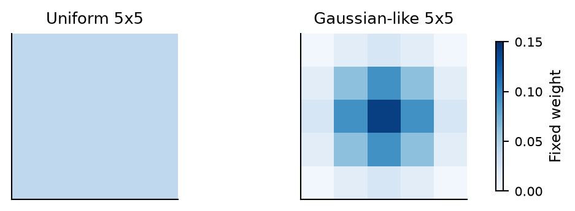
Figure 1. The averaging kernels. The same kernel is applied to the feature grid and the visibility grid.

Using the correct patch positions
At 75% masking, MAE keeps 49 patch tokens from a 14x14 image grid. Those tokens are shuffled and scattered across the image. Treating them as a 7x7 image would put unrelated patches next to one another.
- Scatter visible features back into their original 14x14 positions using ids_keep.
- Create a grid with 1 at visible positions and 0 elsewhere.
- Filter both grids with the same fixed kernel.
- Divide the filtered features by filtered visibility, with a small numerical lower bound.
- Gather the averages back into the original visible-token order.

2. Implementation and experiment setup

What changed in the model
Only the encoder identity additions use the new rule. CLS, the special summary token, keeps its original scalar shortcut. The MLP addition recomputes L from its own input, after the attention addition has changed the features. Gradients pass through the averaging operation. The decoder, learned attention and MLP operations, initialization and reconstruction loss are unchanged.
The unmasked feature-extraction path uses the same rule on the complete grid. Kernel choice, beta and the original decay setting are saved with checkpoints and restored on load. Each MAE variant has 117,038,848 trainable parameters.

Dataset and baseline
We used the approved clane9/imagenet-100 release at revision 0519dc2f402a3a18c6e57f7913db059215eee25b. It contains 126,689 training and 5,000 validation images. The 100 CMC class IDs and their integer labels are fixed in Appendix A. Preparation records contain SHA-256 checksums for all 18 source shards.
The source images were resized to 160 pixels on the shorter side before our transforms. They are therefore not the original full-resolution ImageNet images. The teammate's earlier run was not independently verified. Our baselines are newly trained matched controls on this approved release.
MAE pretraining setting | Value
Architecture | ViT-B/16; 12 encoder blocks, width 768; 8 decoder blocks, width 512
Image size and masking | 224x224; 75% masking; 49 visible patches plus CLS
Epochs and seed | 200 epochs; seed 0; no pretrained MAE weights
Physical / effective batch | 32 images; accumulation over 8 batches; effective batch 256
Optimizer | AdamW; betas (0.9, 0.95); weight decay 0.05
Learning rate | Peak 0.00015; 20 warmup epochs; cosine decay
Training transform | Random resized crop, scale 0.2 to 1.0; horizontal flip; ImageNet normalization
Objective and precision | Normalized masked-pixel reconstruction loss; FP16 mixed precision
Validation | All 5,000 images every 5 epochs; fixed crop and mask seed 12345
Hardware limit | Single H200; 7 GiB PyTorch allocator cap

The original linear decay schedule is preserved over all 24 encoder additions. If q runs from 0 to 23, a(q)=1-(1-a_min)q/23. Attention and MLP use consecutive values. All active MAE variants and fixed decay use a_min=0.7. The standard control sets every multiplier to 1 and retains the same architecture, including its encoder-to-decoder skip connections.

3. MAE classification results
A linear probe trains a single classifier on frozen features. It measures how easy it is to separate classes without changing the backbone. KNN (k-nearest neighbors) predicts a class from nearby training features. Both use the same features and data split for all five models.
Method | Beta | Validation  MAE loss | Linear probe  (%) | KNN  (%)
Standard | - | 0.409020 | 66.92 | 51.24
Fixed decay | - | 0.410559 | 72.02 | 59.90
Uniform beta=0.5 | 0.5 | 0.412325 | 73.70 | 65.74
Uniform beta=1 | 1 | 0.415199 | 65.28 | 50.40
Gaussian beta=0.5 | 0.5 | 0.409581 | 75.66 | 65.98

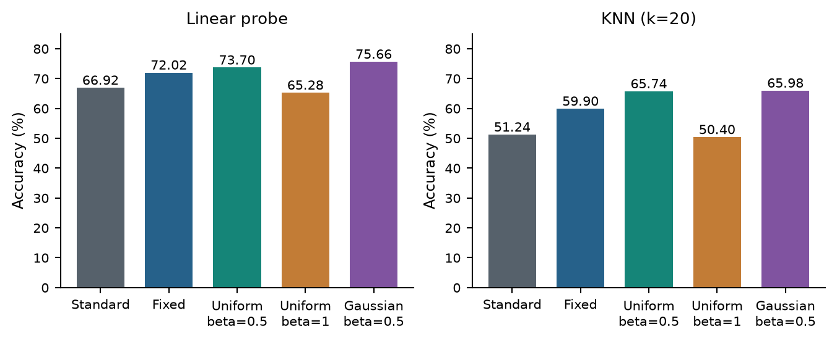
Figure 2. Final evaluation after 200 MAE epochs. The probe fits all 126,689 training images and both metrics use all 5,000 validation images.
Fixed decay improves linear-probe accuracy by 5.10 percentage points over standard shortcuts. The uniform beta=0.5 variant adds 1.68 points over fixed decay. Gaussian beta=0.5 adds 3.64 points and is 1.96 points ahead of uniform beta=0.5. One percentage point is a difference between accuracy percentages, rather than a relative percent increase.
Beta=1 gives the weakest linear probe, even though it preserves the local-average component most strongly. Increasing beta therefore did not produce a steady improvement. The Gaussian KNN gain over uniform beta=0.5 is only 0.24 points, so it should not be treated as a large or established advantage.

Evaluation choices
We kept the repository's pooling: average all final raw encoder tokens, including CLS, without an added output normalization. Extraction uses fixed resize/centre crops and no masking, in batches of 8. The probe runs on CPU for 200 epochs with AdamW, batch 1024, learning rate 0.01 and the existing cosine schedule. Its default weight decay is 0.01. KNN uses cosine-normalized features, k=20 and vote temperature 0.07.
Earlier probes used only 1,000 training and 1,000 validation images. Their scores were 34.7%, 44.6% and 52.3% for the first three methods. Those subset results are retained in the logs, but the full-data results above are the final comparison.

4. Training, validation and probe curves
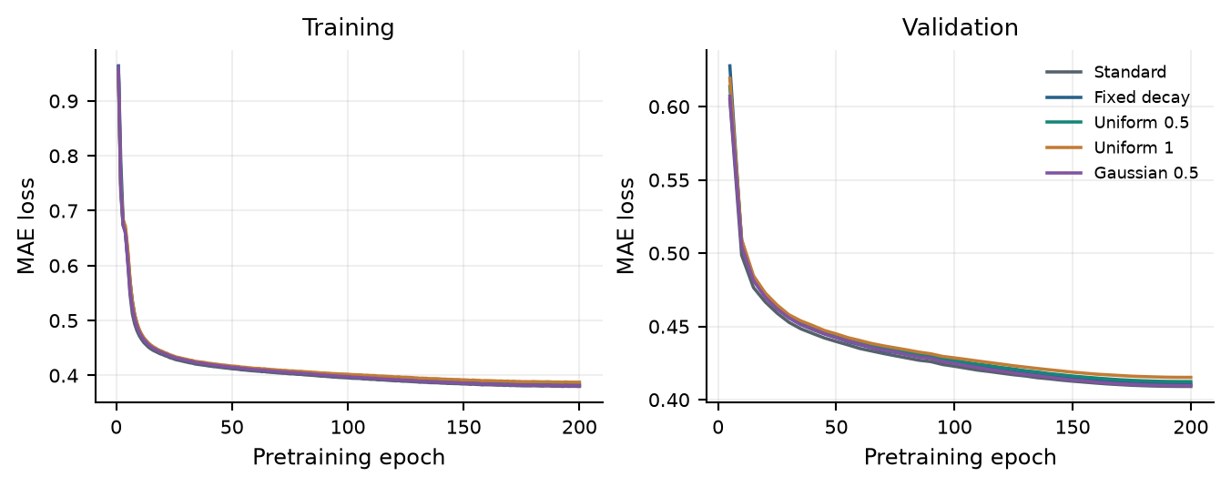
Figure 3. Sample-weighted training epoch losses and every completed MAE validation pass. Validation uses the same crops and masks for all methods.
All five runs completed 200 epochs and 40 full validation passes. Their losses stayed finite. Reconstruction loss and classifier accuracy do not rank the models in the same order. For example, fixed decay classifies better than standard shortcuts despite a slightly higher reconstruction loss.
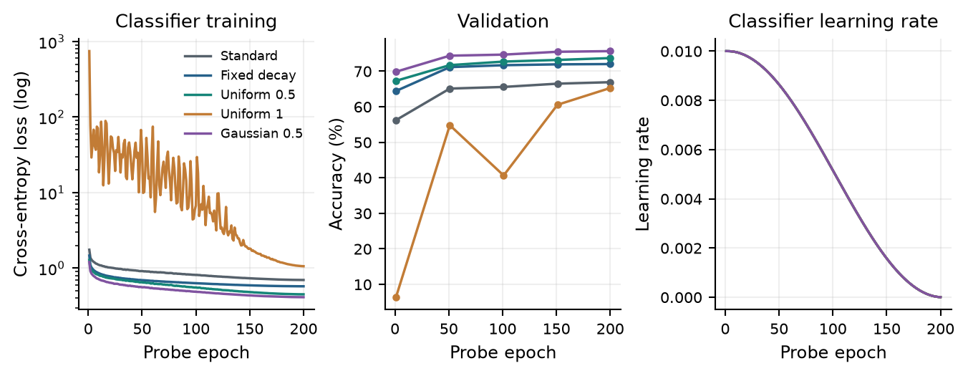
Figure 4. Full-data classifier loss on a log scale, recorded validation accuracy and learning rate. Accuracy was evaluated at probe epochs 1, 51, 101, 151 and 200; intermediate validation measurements were not recorded.
The Gaussian variant finishes at validation MAE loss 0.409581, close to standard shortcuts at 0.409020 and below fixed decay at 0.410559. Uniform beta=1 has the highest final validation loss, 0.415199. This supports treating reconstruction and classification as separate outcomes.
The beta=1 probe has an unstable early loss and validation curve. We kept raw pooled features and the same probe settings for every model. Its lower accuracy may therefore reflect both representation quality and difficulty optimizing the classifier; this experiment does not separate those effects.
Training losses are logged per successful optimizer update and as sample-weighted epoch averages. Classifier loss has its own records. KNN was measured only at the final checkpoint, so Figure 2 reports those final values.

5. Measuring rank and spatial frequency

Rank entropy
For the same 200 validation images, we collect the CLS vector at each encoder block. Rows of Z are images and its 768 columns are channels. Each row is centred across channels, then we form sample-by-sample covariance:
C = Zc Zc^T / (768 - 1)
p_i = lambda_i / sum_j lambda_j; H(C) = -sum_i p_i log(p_i)
The nonnegative eigenvalues lambda_i are the covariance singular values. We use natural logarithms and do not exponentiate H. A smaller value means the covariance spectrum is more concentrated. It is an entropy value, not a literal count of feature dimensions. The metric follows the covariance-based definition requested for this task [1]. Rank is measured after training and never changes the shortcut multipliers.

High-frequency energy and spatial variation
Frequency measurements use complete, unmasked 14x14 patch grids from the same 200 images at every depth. CLS is excluded. We remove each channel's spatial mean and take a 2D Fourier transform. Frequencies with radial magnitude above 0.25 cycles per patch count as high frequency. The high-frequency share is high-frequency energy divided by all non-DC spatial energy.
DC is the constant spatial component. It is removed from both the energy numerator and denominator. We also report absolute high- and low-frequency energy and total spatial energy, averaged over images and summed over channels. Spatial variation is the mean squared difference between horizontally and vertically adjacent patch features. These checks help distinguish a changed frequency balance from an overall change in feature scale.
Final block | Rank  entropy | HF share  (%) | Variation | Total non-DC  energy
Standard | 2.5535 | 53.77 | 1.7593 | 202,434
Fixed decay | 3.1720 | 41.28 | 0.2533 | 37,715
Uniform beta=0.5 | 2.9371 | 14.14 | 0.1193 | 49,298
Uniform beta=1 | 0.0917 | 7.69 | 0.1008 | 160,859
Gaussian beta=0.5 | 3.0905 | 19.32 | 0.1846 | 54,530

Uniform beta=0.5 reduces final high-frequency share from 41.28% under fixed decay to 14.14%. Gaussian beta=0.5 reaches 19.32%. Both retain more low-frequency energy than fixed decay. Their total spatial energy is also higher, so the lower shares do not come from shrinking every feature equally.
Beta=1 gives the lowest high-frequency share, 7.69%, and CLS rank entropy, 0.0917, but poorer classification. Gaussian has higher high-frequency share and rank entropy than uniform beta=0.5, yet better linear probing. These results do not support using either lower entropy or stronger smoothing alone as a reliable accuracy predictor. The probe pools all tokens, while the rank measurement uses CLS, which also limits a direct comparison.

6. How the features change across depth
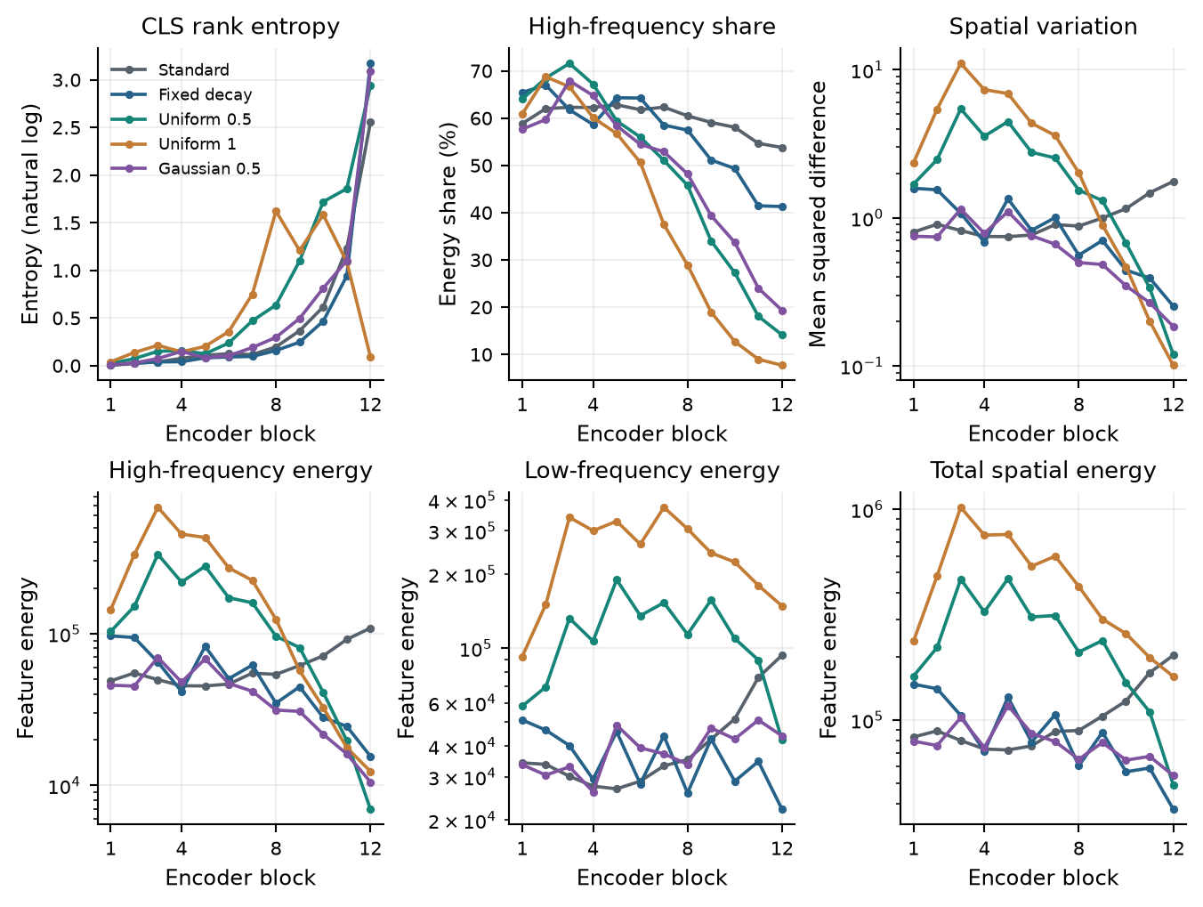
Figure 5. Measurements at all 12 MAE encoder blocks using 200 identical unmasked images. Energy and variation axes use log scales where marked. Low-frequency energy excludes DC. All points come from saved records.
The effect is not uniform across the network. Some active variants have larger variation in early blocks, while the strongest high-frequency suppression appears later. The Gaussian filter retains more short-range detail than the uniform filter in the final features. Its final low-frequency energy is about 43,994, compared with 22,148 for fixed decay.
Uniform beta=1 has very concentrated CLS covariance despite substantial patch-feature energy. Its low rank-entropy value therefore does not show that every patch feature has become uninformative. It does show why the feature type and covariance definition need to remain explicit when discussing rank.
The observed spectral changes are consistent with the intended shortcut mechanism. They do not establish that frequency suppression caused the classification gains. The learned branches can change their behaviour in response to the new shortcut, and all conclusions here come from one training seed.

7. Runtime, memory and implementation checks
Method | Pretrain +  validation (h) | Peak allocated  (GiB) | Peak reserved  (GiB) | Actual  updates
Standard | 6.63 | 4.207 | 4.643 | 98,967
Fixed decay | 6.73 | 4.207 | 4.643 | 98,967
Uniform beta=0.5 | 9.71 | 5.032 | 5.541 | 98,967
Uniform beta=1 | 9.48 | 5.032 | 5.541 | 98,965
Gaussian beta=0.5 | 10.01 | 5.033 | 5.529 | 98,965

Time runs from process setup through the final MAE validation; it excludes final feature extraction and probing. Full-data evaluation took about 5 to 6 additional minutes per model. The active methods used about 20% more peak allocated memory than fixed decay. The Gaussian run took about 49% longer through final validation.
One optimizer update changes the weights after accumulating eight small batches. All methods attempted 99,000 updates. FP16 gradient scaling skipped 33 in the first three models and 35 in the two later variants. Skipped updates were recorded and did not increase the successful-update counter. The small difference in actual update counts should be kept in mind when describing the runs as matched.
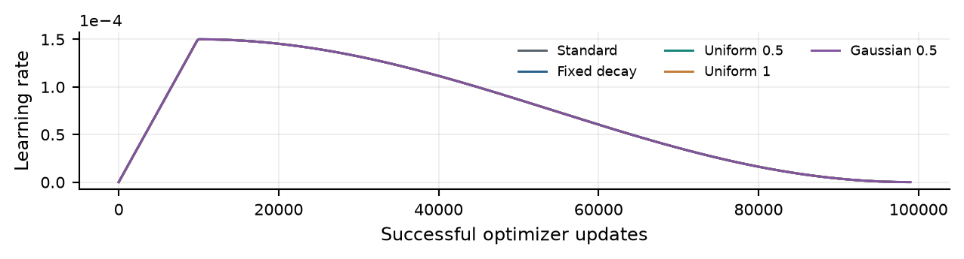
Figure 6. The shared pretraining learning-rate schedule, shown against successful updates. Every 200th recorded update and the final update are displayed for readability.
Check | Outcome
Beta=0 and unit multipliers | Exact recovery of fixed decay and the same-architecture control
Patch positions, shuffled order and CLS | Passed for the masked path and unmasked extraction
Constant inputs and hidden-patch isolation | Passed for uniform and Gaussian averaging
Gradients and finite forward/backward | Passed synthetic checks and real-data pilots
Parameters and checkpoint settings | No trainable parameters added; settings and outputs restore
Validation isolation and logging | Repeatable validation; weights/RNG preserved; counters and separate logs checked

The capped H200 runs are evidence that memory use stays within the planned budget. Observed total device usage was about 6.3 GiB during active training. PyTorch peaks do not include every external CUDA allocation, and the cap does not reproduce RTX 3070 speed or hardware behaviour. Several training updates and unmasked evaluation still need to be checked on an actual RTX 3070.

8. SiT extension
After the MAE study, we applied the same shortcut idea to SiT-B/4. SiT predicts a velocity that moves a noisy compressed image representation towards an image. Its input is a complete 8x8 grid of latent tokens, with no CLS token or missing patches. The shortcut is applied to both encoder and decoder blocks, using the original minimum multiplier 0.8.
All three SiT backbones started from scratch. They share the same frozen stabilityai/sd-vae-ft-ema image compressor, pinned to revision f04b2c4b98319346dad8c65879f680b1997b204a. A VAE is a model that compresses an image into a smaller representation. We cached its mean and log-variance for both image flips, then sampled a fresh latent during each training batch. The compressor weights are shared across methods and are not an MAE pretrained baseline.
SiT used 256x256 inputs, 200 epochs, seed 0, physical batch 64 with four-batch accumulation, AdamW at constant learning rate 0.0001, zero weight decay and FP16 mixed precision. The effective batch remained 256 and the allocator cap remained 7 GiB. EMA weights use a running average of model weights with decay 0.9999. Validation used EMA and fixed noise every five epochs.
SiT method | Velocity  validation loss | Linear probe  (%) | KNN  (%)
Standard | 0.853590 | 18.40 | 13.10
Fixed decay | 0.851626 | 17.22 | 11.70
Uniform beta=0.5 | 0.850967 | 20.74 | 13.86

These classifier results fit 1,000 training images, not the full MAE probe set. We searched blocks 3, 6, 9 and 12 at times 1, 0.75, 0.5 and 0.25. In this code t=1 is clean. Fixed noise, posterior means, mean patch-token pooling and null class conditioning were used. Class labels were never passed to the feature extractor.
For each candidate, the probe fit 10 images per class. Another 5 per class were held out from probe fitting to choose the setting. Those images had been available during backbone pretraining. The standard control selected block 9 at t=0.75. We fixed that setting for all three methods before testing on all 5,000 validation images.
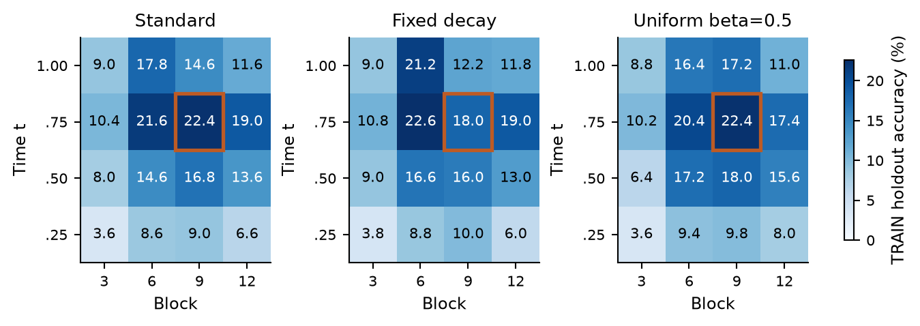
Figure 7. Accuracy on the 500-image training holdout for every SiT candidate. The outlined cell is the one shared setting chosen by the standard control. The official validation set was not used for this choice.

9. What the SiT results support
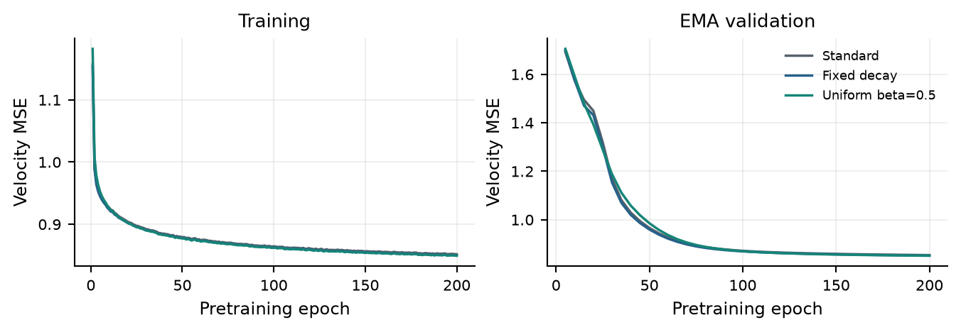
Figure 8. SiT training velocity loss and every completed fixed-noise EMA validation pass. This objective is separate from MAE reconstruction loss.
At the shared setting, frequency-selective decay improves the linear probe by 3.52 points over fixed decay and 2.34 points over the standard control. The scores remain modest. Earlier clean final-block probes gave 9.1%, 9.8% and 9.5% on 1,000 validation images. The new protocol changes the feature layer, noise level and validation sample count, so it is not a direct measure of improvement over that earlier evaluation.
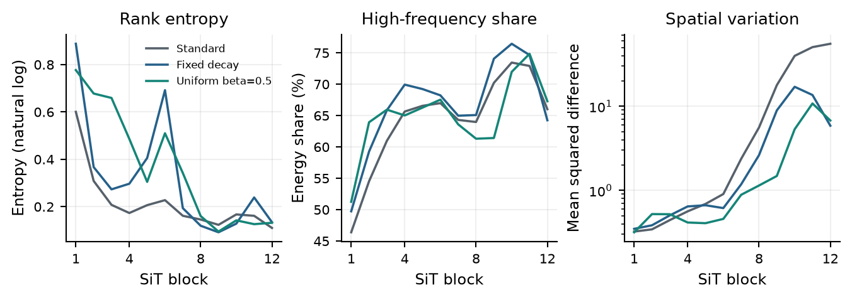
Figure 9. SiT depth measurements from 200 common clean images at t=1. Rank uses mean patch tokens. These are separate from the selected noisy block-9 probe and are not directly comparable with MAE CLS rank.
The clean final-block high-frequency shares are 66.01% for standard shortcuts, 64.24% for fixed decay and 67.27% for frequency-selective decay. The MAE pattern of lower final high-frequency share does not carry over to this SiT measurement. We therefore cannot claim that the same spectral explanation has been established in both models.
SiT peak allocated memory was about 4.69 GiB for all three runs. Their queue finished in 9 hours 22 minutes. No generated-image quality metric was measured. A better linear probe or slightly lower velocity loss does not establish better image generation. SiT also uses class labels during pretraining and a pretrained compressor, so its absolute classifier scores should not be compared with MAE as a controlled architecture comparison.

10. Comparison, conclusions and remaining work

Comparison with published results
MAE method | Published LP (%) [1] | This study LP (%)
Standard shortcuts | 76.5 | 66.92
Fixed decay, a_min=0.7 | 81.8 | 72.02
Gaussian beta=0.5 | Not reported | 75.66

The published ImageNet-100 setup uses 800 pretraining epochs, batch 1024, peak learning rate 0.0006 and 40 warmup epochs; probing runs for 200 epochs [1, Table 3 and Appendix A]. We use 200 pretraining epochs, batch 256 and resized source images. Fixed decay gains 5.10 points here versus 5.3 points in that table. The direction and size of the gain agree, but the absolute scores are not a numerical reproduction.
FID compares generated and real image features; lower is better. For SiT, the residual-decay paper reports FID 16.5 versus 11.8 for its SiT-XL/2 U-Net control and decayed model at 400,000 updates on ImageNet-1K [1, Table 2]. The original SiT paper reports FID 33.0 for SiT-B/2 at 400,000 updates [3]. Our B/4 ImageNet-100 runs have about 99,000 updates and no FID measurement, so these values cannot validate our generation quality.

Conclusions
The main Task 1 result is a useful improvement within our controlled MAE comparison. Gaussian beta=0.5 gives 75.66% linear-probe accuracy, 3.64 points above fixed decay. Uniform beta=0.5 gives a smaller gain. Beta=1 hurts accuracy. The local-average operator and beta both matter.
The frequency measurements show that active shortcuts can preserve more low-frequency energy while reducing the high-frequency share. The strongest suppression is not the best classifier. Rank entropy also fails to order the models by accuracy. These findings support the method as an empirical change, but do not prove a general causal link between frequency, rank and semantic quality.
The implementation, five MAE comparisons, two averaging operators, SiT extension and saved logs/curves are complete. Physical RTX 3070 testing is still pending. Repeated seeds and an untouched test set would be needed for stronger statistical claims; the best MAE variant was identified on the reported validation set. SiT sample generation and FID are also pending if a generation-quality claim is required.

References
[1] Zhang, X., et al. Residual Connections Harm Generative Representation Learning. arXiv:2404.10947v5, 2026 revision. Source
[2] He, K., et al. Masked Autoencoders Are Scalable Vision Learners. arXiv:2111.06377v3, 2021. Source
[3] Ma, N., et al. SiT: Exploring Flow and Diffusion-based Generative Models with Scalable Interpolant Transformers. arXiv:2401.08740v2, 2024. Source
[4] Dataset: clane9/imagenet-100, pinned revision listed in Section 2. Source
[5] Project source: praymesh/decayed_Identity_shortcuts. Source
[6] Frozen SiT compressor: stabilityai/sd-vae-ft-ema. Source

Appendix A. ImageNet-100 classes and labels
A synset is ImageNet's class identifier. Integer labels follow the sorted class list below and are identical in training and validation. Every class has 50 validation images. The mapping is also saved as class_mapping.csv and MAE/configs/imagenet100_cmc_classes.txt.
Label | Synset | Train | Label | Synset | Train
0 | n01558993 | 1300 | 50 | n02974003 | 1300
1 | n01692333 | 1300 | 51 | n03017168 | 1300
2 | n01729322 | 1300 | 52 | n03032252 | 1300
3 | n01735189 | 1300 | 53 | n03062245 | 1154
4 | n01749939 | 1300 | 54 | n03085013 | 1300
5 | n01773797 | 1300 | 55 | n03259280 | 1300
6 | n01820546 | 1300 | 56 | n03379051 | 1300
7 | n01855672 | 1300 | 57 | n03424325 | 1300
8 | n01978455 | 1300 | 58 | n03492542 | 1300
9 | n01980166 | 1300 | 59 | n03494278 | 1300
10 | n01983481 | 1300 | 60 | n03530642 | 1300
11 | n02009229 | 1300 | 61 | n03584829 | 1300
12 | n02018207 | 1300 | 62 | n03594734 | 1300
13 | n02085620 | 1300 | 63 | n03637318 | 1300
14 | n02086240 | 1300 | 64 | n03642806 | 1300
15 | n02086910 | 1300 | 65 | n03764736 | 1097
16 | n02087046 | 860 | 66 | n03775546 | 1300
17 | n02089867 | 1025 | 67 | n03777754 | 1149
18 | n02089973 | 754 | 68 | n03785016 | 1300
19 | n02090622 | 1300 | 69 | n03787032 | 1300
20 | n02091831 | 1300 | 70 | n03794056 | 1300
21 | n02093428 | 1300 | 71 | n03837869 | 1300
22 | n02099849 | 1300 | 72 | n03891251 | 1300
23 | n02100583 | 1300 | 73 | n03903868 | 1156
24 | n02104029 | 1300 | 74 | n03930630 | 1300
25 | n02105505 | 1300 | 75 | n03947888 | 1118
26 | n02106550 | 1300 | 76 | n04026417 | 1300
27 | n02107142 | 1300 | 77 | n04067472 | 1300
28 | n02108089 | 1300 | 78 | n04099969 | 1300
29 | n02109047 | 1300 | 79 | n04111531 | 1300
30 | n02113799 | 1300 | 80 | n04127249 | 1259
31 | n02113978 | 755 | 81 | n04136333 | 1300
32 | n02114855 | 1300 | 82 | n04229816 | 1300
33 | n02116738 | 1300 | 83 | n04238763 | 1162
34 | n02119022 | 1300 | 84 | n04336792 | 1300
35 | n02123045 | 1300 | 85 | n04418357 | 1264
36 | n02138441 | 1300 | 86 | n04429376 | 976
37 | n02172182 | 1300 | 87 | n04435653 | 1300
38 | n02231487 | 1300 | 88 | n04485082 | 1160
39 | n02259212 | 1300 | 89 | n04493381 | 1300
40 | n02326432 | 1300 | 90 | n04517823 | 1300
41 | n02396427 | 1300 | 91 | n04589890 | 1300
42 | n02483362 | 1300 | 92 | n04592741 | 1300
43 | n02488291 | 1300 | 93 | n07714571 | 1300
44 | n02701002 | 1300 | 94 | n07715103 | 1300
45 | n02788148 | 1300 | 95 | n07753275 | 1300
46 | n02804414 | 1300 | 96 | n07831146 | 1300
47 | n02859443 | 1300 | 97 | n07836838 | 1300
48 | n02869837 | 1300 | 98 | n13037406 | 1300
49 | n02877765 | 1300 | 99 | n13040303 | 1300

Split totals: 126,689 training images; 5,000 validation images. Class-list SHA-256: 5ee5db69d488bb799a286d8e181801c3d02798776c1ce9203e5450f64e086e07

Appendix B. Reproduction and source records
Run commands below from /home/jovyan/decayed_Identity_shortcuts, using the visswp environment. Each invocation creates a unique run folder. The complete commands and source paths for every reported model are saved in reports/task1_final/commands.txt and audit.json.

Training queues
python MAE/queue_experiments.py \
--data_root datasets/imagenet100-cmc-160 --epochs 200 \
--batch_size 32 --memory_budget_gib 7 --num_workers 16 \
--output_dir runs/reproduce_main
python MAE/queue_experiments.py --ablations \
--data_root datasets/imagenet100-cmc-160 --epochs 200 \
--batch_size 32 --memory_budget_gib 7 --num_workers 16 \
--output_dir runs/reproduce_ablations
python SiT/queue_local.py --model SiT-B/4 \
--data-root datasets/imagenet100-cmc-160 \
--latent-cache datasets/imagenet100-cmc-160/sit_latents \
--epochs 200 --batch-size 64 --memory-budget-gib 7

Frozen-checkpoint evaluation
python MAE/evaluate_checkpoint.py --checkpoint PATH/checkpoint-last.pth \
--output-dir runs/full_probe --probe-epochs 200 --probe-batch-size 1024
python MAE/queue_evaluations.py --mae-queue PATH/MAE_QUEUE \
--sit-queue PATH/SIT_QUEUE --output-dir runs/checkpoint_evaluation
Source stage | Commit
First three MAE pretraining runs | 6b3d999
SiT pretraining | bd2a953
Full probes and SiT layer/noise audit | 13873e8
Beta=1 and Gaussian pretraining | a4d20e5
Precision metadata label correction | 9d972ad

Training queues took 23 h 05 min for the first three MAE runs, 19 h 40 min for the two later MAE variants and 9 h 22 min for SiT. Together they took about 52 h 08 min. The separate full-evaluation queue took another 17 minutes. These totals exclude data preparation and diagnostic pilots.

Environment and audit notes
The model runs used Python 3.11.16, PyTorch 2.9.0, torchvision 0.24.0, timm 1.0.29, NumPy 2.2.6 and CUDA 12.8. FlashAttention was unavailable, so the PyTorch SDPA attention path was used. SiT additionally used diffusers 0.35.2 and torchdiffeq 0.2.5. Feature extraction used FP16 CUDA autocast; cached features and CPU probes used FP32.
Some standalone evaluation metadata files incorrectly say BF16. Inspection of the executed code and CUDA autocast default confirmed FP16. The original logs were kept unchanged, the label was corrected for future runs, and this report records the discrepancy. All final linear-probe and KNN scores were replayed from saved caches. Dataset indices, labels, counters and checkpoint settings were checked.
Back up datasets/, checkpoints/ and runs/ separately: Git ignores their data, raw logs, feature caches and model weights. Selected tables, figures, commands and this report are kept under reports/task1_final/. A Git commit by itself does not preserve the trained models.

