John the Ripper ZIP Password Lab Manual
Kali Linux Practical File | ZIP Hash Extraction | Dictionary Password Audit
Student Name: Ravi Raj
Admission no.:23SCSE1010519
Date: 08/05/2026
Collage:-Galgotias University
Section:-6

1. Aim
To test the strength of a password-protected ZIP file using John the Ripper in a safe lab environment.

2. Requirements
- Kali Linux
- John the Ripper
- zip and unzip utilities
- zip2john
- rockyou.txt wordlist

3. Theory
John the Ripper is a password auditing tool. It compares extracted password hashes with passwords from a wordlist. If the correct password exists in the wordlist, John can identify it. This lab is only for files that you own or are authorized to test.

4. Complete Commands Together
# Step 1: Create a test file
echo "This is my test file" > test.txt
# Step 2: Create a password protected ZIP file
zip -e secret.zip test.txt
# Step 3: Verify the ZIP is password protected
unzip secret.zip
# Step 4: Extract rockyou wordlist, if it is compressed
sudo gzip -d /usr/share/wordlists/rockyou.txt.gz
# Step 5: Extract ZIP hash using zip2john
zip2john secret.zip > zip_hash.txt
# Step 6: View extracted hash
cat zip_hash.txt
# Step 7: Run John the Ripper using rockyou wordlist
john --wordlist=/usr/share/wordlists/rockyou.txt zip_hash.txt
# Step 8: Show cracked password result
john --show zip_hash.txt

5. Step-by-Step Procedure

Step 1: Create a test file
echo "This is my test file" > test.txt
This command creates a simple text file named test.txt.

Step 2: Create password-protected ZIP
zip -e secret.zip test.txt
This command creates a ZIP archive and asks for a password.

Step 3: Verify ZIP protection
unzip secret.zip
If it asks for a password, the ZIP protection is working.

Step 4: Extract rockyou wordlist
sudo gzip -d /usr/share/wordlists/rockyou.txt.gz
This extracts the common password wordlist used for dictionary testing.

Step 5: Extract ZIP hash
zip2john secret.zip > zip_hash.txt
zip2john converts the ZIP password data into a John-readable hash format.

Step 6: View hash
cat zip_hash.txt
This shows the extracted hash. This is not the real password.

Step 7: Run John
john --wordlist=/usr/share/wordlists/rockyou.txt zip_hash.txt
John tries passwords from rockyou.txt against the hash.

Step 8: Show result
john --show zip_hash.txt
This displays the cracked password if found.

6. Output / Screenshot
The following terminal output screenshot shows the lab execution. In this run, John completed the wordlist test but did not find the password because the selected ZIP password was not present in rockyou.txt.
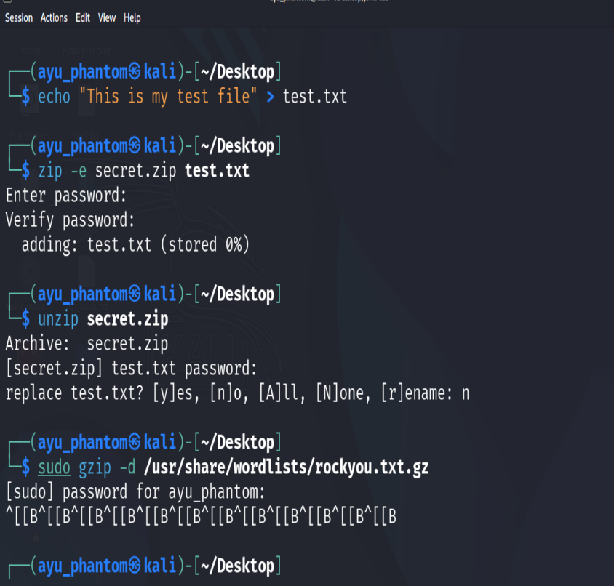
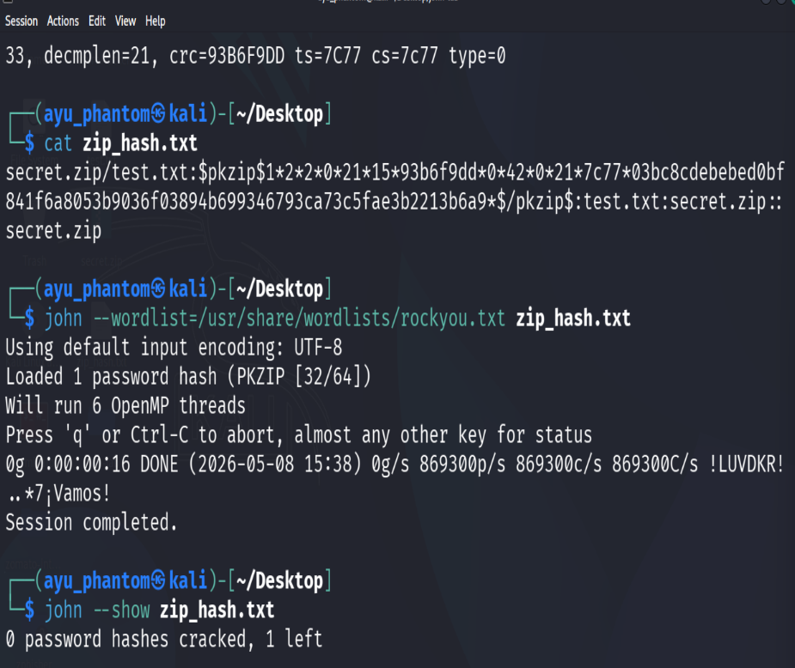
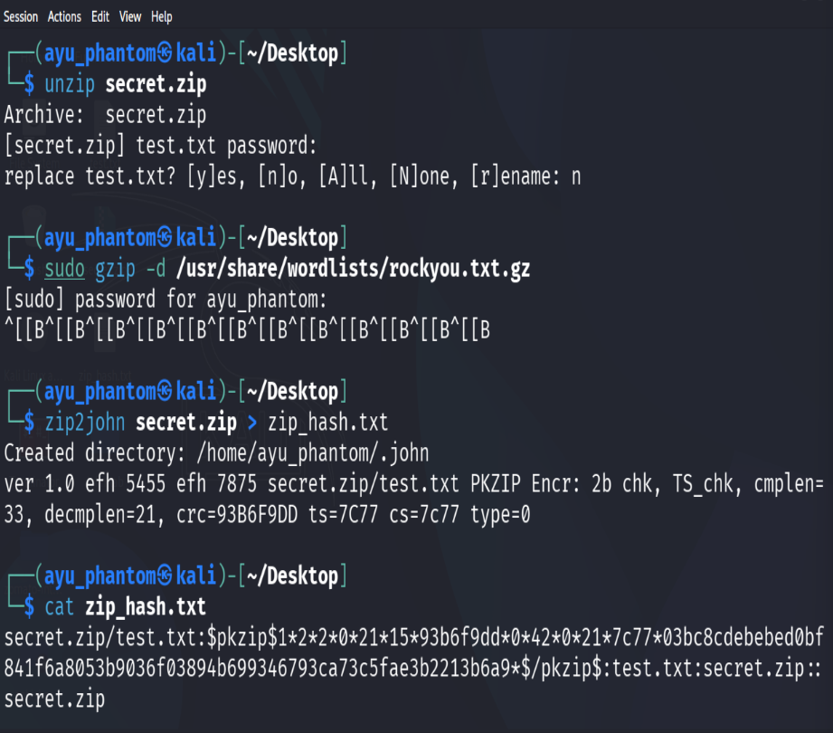
john --show zip_hash.txt
0 password hashes cracked, 1 left

7. Observation
- The ZIP hash was successfully extracted using zip2john.
- John the Ripper successfully loaded the PKZIP hash.
- The password was not cracked because it was not found in the selected wordlist.
- If a weak/common password such as 123456 is used, John may crack it quickly.

8. Result
The password audit process was completed successfully. In this run, no password was cracked because the password was not available in the wordlist.

9. Conclusion
This practical shows that weak passwords can be recovered using dictionary-based password auditing. Strong and unique passwords are important for protecting ZIP/RAR files and sensitive data.

10. Precautions
- Test only your own files or authorized lab files.
- Do not use this method on unauthorized files or systems.
- Use strong passwords that are not present in common wordlists.
- Keep cybersecurity practice ethical and legal.

