# ACTIMEL
Actimel Lte. Ferm. Morango 100g
EAN: 7891025113447
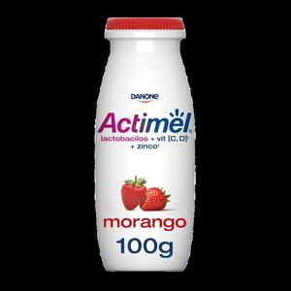

Actimel Lte. Ferm. Tradicional 100g
EAN: 7891025113454
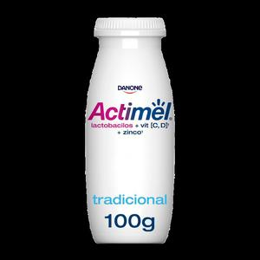

Actimel Lte. Ferment. Morango 600g
EAN: 7891025105220
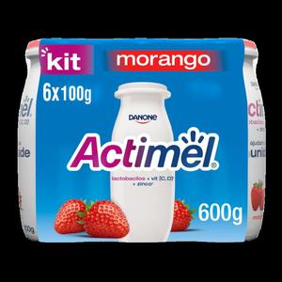

Actimel Lte. Ferment. Tradicional 600g
EAN: 7891025700982
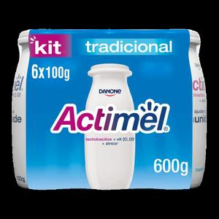

# ACTIVIA
Activia Café da Manhã Amaranto e Ma. 170g
EAN: 7891025117797
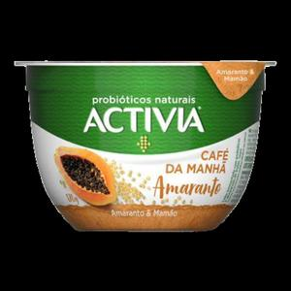

Activia Café da Manhã Lin., Mor. e Ban. 170g
EAN: 7891025117742
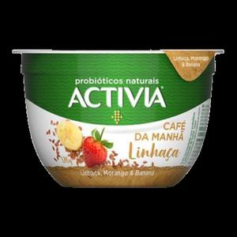

Activia Café da Manhã Quinoa e Fru. Ver. 170g
EAN: 7891025117773
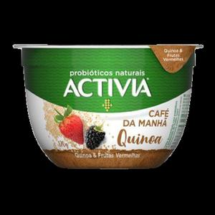

Activia Leite Fermentado X6 450g
EAN: 7891025124320
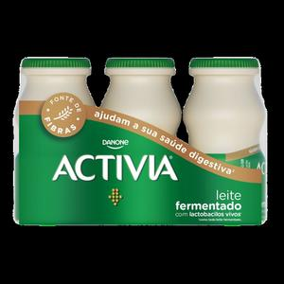

Activia Líquido Ameixa 150g
EAN: 7891025102663
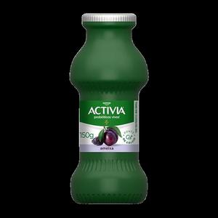

Activia Líquido Ameixa 170g
EAN: 7891025109419
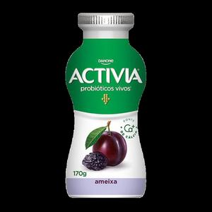

Activia Líquido Ameixa 800g
EAN: 7891025123453
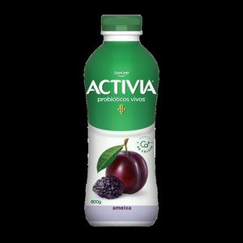

Activia Líquido Aveia 800g
EAN: 7891025123460
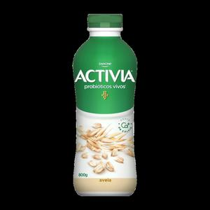

Activia Líquido Morango 150g
EAN: 7891025102656
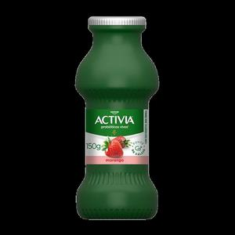

Activia Líquido Morango 170g
EAN: 7891025109396
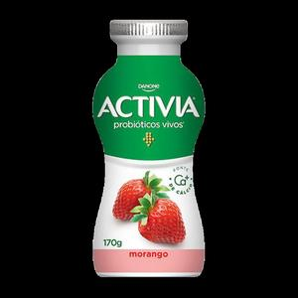

Activia Líquido Morango 1kg
EAN: 7891025112914
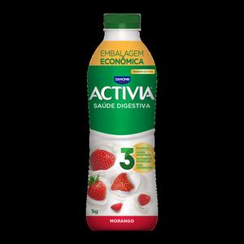

Activia Líquido Morango 800g
EAN: 7891025123477
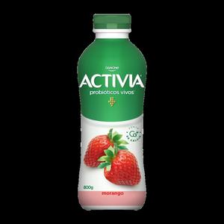

Activia Líquido Vitamina de Frutas 800g
EAN: 7891025123484
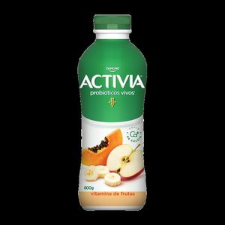

Activia Polpa 340G X4 Ameixa
EAN: 7891025123156
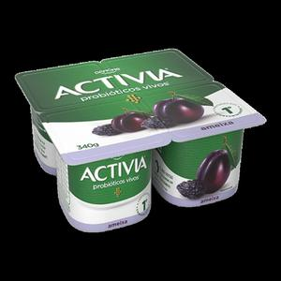

Activia Polpa 340G X4 Morango
EAN: 7891025123163
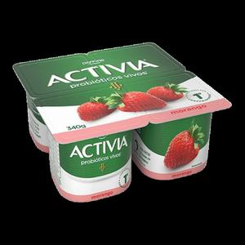

Activia Polpa 510G X6 Ameixa
EAN: 7891025123194
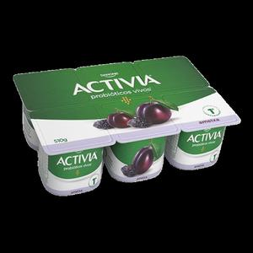

Activia Polpa 510G X6 Mamão E Cereais
EAN: 7891025123217
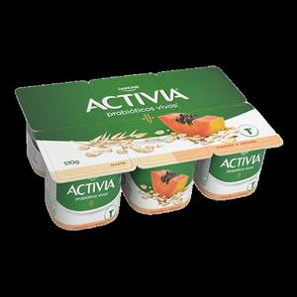

Activia Polpa 510G X6 Morango
EAN: 7891025123200
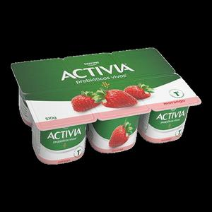

Activia Polpa 510G X6 Zero Ameixa
EAN: 7891025123255
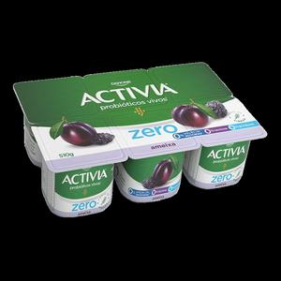

Activia Polpa 510G X6 Zero Morango
EAN: 7891025123828
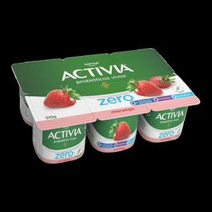

Activia Polpa 680G X8 Ameixa
EAN: 7891025123224
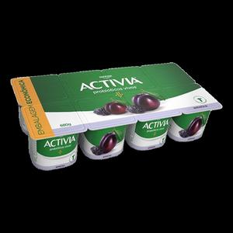

Activia Polpa 680G X8 Mamão E Cereais
EAN: 7891025123248
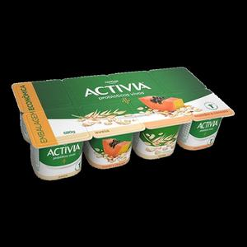

Activia Polpa 680G X8 Morango
EAN: 7891025123231
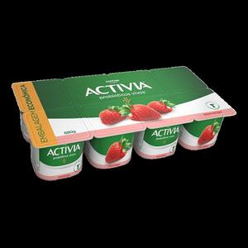

Activia Shot Framb. e Hib. Lf. 100g
EAN: 7891025114666
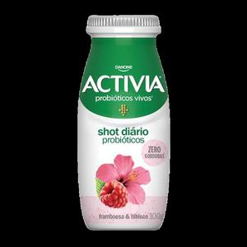

Activia Shot Morango Lf. 100g
EAN: 7891025122432
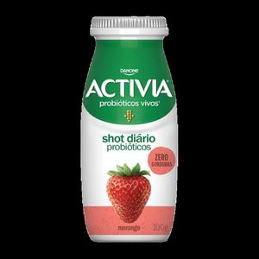

Activia Shot Tradicional Lf. 100g
EAN: 7891025114673
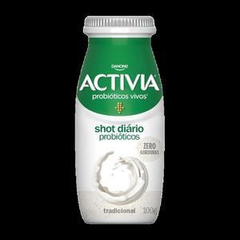

Activia Zero Líquido 800G X1 Frutas Verm
EAN: 7891025125709
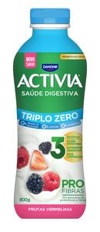

Activia Zero Líquido Ameixa 170g
EAN: 7891025117131
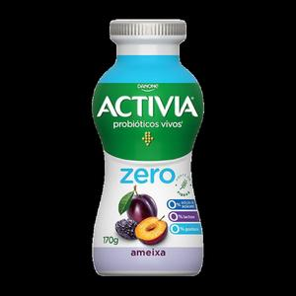

Activia Zero Líquido Ameixa 1kg
EAN: 7891025116608
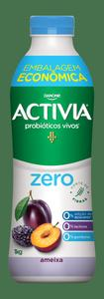

Activia Zero Líquido Ameixa 800g
EAN: 7891025124023
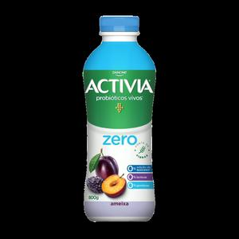

Activia Zero Líquido Morango 170g
EAN: 7891025117162
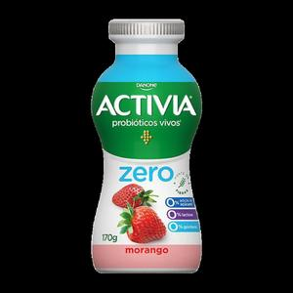

Activia Zero Líquido Morango 1kg
EAN: 7891025116592
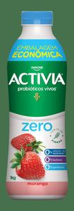

Activia Zero Líquido Morango 800g
EAN: 7891025124030
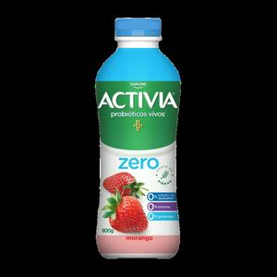

# CORPUS
Corpus Líquido Morango 800g
EAN: 7891025124177
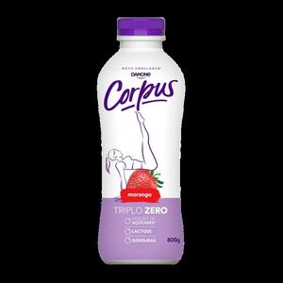

Corpus Líquido Vitamina de Fruta 800g
EAN: 7891025124160
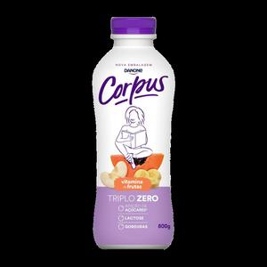

Corpus Líquido sem Lac. Morango 170g
EAN: 7891025114406
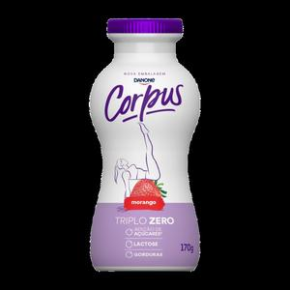

Corpus Polpa Morango 540g
EAN: 7891025120674
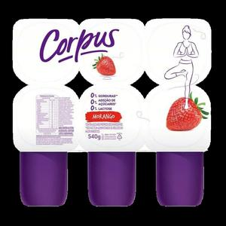

# DANETTE
Danette Choc. Branco 360g
EAN: 7891025200680
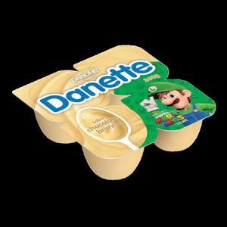

Danette Choc. Branco 540g
EAN: 7891025121602
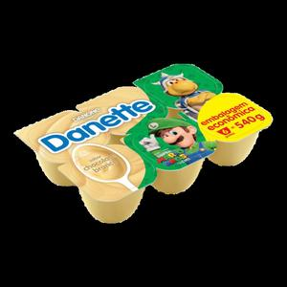

Danette Chocolate 180g
EAN: 7891025110897
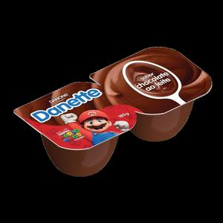

Danette Chocolate 360g
EAN: 7891025201786
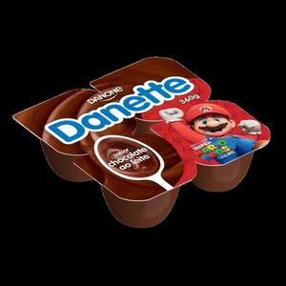

Danette Chocolate 540g
EAN: 7891025121619
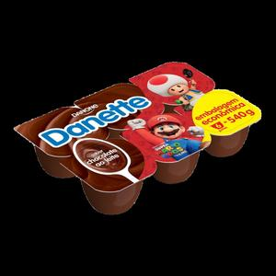

Danette Chocolate 720g
EAN: 7891025105244
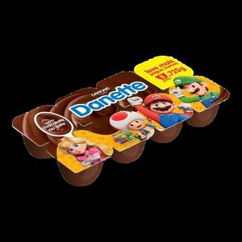

Danette Chocolate Branco 180g
EAN: 7891025124870
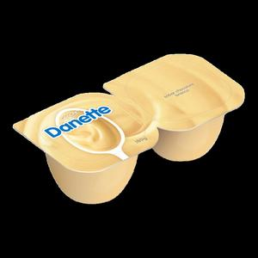

Danette Chocolate Unitário 90g
EAN: 7891025119456
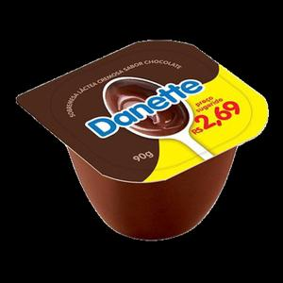

Danette Cremosão Chocolate com Avelã 90g
EAN: 7891025124924
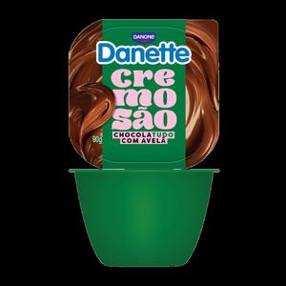

Danette Cremosão Doce de Leite 90g
EAN: 7891025124917
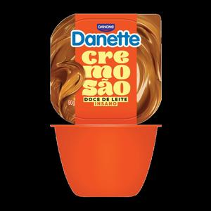

Danette UHT Sabor Chocolate 200Ml
EAN: 7891025119807
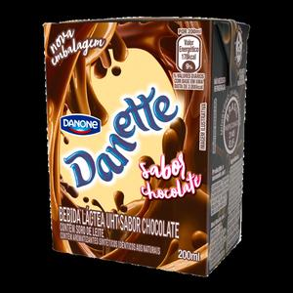

# DANONE
Danone Líquido Banana, Aveia E Mel 170G
EAN: 7891025124856
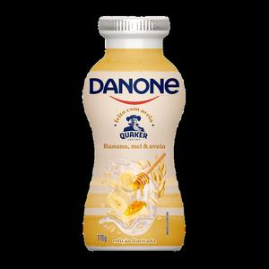

Danone Líquido Banana, Aveia E Mel 800G
EAN: 7891025124450
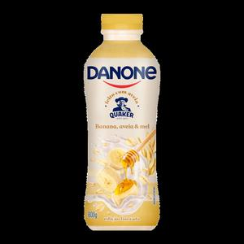

Danone Líquido Coco 1,25kg
EAN: 7891025121909
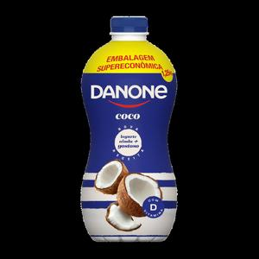

Danone Líquido Morango 1,25kg
EAN: 7891025121923
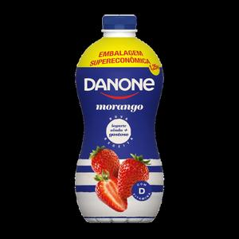

Danone Líquido Morango 170g
EAN: 7891025101376
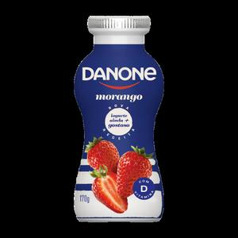

Danone Líquido Morango 850g
EAN: 7891025119869
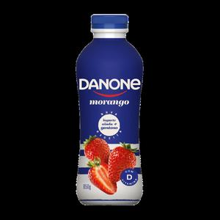

Danone Líquido Morango E Aveia 170G
EAN: 7891025124863
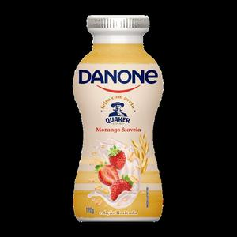

Danone Líquido Morango E Aveia 800G
EAN: 7891025124443
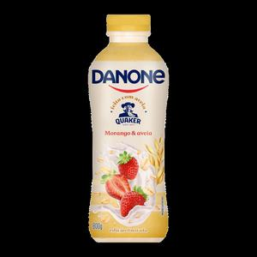

Danone Líquido Original Com Aveia 170G
EAN: 7891025124849
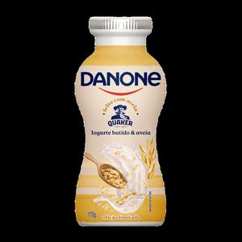

Danone Líquido Original Com Aveia 800G
EAN: 7891025124467
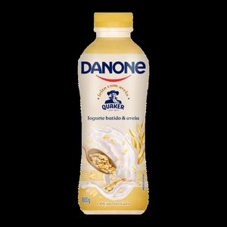

Danone Líquido Vit. de Frutas 170g
EAN: 7891025101161
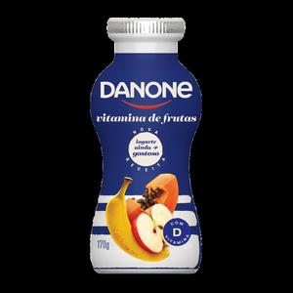

Danone Líquido Vitamina De Frutas 850g
EAN: 7891025119852
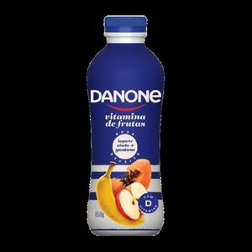

Danone Líquido Vitamina de Frutas 1,25kg
EAN: 7891025121916
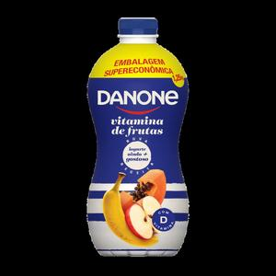

Danone Mais Proteínas Coco 220G
EAN: 7891025124559
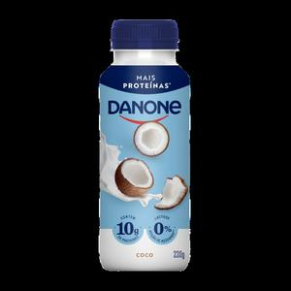

Danone Mais Proteínas Morango 220G
EAN: 7891025124566
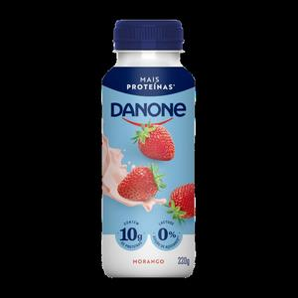

Danone Natural Desnatado 160g
EAN: 7891025120223
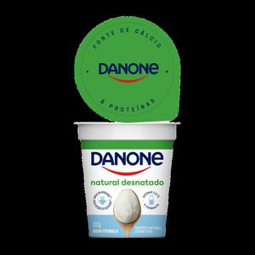

Danone Natural Integral 160g
EAN: 7891025120230
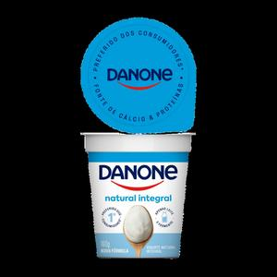

Danone Natural Lar, Cen e Mel 160g
EAN: 7891025121251
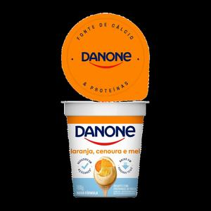

Danone Natural Mel 160g
EAN: 7891025121244
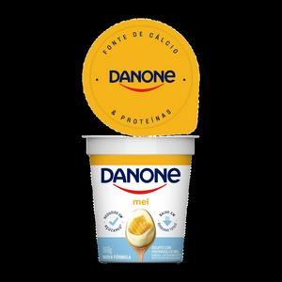

Danone Polpa Mais Proteínas Baunilha 160G
EAN: 7891025124597
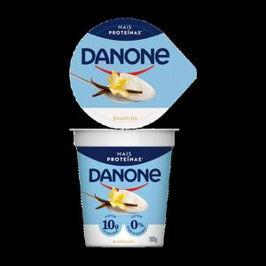

Danone Polpa Mais Proteínas Morango 160G
EAN: 7891025124573
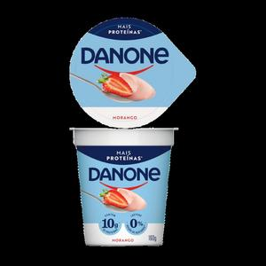

Danone Polpa Mais Proteínas Original 160G
EAN: 7891025124603
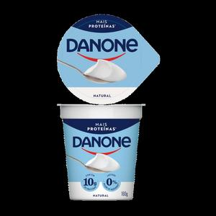

Danone Polpa Mix Frutas 510g
EAN: 7891025121633
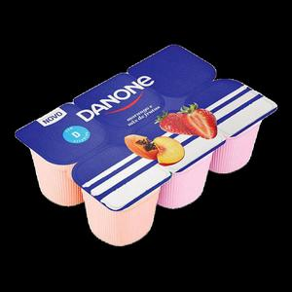

Danone Polpa Morango 510g
EAN: 7891025121626
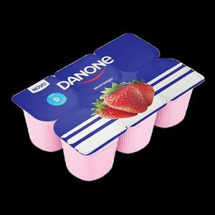

# DANONE GREGO
Danone Grego Ban Light Ori E Mor 510G X6
EAN: 7891025123392
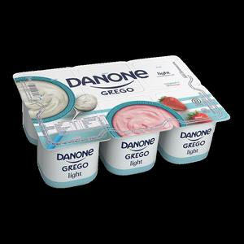

Danone Grego Ban Ori E Frut. Verm 510G
EAN: 7891025123378
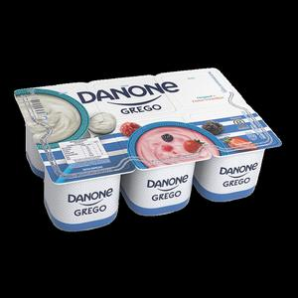

Danone Grego Bandeja Original 340G X4
EAN: 7891025123361
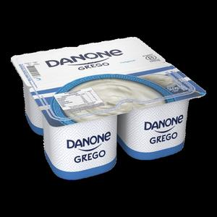

Danone Grego Flocos Pote 90G X1
EAN: 7891025123040
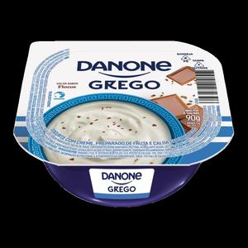

Danone Grego Frutas Vermelhas Pote 90G X1
EAN: 7891025123057
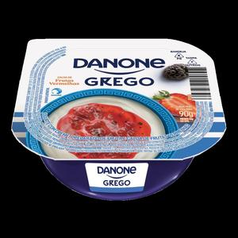

Danone Grego Tradicional Pote 90G X1
EAN: 7891025123064
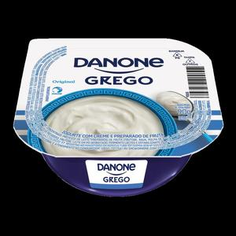

# DANONE KIDS
Danone Kids Líquido Morango 800g
EAN: 7891025124504
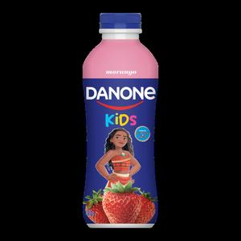

Danone Kids Polpa Morango 510g
EAN: 7891025121640
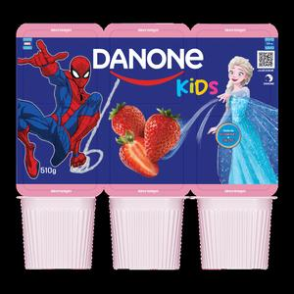

Danone Kids Polpa Multi 510g
EAN: 7891025124436
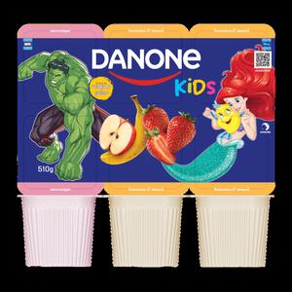

# DANONE ZERO
Danone Zero Líquido 1200G
EAN: 7891025125372
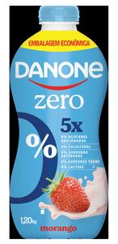

Danone Zero Líquido Batido 1200G
EAN: 7891025125365
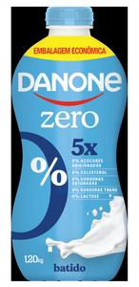

# DANONINHO
Danoninho Bom Dia Banana Com Aveia 70G
EAN: 7891025124535
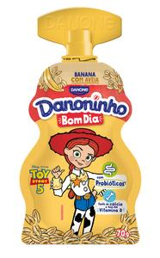

Danoninho Bom Dia Morango Com Aveia 70G
EAN: 7891025124542
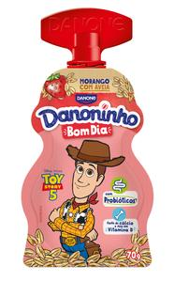

Danoninho Ice Mix Morango 70g
EAN: 7891025122241
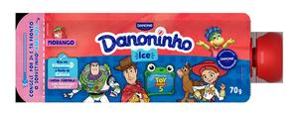

Danoninho Mor. e Ban. Qj. Petit Suisse 480g
EAN: 7891025109938
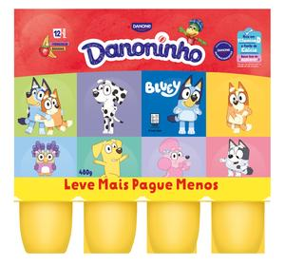

Danoninho Morango 480g
EAN: 7891025109907
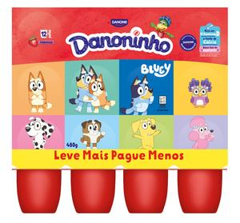

Danoninho Morango Qj. Petit Suisse 320g
EAN: 7891025109891
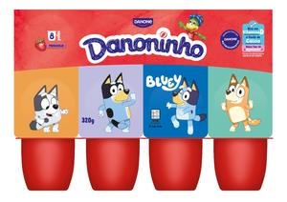

Danoninho Morango Qj. Petit Suisse 80g
EAN: 7891025107392
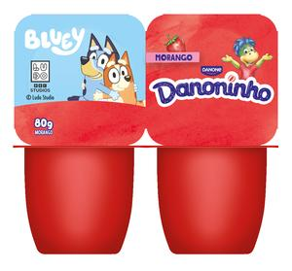

Danoninho Multi Qj Petit Suisse 480g
EAN: 7891025119524
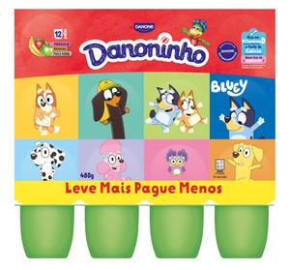

Danoninho Multi Qj. Petit Suisse 320g
EAN: 7891025109884
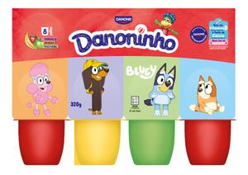

Danoninho Para Beber Banana e Maçã 100g
EAN: 7891025107255
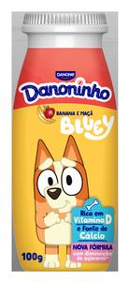

Danoninho Para Beber Morango 100g
EAN: 7891025106067
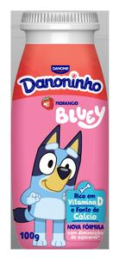

Danoninho Pouch Iogurte Morango 70G
EAN: 7891025125495
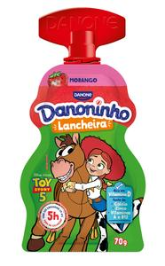

Danoninho Pouch Iogurte Morango E Banana 70G
EAN: 7891025125488
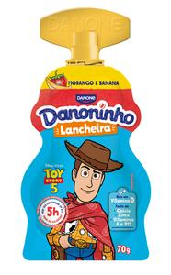

# YOPRO
YoPRO Beb. Láctea UHT 15g Chocolate 250ml
EAN: 7891025115656
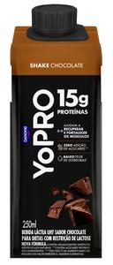

YoPRO Beb. Láctea UHT Coco c/ Bat. Doce 250ml
EAN: 7891025115649
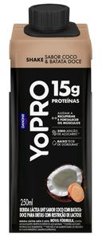

YoPRO Beb. Láctea UHT Morango 250ml
EAN: 7891025122067
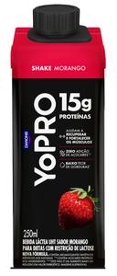

YoPRO Coco Cremoso 160g
EAN: 7891025115335
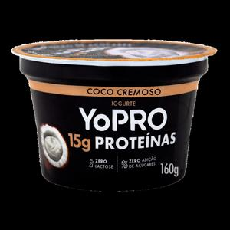

YoPRO Líquido Doce de Leite 250g
EAN: 7891025115588
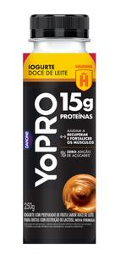

YoPRO Líquido Morango 15G Proteinas 500G
EAN: 7891025124207
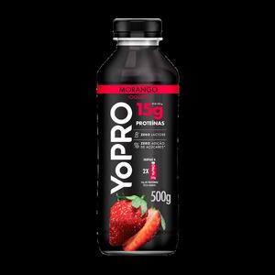

YoPRO Líquido Morango 250g
EAN: 7891025115595
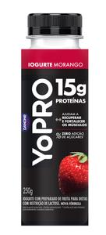

YoPRO Morango 160g
EAN: 7891025115311
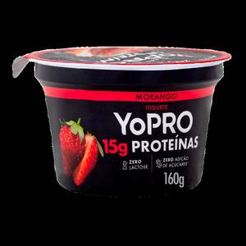

YoPRO Polpa Natural 160g
EAN: 7891025116943
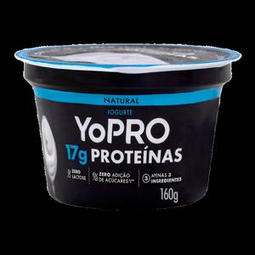

YoPRO Pouch Acaí c/ Banana 160g
EAN: 7891025121442
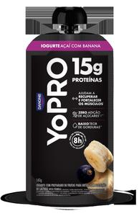

YoPRO Pouch Morango 160g
EAN: 7891025121435
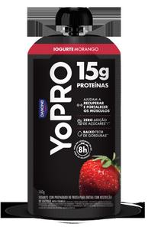

YoPRO UHT 15g Cheese Cake Frut Vermx250ML
EAN: 7891025125501
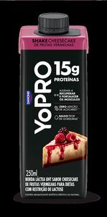

YoPRO UHT 250ml Pack X12 15g Chocolate
EAN: 7891025122043
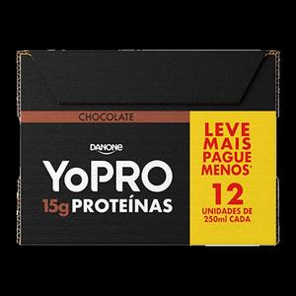

YoPRO UHT 250ml Pack X12 15g Coc/ Bat Doc
EAN: 7891025124221
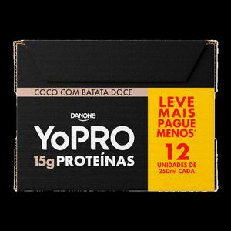

YoPRO UHT 250ml Pack X12 15g Morango
EAN: 7891025124832
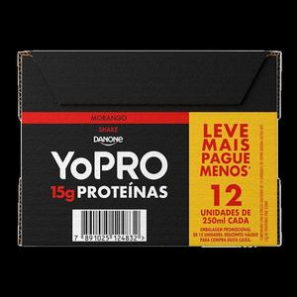

YoPRO UHT Baunilha 15G Proteina 250Ml
EAN: 7891025124627
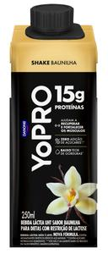

YoPRO UHT Cafe Expresso 15G Proteina 250Ml
EAN: 7891025124269
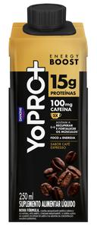

YoPRO UHT Cappuccino 15G Proteina 250Ml
EAN: 7891025124252
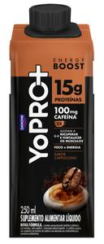

YoPRO UHT Chocolate 23g
EAN: 7891025125167
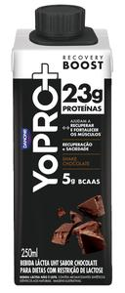

YoPRO UHT Doce De Leite 15G Proteina 250Ml
EAN: 7891025125013
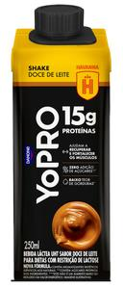

YoPro Liquido 23g Morango 250g
EAN: 7891025125181
