Kyle Parry

Peter Brady

Samuel Jenkins

CSE 687 Object Oriented Design Project

Test Harness – Phase #2

**Architecture**

The architecture of the test harness will consist of three components: Executer, Harness and Logger.

**Executer:** The Executer will be the controller that operates the program and calls and runs the Harness with the tested program. This determines log level and the file location. It also determines the test to be performed.

**Harness:** The Harness is where the functionality will be that will take the callable object and run the tests to be performed and then return a true or false if the function is operating appropriately. The Harness will have a Logger that will log the results of the tests against the tested program. It passes along the log level and file string to the logger. It also sends the message and level 2 log for that individual message.

**Logger:** The logger is the functionality of the Test Harness that will log the results back to the Harness and the Executor to log to the user what the results of the tested program are. The logger then sends all the information to the output file and the location.

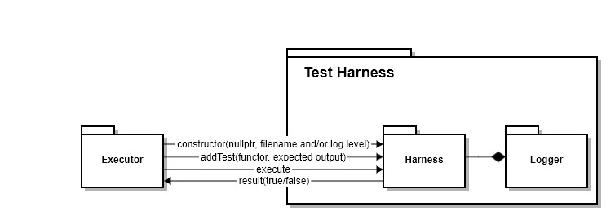

**Design**

The design of the program is that it will consist of three classes: Executer, Harness, and Logger. Each of these classes will have the given member variables and methods as shown in the UML diagram below.

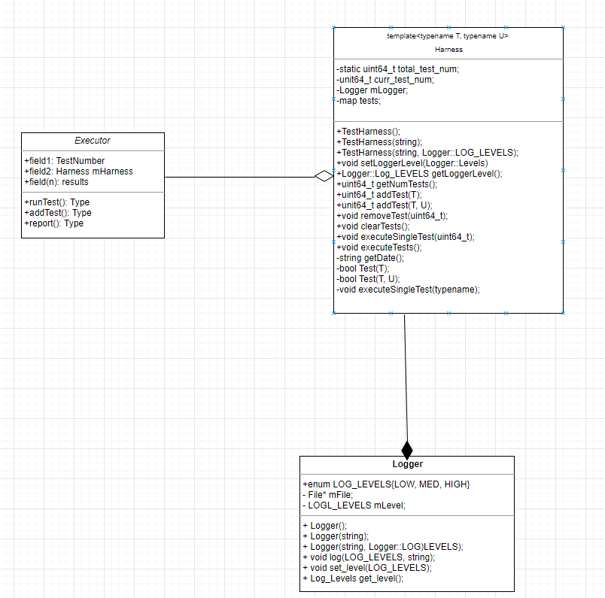

**Contributions:**

* **Kyle –** Designed and implemented the Logger
* **Samuel –** designed the iTests and our executor (main)
* **Peter –** Designed and implemented the Test Harness