Cost_Analysis_Report

P. Brandicourt

April 28, 2016

Cost Risk Analysis Report

# Cost Distribution

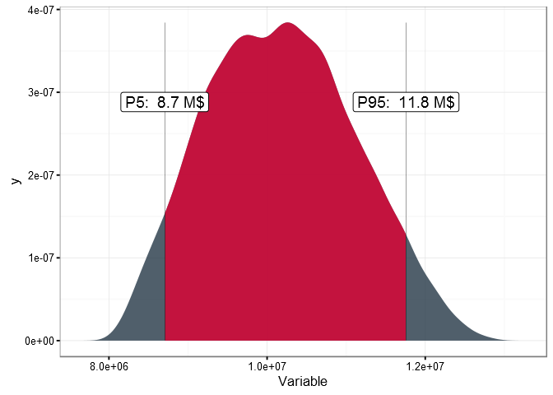

# Percentiles (Total)

|  |  |  |
| --- | --- | --- |
| Percentiles | Value | Deviation |
| P10 | 8.97 M$ | -10.28 % |
| P20 | 9.32 M$ | -6.76 % |
| P30 | 9.62 M$ | -3.84 % |
| P40 | 9.88 M$ | -1.16 % |
| P50 | 10.16 M$ | 1.61 % |
| P60 | 10.42 M$ | 4.16 % |
| P70 | 10.69 M$ | 6.91 % |
| P80 | 11.01 M$ | 10.09 % |
| P90 | 11.43 M$ | 14.34 % |
| P100 | 12.86 M$ | 28.56 % |

# Statistics (Total)

|  |  |  |
| --- | --- | --- |
| Percentiles | Value | Deviation |
| Mean | 10.18 M$ | 1.79 % |
| Median | 10.16 M$ | 1.61 % |
| Std Dev | 0.93 M$ | NA |