2021/05/02

COSE361(03)-Assignment #2

Pacman algorithm

화공생명공학과

2015170063

오원석

Submission

1. Submit multiagent.py and on Blackboard.

- 별도로 첨부하여 제출하였습니다.

2. Submit a pdf file containg:

1. Capture the result of autograder.py in terminal(4/5/5/ points for Q1/Q2/Q3. Total 14 points). (Note: Although you implement Question 1~3 in multiagent.py and get full grades with autograder.py, you will get 0 score without the capture on pdf.)

2. Three discussions when playing Pacman (2Points for each discussion. Total 6 points.)

• How can alpha-beta pruning make it more efficient to explore the minimax tree?

• Is there a situation where the Reflex agent performs better than the minimax or alpha-beta pruning algorithm?

• Ask yourself one question and answer.

1. Capture the result of multiagent.py in terminal

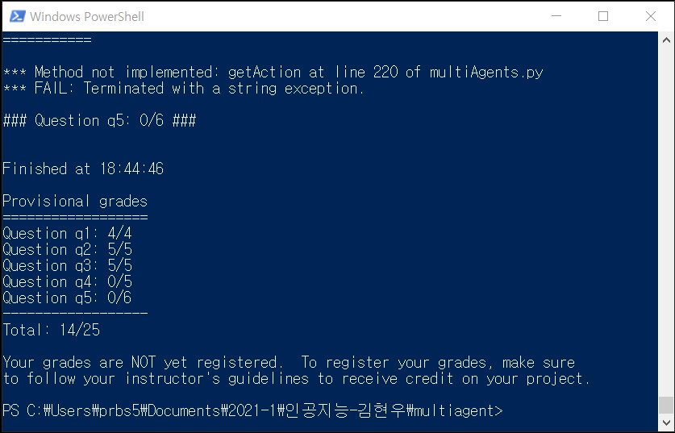

2. Three discussions when playing Pacman (2Points for each discussion. Total 6 points.)

• How can alpha-beta pruning make it more efficient to explore the minimax tree?

Alpha-beta pruning can have the effect of reducing the branching of the minimax tree. In the general case of a minimax tree, this is repeated alternatively where the min value is returned and the max value is returned for each depth, which proceeds to a zero-sum game. Here comes the role of alpha-beta pruning. When a value is determined at a certain stage in determining the Min or Max value, the min or max value above is determined without checking the nodes of the next depth in the process of cutting without looking at the branch is called pruning.  
Let's check Alpha-beta running in Pacman game.  
Minimax tree is implemented in code using a recursive function. Alpha-beta pruning used two functions in this minimax tree: alpha value for Pacman and beta value for Ghost. This recursively calls alpha_value and beta_value for pacman and ghosts. Each leaf node returns an evaluation score. If returned as a minimum node, the beta value will be updated if the value returned is small, and if returned as a maximum node, the alpha value will be updated if the value returned is large. As soon as alpha rises above beta, we stop and remove certain subtrees. This enables faster and more efficient movement of minimax trees.

• Is there a situation where the Reflex agent performs better than the minimax or alpha-beta pruning algorithm?

The reflex agent function returns the score based on the distance from Pacman's ghost and the distance from food. The higher the distance the lower the score the lower the distance the higher score is displayed. Distance from ghost returns a negative value. Therefore the smaller the distance from the ghost the higher the value comes out. Therefore, we calculate the reciprocal of distance from ghosts.  
In other words, assuming that the distance from the ghost is a maze is much smaller then common cases, the minimax or alpha-beta running algorithm may have an advantage. If you check the testcase, it is as follows.

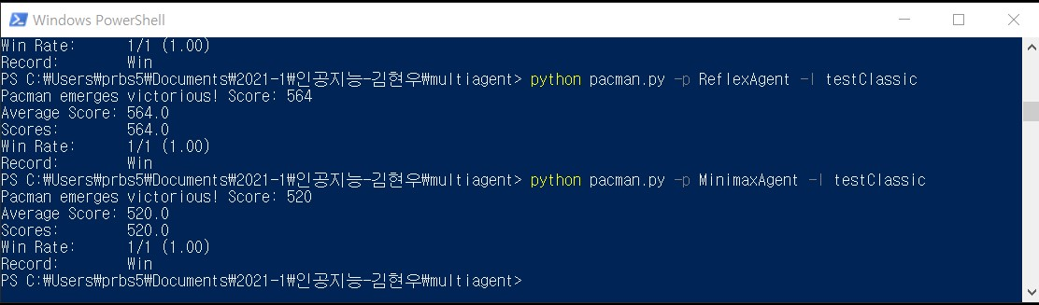

→ Score of Reflex agent function is higher than the minimax or alpha-beta pruning algorithm.



→ Spy shot

• Ask yourself one question and answer.

Question : Different between Minimax and Expectimax in Pacman game.

In question 1, I went over the minimax example. Here, minimax changed 2 or more nodes from the leaf node to min or max values. However, expectimax sent up the greatest from the average value of the nodes. When implemented in pacman, this would create 2 scenarios depending on the ghost: gaining time benefit or not. Time-wise, with expectimax, the probability of eluding the ghost would be higher with an adversarial ghost and conversely with a random ghost, it would take more time.