What I learned during Journey?

1. First, I create a C program and push to github and download locally in different location.
While I try to run that pre-compiled file I got error called "Permission Denied".
Why I got this error?
==> Due to safety [not explaining details in technical terms just understand].
How to solve?
Run command to give executable permission by:
chmod +x [name of compiled file]
chmod = change mode, +x = executable permission

2.

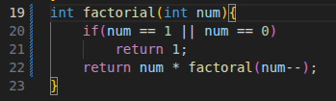
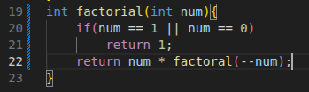

fig(i) fig(ii)

fig(i) → prefix decrement: this will decrease the original num also-existing in same line. So, this will give us output of factorial of num-1 or sometimes correct depending upon compiler.

fig(ii) → postfix decrement: this will parse the num as it is without decreasing. After parsing it will decrease which will cause infinite call of factorial function further it leads to stack overflow.

