**ST. XAVIER’S COLLEGE**

(AFFILIATED TO TRIBHUVAN UNIVERSITY)

MAITIGHAR, KATHMANDU



**ARTIFICIAL INTELLIGENCE ASSIGNMENT #3**

**SUBMITTED BY:**

Pradeep Dahal

4th sem/ 2nd year

017BSCIT029

**SUBMITTED TO:**

|  |  |  |
| --- | --- | --- |
|  | Signature | Remarks |
| Mr. Bal Krishna Subedi  Lecturer, Dept. of Computer Science |  |  |

**Define data model. Why do we need data model?**

Data Models are fundamental entities to introduce abstraction in a DBMS. A Database model defines the logical design and structure of a database and defines how data will be stored, accessed and updated, how data is connected to each other in a database management system. While the Relational Model is the most widely used database model, there are other models too:

* Hierarchical Model
* Network Model
* Entity-relationship Model
* Relational Model

Data Model has proven to be of great importance in various ways because of its advantages in today’s time due to which it is used. Some of the reasons for the need of data model are given below:

**1. Higher quality**

Just as architects consider blueprints before constructing a building, you should consider data before building an app. On average, about 70 percent of software development efforts fail, and a major source of failure is premature coding. A data model helps define the problem, enabling you to consider different approaches and choose the best one.

**2. Reduced cost**

You can build applications at lower cost via data models. Data modeling typically consumes less than 10 percent of a project budget, and can reduce the 70 percent of budget that is typically devoted to programming.

**3. Quicker time to market**

You can also build software faster by catching errors early. In addition, a data model can automate some tasks – design tools can take a model as an input and generate the initial database structure, as well as some data access code.

**4. Clearer scope**

A data model provides a focus for determining scope. It provides something tangible to help business sponsors and developers agree over precisely what is included with the software and what is omitted. Business staff can see what the developers are building and compare it with their understanding. The resulting software becomes easier to maintain and extend.

**5. Faster performance**

A sound model simplifies database tuning. A well-constructed database typically runs fast, often quicker than expected. To achieve optimal performance, the concepts in a data model must be crisp and coherent. Then the proper rules must be used for translating the model into a database design.

**6. Better documentation**

Models document important concepts and jargon, proving a basis for long-term maintenance. The documentation will serve you well through staff turnover. Today, most application vendors can provide a data model of their application upon request. That is because the IT industry recognizes that models are effective at conveying important abstractions and ideas in a concise and understandable manner.

**7. Fewer application errors**

A data model causes participants to crisply define concepts and resolve confusion. As a result, application development starts with a clear vision. Developers can still make detailed errors as they write application code, but they are less likely to make deep errors that are difficult to resolve.

**8. Fewer data errors**

Data errors are worse than application errors. It is one thing to have an application crash, necessitating a restart. It is another thing to corrupt data in a large database.A data model not only improves the conceptual quality of an application, it also lets you leverage database features that improve data quality. Developers can weave constraints into the fabric of a model and the resulting database.

**9. Managed risk**

You can use a data model to estimate the complexity of software, and gain insight into the level of development effort and project risk. You should consider the size of a model, as well as the intensity of inter-table connections.

**10. A good start for data mining**

The documentation inherent in a model serves as a starting point for analytical data mining. You can take day-to-day business data and load it into a dedicated database, known as a “data warehouse.” Data warehouses are constructed specifically for the purpose of data analysis, leveraging that data from routine operations.

### 

**Explain the characteristics of DBMS.**

### Stores any kind of data

A database management system should be able to store any kind of data. It should not be restricted to the employee name, salary and address. Any kind of data that exists in the real world can be stored in DBMS because we need to work with all kinds of data that is present around us.

### Support ACID Properties

[Any DBMS is able to support ACID (Accuracy, Completeness, Isolation, and Durability) properties. It is made sure is every DBMS that the real purpose of data should not be lost while performing transactions like delete, insert an update. Let us take an example; if an employee name is updated then it should make sure that there is no duplicate data and no mismatch of student information.](http://whatisdbms.com/what-is-a-database/)

### [Represents complex relationship between data](http://whatisdbms.com/what-is-a-database/)

Data stored in a database is connected with each other and a relationship is made in between data. DBMS should be able to represent the complex relationship between data to make the efficient and accurate use of data.

### Backup and recovery

There are many chances of failure of whole database. At that time no one will be able to get the database back and for sure company will be in a big loss. The only solution is to take backup of database and whenever it is needed, it can be stored back. All the databases must have this characteristic.

### Structures and described data

A database should not contains only the data but also all the structures and definitions of the data. This data represent itself that what actions should be taken on it. These descriptions include the structure, types and format of data and relationship between them.

### Data integrity

This is one of the most important characteristics of database management system. Integrity ensures the quality and reliability of database system. It protects the unauthorized access of database and makes it more secure. It brings only the consistent and accurate data into the database.

### 

### Concurrent use of database

There are many chances that many users will be accessing the data at the same time. They may require altering the database system concurrently. At that time, DBMS supports them to concurrently use the database without any problem.

**What you understand by three schema architecture? What is the significance of it?**

The three schema architecture is also called ANSI/SPARC architecture or three-level architecture.This framework is used to describe the structure of a specific database system.The three schema architecture is also used to separate the user applications and physical database.The three schema architecture contains three-levels. It breaks the database down into three different categories.

**The three-schema architecture is as follows:**

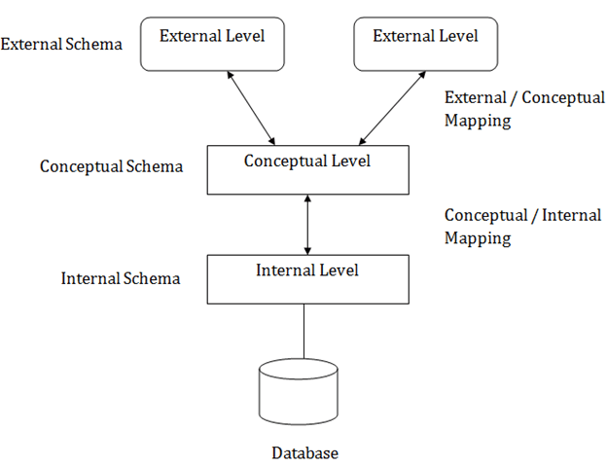

**In the above diagram:**

It shows the DBMS architecture. Mapping is used to transform the request and response between various database levels of architecture. Mapping is not good for small DBMS because it takes more time. In External / Conceptual mapping, it is necessary to transform the request from external level to conceptual schema. In Conceptual / Internal mapping, DBMS transform the request from the conceptual to internal level.

### 1. Internal Level

* The internal level has an internal schema which describes the physical storage structure of the database.
* The internal schema is also known as a physical schema.
* It uses the physical data model. It is used to define that how the data will be stored in a block.
* The physical level is used to describe complex low-level data structures in detail.

### 2. Conceptual Level

* The conceptual schema describes the design of a database at the conceptual level. Conceptual level is also known as logical level.
* The conceptual schema describes the structure of the whole database.
* The conceptual level describes what data are to be stored in the database and also describes what relationship exists among those data.
* In the conceptual level, internal details such as an implementation of the data structure are hidden.
* Programmers and database administrators work at this level.

### 3. External Level

### At the external level, a database contains several schemas that sometimes called as subschema. The subschema is used to describe the different view of the database.

* An external schema is also known as view schema.
* Each view schema describes the database part that a particular user group is interested and hides the remaining database from that user group.
* The view schema describes the end user interaction with database systems.