ST.XAVIER’S COLLEGE

(Affiliated to Tribhuvan University)

Maitighar, Kathmandu



**Cryptography Lab Assignment #2**

**SUBMITTED BY:**

Pradeep Dahal

017BSCIT029

3rd Year/5th Sem

|  |  |
| --- | --- |
| **SUBMITTED TO:** |  |

|  |  |  |
| --- | --- | --- |
|  | **Signature** | **Remarks** |
| **Er. Anil Kumar Shah**  **Lecturer, Dept. of Computer Science** |  |  |

**TITLE: WRITE A PROGRAM TO ENCRYPT AND DECRYPT A MESSAGE USING MONOALPHABETIC CIPHER**

**ALGORITHM**

**Theory**

Monoalphabetic cipher is a substitution cipher in which for a given key, the cipher alphabet for each plain alphabet is fixed throughout the encryption process.[1]

**Procedure**

1. Input the data to be encrypted or decrypted.
2. Iterate through all the characters in the string.
   1. Add/subtract the randomly generated value to the ASCII of the character and mod 26 for encryption/decryption.
3. Join and return the encrypted/decrypted string.

**SOURCE CODE**

**import sys**

**from random import randint**

**def encrypt(x,key):**

**s=[]**

**for i in x:**

**if(ord(i)>64 and ord(i)<91):**

**temp=(((ord(i)-65)+key)%26)+65**

**s.append(chr(temp))**

**elif(ord(i)>96 and ord(i)<123):**

**temp=(((ord(i)-97)+key)%26)+97**

**s.append(chr(temp))**

**elif(ord(i)==32):**

**s.append(i)**

**else:**

**input("Invalid character program terminating. Enter any key to exit")**

**sys.exit()**

**encrypted_text=(''.join(s))**

**return encrypted_text**

**def decrypt(x,key):**

**s=[]**

**for i in x:**

**if(ord(i)>64 and ord(i)<91):**

**temp=(((ord(i)-65)-key)%26)+65**

**s.append(chr(temp))**

**elif(ord(i)>96 and ord(i)<123):**

**temp=(((ord(i)-97)-key)%26)+97**

**s.append(chr(temp))**

**elif(ord(i)==32):**

**s.append(i)**

**else:**

**print("Invalid character program terminating. Enter any key to exit")**

**sys.exit()**

**encrypted_text=(''.join(s))**

**return encrypted_text**

**key=randint(1,250)**

**data=input("Input the data:: Only A-Z and a-z::")**

**encData=encrypt(data,key)**

**print("The encrypted data is:")**

**print(encData)**

**decData=decrypt(encData,key)**

**print("The decrypted data is")**

**print(decData)**

**OBSERVATION**

**Observation 1**

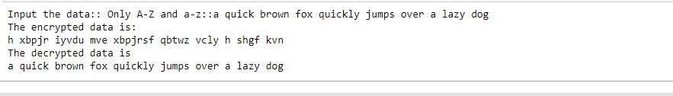

**Observation 2**

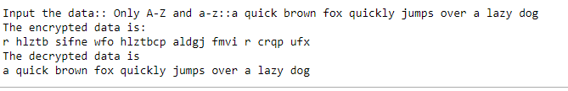

**CONCLUSION**

Thus, Monoalphabetic Cipher was implemented in the python programming language.

**REFERENCE**

[1] “Traditional Ciphers - Tutorialspoint.” [Online]. Available: https://www.tutorialspoint.com/cryptography/traditional_ciphers.htm. [Accessed: 13-Nov-2019].