Automated Retinal Disease Classification from OCT Images Using a Lightweight CNN–SE Architecture

Parth R. Dave¹., Nikunj H. Domadiya²

¹ Research Scholar, Gujarat Technological University, Ahmedabad, Gujarat, India
^{1,2} Assistant Professor, Computer Engineering Department, L. D. College of Engineering, Ahmedabad, Gujarat, India
Corresponding author: Nikunj H. Domadiya (e-mail: domadiyanikunj002@gmail.com), Author(s) Email: Parth R. Dave (e-mail: prd7889@gmail.com)
Abstract In recent times Artificial Intelligence is playing the important role in many fields of medical science. Ophthalmology is a field of medical science in which the disease related to front and back end of the eye is measured and according to that the treatment is provided. The backend of the eye is called retina which is responsible to send the electromagnetic signals to the brain through optic nerve system. Optical Coherence Tomography (OCT) is an imaging method that allows retina specialists to examine the internal structure of the eye in detail. This method contributes to the accurate identification of different retinal disorders: Age-Related Macular Degeneration (AMD), Central Serous Retinopathy (CSR), Macular Hole (MH), Diabetic Retinopathy (DR), Drusen, Diabetic Macular Edema (DME) and Choroidal Neovascularization (CNV). However, manual analysis of OCT images is really time-consuming and subjective according to the domain knowledge of the specialist. Applying deep learning for the automatic classification of retinal diseases from OCT images is valuable for achieving timely, reliable, and early-stage detection of the anomalies. On the top of it many anomalies are having feature overlapping conditions which have to be addressed in detail. To improve the current diagnostic process, this study presents a lightweight CNN-based model for the automated classification of retinal OCT images. The present study develops a computationally efficient model that provides high diagnostic accuracy without the use of complex architectures or transfer learning techniques. In this study, we propose an effective thirteen-layer Convolutional Neural Network (CNN) incorporating Squeeze-and-Excitation (SE) blocks, along with data augmentation and the Adam optimizer. The proposed framework was trained and assessed on OCT-C8 and OCT2017 dataset, which comprises the seven and three classes of abnormalities consecutively and one class as a normal retinal structure in both the datasets. Our proposed approach achieved 97.00% and 99.00% of accuracy while testing on the OCT-C8 and OCT2017 datasets consecutively. The proposed CNN-SE model is a generalized model which achieves faster and accurate inference through a lightweight design.
Keywords Convolutional Neural Network; Artificial Intelligence; Machine Learning; Deep Learning; Optical Coherence Tomography
- Introduction
Optical Coherence Tomography (OCT) is a valuable imaging technique used for the early detection of retinal diseases. It generates high-resolution tomographic images of retinal tissue that enables accurate detection of structural abnormalities within the retina part and macula part. Retinal diseases sometimes may result into irreversible vision loss and therefor the early detection of the abnormalities is essential. Retinal OCT imaging is widely used in ophthalmology to assist in treatment planning and to monitor the success of treatments such as laser therapy, eye injections, and surgical interventions. There are several factors that can lead to retinal disorders, such as genetic defects, stress, aging, lack of physical activity, excessive screen exposure, and unhealthy eating habits. As a result, retinal diseases are becoming more common, making it essential to carry out fast, precise, and consistent evaluations. Automated retinal OCT image classification techniques can be helpful as a suggestive system to the doctors which provide impartial, reliable and diagnostic consistencies for pointing out the abnormalities.
Conventional machine learning algorithms use texture-based detailing retrieved from images to represent local or global information. Various feature extraction techniques such as Local Binary Pattern (LBP) [1], Histogram of Oriented Gradients (HOG) [2], Gray-Level Co-Occurrence Matrix (GLCM) [3], edge detection, and shape detection are applied to obtain a discriminative feature vector. The extracted feature representation is then fed into supervised learning classifiers, including Artificial Neural Networks (ANN) and Support Vector Machines (SVM) [4], or other classifiers to perform the final image classification. However, one major limitation of classical machine learning approaches is that they depend on manually extracted features instead of learning the features directly from the data. Since the image representation relies only on predefined feature descriptors, some important information from the original image may be lost during the feature extraction process. This loss of information can affect how well the model understands the data and may lead to lower accuracy and reduced overall performance of the classification system.
In recent years, advanced computational techniques have gained significant attention in the field of computer vision, as it can automatically extract complex patterns and important features from input images without requiring manual feature engineering. Convolutional Neural Networks (CNNs), in particular, have significantly changed the way image-related tasks are approached which is actually outperforming various traditional and shallow learning methods in several aspects. Deep learning is not confined to image classification; it has also been effectively utilized in visual recognition, medical imaging, multimedia analysis, audio understanding, and text processing. These diverse applications emphasize its flexibility and growing importance across the various real-world applications.
CNNs learn important spatial characteristics and structural relationships in input images by employing successive convolutional and pooling layers. As the data passes through these consecutive layers, increasingly relevant features are extracted and subsequently forwarded to the dense layers where the ultimate classification decision is generated. The fully connected part may consist of multiple hidden units just before reaching to the final output stage. The last layer consists of output nodes representing the different categories defined in the dataset for classification which is enabling the model to accurately assign the input sample to its corresponding category. Appropriate activation functions, model parameters, and hyperparameters are chosen to enhance the learning performance of the network and enhance its generalization capability and robustness on unseen test dataset. In addition to that several techniques are employed to manage problems such as underfitting and overfitting. These methods enable the model to learn efficiently from the training data while ensuring consistent performance when testified on the test dataset.
In past few years, computer vision has witnessed remarkable growth, supported by the emergence of several pre-trained models capable of extracting meaningful information from complex visual data, including NASNetMobile [5], AlexNet [6], VGG16 [7], VGG19[7], ResNet50[8], and GoogLeNet [9], transformer models and lightweight models. These architectures are trained on large and diverse image databases, which helps them learn diverse visual features and patterns. Owing to the rich feature representations acquired during training, these models can be effectively applied to extract features from new image datasets. This is commonly done by removing the final fully connected layer(s) and using the remaining layers of the network to obtain meaningful and detailed features from the input images. The remainder of this manuscript is structured into five sections. Section II reviews the existing literature, while Section III describes the proposed methodology. Section IV presents the experimental setup and discusses the obtained results. Finally, Section V concludes the study and outlines potential directions for future research.

Related Work
Automated OCT image analysis plays a crucial role as a suggestive system between patient and a doctor to identify the anomalies in a grater detailed manner. Many efforts have been carried out over the years to achieve this by applying conventional and contemporary machine learning algorithms with various techniques.
P. P. Srinivasan et al. [10] performed several preparation steps on retinal OCT images, including reducing noise, adjusting the retinal shape, and cropping the images to focus on important areas. After this, features were derived using Histogram of Oriented Gradients (HOG) descriptors [2]. The descriptor vectors for each block were normalized using a small constant, after which the values were capped and normalized again to maintain stability. The normalized histograms obtained from each image block were combined to construct the final feature vector. For multi-class classification, a Support Vector Machine (SVM) classifier [4] was used with a one-versus-one strategy, resulting in three linear SVM classifiers corresponding to the three dataset classes: Age-related Macular Degeneration (AMD), Diabetic Macular Edema (DME), and Normal. The retinal image dataset used in the study was locally developed using OCT images collected from patients with different retinal disorders.
Y.-Y. Liu et al. [11] presented a traditional machine learning approach for detecting macular disorders in retinal OCT images. Their method began with image registration and then focused on the capturing of both broad and detailed features. The overall information was represented using a multi-resolution spatial framework [12], while the finer patterns were described using a PCA-based reduced Local Binary Pattern (LBP) histogram [1]. An SVM classifier was then used to classify the images into macular hole (MH), macular edema (ME), and age-related macular degeneration (AMD) using a locally prepared dataset.
Alsaih K et al. [13] designed another standard method through extracting relevant image characteristics such as Histogram of Oriented Gradients (HOG) [2] and Local Binary Patterns (LBP) [1]. To simplify the feature space, Principal Component Analysis (PCA) was employed to transform the original feature space into a compact lower-dimensional representation while pertaining the most relevant information. The refined set of features was then used for classification with a Support Vector Machine (SVM) [4], and the evaluation was carried out on a dataset collected locally.
On the other hand, several advanced techniques have been proposed for the classification of retinal OCT images. L. Huang et al[14]. put forward a layer-based convolutional neural network for this task. In their work, separate networks were used to learn information from different retinal layers, and these learned features were then brought together and fed into a final model for classification. By focusing on retinal layer–specific features and applying a transfer learning strategy, their approach showed improved results on the OCT2017 [15] and HUCM [14] OCT image datasets, which include four categories: DME, Drusen, CNV, and Normal.
J. Kim and L. Tran [16] formulated a deep learning–based approach that utilized two binary classification models. Before performing the final classification, the input images were subjected to a series of preprocessing steps. This included isolating the region of interest using a U-Net model and adjusting the image orientation based on histogram analysis which actually allows more detailed features to be captured from the OCT2017 [15] dataset. Their method produced better accuracy when compared with the approach reported by L. Huang et al. [14].
Shengyong Diao et al. [17] introduced deep learning–based models to classify age-related macular degeneration (AMD) using retinal OCT images. The framework incorporates two newly developed models, referred to as CM-CNN and CAM-UNet. CM-CNN improves the classification step by making use of region extraction, while CAM-UNet strengthens the region extraction process by incorporating class attention maps. The proposed method gained promising results for the intended classification task.
Hassan E. et al. [18] developed a combined learning strategy that merges neural computation techniques and standard machine learning algorithms to perform automatic classification of retinal OCT scans, using the OCT2017 dataset [15]. In their Enhanced Optical Coherence Tomography (EOCT) model, ResNet-50 [8] is used to learn meaningful features from the images, which are then passed to a Random Forest classifier for decision making. At the time of training, both SGD and Adam optimization algorithms are incorporated to enhance the training process. The implemented framework attained state-of-the-art classification performance.
In [19], authors introduced a model called OCTx to classify retinal OCT images into four categories: Normal retina, Drusen, Choroidal Neovascularization (CNV), and Diabetic Macular Edema (DME). The model is based on an improved ensemble framework that integrates multiple deep learning methods to enhance classification performance. Although the model demonstrated strong performance, its validation using a limited dataset may impact its ability to generalize to larger and more diverse clinical populations.
In [20], the researchers developed a CNN-based model to classify retinal OCT images into three classes: Age-related Macular Degeneration (AMD), Diabetic Macular Edema (DME), and Normal retina. The incorporation of transfer learning with ImageNet parameters improved the model's accuracy from 68.17% to 92.89%. To enhance retinal image classification, the authors developed an ensemble consisting of three CNN models, where each model was initialized using previously learned weights and further optimized through parameter fine-tuning.
In [21], researchers incorporated a deep learning method for retinal OCT image categorization. The study examined different CNN architectures, including AlexNet, VGG, Inception, and ResNet. The highest classification performance was obtained by the Inception1 network when trained with the RMSprop optimization algorithm, achieving 95.53% accuracy and an F1-score of 0.93687. The results indicate that the Inception-based model performed better than the other architectures for retinal image classification.
In [22], the researchers presented a deep neural network framework for classifying eight types of retinal pathology using OCT-C8[23] images. The performance of the NasNetMobile [5] model was assessed by employing various optimizers, namely RMSprop, AdamW, Adam, Nadam, and SGD. The findings demonstrated that the optimization method played a crucial role in determining the model's effectiveness. Among them, SGD produced the best result with 97% classification accuracy and stable convergence within 22 epochs. The findings emphasize the importance of adopting an efficient optimization algorithm for improving retinal OCT image classification.
Dave and Domadiya et al. [24] formulated a CNN-based methodology for retinal OCT image classification. The proposed network comprises six convolutional layers and employs a hybrid pooling strategy that integrates both max pooling and average pooling to formulate representative visual characteristics from the input images. During training, augmentation and an exponential learning rate decay strategy were incorporated to improve model performance. The developed framework was validated on the OCT2017 [15] dataset, comprising Normal, CNV, DME, and Drusen classes. The presented methodology recorded a predictive accuracy of 98.75% for retinal disease diagnosis. A thorough analysis of earlier machine learning and deep learning approaches used for OCT image classification is summarized in Table 1.

Table 1:Overview of Existing Approaches for Retinal OCT Image Classification
Reference | Category | Dataset Used | Key Methodology | Limitation
Y.-Y. Liu et al. [11] | Machine Learning | Local dataset | SVM classifier using both global and local image features | Classification performance is highly dependent on accurate feature extraction and image alignment.
Alsaih K et al. [13] | Machine Learning | Local dataset | HOG, LBP, and PCA features combined with an SVM classifier | Relies on handcrafted feature engineering, which may reduce adaptability to diverse datasets.
L. Huang et al. [14] | Deep Learning | OCT2017, HUCM | Layer-guided CNN developed using transfer learning | Requires retinal layer segmentation before classification, increasing preprocessing complexity.
J. Kim and L. Tran [16] | Deep Learning | OCT2017 | U-Net-based preprocessing with image rotation followed by binary CNN classifiers | Multiple preprocessing stages increase computational complexity and execution time.
S. Diao et al. [17] | Deep Learning | Not specified | CM-CNN integrated with CAM-Unet for retinal image analysis | Separate segmentation and classification networks make the framework more complex.
Hassan E et al. [18] | Hybrid Learning | OCT2017 | ResNet-50 used for feature extraction followed by a Random Forest classifier (EOCT) | Hybrid architecture requires additional training effort and higher implementation complexity.
D. Paul et al. [19] | Ensemble Deep Learning | OCTx, OCT2017 | Ensemble of multiple deep learning models for retinal OCT classification | Limited training data may restrict the model's ability to generalize to unseen clinical images.
Yang J et al. [20] | CNN Ensemble | OCT2017 | Ensemble learning strategy combining multiple CNN models | Increased memory usage and computational requirements during training and inference.
Stanojević et al. [21] | Deep Learning | OCT2017 | Comparative evaluation of CNN models with InceptionV1 showing the best performance | High computational demand limits its suitability for real-time applications.
Madhumithaa S et al. [22] | Deep Learning | OCT-C8 | NasNetMobile architecture optimized using the SGD optimizer | Computationally demanding, making deployment on resource-limited systems challenging.
Dave and Domadiya et al. [24] | Deep Learning | OCT2017 | CNN architecture incorporating hybrid pooling with an optimized training strategy | Validation was limited to four retinal disease categories, reducing its broader applicability.

This study introduces a CNN-based architecture for retinal OCT image classification using the OCT-C8 [23] dataset. The model is intended to provide reliable classification performance while keeping the computational requirements very efficient. The proposed model follows an integrated learning that performs automatic feature extraction and classification from raw OCT scans without manual intervention. It has thirteen convolutional layers and incorporates Squeeze-and-Excitation (SE) blocks to strengthen feature encoding at the channel level by emphasizing important features while diminishing the influence of less relevant ones. Throughout the network, max pooling layers are utilized to shrink the feature map resolution while maintaining the most relevant information. In addition to that data augmentation is performed during training to introduce greater variation in the input data that actually improves the model's generalization ability and reducing the overfitting. The proposed network is optimized using the Adam optimizer, which enables stable and efficient convergence during the learning process. Overall, the proposed architecture achieves a good equilibrium between computational demands and diagnostic performance, making it suitable for retinal OCT image interpretation.

Proposed Work
The proposed approach is implemented using a thirteen-layer CNN architecture comprising the Squeeze and Excitation (SE) blocks, data augmentation, and Adam optimizer. The OCT-C8[23] dataset comprises seven anomaly classes whereas OCT2017 [15] comprises three anomaly classes and one class as a normal retina classes in both the datasets. In some classes, the anomaly features overlap with each other. In such situations, data augmentation is useful because it generates different variations from a single image by applying several transformations. This helps the model learn more detailed analysed patterns and can improve its accuracy.
The Squeeze-and-Excitation (SE) mechanism enhances the feature learning capability of a convolutional neural network by adaptively emphasizing the most informative feature channels. It achieves this by learning the contribution of each channel in the feature map and assigning greater importance to those that contain more useful information. This mechanism improves feature representation by highlighting valuable feature information while reducing the impact of insignificant patterns. As a result, the model is able to learn more meaningful patterns from the input data, leading to improved classification performance with a negligible rise in computational requirements. In addition to this, Adam optimiser ensures the faster convergence and stable learning for the model which actually helps to reach minima on the error surface very smoothly.
The augmented OCT scan images from the OCT-C8 [23] and OCT2017 [15] datasets are fed into the CNN model, where they pass through a sequence of convolutional operations and spatial down-sampling performed by max-pooling layers, SE blocks, and a global average pooling layers to identify refined and discriminative features from the training samples. A dense layer comprising 512 neurons is employed to derive meaningful hierarchical information from the extracted features. The final prediction is performed through a softmax layer with 8 and 4 output neurons consecutively for OCT-C8[23] and OCT2017 [15], which computes the probability distribution across all classes for multi-class classification. Algorithm 1 outlines the complete process of the proposed approach. The subsequent sections provide a detailed description of each algorithmic stage, enabling a better understanding of the proposed approach.
___________________________________________
Algorithm 1: SE-Based Convolutional Neural Network for Retinal OCT Image Classification
___________________________________________
Input: OCT-C8 and OCT2017 dataset with retinal classes
Output: Classified anomalies label
___________________________________________

Step 1: Data Preprocessing
- Load OCT images from training, validation, and test datasets
- Scale all images to 200 × 200 pixels and normalize the pixel intensities by applying a rescaling factor of 1/255.
Step 2: Data Augmentation
- Apply rotation, width and height shifting.
- Apply zooming, shearing, and horizontal flipping transformations to increase data diversity and enhance the model's generalization capability.
Step 3: SE-CNN Model Construction
- Initialize convolution layers with ReLU activation and max-pooling
- Integrate Squeeze-and-Excitation blocks to enhance channel-wise feature learning
Step 4: Feature Learning and Regularization
- Apply global average pooling for feature aggregation.
- Employ a dense layer with 512 neurons followed by a dropout rate of 0.3 to minimize overfitting and improve the model's robustness.
Step 5: Model Training and Optimization
- Compile the model using Adam optimizer and categorical cross-entropy loss
- Train the model using accuracy, precision, and recall metrics
- Apply EarlyStopping and ModelCheckpoint to obtain the best model
Step 6: Model Evaluation
- Evaluate the trained model using previously unseen test images.
- Measure the model's performance by calculating accuracy, generating a confusion matrix, and plotting ROC curves.
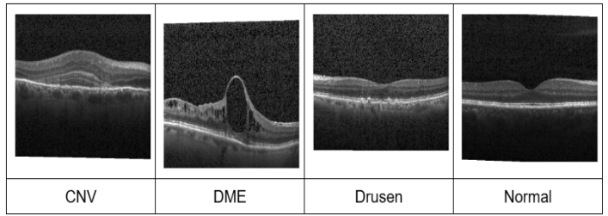
Fig. 2. Sample images of OCT2017

___________________________________________

Method
- Data Preparation
The OCT-C8 dataset [23] contains 8 classes: AMD, CNV, CSR, DME, DR, Drusen, MH and Normal. The dataset used for training consist 18,400 images divided as 2300 images per class. The images provided as part of the training data contains diverse pixel intensity patterns with some noise in it. Noise present in the image can obscure important details, making it challenging to identify and analyse its actual features. The number of dots represented per inch of an image for all the images is 96 and bit depth is 24. The validation and test dataset contains total 2800 images divided as 350 per class. The sample images for each class are shown in Fig.1.
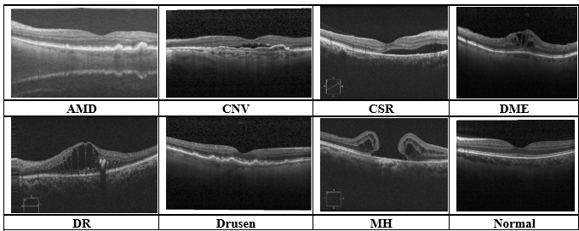
Fig. 1. Sample images of OCT-C8 dataset

A closer observation of Fig. 1 shows that certain features of the AMD and Drusen classes appear quite similar and tend to overlap. This similarity creates difficulties for the model in accurately differentiating between the two categories, which may affect the overall classification accuracy. To mitigate this challenge, data augmentation is applied to all classes in the dataset. This process expands the training dataset by generating diverse samples, thereby enabling the model to learn robust and generalized feature representations.
The OCT2017 dataset [15] includes four categories: CNV, DME, Drusen, and Normal. The training set contains 83,484 images, where CNV has 37,205 images, DME includes 11,348, Drusen contains 8,616, and Normal has 26,315 images. The images in the training set vary in pixel size and also include some noise, while the DPI of all images is 96. The test set consists of 968 images, with 242 images for each class. For validation, 32 images are provided, including 8 images per class. Sample images from each category are illustrated in Fig. 2.

Data Augmentation
Image augmentation is a method which is used to create additional images by applying multiple modification techniques to the available training images. Since some classes share similar or overlapping characteristics, it is important for the CNN model to learn these subtle differences of the features into the images. Image augmentation strengthens the learning process by presenting the model with a broader range of image variations derived from the same dataset. These variations provide additional visual patterns, allowing the model to extract meaningful representations and strengthen its capacity for accurate image feature recognition. To address this, data expansion technique is applied on all the images in training set. As reported by Dave and Domadiya et al. [24], the use of data augmentation can contribute to better model accuracy. The augmentation transformation parameters applied in the proposed method are outlined in Table 2. The training dataset augmentation technique creates the augmented images on the fly which means in the random-access memory of the computer system and does not actually store the augmented images in the hard drive permanently.
Table 2. Configuration Details of Image Transformation Techniques
Parameter Name | Parameter Value
Pixel value normalization | 1./255
Rotation angle | 20
Horizontal shift | 0.1
Height shift | 0.1
Zoom factor | 0.2
Horizontal flipping | True
Shear intensity | 0.1
Fill mode | Nearest

Medical image datasets often show an imbalance among classes and limited diversity in factors such as orientation, brightness, and structural details. These variations are important because they directly influence how accurately the images can be classified. Methods such as shearing, zooming, flipping, rotation, width shift, hight shift fill mode can help generate additional variations in the training dataset images. These transformations enable the model to capture important patterns and detailed features more precisely, particularly for less represented categories and overlapping feature classis AMD and Drusen. As a result, the likelihood of overfitting is minimized and the model becomes more reliable and generalized when applied to real clinical images. By introducing a broader range of training samples, the augmentation process increases the model's resilience capability and improves its overall predictive performance. This also helps the model generalize better when it encounters unseen patient data in practical clinical settings.

Squeeze-and-Excitation Blocks
The Squeeze-and-Excitation (SE) block [25] enhances the capability of convolutional neural networks to learn discriminative representations by modelling the dependencies among different channel-wise responses between different feature channels. Rather than treating every channel in similar way, the SE section enables the framework to determine which channels contain more significant information. By using global information obtained from the feature map, the SE block adjusts the channel responses so that important features are highlighted while less significant features receive lower importance. The overall architecture for SE block is depicted in Fig. 3.
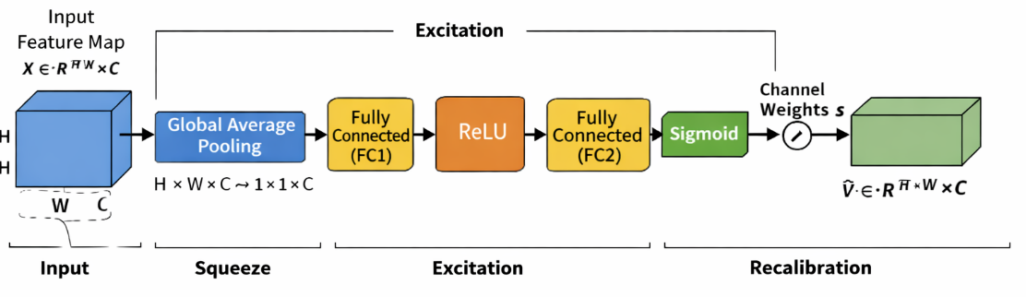
Fig. 3. Architecture of SE block

The operation of the SE block is divided into three key stages: squeeze, excitation, and recalibration. In the squeeze stage, global average pooling is applied to the input feature map $X ∈R^{H* W* C}$ to produce a channel-wise descriptor. In this stage, each channel's spatial dimensions H×W are reduced into one representative value, effectively capturing the global distribution of feature responses. Mathematically, the output of the squeeze operation for the Cth channel is computed as Eq. (1) where Z_{c}​ represents the aggregated statistic of the Cth channel. This descriptor encodes the global contextual information and reflects the overall importance of each channel.

$$Z_{c}=\frac{1}{H*W}\sum_{i=1}^{H}{\sum_{j=1}^{W}{X_{c}\left(i,j\right)}}$$ | (1)

Following the squeeze operation, the excitation module assesses the relevance of each feature channel utilizing the bottleneck structure with two dense layers. The first dense layer compresses the channel dimension to $\frac{C}{r}$ , where r represents the reduction ratio, reducing computational effort while helping the model learn more generalized feature representations. The second dense layer then restores the channel dimension to C, allowing the network to preserve the original feature structure while emphasizing the most informative channels. ReLU [26] activation function is applied after the first layer, followed by a sigmoid function to generate normalized channel-wise weights between 0 and 1. This process can be expressed as Eq. (2)

$$S= σ(W_{2}*δ\left(W_{1}*z\right))$$ | (2)

where “z” is the squeezed vector, W₁​ and W₂​ are the learnable parameters of the fully connected layers, δ denotes the ReLU [26] activation, and σ represents the sigmoid function.
In the final feature refinement step, the learned channel parameters are applied to the actual feature map. Each feature channel is scaled based on its assigned importance value, enabling the network to highlight the most meaningful features while minimizing the influence of less important ones. This is given by Eq. (3).

$$\tilde{X}=s_{c}*X_{c}$$ | (3)

where S_{c}​ is the learned weight for the Cth channel. This feature refinement process improves the network's ability to learn meaningful channel-wise information by giving greater emphasis to the most pertinent attributes while simultaneously diminishing the impact of less beneficial ones. As a result, the model achieves better classification performance with only a small increase in computational cost.

Adam optimizer
The Adam optimizer is a widely used method for training deep learning models due to its ability to perform well in a variety of scenarios. It integrates the concepts of adaptive learning and momentum, allowing the model to adjust how much each parameter is updated during training. Instead of using the same learning rate for all parameters, Adam adapts it based on the behavior of the gradients, which helps the model learn more efficiently and with better stability. In a simple form, the update step can be written as Eq. (4).

$$θ= θ- α* \frac{m}{\left(\sqrt{v}\right)+\left(∈\right)}$$ | (4)

where m captures the average of past gradients and v represents the average of their squared values. These estimates are continuously updated during training, helping the optimizer adapt to the shape of the loss function. Because of this adaptive behaviour, Adam tends to converge faster and requires less manual tuning compared to traditional optimization methods. It performs particularly well in problems involving large datasets, high-dimensional parameters, or noisy gradients. For these reasons, Adam has become a standard choice in many deep learning applications and is often selected as a default optimizer in practical implementations.

CNN Architecture
The proposed CNN model is intended to process input pictures of size 200 × 200 × 3 and gradually learn meaningful features through successive convolutional and pooling operations. This systematic approach to feature extraction allows the network to gather both low-level and high-level imagery features for reliable categorization. The overall architecture of the proposed model is shown in Fig. 6. The neural network starts with a convolutional layer with 16 3 × 3 filters, then uses the ReLU [26] activation function to induce non-linear behaviour. To minimize the spatial dimensions of the retrieved feature maps while conserving the most important data, a 2 × 2 max-pooling layer is performed with the highest activation values retained. The second layer uses 32 filters and follows the same pattern, after which a squeeze-and-excitation (SE) technique is applied to highlight the more relevant feature channels. In the consecutive stages of the model, the number of filters increases to 64, 128, and 160, respectively. Each of these layers is followed by max pooling, and SE blocks are used after every stage to further refine the feature maps by giving more importance to useful features and reducing less important features which actually helps model in understanding the image in greater detail.
Finally, the extracted feature maps are summarized using a global average pooling layer, producing a compact feature representation. This feature vector is then inputted into a dense layer of 512 neurons, where the network learns high-quality structures that aid in correct categorization. To minimize overfitting, the dropout is used at a rate of 0.3, preventing the network from relying excessively on individual neurons during training. The final output layer employs the softmax activation function, with 8 neurons for the OCT-C8 dataset and 4 neurons for the OCT2017 dataset, producing class probabilities for the final prediction. This overall design helps the model learn meaningful spatial features while also improving channel-wise feature representation.

$$MaxPool(x)=max⁡(x_{ij}) _{1≤i≤k,1≤j≤k}$$ | (5)

Following each convolutional layer, a 2 × 2 max-pooling process is conducted to reduce the spatial dimensions of the feature maps. This operation retains the strongest activation value from each local region, retaining the most informative traits while minimizing computational complexity. Instead of considering all values, it simply picks the highest value from each local patch, which helps preserve strong features while discarding less useful information. This process lowers the computational burden while enabling the model to better handle minor changes and variations in the input images, resulting in more reliable feature learning. The mathematical representation of max pooling is given in Eq. (5). The working of max pooling is explained in Fig. 4.
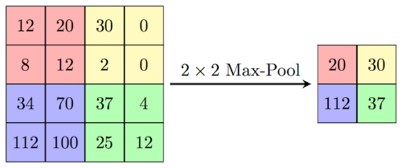
Fig. 4. Illustration of 2x2 max pooling

The ReLU [26] activation function is employed throughout the feature extraction layers of the CNN model. It activates only positive input values while setting negative values to zero, allowing the network to learn efficiently without experiencing the saturation problem over most of the input range. In addition, the ReLU activation function helps alleviate the vanishing gradient issue, allowing gradients to propagate more effectively during training and supporting faster, more stable convergence of the network. The function is expressed in Eq. (6), where x represents the input. Experimental studies have consistently shown that the ReLU activation function enables faster training, particularly in deep and computationally complex neural networks, making it a preferred choice for modern CNN architectures.

F(x) = max(x, 0) | (6)

The last step of the model begins after the last convolution and max pooling procedures, when the feature map size is decreased to 6 × 6 × 160. After the final convolutional stage, the extracted feature maps are summarized using a global average pooling layer, where each 6 × 6 feature map is represented by the average of its values. This process produces a compact 1 × 1 × 160 representation, resulting in a feature vector composed of 160 informative attributes. The resulting feature vector is then fed into a dense layer containing 512 neurons, where the network learns more abstract and discriminative feature representations. These learned representations provide the basis for accurate classification in the final output layer. During training, dropout is employed at a rate of 0.3 to improve the model's capacity to extrapolate and reduce overfitting. Eight neurons are used in the last output layer for the OCT-C8 [23] dataset and four neurons for the OCT2017 [15] dataset, with each neuron representing a distinct class to generate the final classification results. The last layer uses the softmax activation function to calculate the likelihood of each output class. Using these probabilities, the framework assigns the input picture to the class with the greatest confidence score.
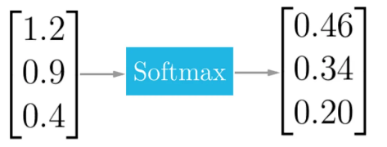
Fig. 5. Softmax layer output illustrating class probabilities

For multiple class classification, the approach employs categorical cross-entropy as a loss function. It evaluates the extent to which the expected probability distribution corresponds to the actual class labels. During training, the model continuously minimizes this loss that actually enables it to make more accurate and reliable predictions over time. The model employs the Adam optimizer because of its ability to give efficient and reliable parameter updates across many learning circumstances. Its adaptive learning rate mechanism makes it simple to implement and helps the network converge effectively during training. It combines ideas from momentum and adaptive learning, which allows the model to adjust how each parameter is updated based on the behavior of the gradients instead of relying on a fixed learning rate. This helps the proposed model achieve a smoother and more consistent training process by improving the stability of parameter updates.
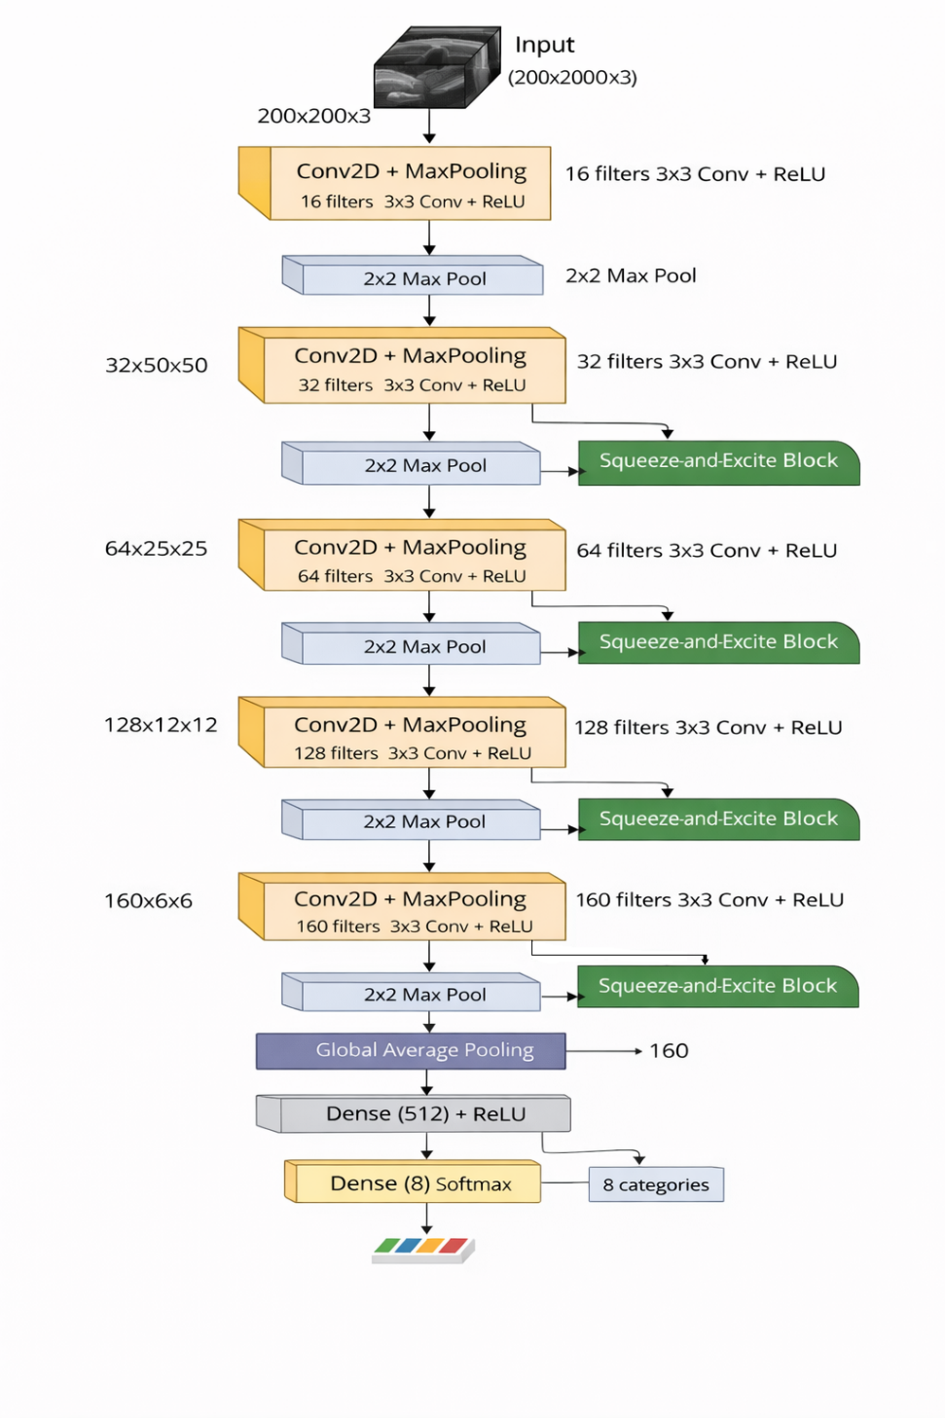
Fig.6. Proposed CNN Model(OCT-C8: 8 Class, OCT 2017: 4 Class)
The parameter update using Adam optimizer is defined in Eq. (7), where m represents the average of past gradients, v represents the average of their squared values, $α$ represents the learning rate and $θ$ represents the parameter to be updated. These values are updated continuously during training process that allows the optimizer to adapt to the mechanism of the loss function. Because of this, Adam usually converges faster and does not require much manual tuning of hyperparameters compared to traditional optimization methods. Due to its effectiveness and adaptability, the Adam optimizer is commonly adopted for applications involving large-scale datasets, complex feature spaces, and fluctuating gradients. These advantages make it an appropriate optimization method for the proposed model.

$$θ= θ- α* \frac{m}{\left(\sqrt{v}\right)+\left(∈\right)}$$ | (7)

$${σ(z)}_{j}= \frac{e^{{(z)}_{j}}}{\sum_{k=1}^{K}{e^{{(z)}_{k}}}}$$ | (8)

The mathematical formulation of the softmax function is presented in Eq. (8), while its response pattern is illustrated in Fig. 4. The function transforms the raw output values of the network into normalized probability scores ranging from 0 to 1, with the total probability across all classes equal to one. In Eq. (8), Z represents the input vector received by the output layer, and j refers to an individual output neuron, where j = 1, 2, ..., K.

Evaluation Setup and Experimental Findings
The proposed solution was executed on a local computing system integrated with an AMD Ryzen 7 5700G 64-bit CPU with Radeon Graphics working at 3.80 GHz and 16 GB of memory. The model development and experimental analysis were carried out using Python, utilizing essential deep learning and data analysis libraries such as Keras, TensorFlow, scikit-learn, and Matplotlib. An early halting technique was used during CNN training for up to 100 epochs to avoid excessive training and limit the possibility of overfitting. The validation loss was monitored as the stopping criterion, with a patience setting of 20 epochs. The model preserved the optimal weights achieved during the 31st epoch for the OCT2017 [15] dataset and the 63rd epoch for the OCT-C8 [23] dataset, respectively. As stated earlier, the OCT2017 [15] dataset consisted of 83,484 samples for training, 32 for validation, and 968 for testing and OCT-C8 [23] consists of 18,400 images for training, 2800 images for validation and 2800 images for testing.
The proposed deep neural network underwent training and testing on two distinct datasets to provide a comprehensive and dependable assessment of its performance. An early stopping mechanism was used to prevent overfitting and enhance the model's capacity to efficiently generalize to new data, and the network was trained for a maximum of 100 epochs. The training process took around 13 hours, while testing was completed in just 109 milliseconds for OCT2017 dataset. On the other side the training process took nearly around 6 hours and testing was completed in 144 milliseconds for OCT-C8 dataset. It is reflecting the efficiency of the lightweight CNN model design. By applying data augmentation along with SE blocks and Adam optimizer, the model was able to learn detailed retinal patterns while maintaining stable performance during training for both the datasets. Several assessment techniques are used to examine the efficacy of the suggested CNN-SE model, including training and validation plots, confusion matrices, ROC curves, and class-wise evaluation metrics. These analyses are conducted for both the OCT2017 and OCT-C8 datasets to understand the model’s classification capability in detail.
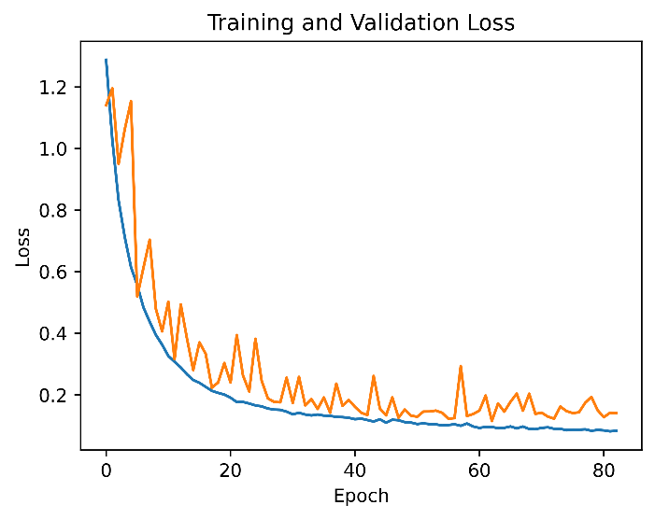
Fig. 7(b). Training and validation loss for OCT-C8 dataset

Fig. 7(a) and Fig. 7(b) show how the loss changes during training for both datasets. In both cases, the training and validation loss keep going down as the number of epochs increases. The curves are smooth and do not incur sudden jumps or changes, which is actually indicating that learning process is stable and smooth. Also, the difference between the training loss and validation loss is minimal throughout a learning mechanism, which actually tells that the model is not overfitting and is learning useful patterns and information from the images of the different classes. Another point to notice over here is that the loss becomes stable faster for the OCT2017 dataset. This means the model reaches convergence in fewer epochs compared to OCT-C8. A possible reason for this is that OCT2017 has more training images, fewer classes and a better balance between classes, that ultimately facilitates the model's learning. On the other side, the OCT-C8 dataset takes some more time to converge that is likely because it has more complex class differences, a greater number of classes and slightly overlapping features.
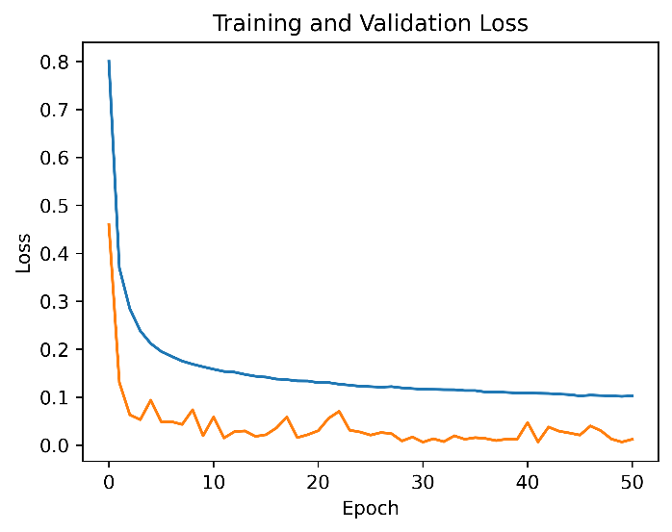
Fig. 7(a). Training and validation loss for OCT2017 dataset

Fig. 8(a) and Fig. 8(b) display the training and validation accuracy curves. In both datasets, the accuracy increases gradually as training progresses. The OCT2017 dataset reaches a high accuracy level quite quickly, while the accuracy for OCT-C8 improves more gradually. This slower improvement may be due to similarities of the features between certain classes like AMD and Drusen, fewer dataset than OCT2017 and a greater number of classes, which makes classification harder. Even despite this, the validation accuracy remains quite close to the training accuracy in both scenarios, demonstrating the model's strong generalization and dependable performance on fresh data.
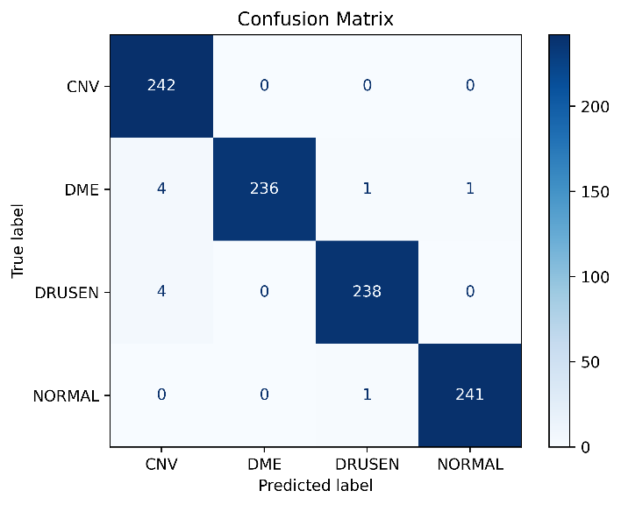
Fig. 9(a). Confusion matrix for OCT2017 test dataset

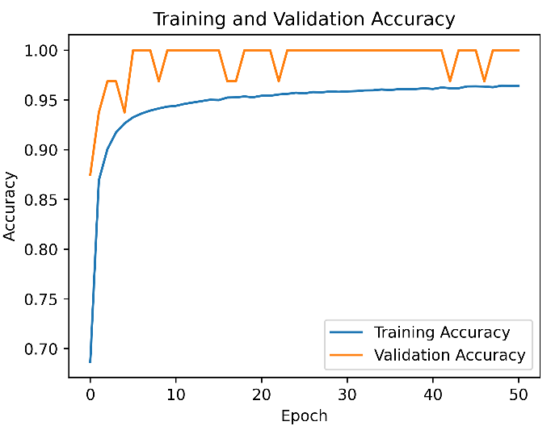
Fig. 8(a). Training and validation accuracy for OCT2017 dataset

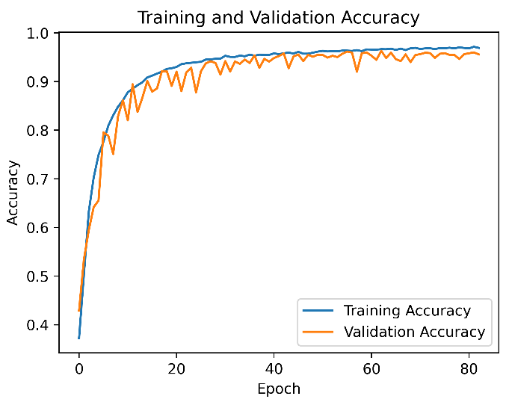
Fig. 8(b). Training and validation accuracy for OCT-C8 dataset

Fig. 9(a) shows the confusion matrix for the OCT2017 test dataset with the support of 242 images per class. The majority of the values are clustered along the diagonal axis, suggesting that most of the samples are properly classified by the model. The CNV class is predicted perfectly with all samples correctly

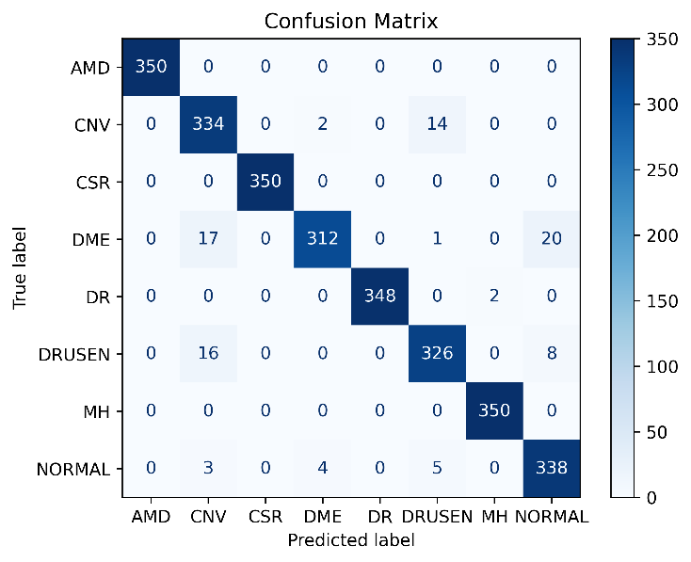
Fig. 9(b). Confusion matrix for OCT-C8 test dataset

identified. For DME, three samples are misclassified as CNV, one as Drusen, and one Normal, but the number is very small compared to the correct predictions. In a same way, the Drusen class has four samples confused with CNV, while the Normal class is almost perfectly classified with only one minor error. This indicates that the model performs very well on this dataset and is able to clearly distinguish between the retinal OCT image classes. Fig. 9(b) presents the confusion matrix for the OCT-C8 test dataset, which includes eight classes and slightly more complex patterns. The majority of forecasts here likewise fall along the diagonal, suggesting excellent overall performance. Classes such as AMD, CSR, DR, and MH are classified almost perfectly, with very few or no errors. However, some confusion can be observed in classes like CNV, DME, Drusen, and Normal. For example, a few CNV samples are misclassified as Drusen, and some DME samples are confused with CNV and Normal. These errors are small but noticeable when compared to the OCT2017 results.
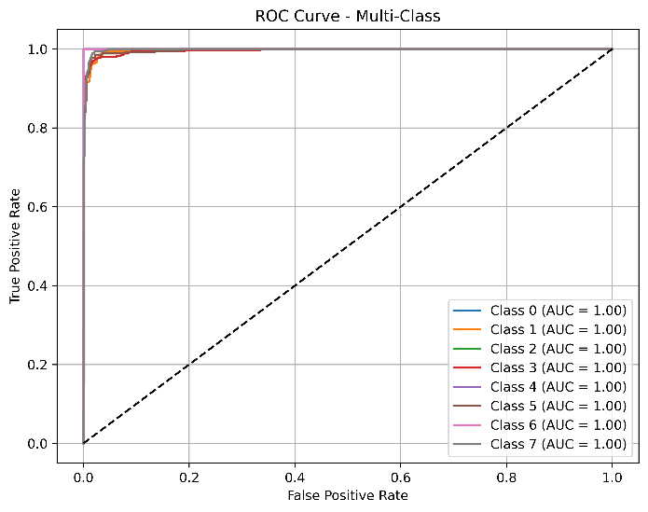
Fig. 10 (b). ROC curve for OCT2017

The difference in performance between the two datasets is mainly because of the number of classes and how complex the classes are. In the OCT-C8 dataset, some classes look quite similar and share common features and information, so it becomes harder for the model to clearly tell them classify. Even with this challenge, the number of correct predictions is still much higher than the wrong ones. Most of the values are still along the diagonal axis, which shows that the model is doing its job very well. Only a small number of samples are misclassified, and these mostly happen between classes that are very similar to each other. Overall, the confusion matrices demonstrate that the model continues to provide good accuracy across all classes. The model's overall performance is unaffected by the minor overlaps across related categories. This demonstrates the model's dependability and improved ability to handle even more complicated data.
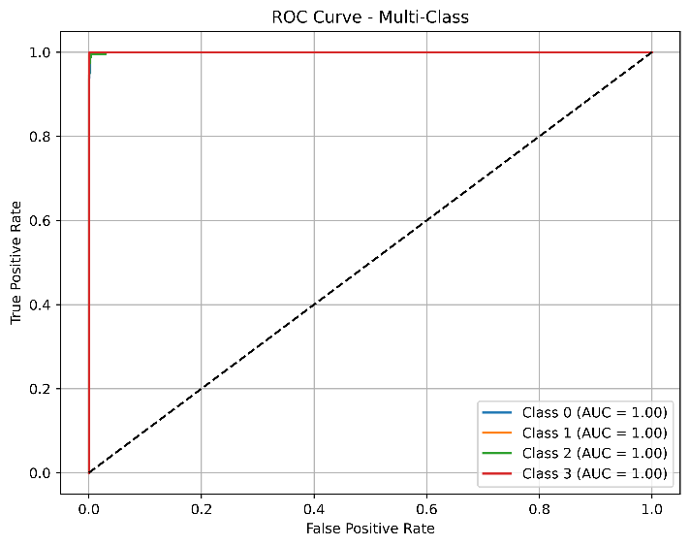
Fig. 10 (a). ROC curve for OCT2017

The ROC curves for both datasets are displayed in Fig. 10(a) and Fig. 10(b), where the curves for every class are quite near to the upper-left corner. This shows that the method maintains a very low false positive rate while achieving a high true positive rate. For the OCT2017 dataset, the curves almost reach the top-left corner with AUC values of 1.00, showing near-perfect performance. For the OCT-C8 dataset, the curves are also very close to ideal, with only slight variation due to higher class complexity. Ultimately, since all curves lie well above the diagonal line, the model clearly performs much better than random guessing and classify the OCT images very effectively.
The findings of the quantitative examination are summarized in Table 3 and Table 4. Table 3 displays the suggested CNN model's performance metrics on the OCT2017 dataset. The findings show consistently high scores for every assessment criterion. With an F1-score of 0.98, the CNV class achieves a precision of 0.97 and a perfect recall of 1.00, indicating that nearly all CNV samples are properly classified with extremely few false negatives. With accuracy ratings of 1.00 and 0.99, the DME and Drusen classes likewise demonstrate excellent performance, and recall values of 0.98 for both, leading to F1-scores of 0.99. The Normal class achieves perfect scores across all three metrics, indicating complete and accurate classification. Overall accuracy of the model is 99.00%, and its weighted and macro averages are also 99.00%. It indicates balanced performance across all classes without any bias. The equal support of 242 samples per class for test dataset further reflects that the dataset is well-balanced, which contributes to the stable and reliable results. The equations below define the widely used evaluation measures, including precision, recall, and F1-score, which are utilized to assess the classification ability of the proposed model.
$$Precision= \frac{True Positives}{True Positives+False Positives}$$ | (9)

$$Recall= \frac{True Positives}{True Positives+False Negatives}$$ | (10)

$$F1 Score=2* \frac{Precision*Recall}{Precision+Recall}$$ | (11)

Table 3. Class-wise Classification Results of the
Proposed CNN–SE Model on the OCT2017 Dataset

 | Precision | Recall | F1-score | Support
Class
CNV | 0.97 | 1.00 | 0.98 | 242
DME | 1.00 | 0.98 | 0.99 | 242
Drusen | 0.99 | 0.98 | 0.99 | 242
Normal | 1.00 | 1.00 | 1.00 | 242
Accuracy |  |  | 0.99 | 968
Macro Avg | 0.99 | 0.99 | 0.99 | 968
Weighted Avg | 0.99 | 0.99 | 0.99 | 968

Table 4. Class-wise Classification Results of the
Proposed CNN–SE Model on the OCT-C8 Dataset
 | Precision | Recall | F1-score | Support
Class
AMD | 1.00 | 1.00 | 1.00 | 350
CNV | 0.90 | 0.95 | 0.93 | 350
CSR | 1.00 | 1.00 | 1.00 | 350
DME | 0.98 | 0.89 | 0.93 | 350
DR | 1.00 | 0.99 | 1.00 | 350
Drusen | 0.94 | 0.93 | 0.94 | 350
MH | 0.99 | 1.00 | 1.00 | 350
Normal | 0.92 | 0.97 | 0.94 | 350
Accuracy |  |  | 0.97 | 2800
Macro Avg | 0.97 | 0.97 | 0.97 | 2800
Weighted Avg | 0.97 | 0.97 | 0.97 | 2800

Ablation Study
Ablation research was conducted to have a better understanding of how each component of the suggested architecture influences the overall performance, by removing or adjusting key components such as the Squeeze-and-Excitation (SE) blocks, data augmentation, and the choice of optimizer. The experiments were conducted on both the OCT2017 and OCT-C8 datasets to guarantee a fair comparison, using the same training and testing configuration.
At the beginning, a basic CNN model was trained without including SE blocks and without applying data augmentation. We call it Model A for the denotation which is shown in Fig. 6 in that SE blocks are not included. This architecture showed lower classification performance, especially for classes like CNV, DME, and Drusen where the features are quite similar. Since no augmentation was used, the training data lacked variation, which made it harder for the model to generalize well on unseen test dataset images. In the second model implementation: Model B, data augmentation was added while keeping the model architecture the same as Model A. With more varied training samples, the model was able to learn better patterns, which improved overall accuracy and reduced overfitting. There was also a clear improvement in recall, especially for minority classes and those with similar visual features.

Table 5. Ablation study of different model implementations
Model | SE Blocks | Data Augmentation | Optimizer | Accuracy (OCT2017) | Accuracy (OCT-C8)
Model A | No | No | Adam | 96.2% | 92.8%
Model B | No | Yes | Adam | 97.8% | 94.6%
Model C | Yes | No | Adam | 97.9% | 94.87%
Model D | Yes | Yes | SGD | 95.3% | 94.1%
Model E (Proposed Model) | Yes | Yes | Adam | 99.0% | 97.0%

In Model C, SE blocks were added to the CNN architecture without using data augmentation. This helped the model focus more on the important feature channels. Because of this, the classification performance improved compared to the baseline model: Model A but similar to Model B, especially when distinguishing between retinal conditions that have similar structures. In addition, the choice of optimizer was also tested by replacing the Adam optimizer with SGD in Model D as well. It was observed that SGD took more epochs to converge and gave slightly lower accuracy, showing that it was less efficient for this particular task.
The proposed model: Model E, includes SE blocks and data augmentation together along with the Adam optimizer. This combination gave the best performance among all the previous model implementations. With better feature representation and more varied training data, the model was able to learn more distinct patterns while maintaining stable training throughout the process. The ablation study highlights that each incorporated component contributes to enhancing the model's effectiveness. The model's capacity to generalize to new samples is enhanced via data augmentation, SE blocks enable better identification of significant features, and the Adam optimizer facilitates stable and efficient model optimization during training. When all these parts are used together, the model gives balanced and strong results for retinal OCT image classification. The results of the ablation study are briefly presented in Table 5.

Table 6. Comparison with existing approaches
Publication Year | References | Approach | Acc (OCT2017 Dataset) | Acc (OCT-C8 Dataset)
2019 | Diaz et al. [27] | Conventional CNN-based classifier | 93 | Not Implemented
2019 | L.Huang et al. [14] | Layer-guided convolutional neural network | 88.4
2020 | Saraiva et al. [28] | Deep CNN architecture | 93.3
2021 | J Kim et al. [16] | Two binary CNN variants (Model 1 / Model 2 with high computational complexity) | 98.1/98.7
2023 | Hassan E et al [18] | Enhanced Optical Coherence Tomography (EOCT)-based framework | 97.47
2023 | Diao et al. [17] | CNN-based classification framework | 96.93
2023 | Michael Opoku et al. [29] | Capsule network integrated with contrast-limited adaptive histogram equalization | 97.7
2024 | Stanojevi´c, M et al. [21] | Deep convolutional neural network model | 95.55
2024 | Yang J et al. [20] | CNN, EfficientNet-V2, and ResNet-based ensemble architecture | 97.89
2025 | Dave and Domadiya et al. [24] | CNN with data augmentation, exponential learning rate decay, and hybrid max–average pooling | 98.75
2026 | Proposed Model | CNN enhanced with SE blocks, Adam optimization, and global average pooling | 99.00 | 97.00

Table 6 shows a comparison of the suggested model with current techniques on the OCT2017 and OCT-C8 datasets. Previous implementations primarily employ CNN-based architectures, including Layer Guided CNN, ensemble models, and capsule networks that are achieving accuracies in a range from 88.4% to 98.75% on OCT2017. The proposed approach combines convolutional layers with squeeze-and-excitation (SE) blocks, optimized using the Adam optimizer algorithm and global average pooling for feature aggregation. This model configuration attains the highest accuracy of 99.00% on OCT2017 and additionally achieves 97.00% accuracy on the OCT-C8 dataset. The results indicate improved feature representation and generalization capability compared to previously implemented approaches.

Conclusion and Future Work
In order to automatically classify retinal illnesses from OCT pictures, this study presents a lightweight CNN-based framework improved with Squeeze-and-Excitation (SE) blocks. Without the use of intricate structures or transfer learning strategies, the suggested model successfully strikes a compromise between classification power and computing economy. The integrated SE blocks enable the network to focus on more relevant features while suppressing the influence of less informative feature channels. Data augmentation adds more variety to the training data, which helps the model avoid overfitting and perform better on new test images, especially in the cases where classes like AMD and Drusen look quite similar. The Adam optimizer also helps in smooth and faster training by updating the model weights in a stable way.
The experimental evaluation on the OCT2017 and OCT-C8 datasets demonstrates the effectiveness of the proposed model, achieving classification accuracies of 99% and 97%, respectively. The training and validation graphs remain smooth and close to each other that shows the model is learning properly without overfitting. The confusion matrices and ROC curves also show that the model can clearly separate different classes with good amount of accuracy. The ablation study further shows that each part of the model, including SE blocks, data augmentation, and selecting the right optimizer is crucial to enhancing both dataset’s performance. Deducing that the model works in a reliable and efficient way and it can be useful in real clinical settings where both accuracy and computational cost matter for faster inference.
Even though the model gives strong results, there is still scope to improve it further. It can be tested on larger and more diverse clinical datasets to check how well it works in real-world conditions. Adding simple visualization methods like Grad-CAM or CAM can help doctors understand which areas the model is focusing on for the real time classifications of the anomalies. Additionally, the model may be enhanced by experimenting with other structures or adjusting parameters and hyperparameters for better performance in overlapping feature classes. This work shows that a simple and well-designed model can give strong results without making things too much complex. With some improvements and real-world testing, it can be useful in supporting faster and more reliable diagnosis in practice.

Acknowledgment
NA

Funding
NA

Data Availability
The datasets used in the research are publicly available and we have cited it properly in the paper [15] and [23].

Author Contribution
Both authors have contributed equally to the proposed research

Declarations
The authors declare no conflict of interest.

References

[1] T. Ojala, M. Pietikainen, and T. Maenpaa, “Multiresolution gray-scale and rotation invariant texture classification with local binary patterns,” IEEE Trans. Pattern Anal. Mach. Intell., vol. 24, no. 7, pp. 971–987, Jul. 2002, doi: 10.1109/TPAMI.2002.1017623.
[2] N. Dalal and B. Triggs, “Histograms of Oriented Gradients for Human Detection,” in 2005 IEEE Computer Society Conference on Computer Vision and Pattern Recognition (CVPR’05), IEEE, pp. 886–893. doi: 10.1109/CVPR.2005.177.
[3] R. M. Haralick, K. Shanmugam, and I. Dinstein, “Textural Features for Image Classification,” IEEE Trans. Syst. Man Cybern., vol. SMC-3, no. 6, pp. 610–621, Nov. 1973, doi: 10.1109/TSMC.1973.4309314.
[4] M. A. Hearst, S. T. Dumais, E. Osuna, J. Platt, and B. Scholkopf, “Support vector machines,” IEEE Intelligent Systems and their Applications, vol. 13, no. 4, pp. 18–28, Jul. 1998, doi: 10.1109/5254.708428.
[5] B. Zoph, V. Vasudevan, J. Shlens, and Q. V. Le, “Learning Transferable Architectures for Scalable Image Recognition,” in 2018 IEEE/CVF Conference on Computer Vision and Pattern Recognition, IEEE, Jun. 2018, pp. 8697–8710. doi: 10.1109/CVPR.2018.00907.
[6] A. Krizhevsky, I. Sutskever, and G. E. Hinton, “ImageNet classification with deep convolutional neural networks,” Commun. ACM, vol. 60, no. 6, pp. 84–90, May 2017, doi: 10.1145/3065386.
[7] K. Simonyan and A. Zisserman, “Very Deep Convolutional Networks for Large-Scale Image Recognition,” Apr. 2015.
[8] K. He, X. Zhang, S. Ren, and J. Sun, “Deep Residual Learning for Image Recognition,” in 2016 IEEE Conference on Computer Vision and Pattern Recognition (CVPR), IEEE, Jun. 2016, pp. 770–778. doi: 10.1109/CVPR.2016.90.
[9] C. Szegedy et al., “Going deeper with convolutions,” in 2015 IEEE Conference on Computer Vision and Pattern Recognition (CVPR), IEEE, Jun. 2015, pp. 1–9. doi: 10.1109/CVPR.2015.7298594.
[10] P. P. Srinivasan et al., “Fully automated detection of diabetic macular edema and dry age-related macular degeneration from optical coherence tomography images,” Biomed. Opt. Express, vol. 5, no. 10, p. 3568, Oct. 2014, doi: 10.1364/BOE.5.003568.
[11] Y.-Y. Liu et al., “Computerized Macular Pathology Diagnosis in Spectral Domain Optical Coherence Tomography Scans Based on Multiscale Texture and Shape Features,” Investigative Opthalmology & Visual Science, vol. 52, no. 11, p. 8316, Oct. 2011, doi: 10.1167/iovs.10-7012.
[12] Jianixn Wu and J. M. Rehg, “Where am I: Place instance and category recognition using spatial PACT,” in 2008 IEEE Conference on Computer Vision and Pattern Recognition, IEEE, Jun. 2008, pp. 1–8. doi: 10.1109/CVPR.2008.4587627.
[13] K. Alsaih et al., “Classification of SD-OCT volumes with multi pyramids, LBP and HOG descriptors: Application to DME detections,” in 2016 38th Annual International Conference of the IEEE Engineering in Medicine and Biology Society (EMBC), IEEE, Aug. 2016, pp. 1344–1347. doi: 10.1109/EMBC.2016.7590956.
[14] L. Huang, X. He, L. Fang, H. Rabbani, and X. Chen, “Automatic Classification of Retinal Optical Coherence Tomography Images With Layer Guided Convolutional Neural Network,” IEEE Signal Process. Lett., vol. 26, no. 7, pp. 1026–1030, Jul. 2019, doi: 10.1109/LSP.2019.2917779.
[15] D. S. Kermany et al., “Identifying Medical Diagnoses and Treatable Diseases by Image-Based Deep Learning,” Cell, vol. 172, no. 5, pp. 1122-1131.e9, Feb. 2018, doi: 10.1016/j.cell.2018.02.010.
[16] J. Kim and L. Tran, “Retinal Disease Classification from OCT Images Using Deep Learning Algorithms,” in 2021 IEEE Conference on Computational Intelligence in Bioinformatics and Computational Biology (CIBCB), IEEE, Oct. 2021, pp. 1–6. doi: 10.1109/CIBCB49929.2021.9562919.
[17] S. Diao et al., “Classification and segmentation of OCT images for age-related macular degeneration based on dual guidance networks,” Biomed. Signal Process. Control, vol. 84, p. 104810, Jul. 2023, doi: 10.1016/j.bspc.2023.104810.
[18] E. Hassan et al., “Enhanced Deep Learning Model for Classification of Retinal Optical Coherence Tomography Images,” Sensors, vol. 23, no. 12, p. 5393, Jun. 2023, doi: 10.3390/s23125393.
[19] D. Paul, A. Tewari, S. Ghosh, and K. C. Santosh, “OCTx: Ensembled Deep Learning Model to Detect Retinal Disorders,” in 2020 IEEE 33rd International Symposium on Computer-Based Medical Systems (CBMS), IEEE, Jul. 2020, pp. 526–531. doi: 10.1109/CBMS49503.2020.00105.
[20] J. Yang, G. Wang, X. Xiao, M. Bao, and G. Tian, “Explainable ensemble learning method for OCT detection with transfer learning,” PLoS One, vol. 19, no. 3, p. e0296175, Mar. 2024, doi: 10.1371/journal.pone.0296175.
[21] M. Stanojević, D. Drašković, and B. Nikolić, “Retinal disease classification based on optical coherence tomography images using convolutional neural networks,” J. Electron. Imaging, vol. 32, no. 03, Nov. 2022, doi: 10.1117/1.JEI.32.3.032004.
[22] M. Selvarajan and M. B. N. M, “Impact of Optimizer Algorithm on NasNetMobile Model for Eight-class Retinal Disease Classification from OCT Images,” Journal of Electronics, Electromedical Engineering, and Medical Informatics, vol. 8, no. 2, pp. 490–503, Mar. 2026, doi: 10.35882/jeeemi.v8i2.1464.
[23] Obuli Sai Naren, “Retinal OCT Image Classification - C8 [Data set],” https://www.kaggle.com/datasets/obulisainaren/retinal-oct-c8/versions/2. Accessed: Jul. 20, 2026. [Online]. Available: https://doi.org/10.34740/KAGGLE/DSV/2736749
[24] P. R. Dave and N. H. Domadiya, “Lightweight deep learning approach for retinal OCT image classification: A CNN with hybrid pooling and optimized learning,” International Journal of Informatics and Communication Technology (IJ-ICT), vol. 15, no. 1, p. 414, Mar. 2026, doi: 10.11591/ijict.v15i1.pp414-427.
[25] J. Hu, L. Shen, and G. Sun, “Squeeze-and-Excitation Networks,” in 2018 IEEE/CVF Conference on Computer Vision and Pattern Recognition, IEEE, Jun. 2018, pp. 7132–7141. doi: 10.1109/CVPR.2018.00745.
[26] V. Nair and G. E. Hinton, “Rectified Linear Units Improve Restricted Boltzmann Machines.”
[27] M. Díaz, J. Novo, P. Cutrín, F. Gómez-Ulla, M. G. Penedo, and M. Ortega, “Automatic segmentation of the foveal avascular zone in ophthalmological OCT-A images,” PLoS One, vol. 14, no. 2, p. e0212364, Feb. 2019, doi: 10.1371/journal.pone.0212364.
[28] A. A. Saraiva et al., “Classification of Optical Coherence Tomography using Convolutional Neural Networks,” in BIOINFORMATICS 2020 - 11th International Conference on Bioinformatics Models, Methods and Algorithms, Proceedings; Part of 13th International Joint Conference on Biomedical Engineering Systems and Technologies, BIOSTEC 2020, SciTePress, 2020, pp. 168–175. doi: 10.5220/0009091001680175.
[29] M. Opoku, B. A. Weyori, A. F. Adekoya, and K. Adu, “CLAHE-CapsNet: Efficient retina optical coherence tomography classification using capsule networks with contrast limited adaptive histogram equalization,” PLoS One, vol. 18, no. 11, p. e0288663, Nov. 2023, doi: 10.1371/journal.pone.0288663.

Author Biography (ARIAL 10, BOLD, H1)

Required Information:
- Full name: Parth R. Dave and Nikunj H. Domadiya
- Email address for each author: 1st Author (prd7889@gmail.com,parthdave.ce@ldce.ac.in), 2nd Author domadiyanikunj002@gmail.com
- Social media account:
- ORCID iD: Parth R. Dave (https://orcid.org/0000-0003-1922-0997) , Nikunj H. Domadiya (https://orcid.org/0000-0002-5804-9910)

 | Prof. Parth R. Davewas born at Halol in Gujarat, India on7th August, 1989. Prof. Dave completed B.E. and M. Tech with specialization in Computer Engineering from Dharmsinh Desai University, Nadiad, Gujarat, India in the years 2011 and 2013 respectively. The author’s major field of study covers machine learning, deep learning, image processing and multimedia information retrieval. He had worked as an Assistant Professor in the Computer Engineering Department at Dharmsinh Desai University, Nadiad, Gujarat, India from 2013 to 2020. He is currently working as an Assistant Professor in the Computer Engineering Department at L. D. College of Engineering, Ahmedabad, Gujarat, India since 2020. He delivers expert talks and serves as reviewer in international conferences and journals. He has also presented papers in International Journals, IEEE Conferences. He can be contacted at email: prd7889@gmail.com.
 | Nikunj H. Domadiya  completed M. Tech and Ph.D. from NIT-Surat, Gujarat, India in the years 2013 and 2020 respectively. The author’s major field of reaserch covers Data Privacy and Security, Machine learning, Deep learning, and multimedia information retrieval. He is currently working as an Assistant Professor in the Computer Engineering Department at L. D. College of Engineering, Ahmedabad, Gujarat, India since 2020. He can be contacted at email: domadiyanikunj002@gmail.com

Each author is required to provide a cover image as shown example below

