city@

CHICAGO srATE ST 312-279-2133

# S STATE ST

CHICAGO "L 60603

cr 08/2015 07:42 'PM EXPIRES 06/06/15

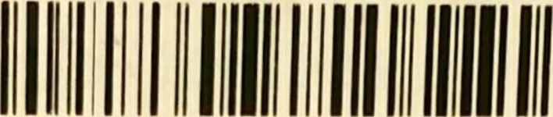

CLEANING SUPPL LES

003030165 DISHWAND BR $2.99

DISHWAND BFIJ SCOTCHBRITE DISH BRUSH 0030-10112 ARM N HAMME $1.64

ARM N HAMMER ICB FROG/FRZ BKNG TOP

2 $0.82 ea

HEALTH-BEAUTY-COSMETICS

049060497 SCHICK 4CT T $13.49 SCHICK 4CT SCHICK HYDR05 CART 4CT

049091676 CREST :IPK $2.99 

CREST IPk 5.802 WHT DEEP CLN TP

## 052070152 MASCARA $7.39

MASCARA 280 VEF 25FLOZ BLKBLK  )2071131 MASCARA $8.59

MASCARA 930 IL 22FLOZ BLK BLK

|  |  |
| --- | --- |
| SUBTOTAL | $37.09 |
| IL TAX 9.250CI% on $37.09  TOTAL | $3.43  $40.52 |
| *3302 GIFT CARD PAYMENT | $40.52 |
| *3302 GIFT CARD BALANCE | $59.83 |

INDICATES SAVINGS

## REC#2-5067-2799-0081-7594-4 VCD#750-212-745

