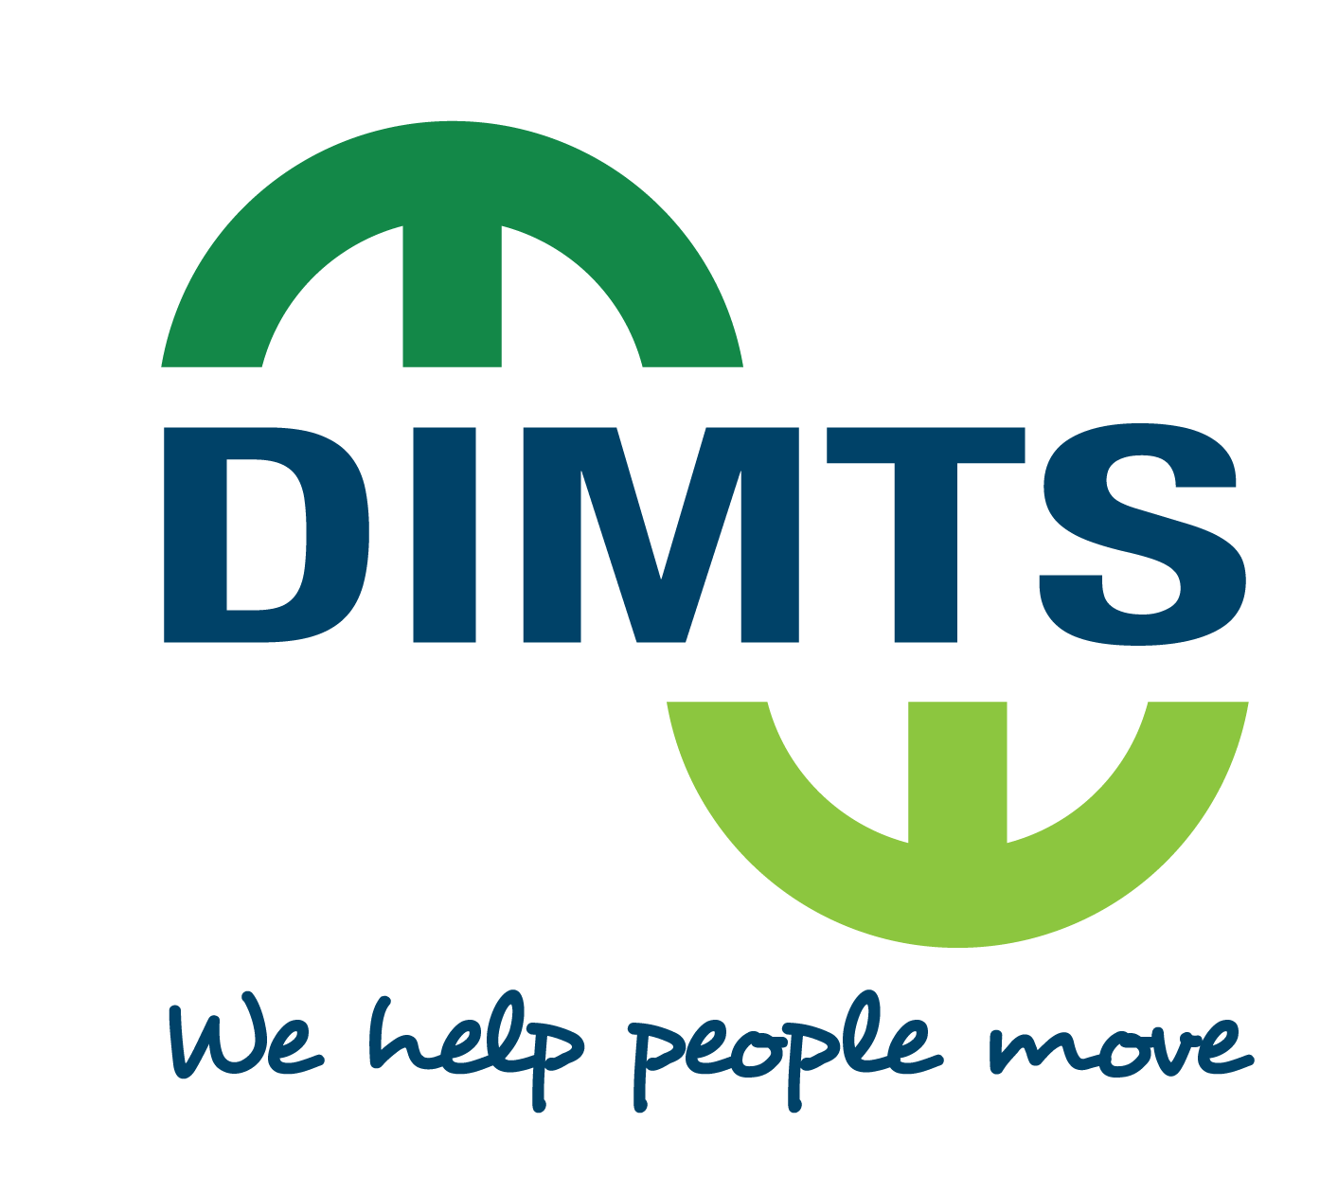

**An ISO 9001, 14001, OHSAS 18001,ISO 27001 & CMMI L3 Certified Company**



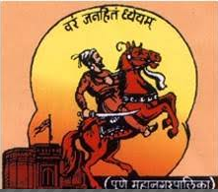

**PUNE MUNICIPAL CORPORATION**

In association with

**PUNE SMART CITY DEVELOPMENT CORPORATION LIMITED &**

**PUNE MAHANAGAR PARIVAHAN MAHAMANDAL LIMITED**

*PROPOSAL FOR*

*AVAILING INCENTIVES UNDER*

*FAME INDIA SCHEME OF GOVERNMENT OF INDIA*

**AGENDA**

|  |  |
| --- | --- |
| **SNo.** | **Description** |
| 1 | FAME INDIA SCHEME |
| 2 | OBJECTIVE |
| 3 | SELECTION PARAMETERS |
| 4 | GoI FUNDING |
| 5 | RESPONSE PARAMETERS |
| 6 | BID SCHEDULE |
| 7 | DIMTS VALUE PROPOSITION |
| 8 | DIMTS – BOARD OF DIRECTORS |
| 9 | DIMTS SOLUTION PORTFOLIO |
| 10 | DIMTS – ELECTRIC BUSES SOLUTION |
| 11 | DIMTS – SUPPORT TO THE PUNE CITY |
| 12 | PROJECT METHODOLOGY |
| 13 | PROPOSAL COST |
| 14 | DIMTS- WORK AWARDED ON NOMINATION |

**FAME INDIA SCHEME**

* GoI approved the National Mission on Electric Mobility in 2011 and subsequently National Mission on Electric Mobility Plan 2020 (NEMMP 2020) in 2013.
* Faster Adoption and Manufacturing of (Hybrid &) Electric Vehicles in India (FAME) Scheme was launched on 1 April 2015.
* Government aims to provide fiscal and monetary incentives through this scheme to kick start this nascent technology. Strong Hybrid, Plug-in Hybrid and Pure Electric technologies (collectively termed as xEV) are covered under this FAME India Scheme.
* Under the scheme, market creation through demand incentives is aimed at incentivizing all vehicle segments i.e. 2-Wheeers, 3-Wheelers Auto, Passenger 4-Wheeler vehicles, Light Commercial vehicles and Buses.

Now, GOI would like to lay greater emphasis on providing affordable and environmentally friendly public and private transportation / vehicular mobility for the masses. To this end, electric buses and three wheelers, including for last mile connectivity, have been added to the scope of the scheme through recent amendments. The demand incentive is available to buyers (end users / consumers) in the form of an upfront reduced price to enable wider adoption

**OBJECTIVE**

* To encourage comprehensive air quality solution of cities
* To promote multi-modal public transportation system through shared electric mobility in the cities

*The present EoI is a Pilot Project under FAME India Scheme specifically designed to give a push to multi-modal public transport. Therefore,* ***it offers enhanced incentives i.e. above the demand incentives notified under the FAME Scheme in respect of electric buses***

**APPLICABILITY/ ELIGIBILITY**

* Cities with 1 Million+ population (as per 2011 census)
* State Government Departments / Undertakings, Municipal Corporations, Public authorities etc of million plus cities will coordinate with respective STUs / transport authorities and 4W/3W aggregators and will submit the consolidated proposal to Department of Heavy Industry.
* Special Category States may also be considered for grant under this EoI through a separate window.

**GoI FUNDING**

|  |  |  |  |  |  |
| --- | --- | --- | --- | --- | --- |
| ***A) ELECTRIC BUSES*** | | | | | |
| **Level 1 (Minimum 15% localisation is achieved)** | | | **Level 2 (Minimum 35% localisation is achieved)** | | |
| 60% of purchase cost or Rs. 1 Crore (whichever is lower) | | | 60% of purchase cost or Rs. 1.5 Crore (whichever is lower) | | |
| ***(B) ELECTRIC 4-WHEELER PASSENGER CAR*** | | | | | |
| **Segment** | | **Level 1 (Range 70 km)** | | | **Level 2 (Range 105 km)** |
| ***Length not exceeding 4 Meters*** BEV (Advance Battery) | | Rs 76000 | | | Rs 124000 |
| ***Length exceeding 4 Meters*** BEV (Advance Battery) | | Rs 60000 | | | Rs 138000 |
| ***(C) ELECTRIC 3-WHEELER (L5 Category)*** | | | | | |
| **Segment** | **Level 1 (Range 50 km)** | | | **Level 2 (Range 80 km)** | |
| BEV (Advance Battery) | Rs 51000 | | | Rs 61000 | |
| ***(D) ELECTRIC 3-WHEELER (Having max. speed less than 25 Km/Hrs)*** | | | | | |
| **Segment** | **Level 1 (Range 50 km)** | | | **Level 2 (Range 80 km)** | |
| BEV (Advance Battery) | Rs 37500 | | | Rs 45000 | |

*\*The total fund not more than Rs. 105 crore will be provided to each selected city in the current FY 2017-18 for a composite basket of electric buses (max. 100 per city), electric 4-wheeler passenger cars & electric 3-wheeler.*

***Charging Infrastructure***

Funding will also be provided for setting up of the charging infrastructure in the selected cities with a ceiling of Rs. 15 crore per city, as per details below:-

|  |  |
| --- | --- |
| ***A) ELECTRIC BUSES*** | |
| 10% of total eligible demand incentive for purchase of fleet of EV buses as per contract agreement between purchaser and OEM / Manufacturer / Supplier to State Transport Undertakings / Municipal Corporations. | |
| ***(B) Electric 4-Wheelers/Electric 3-Wheelers*** | |
| **Type of Charger** | **Demand Incentive** |
| AC Smart Charger with two-way communication for low Voltage Vehicles | 75% of cost or Rs. 1.2 lakh per charger, whichever is lower |
| DC Fast Charger (less than 100 Volt) with standard specification | 75% of cost or Rs. 7 lakh, whichever is lower, per charger  (Cost of charger includes all cost including installation cost) |

* The remaining cost for setting up of charging station including its location and operation cost shall be borne by the concerned authority in consultation with Power Discoms in conformity with Acts and Regulations in this regard. These charging stations shall not be limited to the vehicles sanctioned under the project but shall also be open to public at large.
* The funding is available to only those Electric buses / Electric 4-Wheelers passenger cars / Electric 3-Wheeler, which run on advance battery.

*[NOTE: “Advance Battery” represents the new generation batteries without lead such as Lithium Polymer, Lithium Iron phosphate, Nickel Metal Hydride, Zinc Air, Sodium Air, Nickel Zinc, Lithium Air etc.]*

**RESPONSE DOCUMENT**

* Covering letter
* General details about the City
* Detailed Project Report
* Funding Pattern
* Documents related to tie-up with STUs for buses
* Documents related to tie-up with 3W/4W aggregators
* Other papers / documents related to the Project (if any)

**BID SCHEDULE**

|  |  |
| --- | --- |
| **Activity** | **Details** |
| Last date for receipt of proposals | 30th November 2017 |
| Completion of Evaluation of proposals | 15th December 2017 |
| Conveying the decision of Approving Authority for the Commencement of Project / Proposal by the Proposer | 31st December 2017 |
| Receipt of supply/purchase orders on firms from the Proposer, following due tendering process | 15th February 2018 |

**DIMTS VALUE PROPOSITION**

***Mobility Sector***

***People / Services / Material***

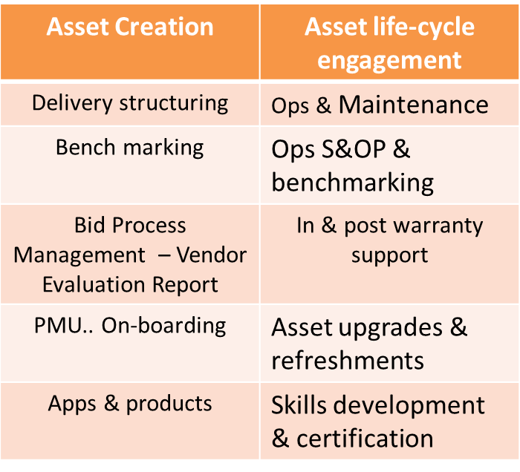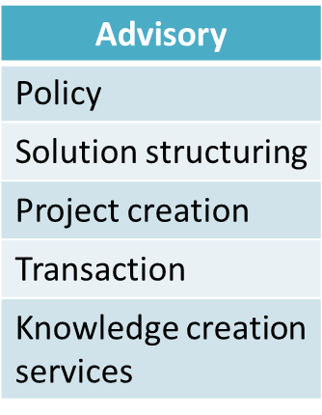

**DIMTS Key Values**

* A ***Joint Venture company set up by the Government of National Capital Territory of Delhi and IDFC Foundation***. ***Strong Public ethos & Public Sector engagement.***
* ***Strong domestic & international Credentials*** & accolades for ***sustainable innovations in urban transportation sector*** through design & technology based interventions… Contractual, ICT, ITS..

***Multi-disciplinary, multi-functional urban and transport planning and developmental solutions and services firm*** covering all modes of transit across 23 States / Central Ministries & Countries overseas

**DIMTS – BOARD OF DIRECTORS**

|  |
| --- |
| **Dr. M. M. Kutty,** *IAS,* Chief Secretary, GNCTD |
| **Mrs. Varsha Joshi,** *IAS,* Secretary cum Commissioner (Transport), GNCTD |
| **Mr. Rakesh Bali,** *IAS,* Special Secretary (Finance), GNCTD |
| **Mr. Dinesh Mohan,** *Professor (IIT, Delhi),* Nominee, GNCTD |
| **Ms. Kiran Dhingra,** *IAS (Retd.),* Independent Director |
| **Dr. O. P. Agarwal,** *IAS (Retd.),* Independent Director |
| **Mr. Jagan Shah,** Director-National Institute of Urban Affairs, Independent Director |
| **Dr. N. S. Rajan,** CEO-IDFC Foundation, Nominee, IDFC Foundation |
| **Mr. Avtar Monga,** Nominee, IDFC Foundation |
| **Mr. M. Ramsekhar,** Managing Director & CEO |

**DIMTS Solutions Portfolio**

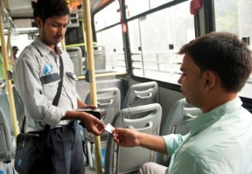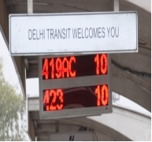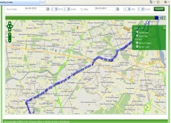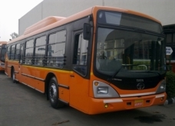

**DIMTS – ELECTRIC BUSES SOLUTION**

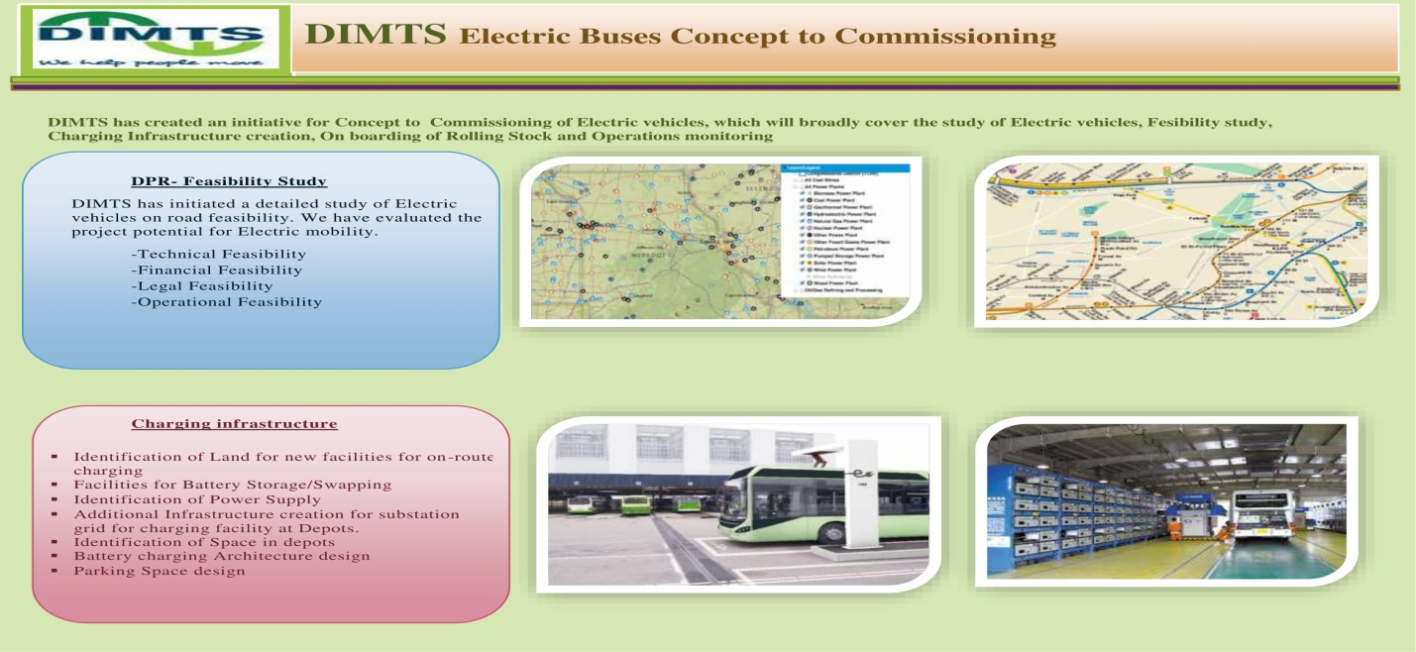

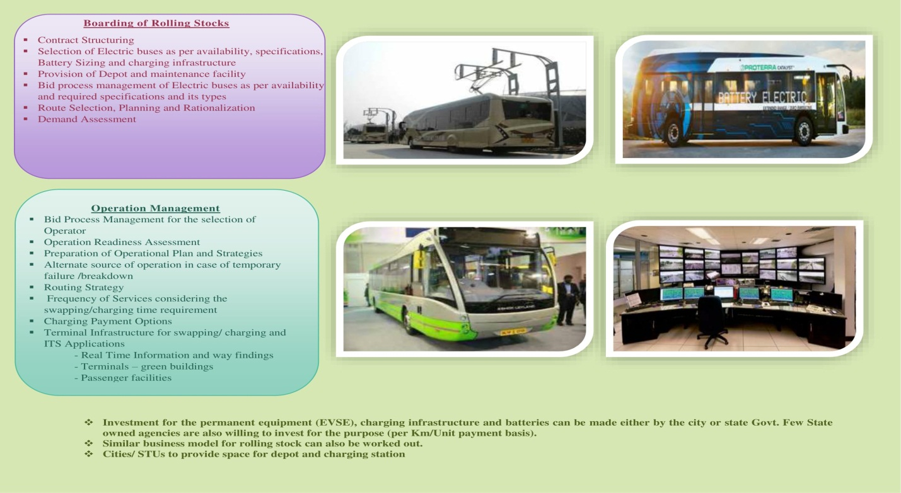

**DIMTS – SUPPORT TO THE PUNE CITY**

|  |  |  |
| --- | --- | --- |
| **S.No.** | **Document** | **Support** |
| 1 | Covering Letter | Client / DIMTS |
| 2 | General details about the City | Data to be provided by Client / Templates to be prepared and provided by DIMTS |
| 3 | Detailed Project Report | 1. Extensive interaction with the City Administration and all stakeholders 2. In detail analysis and study of existing Infrastructure reports like CMP, SCP, etc. (All city related reports and data to be provided by Client) |
| 4 | Funding Pattern | 1. All funding patterns to be explored including convergence 2. Exploration of Concessionaire formation |
| 5 | Documents related to tie-up with STUs for buses | Facilitate City Administration for tie-up with STU and SPV |
| 6 | Documents related to tie-up with 3W/4W aggregators | Identification of best available 3W/4W aggregators for the city and subsequently facilitate tie-up |
| 7 | Other papers / documents related to the Project (if any) | DIMTS is in regular interaction with the Power/ Renewable Energy Ministries, State Owned Agencies, Vehicle Manufacturers and other decision makers for smooth realization of City’s Electric Mobility proposal |

**PROJECT METHODOLOGY**

**TASK I: Project Inception**

* Mobilization of Team
* Secondary Data Collection (*CMP, Master Plan / Development Plan, Smart City proposal, STU/SPV Operation data, Other relevant documents/ reports related to city Electric mobility plan)*
* DIMTS will provide template for data collection.

**TASK II: Data Analysis and Draft report Preparation**

* Preparation of Study Area Profile, Analysis
* Draft Proposal Preparation
* Submission of Draft for Approval

**TASK III: Preparation of Final Report**

*-* Consultants will visit client, if required to obtain the relevant information and all the past studies conducted relevant for the project and also discuss various aspects for the completion of the project.

**PROJECT COSTING AND TIME**

**The cost of the above activity for the preparation of EOI response document would be INR 10 lacs only. (Excluding of all taxes**)

*Time period of 7 days will be required for the preparation of the proposal. (Data Collection to Submission of Final report by 30th Nov, 2017)*

*All efforts will be made to prepare a detailed report as required by DHI. In connection with this proposal, additional information required by DHI can be submitted subsequently.*

**WORK AWARDED ON NOMINATION**

|  |  |
| --- | --- |
| **S. No.** | **Details** |
| **Work Awarded on Nomination other than Government of Delhi** | |
| **1.** | Work Awarded on Nomination basis for Vehicle Tracking System from Ministry of Road Transport and Highways (MoRTH)  Implementation of scheme for setting up of National Level Vehicle Security and Tracking System & City Command and Control Centre for Security of women in Public Road Transport in the Country – award of Program Management Consultancy to DIMTS reg. |
| **2.** | Work Awarded on Nomination by IRSDC  Preparation of Technical & Financial Feasibility Study, Master Plan, Business Plan and providing Transaction and Bid Advisory Services for Development/Redevelopment and Anand Vihar (New Delhi) Railway Station on the Railway Network. |
| **3.** | Work Awarded on Nomination by NCRPB  National Capital Region Planning Board (NCRPB), awarded the work of Rail Rapid Transit System between Delhi – Meerut and Delhi – Panipat to DIMTS on nomination basis. |
| **4.** | Letter from Ministry of Urban Development to Various States  Ministry of Urban Development (MOUD), Urban Transport division vide letter dated 11th July, 2007 indicated that DIMTS (DIMTS is the dedicated transport unit setup by IDFC) may be considered for engagement |
| **5.** | Work awarded on nomination by Ahmedabad Municipal Corporation  Restoration & Repair of Signalized Intersections and Up-gradation of Signaling Control Room for Ahmedabad. |
| **6.** | Work Awarded on Nomination by Mumbai Metropolitan Region Development Authority (MMRDA), Mumbai  MMRDA awarded the work of conducting Technical and Financial Feasibility for Mono Rail in Bandra – Kurla Complex. The Letter of Acceptance for the study is |
| **7.** | Work Awarded on Nomination by Maharashtra State Road Development Corporation (MSRDC), Mumbai  MSRDC as per letter dated 21.02.2012, awarded the work of conducting Techno economic Feasibility Study of Personal Rapid Transit system in Mumbai on nomination basis. |
| **8.** | Work Awarded on Nomination basis from Department of Transport (DoT), Government of Himachal Pradesh   * Transaction Adviser’ for implementation of Vehicle Tracking System (VTS) * Advisory Services for Implementation of Radio Taxi Scheme in Himachal Pradesh * Advisory Services for Implementation of E-Delivery Services |
| **9.** | Work Awarded on Nomination basis from New Okhla Industrial Development Authority, NOIDA  New Okhla Industrial Development Authority awarded the project “Design report with specification & cost estimation for Noida-Greater Noida Expressway Highway Transport Management System (HTMS) Project. |
| **10.** | Work Awarded on Nomination basis from Transport Department, Government of Puducherry  Transport Department, Government of Puducherry awarded the project “Study for Preparation of Comprehensive Mobility Plan (CMP) for Puducherry. |

|  |  |
| --- | --- |
| **11.** | Work Awarded on Nomination from Uttarakhand Infrastructure Development Company Ltd. (U-DeC) for Transport Department Government of Uttarakhand    Preparation of Comprehensive Mobility Plan for Dehradun & Mussoorie for Transport Department, Govt. of Uttarakhand |
| **12.** | Work Awarded to DIMTS on Nomination by Haryana Urban Development Authority (HUDA)   * Design of Northern Peripheral Road from Dwarka to NH-8 in Gurgaon * Design of Southern Peripheral Road from Faridabad to NH-8 in Gurgaon |
| **13.** | Work Awarded to DIMTS on Nomination By Transport Department, Govt. of West Bengal  Consultancy Service in Finalization of Road Safety Action Plan for West Bengal |
| **Work Awarded on Nomination by Government of Delhi** | |
| **14.** | Work Awarded on Nomination from NDMC   * Turnkey Consultancy Services for Development of Foot Over-Bridges, Pedestrian Subways and Underpasses at Seven Locations in NDMC Area * Development & Management of Parking Lots under NDMC Area |
| **15.** | Cabinet Notes No. 1473 and 1032 from Transport Department regarding Terms on Engagement and Payment of DIMTS |
| **16.** | Installation of GPS / GPRS System in Para-transit vehicles (Auto Rickshaws, Balck and Yellow Taxies, Economy Radio Taxies and Gramin Sewa). |

**Some Important Works awarded on nomination by Transport Department, Govt. of NCT of Delhi**

* Implementation of GPS enabled Automatic Vehicle Tracking and Monitoring System with Passenger Information System (AVTMPS) in DTC buses on BRT Corridor
* Supply, Commissioning of Handheld ETM based Electronic Ticketing System
* Designing, Installation and Commissioning Intelligent Signaling System (ISS) at 17 Signalized Intersections of Ambedkar Nagar Delhi Gate BRT Corridor
* Route Rationalization of bus routes in Delhi
* Consultancy Services for Preparation of DPR for 7 New BRT Corridor in Delhi
* Consultancy Services for Feasibility Report for 6 BRT Corridors in Delhi
* Construction of ISBT at Dwarka, Narela, Anand Vihar, Sarai Kale Khan and Renovation/Up-gradation of ISBT at Kashmere Gate
* Upgrading of Monorail Feasibility Study for Delhi
* Issuance of “Smart Card based Driving License System, Permit Card System, Driver Badge System” on BOT basis
* Construction of 750 Bus Queue Shelters for Transport Department, Govt. of GNCTD of Delhi
* Project Management Consultancy work consisting of Construction of 500 BQS of Modern Stainless Steel Design for DTC by DIMTS
* Construction of 800 BQS being by DIMTS for Transport Department, Govt. of GNCTD of Delhi
* Construction of 750 Bus Queue Shelters for BRT Corridors from Ambedkar Nagar to Delhi Gate (Transport Department, Govt. of GNCTD of Delhi)
* Comprehensive Transport & Traffic Study for Delhi form Transport Department, Govt. of NCT of Delhi
* DPR for Delhi Personal Rapid Transit (PRT) System form Transport Department, Govt. of NCT of Delhi
* Project Advisory Services for Development of LRT in Delhi from Transport Department, Govt. of NCT of Delhi
* Operation of Private Stage Carriage Services in Cluster 1-9
* Implementation agency and implementation support for Water Tanker Distribution Management System