**AMAZON WEB SERVICES (AWS)**

* Amazon Web Services, Inc. (AWS) is a subsidiary of Amazon that provides on-demand cloud computing platforms and APIs to individuals, companies, and governments, on a metered pay-as-you-go basis.
* Amazon is one of the foremost and most reputed Cloud Computing service-provider.
* These cloud computing web services provide distributed computing processing capacity and software tools via AWS server farms.
* Product Offerings include:

Simple Storage Service (S3)

Elastic Compute Cloud (EC2)

Simple Queue Service (SQS)

Flexible Payments Service (FPS)

SimpleDB

* AWS's virtual computers emulate most of the attributes of a real computer, including hardware central processing units (CPUs) and graphics processing units (GPUs) for processing; local/RAM memory; hard-disk/SSD storage; a choice of operating systems; networking; and pre-loaded application software such as web servers, databases, and customer relationship management (CRM).

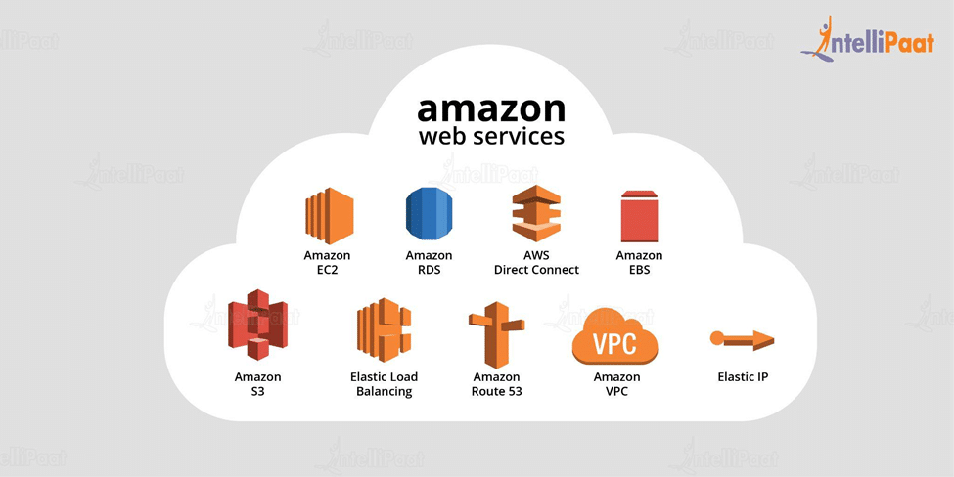

* AWS operates from many global geographical regions including 6 in North America.
* Amazon markets AWS to subscribers as a way of obtaining large-scale computing capacity more quickly and cheaply than building an actual physical server farm.
* All services are billed based on usage, but each service measures usage in varying ways.
* As of 2021 Q4, AWS has 33% market share for cloud infrastructure while the next two competitors Microsoft Azure and Google Cloud have 21%, and 10% respectively, according to Synergy Group

**AWS OFFERING**

▪ Low Ongoing Cost:, pay-as-you-go pricing with no up-front expenses or long-term commitments.

▪ Instant Elasticity & Flexible Capacity: (scaling up and down) Eliminate guessing on your infrastructure capacity needs.

▪ Speed & Agility: Develop and deploy applications faster Instead of waiting weeks or months for hardware to arrive and get installed.

▪ Apps not Ops: Focus on projects. Lets you shift resources away from data center investments and operations and move them to innovative new projects.

▪ Global Reach: Take your apps global in minutes.

▪ Open and Flexible: You choose the development platform or programming model that makes the most sense for your business.

▪ Secure: Allows your application to take advantage of the multiple layers of operational and physical security in the AWS data centers to ensure the integrity and safety of your data.

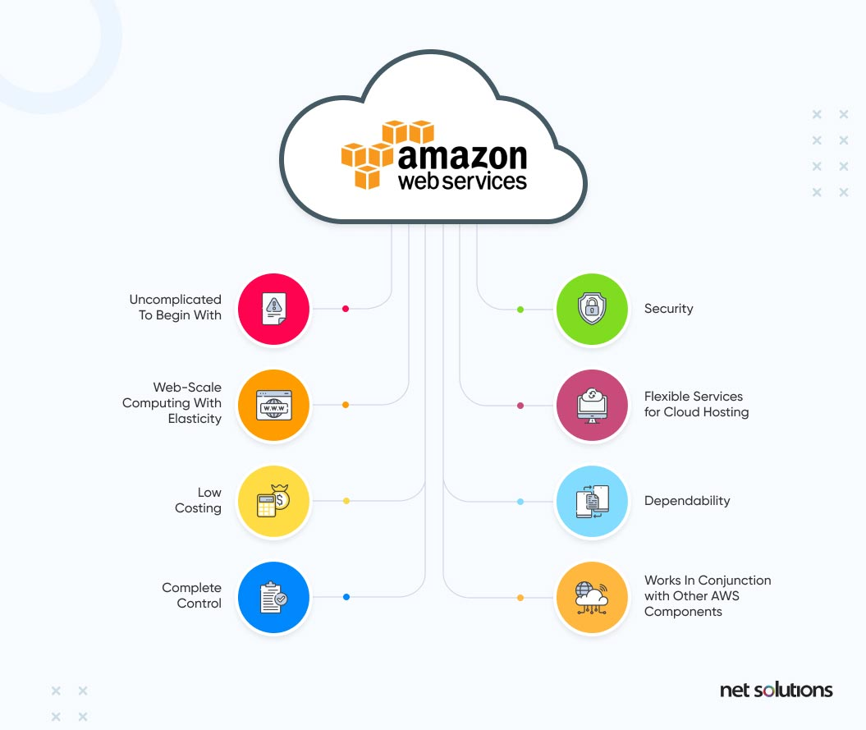

**India's Public Cloud Spending To Reach $7.5 Billion In 2022**

* The end-user spending on public cloud in India is likely to reach $7.5 billion in 2022 — growing 29.3 per cent from 2021, a Gartner report said on Tuesday.
* Cloud system infrastructure services (IaaS) is forecast to record the highest growth this year (39.4 per cent), followed by cloud application infrastructure services (PaaS).
* IaaS will also be the highest spending vertical for end-users in India in 2022.

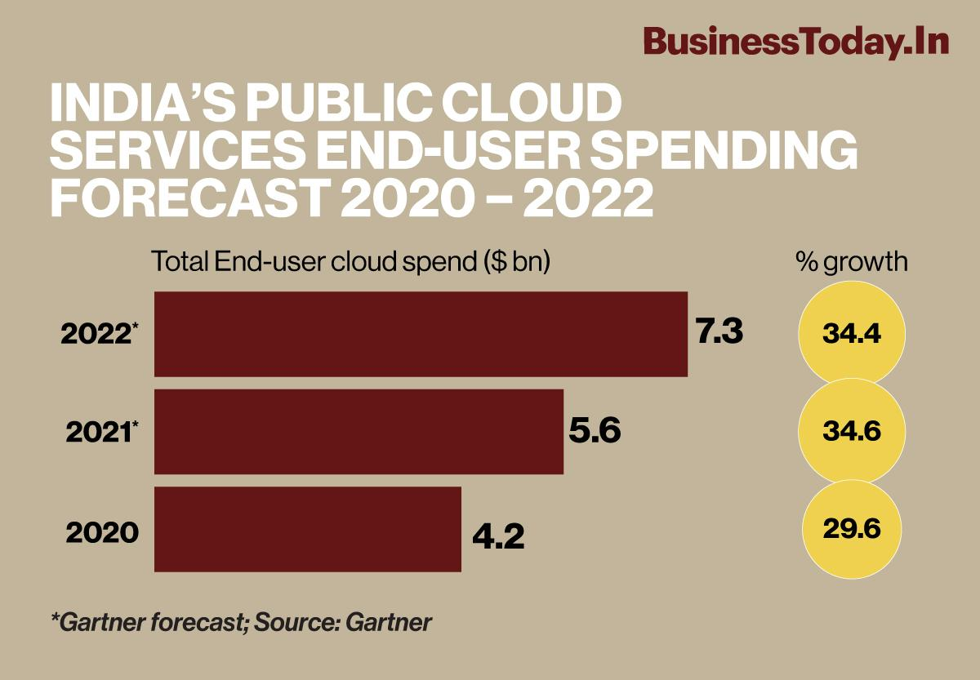

* In 2023, end-user spending is expected to reach nearly $600 billion.
* Global IaaS is forecast to experience the highest end-user spending growth in 2022 at 30.6 per cent, followed by desktop-as-a-service (DaaS) at 26.6 per cent and platform-as-a-service (PaaS) at 26.1 per cent.
* Software-as-a-service (SaaS) remains the largest public cloud services market segment, forecasted to reach $176.6 billion in end-user spending in 2022.

**Cloud Infrastructure Market in India 2022**  
  
Cloud infrastructure includes the essential components needed for cloud computing.

* Cloud computing involves the delivery of computing services such as servers, storage, software, databases, networking, and analytics to customers over the internet.
* IT, e-commerce, communication and media, telecom, manufacturing, transport, logistics, and retail are the sectors that have adopted cloud infrastructure to enhance day-to-day operations.
* Based on service type, the cloud infrastructure market is segmented into Infrastructure-as-a-Service (IaaS), Software-as-a-Service (SaaS), Platform-as-a Service (PaaS), Business Process-as-a-Service (BPaaS), and cloud management and security services.

**COVID-19 impact analysis:**

* The cloud infrastructure market in India is one of the few sectors that has emerged strong amid the pandemic.
* The COVID-19 pandemic resulted in a shift toward remote, virtual operations, because of which the demand for secure, reliable, scalable, and cost-effective technologies services went up.
* This resulted in higher cloud adoption and cloud infrastructure spending.
* The demand for e-learning, telemedicine, and remote working picked up on account of the growing application of cloud computing during the lockdown.
* Some of the other sectors that have become highly reliant on cloud computing services are banking, financial services, and insurance (BFSI), and manufacturing.

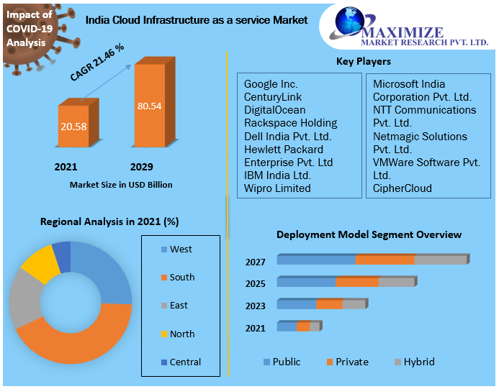

**India Cloud Computing Market- Industry Trends 2027**

* India cloud computing market is expected to grow at a CAGR of 28.1% during the forecast period.
* The high concentration and increasing number of small and medium-sized businesses in India that are rapidly shifting towards cloud computing is emerging as the major driving factor for the market.
* Furthermore, growing investment towards the construction of cloud data centers is expected to boost the India cloud computing market in the forecast period.

# Grid Computing Vs Cloud Computing

|  |  |
| --- | --- |
| Grid Computing is based on the Distributed Computing Architecture. | Cloud Computing is based on the Client-Server Architecture. |
| Scalability is normal. | Scalability is high. |
| While in grid computing, the users do not pay for use. | In cloud computing, the users pay for the use. |
| The user can access Grid Computing with grid middleware. | The user can access Cloud Computing with standard web protocols. |
| Grid computing uses service like distributed computing, distributed pervasive, distributed information. | Cloud computing uses service like IAAS, PAAS, SAAS. |
| In Grid Computing, the users do not have to set up anything. | In Cloud, Computing users do not have to set up anything |
| Grid Computing is a group of interconnected networks and resources which can process massive processing tasks. | In Cloud Computing, more than one computer works and coordinates with each other and resolves the problems together. |
| Grid Computing is less flexible compared to Cloud Computing. | Cloud Computing is flexible compared to Grid Computing. |

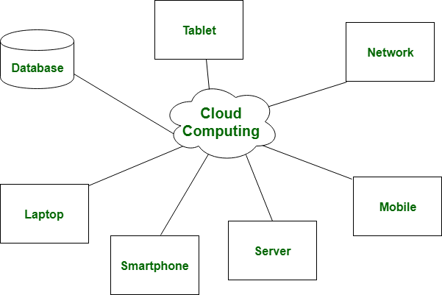

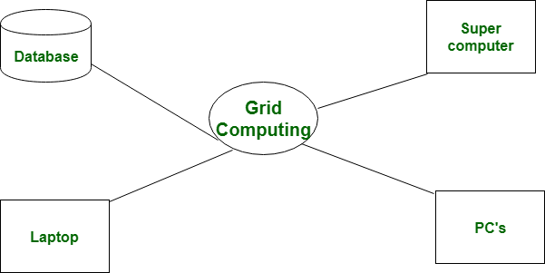

**PARALLEL COMPUTING VS DISTRIBUTED COMPUTING**

