[YOUR INSTITUTION NAME]
[SCHOOL / FACULTY OF COMPUTING AND INFORMATION TECHNOLOGY]
PROJECT TITLE:
CALCULATOR MANAGEMENT SYSTEM
(A C Programming Application with MySQL Database Integration via XAMPP)
Case Study: [Insert Case Study / Organization Name]
Presented by:
Name: [Your Full Name]
Registration Number: [Your Reg. Number]
Course/Program: [Your Course]
Year of Study: [Your Year]
Supervised/Assessed by: [Lecturer's Name]
Date: [Submission Date]

I. Description of the Project
The Calculator Management System is a console-based application developed in the C programming language that goes beyond a simple arithmetic calculator by integrating a MySQL database, hosted through XAMPP, to manage users and to permanently record every calculation performed. Unlike a traditional stand-alone calculator, this system requires each user to register an account and log in before they can access the calculator functions. Once authenticated, a user can perform basic and intermediate arithmetic operations such as addition, subtraction, multiplication, division, exponentiation, square root, and modulus. Every operation carried out is automatically stored in the database together with the operands, the operation performed, the result obtained, and the date and time of the transaction, allowing the user to retrieve a complete calculation history at any time.
The system therefore demonstrates the practical integration of a C application with a relational database using the MySQL Connector/C library, and illustrates core software engineering concepts including user authentication, data persistence, input validation, and modular program design.

II. Problem Statement
Conventional calculators, whether physical devices or simple software programs, perform arithmetic operations but do not retain any record of past calculations once the device is turned off or the program is closed. This makes it difficult for students, accountants, researchers, or any user who performs repeated or sensitive calculations to review, audit, or verify work done previously. In addition, such calculators do not distinguish between different users, meaning that there is no way to track who performed a particular calculation or to keep separate histories for different individuals sharing the same machine.
There is, therefore, a need for a calculator system that not only performs arithmetic operations accurately but also maintains a persistent, user-specific record of all calculations performed, secured behind a login mechanism. This project addresses that gap by combining a C-based calculator engine with a MySQL database managed through XAMPP, providing both computation and reliable data management in a single system.

III. Objectives
1. General Objective
To design and implement a Calculator Management System using the C programming language integrated with a MySQL database (via XAMPP) that allows registered users to perform arithmetic calculations and maintain a persistent history of those calculations.
2. Specific Objectives
- To design and create a relational database capable of securely storing user accounts and calculation records.
- To develop a user registration and login (authentication) module that restricts access to authorized users only.
- To implement core arithmetic operations (addition, subtraction, multiplication, division, power, square root, and modulus) within the C program.
- To connect the C application to the MySQL database using the MySQL Connector/C library so that every calculation performed is automatically saved.
- To provide a calculation-history feature that allows a logged-in user to view all calculations they have previously performed.

IV. System Requirements
1. Functional Requirements of the System
- The system shall allow a new user to register by providing a unique username and password.
- The system shall allow a registered user to log in using their username and password.
- The system shall reject login attempts with incorrect credentials.
- The system shall allow a logged-in user to perform addition, subtraction, multiplication, division, power, square root, and modulus operations.
- The system shall validate user input (e.g., prevent division by zero and square roots of negative numbers).
- The system shall save every calculation performed, together with the operands, operation type, result, and timestamp, to the database.
- The system shall allow a logged-in user to view their own calculation history.
- The system shall allow a user to log out of the system.
2. Non-Functional Requirements of the System
- Performance: The system shall return calculation results and database confirmations within one second under normal load.
- Security: Passwords and user input shall be safely escaped before being used in SQL queries to prevent SQL injection.
- Usability: The console menus shall be simple, clearly labelled, and easy for a first-time user to navigate.
- Reliability: The system shall handle invalid input and database connection failures gracefully, without crashing.
- Portability: The system shall run on any machine with XAMPP (MySQL) and the MySQL Connector/C library installed.
- Maintainability: The source code shall be modular, with each function handling a single, clearly defined responsibility.

V. Algorithm Design
1. Pseudocode of the System
START
CONNECT to MySQL database (calculator_db) via XAMPP
IF connection FAILS THEN
DISPLAY error message
EXIT
ENDIF

REPEAT
DISPLAY Main Menu (1-Register, 2-Login, 3-Exit)
READ mainChoice

CASE mainChoice OF
1: CALL registerUser()
2: IF loginUser() = TRUE THEN
REPEAT
DISPLAY User Menu (1-Calculate, 2-View History, 3-Logout)
READ userChoice
CASE userChoice OF
1: CALL performCalculation()
2: CALL viewHistory()
3: LOGOUT
ENDCASE
UNTIL userChoice = 3 (Logout)
ENDIF
3: EXIT PROGRAM
ENDCASE
UNTIL mainChoice = 3

FUNCTION registerUser()
READ username, password
ESCAPE username, password
INSERT INTO users (username, password) VALUES (username, password)
END FUNCTION

FUNCTION loginUser() RETURNS boolean
READ username, password
ESCAPE username, password
SELECT user_id FROM users WHERE username = username AND password = password
IF a matching row is found THEN
SET current_user_id
RETURN TRUE
ELSE
RETURN FALSE
ENDIF
END FUNCTION

FUNCTION performCalculation()
DISPLAY operation menu (+, -, *, /, ^, sqrt, %)
READ operation choice and operand(s)
IF operation is invalid (e.g. divide by zero) THEN
DISPLAY error
RETURN
ENDIF
COMPUTE result
DISPLAY result
CALL saveCalculation(operand1, operand2, operation, result)
END FUNCTION

FUNCTION saveCalculation(op1, op2, operation, result)
INSERT INTO calculations (user_id, operand1, operand2, operation, result)
VALUES (current_user_id, op1, op2, operation, result)
END FUNCTION

FUNCTION viewHistory()
SELECT * FROM calculations WHERE user_id = current_user_id ORDER BY calc_date DESC
DISPLAY each row
END FUNCTION
END
2. Flowchart Diagram of the System
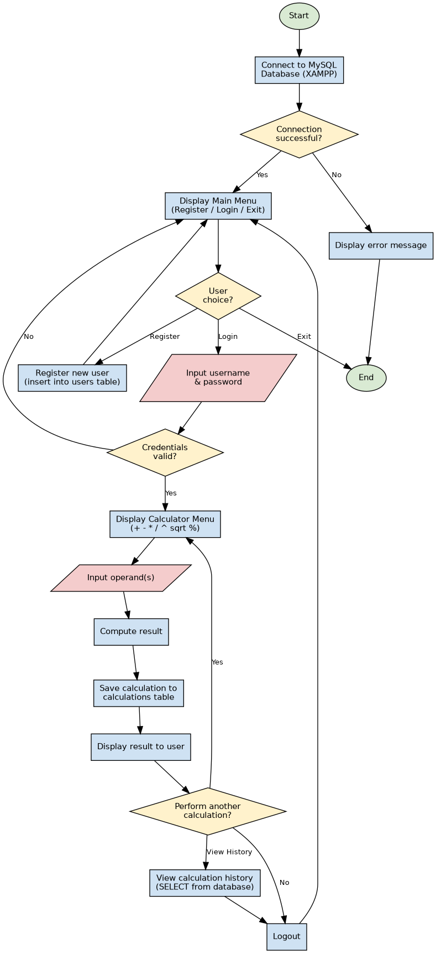
Figure 1: Flowchart of the Calculator Management System

VI. Database Design
1. Entity Relationship Diagram (ERD) of the System
The database consists of two entities: users, which stores the credentials of every registered user, and calculations, which stores every calculation performed together with a foreign key linking it back to the user who performed it. The relationship between the two entities is one-to-many: one user can perform many calculations, but each calculation record belongs to exactly one user.
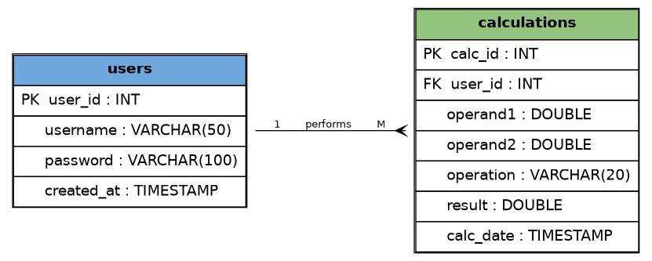
Figure 2: Entity Relationship Diagram (ERD) for the Calculator Management System

VII. System Implementation
The system was implemented in the C programming language and connects to a MySQL database managed through XAMPP using the MySQL Connector/C library (mysql.h). The full annotated source code (calculator.c) and the database creation script (database.sql) accompany this report as separate files. Below is a summary of the implementation steps, followed by placeholders for the screenshots of the running system.
1. Screenshots of the System
[Insert screenshot: XAMPP Control Panel with Apache and MySQL running]
[Insert screenshot: Main Menu of the Calculator Management System (Register / Login / Exit)]
[Insert screenshot: Successful user registration]
[Insert screenshot: Successful login]
[Insert screenshot: Calculator menu and a sample calculation being performed]
[Insert screenshot: Calculation history retrieved from the database]
[Insert screenshot: phpMyAdmin view showing the users and calculations tables with data]

VIII. Conclusion and Recommendations
1. Conclusion
The Calculator Management System successfully demonstrates the integration of a C console application with a MySQL database through XAMPP. The system meets its stated objectives by allowing users to register, authenticate, perform a range of arithmetic operations, and retrieve a persistent history of their calculations. This project confirms that even a conceptually simple tool such as a calculator can be enhanced significantly through database integration, resulting in a system that offers accountability, data persistence, and multi-user support that a traditional calculator cannot provide.
2. Recommendations
- Passwords should be hashed (for example using SHA-256 or bcrypt) rather than stored in plain text, to improve security in any future or production version of the system.
- A graphical user interface (GUI), for example using GTK or a web front end, could be developed to replace the console interface and improve usability.
- Additional scientific calculator functions (trigonometric functions, logarithms, factorials) could be added to extend the system's functionality.
- An administrator role could be introduced to allow monitoring of all users' activity and management of user accounts.
- Input validation could be further strengthened, and unit tests could be added to verify each arithmetic function independently.

