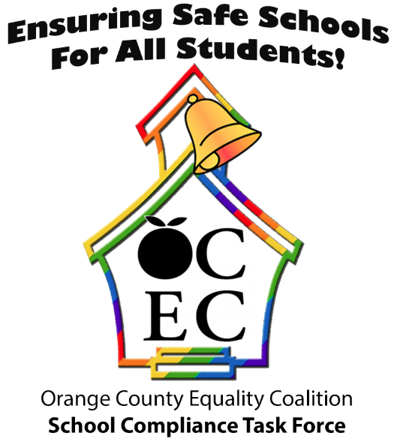
Orange County Equality Coalition (OCEC)
School Compliance Task Force
5405 Alton Pkwy., Suite A-250
Irvine CA 92604
Phone: 714.625.3616
ocec-school-compliance-task-force@googlegroups.com
http://www.ocequality.org

NOTE: Text in green offers instructions for filling out this form and can be deleted before you turn in the form to the district or school. Please contact the OCEC School Compliance Task Force if you would like us to file this form on your behalf.

Uniform Complaint Procedure Discrimination/Harassment Complaint Reporting Form

In accordance with the District’s Uniform Complaint Procedures (5 CCR 4620) each school district shall follow uniform complaint procedures when addressing complaints alleging unlawful discrimination against any protected group. Protected groups put forth under Title IX and in California are enumerated by Education Code §§ 200 and 220,Government Code §11135, and include actual or perceived sex, sexual orientation, gender, ethnicity, race, ancestry, national origin, religion, color, mental or physical disability, and age, as well as association with member of a protected class. Additionally, it is the policy of the State of California, pursuant to Section 200, that all persons should enjoy freedom from discrimination and/or harassment of any kind in the educational institutions of the state. This also includes sexual harassment, which is a form of sexual discrimination (EC § 231.5).

I. Complainant Contact Information: Your contact information goes here or, the OCEC School Compliance Task Force can also be the contact person for this complaint. If this is the case, re-enter the OCEC SCTF info from above here.

Name: ______________________________________________________________
Address: _____________________________________________________________
City: __________________________ Zip: __________________________________
Home Phone: _________________ ________ Work or Cell Phone: _______________

II. Complainant
You are filing this complaint on behalf of: ____________________________________
yourself your child or a (student) another student a group

III. School Information
School Name: _________________________________
Principal’s Name: ______________________________
Address: ________________________________ City: __________ _____________

IV. Basis of Complaint: Check as many boxes as apply.
Please check the following box(s), based on the type(s) of discrimination, harassment, intimidation and bullying you experienced, (Education Code §§ 200 and 220)
Discrimination or harassment in programs receiving state financial assistance based on one of the following protected classes must be handled in accordance with California State law and Education Codes:

 Ethnic Group Identification |  Sex (Title IX) |  National Origin
 Religion |  Sexual Orientation |  Physical or Mental Disability
 Age |  Race/Color |  Gender Identity/Expression
 Gender |  Ancestry |  Ethnicity

V. Details of Complaint
Please answer the following questions to the best of your ability. Attach additional sheets of paper if you need more space. Write what you know and do not worry if some sections are blank or incomplete.

Please describe the type of incident(s) you experienced that led to this complaint, including the events or actions, in as much detail as possible:
______________________________________________________________________
______________________________________________________________________
______________________________________________________________________
______________________________________________________________________

List the individuals involved in the incident(s) complaint of:
______________________________________________________________________
______________________________________________________________________
______________________________________________________________________

List any witnesses to the incident(s):
______________________________________________________________________
______________________________________________________________________

Describe the location where the incident(s) occurred:
______________________________________________________________________
______________________________________________________________________
______________________________________________________________________
______________________________________________________________________

Please list date(s) and times when the incident(s) occurred or when the alleged acts first came to your attention:
______________________________________________________________________
______________________________________________________________________
______________________________________________________________________

What steps, if any, have been taken to resolve this issue?
______________________________________________________________________
______________________________________________________________________
______________________________________________________________________
______________________________________________________________________

__________________________________ _____________________
Signature of person filing complaint Date
Please sign and date above and then deliver to school or district office. You might deliver it directly to the Title IX Officer but this is not necessary; anyone who represents the school can take your complaint, including a person at the front desk. Ask the school/district person who takes the complaint to date stamp it and give you a copy of this date-stamped page. Please contact the Task Force if you would like us to do this for you.

*****************************************************************************************
NOTE TO SCHOOL/DISTRICT: If you would like more information about coming into compliance with state and federal safe school laws, including Title IX, the OCEC School Compliance Task Force can arrange trainings for school employees free of charge.

In addition, you can refer to the following resources:

The California Department of Education Information on Title IX: http://www.cde.ca.gov/re/di/eo/genequitytitleix.asp

The U.S. Department of Education Title IX and Sex/Gender Discrimination Statutes: http://www2.ed.gov/about/offices/list/ocr/docs/tix_dis.html

The U.S. Departments of Justice and Education Joint Guidance to Help Schools Ensure the Civil Rights of Transgender Students: https://www.justice.gov/opa/pr/us-departments-justice-and-education-release-joint-guidance-help-schools-ensure-civil-rights
The California Department of Education Uniform Complaint Procedures (UCP) Brochure: http://www.cde.ca.gov/re/cp/uc/documents/ucpbrochure.doc

The ACLU of Southern California LGBTQ Student Rights Project: https://www.aclusocal.org/issues/lgbt-equality/student-rights-project/

*****************************************************************************************

FOR DISTRICT/SCHOOL USE:

Date complaint received: staff member who received complaint: ____

Date complaint forwarded to Compliance Officer:

Compliance Officer Designation:

