TRIBHUVAN UNIVERSITY
Institute of Science and Technology


Central Department of Computer Science and Information Technology
Kirtipur, Kathmandu, Nepal

Seminar Report on:
“Leveraging RNNs and LSTMs for Emoji Prediction”
In Partial fulfillment of the requirement for Master’s Degree in Computer Science and Information Technology(M.Sc.CSIT), 1st Semester

Under the Supervision of
Dr. Dhiraj Kedar Pandey

Submitted To:
Central Department of Computer Science and Information Technology

Submitted By:
Priya Shrestha
(Roll No:24/081)
November 2025
TRIBHUVAN UNIVERSITY
Institute of Science and Technology

SUPERVISOR’S RECOMMENDATION
This is to certify that Ms. Priya Shrestha (Roll no. 24/081) has successfully completed a seminar report on “Leveraging RNNs and LSTMs for Emoji Prediction” under my supervision. This seminar is a partial fulfilment of the requirements for the degree of Master of Science in Computer Science and Information Technology(M.Sc.CSIT). The seminar paper demonstrates a comprehensive understanding of the subject matter and contributes to the academic discourse in the field of neural networks. I hereby, declare that this seminar report be processed for evaluation and consideration as part of the first semester curriculum.

____________________
Supervisor
Dr. Dhiraj Kedar Pandey
Central Department of Computer Science and Information Technology
Kirtipur, Kathmandu, Nepal

TRIBHUVAN UNIVERSITY
Institute of Science and Technology

LETTER OF APPROVAL

This is to certify that this seminar report prepared by Priya Shrestha [8115034] entitled “Leveraging RNNs and LSTMs for Emoji Prediction” in partial fulfillment for the requirement of Master’s Degree of Computer Science and Information Technology has been well studied. In our opinion, it is satisfactory in scope and quality as a seminar for the required degree.
Evaluation Committee
…………………………………….  Asst. Prof. Sarbin Sayami  Head of Department  Central Department of CSIT | …………………………………….  Dr. Prof. Dhiraj Kedar Panday  Supervisor  Central Department of CSIT
…………………………………….  External Examiner | …………………………………….  Internal Examiner

ACKNOWLEDGEMENT
The success and final outcome of this report required a lot of guidance and assistance from many people and I am very fortunate to have got this all along the completion. I am very glad to express my deepest sense of gratitude and sincere thanks to my highly respected and esteemed supervisor Dr. Dhiraj Kedar Pandey, Central Department of Computer Science and Information Technology for his valuable supervision, guidance, encouragement, and support for completing this report.
I am also thankful to Asst. Prof. Sarbin Sayami (HOD of Central Department of Computer Science and Information Technology) for his constant support throughout the period. His unwavering commitment to academic excellence has fostered an enriching learning environment for all students within the department.

Furthermore, with immense pleasure, I submit by deepest gratitude to the Central Department of Computer Science and Information Technology, Tribhuvan University, and all the faculty members of CDCSIT for providing the platform to explore the knowledge of interest.

Last but not the least, I would like to thank everyone who took participated in this report whether directly or indirectly. Your contributions have been instrumental in its success. Finally, I want to express our gratitude towards all the teachers, teammates and companions who greatly contributed and fueled my determination for the successful completion of this report.

Priya Shrestha [24/081]

ABSTRACT
Emojis play a vital role in modern digital communication, offering a visual and emotional layer to text-based conversations. With the growing popularity of social media platforms and messaging apps, accurately predicting emojis based on text has become a valuable application in natural language processing. The burgeoning field of emoji prediction using Natural Language Processing (NLP) and deep learning techniques is explored, particularly focused on Recurrent Neural Network (RNNs) and Long Short-Term Memory (LSTM) Networks. This seminar report uses Recurrent Neural Network (RNN) and Long Short-Term Memory (LSTM) networks, a type of recurrent neural network capable of learning long-term dependencies in sequential data. The objective is to enhance digital communication by accurately predicting emojis based on text inputs, thus improving user engagement and expressiveness.
The LSTM model effectively addresses the complexities of emoji prediction including the nuances of informal language and the challenge of interpreting emotions. However, challenges such as dataset imbalance and the inherent complexity of capturing diverse emotional expressions remain. The model is implemented using Python and libraries like pandas, TensorFlow, and Keras. The model’s performance is evaluated using metrics such as accuracy, precision, recall, and F1-score. Recommendations for future enhancements and research include addressing dataset imbalances and incorporating advanced techniques like attention mechanisms.
Keywords: Emojis, Natural Language Processing (NLP), Recurrent Neural Networks (RNN), Long Short-Term Memory (LSTM), Tokenization, Emoji Prediction

TABLE OF CONTENTS

SUPERVISOR’S RECOMMENDATION ii
LETTER OF APPROVAL iii
ACKNOWLEDGEMENT iv
ABSTRACT v
TABLE OF CONTENTS vi
LIST OF ABBREVIATIONS viii
LIST OF FIGURES ix
CHAPTER 1: INTRODUCTION 1
1.1 Introduction 1
1.2 Problem Statement 2
1.3 Objectives 2
1.4. Report Organization 3
CHAPTER 2: LITERATURE REVIEW 4
2.1 Background Study 4
2.2. Literature Review 5
CHAPTER 3: METHODOLOGY 7
3.1 Conceptual Framework 7
3.2 Data Collection and Preparation 7
3.2.1 Text Encoding 8
3.2.2 Model Construction 8
3.2.3 Model Training 8
3.2.4 Model Evaluation 9
3.2.5 Model Deployment 9
3.3 Algorithm Description 9
Chapter 4: Implementation and Result Analysis 13
4.1 Implementation 13
4.1.1 Implementation Tools Used 13
4.1.2 Implementation Details 13
4.2 Result Analysis. 14
Performance Metrics and Model Performance 16
CHAPTER 5: CONCLUSION AND FUTURE RECOMMENDATIONS 19
5.1. Conclusion 19
5.2. Future Recommendations 20
REFERENCES 21
APPENDIX 23

LIST OF ABBREVIATIONS
The significance of numerous abbreviations and acronyms used throughout the report is described in the following lists.

Abbreviations  CSV  GLOVE  LSTM  NLP  NN  RNN | Acronyms  COMMA – SEPARATED VALUE  GLOBAL VECTOR REPRESENTATION  LONG SHORT-TERM MEMORY  NATURAL LANGUAGE PROCESSING  NEURAL NETWORK  RECURRENT NEURAL NETWORK

LIST OF FIGURES
Figure 3.1: Flowchart………………………………………………………………….6
Figure 3.2: Data Collection and Preparation…………………………………………..7
Figure 3.3.1: RNN Model……………………………………………………………..10
Figure 3.3.1: LSTM Model……………………………………………………………11
Figure 2: Import Libraries and Read Data………………………….…………………20
Figure 3: Install and Import Emoji Library ……………………….…………………..20
Figure 4: Define Emoji Dictionary and Label Mapping Function…………….……....20
Figure 5: Prepare Data…………………………………………….……………...........21
Figure 6: Tokenize and Pad Sequences………………………….………………..........21
Figure 7: Perform Embedding ………………………….……………………….……..22
Figure 8: Build and Train the Model………….…………………..……….………..….24
Figure 9: Predict on New Data…………………………………….……………..…….25
Figure 4.2.1: Emoji Prediction Confusion Matrix(RNN)………………………………15
Figure 4.2.2: Emoji Prediction Confusion Matrix(LSTM)……………………………..16
Figure 4.2.3: Performance Metrics and Performance Model….……………..………....18

CHAPTER 1: INTRODUCTION

1.1 Introduction
In today’s digital era, expressive communication has become the dominant form of online interaction. Social media usage has grown to unprecedented levels, with more than 5 billion individuals actively engaging on platforms in 2024 [1]. Yet, plain text often falls short in capturing the full range of human emotions. Emojis (small graphical icons) have emerged as a powerful medium of digital expression, acting as visual symbols to convey emotions, sentiments, and context beyond plain words [2].
With the rapid expansion of platforms such as Twitter, Facebook, and Instagram, emojis have become an integral part of online communication, bridging cultural and linguistic gaps [3]. The concept of emojis originated in 1999 when Japanese mobile carrier NTT DoCoMo introduced the first set of 176 emojis. The term “emoji” itself comes from the Japanese words “e” (picture) and “moji” (letter). Since then, emojis have evolved into a global digital language, gaining widespread adoption on iOS in 2011 and WhatsApp in 2013 [4].
At the heart of this project lies the LSTM network, a type of recurrent neural network specifically designed to capture long-term dependencies in sequential data. By leveraging pre-trained embeddings such as GloVe, the model can represent text in a semantic vector space, enabling it to capture context beyond individual keywords [5]. Earlier approaches—such as rule-based systems and probabilistic models—struggled with ambiguity and contextual understanding, while deep learning methods, particularly LSTMs, have demonstrated superior performance by modeling sequential dependencies and richer semantics [6].
This project focuses on designing, implementing, and evaluating an LSTM-based emoji prediction system trained on sentences labeled with corresponding emojis. By experimenting with word embeddings and sequential modeling, the study investigates how effectively LSTMs capture sentence-level semantics for emoji prediction. The findings not only highlight the potential of LSTMs in expressive communication tasks but also contribute to broader research in sentiment analysis, multimodal communication, and contextual language understanding [7].

1.2 Problem Statement
Prediction of emojis, despite its apparent simplicity, presents significant challenges due to the complexity and ambiguity of natural language. Firstly, determining the most contextually appropriate emoji from subtle and nuanced text requires understanding semantic meaning, emotional tone, and informal expressions, making it a non-trivial classification problem. Secondly, keyword-matching approaches based on the language used in chats often fail to capture context, leading to inaccurate or irrelevant predictions due to the prevalence of colloquial expressions and informal language.
Additionally, the imbalance in emoji usage across datasets where certain emojis appear far more frequently than others—further complicates model training, potentially biasing predictions toward popular emojis. Short or ambiguous sentences, sarcasm, and cultural variations in emoji interpretation add to the challenge. Therefore, there is a critical need for models, such as LSTM-based deep learning networks, that can effectively learn sequential dependencies, capture semantic and emotional nuances, and make accurate emoji predictions while maintaining computational efficiency. The primary challenge in emoji prediction is the lack of context-specific user data. Since the same emoji can convey different meanings depending on the user, having user-specific information makes it easier to generate accurate predictions.

1.3 Objectives
The main objective of this seminar includes:
- To accurately predict the most suitable emoji for a given text by capturing semantic meaning and emotional context using both RNN and LSTM model.
- To explore and evaluate the effectiveness and performance of LSTM networks in learning sequential patterns and handling informal language, slang, and contextual ambiguity for reliable emoji prediction using metrices.

1.4. Report Organization
The remainder of this report is organized into five chapters:
- Chapter 1: Introduction Provides an overview of the research, including the background, problem statement, objectives and the structure of the report.

- Chapter 2: Literature Review Surveys prior research on emoji prediction, sentiment analysis, and deep learning approaches such as RNNs and LSTMs. It also highlights existing research gaps and challenges.

- Chapter 3: Methodology Describes the dataset, preprocessing techniques, model architecture, word embeddings, training procedure, and evaluation metrics used in the project.

- Chapter 4: Implementation and Results Details the implementation of the LSTM-based emoji prediction model, system architecture, tools used, and presents experimental results with analysis.

- Chapter 5: Conclusion and Future Work Summarizes key findings, discusses model performance, limitations, and provides recommendations for future improvements in emoji prediction systems.

In addition, the report includes:
- References A complete list of cited works.
- Appendix Contains supporting code, datasets, and supplementary material.

CHAPTER 2: LITERATURE REVIEW

2.1 Background Study
Emojis have become an essential part of digital communication, adding a visual and emotional layer to text messages that plain words often cannot convey. They help express moods, feelings, and subtle nuances, making online conversations more engaging and expressive [1][2]. Predicting the right emoji based on text is a challenging task in Natural Language Processing (NLP) because it requires understanding context, emotion, and meaning in often short, informal, or ambiguous sentences.
Early approaches to emoji prediction relied on simple keyword matching or rule-based methods. These methods were limited because they often failed to capture context, slang, abbreviations, or informal expressions commonly used in chats and social media [3]. Probabilistic models improved on this by estimating the likelihood of emojis for certain words or phrases, but they still struggled with sequential dependencies and emotional subtleties.

Deep learning, especially Long Short-Term Memory (LSTM) networks, offers a better solution. LSTMs can learn patterns in sequences of words, understand context, and capture the meaning of sentences, which is crucial for accurate emoji prediction [4][5]. Using pre-trained word embeddings like GloVe further improves the model’s understanding by mapping words into semantic vector spaces, allowing it to recognize subtle differences in meaning.

Despite these advancements, challenges remain, including dataset imbalance, sarcasm, cultural differences in emoji usage, and short or ambiguous text [6][7]. Still, LSTM-based models provide a powerful framework for predicting emojis, helping make digital communication more expressive, accurate, and engaging.

Moreover, studies demonstrate that LSTM-based models perform well across different languages and writing styles, such as in emoji prediction for Arabic microblogs using deep recurrent neural networks [12]. Recent research explores improvements such as emoji embeddings, sentiment-aware emoji prediction, and attention mechanisms that help the model focus on emotionally relevant words [14]. Context-aware models show that emoji usage patterns vary across users and contexts, indicating that personalization further improves prediction results [15].
In summary, emoji prediction is a complex NLP task that combines sequential language modeling, semantic understanding, and emotion recognition. LSTM-based deep learning models, enhanced with pre-trained embeddings, provide a robust framework to tackle these challenges, enabling more accurate and context-aware emoji predictions, which ultimately enhance expressiveness and engagement in digital communication.

2.2. Literature Review
Extensive research has been conducted on emoji prediction, demonstrating a variety of approaches and their relative effectiveness. Early methods primarily relied on rule-based or keyword-matching techniques, where specific words or phrases in a sentence were mapped to corresponding emojis [1]. While computationally simple, these approaches often failed to capture context, colloquial expressions, or the nuanced emotional meaning of text, leading to inaccurate predictions [2].

Machine learning methods, particularly probabilistic models such as Naive Bayes or logistic regression, were introduced to improve prediction by estimating the likelihood of an emoji given the text [3]. These models incorporated text features like bag-of-words or TF-IDF vectors, offering better performance than rule-based methods. However, they were limited in handling sequential dependencies, contextual meaning, and long-range semantic relationships in sentences [4].

The advent of deep learning, specifically Recurrent Neural Networks (RNNs) and Long Short-Term Memory (LSTM) networks, marked a significant improvement in emoji prediction. LSTMs can model sequential patterns and capture long-term dependencies in text, allowing for a deeper understanding of context, emotion, and semantic nuances [5]. Integrating pre-trained word embeddings such as GloVe further enhanced these models by providing semantic representations of words, which enabled more accurate emoji predictions even in informal or ambiguous text [6].

Recent advancements include attention mechanisms and multimodal approaches, where
models consider additional context such as images, social interactions, or emoji co-occurrence patterns [7]. Attention-based LSTM models allow the network to focus on the most relevant words in a sentence for predicting emojis, improving accuracy and handling complex sentence structures [8] Despite these advances, challenges such as dataset imbalance, sarcasm, short text, cultural differences, and rare emoji predictions remain prevalent, requiring careful model design and evaluation.[9]

Collectively, these research efforts highlight emoji prediction as a rich testbed for evaluating NLP techniques that must balance semantic understanding, contextual reasoning, and efficient sequence modeling [10]. Further exploration of deep learning architectures, attention mechanisms, and multimodal strategies is expected to enhance the accuracy and applicability of emoji prediction models in real-world digital communication [11]

In addition, transformer-based architectures like BERT and GPT have shown strong capabilities in contextual text understanding and are increasingly being applied to emoji prediction tasks [12]. Hybrid approaches combining sentiment analysis with emoji prediction have demonstrated improved accuracy by aligning emotional tone with appropriate emoji output [13]. Researchers have also explored data augmentation and transfer learning techniques to address dataset imbalance and improve generalization in low-resource scenarios [14]. Finally, recent studies highlight the need to incorporate personalization and user preference modeling, as emoji usage patterns vary between individuals and cultures, making personalized prediction a promising future direction [15].

CHAPTER 3: METHODOLOGY

3.1 Conceptual Framework
The conceptual framework for this research is structured to systematically develop, train, and evaluate deep learning models for emoji prediction. The process follows several sequential steps as outlined below:
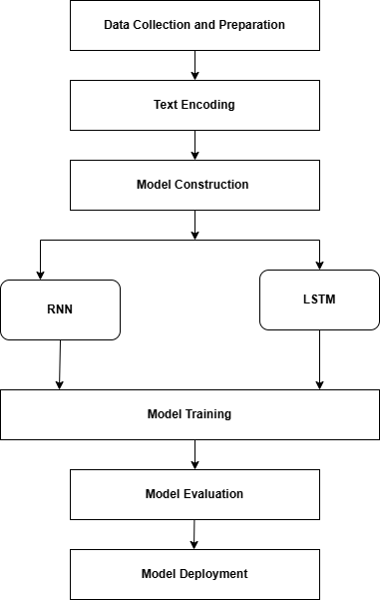

Figure 3.1: Flowchart of proposed model

3.2 Data Collection and Preparation
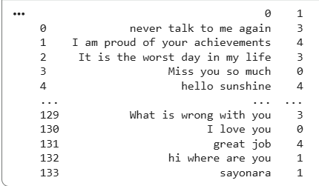

Figure 3.2: Data Collection and Preparation

Begins by gathering textual dataset collected from various sources such as publicly available datasets, web scraping, or user input data along with associated emojis to serve as the training and testing datasets. The collected data may contain noise, missing values, or irrelevant content. Therefore, preprocessing steps such as cleaning unwanted characters, tokenization, and normalization are performed. The main objective of this step is to ensure that the data is consistent and ready for encoding and further processing.

3.2.1 Text Encoding
Machine learning models cannot process raw text, so encoding is required. The cleaned text is then tokenized breaking it into individual words or subwords. These tokens are transformed into sequences of numbers and padded to maintain equal input length. Pre-trained word embeddings (e.g., GloVe) are then used to convert words into dense vector representations that capture contextual meaning. These embeddings serve as input to the neural network.

3.2.2 Model Construction
In this step, different types of recurrent neural network architectures are designed and experimented with:
- RNN: Basic recurrent architecture that processes sequences but struggles with long-term dependencies.
- LSTM (Long Short-Term Memory): An improved advanced recurrent neural network that introduces memory gates to handle long-range dependencies and overcome the vanishing gradient problem.
These models are built with layers such as Embedding, LSTM, Dense, and Dropout for regularization.

3.2.3 Model Training
The prepared dataset is split into training and validation sets. During training, the model learns the relationship between text sequences (input) and emojis (output). Optimization techniques such as Adam and loss functions like categorical cross-entropy are used to minimize error. Hyperparameters such as batch size, number of epochs, and learning rate are tuned for better performance. The objective of this step is to minimize the error between predicted and actual output while improving model accuracy.

3.2.4 Model Evaluation
Once training is completed, each model is evaluated using metrics like accuracy, precision, recall, and F1-score. Confusion matrices are also analyzed to examine prediction performance across emoji categories. This step helps to determine which architecture performs best for emoji sentiment classification.

3.2.5 Model Deployment
The best-performing model is saved and deployed so it can be used for real-time emoji prediction. During deployment, the model takes a text input from the user, processes it through the same encoding steps, and outputs the most suitable emoji based on the learned patterns. This enables integration into applications such as chat systems or sentiment-aware messaging platforms.

3.3 Algorithm Description
This section describes the four deep learning models implemented for the task of emoji prediction from textual input. The aim is to predict an emoji that best represents the meaning, mood, or sentiment expressed in a given sentence. Each model processes the input text as a sequence of words, learns contextual patterns, and outputs the most probable emoji class. Let the input text be represented as X=[x₁, x₂​, x₃​,…,x_{T}​]
where $x_{t}$ is the word embedding at time step $t$, and $T$ is the sequence length.
Each model computes a sequence of hidden states $h_{t}$, which encode contextual information, and then passes the final state to a softmax classifier for emoji prediction.
a. RNN (Recurrent Neural Network)
- Concept:
Recurrent Neural Network are a type of neural network where the output from previous step is fed as input to the current step. RNN maintains a hidden state (“memory”) that stores information from previous inputs, allowing the network to use past context when making predictions. It processes text word by word, keeping track of information through a hidden state that gets updated at each step. This hidden state represents what the network remembers about the sentence so far. Each new word updates the hidden state based on both the current word and the previous state. After processing all words, the final state is used to predict which emoji best represents the entire sentence.
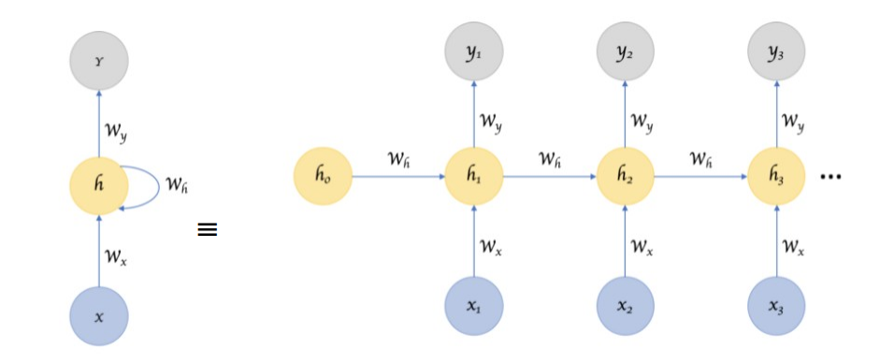

Figure 3.3.1: RNN Model

- Mathematical Operation:
At each time step t:
h_{t}​=tanh(W_{x}X_{t} +W_{h}h_{t-1} + b_{h)}
$$\hat{y}=\text{softmax}(W_{y}h_{t}+b_{y})$$where,
- $W_{x}$: Weight matrix applied to the current input x_{t} (input to hidden)
- $W_{h}$: Weight matrix applied to the previous hidden state $h_{t-1}$
- X_{t :} Input at time step t (current word embedding vector)
- $W_{y}$ : Weight matrix applied to the final hidden state for prediction
- $b_{h}$ : bias added during hidden state calculation
- $b_{y}$: bias added before output layer,
- $h_{t}$ is the hidden state, at time step t,
- h_{t-1}: Previous hidden state
- $\hat{y}$ is the predicted emoji probability distribution.

- Model Flow:
Input text → Embedding → RNN Layer → Dense Output Layer → Softmax → Predicted Emoji

b. LSTM (Long Short-Term Memory Network)
- Concept:
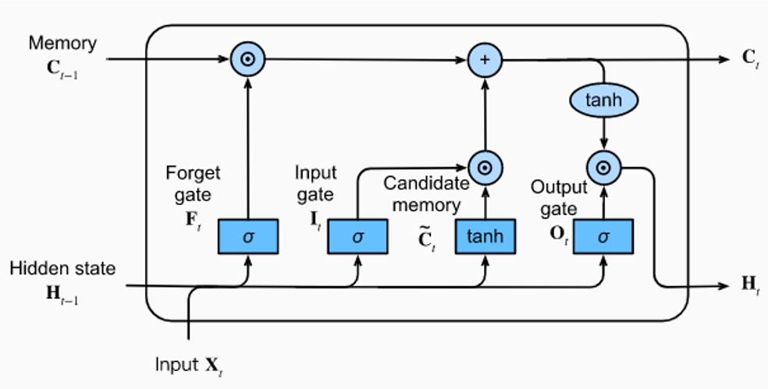

Figure 3.3.2: LSTM Model

LSTM (Long Short-Term Memory) is an improved variant of Recurrent Neural Networks (RNN) designed to learn and retain long-term dependencies in sequential data. Traditional RNNs struggle with the vanishing gradient problem, which makes it difficult for them to remember information over long sequences. LSTMs overcome this limitation by introducing a memory cell that maintains two types of states:
- Cell state (long-term memory) stores important information across many time steps.
- Hidden state (short-term memory) holds information relevant to the current step.

Gates:
LSTMs use three internal “gates”:
- Forget Gate: Determines what information must be remembered and what can be forgotten from previous step.
- Input Gate: Determines what new information to store.
- Output Gate: Determines the next hidden state value.

- Mathematical Operation:
For each time step $t$:
Forget gate : F_{t}=σ(X_{t} W_{f} + H_{t-1} U_{f})Input gate : I_{t}= σ (X_{t} W_{i} + H_{t-1} U_{i})
H’_{t} = tanh(X_{t} W_{c} + H_{t-1} U_{c}) [New candidate information]
C_{t =} σ (C_{t-1} F_{t}+ I_{t} H’_{t}) [New cell state]

Output gate : O_{t}= σ (X_{t} W_{o} + H_{t-1} U_{o})
H_{t} = tanh(C_{t *} O_{t}) [New information]

Finally, the output emoji is predicted as: $\hat{y}=\text{softmax}(W_{y}H_{t}+b_{y})$
where
- W_{f}, U_{f}, W_{c}, U_{c,} W_{i}, U_{i,} W_{o}, U_{o} : Weight matrices
- X_{t :} Input at time step t (current word embedding vector)
- $b_{y}$: bias added before output layer,
- $H_{t}$ is the hidden state, at time step t,
- h_{t-1}: Previous hidden state
- C_{t} : cell state
- H’_{t:}: new candidate information
- $\hat{y}$ is the predicted emoji probability distribution.

- Model Flow:
Input → Embedding → LSTM Layer → Dense Output Layer → Softmax → Predicted Emoji

Chapter 4: Implementation and Result Analysis

4.1 Implementation

4.1.1 Implementation Tools Used
In the implementation of this project, the following tools and libraries were utilized. Python (the primary programming language), Keras (a high-level neural networks API built on TensorFlow), NumPy (for numerical computations), Pandas (for data manipulation and analysis) Matplotlib (for plotting and visualization)

4.1.2 Implementation Details
Implementation details include:

1. Import Libraries and Read Data
In the implementation plan, the necessary libraries like pandas, numpy, tensorflow , keras , embedding, emojis, RNN, LSTM, etc were imported. Then ‘.csv’ file holding texts and their corresponding integer values for emojis were read in figure 2.

2. Install and Import Emoji Library
Install the emoji library and import it to handle emoji data in figure 3.

3. Define Emoji Dictionary and Label Mapping Function
Define a dictionary to map labels to the emojis and create a function to convert labels to emoji characters in figure 4.

4. Prepare Data
Extract input texts (X) and labels(Y) from the DataFrame in figure 5.

5. Tokenization and Pad Sequences
The input text data (x) are converted into tokens using a Keras tokenizer (texts to sequences function) and y data into one hot encoding using categorical function. The length of the sentences is fixed using maxlen function and padding truncate the values in figure 6.

6. Perform Embedding
Assuming pre-trained embeddings, prepare the embedding matrix to turns words (or tokens) into dense vector in figure 7.

7. Build and train the model
Construct the both model RNN and LSTM in figure 8.

8. Predict on new data
Prepare test data, tokenize, padsequences and make predictions using the trained model in figure 9.

4.2 Result Analysis.
Evaluation of the emoji prediction using LSTM model is based on the confusion matrix.
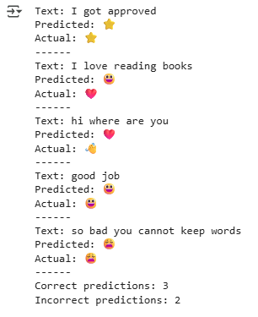
  - RNN

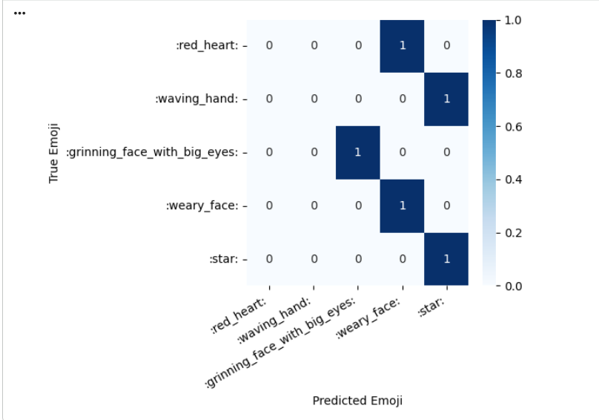

Figure 4.2.1: Emoji Prediction Confusion Matrix(RNN)

  - LSTM
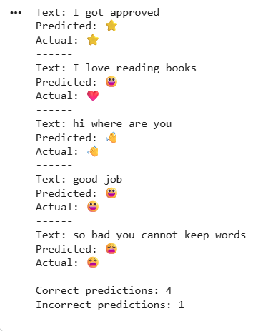

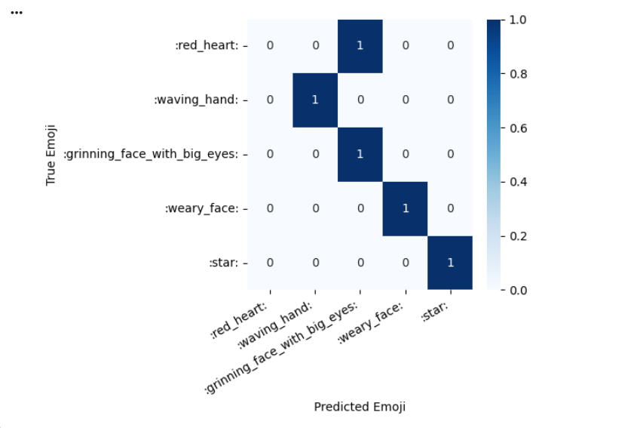

Figure 4.2.2: Emoji Prediction Confusion Matrix (LSTM)

Performance Metrics and Model Performance
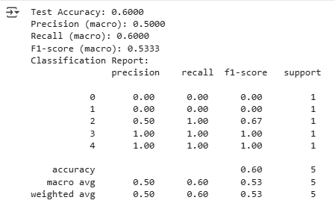
  - RNN

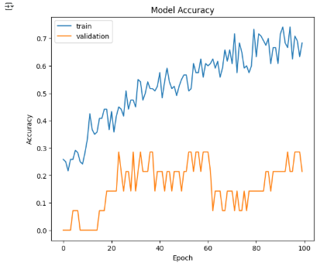

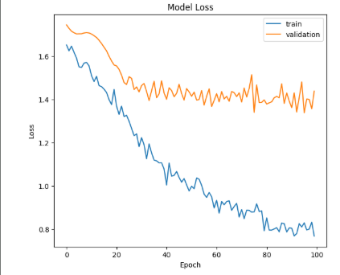

  - LSTM
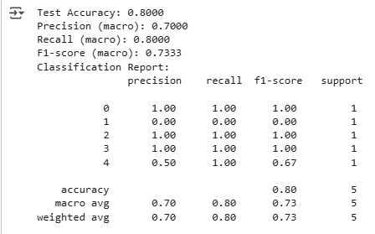

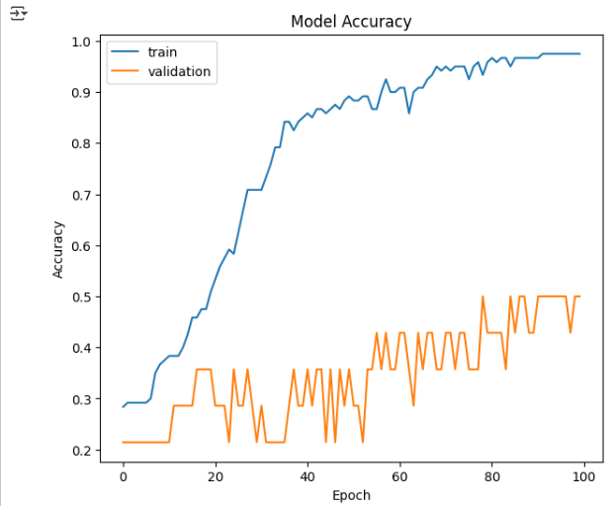

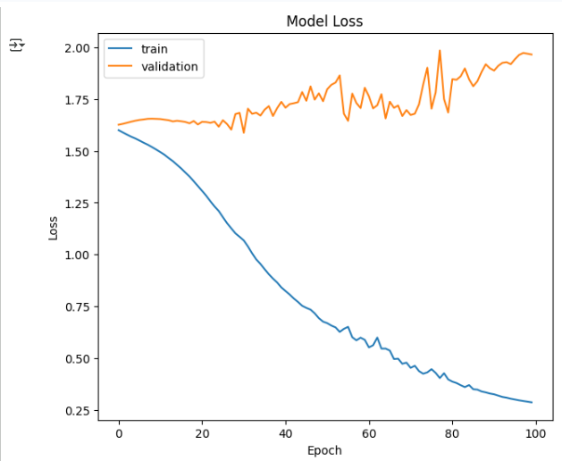

Figure 4.2.3: Performance Metrics and Performance Model

CHAPTER 5: CONCLUSION AND FUTURE RECOMMENDATIONS

5.1. Conclusion
In conclusion, two deep learning architectures RNN and LSTM (Long Short-Term Memory) were implemented and compared for emoji prediction from text sequences. Both models were trained using labeled text emoji pairs and evaluated based on training accuracy, validation accuracy, loss, and classification performance. The results show that while the RNN can learn basic sequential patterns, it struggles to maintain long-term dependencies in the text. This leads to lower accuracy and unstable validation performance, especially as sentences become longer.

In contrast, the LSTM model achieved significantly better performance, reaching higher training and test accuracy, and showing improved recall and F1-score across multiple emoji classes. LSTM’s internal memory mechanism (input, forget, and output gates) helps it effectively preserve contextual information across sequences, making it more suitable for understanding sentiment and tone required for emoji prediction.

However, overfitting was observed in LSTM training as the training accuracy increased while validation accuracy fluctuated. This indicates that while LSTM learns the training data well, additional regularization or more diverse data is needed to improve generalization.
Moreover, the LSTM model performed significantly better, achieving higher accuracy and improved classification results across multiple emoji classes. LSTM’s gating mechanism allowed it to remember important information over longer sequences, making it more effective for understanding emotional tone and sentiment in text. Overall, LSTM proved to be the superior approach for emoji prediction, while RNN was faster but less accurate and less reliable.

5.2. Future Recommendations
Based on the observations from this study, the following recommendations can guide further
research and implementation:
- Use larger and balanced datasets
The model’s performance may be affected by the imbalance in the dataset, where certain emojis are underrepresented.
- Try advanced models
Experiment with Bi-LSTM, GRU, or Transformer models (BERT, GPT) for improved contextual understanding.
- Apply regularization techniques
Regularization Techniques such as dropout and early stopping must be applied to prevent overfitting in LSTM.
- Optimize hyperparameters
Hyperparameters such as learning rate, batch size, number of neurons must be optimized to improve overall performance and training efficiency.
- Incorporate user context and sentiment awareness
Analyze the emotion of the text, not just the words. By detecting whether the message is positive, negative, or neutral, the model can choose a more accurate emoji.

REFERENCES

[1] | R. Ranjan, P. Yadav, "Emoji prediction using LSTM and Naive Bayes," in TENCON 2021-2021 IEEE Region 10 Conference (TENCON), 2021, pp. 284–288.
[2] | Kone, V., et al, "Emoji prediction using bi-directional LSTM," in ITM Web of Conferences, 2023, pp. 02004.
[3] | Zhang, L., et al, "Emoji prediction: A transfer learning approach," in Future of Information and Communication Conference, 2020, pp. 864–872.
[4] | Shaik, A., et al. "Recurrent neural network with emperor penguin-based Salp swarm (RNN-EPS2) algorithm for emoji based sentiment analysis," in Multimedia Tools and Applications, vol. 83, no. 12, pp. 35097–35116, 2024.
[5] | H. Raj, S. Balachandran. "Future emoji entry prediction using neural networks," in Journal of Computer Science, vol. 16, no. 2, pp. 150–157, 2020.
[6] | Zhou, C., et al. "A C-LSTM neural network for text classification," in arXiv preprint arXiv:1511.08630, 2015.
[7] | A. Sherstinsky. "Fundamentals of recurrent neural network (RNN) and long short-term memory (LSTM) network," in Physica D: Nonlinear Phenomena, vol. 404, pp. 132306, 2020.
[8] | Yu, Y., et al. "A review of recurrent neural networks: LSTM cells and network architectures," in Neural computation, vol. 31, no. 7, pp. 1235–1270, 2019.
[9] | Bai, Q., et al. "A systematic review of emoji: Current research and future perspectives," in Frontiers in psychology, vol. 10, pp. 476737, 2019.
[10] | Liu, C., Fang, F., Lin, X., Cai, T., Tan, X., Liu, J., & Lu, X. (2021). Improving sentiment analysis accuracy with emoji embedding. Journal of Safety Science and Resilience, 2(4), 246–252.
[11]  [12]  [13]  [14]  [15] | Mittal, M., Arora, M., & Pandey, T. (2019). Emoticon prediction on textual data using stacked LSTM model. In International Conference on Communication and Intelligent Systems (pp. 259–269).  Al-Azani, S., & El-Alfy, E.S. (2018). Emojis-based sentiment classification of Arabic microblogs using deep recurrent neural networks. In 2018 international conference on computing sciences and engineering (ICCSE) (pp. 1–6).  Hussain, S., Alhussayni, K., & Obayes, H. (2024). Iraqi Dialect Emoji Prediction Based on Deep CNN-LSTM Architecture. In National Conference on New Trends in Information and Communications Technology Applications (pp. 128–141).  Lou, Y., Zhang, Y., Li, F., Qian, T., & Ji, D. (2020). Emoji-based sentiment analysis using attention networks. ACM Transactions on asian and low-resource language information processing (TALLIP), 19(5), 1–13.  Gupta, A., Bhatia, B., Chugh, D., Himabindu, G., Sethia, D., Agarwal, E., Sani, D., & Garg, S. (2021). Context-aware emoji prediction using deep learning. In International Conference on Artificial Intelligence and Speech Technology (pp. 244–254).

APPENDIX
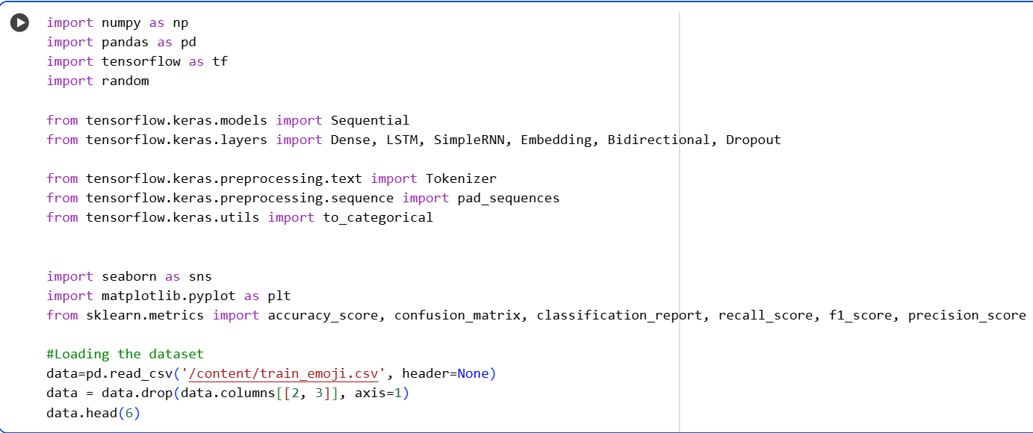

Figure 2: Import Libraries and Read Data

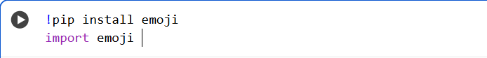

Figure 3: Install and Import Emoji Library

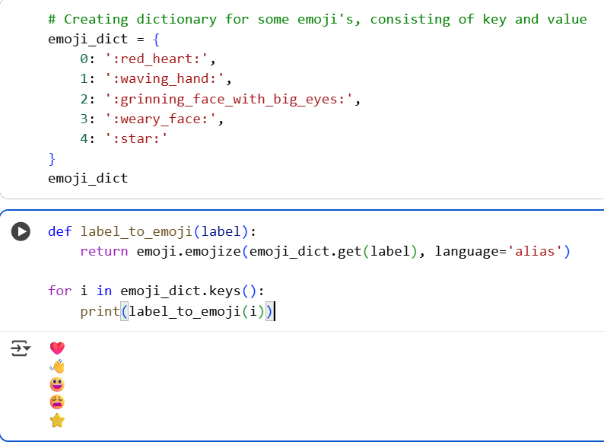

Figure 4: Define Emoji Dictionary and Label Mapping Function

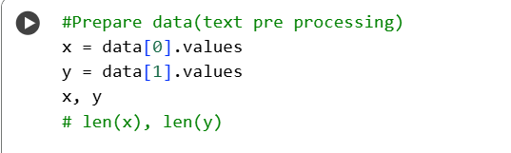

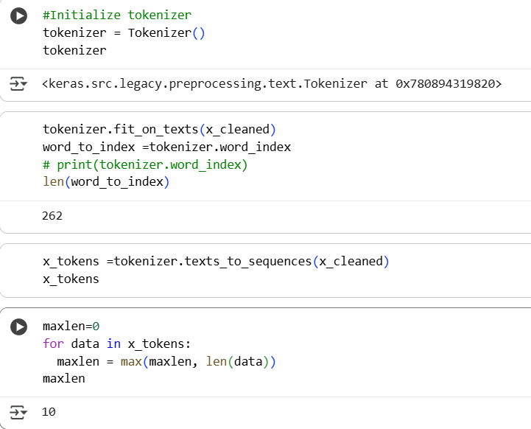
Figure 5: Prepare Data

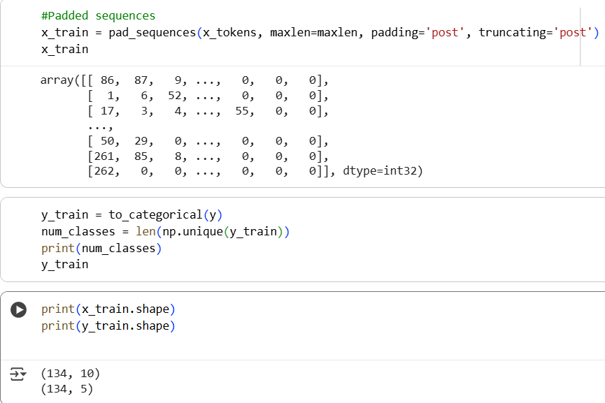

Figure 6: Tokenization and Pad Sequences
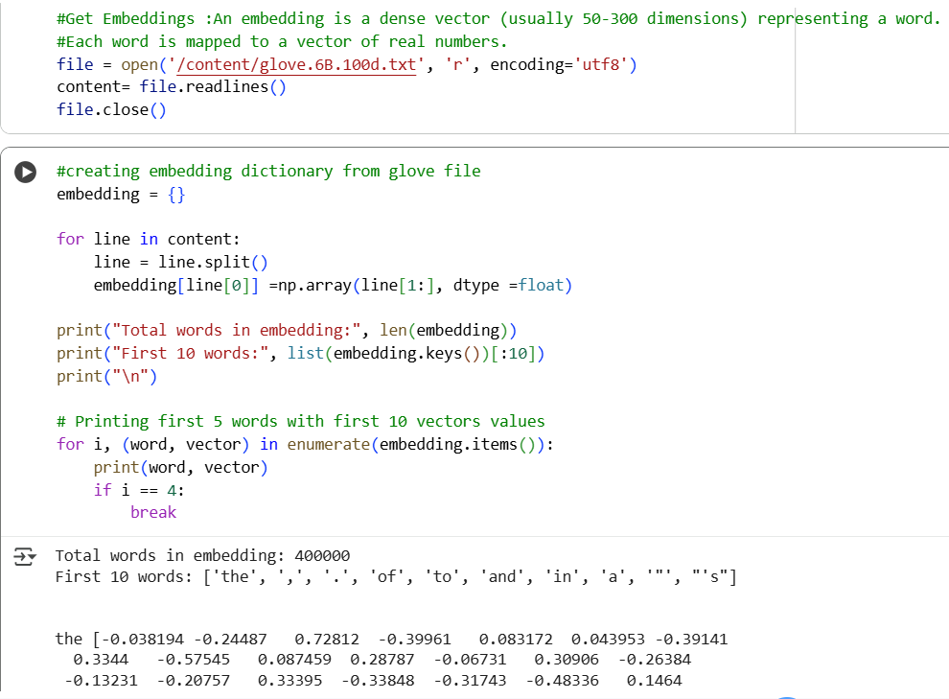

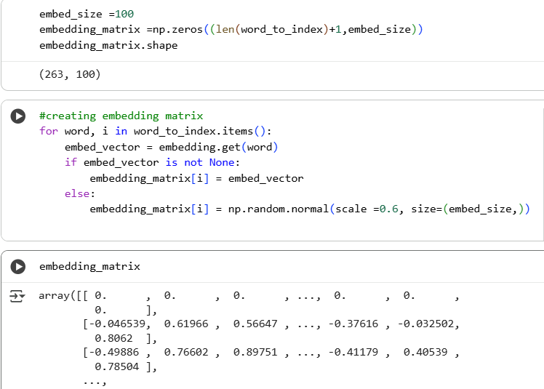

Figure 7: Perform Embedding

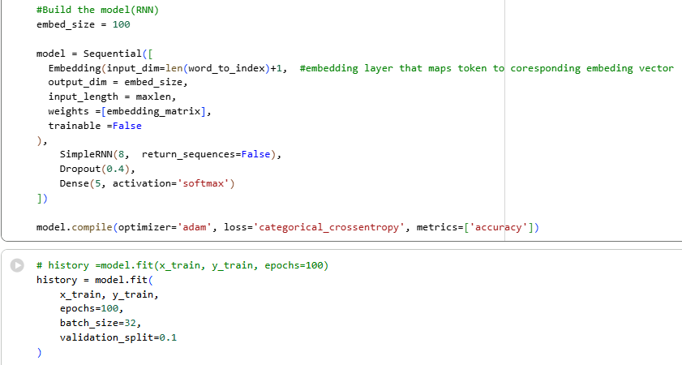

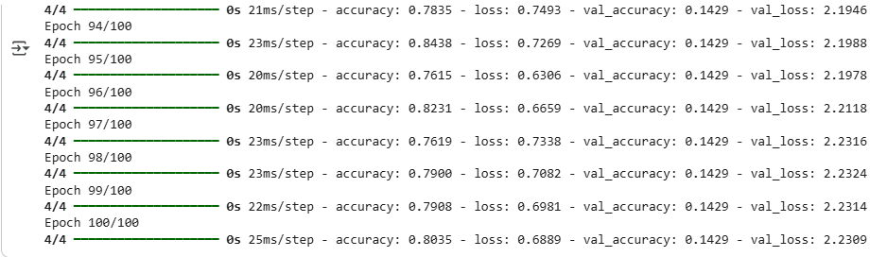

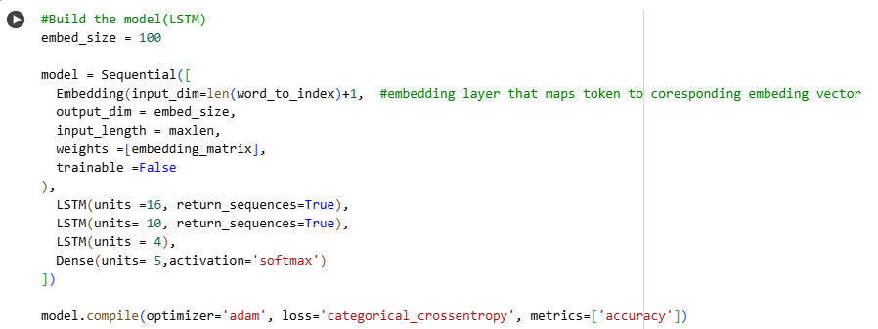

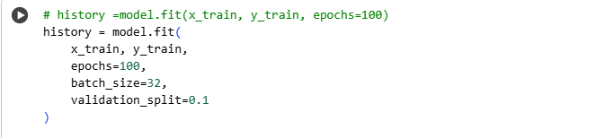

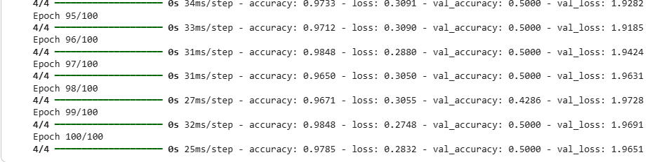

Figure 8: Build and train the model

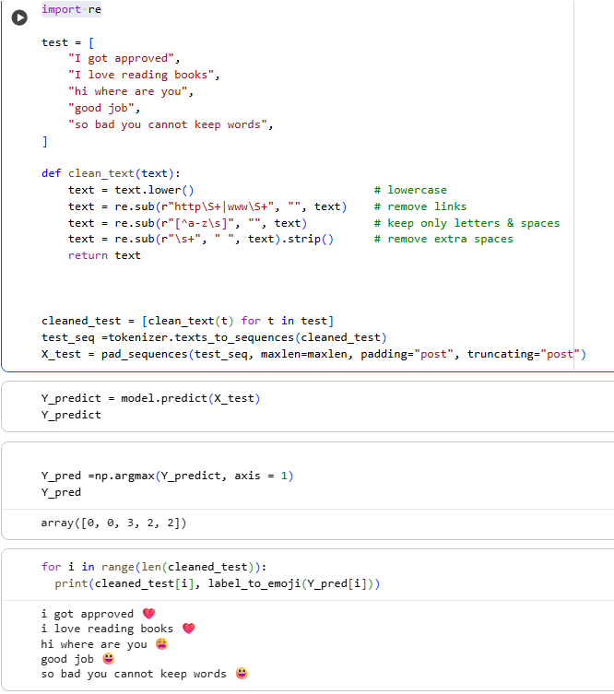

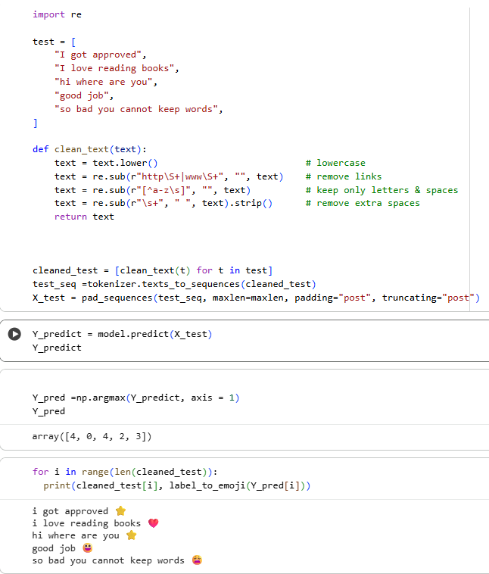

Figure 9: Predict on new data
