Main Components
The main Components of my chosen solution method are Simulated Annealing (SA) and with large neighborhood search operator. SA is a local search method that provide a good way to search neighborhoods and in combination with a large neighborhood operator this proves below to be quite an effective way of solving the given instances of PDPTW.

Simulated Annealing (SA)
I have chosen to use a Simulated annealing meta heuristic in to solve this problem. The basic components of SA are having a cooling schedule that determine the probability of accepting a proposed solution s* over the current solution s. As s* always is being accepted if it is better than current s, the probability function is determining whether or not s* should be kept as the current solution if it brings the system to a worse state. A cooling schedule needs a starting temperature T0 and a finishing temperature Tf. It also needs a probability function which can be either linear, exponential og logarithmic. The stopping criteria is based on amount of iterations (N) which is determined before starting up the algorithm.

Cooling Schedule
I used an exponantial cooling schedule in my solution. This makes the solution go from a like random walk in the beginning of the search and relatively quickly move over to a local search solution. This by far outdid a linear search and made the algorithm very robust. The T is determined with the following formula:
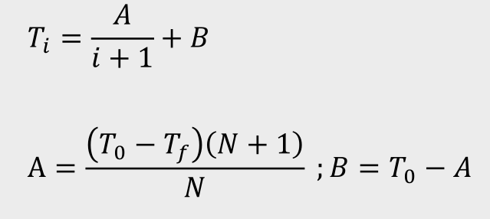

Determining T0 and Tf
To determine the T0 and Tf I used the following formula:
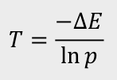
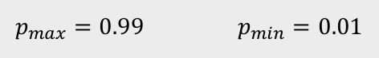
in ΔE ∈ [1,max ΔE ]

For T0 I used the maximum possible improvement which I determined using the following formula:

max ΔE = max(call_cost) – 2*mean(route_cost) - mean(unload_cost) – mean(load_cost)

where call_cost is the cost of not transporting a call, route_cost is the cost of getting to a certain node (to transport a call I need to go to two nodes), unload_cost is the cost of unloading a call and load_cost is the cost of loading a call.

T0 is then simply -maxΔE/ln(0.99) which I calculate during each instance in my matlab code.

The Tf is set to the minimum improvement possible which in our case I have set to 1 as there definitely exist an improvement of 1 (see results of instance 1 which ends up in two different local optimum with 1 difference). The Tf is then set to -1/ln(0.01) in all cases.

Operators
The operators I have chosen in my method I divided up in two categories, feasible operators and non-feasible operators:

Feasible Operators
The feasible operators differ from the non feasible operators to the fact that they always return a feasible solution and therefore have no need of the feasibility functions. I found the combination of fast operators such as the non feasible operators combined with the slower more reliable feasible operators to be a good and effective combination when solving a PDPTW problem.

Best-Greedy-Insertion
This operator always tries to insert a call from the unassigned calls unless there are no unassigned calls in which it removes a random call from the solution and reinserts it again in a random vehicle. To do this I have designed two insertion functions. The first insertion function tries to minimize the time to pickup the next call. Since time and costs are highly corrolated this proves to be a very effective way of inserting calls in a best-fit way. However it does not always succeed. Therefore I build another insertion function that uses a more greedy approach. This always tries to deliver the call that has the lower upper bound not caring if that call is far away or not to be sure the call gets delivered on time. This leads to more, but less effective, solutions. The best-greedy-insertion operator therefore tries to insert the selected call first after the best-fit principle then if that doesn’t work, in the . The operator makes sure to test all vehicles and returns a null solution if the call could not be inserted. In which case the initial solution is returned to the program to move on to the next iteration.

Reinsertion Large
This operator reinserts a certain amount of calls (dependant on the total amount of calls in the instance) to effectively move the current solution over a greater distance than the other operators (ie. a large neighborhood). This operator successfully moves a solution from a local optimum to greatly increase the chance of finding a better global optimum. The operator removes x amount of calls from a given solution and then reinserts them using the insertion functions mentioned above.

Reference list:

M. I. Hosny, Investigating Heuristic and Meta-Heuristic Algorithms for Solving Pickup and Delivery Problems, 2010

