Increasing the intensity of the FERMILAB BOOSTER
E. Prebys, C. Ankenbrandt, W. Chou, A. Drozhdin, P. Kasper, J. Lackey, N. Mokhov, W. Pellico,
T. Sullivan, R. Tomlin, W. Chou, R. Webber
FNAL, Batavia, IL 60510

Abstract

The Fermilab Booster is a fast-cycling synchrotron which accelerates protons from 400 MeV to 8 GeV of kinetic energy. Until recently, the primary demand for protons was for antiproton production, which typically uses about 7E15 protons per hour. Over the next few years, the Fermilab neutrino program will increase that demand dramatically over the next few years, possibly beyond 1.8E17 protons per hour. This paper discusses the issues involved in reaching these intensities, and the plan for achieving these goals.

Introduction

Overview

The Fermilab Booster [1] is a synchrotron which takes 400 MeV protons ions from the Fermilab Linac and accelerates them to 8 GeV for use by all of the lab's physics programs. It is 473 m in circumference and has a harmonic number of 84. The 96 combined function magnets which form it's 24-fold symmetric lattice are configured in an offset 15 Hz resonant circuit..

Projected Proton Demand

Figure 1 shows the projected proton demand through the end of this decade. The major users of protons are
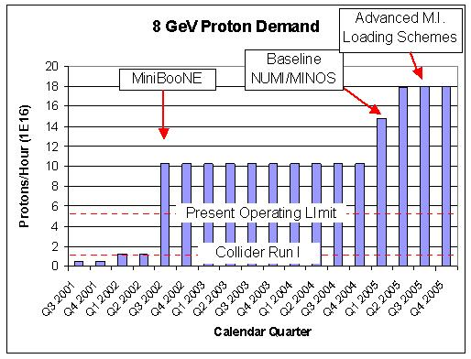
Figure 1: Projected Proton Demand

Limiting Factors

There are several factors which limit the total flux from the Booster:
- Maximum batch size: ~5E12 protons, limited by beam stability.
- Maximum average repetition rate: ~7.5Hz, limited by heating of the RF cavities and the magnets in the injection chicane.
- Above-ground radiation: dictated by the occupancy classes of the various buildings above the Booster.
- Beam loss in the tunnel: limited by component damage and activation.
Obviously the last two items are correlated, and it is the beam loss in the tunnel which is currently the limiting factor.

Known Lattice Problems

Both of the Booster’s extraction regions involve a chicane to vertically steer the beam around the extraction septum during acceleration. These chicanes operate at fixed current, and bend the beam by 42 mr at injection. It has recently been discovered that edge focusing effects in these chicanes cause severe lattice distortions, which are worst at injection and fall off as 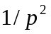. Figure 2 shows the effect on the these chicanes at injection. It is now belived that these lattice distortions are a major cause of losses early in the cycle, and ameliorating the situation has become one of our highest priorities.

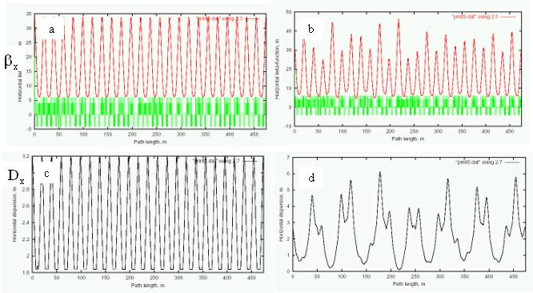

Figure 2: Lattice distortions due to the extraction chicanes. The ideal horizontal function is shown in (a), while (b) shows the lattice function with the effects of the chicanes. The same thing is shown for the horizontal dispersion in (c) and (d), respectively.

RECENT PERFORMANCE
Figure 3a shows the output of the Booster in protons per minute starting in August, 2002, when the MiniBooNE experiment begain running. Although the proton flux has increase by more than a factor of eight during this period, the average power loss in the beam, and average activation in the Booster tunnel have only increased by about a factor of two. This is illustrated in figure 3b, which shows the power loss per proton over the same period. The primary reasons for this improved performace are:

- Tuning to minimize losses around the ring, based on 60 individual loss monitors.
- Tuning to minimize the current in the extraction doglegs, thereby minimizing the deleterious effects on the lattice at injection.

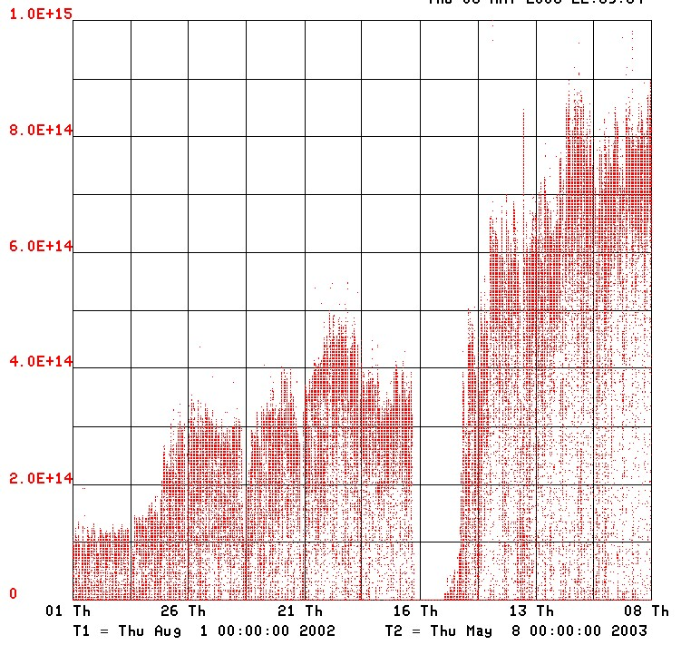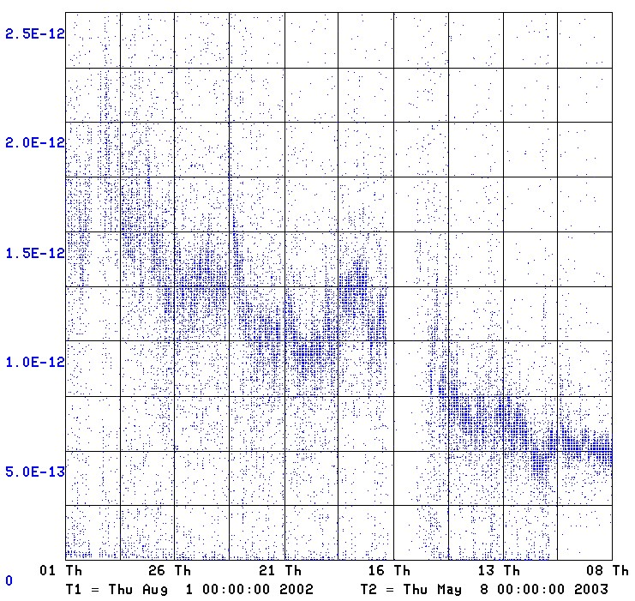The layout of the text on the page is illustrated in Fig. 1. Note that the paper’s title and the author list should be the width of the full page. Tables and figures may span the whole 170 mm page width, if desired (see Fig. 2).

*Revised by Sara Webber, FNAL, January 10, 2003.
#lucas@fnal.gov

Figure 1: Layout of papers.
Fonts
In order to produce good Adobe Acrobat PDF files, the editorial staff asks authors to use only Times (in bold or italic) and Symbol from the standard postscript set of fonts. The editorial staff is aware of problems processing Asian and Cyrillic fonts and will have experts in these matters available at the conference.

Title and Author List
The title should use 14pt bold uppercase letters and be centered on the page. The names of authors and their organizations/affiliations and mailing addresses should be grouped by affiliation and listed in 12pt upper and lowercase letters. The name of the submitting or primary author should be first, followed by the co-authors in alphabetical order by affiliation.

Section Headings
Section headings should not be numbered. They should use 12pt bold uppercase letters and be centered in the column. All section headings should appear directly above the text—there should never be a column break between a heading and the following paragraph.

Subsection Headings
Subsection headings should not be numbered. They should use 12pt italic letters and be left aligned in the column. Subsection headings should appear directly above the text—there should never be a column break between a subheading and the following paragraph.

Paragraph Text
Paragraphs should use 10pt font and be justified (touch each side) in the column. The beginning of each paragraph should be indented approximately 3mm (.13 in). The last line of a paragraph should not be printed by itself at the beginning of a column nor should the first line of a paragraph be printed by itself at the end of a column.

Figures, Tables and Equations
Place figures and tables as close to their place of mention as possible. Lettering in figures and tables should be large enough to reproduce clearly. Use of non-approved fonts in figures can lead to problems when the files are processed. Please use the approved fonts when possible [2] .
All figures and tables must be given sequential numbers (1, 2, 3, etc.) and have captions (10pt font) placed below figures and above tables being described. Captions that are one line should be centered in the column, while captions that span more than one line should be justified.
Text should not be obscured by figures. For more information on working with figures in Microsoft Word (including how to insert them in the most efficient manner), see the Microsoft Word help files.
If a displayed equation needs a number, place it flush with the right margin of the column (see Eq. 1). Units should be written using the roman font, not the italic font.

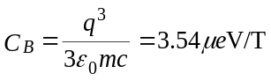

(1)

References
All bibliographical and web references should be numbered and listed at the end of the paper in a section called “References.” When referring to a reference in the text, place the corresponding reference number in square brackets [3].

Footnotes
Footnotes on the title and author lines may be used for acknowledgements, affiliations and e-mail addresses. A nonnumeric sequence of characters (*, #, †, ‡) should be used. All other notes should be included in the reference section and use the normal numeric sequencing.
Word users—do not use Word’s footnote feature (Insert, Footnote) to insert footnotes, as this will create formatting problems. Instead, insert footnotes manually in a text box at the bottom of the first column. Footnotes should only appear at the bottom of the first column on the first page.

Acronyms
Acronyms should be defined the first time they appear.

Page Numbers
DO NOT include any page numbers. The editorial staff will add them when they produce the final proceedings.

Templates
Templates and examples can be retrieved through Web browsers like Netscape and Internet Explorer by loading to disk. See your local documentation for details about how to do this.
Template documents for the recommended word processing software are available from the JACoW Website and exist for LaTeX and Microsoft Word (Mac and PC) for US letter and A4 paper sizes.
Authors are required to use templates for the correct paper size and advised to use the template corresponding to the correct version of Word. Do not transport the document across different platforms e.g. Mac↔PC.
Please see the help files for instructions on how to install templates in your Microsoft templates folder.

Checklist for electronic Publication
- Use only Times (bold or italic) and Symbol fonts for text—10pt minimum.
- Figures should be in Times (bold or italic) and Symbol fonts when possible—6pt minimum.
- Check that the postscript file prints correctly.
- Check that there are no page numbers.
- Check that the margins are correct on the printed version. There may be differences of ±1 mm on the margins from one printer to another.
- Check the size of the postscript file—an average size should be about 100-300 kbytes. If the file size is over 300 kbytes, please try to make it smaller.

References
[1] Fermilab Technical Memo TM-405 (1973)
[2] A. Name and D. Person, Modern Editor’s Journal 25 (1997) 56.
[3] A.N. Other, “A Very Interesting Paper,” EPAC’96, Sitges, June 1996,p. 7984.

