Compared to last version (1.5), this version:
- Has (I think) all but section 3 and 4 in pretty good shape. Final editing is needed, but all but 3 and 4 are pretty complete. And sections 3 and 4 have rough text.
- Has major smoothing operation on section 2 by Dave. Mostly this was moving modifications from 2a to 2b. But some further input is needed (see next set of comments).

Questions / Tasks for Proton Team members:
- All: Are 2a3 and 3a3 necessary or are they blended into 2a2 and 3a2? Dave is tempted to drop them.
- All: Can’t we put some of the Short Term modifications into the Mid Term? The Short Term is overwhelming … oh, maybe that’s the whole point.
- Peter: See the xxx associated with one liners for Booster modifications. We need short descriptive text for each one.
- Shekhar: See the items marked with xxx for Main Injector; I’m not sure what is true; if I did I’d change it.
- Eric: Need Figure 2a.
- Peter: Need new Table 2a showing 5.5E12 ppp for pbar. Let it shreik.
- Peter: Need a new Table 2b showing 5.5E12 ppp for pbar.

To Do List for Dave:
- Let Proton Team know this exercise is terminal so they better get their words in ASAP.
- Get rid of the “we” in section 2 where it refers to the MI group.
- Say why you are not including downtime so Jeff Appel will see why
- Clean up section 3.
- Incorporate the penultimate round of comments from the Proton Team.
- Clean up all other unedited sections.
- Add references in the actual text … you only have one so far.
- Remove the names of editors
- Match page numbers in Outline to the text.
- Give the Proton Team a final read looking for factual errors.
- Clean up final comments by Proton Team.
- Send it to Mike Church; iterate with team to make changes
- Send it to Mike Witherell.
- Rest. Oops. Make the Aspen Talk. Then rest.

Report to the Fermilab Director

by the Proton Source Committee

Draft of May 26, 2003

- Introduction
  - Ground Rules
  - Charge
  - Methodology and What is New
  - People Contributing

- Short Term: Protons from /03 through 1/05 (NuMI turn on)
a. Short Term Demands
    - Collider + MiniBooNE
    - Collider + MiniBooNE + Meson120
    - Preparing for Collider Improvements and NuMI
  - Short Term Modifications

- Mid Term: Protons from 1/05 through 9/08 (E906 and CKM turn on)
        - Mid Term Demands
- Collider + NuMI + Meson120
- Collider + NuMI + MiniBooNE + Meson120
- Preparing for Protons Beyond 9/08
        - Mid Term Modifications

- Long Term: Protons Beyond 9/08
  - Long Term Demands
  - Long Term Modifications

- Collaboration and Organization
  - Collaboration
  - Organization

- Summary

References

Appendix: Charge to the Proton Source Committee
Appendix: Proton Demands Spreadsheet

1. Introduction [Finley / Stefanski]

The Proton Source Committee was formed in February 2003 by the Fermilab Director to provide advice on the use of protons at Fermilab through the end of the decade. This report provides the written part of that advice. This introduction gives background information, and the major technical part of the report is in three sections addressing the short, mid, and long-term parts of the decade. Issues addressing collaboration and organization are reported in their own section. The summary is written deliberately making use of jargon from earlier parts of the report.

1a. Ground Rules

The Chair set the following ground rules for the committee: 1) Antitprotons will be required for the entire time period considered by the committee, 2) A “New Proton Source” will not be the default solution to increasing proton demands, 3) Specific on-going activities will be supported as long as they are seen to fit sensibly into an overall view, and 4) This committee leaves physics decisions to the Director.

This committee is aware of another advisory panel for the Director, the Long Range Planning Committee chaired by Hugh Montgomery, and this committee will try to hand off to it gracefully since its horizon extends well beyond that of this committee.

1b. Charge and Membership

The full charge to the committee is given in an Appendix. Its five points are repeated here for convenience, and several words are underlined for emphasis:

- Identify users of protons over the period 2003-2010 and the demands represented by each.
- Establish technical goals for delivery of protons, both from the Booster and Main Injector, over the period.
- Identify major modifications to the Proton Source and Main Injector that will be required to meet these goals assuming availability of Fermilab resources at the few x $10M level over the period.
- Identify possible resources and opportunities for collaboration by institutions outside Fermilab.
- Suggest an organization for implementing a program of modifications, including opportunities for integration of collaborators outside Fermilab.

The committee is composed of David Finley (Chair), Janet Conrad, Doug Michael, Greg Bock, Shekhar Mishra, Eric Prebys, Chuck Ankenbrandt, Peter Kasper, Alberto Marchionni, and Ray Stefanski. (Although Greg Bock could not attend the meetings, he is still considered a member of the committee.)

The Chair requested that one co-spokesperson from MiniBooNE (J. Conrad) and one from MINOS (D. Michael) be included on the committee because the needs of these neutrino experiments drive the annual demands for protons. The Chair requested various members of the Beams Division be included because of some combination of their expertise and/or their management position as being responsible for the accelerators that provide protons. One of the Chair’s duties was to cover all aspects not obviously covered by other members such as proton needs for Run II, users of the Linac, etc. However, the needs for Meson120 were covered by a combination of several members and the Chair.

1c. Methodology and What Is New

The committee gathered initial information from its own membership and by “interviewing” people either at the direction of the Chair or on their own initiative. A list of people contributing is given in the next section. Team members presented individual reports at the weekly meetings. These reports and other information are presently stored on the Proton Team website http://www-bd.fnal.gov/proton/ProtonTeam/.

Jeff Appel, the Head of Program Planning, provided a draft schedule shown in Figures Ia and Ib. The committee used this to divide the decade into three periods: Short Term (present program), Mid Term (MINOS data taking), and Long Term (CKM, E906 and an anticipated large increase in 120 GeV protons for the Neutrino Program). These periods are characterized by major changes in proton user demands.

The uncertainties with the Long Term are many, but the committee believes some kind of physics program (most likely neutrino physics) will eventually demand more protons than reasonable upgrades of the present Linac and Booster can accommodate; at that point it would be prudent for a New Proton Driver to be available. There are also uncertainties with the Mid Term, for example, what actions might be taken if the present plan for upgrading Run II do not pan out; in this report we assume that the Recycler will work with electron cooling by mid-2005 when MINOS is well underway.

The demands are listed in Tables Ia, Ib and Ic for the Short Term, Mid Term, and Long Term. In order to help the committee evaluate the consequences of the demands on Booster and Main Injector, Peter Kasper developed something new, the “Proton Demand Consequences” spreadsheet. This spreadsheet is explained in detail in an Appendix and is available by sending and email to kasper@fnal.gov.

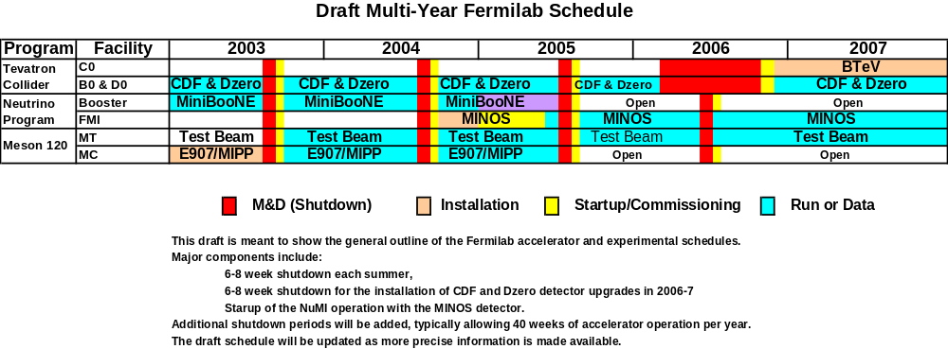
Figure Ia. A draft schedule from now until the end of 2007.

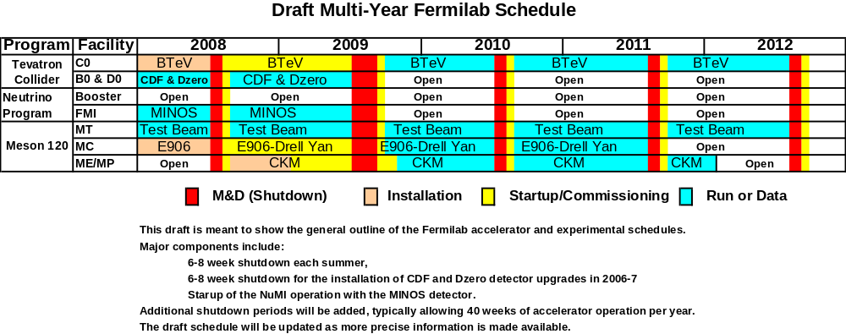
Figure Ib. A draft schedule from 2008 to beyond the end of the decade.

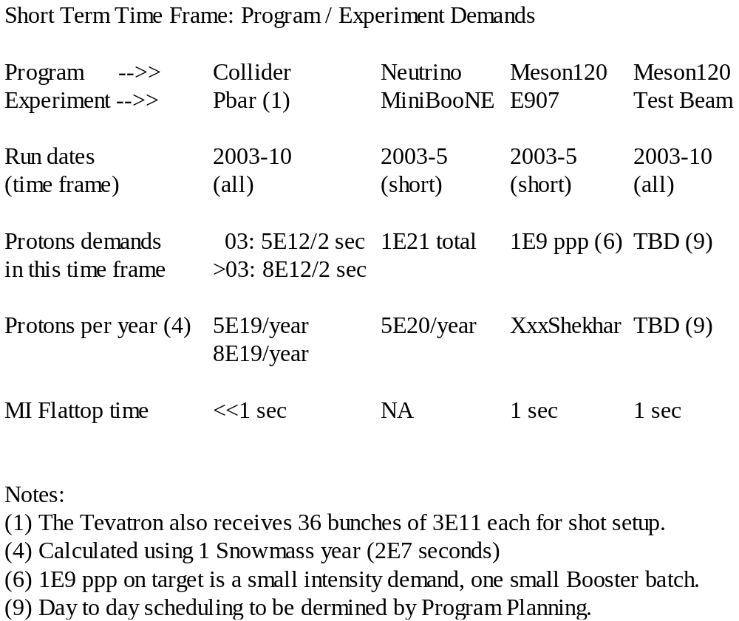Table Ia. Proton Demands for the Short Term.

Table Ib. Proton Demands for the Mid Term.

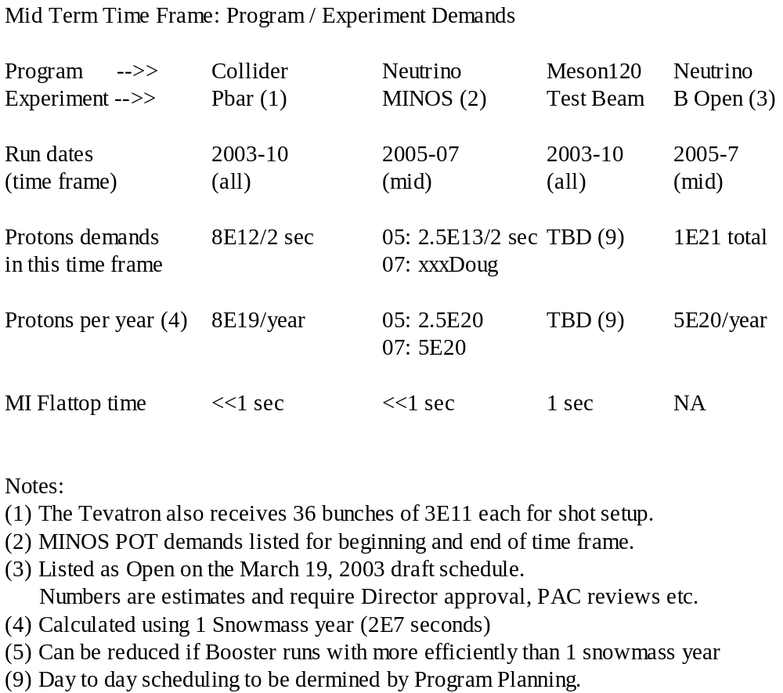

Table Ic. Proton Demands for the Long Term.
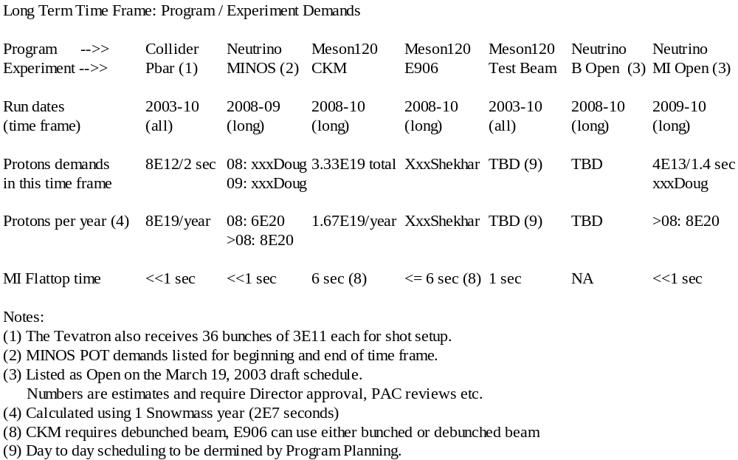

1d. People Contributing

Some of the people contributing to the information gathered by the committee though “interviews” include: Jeff Appel, Alan Bross, Chuck Brown, Joel Butler, Dave Capista, Weiren Chou, Mike Church, John Cooper, Peter Cooper, Mary Anne Cummings, Paul Czarapata, Roger Dixon, Bill Foster, Nancy Grossman, Steve Holmes, Ioanis Kourbanis, Arlene Lennox, Peter Limon, Elliott McCrory, Dave McGinnis, John Marriner, Bob Mau, Hugh Montgomery, Craig Moore, Francois Ostiguy, Bill Pellico, Milorad Popovic, Stephen Pordes, Rajendran Raja, Jeff Spalding, Panagiotis Spentzouris, Bob Tschirhart, Bob Webber xxxDid Eric talk with him?xxx, and Vicky White.

2. Short Term: Through NuMI Turn On In 1/05 [Prebys]

This period starts in April 2003 and extends until NuMI/MINOS has begun to take data as shown in Figure Ia.

First, the committee notes without further comment that the reliance of the Linac on a single vendor for the 5MW 7835 power tubes represents a significant vulnerability that may result in no protons at all for Fermilab for an unacceptably long period, and the lab obviously has to mitigate this vulnerability.

Because the demands for Linac beam not going to the Booster are small compared to the demands of other parts of the Fermilab experimental program, we mention them here only. These demands are best expressed as a percentage of time per week for which beam is required. MUCOOL is expected to require about 3% of a week, and to be scheduled by Program Planning. Beam maintenance and beam studies are expected to continue to require about 1.0% of a week. The Neutron Therapy Facility (NTF) requires beam parasitically to the HEP program about 1.8% of the time, and the successful arrangements with Accelerator Operations for day-to-day delivery of the beam are expected to remain in effect. The Linac will operate better with minor modifications, and the Beams Division management is expected to accommodate these as it sees fit. On the other hand, major changes to the Linac, such as a new front end or a replacement for the original low energy linac, should only be done in relationship to advice received from the Long Range Planning committee. MUCOOL is expected to require beam in the Mid Term, and beam maintenance and NTF are expected to last to the Long Range.

Downstream of the Linac, the experimental program today requires protons for the following:

MiniBooNE: 8 GeV protons from the Booster;
Run II: 120 GeV protons for Antiproton Stacking from the Main Injector;
Run II: 150 GeV protons from the Main Injector for the Tevatron;
Test Beam: 120 GeV protons for commissioning Meson120.

In addition to providing beam in the Short Term to experiments, in order to meet the needs for the beginning of the Mid Term, there are several changes that are required. Some of these changes are “modifications” requiring the usually identified resources (people, money and time). Some modifications will require down time to install equipment, and most modifications also require commissioning which usually uses beam time. In addition to these usual kinds of “modifications”, some other changes are better described as “operational” changes that mostly require beam study time.
In the short term, the demands on the Booster and the Main Injector can be considered separately. In this section, we consider these demands in light of the combination of MiniBooNE and stacking.

2a.Short Term Demands [Conrad / Mishra, Kasper]

2a.1 Collider + MiniBooNE

Booster demands for these two programs at the moment are well understood. The Collider needs 1 pulse at 5E12 delivered to the Main Injector at an average rate of 0.5 Hz for antiproton production (antiproton stacking). The Collider also requires protons destined for the Tevatron during shot setup, but this is not a Booster intensity issue, and is not considered here. MiniBooNE needs 1E21 protons on target to complete the neutrino running. (In the Mid-Term MiniBooNE may also request an additional 1E21 protons on target for antineutrino running to definitively address the LSND signal. However, in the "short term” period considered in this section of the report, only neutrino running is relevant.) Putting 5E20 per year for MiniBooNE into the Proton Demands Consequences Spreadsheet (see Appendix) we obtain the Booster requirements shown in Table 2a.

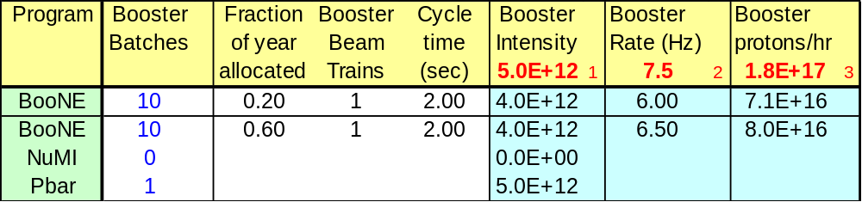
Table 2a: Today’s Booster performance requirements for antiproton stacking + MiniBooNE.

The combined goals require the Booster to run at 6.5 Hz, which is within the assumed capability of the Booster equipment. The single batch (pulse) intensity is 5E12 ppp, which is regularly exceeded for stacking. The parameter that has not been achieved to date is the required 8E16 protons/hour. The highest throughput obtained so far is about 5E16 pph.
Under present conditions, the cumulative losses sustained in delivering protons at 8E16 protons/hour would exceed the administrative limit. The main issue is activation of high-maintenance equipment. This might not only damages the equipment but can also render it unserviceable under the present maintenance procedures. As a result, the Booster output is limited by administrative constraints. The priority for providing protons is defined to be: 100% of the stacking request with the remainder within the administrative limit delivered to MiniBooNE.
Figure 2a shows the increase in loss as a function of protons per pulse (ppp). It can be seen that losses become significantly nonlinear with respect to proton intensity between 4 and 5E12 ppp. Therefore in the short term, solutions for losses focus on intensities that do not exceed 5E12 ppp. (Note that while 5.5E12 ppp have been routinely achieved for antiproton stacking, 5E12 ppp for antiproton stacking +MiniBooNE requires upgrades, as discussed below.)

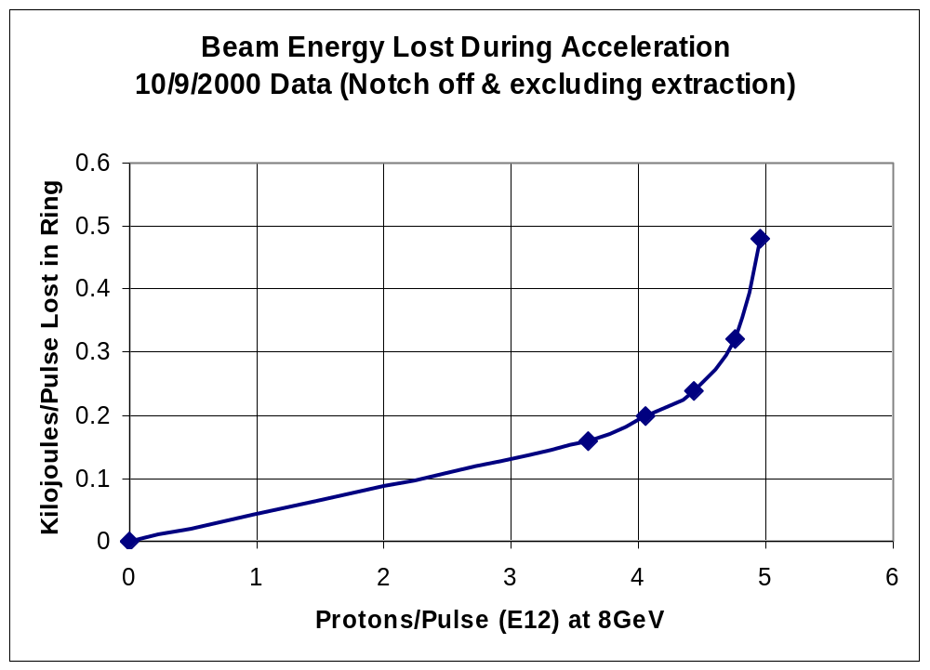

Figure 2a. Booster losses as a function of per pulse intensity.

The administrative limit on Booster losses has been in place since the turn-on of MiniBooNE (9/1/02). Because the stacking rate is guaranteed, this has meant that the MiniBooNE rate has been substantially lower than requested. In the autumn of 2002, the MiniBooNE rate was a factor of 8 low. However over the last six months, the Booster Group and MiniBooNE collaborators have made substantial improvements. Present running has climbed to about 50% of the required MiniBooNE rate with losses substantially reduced as shown in Figure 2b. The Proton Demands Consequences spreadsheet for running on April 15, 2003 is shown in Table 2b.

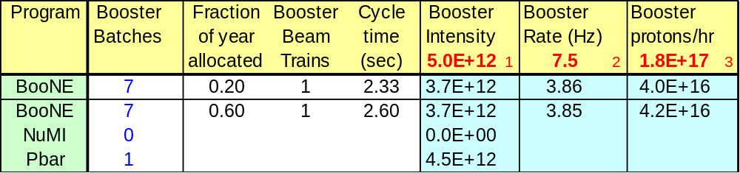
Table 2b. Booster performance as on April 15, 2003. This corresponds to a rate of 2.6E20 protons/year for MiniBooNE. XxxThis should be changed to show 5.5E12 to pbar xxx

In order to meet the antiproton stacking+ MiniBooNE demands, as well as NuMI expectations at turn-on in January 2005, we consider two phases of Booster improvement. The first set is expected to be enacted during the 2003 shutdown. The second is under consideration and we strongly endorse for action by the beginning of summer, 2004.
The following improvements are assumed to take place during the 2003 shuutdown:
- The collimator is installed.
- The two prototype wider aperture RF cavities are installed.
- The long 3 extraction region is rearranged to maximize the separation between the dogleg magnets.
- The ramp monitoring software is in place.

- Upgrades to the loss monitor system are in place.

The committee strongly endorses installing these upgrades as early as possible, as these represent a benchmark for what needs to be achieved in the future. With these upgrades it should be possible to meet the Booster performance requirements shown in Table 2a.. We recommend that the lab adopt this as a base goal for running conditions for the Fall of 2003.
In order to approach the final goals of the short-term program, by summer 2004, the required Booster performance is shown in Table 2c. We recommend the lab adopt this running condition as a base goal for October 2004. The following program of modifications is the minimum necessary for meeting these goals:

- Replacing the long 13 extraction septum (MP01) and modifying the extraction dogleg to match that at long 3.
- Replacing the weakest parts of the ORBUMP system
- Installing the radworker robot
- Upgrading the dampers

- Recomissioning of the γ_{T} jump
Justification for these modifications appears in section xxx, below.

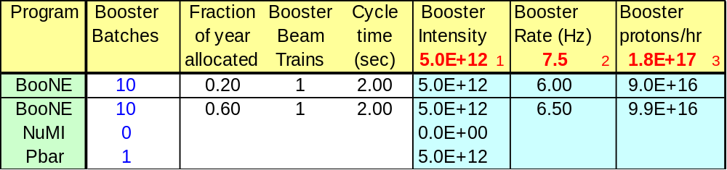
Table 2c. Booster performance goals for October 2004.

The committee notes that achieving the October 2004 goal requires a strong commitment by the laboratory management.
If these goals are not met, to complete the Neutrino running for MiniBooNE, delivery beyond 9E16 pph or running beyond January 2005 must be considered as options. In our opinion, raising the protons per pulse, while a good goal, is going to be technically more difficult than extending MiniBooNE running.
However, the committee endorses continued efforts to increase the protons per pulse beyond 5E12 ppp, in order to lay the groundwork for more margin for successful NuMI running, and better antiproton production. While a plan for achieving the initial NuMI goals is in place, we note that there is little margin for error on the assumptions that have been made. Increased protons per pulse could make up for issues in other aspects of NuMI initial proton delivery. For example, Table 2dshows the proton-per-pulse needs if, in the NuMI era, the required time for proton stacking in the Main Injector is greater than 1 "click" (ie one15 Hz cycle, see appendix A). This table assumes 2.5E20 ppy to NuMI. One can see that achieving 5.5 ppp is required under this circumstance.

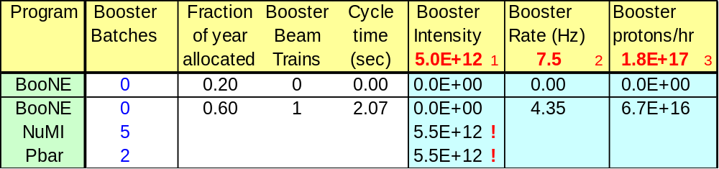
Table 2d. Alternative NuMI initial running conditions that motivate the stretch goals. The exclamation points indicate values beyond the base goal (see appendix A)

Thus, the committee recommends that the stretch goal for the Booster in the short term be running under the conditions presented in Table 2d.

2a.2 Collider + MiniBooNE + Meson120

The Meson120 program begins in the Summer of 2003 with beam provided to E907 and Testbeam.
This program requires a single low intensity Booster pulse at most a few times a minute, which is much less than the MiniBooNE requirement or the antiproton stacking requirement. Therefore, the impact of the Meson120 program on Booster is minimal. However, the impact on Main Injector running is noted as a harbinger of issues during the mid term and long term, since it requires the Main Injector to stay at 120 GeV for the duration of the slow spill and this time is not available for the 120 GeV Neutrino program or for the Collider program’s need for antiproton stacking. We note that if the typical store period is maintained by the collider, there is more than sufficient time to stack while still providing protons to Meson120. The actual apportionment of time will have to be determined by Program Planning.

Once Fermilab is running three physics programs, in this case two using the Main Injector, and one using the Booster directly, the synergy between the needs makes it difficult to assess each program. In order to address this problem, we introduce a tool for Program Planning that should helpto undedrstand the proton economcis issues, as they become even more entwined.

Xxx Introduce Proton Demands Consequences Spreadsheet here with the three constraints on the Booster xxx

2a.3 Preparing for Collider Improvements and NuMI

xxx Need text here …

2b. Short Term Modifications [Prebys / Mishra, Ankenbrandt]

We list here most of the modifications needed in the Short Term to address the demands presented above. We include a short description of each and some of the issues which management should consider as it makes decisions to provide protons for the Fermilab physics program. The list is long, but it is indicative of what is needed.

Short Term Recommended Modifications and Activities

We need to put in dependencies on Short, Mid and Long Term Modifications and Activities xxx

Booster Collimator. This is an ongoing activity, and is crucial for raising the number of protons delivered by the Booster. The purpose of the collimator is to control losses, and it will make the presently implemented administrative limit on losses obsolete. The committee strongly recommends this be completed as soon as possible.

Booster Dog Leg Rearrangement. This modification is currently being investigated. Edge focusing effects in the dog leg magnets are responsible for significant distortions in the lattice. Beam measurements suggest that this effect is the principle limitation on the Booster intensity. Reducing the fields in these magnets in fact led to a factor of two reduction in the uncontrolled losses in the Booster and allowed one of the major steps upward in the last six months for the MiniBooNE hourly proton rate. Much of the effect may be alleviated by this modification, and the committee strongly recommends this be completed as soon as possible.

Booster Installation of of Two Wider Aperture RF Cavities. These wider aperture RF cavities are being made in collaboration with MiniBooNE and MINOS collaborators. They will replace the two most radioactive RF cavities in theBooster, and the intent is this will reduce the amount of radiation received by people performing regular maintenance on the parts of the RF system in the beam enclosure.

Booster Notch Creation Improvements. Early in the Booster acceleration cycle, a vertical kicker is used to create a “notch” in the circulating beam, currently about 3 RF buckets (60 ns) long. Extraction is timed so that the position of this notch is at the extraction septum as the beam is sweeping across it, thereby reducing extraction losses. Even though this notch is created early in the cycle, it is still one of the worst losses, and in fact will be unacceptable at higher intensities. A number of schemes are being considered to ameliorate the situation, including:
- Shielding the area where the extracted beam hits and just living with the situation.
- Resonantly pinging the beam and extracting the notch at the collimator.
- Creating the notch in the Linac, either at the ion source or with a laser early in the Linac.
It should be noted that notch creation schemes in the Linac are not compatible with our existing beam cogging scheme.

Xxx Booster Radiation Protection. Includes radiation worker robot.

Xxx Booster Completion of Monitoring Software.

Booster Dampers. The Booster currently employs a longitudinal damping system to damp coupled-bunch oscillations. This is a mode-based system, which detects individual resonance lines and feeds a damping signal to a dedicated cavity. The philosophy is sound, but the system suffers from power limitation, as well as maintenance and scalability problems. A new system is being designed which will be easier to expand and to maintain, and eventually we plan to add a second solid state amplifier to increase damping power.

Booster Gamma-t Jump Recomissioning: The Booster includes a pulsed quadrupole “gamma-t” system to preserve longitudinal emittance through transition. The system has been demonstrated to work, but is not currently used, both because of alignment problems and because the reduced longitudinal emittance actually exacerbates the coupled-bunch problems after transition. There is a plan to recomission the system, in the hopes of reducing post-transition losses.

Booster to 8 GeV Line Aperture Increase. This is required for NuMI operation. The 8 GeV beam line from the Booster to the Main Injector utilizes permanent magnets over much of its length. At the Booster end, however, higher fields were required and available beam line magnets were used. These magnets were refurbished at modest cost as part of the FMI project; however, their aperture is not as large as needed, especially in a region that is under-shielded and in close proximity to the west Booster tower office building. While personnel radiation protection is assured through the use of interlocked detectors, the tight magnet aperture will likely impair our ability to push the intensity up to the levels required by NuMI. A new magnet design was completed in FY01, fabrication began in FY02, and these magnets must be installed before the NuMI operation begins.

Main Injector Damper Systems. A new longitudinal damper is being developed to reduce the longitudinal emittance growth in the Main Injector. A set of transverse dampers will be needed to reduce the transverse growth of the proton beam at NuMI intensities. Longitudinal damper technology will be used to develop these transverse dampers.

There is a sizable longitudinal emittance growth in the Main Injector between injection and flat top energies. This growth is due to two modes that are excited by the Main Injector RF cavities. We are in process of building a Longitudinal Damper to damp any residual coupled-bunch structure from the Booster that is present at injection and damp the observed coupled-bunch motion in the Main Injector associated with the MIRF cavity modes at 128 MHz (3rd harmonic) and 224 MHz (5th harmonic). It will also damp a coupled-bunch mode associated with a MIRF cavity mode at 66 MHz and dipole oscillations after transition due to transient beam loading or time or phase errors encountered during transition crossing. This damper will improve the beam quality Main Injector delivers to Tevatron, antiproton production, and to NuMI when it becomes operational.

Due to multimode operation of the Main Injector and hysteresis in the Main Injector magnets, the transverse injection oscillation from mode to mode is larger than desired. The injection oscillations directly contribute to the transverse emittance growth of the beam. At present this growth is control by reducing the injection oscillation for the high priority cycles at a particular time. R&D is underway to build an injection damper that will be used to damp the injection oscillation regardless of the mode and reduce the operational complexity. Higher intensity operation of the Main Injector will require additional dampers. R&D on these dampers will start after the commissioning of the longitudinal dampers. These dampers are absolutely required for NuMI operation.

Main Injector BPM System. The Main Injector BPM upgrade that was started in FY03 will continue into FY04 due to budget and manpower limitations. It is needed for the 2.5 MHz operation of the Main Injector xxx which is required for xxx. The present BPMs in the Main Injector have considerable operational limitations primarily since they are designed to expect bunches to be spaced at 53 MHz. In addition, the system can only measure beam positions for about 20 bunches, whereas the Main Injector can hold about 480 bunches. . At present, we do not have position information for coalesced beam (2.5 MHz) that is routinely used for Run II operation. Main Injector also supports several modes of operation in a supercycle of the accelerator complex. Due to the buffer limitation in the present system, data from an acceleration cycle gets overwritten by the subsequent beam acceleration cycle. This requires considerable time in tuning the machine. We are doing R&D on upgrading the BPM electronics, and the new BPMs will operate in multi-frequency mode, will have multiple data buffers, and will have a larger range in intensity. Due to Beams Divison resource limitations, R&D on this BPM upgrade may not start until late in FY03 and installation will extend into FY04.

Main Injector Slip Stacking. Slip stacking is the process where two Booster batches are stacked in longitudinal phase space and both end up where a single Booster batch would normally be in time. In principle, one could nearly double the intensity of the Main Injector with this process. Straightforward modifications to the low level RF (LLRF) have beenimplemented. It is expected that progress with this technique will be limited by the success of beam loading compensation systems and collective beam phenomena. Studies to implement slip stacking in the Main Injector should conclude in FY03.

Main Injector Beam Loading Compensation. Cavity beam loading becomes increasingly important when the cavity voltage is low or the beam current is high. The beam-loading compensation through the ramp is needed. Further improvements to the beam loading compensation will be needed for slip stacking. R&D work and initial installation and commissioning of the beam loading compensation began in FY02 and will have to continue into FY04.

Main Injector Lattice Changes for NuMI Extraction. The MINOS experiment will start running with single turn extracted beam from the Main Injector. NuMI extraction will require modification in the Main Injector orbit, and since the NuMI extraction point is located in the Main Injector RF section, one concern is synchro-betatron coupling. Beam studies will be needed to make the NuMI high intensity operation reliable. The loss of beam at the extraction septum magnet is a concern due to its proximity to the Main Injector RF cavities. We will look at possible modifications to the Main Injector lattice, larger aperture magnets etc to reduce losses during the extraction process.

Xxx Is this only for pbar? If so, drop it. Main Injector Beam Loading Improvement. A Beam Loading compensation feed forward system was installed and commissioned by the end of FY02 for antiproton coalescing. The present compensation is done at a fixed energy. We are upgrading this hardware to implement a beam loading compensation on the Main Injector ramp.

Xxx If this is for pbars only, drop it. Main Injector 2.5 MHz RF System. The Recyler will bunch the antiprotons in 2.5 MHz and transfer them to the Main Injector. A 2.5 MHz acceleration scheme is being developed in the Main Injector. This will accelerate the antiproton through Main Injector transition energy to 26 GeV. At 26 GeV the beam will be transferred from 2.5 MHz to 53 MHz and accelerated to 150 GeV. This process will eliminate the present coalescing process in the Main Injector for antiproton beam. Calculations show that this process can reduce the longitudinal emittance of the antiproton beam injected into the Tevatron from the Main Injector.

Xxx If this is for pbars only, drop it. Main Injector Antiproton Tune Measurements. In Main Injector to improve operation reliability we are installing new hardware and software to measure the antiproton tune through the Main Injector ramp. We are also developing hardware and software to automate the tune and chromaticity measurements.

Main Injector Radiation Protection. As the intensities and losses increase, this will be required more and more to perform maintenance on the equipment in the beam enclosure, without increasing the radiation dose received by people. This will have to be continued in the Mid Term and Long Term.

Main Injector Beam Loss Control. A collimator system to control losses in the Main Injector should be considered, perhaps similar to the one in the Booster. This will likely be required as the total beam current in the Main Injector continues to increase.

Main Injector Fast Proton Stacking. This includes development of concepts such as RF “barrier bucket” stacking and “fast stacking” considered for the Recycler. R&D should go on in the Short Term, but implementation might not happen until the Mid Term.

Short Term Modifications Needing More Information

Booster Dog Leg Replacement. As noted earlier, the nonlinearities in the dog leg magnets are responsible for distortions in the lattice which cause the most significant beam loss in the Booster at the moment, and much of the effect may be alleviated by the Booster dog leg rearrangement. Nevertheless, the concept and design of this modification should be pursued along with cost estimates, but large M&S expenditures should wait until the gains from the Booster Dog Rearrangement are demonstrated and understood.

Booster Replacement of Remaining RF Cavities. After the two larger aperture RF cavities are installed, it is an open question if the remaining RF cavities should also be replaced. It is possible that the collimator for the Booster will reduce the radiation levels in the RF cavities to acceptable levels, and the beam physics models are not good enough predict what will happen in detail. This modification is estimated to cost several M$’s. Thus, it seems prudent to wait until it is clearer that this modification will do some good.

Booster Replacement of High Power RF System. The RF power tubes for the Booster are located on the RF cavities in the beam enclosure. These tubes require regular maintenance and the people who do the work receive a radiation dose dependent on how radioactive the cavities and other nearby components happen to be. The replacement system would not have these high maintenance tubes, the equipment that does require regular maintenance would be moved out of the beam enclosure, the replacement would be more reliable, and parts for the system would be more available since the system would be modern. Although this modification is estimated to cost about $10M, a cost benefit analysis indicates the replacement system would easily pay for itself by the end of the decade if it were started in the next year or so. Before a decision is made to support this modification, the amount of downtime needed to install the system must be evaluated.

Main Injector Aperture Increase. The Main Injector is designed to have 40-pi mm-mr aperture. The quadrupole and Lambertson magnets placed in the lattice for injection and extraction of the beam are currently limiting the apertures and are a cause of beam loss. A calculation effort is underway with the goal of improving these magnet apertures. A total of 12 larger aperture Lambertson and 4 quadrupole magnets could be required.

3. Mid Term: Through E906 and CKM In 9/08 [Mishra]

This period extends until E906 and CKM are running. The most important issues regarding proton intensity will be the following:

- Cycle time of the anti-proton source: It is clear that more anitprotons can be produced if the Anitproton Source can be cycled more rapidly. However, because the Main Injector cycle time will be tied to that of the Anitproton Source, the number of protons which can be delivered to NuMI will also depend on the Anitproton Source cycle time. Hence, it is crucial, even for NuMI that the planned upgrades for Run II which will permit a 2 second cycle time are successfully completed.
- Stacking of batches of Booster protons into the Main Injector.
- The ability of the Main Injector to handle large, multi-batch proton intensities.
- Protons per cycle and proton losses in the Booster.

3a. Mid Term Demands [Michael / Mishra, Marchionni]

This time frame will consist of running the collider for CDF and D0, running the NuMI beamline for MINOS, running the Main Injector for slow-spill extraction experiments and test beams and possibly extended running of Mini-BooNE using Booster protons. Although preparations for E906, CKM and BTeV are expected, these experiments are not expected to be ready for any large-scale use of protons in this time frame. The primary focus of accelerator work in this timeframe will be the ongoing improvements to Run II luminosity and increasing the proton intensity delivered to the NuMI Beamline.

3a.1 Collider + NuMI + Meson120

All of these programs depend on protons accelerated through the Main Injector. The most common mode of operation will be Main Injector cycles that will simultaneously accelerate protons to 120 GeV for anitproton production and for NuMI.

The Run II plan for anitproton production calls for two batches of 4e12 Booster protons to be slip-stacked in the Main Injector and delivered to the anitproton target with Main Injector cycle time of ~2.0 s. It is hoped that can eventually be increased to a total of 5e12 protons per batch. This will depend on the ability to successfully address beam loading issues during the slip-stacking in the Main Injector. Likewise, the exact Antiproton Source cycle time depends on the successful completion of some Run II upgrade plans. If everything works very well, it is possible that the Anitproton Source cycle time will be limited by the total time it takes to fill the Main Injector with protons from the Booster combined with the Main Injector ramp time. On the other hand, if some of the Run II anti-proton accumulator upgrades do not work as well as expected, the Anitproton Source cycle time, and hence the Main Injector cycle time will have to be > 2.0 seconds, perhaps as high as 3 seconds on average. The most critical issue is electron cooling, followed by the debuncher cycle rate capability.

The demand for protons to the NuMI target is determined by the needs of MINOS. The laboratory management has committed to planning to deliver 2.5e20 120 GeV protons per year of operation for MINOS starting in April 2005 and continuing through April 2009, for a nominal total of 10e20 protons delivered. We note that as yet no formal plan to accomplish this exists. Nominally, this number of protons per year can be delivered by injecting five batches of Booster protons, each with 5e12 protons, into the Main Injector every 2.0 seconds, accelerating to 120 GeV and then repeating this cycle for a total of 2e7 seconds per year. Of course, there are several factors which can reduce this total number of protons, including issues of the Antiproton Source cycle time, time required for antiproton transfers, time spent running for Meson 120, difficulties accelerating this total number of protons and other downtimes of the accelerator complex and beamline which may result in less than 2e7 seconds of operation per year. One possible result is that fewer total protons will be delivered in the planned four year running period. We note that previously published physics sensitivity plots for MINOS have been based on a total of 7.4e20 protons on target, an approximate match to the running scenario stated here taking some account of realistic reduction factors.

The MINOS Collaboration is expected to make a formal request to Fermilab for more protons to be delivered in this period than the nominal plan described above. Rather than the nominal 7.4e20 protons in 4 years of running the request is expected to be for 25e20 protons in five years of running. The request is based on improved sensitivity for all of the physics measurements (all are statistics limited) but with particular emphasis on the energy dependence of the disappearance of ν_{μ} CC events, the associated measurement of the oscillation parameters, and discovery potential for ν_{e} appearance. The addition of one extra year of running compared to the nominal plan can boost the expected number of protons to roughly 9.5e20. However, it is clear that to deliver any very significantly larger number of protons than this will require both some qualitative and quantitative improvements in providing protons for NuMI. The major assumptions on which the MINOS request is based are:

- Increased protons per pulse (cycle) from the Booster
- Stacking of batches of Booster protons into the Main Injector for NuMI, similar to that planned for anitproton production
- Reduction of the Main Injector cycle time either by reducing the ramp time or removal of the Booster cycle time from the filling time at 8 GeV [JM].
- Ability of the Main Injector to accommodate up to 6E13 protons per cycle

During this period the allotment of time among slow-spill for Meson120, the 120 GeV Neutrino program, and the Collider’s need for antiproton stackingwill be set by Program Planning. The main technical requirement forMeson120 is the establishment of resonant extraction with acceptable losses. The spill length can be as long as 6 seconds.

3a.2 Collider + NuMI + MiniBooNE + Meson120

xxx This is text from Janet xxx

In this mid-term period MiniBooNE will continue running to complete its physics program. If 1E21 pot was not reached in the short-term, neutrino running will extend into this period. After this, MiniBooNE will run in antineutrino mode. The present expectation is that this run-mode will extend to 1E21 pot, although this may be adjusted in the presentation to the PAC in autumn 2003.

It is technically possible to run MiniBooNE, stacking and the Main Injector programs (including (including NuMI) simultaneously. MiniBooNE receives pulses while the Main Injector is ramping. The modifications which must be done to the Booster to accomplish this are listed under modifications and are less than $500k.

The limitation to running these programs simulatenously comes from Booster losses. Improvements of a factor of 2 are required to meet the labs approved requests for the other program and run MiniBooNE at its present level. As discussed in the modifications section, there are reasonable ideas on how to aaccomplish the required lower losses.

It should be noted that running MiniBooNE while bringing up NuMI provides an advantage. The MiniBooNE group is well versed in the Booster operation and can provide extra support for smooth Booster running during NuMI turn-on. This is a continuation of its present contribution to the collider program of maintaining smooth Booster running during shot setup, which has been publicly noted by Operations.

Xxx The text from Janet ends here and the text from Doug begins xxx

The current draft Fermilab schedule shows the Mini-BooNE beamline “open” starting in 2005. The Mini-BooNE Collaboration is requesting to run with anti-neutrinos during this time. The request is for a total of 1e21 protons to be delivered to the Mini-BooNE target during 2005 and 2006 (complete by 2007). The assumption is that this can be achieved by running the Booster at an average of 5 Hz for Mini-BooNE. In 2005, the Main Injector will require 7 batches of Booster protons every 2 s (3.5 Hz average) for anitproton production and NuMI, for a total average Booster acceleration rate of 8.5 Hz. In 2006, the demand for protons for the Main Injector assumes 2 batches slip-stacked for antiproton production and 8 batches slip-stacked for NuMI for a total of 10 Booster batches every 2.2 s (4.5 Hz average) so the total average required Booster acceleration rate would be 9.5 Hz. Should any intrinsic limitations be encountered in achieving this rate, it should be possible to slightly extend the Mini-BooNE running into 2007 in order to accomplish the full exposure request.

3a.3. Preparing for Protons Beyond 9/08

Xxx Need text here … or drop it.

3b. Modifications [Mishra / Prebys, Bock]

Here we list the modifications need for the Mid Term.

Mid Term Recommended Modifications and Activities

Xxx We need to put in dependencies on Short, Mid and Long Term Modifications and Activities.

Main Injector Beam Permit For NuMI. This is required to assure the beam losses in the NuMI beam line are acceptable.

Main Injector Operation of NuMI and Antiproton Stacking In The Same Cycle. This is required in order to meet the annual proton demand for MINOS and antiproton stacking.

Main Injector Intensities In Excess of 4E13. Conceptual development by Fermilab staff and as well as collaborative efforts is encouraged.

4. Long Term: Beyond 9/08 [Mishra]

4a. Demands [Michael / Conrad]

The draft Fermilab schedule shown in Figure Ib calls for the physics program to undergo important transitions in the period 2008-2010, especially with regard to proton demands. The following helps to define the changing proton demands in this time frame:

- The CDF and D0 experiments finish in 2008 and BTeV starts commissioning.
- E906 is commissioning in 2008 and CKM is commissioning in 2009.
- MINOS finishes in 2009.

If these were to take place as stated, then there would be a transient crunch for protons while all three programs were running: Collider, 120 GeV Neutrinos, and Meson120. However by 2010, proton demands would drop to less than pre-MiniBooNE levels. And the present Linac, Booster and Main Injector proton source could likely provide for the demands. (Assuming a long-range solution for the low energy part of the Linac will be in place at that time.) And the reader could skip to the next section of this report.

However the committee added a few assumptions full well knowing that the Long Range Planning committee may or may not make similar assumptions. And the PAC and the Director may or may not approve the physics program implied by these assumptions. But these assumptions do serve to focus on a potential proton crunch that derives from using the Main Injector to run the three physics programs at the same time: Collider, 120 GeV Neutrinos, and Meson120. These assumptions are:

- One assumption is the Collider program, in serving BTeV, will continue to demand protons for antiproton stacking at a level no less than CDF and D0 will when they turn off.
- CKM and E906 require a slow spill, and thus it is assumed that whatever time the Main Injector is at 120 GeV providing slow spill will reduce the time available for antiproton stacking and the 120 GeV Neutrino program.
- MINOS will submit a request for running which will extend into 2010. Also, several new experiments are under consideration for the NuMI beamline. The main experiment in terms of proton demands is a new off-axis, long-baseline experiment. The LOI for this experiment has assumed at least 4E20 protons per year of operation, and a higher number of protons per year will certainly be useable (assuming the NuMI beam line can be made to handle it). Already the experiment is proposing a rather large 40 kT far detector, but it may be sensible to invest some fraction of the cost of this new experiment in proton intensity from the Main Injector. In addition to the long-baseline experiments, three new short-baseline experiments are under consideration for high-statistics measurements of neutrino cross-sections and related physics in the NuMI near detector hall. A 120 GeV Neutrino program such as this will certainly increase the demands for protons, possibly beyond what the present arrangement of Linac, Booster and Main Injector can provide.
- The committee notes that the ability to supply 8 GeV beam directly to experiments should be maintained in the long term because this maintains the lab’s ability to respond to physics proposals. One new experiment (FINeSE) for measurement of neutrino cross-sections is under consideration for the present 8 GeV MiniBooNE beamline. Also should MiniBooNE confirm the LSND oscillation signal, it is very likely that a follow-up experiment (BooNE) to provide more precision in the oscillations measurements will be of great interest in this beamline.
- If the Main Injector eventually becomes capable of satisfying the demands of a 120 GeV Neutrino program, it could easily use up the 7.5 Hz capacity of the present Booster for delivering beam. One can imagine going beyond this to the 15 Hz capacity of the Linac and upgrading the Booster to accept the additional protons, including methods for further reducing and controlling losses. One would consider this if the Main Injector is not in fact a bottleneck for accepting 8 GeV protons, and an 8 GeV Neutrino physics program is required.

Finally, as the Fermilab physics program actually shifts from being dominated by the Collider program to the Collider sharing with Neutrino programs based on beamlines driven by the Main Injector and Booster, and both of these sharing with the Meson120 program based on beamlines driven by the Main Injector, it will become increasingly important to invest sensibly in these machines. In particular, the Neutrino programs will directly benefit from higher beam intensities per pulse as well as higher beam pulse repetition rates. The nominal demand of the 120 GeV Neutrino program could easily require on the order of 1 MW by 2010. Indeed in the time frame beyond the charge of this committee (beyond 2010), but within that of the Long Range Planning committee, the existence of a New Proton Source - a replacement of the Linac and Booster – could very easily be essential for the future physics program at Fermilab. It should be apparent that modifications that increase the capabilities of the Main Injector, such as handling higher beam intensities and decreasing ramp time, should be done in a manner which will continue to be useful once a New Proton Source becomes operational.

4b. Modifications [Marchionni (MI) & Prebys (Booster)]

Here we list the modifications that are likely needed to meet the protons demands in the Long Term. They are less in number than the Short Term and Mid Term because most modifications are required in order to finish the Mid Term successfully.

Long Term Recommended Modifications and Activities

Xxx We need to put in dependencies on Short, Mid and Long Term Modifications and Activities.

Main Injector Debunched Resonant Extraction. This is required for CKM and must be done in a way that preserves the information from the beam diagnostics.

Long Term Modifications Needing More Information

#1 Faster Main Injector Ramp. Increasing the Main Injector ramp rate can obviously increase the number of protons per hour delivered by the Main Injector for the 120 GeV Neutrino Program. A study that was started in FY03, if demonstrated to be technically feasible, shows the Main Injector ramp time can be reduced from the current 1.5 sec to 0.75 sec.

#2 Main Injector Shorter Ramp Time. This modification includes both more RF power and more magnet power supplies. This will provide more protons per year to the 120 GeV Neutrino Program as long as anitproton stacking for Run II does not slow the Main Injector cycle time down. It appears to be relatively low risk approach to getting more protons per year in that it requires engineering development to get more cycles per year rather than the beam physics R&D that is needed to get more protons per cycle. This modification alone is expected to cost a few $10M’s. A decision on this must fold in with the recommendations of the Long Range Planning committee.

5. Collaboration and Organization [Mishra ]

5a. Collaboration [Michael, Conrad]

Collaboration divides into three types: within the lab (sometimes called cooperation in this report), with members of the accelerator physics community outside Fermilab, and with the HEP users of the lab. We recommend that the Director appoint a senior member of the lab to investigate methods of facilitating collaboration. In particular, we hope that those who have had substantial experience with collaboration will be interviewed to understand what works and what does not. Subsequently, it might make sense for the Director or the Beams Division Head to appoint an ombudsperson, or other staff position, to assure that appropriate collaboration resources will indeed be brought to bear on activities that will increase the performance of the accelerators for the benefit of the collaborators.

The committee offers the following as input to this process.

By all accounts, the accelerator departments that must carry out work for increased proton intensity have less manpower than is required to carry out all of the work necessary to meet the experiments’ demands. Of course, one way to address this is to add manpower to these groups via hiring and the committee strongly recommends that such hiring be a high priority of the laboratory. Although this is perhaps the most direct solution, on its own it may not represent a complete and most optimal solution in terms of achieving the necessary work for a particular cost. Collaboration with other Fermilab and outside institutions can offer:

- Additional manpower and infrastructure resources to carry out work more rapidly
- Lower cost manpower
- Advantageous purchase fabrication policies
- Additional physicist intellectual involvement in accelerator issues

An increasingly interesting path to accomplish at least some of the projects described here is to develop more collaborations with non-Beams Division groups:

- Other Fermilab Divisions
- Other accelerator laboratories
- Universities and other non-accelerator laboratory groups

Although still a very small part of the total accelerator activity, important examples of such collaboration have already been underway in the last few years. The examples listed here are familiar to most of the committee members; there are certainly others.

- Mini-BooNE has had collaborators working together with Booster staff working on several projects such as quadrupole correctors, wider-aperture RF cavities, a and better monitoring software.
- MINOS has had Fermilab and non-Fermilab collaborators working on proton intensity and plans to continue to increase the number of people involved as MINOS detector construction is completed. Some of the projects that have been addressed or are being addressed include Main Injector beam characterization, Main Injector multi-batch operation, Booster wider-aperture RF cavities, Linac steering, and Main Injector dampers.

For construction of detectors, Fermilab has a very well established history and protocol for collaboration with various outside institutions that permits effective collaboration. To a first approximation, there is little history of this type of collaboration with by people in the Beams Division. Subsequently, few “collaboration tools” currently exist within Beams Division, and the committee believes that this is a crucial issue that should be addressed. Important examples of such collaboration tools are:

- Involvement in the management process. This can take several possible forms:
  - A “Proton Intensity” Management Board: This is a group of Beams Division managers and senior collaborators who meet regularly to discuss the status of various projects and appropriate management response to the challenges presented. Ideally, such a board will find consensus on actions to be taken but when necessary Fermilab managers may have to simply make difficult decisions after consulting with the Board.
  - Involvement of collaborators in line management positions. This is routine within detector construction projects and even a very few “high level” managers can make a very big difference in the effectiveness of collaboration.
  - A senior manager within Beams Division specifically charged to assure that collaboration is effective. One natural position for this responsibility is the Deputy Head of the Beams Division.
- Clear definitions of tasks to permit as much outside ownership of responsibility as possible.
- Deliberate and transparent management processes which permit collaborators to understand that management decisions have been taken fairly and for optimum technical and cost reasons.
- Assignment of responsibility for complete sub-systems, possibly using Memoranda of Understanding (MOUs) and Statements of Work (SOWs), outside of Fermilab with Fermilab holding management oversight responsibility.

Beyond the tools required for such collaboration, it is essential that Fermilab personnel at all responsibility levels at least accept and ideally embrace the concept of collaboration. The current level of collaboration with accelerator groups might best be referred to as “primordial/developing”. Over the last couple of years, there have been a couple of examples of successful, satisfactory collaboration. But even in these cases there have been substantial potential barriers to overcome in development of the collaboration. In other cases, collaboration has been a complete failure due to a complicated collection of reasons. However, in most such cases the outside collaborators have come away with an impression (at least) of hostility towards such collaboration at several levels of responsibility. The success of future collaboration will require that the Beams Division both adopt the essential tools to permit effective collaboration and that there be a commitment to such collaboration at all levels within the Division. Such a commitment must originate with the Director and follow an unbroken chain to those doing “hands-on” work. It is the finding of the Committee that this is not clearly the case at the present time, or if so it is not clear to everyone within that chain that this is in fact the expectation. If necessary, changes in management responsibility should be affected to accomplish a clearly unbroken chain of commitment to collaboration.

On the part of outside collaborators, it must be realized that machine improvement projects are no different than detector construction projects. They both take years rather than weeks or months to plan and carry out. Although relatively short-term collaborators can make some contributions, a far more effective model for collaboration will be substantial involvement of time and resources over an extended period of time. It is important to note that most physicists available for collaboration on Beams Division projects are “particle physicists” rather than “accelerator physicists”. Although it is generally understood what these two terms mean, we find the distinction unnecessary and actually destructive to a healthy collaboration process. Particle physicists are not without interest in the technical issues in the accelerator complex, but understandably their primary motivation comes from the desire to have successful experiments. In order to do this, such physicists must devote time and effort to activities other than just work on accelerator issues full time.

This is generally not the way that most “accelerator physicists” within Beams Division work however, and the expectation can be that unless collaborators are prepared to also work in this way that nothing useful can be done. We believe that on average there is currently too much separation between many Beams Division physicists and particle physics experiments. Nevertheless, the committee notes that experiments with substantial Beams Division participation from the outset have benefited greatly in their development of rational beam delivery programs. Beams Division management should encourage its physicists to join experiments as full-fledged collaborators from the time of Letter of Intent. Similarly, we recommend that the Director encourage nascent experiments to seek Beams Division collaborators as active and full members.. Experiments are interested in getting the protons they need and are likely to warmly welcome such explicit participation. The lower the barrier between “particle physics” and “accelerator physics”, the easier collaborations will become, and the more the Fermilab physics program will thrive.

There are a few final points that we think are important to call out to help encourage collaboration. First, it must be realized that projects to be undertaken must have some intellectual interest for outside collaborators, not just tasks to be mindlessly carried out. This requires packaging work in relatively complete sub-systems as much as possible and then “giving responsibility” to the collaborators. The second thing is that institutions outside Fermilab will generally not have their own funds to cover the costs of material purchase and fabrication. Rather, they have funds that are to be directed for the best use of carrying out their specific projects, and these funds are primarily to be allocated towards salary and travel for physicists and students within the groups. It is important that Beams Division personnel understand these issues and work together with collaborators to identify tasks that will be a good fit for collaboration.

5b. Organization [Mishra, Ankenbrandt]

Planning for delivering the proton intensities needed for the Fermilab physics program is important and complicated. It will be similar in many respects to the planning and organizing currently underway for increased collider luminosity. Each requires coordinated efforts across several Beams Division departments and interactions outside Beams Division in order to produce a unified effort.

The Director of the Beams Division Head should seriously consider appointing an individual responsible for and with the authority for developing the proton intensity plan and coordinating the efforts required for preparing for and delivering the required intensity. The plan must be fully integrated with all Beams Division efforts and thus some authority must derive from Beams Division Headquarters. This individual will also need to work especially closely with Program Planning and/or spokespersons of experiments to determine what proton demands are needed, and when. Finally the individual needs to have sufficient authority to work effectively with people in the Computing, Particle Physics and Technical Divisions. These planning efforts should begin in the very near future.

Also, the laboratory should consider establishing a PMG-level standing committee for oversight and coordination of the proton intensity effort. This lab-wide oversight should begin soon after the establishment of the planning process. However, some caution is in order here, because PMG’s usually have spokespersons from all interested experiments; and in this case that would be a lot of people, and some thought should be given it whether such a PMG would become unwieldy and eventually ineffective.

The committee also highly recommends that there be a permanent group whose job is to perform impartial technical evaluations of ideas for improving the accelerators. This group’s purview should not be limited to protons only, but it should include all ideas that can improve the performance of the accelerators. The point of this group is to help to promote ideas fairly, so that the best technical ideas survive, which are not necessarily those of the most persistent. The group would deal with ideas at varying levels of completeness, but nevertheless it will try to assure that all the associated technical complications have been identified and considered. Negative aspects would not be downplayed or ignored simply because proponents sometimes tend to ignore them, and positive aspects would be less exaggerated or pushed along simply because of whose idea it was. Once such a group is effective technically and supported by management, it should be able to provide credible input for management to bring the best ideas into reality most efficiently. Ideally, it would also identify good ideas which otherwise would get lost because their proponents have difficulty getting management's attention or are too busy to properly develop them.

Finally, the committee suggests that a group be formed to nurture and develop ideas in addition to evaluating them. This group could be a natural connection to help get collaborations started with initial idea processing, and it could provide a natural place to educate people in accelerator physics.

6. Summary [Stefanski / Finley]

Here we summarize the information given above.

Summary of Technical Matters

1. First, the committee notes that the reliance of the Linac on a single vendor for the 5MW 7835 power tubes represents a significant vulnerability that may result in no protons at all for Fermilab for an unacceptably long period, and the lab obviously has to mitigate this vulnerability.

2. Insufficient control of radiation in the Booster continues to be the primary limitation on its performance, and control of radiation in the Main Injector is expected to become a limitation with or without a new proton driver. Either the Beams Division arranges to overcome these radiation limitations, or better understands the actual limitations and consequently redefines what is acceptable, or those parts of the physics program demanding more and more protons will continue to be limited.

3. Run II, MiniBooNE and NuMI can run at the same time assuming the Booster losses are reduced or controlled by a combined factor of two better than today.

4. Proton stacking in the Main Injector is required. Slip stacking appears to be the best hope for meeting the Run II proton intensity demand for antiproton stacking. Fast stacking of some kind appears to be the best hope for increasing the MINOS proton intensity demands. The present performance of slip stacking is about a factor of six too low, and fast stacking has not yet been attempted. Either sufficient time must be given to develop proton stacking into an operational technique, or Run II and MINOS will continue to be limited to the present intensity level.

5. Multibatch transfers between the Booster and the Main Injector are demanded both by Run II (two batches in 2004) and NuMI (five batches in 2005). At present the Booster extracts a single batch with acceptable losses by creating a beam-free notch for the extraction kicker. At present there is a concept for how to transfer multiple Booster batches to the Main Injector by also creating notches. But the implementation of the concept is lacking because pulse-to-pulse variations in the phase of the Booster beam make the simple concept unworkable operationally. If notching cannot be made operational for multibatch transfers, then the losses will have to be controlled in some other manner, or the number of protons delivered to the Main Injector will not even approach the Short Term needs.

6. Proton intensity in the Main Injector will continue to be limited by the ability to implement operational control of instabilities. In the past, the Main Injector has consistently provided about 1.5E13 during operation, but the Mid Term demands are more than a factor of two larger, 3.3E13 (8E12 for Antiproton Stacking plus 2.5E13 for MINOS). Although on paper the total intensity limitation in the Main Injector exceeds 5E13, progress will require sufficient beam study time as well as priority in assigning people to make modifications.

7. The continually increasing proton demands of the neutrino program will require modifications, but it is not clear at this point which ones are the most feasible. These include increasing the Booster batch intensity, barrier stacking in the Main Injector, and shortening the Main Injector cycle time. And once the Recycler is not being used to make antiprotons, it could be used to stack protons from the Booster. Determining which ones of these to pursue should start as soon as possible.

Summary of Organizational Matters

1. Several organization changes should be made to help assure the maximum utilization of available resources. An individual should be made responsible and given the authority to develop and implement a plan for delivering the protons demanded by the upcoming physics programs. This plan would likely include some incarnation of a PMG-style enterprise. A group should be formed to technically evaluate ideas for improving the accelerators in a fair manner. And a group should be formed to nurture and develop ideas as well as to facilitate the intellectual involvement of physicists in accelerator physics.

2. For collaboration between the Beams Division and non-Fermilab institutions to succeed better than it has so far, the Beams Division or the Directorate must provide a high level point of contact with sufficient clout to wisely guide the department heads and group leaders along the path of success. The same point of contact could also make cooperative efforts between the Beams Division and other Divisions within the lab work much better.

3. Program Planning will have to determine just how to timeshare the Main Injector between cycles using slow resonant extraction for Meson120 fixed target experiments, and cycles using fast, single turn extraction for Antiproton Stacking and MINOS.

Finally the members of the committee wish to thank all those that contributed to this report, and especially we wish to thank Mike Witherell for the opportunity to serve on this committee. It was not boring.

References

[AM1] Alberto Marchionni, “DRAFT Report on slow resonant extraction in Main Injector for CKM” May 18, 2003;
[AM2] Alberto Marchionni, “NuMI Requirements for CD4” presented to the committee.
[BC] B. Choudhary, et al. “Accelerator Improvement Options for NuMI Proton Intensity”, August 2002; xxx is this a TM or something (e-mail sent to Doug.)?.
[EM1] Elliott McCrory, “The Linac” March 19, 2003; Beams Division Seminar.
[EM2] Elliott McCrory, “Proton Economics” March 20, 2003; talk given to DOE Breakout Session.
[EP] Eric Prebys, “Booster to 2010”, December 19, 2002 DOE talk given to Breakout Session.
[JM] John Marriner, “Megawatt Proton Source” June 17, 2002; memo to Mike Witherell.
[MW] Mike Witherell, “Charge to the Proton Team” February 19, 2003; memo to David Finley.
[PK] Peter Kasper, “Proton Economics with and without a Proton Driver” May 11, 2001, http://projects.fnal.gov/protondriver/proton_economics/sld001.htm
[RS] Ray Stefanski, “An Estimate of flux requirements for M'BooNE running under present conditions with some improvements”, April 21, 2003; www-bd.fnal.gov/proton/ProtonTeam/MB_flux_estimate.jpg.
[SM] C. Shekhar Mishra, Thornton Murphy, and Rajendran Raja, “A scheme to extract a low intensity slow spill Main Injector beam to the Meson Area without compromising antiproton production rate”, October 2000; Fermilab TM-2131.

Appendix: Charge to the Proton Source Committee
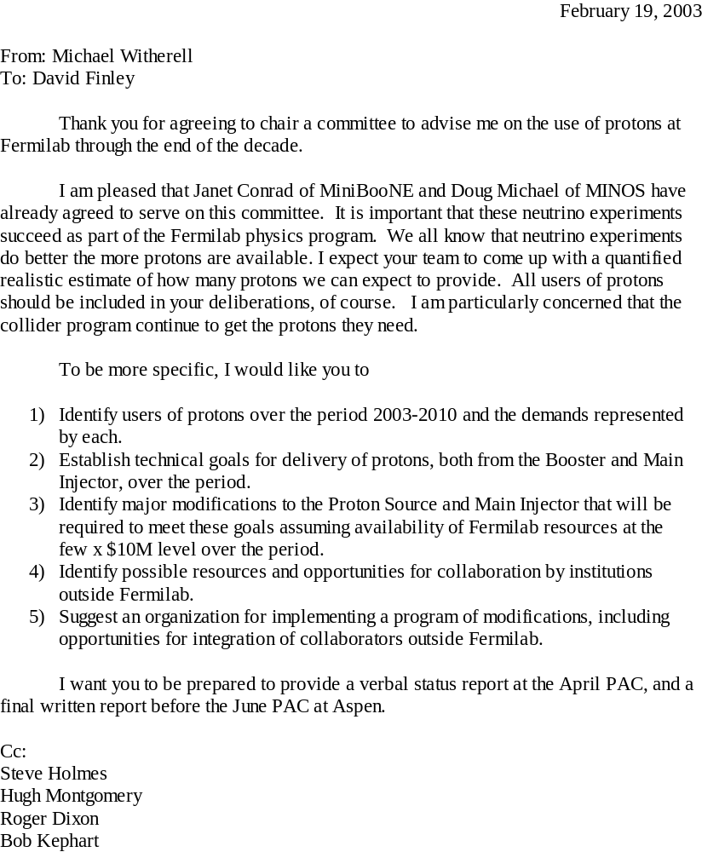

Appendix: Proton Demands Consequences Spreadsheet

The “Proton Demands Consequences” spreadsheet (see figure A.) expresses the proton requests of a given physics program in terms of the demands that would be required of the Fermilab Booster. At present, the Booster limits the total number of protons that can be delivered to users. The limitations can be expressed in terms of three performance parameters:
- Intensity or protons per cycle. Intensities of a little over 5E12 have been achieved, but the acceleration efficiency and beam quality is very poor at these intensities.
- Machine rep-rate. The main magnets of the Booster were designed to cycle resonantly at 15 Hz, however, the RF system and various pulsed devices such as the injection and extraction magnets only cycle when there is beam and will overheat if operated continuously at 15 Hz. Currently the Booster is only able to run at an average rate of 7.5 Hz.
- Protons per hour. The biggest limitation on Booster operation comes from the activation of accelerator elements due to beam loss during the acceleration cycle. A system of loss monitors is used to prevent excessive activation by turning off the beam when losses in any given area become excessive. At present the highest beam rate that has been achieved without tripping this system is about 5e16 p/hr. If ways can be found to control or prevent the beam losses, the Booster Shielding Assessment would limit the hourly intensity to 1.8e17 p/hr.
The spreadsheet calculates these parameters using the constraints imposed by the relevant operational parameters of the Booster and the Main Injector. The goal is to assess the feasibility of a proposed physics program. Alternatively it can be used to evaluate how changes to the assumed machine parameters will impact a physics program.

To perform the calculation the spreadsheet divides the available up time between three types of machine cycle:
- Booster only cycles where the Main Injector is unavailable and the Booster can be dedicated to an 8 GeV program (e.g. MiniBooNE or BooNE).
- Fast extraction Main Injector cycles in which beam is extracted in a single turn to either the P-bar source or the NuMI beam line.
- Slow spill extraction Main Injector cycles in which beam is resonantly extracted to experiments in the Switchyard 120 beamlines such as CKM.
To arbitrate between the various cycle types it first satisfies the needs of the slow spill users since their instantaneous beam rate is fixed by the needs of the experiment and this in turn constrains the amount of calendar time that is required to meet their needs. The remaining Main Injector up time is then allocated to fast spill users and the Booster intensity required to meet their needs is calculated. 8 GeV users can be allocated beam time whenever the Main Injector is not running or during those parts of the Main Injector cycles during which the Booster is not being used (i.e. during Main Injector acceleration and extraction).

The spreadsheet uses the input parameters (shown in blue on Figure A) to calculate various machine performance parameters (shown in black). The input parameters are organized into five categories:

- Program Requests:
A simple measure of the feasibility of any experiment is the total number of protons required to obtain an interesting level of statistical precision and the time required to accumulate those protons. For this reason we express the experiment requests in terms of protons per year. Of course additional constraints often apply and those that affect the rate at which protons can be delivered are included as parameters. For instance the MiniBooNE horn limits their average cycle rate to 5 Hz with the additional constraint that there be no more than 10 consecutive beam pulses in a supercycle. In the case of slow spill experiments such as CKM, an additional constraint is imposed by the maximum instantaneous beam intensity that the experimental apparatus can tolerate. The length of the spill is also an additional degree of freedom for these experiments that will affect the overall efficiency of the program.

- Up time:
The fraction of the year available to any physics program is never 100% and will naturally to be less for those programs requiring both the Booster and the Main Injector to be available.

- Machine Parameters:
The machine parameters that affect the rate at which protons can be delivered to the program are:
  - Main Injector acceleration time expressed in “clicks”. A click is the length of a Booster cycle. This unit is chosen because the overall Main Injector cycle must be an integral number of clicks.
  - Time required for slip-stacking in the Main Injector. The Main Injector can hold a total of 6 Booster batches. If the total number of batches requested for a Main Injector cycle exceeds 6, or if the number of batches to be extracted to the P-bar source exceeds 1, then some sort of stacking scheme is required. Depending on the scheme being assumed, there will be a time overhead required to perform the necessary RF manipulations. This parameter allows this overhead to be taken into account.
  - CKM is requesting debunched beam. There may be some time overhead required to do this that needs to be taken into account.
  - The Booster requires two prepulses to charge the capacitor banks in the power supplies of the pulsed devices in preparation for a train of beam cycles. These prepulses need to be accounted for when calculating the machine rep-rate.
  - The rate at which the P-bar source can accept beam is limited by the rate at which it can cool the antiprotons. This sets a lower limit on the total Main Injector cycle time. (In practice this number depends on the beam intensity in the accumulator and hence this parameter should represent the average P-bar cycle time.)

- Constants:
This section defines the length of a year in seconds and, more interestingly, the length of a Booster cycle. The latter defines a “click” and is 1/15 of a second.

- Booster Batches:
It is in this table column that the spreadsheet user allocates beam to the three cycle types. For a given cycle type it determines how booster batches are shared among the competing experiments that are able to use those cycles. BooNE cycles can be added to any of the three types, but if the user attempts to allocate more than is allowed by the 5 Hz limit the spreadsheet will flag the entry with a red “!”.

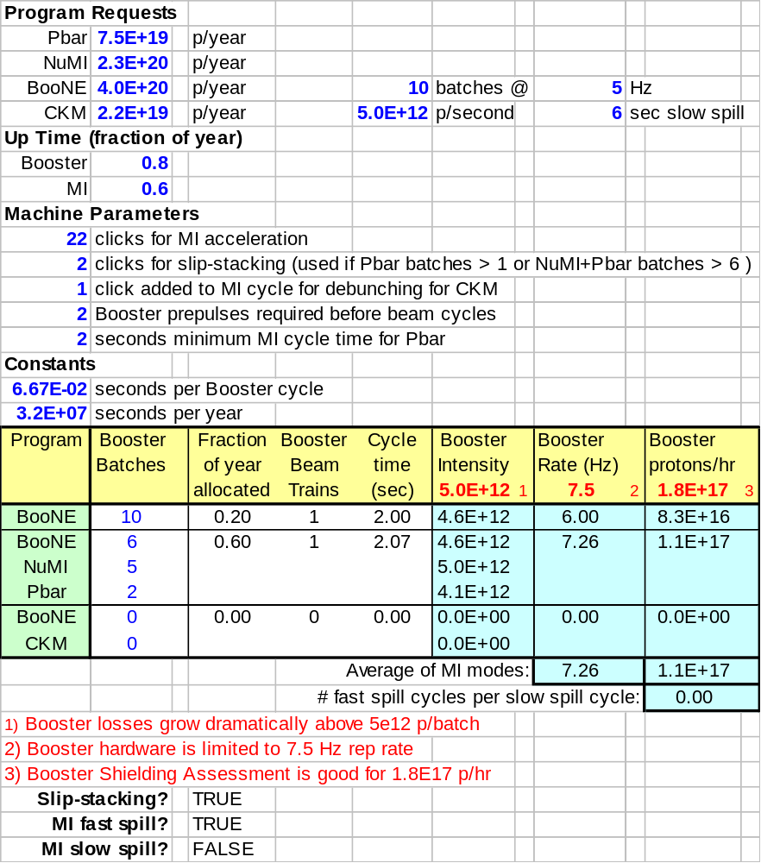
Figure A: Protons Demands Spreadsheet

The end results are shown in the last three columns of the table that are highlighted in pale blue. If any result exceeds the limits shown in the column headings the result will be flagged with a red “!”. (These numbers can be altered to reflect machine improvements.) Note however, that when a mixture of slow and fast Main Injector cycles is called for, then one should pay attention to the average machine rep-rate and the average protons per hour, rather than the rates for the individual cycle types. Also shown is the admixture of fast and slow extraction cycles that is implied by these results.

