Report of the Fermilab Director by the Proton Source Committee
Draft of April 22, 2003

Names in [brackets] are:
[Primary Person Responsible for Text / Secondary people Responsible for Text]

- Introduction [Finley / Stefanski]
  - Ground Rules
    - Collider runs throughout decade
    - New Proton Driver
  - Charge
  - Methodology and What is New
  - People Contributing
I.5 Operational Overview

To better understand some of the issues involved, it’s useful to have a qualitative overview of accelerator operation, particularly as it relates to proton delivery. We’ll start with a description of the Booster, since it sets some fundamental parameters for the entire complex.

Booster

The Fermilab Booster takes the 400 MeV protons delivered by the Linac (described below) and accelerates them to 8 GeV. The fields of the main lattice elements in the Booster oscillate in an offset sine wave at 15 Hz, which sets a fundamental timing for the entire complex.

The 400 MeV beam is injected into the Booster over several revolutions (“turns”). After acceleration, the 8 GeV beam is extracted in a single turn. This 1.6 usec pulse is referred to as a Booster “batch”. Protons can be directed to either the Main Injector or to the MiniBooNE beam line on a batch by batch basis. At the moment, the practical limit for a batch is slightly more than 5E12 protons.

The Booster can, and does, accelerate protons batches at instantaneous rate of 15 Hz; however, the heating of certain pulsed elements limits the average repetition rate to somewhat less. The limiting elements are:
- The “ORBUMP” magnets, which comprise a pulsed chicane that steers the beam out through the ion stripping foil during injection.
- The RF system, the rate of which is limited by heating of the RF cavities.
Extended operation has been demonstrated at an average rate of 7.5 Hz.

In addition, these elements require 1 or 2 prepulses to condition them prior to a 15 Hz “batch train”. Therefore, it’s important to optimize the arrangement of Booster pulses to minimize the number of prepulses required.

Main Injector

Because of the complexity and versatility of the Main Injector, we’ll concentrate on those facets related to proton delivery.

The Main Injector takes proton batches from the Booster and accelerates them either to 150 GeV for Tevatron loading or to 120 GeV, at which point they can be:
- extracted in a single turn to the antiproton production target.
- extracted in a single turn to the NuMI beam line.
- extracted to the switchyard, either in a single turn, or resonantly over a second or so.
It takes about 1.4 seconds for the Main Injector to ramp accelerate protons to 120 GeV.

The Main Injector is exactly seven times the circumference of the Booster, so seven batches will fit; however, because of the fall time if the injection kicker, one slot must be left empty, so the Main Injector can hold six Booster batches in a row. More exotic loading schemes, such as slip stacking or RF barrier bucket techniques, might allow more batches to be loaded, and these will be discussed later.

Although multibatch loading has been demonstrated in the Main Injector at low intensity, several improvements will have to be made to stably accelerate 6 high intensity batches.

Operational Modes

At present, the only significant demands for protons come from antiproton production and MiniBooNE. During antiproton stacking, a single Booster batch is sent to the Main Injector, and then a series of batches is sent to MiniBooNE while the stacking batch is being accelerated. In this way, the MiniBooNE batches do not affect the overall timeline of antiproton production. In practice, stacking runs at the highest rate allowed by cooling in the debuncher, and MiniBooNE takes as many of the remaining protons as possible, subject to the beam loss limitations in the Booster.

From the standpoint of the Booster, adding NuMI or Switchyard 120 operation will not change things dramatically, except in the total number of protons required. In addition to a stacking batch, some number of NuMI of SY120 batches will be sent to the Main Injector, again followed by MiniBooNE batches while the Main Injector is ramping.

There will, however, be significant operational considerations in coordinating stacking, NuMI, and Swithyard 120 operation in the Main Injector. The baseline plan for NuMI is to

- Short Term: Protons from 4/03 through 1/05 (NuMI turn on) [Prebys]
  - Demands/request/physics requirement [Conrad / Mishra, Kasper]
    - Collider + MiniBooNE

In the short term, the demands on the Booster and the Main Injector can be considered separately. In this section, we consider these demands in light of the combination of MiniBooNE and stacking.

Booster demands for these two programs are well understood. The collider needs 1 pulse at 5E12 delivered to the Main Injector at an average rate of 0.5 Hz for P-bar stacking. MiniBooNE needs 1E21 protons on target to complete the neutrino running and 1E21 protons on target for antineutrino running to definitively address the LSND signal. However, in the "short term” period considered in this section of the report, only neutrino running is relevant. The original plan was to deliver the protons to MiniBooNE at a rate of 5e20 protons per year. Putting these numbers into the Proton Demands Spreadsheet (see Appendix A) we obtain the Booster requirements shown in figure X1.

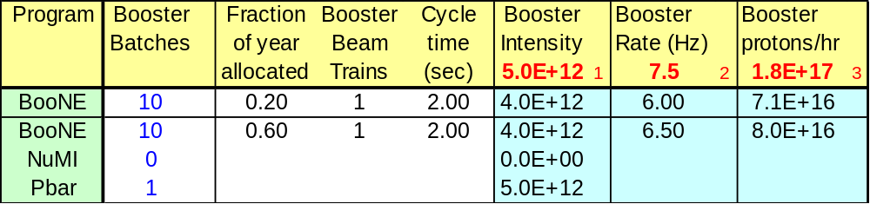
Figure X1: Baseline Booster performance requirements for P-bar stacking + MiniBooNE in the period up to 2005.

The combined goals require the Booster to run at 6.5 Hz, which is within the well-tested capability of the Booster equipment. The per pulse intensity is 5E12 ppp, which is regularly delivered to stacking. If this had been delivered to the experiments as of 9/02, the MiniBooNE startup, then MiniBooNE would have met its neutrino-running goal before 1/05. The parameter that has not been achieved to date is the required 8.0E16 protons/hour. The highest throughput so far obtained is about 5E16 p/hr. And is limited by the activation levels of Booster components from beam losses.
Under present conditions, the cumulative losses sustained in delivering protons at 8.0E16 protons/hour would be intolerable. The main issue is activation of high-maintenance equipment. This not only damages the equipment but can also render it unserviceable under the present maintenance procedures. As a result, the Booster output is limited by administrative constraints. The priority for providing protons is defined to be: 100% of the stacking request with the remainder within the administrative limit delivered to MiniBooNE.
Figure X2 shows the increase in loss as a function of protons per cycle (ppp). It can be seen that losses become significantly nonlinear with respect to proton intensity between 4 and 5E12 ppp. Therefore in the short term, solutions for losses focus on per pulse intensities that do not exceed 5E12. (Note that while 5E12 ppp has been achieved for stacking, 5E12 ppp for stacking +MiniBooNE requires upgrades, as discussed below.)
Include figure X2
This administrative limit has been enforced since the turn-on of MiniBooNE (9/1/02). Because the stacking rate is guaranteed, this has meant that the MiniBooNE rate has been substantially lower than requested. Last autumn, the MiniBooNE rate was a factor of 8 low. However, over the last six months substantial improvements have been made by the Booster Group and MiniBooNE collaborators. The active involvement of the MiniBooNE collaborators in Booster monitoring has been important to improving output while reducing losses. Present running has climbed to 50% of the requested MiniBooNE rate with losses substantially reduced (figure). The Proton Demands spreadsheet for running on April 15, 2003 is shown in figure X3

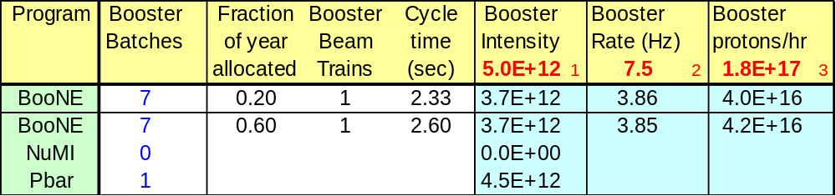
Figure X3: Booster performance as on April 15, 2003. This corresponds to a rate of 2.6E20 protons/year for MiniBooNE.
In order to meet the stacking+ MiniBooNE physics goals, as well as NuMI expectations at turn-on in 1/05, we consider two phases of Booster improvement. The first set is expected to be enacted during the 2003 shutdown. The second is under consideration and we strongly endorse for action by the beginning of summer, 2004.
The following improvements expected during the 2003 shuutdown:
  - The collimator
  - The prototype RF cavities
  - The ramp monitoring software
  - Upgrades to the loss monitor system

The Proton Source Team strongly endorses installing these upgrades as early as possible, as these represent a benchmark for what needs to be achieved in the future. With these upgrades it should be possible to meet the Booster performance requirements shown in fig. X1. We recommend that the lab adopt this as a base goal for running conditions for October, 2003.
In order to approach the final goals of the short-term program, by summer 2004, the required Booster performance is shown on fig. X4. We recommend the lab adopt this running condition as a base goal for October 2004. The following program of modifications is the minimum necessary for meeting these goals:
  - Replacing all RF with wide aperture cavities
  - Correcting the dog leg problem
  - Replacing the orbump system
  - Installing the radworker robot
  - Upgrading the dampers
  - Installation of the γ_{T} jump
Justification for these modifications appears in section xxx, below.

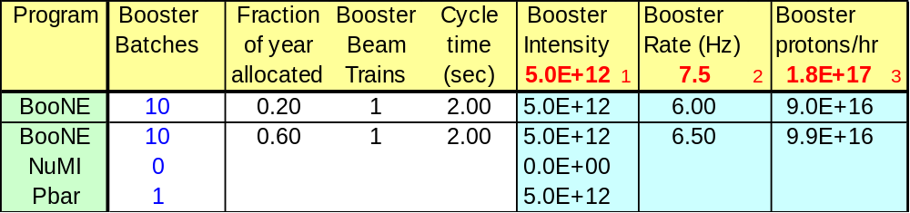
Figure X4: Booster performance goals for October 2004.

The committee notes that achieving the October, 2004 goal requires a strong commitment by the laboratory management.
If these goals are not met, to complete the neutrino running for MiniBooNE, delivery beyond 9E16 pph or running beyond 1/05 must be considered. The former possibility will be considered here and the latter in the following chapter on post 1/05 running. In our opinion, raising the protons per pulse, while a good goal, is going to be technically more difficult than extending MiniBooNE running past 1/05.
However, the committee endorses continued efforts to increase the protons per pulse beyond 5E12 ppp, in order to lay the ground work for successful NuMI running. While a plan for achieving the initial NuMI goals is in place, we note that there is little margin for error on the assumptions that have been made. Increased protons per pulse could make up for issues in other aspects of NuMI initial proton delivery. For example, Fig XX shows the proton-per-pulse needs if, in the NuMI era, the rquired time for stacking is greater than 1 "click" (ie one15 Hz cycle, see appendix A). This table assumed 2.5E20 ppy to NuMI. One can see that achieving 5.5 ppp is required under this circumstance.

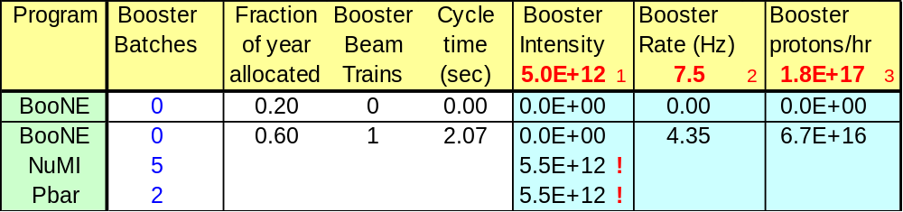
Fig. X5: Alternative NuMI initial running conditions that motivate the stretch goals. The exclamation points indicate values beyond the base goal (see appendix A)

As a result, the committee recommends that the stretch goal for the Booster in the short term be running under the conditions presented in fig. X5.

******************* stretch table here *******************

    - Collider + MiniBooNE + Meson120

The Meson120 program will begin in xx/03 with beam provided to E907 and Testbeam.
This program requires xxx ppy, which is xxx orders of magnitude less than the MiniBooNE requirement and xxx times less than stacking. Therefore, the impact of this program on Booster is minimal. The Booster must provide xxx pph, and this increment must be obtained through the improvements listed in the previous section, providing another reason for the committee to strongly endorse improvements in Booster Proton Throughput. The impact on Main Injector running should be noted as a harbinger of issues during the post-1/05 era. We note that if the typical store-period is maintained by the collider, there is more than sufficient time to stack while still providing protons to Meson120.

The impact of Meson120 on the Main Injector is...

Once one has three programs, the synergy between the needs makes it difficult to assess ch program. In order to address this problem, we introduce a tool for program planning which allows one to unedrstand the proton economcis issues....

      - Meson120 = E907 + Test Beam
      - Introduce Proton Economics Spreadsheet here with the three constraints on the Booster
    - Preparing for Collider Improvements and NuMI
  - Modifications, costs and downtime [Prebys / Mishra, Ankenbrandt]

- Mid Term: Protons from 1/05 through 9/08 (E906 and CKM turn on) [Mishra]
  - Demands/request/physics requirement [Michael / Mishra, Marchionni]
    - Collider + NuMI + Meson120
      - Collider = CDF / D0 then BTeV
      - Meson120 = E906 + CKM + Test Beam
    - Collider + NuMI + MiniBooNE + Meson120
    - Preparing for Protons Beyond 9/08
  - Modifications, costs and downtime [Mishra / Prebys, Bock]

- Long Term: Protons Beyond 9/08 [Mishra]
  - Demands [Michael / Conrad]

BooNE -- need to plan for success. FINeSE. Other programs -- ask Peter K.

    - Demands will exceed capabilities >>> Need New Proton Driver
  - Modifications, costs and downtime [Marchionni (MI) & Prebys (Booster)]
    - Costs will exceed few $10M's >>> Need New Proton Driver

- Collaboration and Organization [Mishra]
  - Collaboration [Michael, Conrad]

Collaboration divides into three types: within the lab, with members of the accelerator physics community and with the HEP users of the lab. We recommend that Roger Dixon appoint a senior member of beams division to investigate methods of facilitating collaboration. In particular, we hope that those who have had substantial experience with collaboration will be interviewed to understand what works and what does not. We recommend that the beams division appoint an ombusdsperson for

  - Organization [Mishra, Ankenbrandt]

- Summary [Stefanski / Finley]

