Niobium Tin Quadrupoles

Version 0 - June 12, 2012

1. Overview

Interaction Region Quadrupoles based on Nb₃Sn have the potential to support higher luminosities than could be obtained using NbTi. In particular,

- The capability to operate at higher field may be exploited to achieve high focusing power, in particular by increasing the aperture while maintaining a sufficiently high gradient to control the overall length of the triplet. The large aperture can also accommodate thick absorbers to control the thermal loads and increase the radiation lifetime of the magnet
- Large thermal margins are expected to result in more reliable operation under high heat loads

Significant investments in National Laboratory base programs and LARP have given the US a leadership position in Nb₃Sn accelerator magnet technology. Following the successful tests of the LARP LR, TQ, LQ and HQ models, Nb3Sn technology is now regarded as the baseline for the new LHC IR. The development and construction of Nb₃Sn quadrupoles for the LHC luminosity upgrade will contribute to further refining and expanding the unique US capabilities in this critical sector of accelerator technology.

2. Technical plan

- The HL-LHC design is being carried out through the Hi-Lumi project, in which USLARP is fully integrated. Key milestones:

  - June 2012, aperture selection; expect 150 mm; should be official by the time we finalize this document
  - ~2014 CDR
  - ~2016 TDR

- The IR quadrupole development plan is subdivided in three major portions:

  - Technology demonstration. All fundamental technical elements have already been demonstrated (conductor and cable performance, coil design and fabrication, mechanical structure design, length scale up). They are now being combined in the 4 m long, 120 mm aperture LHQ. LARP, CERN and DOE have agreed that a successful test of LHQ will complete the technology demonstration. We expect the LHQ test at the end of 2014.
    - Discuss some of the outstanding issues, in particular radiation damage and cooling; also field quality
  - Prototype development, consisting of short and long models of the final design, including a fully integrated pre-series magnet
    - Describe in more detail, mention CERN participation
  - Construction project, consisting of fabrication of 16 cold masses and 4 spares

- The program details are being discussed by a planning group with representatives for BNL, FNAL, LBNL and CERN. After reviewing different scenarios, the baseline plan includes the following key elements:

  - The Nb₃Sn magnets will use a continuously wound 2-layer coil design with a ~18 mm wide cable.
  - The baseline conductor for the construction project will be OST-RRP. Several design options exist, some are already production level and some need further development. In parallel, CERN is developing PIT as a possible alternative
  - The Nb₃Sn magnets will meet the magnetic length requirement for each optics element of the triplet ~8 m) using two ~4 m long coils assembled in common cryostat

    - We initially analyzed a program based on full length coils, but we found that it would be difficult to complete a prototype of this design with sufficient schedule margin before the start of production.
    - The use of half-length coils removes this difficulty and the associated risks, since the performance of Nb3Sn coils close to 4 m length is already demonstrated by LQ/LR tests, and the LHQ is expected to confirm/extend these results to 120 mm aperture around 2015. Based on these results we will be able to confidently move forward on the required time scale (see schedule)
    - We are still considering using full length coils for part of the production (Q2a/b)

3. Infrastructure and resources

The infrastructure currently available at the National Laboratories allows production of 4 m long Nb₃Sn coils, with small modifications/upgrades. Additional infrastructure and tooling needed to meet the production schedule may be needed but we do not expect any particular issues

The technical teams at BNL, FNAL and LBNL (should also include CERN here?) are adequate to initiate and support the project. Additional personnel will have to be trained to carry out the production.

Upgrades of the Fermilab magnet test facility are in the plan to support the prototype development. Test facility upgrades are needed if all cold masses are to be tested in the US prior to shipping.

4. Schedule and milestones

- Include CDR milestone?
- In line 7, change to LHQM/LHQ assembly and test?

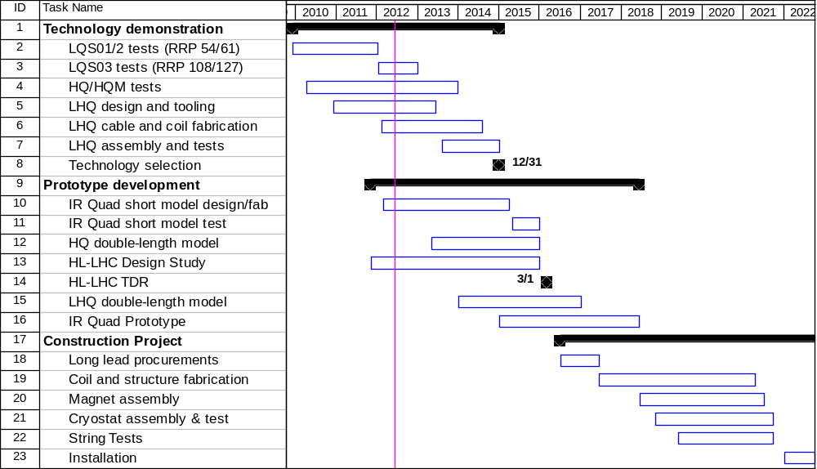

Nb₃Sn Quadrupole Construction Project Schedule

Describe key elements of the schedule:

- …

The new schedule appears to have sufficient margin to accommodate delays in various areas without affecting the overall outcome. Examples:

  - A delay of the technology demonstration target by up to 1 year with respect to the current date (12/2014) would not affect other tasks or the decision process.
  - The Dec 2016 target for a successful test of the double-length LHQ is quite reasonable but a delay does not seem to affect other tasks or the decision process.
    - In fact, depending on the design this test may not be required
  - Additional margin of perhaps 6 months could be obtained by overlapping the end of production with the start of installation – however, this would create additional constraints. For the time being, we will keep the two phases independent of each other.

5. Cost estimates:

- In the works, expect first estimates for both R&D, prototype and construction in the next meeting of the planning group, June 22

