ORBUMP Current Path Issues

It’s very important to minimize the orbit distortion caused by the ORBUMP magnet system during injection. The main concern is net dipole moment cause by improperly matched magnetic fields in the dogleg. The present current path of the magnets is shown below

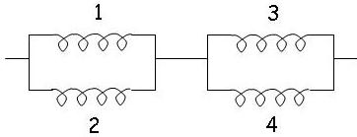

The nominal fields that a particle sees are

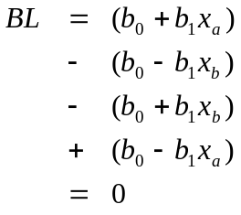

Where the overall sign of each term comes from the magnet polarity and the relative sign of the quadrupole term comes from the magnet orientations. Position x_{a} and x_{b} are the circulating and bumped-out orbits, respectively. As you can see, the alternating orientation of the magnets results in a fortuitous cancellation of the quadrupole contributions, which would otherwise be quite worrisome.

However, problems can also arise from current imbalances. If we assume that magnet 1 has a relative impedance which is ε higher than the others, then the fields are perturbed as

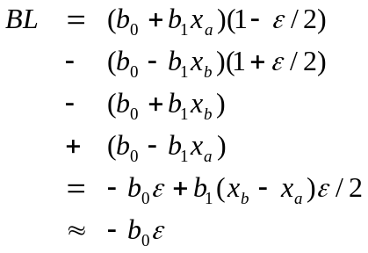

Using the measured value of b0=.156T-m, means that the magnitude of the net dipole for a 1% impedance mismatch would be .00156T-m, giving and angular kick of .00049 at injection. This would cause a maximum orbital distortion of
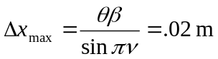
which would be unacceptably large.

On the other hand, we could achieve the same nominal currents in the following configuration
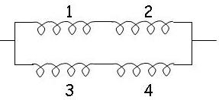

In this case, the same impedance mismatch would give a net dipole of

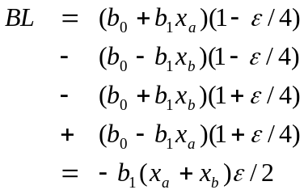
Using the nominal values of x_{a}=.040, x_{b}=-.004, and b₁=.0122 T, we get a anomalous dipole field of 0.000004392 T-m, giving an angular kick of 1.4x10⁻⁶. This gives a maximum closed orbit distortion of
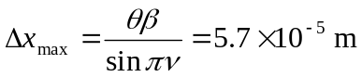

which is negligible. In fact, because the balance of the dipole kicks is more or less guaranteed in this scenario, the orbital distortion will be dominated by the mismatch of the lateral offset of two halves of the dogleg, which is
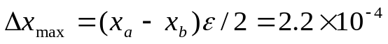
for a 1% impedance mismatch. That’s still two orders of magnitude lower than the present configuration.

