A Proposed H- Injection System for the Fermilab Booster
Milorad Popovic, C. Ankenbrandt, F. Garcia, J. Lackey, W. Pellico and E. Prebys
Fermi National Accelerator Laboratory
DRAFT

April 12, 2005

Abstract
This note proposes a simple modification to the H- injection system in the Fermilab Booster. The suggested scheme may also be relevant for H- injection into the SNS and/or other existing or planned accelerator complexes that use H- injection.

Introduction
At present, the H- beam from the Linac is injected into the Fermilab Booster using a DC septum magnet and four pulsed magnets that cause a local orbit-bump (hence the name Orbump). The role of the DC Septum magnet is to bend the incoming H- beam parallel to the circulating beam. The first two Orbump magnets combine the two beams, after which they pass through a stripping foil. The last two Orbump magnets restore the circulating orbit to its normal position. Figure 1 illustrates the present Orbump system and the trajectories of the circulating and injected beams
Circulating Beam
Injected Beam
H-
Stripping
Orb1
Orb2
Orb3
Orb4
Foil
Figure 1. The present injection system concept.

The next two drawings provide a more detailed schematic layout of the arrangement of the present injection system with the DC Septum and the four Orbump magnets. Figure 2 is a side view and Figure 3 is a top view of the injection straight section.
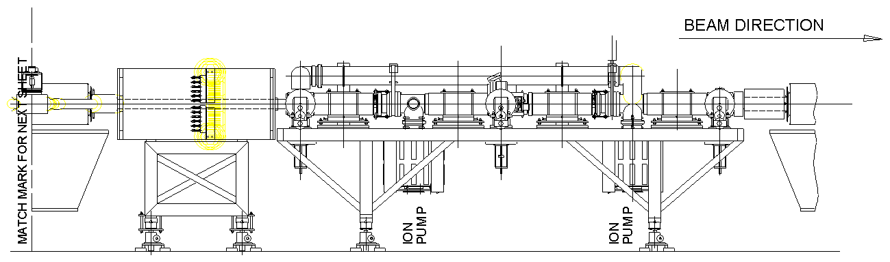

Figure 2. Elevation view of the present layout of the injection components.
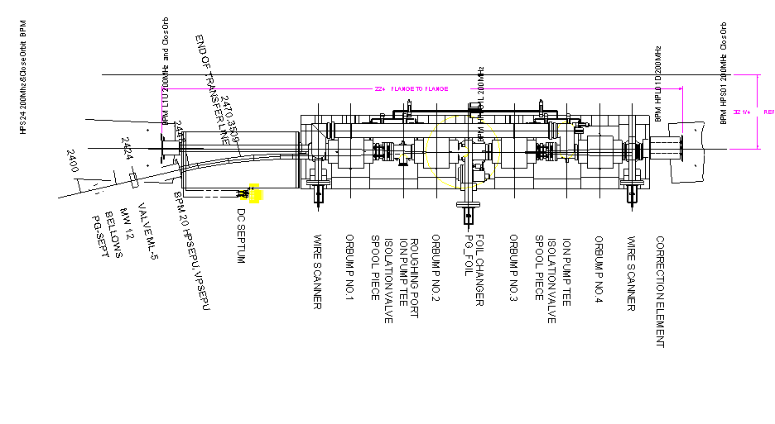
Figure 3. Plan view of the present layout of the injection components.

As can be seen from these drawings, the DC Septum occupies almost a quarter of the available space, and the four Orbump magnets are positioned close to each other in order to fit them into the available space.

A modification to the existing injection system in order to enable operation at higher repetition rates is currently underway. The current plan assumes the very same configuration of the magnets. The plan is to replace the Orbump magnets with new ones having improved cooling for increased pulse operations; their field strength will be similar to the existing ones. Because the injection region is a high beam loss area, it is necessary to build a completely new Injection Girder in order to avoid working with activated components.

The New Scheme

Since a complete rebuild of the injection section is planned, it is reasonable to consider alternative layouts. After some consideration a much simpler injection layout with several attractive features has been found. A conceptual layout of the proposed new scheme is shown in Figure 4.
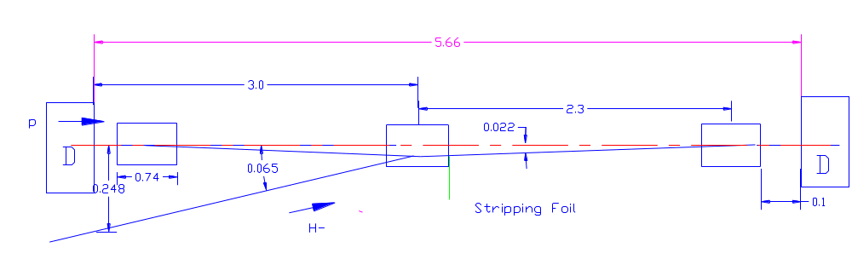
Figure 4. Layout of the proposed new scheme.

The geometrical layout has been calculated as follows. The center of the beam on the stripping foil is constrained to be 4.5 cm from the center of the undeflected circulating beam. This fixes the bending angle of the two outside Orbump magnets to be 0.022 radians. The central Orbump magnet runs at twice the strength of the outer ones, bending the two beams through +/-0.044 radians. Thus the H- beam entering the middle Orbump magnet is 6.7 cm from the center of the circulating beam and makes an angle of 0.065 radians with respect to the trajectory of the circulating beam. At the downstream end of the last upstream lattice magnet, a D magnet whose horizontal half-size is 22.5 cm, the H- beam is 24.8 cm from the center of the circulating beam.

This configuration provides several advantages. First of all, there are fewer components because a DC Septum magnet is not needed and there are only three Orbump magnets. Secondly, the Orbump magnets are much more separated than now, so the first and last ones run at about half the current needed in the present configuration. This significantly reduces deleterious edge focusing effects.
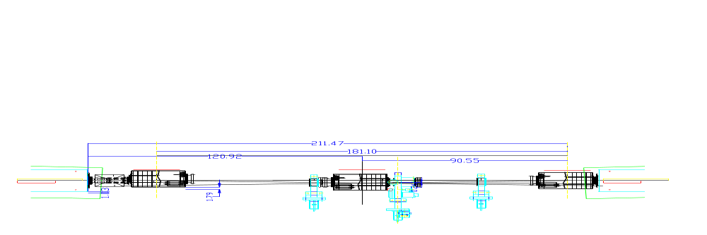

Figure 5. Plan view of the suggested layout of the injection components.

Figure 6 shows the circuit with the upstream and downstream magnets in parallel at about half the present current.
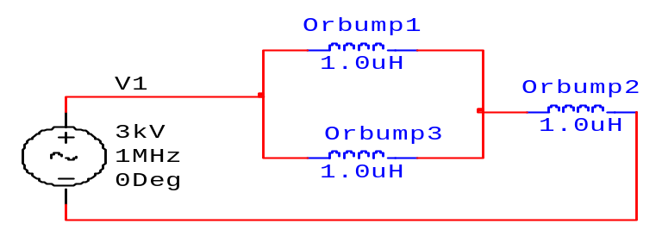
Figure 6.
This configuration requires minor modifications to the last part of the 400 MeV transfer line. At this time the DC Septum bends the incoming H- beam through about 13 degrees. In the new scheme the H- beam has to arrive at an angle of about 3 degrees with respect to the circulating beam. Figure 7 shows one possible modification of the transfer line using two bending magnets. In this configuration quad Q13, after the Debuncher, stays where it is now, Q14 is removed (presently it is turned off), and two Cooling ring dipoles are used to bend the beam through a total of 17 degrees. These magnets are currently used in the 400 MeV line and each magnet bends the beam through 9.6 degrees.
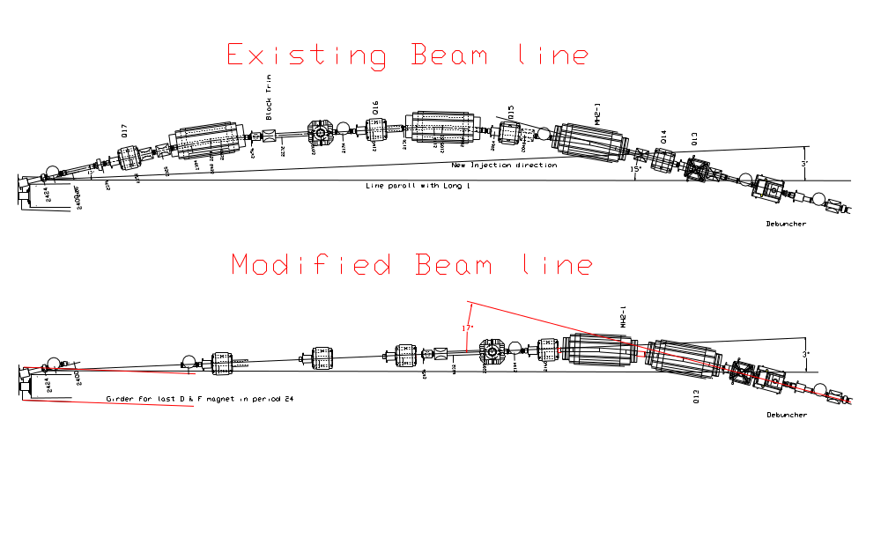
Figure 7.

The next two figures show results of a Trace3D simulation of the present 400MeV beam line and the new line modified to accommodate the simplified beam injection scheme.

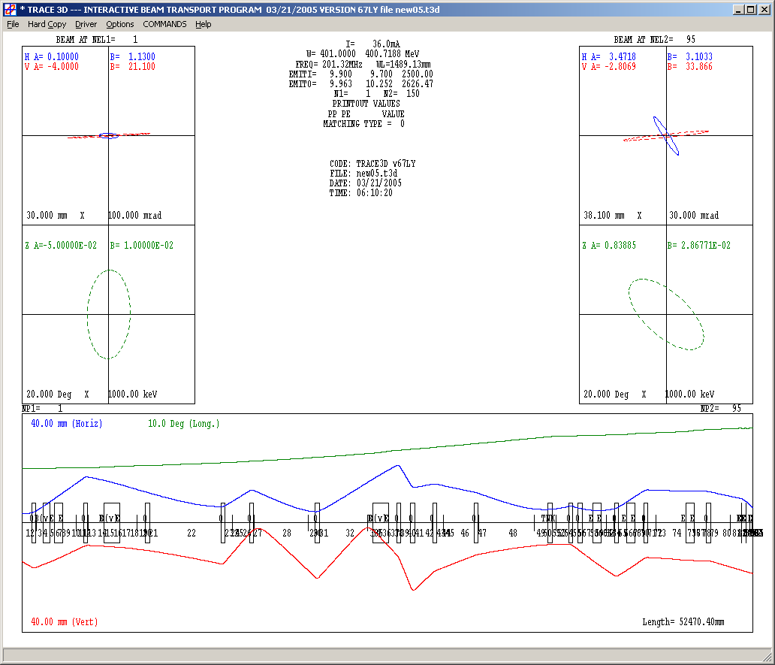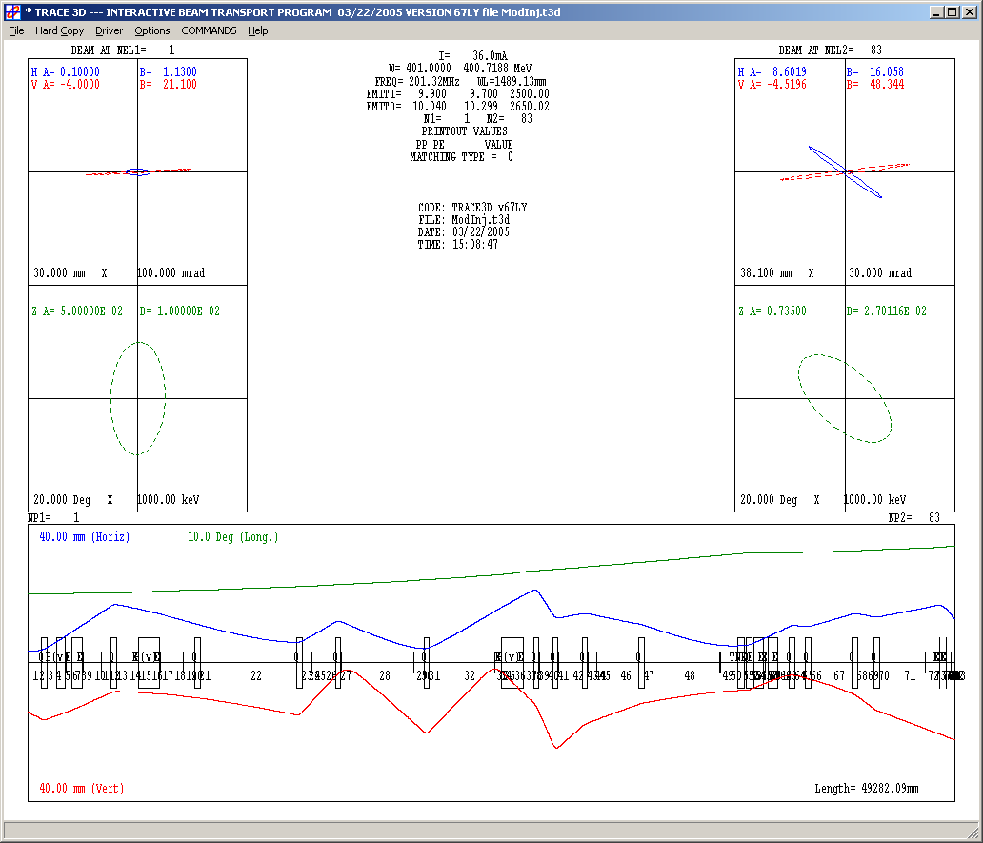

Reference
Booster Rookie Book

